

CAPSTONE PROJECT REPORT
Report 3 – Software Requirement Specification

– Hanoi, Oct 2026 –

Table of Contents
Table of Contents 2
Change Log 8
Definition and Acronyms 9
I. Overall Requirements 10
1. Context Diagram 10
2. Main Business Flow 10
2.1 Replenishment, Procurement and Goods Receiving (BF-01) 10
2.2 Defective Goods Isolation and Disposition (BF-02) 11
2.3 Warehouse Transfer and Discrepancy Resolution (BF-03) 12
2.4 Stocktake and Inventory Adjustment (BF-04) 13
2.5 Sales Order Fulfilment and Internal Invoice (BF-05) 14
2.6 Customer Return and Returned Goods Classification (BF-06) 15
2.7 Supplier Return and Inventory Reconciliation (BF-07) 16
3. Conceptual Data Model 17
3.1 Entity Relationship Diagram 17
3.2 Entity Descriptions 18
3.3 Data Business Rules 20
4. User Requirements 21
4.1 Actors 21
4.2 Use Cases (UC) 21
4.3 Use Case Diagrams 23
4.3.1 24
4.3.2 25
4.3.3 26
4.3.4 27
4.3.5 27
4.4 Permission Matrix 27
5. System Functionalities 31
5.1 Screen Inventory 31
a. Screen Flow 31
b. Screen List 31
5.2 External API Inventory 32
5.3 Background Job Inventory 32
II. Use Case Specifications 32
1. Purchase Delivery and Partial Receiving (FE-01) 32
1.1 UC-01: View replenishment request list 32
1.2 UC-02: View replenishment request details 33
1.3 UC-03: Create replenishment request 34
1.4 UC-04: Approve or reject replenishment request 34
1.5 UC-05: View purchase order list 35
1.6 UC-06: View purchase order details 36
1.7 UC-07: Manage Purchase Order and Supplier Confirmation 37
1.8 UC-08: View goods receipt list 37
1.9 UC-09: View goods receipt details 38
1.10 UC-10: Create goods receipt from purchase order 38
2. Master Data, Tile Traceability and Selling Price (FE-02) 39
2.1 UC-11: View product list 39
2.2 UC-12: View product details 40
2.3 UC-13: Maintain Product and Packaging 40
2.4 UC-14: View lot list 41
2.5 UC-15: View lot details 41
2.6 UC-16: Maintain Product Lot 42
2.7 UC-17: View supplier list 42
2.8 UC-18: View supplier details 43
2.9 UC-19: Maintain Supplier 44
2.10 UC-20: View Customer List 44
2.11 UC-21: View Customer Details 44
2.12 UC-22: Maintain Customer 45
2.13 UC-23: View Selling Price List 45
2.14 UC-24: View Selling Price Details 45
2.15 UC-25: Maintain Selling Price 46
3. Goods Receiving Quality Control (FE-03) 46
3.1 UC-26: Inspect and Post Goods Receipt 46
4. Bin-level Inventory and Location Movement (FE-04) 47
4.1 UC-27: View warehouse and location list 47
4.2 UC-28: View storage location details 47
4.3 UC-29: Maintain Storage Location 48
4.4 UC-30: View stock by lot, location, and quality status 48
4.5 UC-31: View inventory balance details 49
4.6 UC-32: Create Put-away Transfer Order 50
4.7 UC-33: Confirm Put-away Transfer Order 50
4.8 UC-34: View location movement list 50
4.9 UC-35: View location movement details 51
4.10 UC-36: Create location movement 52
4.11 UC-37: Confirm actual location movement 52
5. Warehouse Transfer and Discrepancy Management (FE-05) 53
5.1 UC-38: View warehouse transfer list 53
5.2 UC-39: View warehouse transfer details 54
5.3 UC-40: Create Transfer Request 55
5.4 UC-41: Review Transfer Request 55
5.5 UC-42: Create Warehouse Transfer Order 55
5.6 UC-43: Confirm Warehouse Transfer Order 56
5.7 UC-44: Review Transfer Difference Resolution 56
6. Sales Order, Outbound Delivery, Picking, Goods Issue and Internal Invoice (FE-06) 57
6.1 UC-45: View Sales Order List 57
6.2 UC-46: View Sales Order Details 57
6.3 UC-47: Create Sales Order 57
6.4 UC-48: Update or Cancel Sales Order 58
6.5 UC-49: View Outbound Delivery List 58
6.6 UC-50: View Outbound Delivery Details 58
6.7 UC-51: Create Outbound Delivery 59
6.8 UC-52: View Picking Transfer Order List 59
6.9 UC-53: View Picking Transfer Order Details 59
6.10 UC-54: Create Picking Transfer Order 60
6.11 UC-55: Confirm Picking Transfer Order 60
6.12 UC-56: View goods issue list 61
6.13 UC-57: View goods issue details 61
6.14 UC-58: Post Goods Issue 62
6.15 UC-59: View Internal Invoice List 62
6.16 UC-60: View Internal Invoice Details 63
6.17 UC-61: Create Internal Invoice 63
6.18 UC-62: Issue Internal Invoice and Produce PDF 63
7. Defective Goods, Returns and Refund Control (FE-07) 64
7.1 UC-63: View defective goods list 64
7.2 UC-64: View defective goods details 64
7.3 UC-65: Inspect Defective Goods and Submit Disposition 65
7.4 UC-66: Approve or reject defective goods disposition 65
7.5 UC-67: Record approved defective goods disposition 66
7.6 UC-68: View customer return list 67
7.7 UC-69: View customer return details 68
7.8 UC-70: Create Customer Return Request 68
7.9 UC-71: Review Customer Return Request 69
7.10 UC-72: Inspect Customer Return 69
7.11 UC-73: Confirm Customer Return Receipt 69
7.12 UC-74: View Refund Request List 70
7.13 UC-75: View Refund Request Details 70
7.14 UC-76: Create Customer Return Refund Request 70
7.15 UC-77: Review Customer Return Refund Request 71
7.16 UC-78: Record Refund Completion 71
7.17 UC-79: View supplier return request list 72
7.18 UC-80: View supplier return request details 72
7.19 UC-81: Create Supplier Return Request 73
7.20 UC-82: Confirm Supplier Return Dispatch 73
7.21 UC-83: Review Supplier Return Closure 74
8. Stocktake and Inventory Adjustment (FE-08) 74
8.1 UC-84: View stocktake list 74
8.2 UC-85: View stocktake details 75
8.3 UC-86: Create Stocktake Session 75
8.4 UC-87: Perform Stocktake Count and Record Results 76
8.5 UC-88: Reconcile Stocktake 76
8.6 UC-89: View inventory adjustment request list 77
8.7 UC-90: View inventory adjustment request details 77
8.8 UC-91: Create Inventory Adjustment Request 78
8.9 UC-92: Approve Inventory Adjustment 78
8.10 UC-93: Clear Stocktake Difference 79
9. Access Administration, Audit and Operational Reporting (FE-09) 79
9.1 UC-94: Sign in to the system 79
9.2 UC-95: View account list 80
9.3 UC-96: View account details 80
9.4 UC-97: Maintain Staff Account 81
9.5 UC-98: Assign roles and operation permissions 81
9.6 UC-99: View Operational Reports 82
9.7 UC-100: View stock movement log 83
9.8 UC-101: View stock movement details 83
9.9 UC-102: Trace a product lot through source documents 84
III. Functional Requirements 84
1. Access Administration (FE-09) 85
1.1 Sign In 85
1.1.1 SC-01: Sign In 85
1.2 Account List and Details 86
1.2.1 SC-02: Accounts and Permissions 86
2. Products and Lots (FE-02) 87
2.1 Product and Unit Conversion 87
2.1.1 SC-03: Products and Packaging 87
2.2 Lot List and Details 88
2.2.1 SC-04: Product Lots 88
3. Supplier Master Data (FE-02) 89
3.1 Supplier List and Details 89
3.1.1 SC-05: Suppliers 89
4. Purchasing (FE-01) 90
4.1 Replenishment Requests 90
4.1.1 SC-06: Replenishment Requests 90
4.2 Purchase Orders 92
4.2.1 SC-07: Purchase Orders 92
5. Goods Receiving and Inspection (FE-01, FE-03) 93
5.1 Goods Receipts and Inspection 93
5.1.1 SC-08: Goods Receipt and Inspection 93
6. Warehouse and Storage Locations (FE-04) 95
6.1 Warehouse Locations 95
6.1.1 SC-09: Warehouse Locations 95
7. Inventory and Defective Goods (FE-04, FE-07) 96
7.1 Inventory by Lot and Status 96
7.1.1 SC-10: Inventory by Lot and Status 96
7.2 Defective Goods and Disposition 97
7.2.1 SC-11: Defective Goods and Disposition 97
8. Location Movement and Warehouse Transfer (FE-04, FE-05) 98
8.1 Location Movements 98
8.1.1 SC-12: Location Movements 98
8.2 Warehouse Transfers and Discrepancies 99
8.2.1 SC-13: Warehouse Transfers 99
9. Stocktake and Inventory Adjustment (FE-08) 101
9.1 Stocktake and Counting 101
9.1.1 SC-14: Stocktake Sessions and Counts 101
9.2 Inventory Adjustment Requests 102
9.2.1 SC-15: Adjustment Requests and Clear Difference 102
10. Sales Orders and Goods Issue (FE-06) 104
10.1 Sales Orders 104
10.1.1 SC-16: Sales Orders 104
10.2 Goods Issue and Actual Dispatch 105
10.2.1 SC-17: Goods Issue 105
11. Customer and Supplier Returns (FE-07) 106
11.1 Customer Goods Returns 106
11.1.1 SC-18: Customer Returns 106
11.2 Supplier Return Requests 108
11.2.1 SC-19: Supplier Returns 108
12. Operational Reports (FE-09) 109
12.1 Inventory Reports 109
12.1.1 SC-20: Operational Reports 109
13. Inventory Audit Trail (FE-09) 110
13.1 Stock Movement Log and Lot Trace 110
13.1.1 SC-21: Stock Movement and Lot Trace 110
14. Outbound Deliveries 111
14.1 SC-22: Outbound Deliveries 111
15. Picking Transfer Orders 112
15.1 SC-23: Picking Transfer Orders 112
16. Customers 112
16.1 SC-24: Customers 112
17. Selling Prices 112
17.1 SC-25: Selling Prices 112
18. Internal Invoices 113
18.1 SC-26: Internal Invoices 113
19. Refund Requests 113
19.1 SC-27: Refund Requests 113
20. Background Job Inventory 114
20.1 Process Status Email Events 114
21. External API Inventory 114
21.1 SMTP Service 114
IV. Non-Functional Requirements 114
1. External Interfaces 114
2. Quality Attributes 114
2.1 Usability 114
2.2 Performance 115
2.3 Security 115
2.4 Reliability and Data Integrity 115
2.5 Maintainability and Traceability 115
V. Requirement Appendix 115
1. Business Rules 115
2. System Messages 117
3. Other Requirements 118

Change Log
Date | A/M/D | In Charge | Change Description
09 Oct 2026 | M | Project documentation | Refined all 109 UC specifications; aligned FE names and UI mockups; specified 176 screen fields with proposed MongoDB types, entry requirements, defaults and validations.
15/10/2026 | M | Project Team | Synchronized the nine-feature scope and 102 UCs into the full report; enforced operation-specific permissions, updated detailed screen requirements, MongoDB and SMTP, and excluded general policy management.

A = Added; M = Modified; D = Deleted. This revision date records document editing, not business sign-off.

Definition and Acronyms
Acronym / Term | Definition
WMSD | Warehouse Management System
SRS | Software Requirements Specification
UC | Use Case
FE | Feature
BF | Business Flow
PO | Purchase Order
UoM | Unit of Measure
GR | Goods Receipt
Lot | A tile batch identified by number, tone and actual calibre
Usable stock | Accepted quantity eligible for goods issue or applicable movement
Physical stock | Quantities physically recorded across quality classifications
Cut-off snapshot | Stock balance preserved at the defined stocktake cut-off
N–X–T | Inbound–Outbound–Closing Stock report (local stock ledger terminology)

I. Overall Requirements

1. Context Diagram
WMSD serves exactly five application roles: Store Owner, Accountant, Inventory Staff, Sales Staff and Administrator. Suppliers and customers are external business parties, not additional application roles. WMSD includes Sales Orders, Outbound Deliveries, picking Transfer Orders, Post Goods Issue, internal invoice issuance with PDF/print output, SMTP order/invoice status notifications, customer and supplier returns, and approval and evidence recording for externally completed customer-return refunds. Master data and manually entered selling prices are included; any margin calculation is performed outside WMSD. Sales payment collection, deposits, receivables, debt, full accounting, statutory e-invoicing and live MISA integration are excluded. A general-purpose function to create or edit business policies is not implemented.
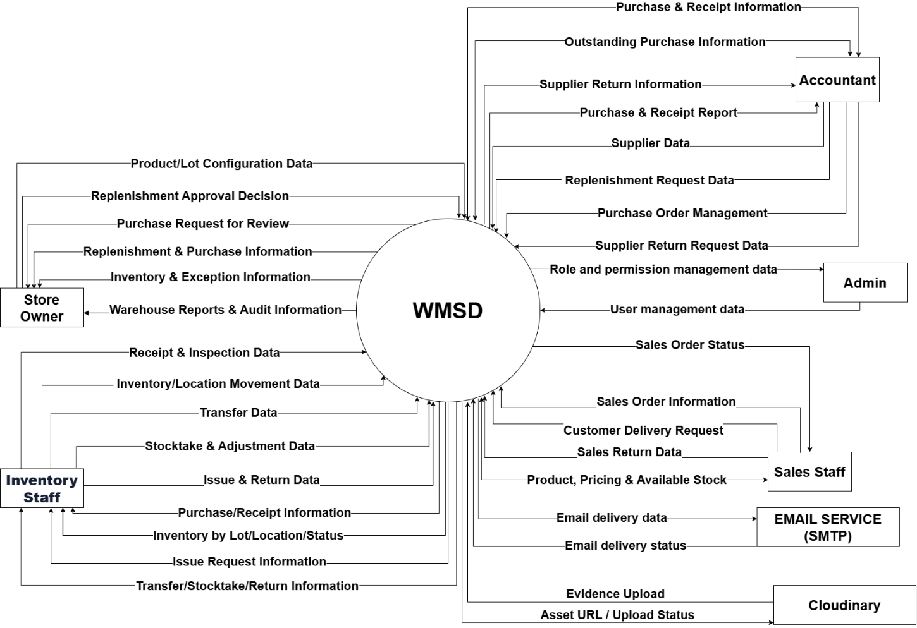
Figure 1. System context diagram — source-defined interacting roles

2. Main Business Flow

2.1 Replenishment, Procurement and Goods Receiving (BF-01)
Trigger: The Accountant reviews warehouse replenishment needs and creates a request for the Store Owner to review.
End condition: If the request is not approved, WMSD records it as rejected and the Accountant revises it; no purchase order is created in this flow. If approved, the Accountant creates a purchase order and records the supplier’s confirmation. After the goods arrive, Inventory Staff records and inspects the receipt. Accepted goods are put away and posted to inventory by lot, location, and status, and WMSD updates the outstanding purchase quantity.
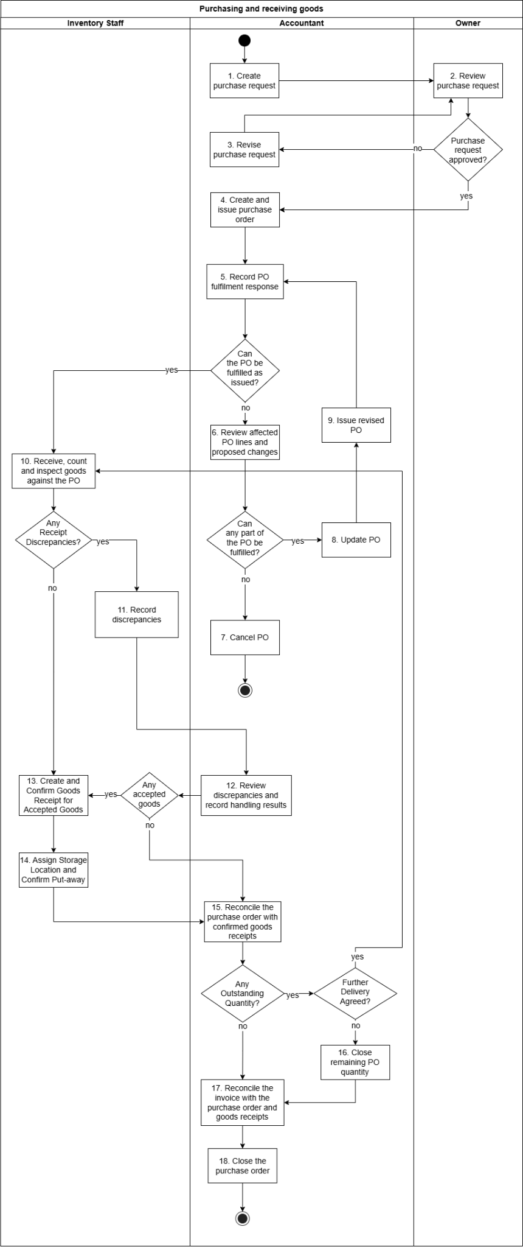
Figure 1. Replenishment, Procurement and Goods Receiving — actor/system workflow.
Decision handling: A rejected request cannot proceed to purchase order creation. During receiving, accepted quantities are recorded as usable inventory. Defective or discrepant quantities are documented and kept outside usable inventory. The goods acceptance decision determines which path is followed.

2.2 Defective Goods Isolation and Disposition (BF-02)
Trigger: Inventory Staff identifies defective, damaged or otherwise non-usable goods during warehouse operations and records the defect information.
End condition: The defective quantity is isolated and its disposition is approved and processed, with inventory quantities, final stock status and movement history updated accordingly. Rejected disposition proposals remain subject to revision and further review.
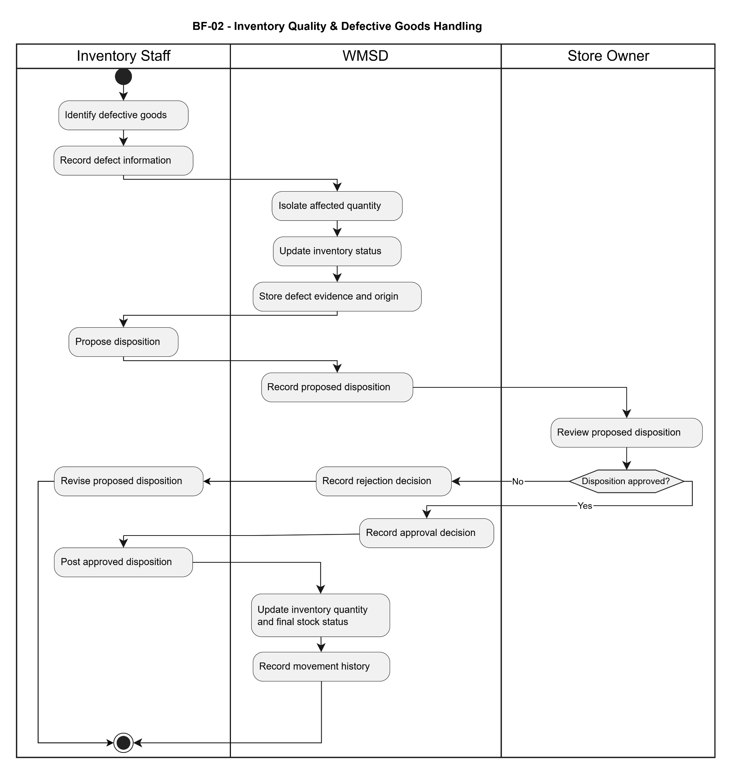
Figure 2. Defective Goods Isolation and Disposition — actor/system workflow.
Decision handling: Identified defective quantities are separated from usable inventory to prevent unauthorized issuing or movement. If a disposition proposal is rejected, the rejection is recorded and the proposal must be revised before further processing. Only approved dispositions may be posted, and the system records the resulting stock changes and movement history.

2.3 Warehouse Transfer and Discrepancy Resolution (BF-03)
Trigger: Inventory Staff creates a Transfer Request. Store Owner reviews it; on approval, Inventory Staff creates and confirms the Transfer Order.
End condition: The transfer is completed after the dispatched and received quantities are reconciled, and the destination inventory is updated. Transfers with unresolved quantity discrepancies remain open until an approved resolution is recorded and applied.
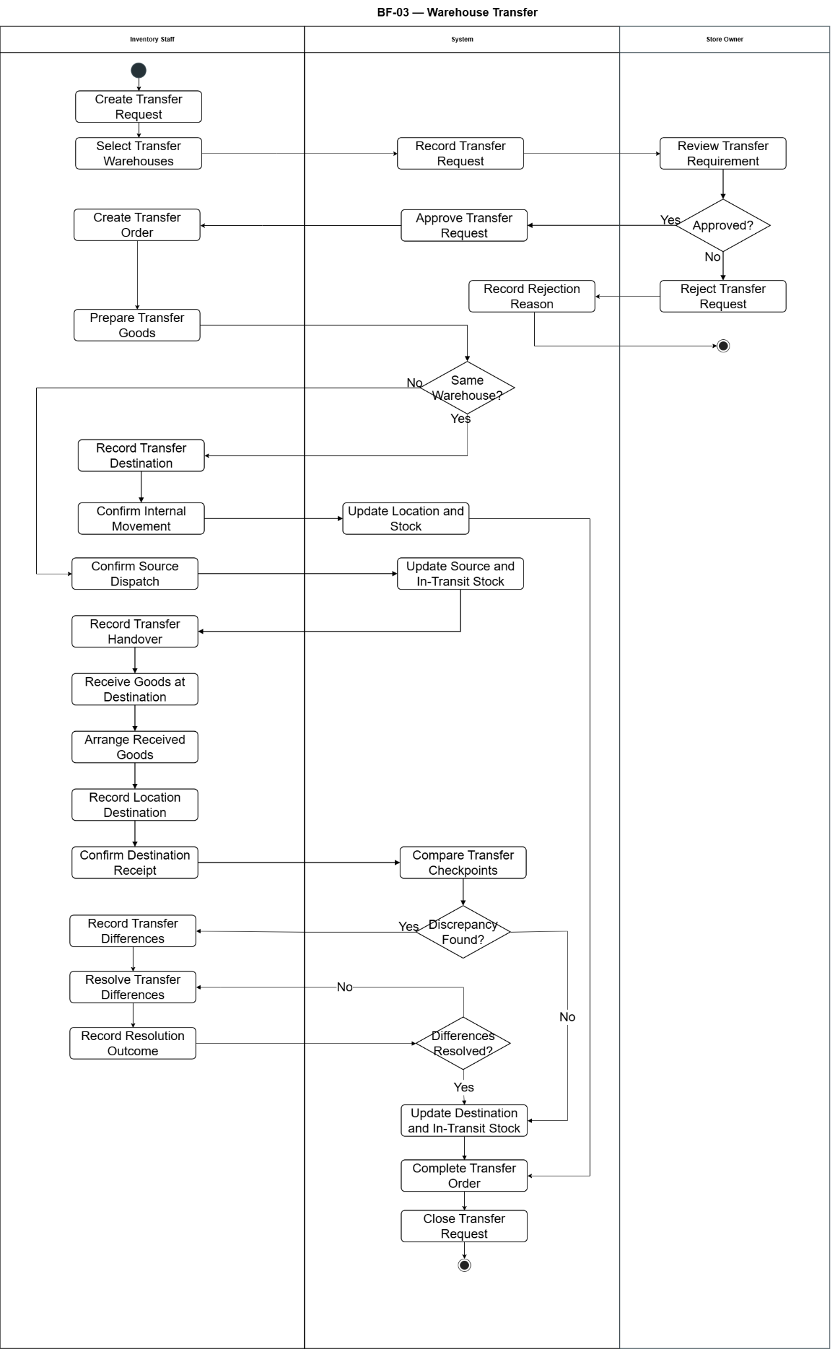
Figure 3. Warehouse Transfer and Discrepancy Resolution — actor/system workflow.
Decision handling: Upon dispatch, the system reduces usable inventory at the source warehouse and records the transferred quantity as In Transit. After receiving, the system compares dispatched and received quantities. Matching quantities allow the transfer to be completed. If a discrepancy exists, the system records the difference and creates a resolution request. Approved resolutions update the relevant inventory balances before closure; rejected or unresolved requests keep the transfer open.

2.4 Stocktake and Inventory Adjustment (BF-04)
Trigger: Store Owner plans and creates a stocktake session, defining its scope and assigned counters.
End condition: The stocktake is completed when no variance is identified, or an approved inventory adjustment is posted for verified discrepancies. Inventory balances and adjustment history reflect the approved results.
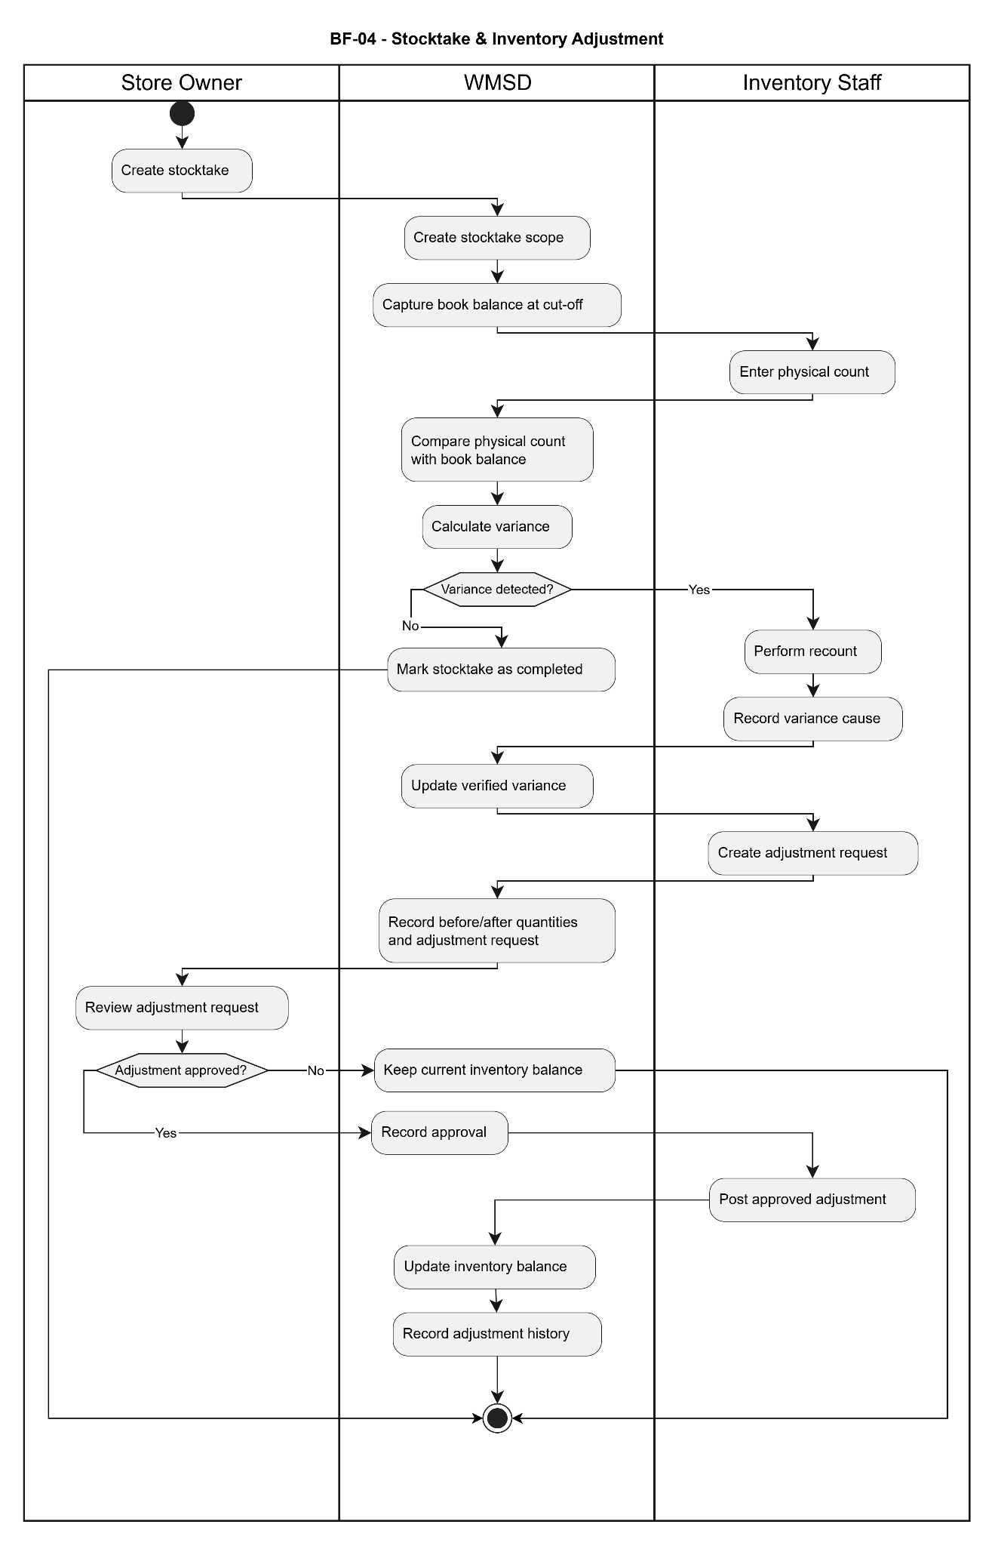
Figure 4. Stocktake and Inventory Adjustment — actor/system workflow.
Decision handling: Inventory Staff activates counting with an immutable book snapshot, records count/recount attempts and reconciles relevant post-cutoff movements. No discrepancy completes the session without an adjustment. A discrepancy requires an Inventory Staff adjustment request, Store Owner approval and separate Store Owner Clear Difference. Approval does not post stock; only authorized Clear Difference posts the approved version once.

2.5 Sales Order Fulfilment and Internal Invoice (BF-05)
Trigger: Sales Staff creates a Sales Order and an Outbound Delivery for eligible outstanding quantities.
End condition: Inventory Staff confirms picking into staging and posts actual Goods Issue once. Accountant creates and issues the internal invoice for eligible unbilled quantities. SMTP notifications follow committed status events.
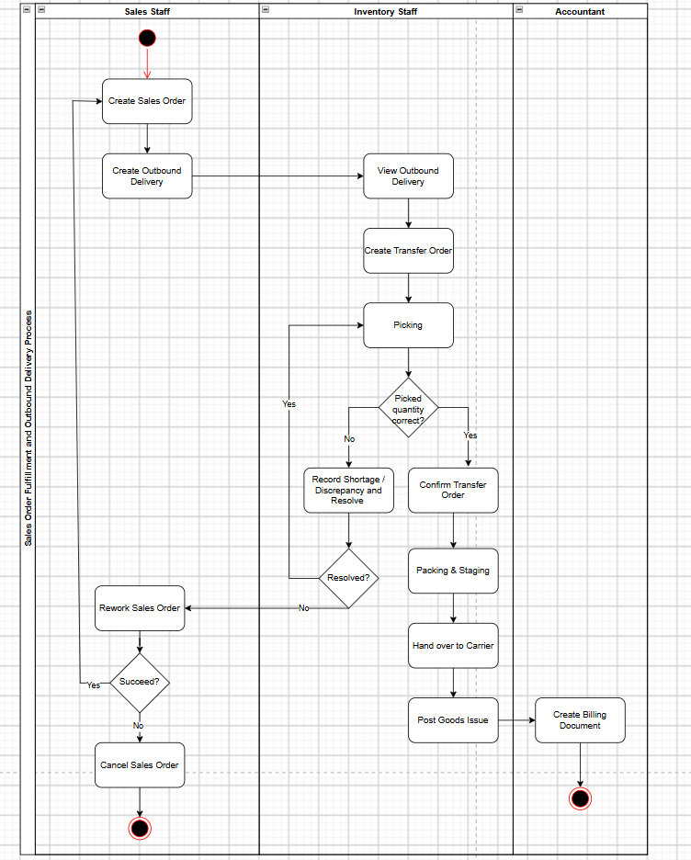
Figure 5. Warehouse Issue and Stock Deduction — actor/system workflow.
Decision handling: Validate usable stock, lot/location and outstanding delivery quantities. Picking TO confirmation moves stock to staging without deducting the warehouse total. PGI deducts actual dispatched stock once. Invoice creation/issuance must prevent duplicate billing; neither action collects payment or creates a debt ledger.

2.6 Customer Return and Returned Goods Classification (BF-06)
Trigger: Inventory Staff creates a customer-return request linked to the original sale/issue for Store Owner review before inspection.
End condition: Inventory Staff records inspection/classification and confirms accepted returned quantities. Accountant may request a refund; Store Owner approves it; Accountant records externally completed refund evidence. The original invoice remains immutable.
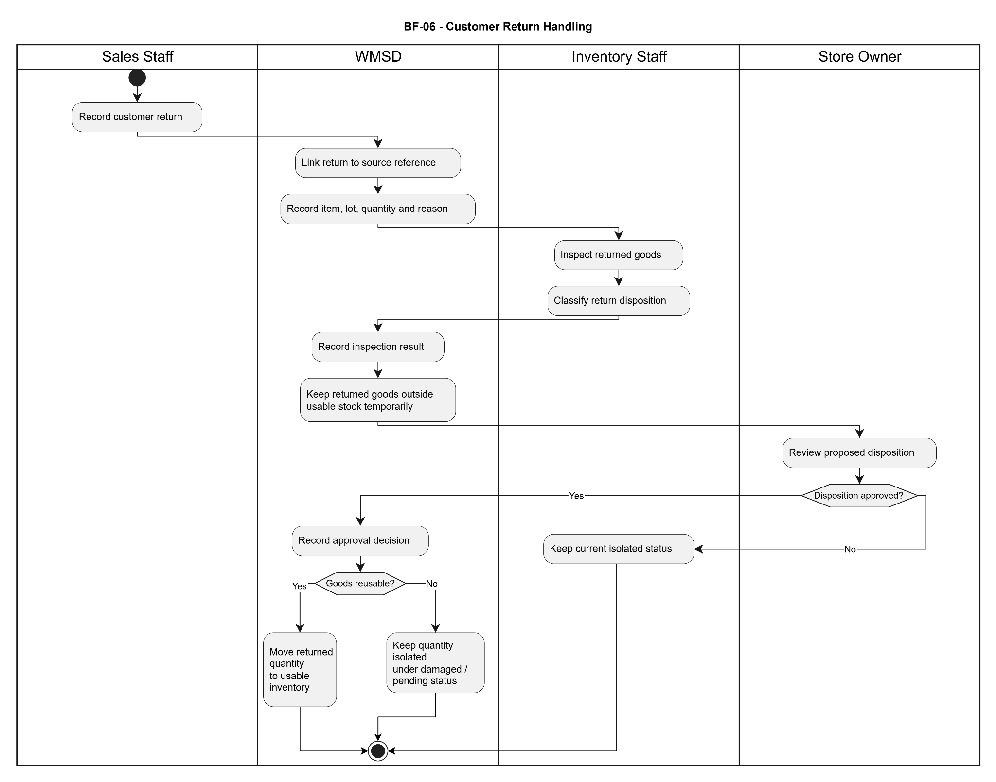
Figure 6. Customer Return and Returned Goods Classification — actor/system workflow.
Decision handling: Only accepted quantities are posted according to inspection quality status. Refund eligibility is bounded by accepted return quantities and evidence of the original external payment, less prior or pending refunds. No sales-payment collection or bank transfer is executed in WMSD.

2.7 Supplier Return and Inventory Reconciliation (BF-07)
Trigger: An authorized user creates a supplier return request for goods that must be returned to the supplier, referencing the original receipt, product, lot, storage location, quantity and return reason.
End condition: Inventory Staff records supplier acceptance, actual dispatch and acknowledgement. Store Owner reviews the reconciled result and closes the supplier return. Unresolved differences remain open.
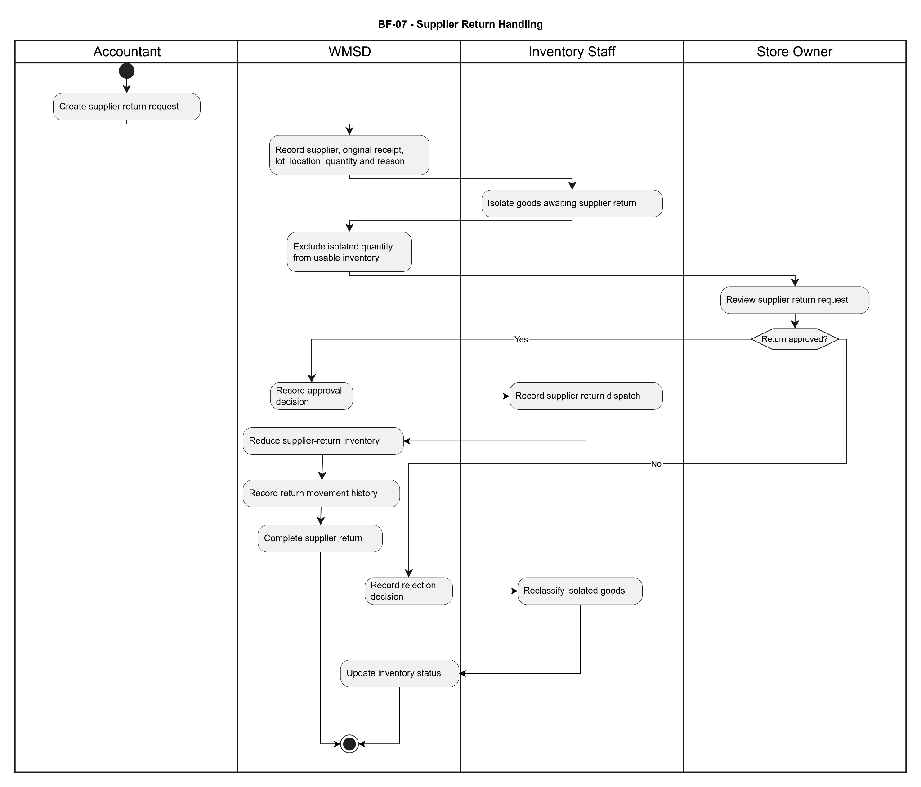
Figure 7. Supplier Return and Inventory Reconciliation — actor/system workflow.
Decision handling: Isolate affected stock, record external supplier acceptance and dispatch only eligible quantities. Do not deduct goods again if they never entered owned inventory. Store Owner closure requires reconciled quantities and acknowledgement.

3. Conceptual Data Model

3.1 Entity Relationship Diagram
The following Crow’s-Foot conceptual diagram follows the 15 business entities and the attribute-box presentation in the supplied ERD reference. Relationship labels are business verbs. Multiplicities are conceptual and should be confirmed against the final physical data model; PK/FK columns are intentionally omitted.
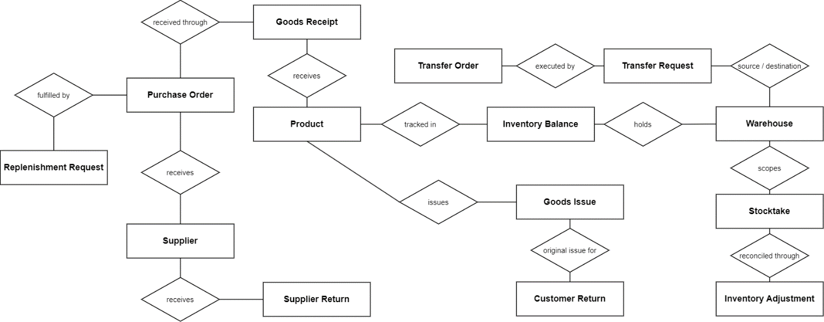

Figure 9. Conceptual entity relationship diagram — entity attributes and labelled cardinalities

3.2 Entity Descriptions
Entity: Warehouse
Field | Value
Purpose | Logical or physical warehouse referenced by put-away, stock, transfer and reporting.
Key business attributes | Warehouse ID, Name, Status
Business identity | Warehouse ID distinguishes warehouse records.
Status / lifecycle | Active or inactive for new selection.
UC traceability | UC-41–46; UC-61–69

Entity: Defective Goods Case
Field | Value
Purpose | Evidence-based record of defective or quarantined goods and authorized disposition.
Key business attributes | Case ID, Lot / Location, Defective Quantity, Disposition Status
Business identity | Case ID identifies the defect incident and links lot/location.
Status / lifecycle | Under review, approved/rejected, handled; technical enum not specified.
UC traceability | UC-49–56

Entity: Goods Issue
Field | Value
Purpose | Physical goods issue created against a source issue request.
Key business attributes | Issue ID, Source Request, Actual Quantity, Status
Business identity | Issue ID references the related issue request.
Status / lifecycle | Prepared and actual issued quantities separately retained.
UC traceability | UC-82–89

Entity: Location
Field | Value
Purpose | An addressable storage place in a warehouse, including area, aisle and rack.
Key business attributes | Location ID, Code, Area, Rack, Status
Business identity | Location code identifies the place within the warehouse.
Status / lifecycle | Active/inactive; cannot deactivate while any quantity remains.
UC traceability | UC-41–46

Entity: Inventory Balance
Field | Value
Purpose | Quantity for a product lot at a warehouse location and quality state.
Key business attributes | Balance ID, Product / Lot, Location, Usable Quantity, Quality Status
Business identity | Unique logical balance scope is warehouse, location, product, lot and quality status.
Status / lifecycle | Accepted, pending inspection, defective, quarantined or in transit as appropriate.
UC traceability | UC-47–56

Entity: Warehouse Transfer
Field | Value
Purpose | Stock transfer documenting source dispatch, handover, receipt and discrepancies.
Key business attributes | Transfer ID, Source / Destination, Dispatched / Received, Status
Business identity | Transfer ID identifies the cross-warehouse transaction.
Status / lifecycle | Planned, in transit, received, discrepancy pending; exact codes to confirm.
UC traceability | UC-61–69

Entity: Lot
Field | Value
Purpose | Actual product batch distinguished by lot, tone and calibre.
Key business attributes | Lot ID, Lot Number, Tone, Actual Calibre, Production Date
Business identity | Identity uses the product and lot-characteristic combination.
Status / lifecycle | Lot record retains link to posted stock movements.
UC traceability | UC-14–17

Entity: Goods Return
Field | Value
Purpose | Customer-return or supplier-return process and its resulting inventory status.
Key business attributes | Return ID, Return Type, Quantity, Approval Status
Business identity | Return ID, type and related source document distinguish returns.
Status / lifecycle | Inspected, pending decision, approved, dispatched/posted as applicable.
UC traceability | UC-90–101

Entity: Stocktake
Field | Value
Purpose | Count period/scope with immutable system balance at its cutoff.
Key business attributes | Stocktake ID, Cut-off Time, Scope, Status
Business identity | Stocktake ID and cutoff distinguish individual inventory counts.
Status / lifecycle | Created, snapshot captured, counted and reconciled; codes to confirm.
UC traceability | UC-70–76

Entity: Inventory Adjustment
Field | Value
Purpose | Request and resulting stock delta for a documented stocktake variance.
Key business attributes | Adjustment ID, Variance, Cause, Approval Status
Business identity | Adjustment ID links the request to its stocktake and approval.
Status / lifecycle | Pending approval, approved/rejected, posted; one valid post only.
UC traceability | UC-77–81

Entity: Product
Field | Value
Purpose | Tile catalogue item and its packaging/unit conversion definition.
Key business attributes | Product ID, Code, Name, Unit Conversion Rule
Business identity | Product code identifies the item; conversions are product-specific.
Status / lifecycle | Active/inactive; historical quantities remain linked.
UC traceability | UC-08–13

Entity: Goods Receipt
Field | Value
Purpose | An individual supplier delivery linked to its purchase order.
Key business attributes | Receipt ID, Receipt / Order Reference, Accepted Quantity, Status
Business identity | Receipt ID identifies each delivery separately.
Status / lifecycle | Receiving, inspected and accepted portions are tracked independently.
UC traceability | UC-33–40

Entity: Replenishment Request
Field | Value
Purpose | Request for stock replenishment requiring Store Manager decision.
Key business attributes | Request ID, Requested Quantity, Approval Status
Business identity | Request ID differentiates submitted proposals.
Status / lifecycle | Pending decision, approved, or rejected; exact system status codes unconfirmed.
UC traceability | UC-23–26

Entity: Purchase Order
Field | Value
Purpose | Supplier order created from an approved replenishment request.
Key business attributes | Order ID, Order Number, Supplier, Status
Business identity | Order number and individual item lines reference the request.
Status / lifecycle | Tracks ordered, confirmed, received and outstanding quantities.
UC traceability | UC-27–32

Entity: Supplier
Field | Value
Purpose | Supplier reference used for purchasing and supplier returns.
Key business attributes | Supplier ID, Name, Status
Business identity | Supplier code distinguishes supplier records.
Status / lifecycle | Active/inactive; inactive suppliers cannot be selected for new orders.
UC traceability | UC-18–22

3.3 Data Business Rules
Rule | Description | Applies To
DR-01 | Product and lot identifiers must distinguish tone/calibre to avoid merging physically different tiles. | UC-13, UC-16, UC-26, UC-30
DR-02 | Box/piece/m² conversions are product-specific and must not retrospectively change posted historical quantities. | UC-13, UC-26, UC-87
DR-03 | A purchase order may have multiple receipts; editing/canceling an outstanding part cannot erase receipts already posted. | UC-07, UC-07, UC-06, UC-08, UC-09, UC-10
DR-04 | Only accepted goods or subsequently authorized accepted disposition increase usable stock; other quality states remain separate. | UC-26, UC-26, UC-26, UC-26, UC-65–56
DR-05 | A location containing stock in any quality state cannot be deactivated; inactive locations are not available for new transactions. | UC-29, UC-29, UC-29, UC-33
DR-06 | Movement between locations of the same warehouse does not change overall warehouse quantity. | UC-36, UC-37
DR-07 | Cross-warehouse transfer records dispatch, handover and destination receipt separately; discrepancies require evidence and approval. | UC-40, UC-43, UC-43, UC-43, UC-43, UC-43, UC-44
DR-08 | Stocktake compares counted quantity with an immutable system snapshot; later transactions remain separately identifiable. | UC-86, UC-87, UC-87, UC-87, UC-88
DR-09 | Inventory adjustments are posted only for approved requests and cannot be posted twice. | UC-91, UC-92, UC-93
DR-10 | Goods issue deducts actual issued quantity from the specified eligible lot/location without making available stock negative. | UC-47, UC-56, UC-57, UC-54, UC-55, UC-58
DR-11 | Customer returns cannot increase usable stock until inspection and the disposition decision are completed. | UC-70, UC-72, UC-72, UC-71
DR-12 | Supplier return dispatch does not deduct the same goods twice when they were rejected at receipt. | UC-81, UC-82, UC-83, UC-82
DR-13 | Every posted stock movement is traceable to source document, original and resulting quantities, user and time. | UC-100, UC-101, UC-102
DR-14 | Deactivation of a master record prevents selection for new operations but must not erase historical references. | UC-97, UC-97, UC-13, UC-19

4. User Requirements

4.1 Actors
# | Actor | Description
1 | Store Owner | Business approval, master data, stocktake session and Clear Difference.
2 | Accountant | Purchasing, internal invoice and externally completed refund evidence.
3 | Inventory Staff | Warehouse receiving, storage, TO, PGI, returns and count execution.
4 | Sales Staff | Customer reference, Sales Order and Outbound Delivery.
5 | Administrator | Accounts, permissions and technical configuration; no implied business approval.

4.2 Use Cases (UC)
The current catalogue contains 102 active use cases, UC-01 through UC-102, grouped into nine features. List and detail UCs remain separate. Fine-grained data entry is included in its inspection/confirmation UC, while approval and stock-posting operations remain separately authorized.
ID | Use Case | Feature | Use Case Description
UC-01 | View replenishment request list | FE-01 | Search requests by status, date, creator, and approval decision.
UC-02 | View replenishment request details | FE-01 | Display required products, reference stock, requested quantities, and approval history.
UC-03 | Create replenishment request | FE-01 | Propose replenishment after checking stock and recording products, quantities, and reasons.
UC-04 | Approve or reject replenishment request | FE-01 | Review the request and record decision, approver, time, and rejection reason.
UC-05 | View purchase order list | FE-01 | Filter orders by supplier, date, status, and outstanding quantity.
UC-06 | View purchase order details | FE-01 | Display order lines, supplier confirmations, and partial receipt history. Display ordered, confirmed, received, accepted and outstanding quantities with source receipts. This is read-only, not a separate outstanding-quantity UC.
UC-07 | Manage Purchase Order and Supplier Confirmation | FE-01 | Create or maintain a PO and record the external supplier confirmation in the same purchasing workflow.
UC-08 | View goods receipt list | FE-01 | Search deliveries associated with purchase orders and their processing status.
UC-09 | View goods receipt details | FE-01 | Display delivered, accepted, pending inspection, defective, and rejected quantities.
UC-10 | Create goods receipt from purchase order | FE-01 | Record each supplier delivery separately and link it to its purchase order.
UC-11 | View product list | FE-02 | Search products by item code, name, size, and status.
UC-12 | View product details | FE-02 | Display tile attributes, packaging specifications, and units of measure.
UC-13 | Maintain Product and Packaging | FE-02 | Create, update or deactivate products and maintain their packaging/unit conversions.
UC-14 | View lot list | FE-02 | Search lots by product, lot number, tone, and actual calibre.
UC-15 | View lot details | FE-02 | Display production date, tone, actual calibre, and related transaction history.
UC-16 | Maintain Product Lot | FE-02 | Create and update product-lot reference information.
UC-17 | View supplier list | FE-02 | Search suppliers by code, name, and cooperation status.
UC-18 | View supplier details | FE-02 | Display contact information and related purchases, receipts, and returns.
UC-19 | Maintain Supplier | FE-02 | Maintain supplier identity/contact data and control supplier availability with separate operation permissions.
UC-20 | View Customer List | FE-02 | Read-only customer search and listing.
UC-21 | View Customer Details | FE-02 | Read-only customer details.
UC-22 | Maintain Customer | FE-02 | Create or update basic customer reference information.
UC-23 | View Selling Price List | FE-02 | Read-only selling price search and listing.
UC-24 | View Selling Price Details | FE-02 | Read-only selling price details.
UC-25 | Maintain Selling Price | FE-02 | Maintain manually entered sale prices and optional externally calculated margin information.
UC-26 | Inspect and Post Goods Receipt | FE-03 | Inspect the draft receipt and post the actual accepted and segregated quantities in one inspection workflow.
UC-27 | View warehouse and location list | FE-04 | Search by warehouse, area, aisle, rack, and location code.
UC-28 | View storage location details | FE-04 | Display capacity, status, and lot-level quantities at a location.
UC-29 | Maintain Storage Location | FE-04 | Create, update or deactivate storage locations.
UC-30 | View stock by lot, location, and quality status | FE-04 | Filter inventory by product, warehouse, lot, tone, calibre, and quality status.
UC-31 | View inventory balance details | FE-04 | Display physical quantity, usable quantity, and source movement documents.
UC-32 | Create Put-away Transfer Order | FE-04 | Create a put-away TO from posted goods receipt quantities.
UC-33 | Confirm Put-away Transfer Order | FE-04 | Confirm placement of received goods into their destination bins.
UC-34 | View location movement list | FE-04 | Search same-warehouse movements by lot and status.
UC-35 | View location movement details | FE-04 | Display source, destination, and actual transferred quantities.
UC-36 | Create location movement | FE-04 | Specify lot, quantity, source and destination locations within the same warehouse.
UC-37 | Confirm actual location movement | FE-04 | Decrease source-location quantity and increase destination-location quantity without changing warehouse total.
UC-38 | View warehouse transfer list | FE-05 | Search transfers by source/destination warehouse and in-transit/received status.
UC-39 | View warehouse transfer details | FE-05 | Display dispatched, handed-over, and received quantities and discrepancies by lot.
UC-40 | Create Transfer Request | FE-05 | Create a warehouse transfer request (TR).
UC-41 | Review Transfer Request | FE-05 | Approve or reject the warehouse TR.
UC-42 | Create Warehouse Transfer Order | FE-05 | Create the TO for an approved warehouse TR.
UC-43 | Confirm Warehouse Transfer Order | FE-05 | Confirm actual warehouse transfer quantities and handle checkpoint differences within the same workflow.
UC-44 | Review Transfer Difference Resolution | FE-05 | Approve or reject a discrepancy resolution submitted from TO confirmation.
UC-45 | View Sales Order List | FE-06 | Read-only sales order search and listing.
UC-46 | View Sales Order Details | FE-06 | Read-only sales order details.
UC-47 | Create Sales Order | FE-06 | Create a sales order with customer, quantities and selling prices.
UC-48 | Update or Cancel Sales Order | FE-06 | Maintain an unfulfilled sales order or cancel its outstanding part.
UC-49 | View Outbound Delivery List | FE-06 | Read-only outbound delivery search and listing.
UC-50 | View Outbound Delivery Details | FE-06 | Read-only outbound delivery details.
UC-51 | Create Outbound Delivery | FE-06 | Create a delivery from outstanding Sales Order quantities.
UC-52 | View Picking Transfer Order List | FE-06 | Read-only picking transfer order search and listing.
UC-53 | View Picking Transfer Order Details | FE-06 | Read-only picking transfer order details.
UC-54 | Create Picking Transfer Order | FE-06 | Create a warehouse picking TO from an outbound delivery.
UC-55 | Confirm Picking Transfer Order | FE-06 | Confirm actual picking into the staging location.
UC-56 | View goods issue list | FE-06 | Search by source request, issue date, and status.
UC-57 | View goods issue details | FE-06 | Display lot, location, prepared quantity, and actual issued quantity by line.
UC-58 | Post Goods Issue | FE-06 | Post actual outbound dispatch (PGI), separately from picking confirmation.
UC-59 | View Internal Invoice List | FE-06 | Read-only internal invoice search and listing.
UC-60 | View Internal Invoice Details | FE-06 | Read-only internal invoice details.
UC-61 | Create Internal Invoice | FE-06 | Prepare an internal invoice from posted goods issue and the Sales Order.
UC-62 | Issue Internal Invoice and Produce PDF | FE-06 | Issue the internal invoice and provide its PDF/print output.
UC-63 | View defective goods list | FE-07 | Filter defective goods by product, lot, location, cause, status, and proposed disposition.
UC-64 | View defective goods details | FE-07 | Display affected quantity, evidence, recorder, and related handling actions.
UC-65 | Inspect Defective Goods and Submit Disposition | FE-07 | Record a defect or quarantined inspection and submit the proposed disposition as one workflow.
UC-66 | Approve or reject defective goods disposition | FE-07 | Review cause and evidence and approve or reject the proposed handling.
UC-67 | Record approved defective goods disposition | FE-07 | Update quantities and quality status according to the approved resolution.
UC-68 | View customer return list | FE-07 | Search returns by source, reason, and inspection status.
UC-69 | View customer return details | FE-07 | Display lot, quantity, condition, and proposed resolution.
UC-70 | Create Customer Return Request | FE-07 | Register a customer return linked to the original sale and actual issue.
UC-71 | Review Customer Return Request | FE-07 | Accept or reject the request for return inspection; this is not refund approval.
UC-72 | Inspect Customer Return | FE-07 | Receive, inspect and classify returned goods in one inspection UC.
UC-73 | Confirm Customer Return Receipt | FE-07 | Post accepted returned quantities and complete their warehouse disposition.
UC-74 | View Refund Request List | FE-07 | Read-only refund request search and listing.
UC-75 | View Refund Request Details | FE-07 | Read-only refund request details.
UC-76 | Create Customer Return Refund Request | FE-07 | Request an externally executed refund for an accepted customer return.
UC-77 | Review Customer Return Refund Request | FE-07 | Approve or reject the proposed refund.
UC-78 | Record Refund Completion | FE-07 | Record evidence that the approved refund was paid outside the application.
UC-79 | View supplier return request list | FE-07 | Search by supplier, lot, reason, and approval status.
UC-80 | View supplier return request details | FE-07 | Display lot, location, quantity, source receipt, evidence, and approval decision.
UC-81 | Create Supplier Return Request | FE-07 | Prepare a supplier return linked to original receipt/PO.
UC-82 | Confirm Supplier Return Dispatch | FE-07 | Post actual return to supplier and record handover/acknowledgement.
UC-83 | Review Supplier Return Closure | FE-07 | Review supplier acknowledgement and authorize closure.
UC-84 | View stocktake list | FE-08 | Search stocktakes by warehouse, scope, cutoff time, and status.
UC-85 | View stocktake details | FE-08 | View included lots/locations, system snapshot, counted quantities, and variances.
UC-86 | Create Stocktake Session | FE-08 | Plan the stocktake and create its session, covering business-flow steps 1 and 2.
UC-87 | Perform Stocktake Count and Record Results | FE-08 | Freeze book quantity at count activation, perform physical counting and record results; count and recount share one UC with attempt history. Covers steps 3 and 4.
UC-88 | Reconcile Stocktake | FE-08 | Compare the finalized physical count with the frozen book quantity, investigate reasons and follow the discrepancy decision in step 5.
UC-89 | View inventory adjustment request list | FE-08 | Search by stocktake, lot, location, variance reason, and approval status.
UC-90 | View inventory adjustment request details | FE-08 | Display before/after quantities, cause, creator, evidence, and approval decision.
UC-91 | Create Inventory Adjustment Request | FE-08 | Create the step 6 request only for reconciled, nonzero stocktake differences.
UC-92 | Approve Inventory Adjustment | FE-08 | Review and approve the documented difference in step 7; approval does not clear stock.
UC-93 | Clear Stocktake Difference | FE-08 | Execute step 8 by posting the approved difference and closing the reconciled stocktake.
UC-94 | Sign in to the system | FE-09 | Access authorized functions according to the assigned account and role.
UC-95 | View account list | FE-09 | Search and filter accounts by name, role, and active status.
UC-96 | View account details | FE-09 | Display the selected account's information, assigned role, and status.
UC-97 | Maintain Staff Account | FE-09 | Create, update, activate or deactivate staff accounts; role assignment remains separately controlled.
UC-98 | Assign roles and operation permissions | FE-09 | Configure view, create, edit, and transaction-recording permissions by role.
UC-99 | View Operational Reports | FE-09 | Run authorized inventory, purchase/receipt, transfer and stocktake reports from one reporting workspace.
UC-100 | View stock movement log | FE-09 | Filter movements by product, lot, location, transaction type, and time.
UC-101 | View stock movement details | FE-09 | Display source document, before/after quantity, operator, time, and reason.
UC-102 | Trace a product lot through source documents | FE-09 | Link a lot's receipts, movements, issues, returns, and inventory adjustments.

4.3 Use Case Diagrams
Use case permissions are specified by the current catalogue, detailed UC preconditions and operation-level permission matrix. A merged UC does not grant every listed actor every sub-operation.

4.3.1. Accountant
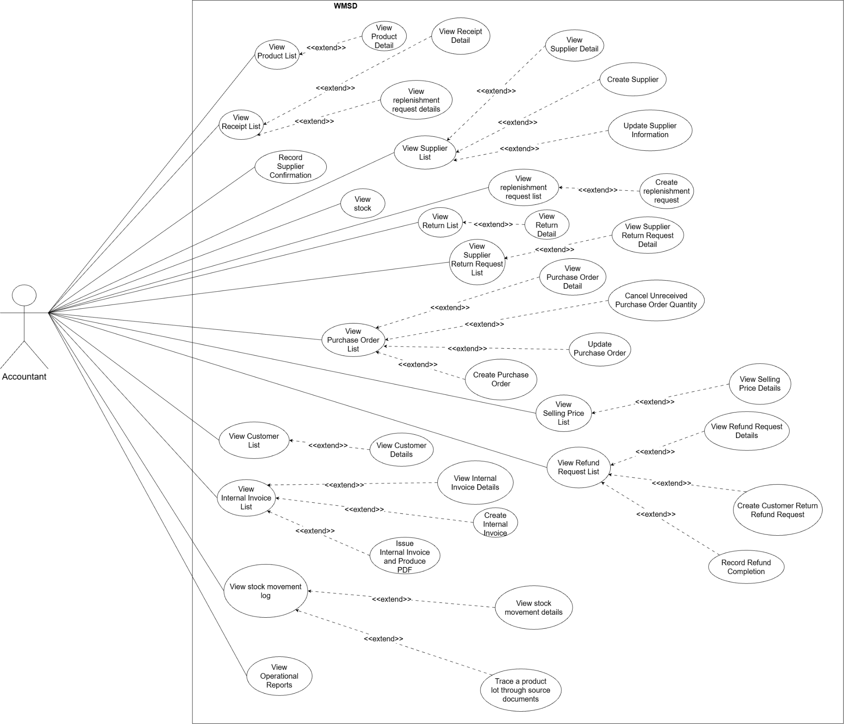

4.3.2. Admin
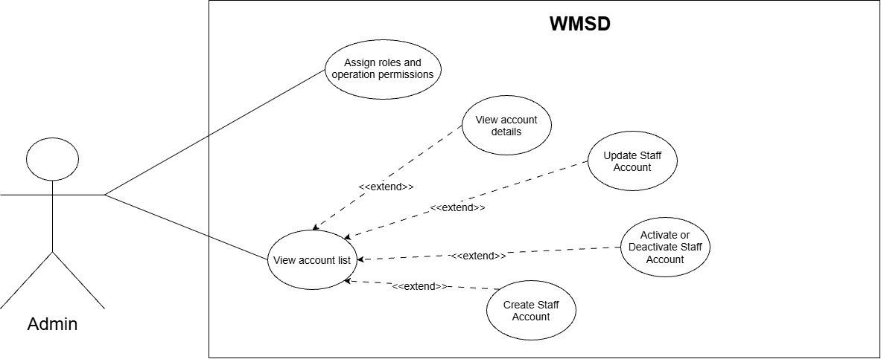

4.3.3 . Store Owner
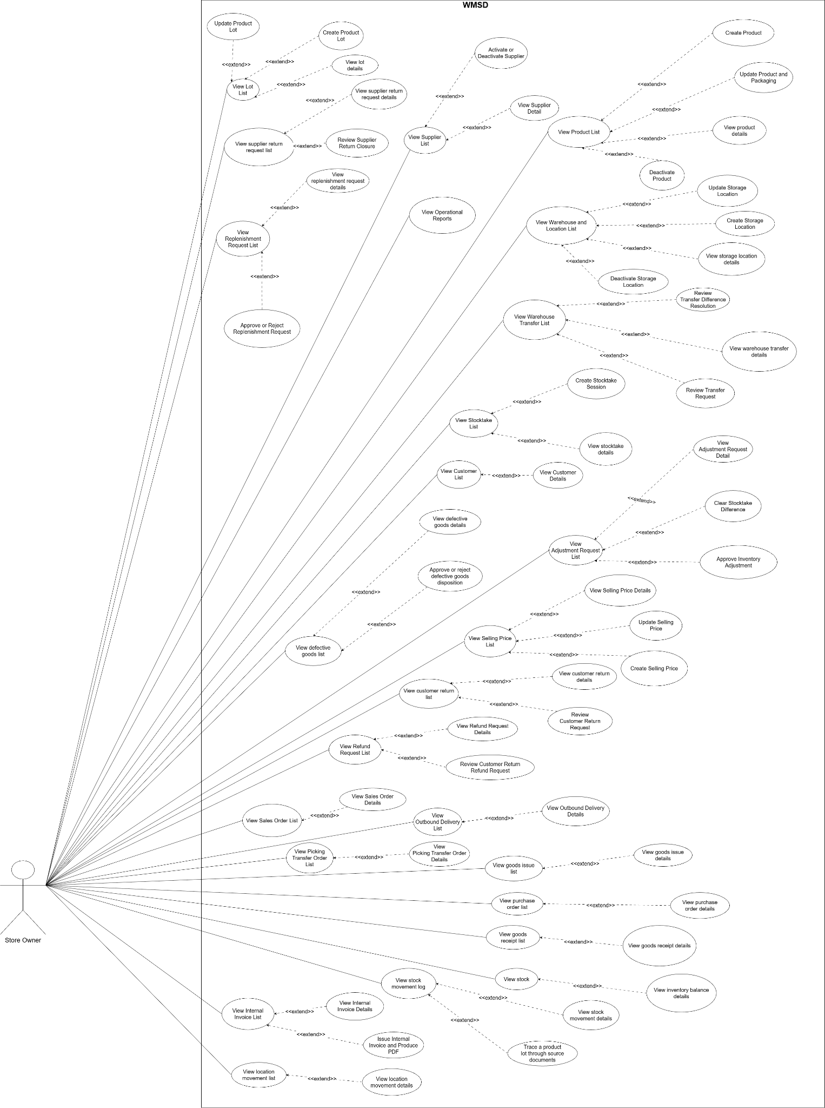

4.3.4. Inventory Staff
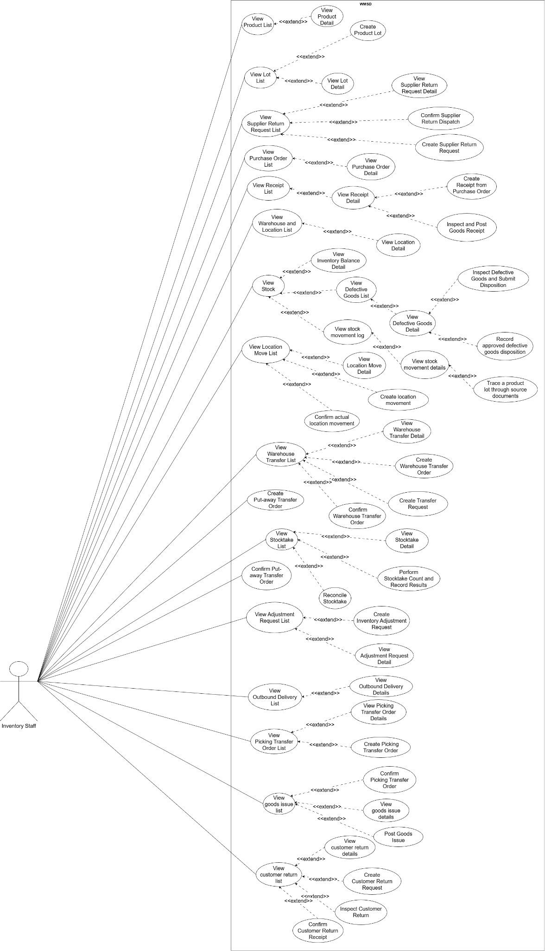

4.3.5 . Sales Staff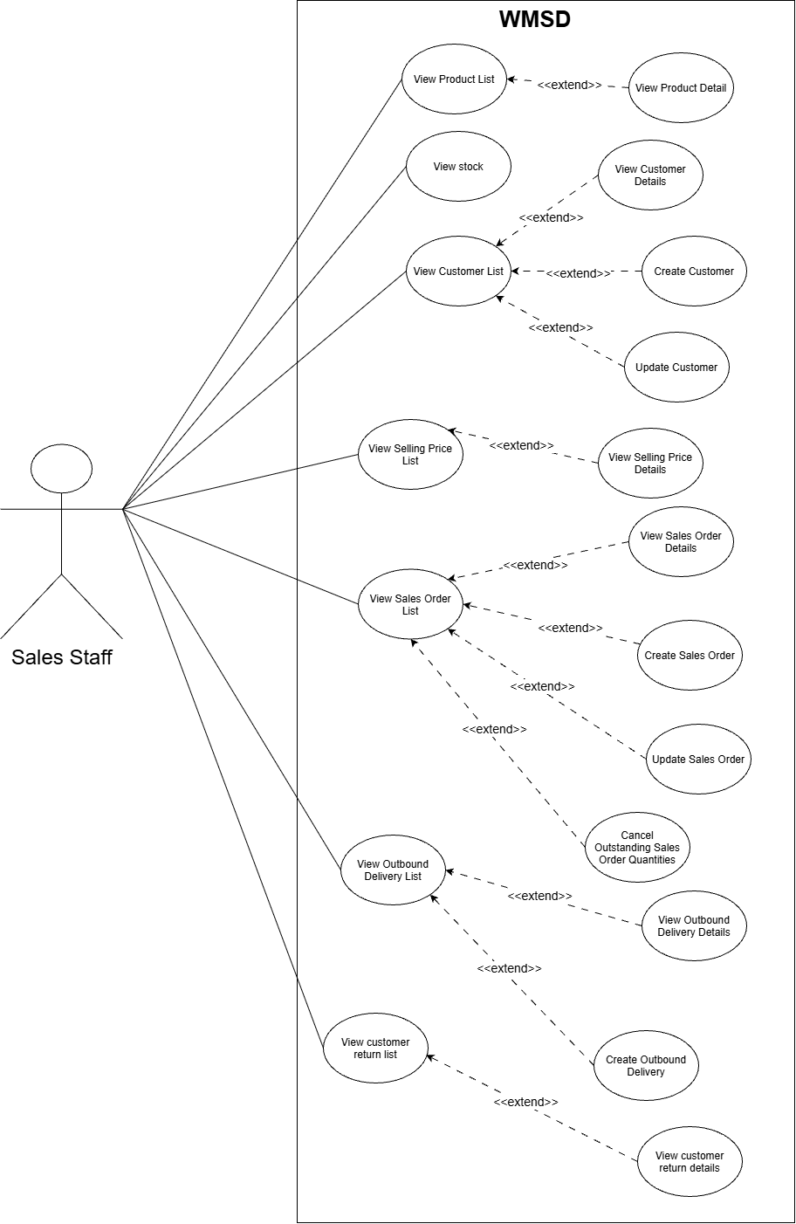

4.4 Permission Matrix

UC | Operation | Store Owner | Accountant | Inventory Staff | Sales Staff | Administrator
UC-01 | View replenishment request list | View | View | — | — | —
UC-02 | View replenishment request details | View | View | — | — | —
UC-03 | Create replenishment request | — | Perform | — | — | —
UC-04 | Approve or reject replenishment request | Approve | — | — | — | —
UC-05 | View purchase order list | View | View | Receiving scope only | — | —
UC-06 | View purchase order details | View | View | Receiving scope only | — | —
UC-07 | Manage Purchase Order and Supplier Confirmation | — | Perform | — | — | —
UC-08 | View goods receipt list | View | View | View | — | —
UC-09 | View goods receipt details | View | View | View | — | —
UC-10 | Create goods receipt from purchase order | — | — | Perform | — | —
UC-11 | View product list | View | View | View | View | —
UC-12 | View product details | View | View | View | View | —
UC-13 | Maintain Product and Packaging | Perform | — | — | — | —
UC-14 | View lot list | View | — | View | — | —
UC-15 | View lot details | View | — | View | — | —
UC-16 | Maintain Product Lot | Create / Update | — | Create only | — | —
UC-17 | View supplier list | View | View | — | — | —
UC-18 | View supplier details | View | View | — | — | —
UC-19 | Maintain Supplier | Activate / Deactivate | Create / Update | — | — | —
UC-20 | View Customer List | View | View | — | View | —
UC-21 | View Customer Details | View | View | — | View | —
UC-22 | Maintain Customer | — | — | — | Perform | —
UC-23 | View Selling Price List | View | View | — | View | —
UC-24 | View Selling Price Details | View | View | — | View | —
UC-25 | Maintain Selling Price | Perform | — | — | — | —
UC-26 | Inspect and Post Goods Receipt | — | — | Perform | — | —
UC-27 | View warehouse and location list | View | — | View | — | —
UC-28 | View storage location details | View | — | View | — | —
UC-29 | Maintain Storage Location | Perform | — | — | — | —
UC-30 | View stock by lot, location, and quality status | View | View | View | Usable stock only | —
UC-31 | View inventory balance details | View | — | View | — | —
UC-32 | Create Put-away Transfer Order | — | — | Perform | — | —
UC-33 | Confirm Put-away Transfer Order | — | — | Perform | — | —
UC-34 | View location movement list | View | — | View | — | —
UC-35 | View location movement details | View | — | View | — | —
UC-36 | Create location movement | — | — | Perform | — | —
UC-37 | Confirm actual location movement | — | — | Perform | — | —
UC-38 | View warehouse transfer list | View | — | View | — | —
UC-39 | View warehouse transfer details | View | — | View | — | —
UC-40 | Create Transfer Request | — | — | Perform | — | —
UC-41 | Review Transfer Request | Approve | — | — | — | —
UC-42 | Create Warehouse Transfer Order | — | — | Perform | — | —
UC-43 | Confirm Warehouse Transfer Order | — | — | Perform | — | —
UC-44 | Review Transfer Difference Resolution | Approve | — | — | — | —
UC-45 | View Sales Order List | View | — | — | View | —
UC-46 | View Sales Order Details | View | — | — | View | —
UC-47 | Create Sales Order | — | — | — | Perform | —
UC-48 | Update or Cancel Sales Order | — | — | — | Perform | —
UC-49 | View Outbound Delivery List | View | — | View | View | —
UC-50 | View Outbound Delivery Details | View | — | View | View | —
UC-51 | Create Outbound Delivery | — | — | — | Perform | —
UC-52 | View Picking Transfer Order List | View | — | View | — | —
UC-53 | View Picking Transfer Order Details | View | — | View | — | —
UC-54 | Create Picking Transfer Order | — | — | Perform | — | —
UC-55 | Confirm Picking Transfer Order | — | — | Perform | — | —
UC-56 | View goods issue list | View | — | View | — | —
UC-57 | View goods issue details | View | — | View | — | —
UC-58 | Post Goods Issue | — | — | Perform | — | —
UC-59 | View Internal Invoice List | View | View | — | — | —
UC-60 | View Internal Invoice Details | View | View | — | — | —
UC-61 | Create Internal Invoice | — | Perform | — | — | —
UC-62 | Issue Internal Invoice and Produce PDF | Export / Print issued only | Issue / Export / Print | — | — | —
UC-63 | View defective goods list | View | — | View | — | —
UC-64 | View defective goods details | View | — | View | — | —
UC-65 | Inspect Defective Goods and Submit Disposition | — | — | Perform | — | —
UC-66 | Approve or reject defective goods disposition | Approve | — | — | — | —
UC-67 | Record approved defective goods disposition | — | — | Perform | — | —
UC-68 | View customer return list | View | View | View | Related sales records only | —
UC-69 | View customer return details | View | View | View | Related sales records only | —
UC-70 | Create Customer Return Request | — | — | Perform | — | —
UC-71 | Review Customer Return Request | Approve | — | — | — | —
UC-72 | Inspect Customer Return | — | — | Perform | — | —
UC-73 | Confirm Customer Return Receipt | — | — | Perform | — | —
UC-74 | View Refund Request List | View | View | — | — | —
UC-75 | View Refund Request Details | View | View | — | — | —
UC-76 | Create Customer Return Refund Request | — | Perform | — | — | —
UC-77 | Review Customer Return Refund Request | Approve | — | — | — | —
UC-78 | Record Refund Completion | — | Perform | — | — | —
UC-79 | View supplier return request list | View | View | View | — | —
UC-80 | View supplier return request details | View | View | View | — | —
UC-81 | Create Supplier Return Request | — | — | Perform | — | —
UC-82 | Confirm Supplier Return Dispatch | — | — | Perform | — | —
UC-83 | Review Supplier Return Closure | Approve | — | — | — | —
UC-84 | View stocktake list | View | — | View | — | —
UC-85 | View stocktake details | View | — | View | — | —
UC-86 | Create Stocktake Session | Perform | — | — | — | —
UC-87 | Perform Stocktake Count and Record Results | — | — | Perform | — | —
UC-88 | Reconcile Stocktake | — | — | Perform | — | —
UC-89 | View inventory adjustment request list | View | — | View | — | —
UC-90 | View inventory adjustment request details | View | — | View | — | —
UC-91 | Create Inventory Adjustment Request | — | — | Perform | — | —
UC-92 | Approve Inventory Adjustment | Approve | — | — | — | —
UC-93 | Clear Stocktake Difference | Perform | — | — | — | —
UC-94 | Sign in to the system | Use | Use | Use | Use | Use
UC-95 | View account list | — | — | — | — | View
UC-96 | View account details | — | — | — | — | View
UC-97 | Maintain Staff Account | — | — | — | — | Perform
UC-98 | Assign roles and operation permissions | — | — | — | — | Perform
UC-99 | View Operational Reports | All report groups | Movement; purchase/receipt | Movement; stock; transfer; stocktake | — | —
UC-100 | View stock movement log | View | Purchase / supplier scope | View | — | —
UC-101 | View stock movement details | View | Purchase / supplier scope | View | — | —
UC-102 | Trace a product lot through source documents | View | Purchase / supplier scope | View | — | —

5. System Functionalities

5.1 Screen Inventory

a. Screen Flow
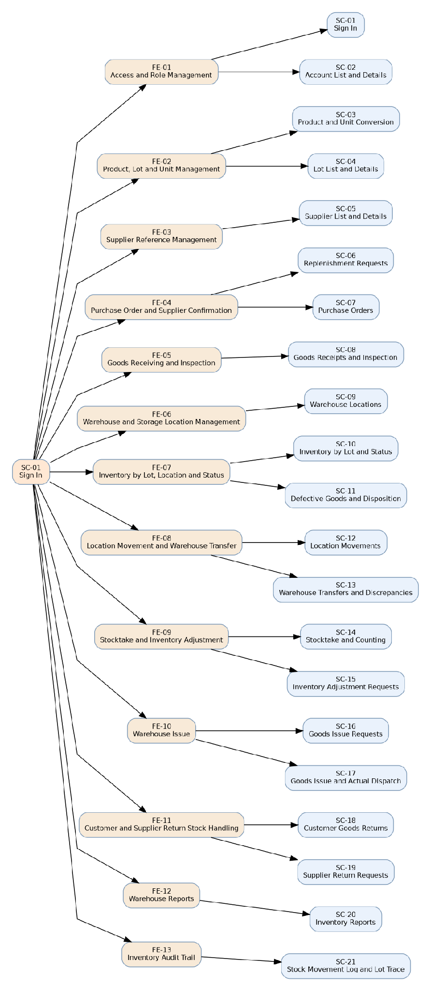
Figure 23. Screen flow by feature and related screens

b. Screen List
# | Screen Name | Feature | Description
SC-01 | Sign In | FE-09 | UC-94
SC-02 | Accounts and Permissions | FE-09 | UC-95, UC-96, UC-97, UC-98
SC-03 | Products and Packaging | FE-02 | UC-11, UC-12, UC-13
SC-04 | Product Lots | FE-02 | UC-14, UC-15, UC-16
SC-05 | Suppliers | FE-02 | UC-17, UC-18, UC-19
SC-06 | Replenishment Requests | FE-01 | UC-01, UC-02, UC-03, UC-04
SC-07 | Purchase Orders | FE-01 | UC-05, UC-06, UC-07
SC-08 | Goods Receipt and Inspection | FE-01, FE-03, FE-04 | UC-08, UC-09, UC-10, UC-26, UC-32, UC-33
SC-09 | Warehouse Locations | FE-04 | UC-27, UC-28, UC-29
SC-10 | Inventory by Lot and Status | FE-04 | UC-30, UC-31
SC-11 | Defective Goods and Disposition | FE-07 | UC-63, UC-64, UC-65, UC-66, UC-67
SC-12 | Location Movements | FE-04 | UC-34, UC-35, UC-36, UC-37
SC-13 | Warehouse Transfers | FE-05 | UC-38, UC-39, UC-40, UC-41, UC-42, UC-43, UC-44
SC-14 | Stocktake Sessions and Counts | FE-08 | UC-84, UC-85, UC-86, UC-87, UC-88
SC-15 | Adjustment Requests and Clear Difference | FE-08 | UC-89, UC-90, UC-91, UC-92, UC-93
SC-16 | Sales Orders | FE-06 | UC-45, UC-46, UC-47, UC-48
SC-17 | Goods Issue | FE-06 | UC-56, UC-57, UC-58
SC-18 | Customer Returns | FE-07 | UC-68, UC-69, UC-70, UC-71, UC-72, UC-73
SC-19 | Supplier Returns | FE-07 | UC-79, UC-80, UC-81, UC-82, UC-83
SC-20 | Operational Reports | FE-09 | UC-99
SC-21 | Stock Movement and Lot Trace | FE-09 | UC-100, UC-101, UC-102
SC-22 | Outbound Deliveries | FE-06 | UC-49, UC-50, UC-51
SC-23 | Picking Transfer Orders | FE-06 | UC-52, UC-53, UC-54, UC-55
SC-24 | Customers | FE-02 | UC-20, UC-21, UC-22
SC-25 | Selling Prices | FE-02 | UC-23, UC-24, UC-25
SC-26 | Internal Invoices | FE-06 | UC-59, UC-60, UC-61, UC-62
SC-27 | Refund Requests | FE-07 | UC-74, UC-75, UC-76, UC-77, UC-78

5.2 External API Inventory
# | API Name | Calling Path | Description
API-01 | SMTP service | Server-side SMTP connection | Send order and invoice status messages after a committed business event. No customer-facing application role is created.

5.3 Background Job Inventory
# | Job Name | Group | Description
JOB-01 | Process status email events | Notification | Send queued SMTP events, record sent/failed result and retry without changing the business document or duplicating a successful send.

II. Use Case Specifications

1. Purchase Delivery and Partial Receiving (FE-01)

1.1 UC-01: View replenishment request list
Primary Actors | Store Owner, Accountant | Secondary Actors | None
Description | Search requests by status, date, creator, and approval decision.  Feature: FE-01; Screen: SC-06.
Preconditions | Access: The actor is signed in and authorized to view Replenishment list under UC-01.  Reference data: Replenishment requests exist.  Optional search/filter inputs: Creation date, creator, status, approval decision. No filters are mandatory; the actor may run an unfiltered list/report within permission scope.  Display fields: Request number, products, quantity, decision. Values are retrieved from saved records; any displayed quantity is reconciled from the corresponding business transactions.  Result scope: Access rights and existing document/quality states determine which records can be opened.  Authorization: Permission is checked for this exact action and record on the server. A list/detail permission does not grant create, update, approve or post rights. Inventory Staff is limited to assigned warehouses; Administrator account/role maintenance does not grant business-operation rights.
Normal Flow | 1. The actor navigates to SC-06 and selects “View replenishment request list”.  2. The system checks role authorization and presents the permitted scope of records.  3. The actor optionally enters filters: Creation date, creator, status, approval decision.  4. The system validates referenced record identity, supplied filter values and date-range order where applicable.  5. The system retrieves matching records using their current persisted links and permissions.  6. The system displays Request number, products, quantity, decision with the relevant linked source references and recorded statuses.  7. The actor may inspect a result or adjust filters; this read-only action does not create, update or post inventory.
Alternative Flows | A1 — Step 2: Actor lacks view permission; show MSG-04 and reveal no protected data.  A2 — Step 3/4: A selected record identifier does not exist or is outside authorized scope; show a non-disclosing not-found/permission result.  A3 — Step 3/5: No record matches the filters; show MSG-01 and an empty list rather than sample or fabricated rows.  A4 — Step 4: Filters conflict (for example, From Date after To Date) or have an invalid value; highlight the filter, leave the stored data unchanged.  A5 — Step 5/6: A linked document is unavailable or historical/inactive; preserve the original reference and present only data for which the actor has access.  A6 — Permission denied: Reject an unauthorized sub-operation, direct request, record or warehouse scope without changing data; show MSG-04.
Postconditions | Successful outcome: The actor has seen the Replenishment list and its relevant Request number, products, quantity, decision.  Persisted business data: No creation, status transition, inventory change or approval occurs from viewing or filtering.  Empty/error outcome: No record is modified; the user can revise filters or return to the list.

1.2 UC-02: View replenishment request details
Primary Actors | Store Owner, Accountant | Secondary Actors | None
Description | Display required products, reference stock, requested quantities, and approval history.  Feature: FE-01; Screen: SC-06.
Preconditions | Access: The actor is signed in and authorized to view Selected replenishment request under UC-02.  Reference data: Request exists.  Required navigation input: Request number. A specific record must be selected before its details can be displayed.  Display fields: Product lines, available stock reference, approval history. Values are retrieved from saved records; any displayed quantity is reconciled from the corresponding business transactions.  Result scope: Access rights and existing document/quality states determine which records can be opened.  Authorization: Permission is checked for this exact action and record on the server. A list/detail permission does not grant create, update, approve or post rights. Inventory Staff is limited to assigned warehouses; Administrator account/role maintenance does not grant business-operation rights.
Normal Flow | 1. The actor navigates to SC-06 and selects “View replenishment request details”.  2. The system checks role authorization and presents the permitted scope of records.  3. The actor selects the target Selected replenishment request by Request number.  4. The system validates referenced record identity, supplied filter values and date-range order where applicable.  5. The system retrieves matching records using their current persisted links and permissions.  6. The system displays Product lines, available stock reference, approval history with the relevant linked source references and recorded statuses.  7. The actor may inspect a result or adjust filters; this read-only action does not create, update or post inventory.
Alternative Flows | A1 — Step 2: Actor lacks view permission; show MSG-04 and reveal no protected data.  A2 — Step 3/4: A selected record identifier does not exist or is outside authorized scope; show a non-disclosing not-found/permission result.  A3 — Step 3/5: No record matches the filters; show MSG-01 and an empty list rather than sample or fabricated rows.  A4 — Step 4: Filters conflict (for example, From Date after To Date) or have an invalid value; highlight the filter, leave the stored data unchanged.  A5 — Step 5/6: A linked document is unavailable or historical/inactive; preserve the original reference and present only data for which the actor has access.  A6 — Permission denied: Reject an unauthorized sub-operation, direct request, record or warehouse scope without changing data; show MSG-04.
Postconditions | Successful outcome: The actor has seen the Selected replenishment request and its relevant Product lines, available stock reference, approval history.  Persisted business data: No creation, status transition, inventory change or approval occurs from viewing or filtering.  Empty/error outcome: No record is modified; the user can revise filters or return to the list.

1.3 UC-03: Create replenishment request
Primary Actors | Accountant | Secondary Actors | None
Description | Propose replenishment after checking stock and recording products, quantities, and reasons.  Feature: FE-01; Screen: SC-06.
Preconditions | Access & identity: Actor is signed in and explicitly authorized for UC-03.  Source records / workflow state: Accountant can view product catalogue and reference stock.  Required inputs (business minimum): Product line(s); requested quantity for each line; replenishment reason.  Optional or source-undefined inputs: Reference on-hand quantity; supporting source document.  Validation and uniqueness: At least one line; positive quantities; eligible products; no forced automatic purchase.  Technical field specification: Use the MongoDB field contract and server-side validations for the linked screen.  Authorization: Permission is checked for this exact action and record on the server. A list/detail permission does not grant create, update, approve or post rights. Inventory Staff is limited to assigned warehouses; Administrator account/role maintenance does not grant business-operation rights.
Normal Flow | 1. A accountant opens SC-06 and selects “Create replenishment request”.  2. The system checks permission, displays the relevant form and current source values.  3. Accountant reviews available stock and identifies replenishment demand  4. Select product lines, requested quantities and reasons  5. System records reference stock and the creator  6. Accountant submits the request for Store Owner approval.  7. The system validates all mandatory input fields, cross-document quantities, actor authorization and referenced record state before accepting confirmation.  8. On success the system saves the specific business outcome and updates related documents or eligible stock only if this UC explicitly performs a stock-posting operation.  9. The system displays the resulting record/status and source references; inventory-affecting operations retain the before/after movement details.
Alternative Flows | A1 — At step 2, access/role check fails: show MSG-04 and reveal no protected record; no data are changed.  A2 — At step 3–6, a required input is absent: identify the specific missing field (MSG-02); retain entered information without committing.  A3 — At the validation step 7, a reference is inactive, duplicate, outside the current workflow stage or violates the business rule: explain the specific field/record; do not partially post.  A4 — Business-specific exception: Missing line/reason or nonpositive quantity blocks submission.  A5 — Permission denied: Reject an unauthorized sub-operation, direct request, record or warehouse scope without changing data; show MSG-04.
Postconditions | Successful outcome: Replenishment request is stored for Store Owner decision; no PO/receipt/stock yet.  No inventory balance is changed unless the described UC expressly authorizes a stock movement.  Failure outcome: Missing inputs, a rejected action or a failed validation leave existing posted transactions and inventory unchanged.  Traceability: Existing source references, responsible actor and action time are retained where this UC creates or updates a business record.

1.4 UC-04: Approve or reject replenishment request
Primary Actors | Store Owner | Secondary Actors | None
Description | Review the request and record decision, approver, time, and rejection reason.  Feature: FE-01; Screen: SC-06.
Preconditions | Access & identity: Actor is signed in and explicitly authorized for UC-04.  Source records / workflow state: Store Owner can see an undecided request and its stock basis.  Required inputs (business minimum): Pending replenishment request; approve/reject decision.  Optional or source-undefined inputs: Rejection reason (required on rejection).  Validation and uniqueness: Only pending requests can be decided; rejection contains rationale.  Technical field specification: Use the MongoDB field contract and server-side validations for the linked screen.  Authorization: Permission is checked for this exact action and record on the server. A list/detail permission does not grant create, update, approve or post rights. Inventory Staff is limited to assigned warehouses; Administrator account/role maintenance does not grant business-operation rights.
Normal Flow | 1. A store owner opens SC-06 and selects “Approve or reject replenishment request”.  2. The system checks permission, displays the relevant form and current source values.  3. Store Owner opens a pending replenishment request  4. System displays requested lines, reference inventory and reason  5. Store Owner chooses Approve or Reject and records a reason when rejecting  6. System records decision, approver and decision time and controls purchase-order eligibility.  7. The system validates all mandatory input fields, cross-document quantities, actor authorization and referenced record state before accepting confirmation.  8. On success the system saves the specific business outcome and updates related documents or eligible stock only if this UC explicitly performs a stock-posting operation.  9. The system displays the resulting record/status and source references; inventory-affecting operations retain the before/after movement details.
Alternative Flows | A1 — At step 2, access/role check fails: show MSG-04 and reveal no protected record; no data are changed.  A2 — At step 3–6, a required input is absent: identify the specific missing field (MSG-02); retain entered information without committing.  A3 — At the validation step 7, a reference is inactive, duplicate, outside the current workflow stage or violates the business rule: explain the specific field/record; do not partially post.  A4 — Business-specific exception: Repeated or unauthorized approval is rejected.  A5 — At source-defined 4: The Manager rejects the request: record the rejection reason and do not permit purchase-order creation from that request.  A6 — Reject outcome: a rejection reason is mandatory; record rejection and keep the proposed stock operation unposted.  A7 — Permission denied: Reject an unauthorized sub-operation, direct request, record or warehouse scope without changing data; show MSG-04.
Postconditions | Successful outcome: Decision, approver and decision timestamp recorded; only approved request is PO-eligible.  No inventory balance is changed unless the described UC expressly authorizes a stock movement.  Failure outcome: Missing inputs, a rejected action or a failed validation leave existing posted transactions and inventory unchanged.  Traceability: Existing source references, responsible actor and action time are retained where this UC creates or updates a business record.

1.5 UC-05: View purchase order list
Primary Actors | Store Owner, Accountant, Inventory Staff | Secondary Actors | None
Description | Filter orders by supplier, date, status, and outstanding quantity.  Feature: FE-01; Screen: SC-07.
Preconditions | Access: The actor is signed in and authorized to view Purchase order list under UC-05.  Reference data: Orders exist.  Optional search/filter inputs: Supplier, order date, status, outstanding qty. No filters are mandatory; the actor may run an unfiltered list/report within permission scope.  Display fields: Order number, supplier, confirmed/received/outstanding. Values are retrieved from saved records; any displayed quantity is reconciled from the corresponding business transactions.  Result scope: Access rights and existing document/quality states determine which records can be opened.  Authorization: Permission is checked for this exact action and record on the server. A list/detail permission does not grant create, update, approve or post rights. Inventory Staff is limited to assigned warehouses; Administrator account/role maintenance does not grant business-operation rights.  Operation scope: Inventory Staff may view only the PO information needed for assigned-warehouse receiving: supplier/order reference, products, units, confirmed/outstanding quantities and delivery schedule. Purchase prices, financial information and PO modification are not granted by this view.
Normal Flow | 1. The actor navigates to SC-07 and selects “View purchase order list”.  2. The system checks role authorization and presents the permitted scope of records.  3. The actor optionally enters filters: Supplier, order date, status, outstanding qty.  4. The system validates referenced record identity, supplied filter values and date-range order where applicable.  5. The system retrieves matching records using their current persisted links and permissions.  6. The system displays Order number, supplier, confirmed/received/outstanding with the relevant linked source references and recorded statuses.  7. The actor may inspect a result or adjust filters; this read-only action does not create, update or post inventory.
Alternative Flows | A1 — Step 2: Actor lacks view permission; show MSG-04 and reveal no protected data.  A2 — Step 3/4: A selected record identifier does not exist or is outside authorized scope; show a non-disclosing not-found/permission result.  A3 — Step 3/5: No record matches the filters; show MSG-01 and an empty list rather than sample or fabricated rows.  A4 — Step 4: Filters conflict (for example, From Date after To Date) or have an invalid value; highlight the filter, leave the stored data unchanged.  A5 — Step 5/6: A linked document is unavailable or historical/inactive; preserve the original reference and present only data for which the actor has access.  A6 — Permission denied: Reject an unauthorized sub-operation, direct request, record or warehouse scope without changing data; show MSG-04.
Postconditions | Successful outcome: The actor has seen the Purchase order list and its relevant Order number, supplier, confirmed/received/outstanding.  Persisted business data: No creation, status transition, inventory change or approval occurs from viewing or filtering.  Empty/error outcome: No record is modified; the user can revise filters or return to the list.

1.6 UC-06: View purchase order details
Primary Actors | Store Owner, Accountant, Inventory Staff | Secondary Actors | None
Description | Display order lines, supplier confirmations, and partial receipt history. Display ordered, confirmed, received, accepted and outstanding quantities with source receipts. This is read-only, not a separate outstanding-quantity UC.  Feature: FE-01; Screen: SC-07.
Preconditions | Access: The actor is signed in and authorized to view Selected purchase order under UC-06.  Reference data: PO exists.  Required navigation input: Order number. A specific record must be selected before its details can be displayed.  Display fields: Product lines, ordered, confirmed, received, outstanding, receipt links. Values are retrieved from saved records; any displayed quantity is reconciled from the corresponding business transactions.  Result scope: Access rights and existing document/quality states determine which records can be opened.  Authorization: Permission is checked for this exact action and record on the server. A list/detail permission does not grant create, update, approve or post rights. Inventory Staff is limited to assigned warehouses; Administrator account/role maintenance does not grant business-operation rights.  Operation scope: Inventory Staff may view receiving-related PO detail only within assigned warehouses; direct detail/evidence access enforces the same restriction as the list. It cannot modify the PO or view purchasing financial data.
Normal Flow | 1. The actor navigates to SC-07 and selects “View purchase order details”.  2. The system checks role authorization and presents the permitted scope of records.  3. The actor selects the target Selected purchase order by Order number.  4. The system validates referenced record identity, supplied filter values and date-range order where applicable.  5. The system retrieves matching records using their current persisted links and permissions.  6. The system displays Product lines, ordered, confirmed, received, outstanding, receipt links with the relevant linked source references and recorded statuses.  7. The actor may inspect a result or adjust filters; this read-only action does not create, update or post inventory.  Additional requirement: Display ordered, confirmed, received, accepted and outstanding quantities with source receipts. This is read-only, not a separate outstanding-quantity UC.
Alternative Flows | A1 — Step 2: Actor lacks view permission; show MSG-04 and reveal no protected data.  A2 — Step 3/4: A selected record identifier does not exist or is outside authorized scope; show a non-disclosing not-found/permission result.  A3 — Step 3/5: No record matches the filters; show MSG-01 and an empty list rather than sample or fabricated rows.  A4 — Step 4: Filters conflict (for example, From Date after To Date) or have an invalid value; highlight the filter, leave the stored data unchanged.  A5 — Step 5/6: A linked document is unavailable or historical/inactive; preserve the original reference and present only data for which the actor has access.  A6 — Permission denied: Reject an unauthorized sub-operation, direct request, record or warehouse scope without changing data; show MSG-04.
Postconditions | Successful outcome: The actor has seen the Selected purchase order and its relevant Product lines, ordered, confirmed, received, outstanding, receipt links.  Persisted business data: No creation, status transition, inventory change or approval occurs from viewing or filtering.  Empty/error outcome: No record is modified; the user can revise filters or return to the list.

1.7 UC-07: Manage Purchase Order and Supplier Confirmation
Primary Actors | Accountant | Secondary Actors | None
Description | Create or maintain a PO and record the external supplier confirmation in the same purchasing workflow.  Feature: FE-01; Screen: SC-07.
Preconditions | Authenticated active user with the named operation permission. Referenced records must exist and be in an eligible state.  Authorization: Permission is checked for this exact action and record on the server. A list/detail permission does not grant create, update, approve or post rights. Inventory Staff is limited to assigned warehouses; Administrator account/role maintenance does not grant business-operation rights.
Normal Flow | 1. Create a PO from an approved replenishment request.  2. Maintain unreceived quantities or cancel the eligible outstanding portion.  3. Record supplier-confirmed quantities and expected delivery dates.  4. Preserve received quantities and all changes in history.
Alternative Flows | A1 — Invalid input, permission, state or reference: reject without partially changing data.  A2 — Repeated or concurrent confirmation: return the current result or require refresh; never repeat a posting.  A3 — Permission denied: Reject an unauthorized sub-operation, direct request, record or warehouse scope without changing data; show MSG-04.
Postconditions | The business outcome, actor, time and source references are saved. Stock changes only when the normal flow explicitly posts a movement.

1.8 UC-08: View goods receipt list
Primary Actors | Store Owner, Accountant, Inventory Staff | Secondary Actors | None
Description | Search deliveries associated with purchase orders and their processing status.  Feature: FE-01; Screen: SC-08.
Preconditions | Access: The actor is signed in and authorized to view Goods receipt list under UC-08.  Reference data: Receipts exist.  Optional search/filter inputs: PO, receipt reference, status, date. No filters are mandatory; the actor may run an unfiltered list/report within permission scope.  Display fields: Receipt number, PO, delivered/inspected state. Values are retrieved from saved records; any displayed quantity is reconciled from the corresponding business transactions.  Result scope: Access rights and existing document/quality states determine which records can be opened.  Authorization: Permission is checked for this exact action and record on the server. A list/detail permission does not grant create, update, approve or post rights. Inventory Staff is limited to assigned warehouses; Administrator account/role maintenance does not grant business-operation rights.
Normal Flow | 1. The actor navigates to SC-08 and selects “View goods receipt list”.  2. The system checks role authorization and presents the permitted scope of records.  3. The actor optionally enters filters: PO, receipt reference, status, date.  4. The system validates referenced record identity, supplied filter values and date-range order where applicable.  5. The system retrieves matching records using their current persisted links and permissions.  6. The system displays Receipt number, PO, delivered/inspected state with the relevant linked source references and recorded statuses.  7. The actor may inspect a result or adjust filters; this read-only action does not create, update or post inventory.
Alternative Flows | A1 — Step 2: Actor lacks view permission; show MSG-04 and reveal no protected data.  A2 — Step 3/4: A selected record identifier does not exist or is outside authorized scope; show a non-disclosing not-found/permission result.  A3 — Step 3/5: No record matches the filters; show MSG-01 and an empty list rather than sample or fabricated rows.  A4 — Step 4: Filters conflict (for example, From Date after To Date) or have an invalid value; highlight the filter, leave the stored data unchanged.  A5 — Step 5/6: A linked document is unavailable or historical/inactive; preserve the original reference and present only data for which the actor has access.  A6 — Permission denied: Reject an unauthorized sub-operation, direct request, record or warehouse scope without changing data; show MSG-04.
Postconditions | Successful outcome: The actor has seen the Goods receipt list and its relevant Receipt number, PO, delivered/inspected state.  Persisted business data: No creation, status transition, inventory change or approval occurs from viewing or filtering.  Empty/error outcome: No record is modified; the user can revise filters or return to the list.

1.9 UC-09: View goods receipt details
Primary Actors | Store Owner, Accountant, Inventory Staff | Secondary Actors | None
Description | Display delivered, accepted, pending inspection, defective, and rejected quantities.  Feature: FE-01; Screen: SC-08.
Preconditions | Access: The actor is signed in and authorized to view Selected goods receipt under UC-09.  Reference data: Receipt exists.  Required navigation input: Receipt number. A specific record must be selected before its details can be displayed.  Display fields: Physical quantities and accepted/pending/defective/rejected parts. Values are retrieved from saved records; any displayed quantity is reconciled from the corresponding business transactions.  Result scope: Access rights and existing document/quality states determine which records can be opened.  Authorization: Permission is checked for this exact action and record on the server. A list/detail permission does not grant create, update, approve or post rights. Inventory Staff is limited to assigned warehouses; Administrator account/role maintenance does not grant business-operation rights.
Normal Flow | 1. The actor navigates to SC-08 and selects “View goods receipt details”.  2. The system checks role authorization and presents the permitted scope of records.  3. The actor selects the target Selected goods receipt by Receipt number.  4. The system validates referenced record identity, supplied filter values and date-range order where applicable.  5. The system retrieves matching records using their current persisted links and permissions.  6. The system displays Physical quantities and accepted/pending/defective/rejected parts with the relevant linked source references and recorded statuses.  7. The actor may inspect a result or adjust filters; this read-only action does not create, update or post inventory.
Alternative Flows | A1 — Step 2: Actor lacks view permission; show MSG-04 and reveal no protected data.  A2 — Step 3/4: A selected record identifier does not exist or is outside authorized scope; show a non-disclosing not-found/permission result.  A3 — Step 3/5: No record matches the filters; show MSG-01 and an empty list rather than sample or fabricated rows.  A4 — Step 4: Filters conflict (for example, From Date after To Date) or have an invalid value; highlight the filter, leave the stored data unchanged.  A5 — Step 5/6: A linked document is unavailable or historical/inactive; preserve the original reference and present only data for which the actor has access.  A6 — Permission denied: Reject an unauthorized sub-operation, direct request, record or warehouse scope without changing data; show MSG-04.
Postconditions | Successful outcome: The actor has seen the Selected goods receipt and its relevant Physical quantities and accepted/pending/defective/rejected parts.  Persisted business data: No creation, status transition, inventory change or approval occurs from viewing or filtering.  Empty/error outcome: No record is modified; the user can revise filters or return to the list.

1.10 UC-10: Create goods receipt from purchase order
Primary Actors | Inventory Staff | Secondary Actors | None
Description | Record each supplier delivery separately and link it to its purchase order.  Feature: FE-01; Screen: SC-08.
Preconditions | Access & identity: Actor is signed in and explicitly authorized for UC-10.  Source records / workflow state: Purchase order exists and delivery is physically presented for receipt.  Required inputs (business minimum): Source PO; delivery identifier / receipt reference; delivered line(s).  Optional or source-undefined inputs: Carrier note / external document reference.  Validation and uniqueness: The delivery is captured independently; no automatic accepted stock increase.  Technical field specification: Use the MongoDB field contract and server-side validations for the linked screen.  Authorization: Permission is checked for this exact action and record on the server. A list/detail permission does not grant create, update, approve or post rights. Inventory Staff is limited to assigned warehouses; Administrator account/role maintenance does not grant business-operation rights.
Normal Flow | 1. A inventory staff opens SC-08 and selects “Create goods receipt from purchase order”.  2. The system checks permission, displays the relevant form and current source values.  3. Inventory Staff selects a purchase order and identifies the current delivery  4. System displays relevant order lines and quantity outstanding  5. Staff creates a distinct goods receipt for the delivery  6. System links the new receipt to its purchase order without posting accepted stock yet.  7. The system validates all mandatory input fields, cross-document quantities, actor authorization and referenced record state before accepting confirmation.  8. On success the system saves the specific business outcome and updates related documents or eligible stock only if this UC explicitly performs a stock-posting operation.  9. The system displays the resulting record/status and source references; inventory-affecting operations retain the before/after movement details.
Alternative Flows | A1 — At step 2, access/role check fails: show MSG-04 and reveal no protected record; no data are changed.  A2 — At step 3–6, a required input is absent: identify the specific missing field (MSG-02); retain entered information without committing.  A3 — At the validation step 7, a reference is inactive, duplicate, outside the current workflow stage or violates the business rule: explain the specific field/record; do not partially post.  A4 — Business-specific exception: Duplicate delivery reference is flagged for checking rather than double recording.  A5 — Permission denied: Reject an unauthorized sub-operation, direct request, record or warehouse scope without changing data; show MSG-04.
Postconditions | Successful outcome: A receipt document is linked to the PO and awaits physical count and inspection.  No inventory balance is changed unless the described UC expressly authorizes a stock movement.  Failure outcome: Missing inputs, a rejected action or a failed validation leave existing posted transactions and inventory unchanged.  Traceability: Existing source references, responsible actor and action time are retained where this UC creates or updates a business record.

2. Master Data, Tile Traceability and Selling Price (FE-02)

2.1 UC-11: View product list
Primary Actors | Store Owner, Accountant, Inventory Staff, Sales Staff | Secondary Actors | None
Description | Search products by item code, name, size, and status.  Feature: FE-02; Screen: SC-03.
Preconditions | Access: The actor is signed in and authorized to view Product list under UC-11.  Reference data: Product master is readable.  Optional search/filter inputs: Product code, name, nominal size, status. No filters are mandatory; the actor may run an unfiltered list/report within permission scope.  Display fields: Product code, category, size, product status. Values are retrieved from saved records; any displayed quantity is reconciled from the corresponding business transactions.  Result scope: Access rights and existing document/quality states determine which records can be opened.  Authorization: Permission is checked for this exact action and record on the server. A list/detail permission does not grant create, update, approve or post rights. Inventory Staff is limited to assigned warehouses; Administrator account/role maintenance does not grant business-operation rights.
Normal Flow | 1. The actor navigates to SC-03 and selects “View product list”.  2. The system checks role authorization and presents the permitted scope of records.  3. The actor optionally enters filters: Product code, name, nominal size, status.  4. The system validates referenced record identity, supplied filter values and date-range order where applicable.  5. The system retrieves matching records using their current persisted links and permissions.  6. The system displays Product code, category, size, product status with the relevant linked source references and recorded statuses.  7. The actor may inspect a result or adjust filters; this read-only action does not create, update or post inventory.
Alternative Flows | A1 — Step 2: Actor lacks view permission; show MSG-04 and reveal no protected data.  A2 — Step 3/4: A selected record identifier does not exist or is outside authorized scope; show a non-disclosing not-found/permission result.  A3 — Step 3/5: No record matches the filters; show MSG-01 and an empty list rather than sample or fabricated rows.  A4 — Step 4: Filters conflict (for example, From Date after To Date) or have an invalid value; highlight the filter, leave the stored data unchanged.  A5 — Step 5/6: A linked document is unavailable or historical/inactive; preserve the original reference and present only data for which the actor has access.  A6 — Permission denied: Reject an unauthorized sub-operation, direct request, record or warehouse scope without changing data; show MSG-04.
Postconditions | Successful outcome: The actor has seen the Product list and its relevant Product code, category, size, product status.  Persisted business data: No creation, status transition, inventory change or approval occurs from viewing or filtering.  Empty/error outcome: No record is modified; the user can revise filters or return to the list.

2.2 UC-12: View product details
Primary Actors | Store Owner, Accountant, Inventory Staff, Sales Staff | Secondary Actors | None
Description | Display tile attributes, packaging specifications, and units of measure.  Feature: FE-02; Screen: SC-03.
Preconditions | Access: The actor is signed in and authorized to view Selected product under UC-12.  Reference data: Product exists.  Required navigation input: Product code. A specific record must be selected before its details can be displayed.  Display fields: Product identifiers, tile attributes, unit conversion. Values are retrieved from saved records; any displayed quantity is reconciled from the corresponding business transactions.  Result scope: Access rights and existing document/quality states determine which records can be opened.  Authorization: Permission is checked for this exact action and record on the server. A list/detail permission does not grant create, update, approve or post rights. Inventory Staff is limited to assigned warehouses; Administrator account/role maintenance does not grant business-operation rights.
Normal Flow | 1. The actor navigates to SC-03 and selects “View product details”.  2. The system checks role authorization and presents the permitted scope of records.  3. The actor selects the target Selected product by Product code.  4. The system validates referenced record identity, supplied filter values and date-range order where applicable.  5. The system retrieves matching records using their current persisted links and permissions.  6. The system displays Product identifiers, tile attributes, unit conversion with the relevant linked source references and recorded statuses.  7. The actor may inspect a result or adjust filters; this read-only action does not create, update or post inventory.
Alternative Flows | A1 — Step 2: Actor lacks view permission; show MSG-04 and reveal no protected data.  A2 — Step 3/4: A selected record identifier does not exist or is outside authorized scope; show a non-disclosing not-found/permission result.  A3 — Step 3/5: No record matches the filters; show MSG-01 and an empty list rather than sample or fabricated rows.  A4 — Step 4: Filters conflict (for example, From Date after To Date) or have an invalid value; highlight the filter, leave the stored data unchanged.  A5 — Step 5/6: A linked document is unavailable or historical/inactive; preserve the original reference and present only data for which the actor has access.  A6 — Permission denied: Reject an unauthorized sub-operation, direct request, record or warehouse scope without changing data; show MSG-04.
Postconditions | Successful outcome: The actor has seen the Selected product and its relevant Product identifiers, tile attributes, unit conversion.  Persisted business data: No creation, status transition, inventory change or approval occurs from viewing or filtering.  Empty/error outcome: No record is modified; the user can revise filters or return to the list.

2.3 UC-13: Maintain Product and Packaging
Primary Actors | Store Owner | Secondary Actors | None
Description | Create, update or deactivate products and maintain their packaging/unit conversions.  Feature: FE-02; Screen: SC-03.
Preconditions | Authenticated active user with the named operation permission. Referenced records must exist and be in an eligible state.  Authorization: Permission is checked for this exact action and record on the server. A list/detail permission does not grant create, update, approve or post rights. Inventory Staff is limited to assigned warehouses; Administrator account/role maintenance does not grant business-operation rights.
Normal Flow | 1. Enter product identity and packaging conversions.  2. Validate positive conversions, uniqueness and referenced units.  3. Save changes; block deactivation when an active transaction requires the product and preserve historical transaction snapshots.
Alternative Flows | A1 — Invalid input, permission, state or reference: reject without partially changing data.  A2 — Repeated or concurrent confirmation: return the current result or require refresh; never repeat a posting.  A3 — Permission denied: Reject an unauthorized sub-operation, direct request, record or warehouse scope without changing data; show MSG-04.
Postconditions | The business outcome, actor, time and source references are saved. Stock changes only when the normal flow explicitly posts a movement.

2.4 UC-14: View lot list
Primary Actors | Store Owner, Inventory Staff | Secondary Actors | None
Description | Search lots by product, lot number, tone, and actual calibre.  Feature: FE-02; Screen: SC-04.
Preconditions | Access: The actor is signed in and authorized to view Lot list under UC-14.  Reference data: Product lots are recorded.  Optional search/filter inputs: Product, lot number, tone, actual calibre. No filters are mandatory; the actor may run an unfiltered list/report within permission scope.  Display fields: Product, lot, tone, calibre, quantity presence. Values are retrieved from saved records; any displayed quantity is reconciled from the corresponding business transactions.  Result scope: Access rights and existing document/quality states determine which records can be opened.  Authorization: Permission is checked for this exact action and record on the server. A list/detail permission does not grant create, update, approve or post rights. Inventory Staff is limited to assigned warehouses; Administrator account/role maintenance does not grant business-operation rights.
Normal Flow | 1. The actor navigates to SC-04 and selects “View lot list”.  2. The system checks role authorization and presents the permitted scope of records.  3. The actor optionally enters filters: Product, lot number, tone, actual calibre.  4. The system validates referenced record identity, supplied filter values and date-range order where applicable.  5. The system retrieves matching records using their current persisted links and permissions.  6. The system displays Product, lot, tone, calibre, quantity presence with the relevant linked source references and recorded statuses.  7. The actor may inspect a result or adjust filters; this read-only action does not create, update or post inventory.
Alternative Flows | A1 — Step 2: Actor lacks view permission; show MSG-04 and reveal no protected data.  A2 — Step 3/4: A selected record identifier does not exist or is outside authorized scope; show a non-disclosing not-found/permission result.  A3 — Step 3/5: No record matches the filters; show MSG-01 and an empty list rather than sample or fabricated rows.  A4 — Step 4: Filters conflict (for example, From Date after To Date) or have an invalid value; highlight the filter, leave the stored data unchanged.  A5 — Step 5/6: A linked document is unavailable or historical/inactive; preserve the original reference and present only data for which the actor has access.  A6 — Permission denied: Reject an unauthorized sub-operation, direct request, record or warehouse scope without changing data; show MSG-04.
Postconditions | Successful outcome: The actor has seen the Lot list and its relevant Product, lot, tone, calibre, quantity presence.  Persisted business data: No creation, status transition, inventory change or approval occurs from viewing or filtering.  Empty/error outcome: No record is modified; the user can revise filters or return to the list.

2.5 UC-15: View lot details
Primary Actors | Store Owner, Inventory Staff | Secondary Actors | None
Description | Display production date, tone, actual calibre, and related transaction history.  Feature: FE-02; Screen: SC-04.
Preconditions | Access: The actor is signed in and authorized to view Selected lot under UC-15.  Reference data: Lot exists.  Required navigation input: Product, lot number. A specific record must be selected before its details can be displayed.  Display fields: Lot attributes, production date, stock history. Values are retrieved from saved records; any displayed quantity is reconciled from the corresponding business transactions.  Result scope: Access rights and existing document/quality states determine which records can be opened.  Authorization: Permission is checked for this exact action and record on the server. A list/detail permission does not grant create, update, approve or post rights. Inventory Staff is limited to assigned warehouses; Administrator account/role maintenance does not grant business-operation rights.
Normal Flow | 1. The actor navigates to SC-04 and selects “View lot details”.  2. The system checks role authorization and presents the permitted scope of records.  3. The actor selects the target Selected lot by Product, lot number.  4. The system validates referenced record identity, supplied filter values and date-range order where applicable.  5. The system retrieves matching records using their current persisted links and permissions.  6. The system displays Lot attributes, production date, stock history with the relevant linked source references and recorded statuses.  7. The actor may inspect a result or adjust filters; this read-only action does not create, update or post inventory.
Alternative Flows | A1 — Step 2: Actor lacks view permission; show MSG-04 and reveal no protected data.  A2 — Step 3/4: A selected record identifier does not exist or is outside authorized scope; show a non-disclosing not-found/permission result.  A3 — Step 3/5: No record matches the filters; show MSG-01 and an empty list rather than sample or fabricated rows.  A4 — Step 4: Filters conflict (for example, From Date after To Date) or have an invalid value; highlight the filter, leave the stored data unchanged.  A5 — Step 5/6: A linked document is unavailable or historical/inactive; preserve the original reference and present only data for which the actor has access.  A6 — Permission denied: Reject an unauthorized sub-operation, direct request, record or warehouse scope without changing data; show MSG-04.
Postconditions | Successful outcome: The actor has seen the Selected lot and its relevant Lot attributes, production date, stock history.  Persisted business data: No creation, status transition, inventory change or approval occurs from viewing or filtering.  Empty/error outcome: No record is modified; the user can revise filters or return to the list.

2.6 UC-16: Maintain Product Lot
Primary Actors | Store Owner, Inventory Staff | Secondary Actors | None
Description | Create and update product-lot reference information.  Feature: FE-02; Screen: SC-04.
Preconditions | Authenticated active user with the named operation permission. Referenced records must exist and be in an eligible state.  Authorization: Store Owner may create and update lot reference information. Inventory Staff may create a lot only; it may not update an existing lot or change its master status. Stock quality changes must use the authorized inspection or disposition workflow. Posted lot references and movement history cannot be overwritten.
Normal Flow | 1. Select create or update and verify the permission for that exact operation.  2. Store Owner or Inventory Staff may create a lot; only Store Owner may update an existing lot.  3. Validate product, lot identity, tone, calibre and duplicate references.  4. Save master data without rewriting posted stock history or bypassing quality-control workflows.
Alternative Flows | A1 — Invalid input, permission, state or reference: reject without partially changing data.  A2 — Repeated or concurrent confirmation: return the current result or require refresh; never repeat a posting.  A3 — Permission denied: Reject an unauthorized sub-operation, direct request, record or warehouse scope without changing data; show MSG-04.
Postconditions | The business outcome, actor, time and source references are saved. Stock changes only when the normal flow explicitly posts a movement.

2.7 UC-17: View supplier list
Primary Actors | Store Owner, Accountant | Secondary Actors | None
Description | Search suppliers by code, name, and cooperation status.  Feature: FE-02; Screen: SC-05.
Preconditions | Access: The actor is signed in and authorized to view Supplier list under UC-17.  Reference data: Supplier directory exists.  Optional search/filter inputs: Supplier code, name, cooperation status. No filters are mandatory; the actor may run an unfiltered list/report within permission scope.  Display fields: Supplier identity, contact summary, active status. Values are retrieved from saved records; any displayed quantity is reconciled from the corresponding business transactions.  Result scope: Access rights and existing document/quality states determine which records can be opened.  Authorization: Permission is checked for this exact action and record on the server. A list/detail permission does not grant create, update, approve or post rights. Inventory Staff is limited to assigned warehouses; Administrator account/role maintenance does not grant business-operation rights.
Normal Flow | 1. The actor navigates to SC-05 and selects “View supplier list”.  2. The system checks role authorization and presents the permitted scope of records.  3. The actor optionally enters filters: Supplier code, name, cooperation status.  4. The system validates referenced record identity, supplied filter values and date-range order where applicable.  5. The system retrieves matching records using their current persisted links and permissions.  6. The system displays Supplier identity, contact summary, active status with the relevant linked source references and recorded statuses.  7. The actor may inspect a result or adjust filters; this read-only action does not create, update or post inventory.
Alternative Flows | A1 — Step 2: Actor lacks view permission; show MSG-04 and reveal no protected data.  A2 — Step 3/4: A selected record identifier does not exist or is outside authorized scope; show a non-disclosing not-found/permission result.  A3 — Step 3/5: No record matches the filters; show MSG-01 and an empty list rather than sample or fabricated rows.  A4 — Step 4: Filters conflict (for example, From Date after To Date) or have an invalid value; highlight the filter, leave the stored data unchanged.  A5 — Step 5/6: A linked document is unavailable or historical/inactive; preserve the original reference and present only data for which the actor has access.  A6 — Permission denied: Reject an unauthorized sub-operation, direct request, record or warehouse scope without changing data; show MSG-04.
Postconditions | Successful outcome: The actor has seen the Supplier list and its relevant Supplier identity, contact summary, active status.  Persisted business data: No creation, status transition, inventory change or approval occurs from viewing or filtering.  Empty/error outcome: No record is modified; the user can revise filters or return to the list.

2.8 UC-18: View supplier details
Primary Actors | Store Owner, Accountant | Secondary Actors | None
Description | Display contact information and related purchases, receipts, and returns.  Feature: FE-02; Screen: SC-05.
Preconditions | Access: The actor is signed in and authorized to view Selected supplier under UC-18.  Reference data: Supplier exists.  Required navigation input: Supplier code. A specific record must be selected before its details can be displayed.  Display fields: Contact fields, related purchases, receipts, returns. Values are retrieved from saved records; any displayed quantity is reconciled from the corresponding business transactions.  Result scope: Access rights and existing document/quality states determine which records can be opened.  Authorization: Permission is checked for this exact action and record on the server. A list/detail permission does not grant create, update, approve or post rights. Inventory Staff is limited to assigned warehouses; Administrator account/role maintenance does not grant business-operation rights.
Normal Flow | 1. The actor navigates to SC-05 and selects “View supplier details”.  2. The system checks role authorization and presents the permitted scope of records.  3. The actor selects the target Selected supplier by Supplier code.  4. The system validates referenced record identity, supplied filter values and date-range order where applicable.  5. The system retrieves matching records using their current persisted links and permissions.  6. The system displays Contact fields, related purchases, receipts, returns with the relevant linked source references and recorded statuses.  7. The actor may inspect a result or adjust filters; this read-only action does not create, update or post inventory.
Alternative Flows | A1 — Step 2: Actor lacks view permission; show MSG-04 and reveal no protected data.  A2 — Step 3/4: A selected record identifier does not exist or is outside authorized scope; show a non-disclosing not-found/permission result.  A3 — Step 3/5: No record matches the filters; show MSG-01 and an empty list rather than sample or fabricated rows.  A4 — Step 4: Filters conflict (for example, From Date after To Date) or have an invalid value; highlight the filter, leave the stored data unchanged.  A5 — Step 5/6: A linked document is unavailable or historical/inactive; preserve the original reference and present only data for which the actor has access.  A6 — Permission denied: Reject an unauthorized sub-operation, direct request, record or warehouse scope without changing data; show MSG-04.
Postconditions | Successful outcome: The actor has seen the Selected supplier and its relevant Contact fields, related purchases, receipts, returns.  Persisted business data: No creation, status transition, inventory change or approval occurs from viewing or filtering.  Empty/error outcome: No record is modified; the user can revise filters or return to the list.

2.9 UC-19: Maintain Supplier
Primary Actors | Store Owner, Accountant | Secondary Actors | None
Description | Maintain supplier identity/contact data and control supplier availability with separate operation permissions.  Feature: FE-02; Screen: SC-05.
Preconditions | Authenticated active user with the named operation permission. Referenced records must exist and be in an eligible state.  Authorization: Accountant may create and update supplier identity/contact information, but cannot activate or deactivate a supplier. Store Owner may activate or deactivate an existing supplier, but does not acquire create/update rights through this merged UC. Historical references are retained; inactive suppliers cannot be selected for new purchase documents.
Normal Flow | 1. Select the requested operation.  2. For create/update, authorize Accountant and validate identity/contact information and duplicates.  3. For activate/deactivate, authorize Store Owner and validate the current supplier state.  4. Save the authorized change and retain historical purchase references and audit information.
Alternative Flows | A1 — Invalid input, permission, state or reference: reject without partially changing data.  A2 — Repeated or concurrent confirmation: return the current result or require refresh; never repeat a posting.  A3 — Permission denied: Reject an unauthorized sub-operation, direct request, record or warehouse scope without changing data; show MSG-04.
Postconditions | The business outcome, actor, time and source references are saved. Stock changes only when the normal flow explicitly posts a movement.

2.10 UC-20: View Customer List
Primary Actors | Store Owner, Accountant, Sales Staff | Secondary Actors | None
Description | Read-only customer search and listing.  Feature: FE-02; Screen: SC-24.
Preconditions | Active authenticated account; operation permission and record/warehouse scope checked on the server. Referenced documents exist in an eligible state.  Authorization: Permission is checked for this exact action and record on the server. A list/detail permission does not grant create, update, approve or post rights. Inventory Staff is limited to assigned warehouses; Administrator account/role maintenance does not grant business-operation rights.
Normal Flow | 1. Open the authorized screen and apply record scope.  2. Apply optional filters and retrieve matching records.  3. Display results; any processing action links to its separately authorized UC.
Alternative Flows | A1 — Invalid input, inactive reference or insufficient permission: reject without changing business data.  A2 — Concurrent update or duplicate confirmation: re-read the current state; never repeat a posting.  A3 — Permission denied: Reject an unauthorized sub-operation, direct request, record or warehouse scope without changing data; show MSG-04.
Postconditions | No persisted business data, approval or inventory is changed by viewing.

2.11 UC-21: View Customer Details
Primary Actors | Store Owner, Accountant, Sales Staff | Secondary Actors | None
Description | Read-only customer details.  Feature: FE-02; Screen: SC-24.
Preconditions | Active authenticated account; operation permission and record/warehouse scope checked on the server. Referenced documents exist in an eligible state.  Authorization: Permission is checked for this exact action and record on the server. A list/detail permission does not grant create, update, approve or post rights. Inventory Staff is limited to assigned warehouses; Administrator account/role maintenance does not grant business-operation rights.
Normal Flow | 1. Open the authorized screen and apply record scope.  2. Select a record and display its lines, statuses, history and source references.  3. Display results; any processing action links to its separately authorized UC.
Alternative Flows | A1 — Invalid input, inactive reference or insufficient permission: reject without changing business data.  A2 — Concurrent update or duplicate confirmation: re-read the current state; never repeat a posting.  A3 — Permission denied: Reject an unauthorized sub-operation, direct request, record or warehouse scope without changing data; show MSG-04.
Postconditions | No persisted business data, approval or inventory is changed by viewing.

2.12 UC-22: Maintain Customer
Primary Actors | Sales Staff | Secondary Actors | None
Description | Create or update basic customer reference information.  Feature: FE-02; Screen: SC-24.
Preconditions | Authenticated active user with the named operation permission. Referenced records must exist and be in an eligible state.  Authorization: Permission is checked for this exact action and record on the server. A list/detail permission does not grant create, update, approve or post rights. Inventory Staff is limited to assigned warehouses; Administrator account/role maintenance does not grant business-operation rights.
Normal Flow | 1. Enter or update necessary customer/contact and invoice-reference information.  2. Validate required fields and possible duplicates.  3. Save changes without altering historical Sales Order or invoice snapshots.
Alternative Flows | A1 — Invalid input, permission, state or reference: reject without partially changing data.  A2 — Repeated or concurrent confirmation: return the current result or require refresh; never repeat a posting.  A3 — Permission denied: Reject an unauthorized sub-operation, direct request, record or warehouse scope without changing data; show MSG-04.
Postconditions | The business outcome, actor, time and source references are saved. Stock changes only when the normal flow explicitly posts a movement.

2.13 UC-23: View Selling Price List
Primary Actors | Store Owner, Accountant, Sales Staff | Secondary Actors | None
Description | Read-only selling price search and listing.  Feature: FE-02; Screen: SC-25.
Preconditions | Active authenticated account; operation permission and record/warehouse scope checked on the server. Referenced documents exist in an eligible state.  Authorization: Permission is checked for this exact action and record on the server. A list/detail permission does not grant create, update, approve or post rights. Inventory Staff is limited to assigned warehouses; Administrator account/role maintenance does not grant business-operation rights.
Normal Flow | 1. Open the authorized screen and apply record scope.  2. Apply optional filters and retrieve matching records.  3. Display results; any processing action links to its separately authorized UC.
Alternative Flows | A1 — Invalid input, inactive reference or insufficient permission: reject without changing business data.  A2 — Concurrent update or duplicate confirmation: re-read the current state; never repeat a posting.  A3 — Permission denied: Reject an unauthorized sub-operation, direct request, record or warehouse scope without changing data; show MSG-04.
Postconditions | No persisted business data, approval or inventory is changed by viewing.

2.14 UC-24: View Selling Price Details
Primary Actors | Store Owner, Accountant, Sales Staff | Secondary Actors | None
Description | Read-only selling price details.  Feature: FE-02; Screen: SC-25.
Preconditions | Active authenticated account; operation permission and record/warehouse scope checked on the server. Referenced documents exist in an eligible state.  Authorization: Permission is checked for this exact action and record on the server. A list/detail permission does not grant create, update, approve or post rights. Inventory Staff is limited to assigned warehouses; Administrator account/role maintenance does not grant business-operation rights.
Normal Flow | 1. Open the authorized screen and apply record scope.  2. Select a record and display its lines, statuses, history and source references.  3. Display results; any processing action links to its separately authorized UC.
Alternative Flows | A1 — Invalid input, inactive reference or insufficient permission: reject without changing business data.  A2 — Concurrent update or duplicate confirmation: re-read the current state; never repeat a posting.  A3 — Permission denied: Reject an unauthorized sub-operation, direct request, record or warehouse scope without changing data; show MSG-04.
Postconditions | No persisted business data, approval or inventory is changed by viewing.

2.15 UC-25: Maintain Selling Price
Primary Actors | Store Owner | Secondary Actors | None
Description | Maintain manually entered sale prices and optional externally calculated margin information.  Feature: FE-02; Screen: SC-25.
Preconditions | Active authenticated account; operation permission and record/warehouse scope checked on the server. Referenced documents exist in an eligible state.  Authorization: Permission is checked for this exact action and record on the server. A list/detail permission does not grant create, update, approve or post rights. Inventory Staff is limited to assigned warehouses; Administrator account/role maintenance does not grant business-operation rights.
Normal Flow | 1. Select product, unit and effective date.  2. Enter selling price directly or enter a margin calculated outside the application together with the final selling price.  3. Validate nonnegative price and coherent dates; retain prior price history.  4. Save the price basis. No automatic margin-to-price formula or unapproved threshold is introduced.
Alternative Flows | A1 — Invalid input, inactive reference or insufficient permission: reject without changing business data.  A2 — Concurrent update or duplicate confirmation: re-read the current state; never repeat a posting.  A3 — Permission denied: Reject an unauthorized sub-operation, direct request, record or warehouse scope without changing data; show MSG-04.
Postconditions | The described outcome and actor/time/source references are saved. No stock movement occurs unless explicitly stated in the flow.

3. Goods Receiving Quality Control (FE-03)

3.1 UC-26: Inspect and Post Goods Receipt
Primary Actors | Inventory Staff | Secondary Actors | None
Description | Inspect the draft receipt and post the actual accepted and segregated quantities in one inspection workflow.  Feature: FE-03; Screen: SC-08.
Preconditions | Active authenticated account; operation permission and record/warehouse scope checked on the server. Referenced documents exist in an eligible state.  Authorization: Permission is checked for this exact action and record on the server. A list/detail permission does not grant create, update, approve or post rights. Inventory Staff is limited to assigned warehouses; Administrator account/role maintenance does not grant business-operation rights.
Normal Flow | 1. Open the draft receipt linked to its PO.  2. Enter actual quantity, lot, tone, calibre, condition, inspection classification and discrepancy evidence in the receipt lines.  3. Reconcile received quantities; separate accepted, pending, damaged and rejected goods.  4. Confirm receipt posting once to the receiving/interim location and correct quality status; update outstanding PO quantity.  5. Create or select the subsequent put-away task; pending/nonusable goods remain unavailable.
Alternative Flows | A1 — Short, excess, damaged or mismatched goods: record the variance and evidence within this UC; do not release unaccepted stock.  A2 — Duplicate confirmation or changed PO balance: reject or return the already posted result without another receipt.  A3 — Permission denied: Reject an unauthorized sub-operation, direct request, record or warehouse scope without changing data; show MSG-04.
Postconditions | The described outcome and actor/time/source references are saved. No stock movement occurs unless explicitly stated in the flow.

4. Bin-level Inventory and Location Movement (FE-04)

4.1 UC-27: View warehouse and location list
Primary Actors | Store Owner, Inventory Staff | Secondary Actors | None
Description | Search by warehouse, area, aisle, rack, and location code.  Feature: FE-04; Screen: SC-09.
Preconditions | Access: The actor is signed in and authorized to view Warehouse/location list under UC-27.  Reference data: Warehouse/location records exist.  Optional search/filter inputs: Warehouse, area, location code, status. No filters are mandatory; the actor may run an unfiltered list/report within permission scope.  Display fields: Warehouse, location code, rack, current status. Values are retrieved from saved records; any displayed quantity is reconciled from the corresponding business transactions.  Result scope: Access rights and existing document/quality states determine which records can be opened.  Authorization: Permission is checked for this exact action and record on the server. A list/detail permission does not grant create, update, approve or post rights. Inventory Staff is limited to assigned warehouses; Administrator account/role maintenance does not grant business-operation rights.
Normal Flow | 1. The actor navigates to SC-09 and selects “View warehouse and location list”.  2. The system checks role authorization and presents the permitted scope of records.  3. The actor optionally enters filters: Warehouse, area, location code, status.  4. The system validates referenced record identity, supplied filter values and date-range order where applicable.  5. The system retrieves matching records using their current persisted links and permissions.  6. The system displays Warehouse, location code, rack, current status with the relevant linked source references and recorded statuses.  7. The actor may inspect a result or adjust filters; this read-only action does not create, update or post inventory.
Alternative Flows | A1 — Step 2: Actor lacks view permission; show MSG-04 and reveal no protected data.  A2 — Step 3/4: A selected record identifier does not exist or is outside authorized scope; show a non-disclosing not-found/permission result.  A3 — Step 3/5: No record matches the filters; show MSG-01 and an empty list rather than sample or fabricated rows.  A4 — Step 4: Filters conflict (for example, From Date after To Date) or have an invalid value; highlight the filter, leave the stored data unchanged.  A5 — Step 5/6: A linked document is unavailable or historical/inactive; preserve the original reference and present only data for which the actor has access.  A6 — Permission denied: Reject an unauthorized sub-operation, direct request, record or warehouse scope without changing data; show MSG-04.
Postconditions | Successful outcome: The actor has seen the Warehouse/location list and its relevant Warehouse, location code, rack, current status.  Persisted business data: No creation, status transition, inventory change or approval occurs from viewing or filtering.  Empty/error outcome: No record is modified; the user can revise filters or return to the list.

4.2 UC-28: View storage location details
Primary Actors | Store Owner, Inventory Staff | Secondary Actors | None
Description | Display capacity, status, and lot-level quantities at a location.  Feature: FE-04; Screen: SC-09.
Preconditions | Access: The actor is signed in and authorized to view Selected location under UC-28.  Reference data: Location exists.  Required navigation input: Warehouse + location code. A specific record must be selected before its details can be displayed.  Display fields: Area, aisle, rack, status, stock by lot/quality. Values are retrieved from saved records; any displayed quantity is reconciled from the corresponding business transactions.  Result scope: Access rights and existing document/quality states determine which records can be opened.  Authorization: Permission is checked for this exact action and record on the server. A list/detail permission does not grant create, update, approve or post rights. Inventory Staff is limited to assigned warehouses; Administrator account/role maintenance does not grant business-operation rights.
Normal Flow | 1. The actor navigates to SC-09 and selects “View storage location details”.  2. The system checks role authorization and presents the permitted scope of records.  3. The actor selects the target Selected location by Warehouse + location code.  4. The system validates referenced record identity, supplied filter values and date-range order where applicable.  5. The system retrieves matching records using their current persisted links and permissions.  6. The system displays Area, aisle, rack, status, stock by lot/quality with the relevant linked source references and recorded statuses.  7. The actor may inspect a result or adjust filters; this read-only action does not create, update or post inventory.
Alternative Flows | A1 — Step 2: Actor lacks view permission; show MSG-04 and reveal no protected data.  A2 — Step 3/4: A selected record identifier does not exist or is outside authorized scope; show a non-disclosing not-found/permission result.  A3 — Step 3/5: No record matches the filters; show MSG-01 and an empty list rather than sample or fabricated rows.  A4 — Step 4: Filters conflict (for example, From Date after To Date) or have an invalid value; highlight the filter, leave the stored data unchanged.  A5 — Step 5/6: A linked document is unavailable or historical/inactive; preserve the original reference and present only data for which the actor has access.  A6 — Permission denied: Reject an unauthorized sub-operation, direct request, record or warehouse scope without changing data; show MSG-04.
Postconditions | Successful outcome: The actor has seen the Selected location and its relevant Area, aisle, rack, status, stock by lot/quality.  Persisted business data: No creation, status transition, inventory change or approval occurs from viewing or filtering.  Empty/error outcome: No record is modified; the user can revise filters or return to the list.

4.3 UC-29: Maintain Storage Location
Primary Actors | Store Owner | Secondary Actors | None
Description | Create, update or deactivate storage locations.  Feature: FE-04; Screen: SC-09.
Preconditions | Authenticated active user with the named operation permission. Referenced records must exist and be in an eligible state.  Authorization: Permission is checked for this exact action and record on the server. A list/detail permission does not grant create, update, approve or post rights. Inventory Staff is limited to assigned warehouses; Administrator account/role maintenance does not grant business-operation rights.
Normal Flow | 1. Enter warehouse, code, type and operating attributes.  2. Validate uniqueness and warehouse reference.  3. Save changes; prevent deactivation while stock or open movements remain.
Alternative Flows | A1 — Invalid input, permission, state or reference: reject without partially changing data.  A2 — Repeated or concurrent confirmation: return the current result or require refresh; never repeat a posting.  A3 — Permission denied: Reject an unauthorized sub-operation, direct request, record or warehouse scope without changing data; show MSG-04.
Postconditions | The business outcome, actor, time and source references are saved. Stock changes only when the normal flow explicitly posts a movement.

4.4 UC-30: View stock by lot, location, and quality status
Primary Actors | Store Owner, Accountant, Inventory Staff, Sales Staff | Secondary Actors | None
Description | Filter inventory by product, warehouse, lot, tone, calibre, and quality status.  Feature: FE-04; Screen: SC-10.
Preconditions | Access: The actor is signed in and authorized to view Inventory balance list under UC-30.  Reference data: Inventory balances exist.  Optional search/filter inputs: Warehouse, product, lot, location, quality status. No filters are mandatory; the actor may run an unfiltered list/report within permission scope.  Display fields: Lot, location, actual/usable qty, status. Values are retrieved from saved records; any displayed quantity is reconciled from the corresponding business transactions.  Result scope: Access rights and existing document/quality states determine which records can be opened.  Authorization: Store Owner and Inventory Staff may view stock within their authorized scope. Sales Staff may view usable availability only; purchase costs and unrestricted quarantine/defective balances are excluded.
Normal Flow | 1. The actor navigates to SC-10 and selects “View stock by lot, location, and quality status”.  2. The system checks role authorization and presents the permitted scope of records.  3. The actor optionally enters filters: Warehouse, product, lot, location, quality status.  4. The system validates referenced record identity, supplied filter values and date-range order where applicable.  5. The system retrieves matching records using their current persisted links and permissions.  6. The system displays Lot, location, actual/usable qty, status with the relevant linked source references and recorded statuses.  7. The actor may inspect a result or adjust filters; this read-only action does not create, update or post inventory.
Alternative Flows | A1 — Step 2: Actor lacks view permission; show MSG-04 and reveal no protected data.  A2 — Step 3/4: A selected record identifier does not exist or is outside authorized scope; show a non-disclosing not-found/permission result.  A3 — Step 3/5: No record matches the filters; show MSG-01 and an empty list rather than sample or fabricated rows.  A4 — Step 4: Filters conflict (for example, From Date after To Date) or have an invalid value; highlight the filter, leave the stored data unchanged.  A5 — Step 5/6: A linked document is unavailable or historical/inactive; preserve the original reference and present only data for which the actor has access.  A6 — Permission denied: Reject an unauthorized sub-operation, direct request, record or warehouse scope without changing data; show MSG-04.
Postconditions | Successful outcome: The actor has seen the Inventory balance list and its relevant Lot, location, actual/usable qty, status.  Persisted business data: No creation, status transition, inventory change or approval occurs from viewing or filtering.  Empty/error outcome: No record is modified; the user can revise filters or return to the list.

4.5 UC-31: View inventory balance details
Primary Actors | Store Owner, Inventory Staff | Secondary Actors | None
Description | Display physical quantity, usable quantity, and source movement documents.  Feature: FE-04; Screen: SC-10.
Preconditions | Access: The actor is signed in and authorized to view Selected inventory line under UC-31.  Reference data: Balance line exists.  Required navigation input: Product, lot, location, quality status. A specific record must be selected before its details can be displayed.  Display fields: Qty and UoM, source documents, last movement. Values are retrieved from saved records; any displayed quantity is reconciled from the corresponding business transactions.  Result scope: Access rights and existing document/quality states determine which records can be opened.  Authorization: Permission is checked for this exact action and record on the server. A list/detail permission does not grant create, update, approve or post rights. Inventory Staff is limited to assigned warehouses; Administrator account/role maintenance does not grant business-operation rights.
Normal Flow | 1. The actor navigates to SC-10 and selects “View inventory balance details”.  2. The system checks role authorization and presents the permitted scope of records.  3. The actor selects the target Selected inventory line by Product, lot, location, quality status.  4. The system validates referenced record identity, supplied filter values and date-range order where applicable.  5. The system retrieves matching records using their current persisted links and permissions.  6. The system displays Qty and UoM, source documents, last movement with the relevant linked source references and recorded statuses.  7. The actor may inspect a result or adjust filters; this read-only action does not create, update or post inventory.
Alternative Flows | A1 — Step 2: Actor lacks view permission; show MSG-04 and reveal no protected data.  A2 — Step 3/4: A selected record identifier does not exist or is outside authorized scope; show a non-disclosing not-found/permission result.  A3 — Step 3/5: No record matches the filters; show MSG-01 and an empty list rather than sample or fabricated rows.  A4 — Step 4: Filters conflict (for example, From Date after To Date) or have an invalid value; highlight the filter, leave the stored data unchanged.  A5 — Step 5/6: A linked document is unavailable or historical/inactive; preserve the original reference and present only data for which the actor has access.  A6 — Permission denied: Reject an unauthorized sub-operation, direct request, record or warehouse scope without changing data; show MSG-04.
Postconditions | Successful outcome: The actor has seen the Selected inventory line and its relevant Qty and UoM, source documents, last movement.  Persisted business data: No creation, status transition, inventory change or approval occurs from viewing or filtering.  Empty/error outcome: No record is modified; the user can revise filters or return to the list.

4.6 UC-32: Create Put-away Transfer Order
Primary Actors | Inventory Staff | Secondary Actors | None
Description | Create a put-away TO from posted goods receipt quantities.  Feature: FE-04; Screen: SC-08.
Preconditions | Active authenticated account; operation permission and record/warehouse scope checked on the server. Referenced documents exist in an eligible state.  Authorization: Permission is checked for this exact action and record on the server. A list/detail permission does not grant create, update, approve or post rights. Inventory Staff is limited to assigned warehouses; Administrator account/role maintenance does not grant business-operation rights.
Normal Flow | 1. Select unallocated posted receipt lines.  2. Assign valid destination bins and quantities with capacity/compatibility checks.  3. Save the TO without posting a second receipt.
Alternative Flows | A1 — Invalid input, inactive reference or insufficient permission: reject without changing business data.  A2 — Concurrent update or duplicate confirmation: re-read the current state; never repeat a posting.  A3 — Permission denied: Reject an unauthorized sub-operation, direct request, record or warehouse scope without changing data; show MSG-04.
Postconditions | The described outcome and actor/time/source references are saved. No stock movement occurs unless explicitly stated in the flow.

4.7 UC-33: Confirm Put-away Transfer Order
Primary Actors | Inventory Staff | Secondary Actors | None
Description | Confirm placement of received goods into their destination bins.  Feature: FE-04; Screen: SC-08.
Preconditions | Active authenticated account; operation permission and record/warehouse scope checked on the server. Referenced documents exist in an eligible state.  Authorization: Permission is checked for this exact action and record on the server. A list/detail permission does not grant create, update, approve or post rights. Inventory Staff is limited to assigned warehouses; Administrator account/role maintenance does not grant business-operation rights.
Normal Flow | 1. Open the created put-away TO and inspect its receipt reference.  2. Record actual destination bin and quantity by lot and quality status.  3. Confirm the movement from interim location to destination; preserve total warehouse quantity.  4. Release only accepted eligible goods as usable; retain nonusable classifications.
Alternative Flows | A1 — Invalid input, inactive reference or insufficient permission: reject without changing business data.  A2 — Concurrent update or duplicate confirmation: re-read the current state; never repeat a posting.  A3 — Permission denied: Reject an unauthorized sub-operation, direct request, record or warehouse scope without changing data; show MSG-04.
Postconditions | The described outcome and actor/time/source references are saved. No stock movement occurs unless explicitly stated in the flow.

4.8 UC-34: View location movement list
Primary Actors | Store Owner, Inventory Staff | Secondary Actors | None
Description | Search same-warehouse movements by lot and status.  Feature: FE-04; Screen: SC-12.
Preconditions | Access: The actor is signed in and authorized to view Location movement list under UC-34.  Reference data: Movements exist.  Optional search/filter inputs: Warehouse, movement reference, date/status. No filters are mandatory; the actor may run an unfiltered list/report within permission scope.  Display fields: Source/destination locations, planned/actual qty. Values are retrieved from saved records; any displayed quantity is reconciled from the corresponding business transactions.  Result scope: Access rights and existing document/quality states determine which records can be opened.  Authorization: Permission is checked for this exact action and record on the server. A list/detail permission does not grant create, update, approve or post rights. Inventory Staff is limited to assigned warehouses; Administrator account/role maintenance does not grant business-operation rights.
Normal Flow | 1. The actor navigates to SC-12 and selects “View location movement list”.  2. The system checks role authorization and presents the permitted scope of records.  3. The actor optionally enters filters: Warehouse, movement reference, date/status.  4. The system validates referenced record identity, supplied filter values and date-range order where applicable.  5. The system retrieves matching records using their current persisted links and permissions.  6. The system displays Source/destination locations, planned/actual qty with the relevant linked source references and recorded statuses.  7. The actor may inspect a result or adjust filters; this read-only action does not create, update or post inventory.
Alternative Flows | A1 — Step 2: Actor lacks view permission; show MSG-04 and reveal no protected data.  A2 — Step 3/4: A selected record identifier does not exist or is outside authorized scope; show a non-disclosing not-found/permission result.  A3 — Step 3/5: No record matches the filters; show MSG-01 and an empty list rather than sample or fabricated rows.  A4 — Step 4: Filters conflict (for example, From Date after To Date) or have an invalid value; highlight the filter, leave the stored data unchanged.  A5 — Step 5/6: A linked document is unavailable or historical/inactive; preserve the original reference and present only data for which the actor has access.  A6 — Permission denied: Reject an unauthorized sub-operation, direct request, record or warehouse scope without changing data; show MSG-04.
Postconditions | Successful outcome: The actor has seen the Location movement list and its relevant Source/destination locations, planned/actual qty.  Persisted business data: No creation, status transition, inventory change or approval occurs from viewing or filtering.  Empty/error outcome: No record is modified; the user can revise filters or return to the list.

4.9 UC-35: View location movement details
Primary Actors | Store Owner, Inventory Staff | Secondary Actors | None
Description | Display source, destination, and actual transferred quantities.  Feature: FE-04; Screen: SC-12.
Preconditions | Access: The actor is signed in and authorized to view Selected location movement under UC-35.  Reference data: Movement exists.  Required navigation input: Movement no.. A specific record must be selected before its details can be displayed.  Display fields: Lot, source/destination, planned/actual qty, postings. Values are retrieved from saved records; any displayed quantity is reconciled from the corresponding business transactions.  Result scope: Access rights and existing document/quality states determine which records can be opened.  Authorization: Permission is checked for this exact action and record on the server. A list/detail permission does not grant create, update, approve or post rights. Inventory Staff is limited to assigned warehouses; Administrator account/role maintenance does not grant business-operation rights.
Normal Flow | 1. The actor navigates to SC-12 and selects “View location movement details”.  2. The system checks role authorization and presents the permitted scope of records.  3. The actor selects the target Selected location movement by Movement no..  4. The system validates referenced record identity, supplied filter values and date-range order where applicable.  5. The system retrieves matching records using their current persisted links and permissions.  6. The system displays Lot, source/destination, planned/actual qty, postings with the relevant linked source references and recorded statuses.  7. The actor may inspect a result or adjust filters; this read-only action does not create, update or post inventory.
Alternative Flows | A1 — Step 2: Actor lacks view permission; show MSG-04 and reveal no protected data.  A2 — Step 3/4: A selected record identifier does not exist or is outside authorized scope; show a non-disclosing not-found/permission result.  A3 — Step 3/5: No record matches the filters; show MSG-01 and an empty list rather than sample or fabricated rows.  A4 — Step 4: Filters conflict (for example, From Date after To Date) or have an invalid value; highlight the filter, leave the stored data unchanged.  A5 — Step 5/6: A linked document is unavailable or historical/inactive; preserve the original reference and present only data for which the actor has access.  A6 — Permission denied: Reject an unauthorized sub-operation, direct request, record or warehouse scope without changing data; show MSG-04.
Postconditions | Successful outcome: The actor has seen the Selected location movement and its relevant Lot, source/destination, planned/actual qty, postings.  Persisted business data: No creation, status transition, inventory change or approval occurs from viewing or filtering.  Empty/error outcome: No record is modified; the user can revise filters or return to the list.

4.10 UC-36: Create location movement
Primary Actors | Inventory Staff | Secondary Actors | None
Description | Specify lot, quantity, source and destination locations within the same warehouse.  Feature: FE-04; Screen: SC-12.
Preconditions | Access & identity: Actor is signed in and explicitly authorized for UC-36.  Source records / workflow state: Both active locations are in the same warehouse and source contains lot.  Required inputs (business minimum): Warehouse; lot; source location; destination location; planned qty.  Optional or source-undefined inputs: Movement note.  Validation and uniqueness: Different source/destination; planned qty >0 and within eligible source.  Technical field specification: Use the MongoDB field contract and server-side validations for the linked screen.  Authorization: Permission is checked for this exact action and record on the server. A list/detail permission does not grant create, update, approve or post rights. Inventory Staff is limited to assigned warehouses; Administrator account/role maintenance does not grant business-operation rights.
Normal Flow | 1. A inventory staff opens SC-12 and selects “Create location movement”.  2. The system checks permission, displays the relevant form and current source values.  3. Inventory Staff identifies a lot, source location and destination location  4. Verify that both locations belong to the same warehouse  5. Record intended movement quantity  6. System validates eligible source stock and creates the movement record.  7. The system validates all mandatory input fields, cross-document quantities, actor authorization and referenced record state before accepting confirmation.  8. On success the system saves the specific business outcome and updates related documents or eligible stock only if this UC explicitly performs a stock-posting operation.  9. The system displays the resulting record/status and source references; inventory-affecting operations retain the before/after movement details.
Alternative Flows | A1 — At step 2, access/role check fails: show MSG-04 and reveal no protected record; no data are changed.  A2 — At step 3–6, a required input is absent: identify the specific missing field (MSG-02); retain entered information without committing.  A3 — At the validation step 7, a reference is inactive, duplicate, outside the current workflow stage or violates the business rule: explain the specific field/record; do not partially post.  A4 — Business-specific exception: Cross-warehouse destination requires transfer UC-40.  A5 — Permission denied: Reject an unauthorized sub-operation, direct request, record or warehouse scope without changing data; show MSG-04.
Postconditions | Successful outcome: Location movement document created, not yet final stock effect.  No inventory balance is changed unless the described UC expressly authorizes a stock movement.  Failure outcome: Missing inputs, a rejected action or a failed validation leave existing posted transactions and inventory unchanged.  Traceability: Existing source references, responsible actor and action time are retained where this UC creates or updates a business record.

4.11 UC-37: Confirm actual location movement
Primary Actors | Inventory Staff | Secondary Actors | None
Description | Decrease source-location quantity and increase destination-location quantity without changing warehouse total.  Feature: FE-04; Screen: SC-12.
Preconditions | Access & identity: Actor is signed in and explicitly authorized for UC-37.  Source records / workflow state: Movement exists; physical operation has taken place.  Required inputs (business minimum): Prepared location movement; actual moved quantity.  Optional or source-undefined inputs: Execution note.  Validation and uniqueness: Actual qty >0 and <= source usable stock; active destination same warehouse.  Technical field specification: Use the MongoDB field contract and server-side validations for the linked screen.  Authorization: Permission is checked for this exact action and record on the server. A list/detail permission does not grant create, update, approve or post rights. Inventory Staff is limited to assigned warehouses; Administrator account/role maintenance does not grant business-operation rights.
Normal Flow | 1. A inventory staff opens SC-12 and selects “Confirm actual location movement”.  2. The system checks permission, displays the relevant form and current source values.  3. Inventory Staff opens a pending location movement  4. Enter actual moved quantity by lot  5. System checks source available balance and active destination  6. System subtracts from source and adds to destination atomically without changing warehouse total.  7. The system validates all mandatory input fields, cross-document quantities, actor authorization and referenced record state before accepting confirmation.  8. On success the system saves the specific business outcome and updates related documents or eligible stock only if this UC explicitly performs a stock-posting operation.  9. The system displays the resulting record/status and source references; inventory-affecting operations retain the before/after movement details.
Alternative Flows | A1 — At step 2, access/role check fails: show MSG-04 and reveal no protected record; no data are changed.  A2 — At step 3–6, a required input is absent: identify the specific missing field (MSG-02); retain entered information without committing.  A3 — At the validation step 7, a reference is inactive, duplicate, outside the current workflow stage or violates the business rule: explain the specific field/record; do not partially post.  A4 — Business-specific exception: Insufficient stock / repeated confirmation prevents posting.  A5 — At source-defined 3: Destination belongs to another warehouse: require the warehouse-transfer flow instead.  A6 — At source-defined 3: Source balance is insufficient: reject confirmation.  A7 — Duplicate or interrupted posting: do not repeat the quantity change; retain or report the existing posted result.  A8 — Permission denied: Reject an unauthorized sub-operation, direct request, record or warehouse scope without changing data; show MSG-04.
Postconditions | Successful outcome: Equal source reduction and destination increase; total warehouse unchanged.  Data integrity: The exact linked lot/location and quantity/status change is reflected in stock and UC-100–UC-102 audit history.  Failure outcome: Missing inputs, a rejected action or a failed validation leave existing posted transactions and inventory unchanged.  Traceability: Existing source references, responsible actor and action time are retained where this UC creates or updates a business record.

5. Warehouse Transfer and Discrepancy Management (FE-05)

5.1 UC-38: View warehouse transfer list
Primary Actors | Store Owner, Inventory Staff | Secondary Actors | None
Description | Search transfers by source/destination warehouse and in-transit/received status.  Feature: FE-05; Screen: SC-13.
Preconditions | Access: The actor is signed in and authorized to view Warehouse transfer list under UC-38.  Reference data: Transfers exist.  Optional search/filter inputs: Source/destination warehouse, status. No filters are mandatory; the actor may run an unfiltered list/report within permission scope.  Display fields: Transfer no., dispatched/received qty, status. Values are retrieved from saved records; any displayed quantity is reconciled from the corresponding business transactions.  Result scope: Access rights and existing document/quality states determine which records can be opened.  Authorization: Permission is checked for this exact action and record on the server. A list/detail permission does not grant create, update, approve or post rights. Inventory Staff is limited to assigned warehouses; Administrator account/role maintenance does not grant business-operation rights.
Normal Flow | 1. The actor navigates to SC-13 and selects “View warehouse transfer list”.  2. The system checks role authorization and presents the permitted scope of records.  3. The actor optionally enters filters: Source/destination warehouse, status.  4. The system validates referenced record identity, supplied filter values and date-range order where applicable.  5. The system retrieves matching records using their current persisted links and permissions.  6. The system displays Transfer no., dispatched/received qty, status with the relevant linked source references and recorded statuses.  7. The actor may inspect a result or adjust filters; this read-only action does not create, update or post inventory.
Alternative Flows | A1 — Step 2: Actor lacks view permission; show MSG-04 and reveal no protected data.  A2 — Step 3/4: A selected record identifier does not exist or is outside authorized scope; show a non-disclosing not-found/permission result.  A3 — Step 3/5: No record matches the filters; show MSG-01 and an empty list rather than sample or fabricated rows.  A4 — Step 4: Filters conflict (for example, From Date after To Date) or have an invalid value; highlight the filter, leave the stored data unchanged.  A5 — Step 5/6: A linked document is unavailable or historical/inactive; preserve the original reference and present only data for which the actor has access.  A6 — Permission denied: Reject an unauthorized sub-operation, direct request, record or warehouse scope without changing data; show MSG-04.
Postconditions | Successful outcome: The actor has seen the Warehouse transfer list and its relevant Transfer no., dispatched/received qty, status.  Persisted business data: No creation, status transition, inventory change or approval occurs from viewing or filtering.  Empty/error outcome: No record is modified; the user can revise filters or return to the list.

5.2 UC-39: View warehouse transfer details
Primary Actors | Store Owner, Inventory Staff | Secondary Actors | None
Description | Display dispatched, handed-over, and received quantities and discrepancies by lot.  Feature: FE-05; Screen: SC-13.
Preconditions | Access: The actor is signed in and authorized to view Selected warehouse transfer under UC-39.  Reference data: Transfer exists.  Required navigation input: Transfer no.. A specific record must be selected before its details can be displayed.  Display fields: Source/destination, dispatch/handover/receipt, differences. Values are retrieved from saved records; any displayed quantity is reconciled from the corresponding business transactions.  Result scope: Access rights and existing document/quality states determine which records can be opened.  Authorization: Permission is checked for this exact action and record on the server. A list/detail permission does not grant create, update, approve or post rights. Inventory Staff is limited to assigned warehouses; Administrator account/role maintenance does not grant business-operation rights.
Normal Flow | 1. The actor navigates to SC-13 and selects “View warehouse transfer details”.  2. The system checks role authorization and presents the permitted scope of records.  3. The actor selects the target Selected warehouse transfer by Transfer no..  4. The system validates referenced record identity, supplied filter values and date-range order where applicable.  5. The system retrieves matching records using their current persisted links and permissions.  6. The system displays Source/destination, dispatch/handover/receipt, differences with the relevant linked source references and recorded statuses.  7. The actor may inspect a result or adjust filters; this read-only action does not create, update or post inventory.
Alternative Flows | A1 — Step 2: Actor lacks view permission; show MSG-04 and reveal no protected data.  A2 — Step 3/4: A selected record identifier does not exist or is outside authorized scope; show a non-disclosing not-found/permission result.  A3 — Step 3/5: No record matches the filters; show MSG-01 and an empty list rather than sample or fabricated rows.  A4 — Step 4: Filters conflict (for example, From Date after To Date) or have an invalid value; highlight the filter, leave the stored data unchanged.  A5 — Step 5/6: A linked document is unavailable or historical/inactive; preserve the original reference and present only data for which the actor has access.  A6 — Permission denied: Reject an unauthorized sub-operation, direct request, record or warehouse scope without changing data; show MSG-04.
Postconditions | Successful outcome: The actor has seen the Selected warehouse transfer and its relevant Source/destination, dispatch/handover/receipt, differences.  Persisted business data: No creation, status transition, inventory change or approval occurs from viewing or filtering.  Empty/error outcome: No record is modified; the user can revise filters or return to the list.

5.3 UC-40: Create Transfer Request
Primary Actors | Inventory Staff | Secondary Actors | None
Description | Create a warehouse transfer request (TR).  Feature: FE-05; Screen: SC-13.
Preconditions | Active authenticated account; operation permission and record/warehouse scope checked on the server. Referenced documents exist in an eligible state.  Authorization: Permission is checked for this exact action and record on the server. A list/detail permission does not grant create, update, approve or post rights. Inventory Staff is limited to assigned warehouses; Administrator account/role maintenance does not grant business-operation rights.
Normal Flow | 1. Enter source and destination warehouses, product, lot, quantity, reason and expected date.  2. Validate eligible source stock and destination information.  3. Submit the TR for Store Owner review; no inventory posting occurs.
Alternative Flows | A1 — Invalid input, inactive reference or insufficient permission: reject without changing business data.  A2 — Concurrent update or duplicate confirmation: re-read the current state; never repeat a posting.  A3 — Permission denied: Reject an unauthorized sub-operation, direct request, record or warehouse scope without changing data; show MSG-04.
Postconditions | The described outcome and actor/time/source references are saved. No stock movement occurs unless explicitly stated in the flow.

5.4 UC-41: Review Transfer Request
Primary Actors | Store Owner | Secondary Actors | None
Description | Approve or reject the warehouse TR.  Feature: FE-05; Screen: SC-13.
Preconditions | Active authenticated account; operation permission and record/warehouse scope checked on the server. Referenced documents exist in an eligible state.  Authorization: Permission is checked for this exact action and record on the server. A list/detail permission does not grant create, update, approve or post rights. Inventory Staff is limited to assigned warehouses; Administrator account/role maintenance does not grant business-operation rights.
Normal Flow | 1. Review transfer need, quantity and warehouses.  2. Approve the request for TO creation, or record rejection reason (business-flow step 2a).  3. Persist the decision; a rejected request ends without movement.
Alternative Flows | A1 — Invalid input, inactive reference or insufficient permission: reject without changing business data.  A2 — Concurrent update or duplicate confirmation: re-read the current state; never repeat a posting.  A3 — Permission denied: Reject an unauthorized sub-operation, direct request, record or warehouse scope without changing data; show MSG-04.
Postconditions | The described outcome and actor/time/source references are saved. No stock movement occurs unless explicitly stated in the flow.

5.5 UC-42: Create Warehouse Transfer Order
Primary Actors | Inventory Staff | Secondary Actors | None
Description | Create the TO for an approved warehouse TR.  Feature: FE-05; Screen: SC-13.
Preconditions | Active authenticated account; operation permission and record/warehouse scope checked on the server. Referenced documents exist in an eligible state.  Authorization: Permission is checked for this exact action and record on the server. A list/detail permission does not grant create, update, approve or post rights. Inventory Staff is limited to assigned warehouses; Administrator account/role maintenance does not grant business-operation rights.
Normal Flow | 1. Select the approved TR and outstanding quantity.  2. Assign source and destination bins/lots and validate availability.  3. Save the executable TO; do not post stock before confirmation.
Alternative Flows | A1 — Invalid input, inactive reference or insufficient permission: reject without changing business data.  A2 — Concurrent update or duplicate confirmation: re-read the current state; never repeat a posting.  A3 — Permission denied: Reject an unauthorized sub-operation, direct request, record or warehouse scope without changing data; show MSG-04.
Postconditions | The described outcome and actor/time/source references are saved. No stock movement occurs unless explicitly stated in the flow.

5.6 UC-43: Confirm Warehouse Transfer Order
Primary Actors | Inventory Staff | Secondary Actors | None
Description | Confirm actual warehouse transfer quantities and handle checkpoint differences within the same workflow.  Feature: FE-05; Screen: SC-13.
Preconditions | Active authenticated account; operation permission and record/warehouse scope checked on the server. Referenced documents exist in an eligible state.  Authorization: Permission is checked for this exact action and record on the server. A list/detail permission does not grant create, update, approve or post rights. Inventory Staff is limited to assigned warehouses; Administrator account/role maintenance does not grant business-operation rights.
Normal Flow | 1. Open an authorized TO created from an approved TR.  2. Record actual source dispatch, handover and destination receipt quantities, lot/status and evidence as workflow fields, not standalone UCs.  3. For staged dispatch, decrease source stock and record In Transit once; on receipt clear the corresponding In Transit quantity and increase destination stock once.  4. Compare actual checkpoints; if differences exist, record findings and a proposed resolution and keep the transfer open.  5. After matching receipt or approved resolution execution, confirm accepted quantities and close only when all dispatched quantities are reconciled.
Alternative Flows | A1 — Shortage, wrong lot or damage: retain the unresolved balance, segregate unfit goods and submit the resolution to UC-44.  A2 — Rejected resolution: revise the proposal in this UC; do not close or silently write off the difference.  A3 — Retried confirmation: return the existing result without duplicate stock movements.  A4 — Permission denied: Reject an unauthorized sub-operation, direct request, record or warehouse scope without changing data; show MSG-04.
Postconditions | The described outcome and actor/time/source references are saved. No stock movement occurs unless explicitly stated in the flow.

5.7 UC-44: Review Transfer Difference Resolution
Primary Actors | Store Owner | Secondary Actors | None
Description | Approve or reject a discrepancy resolution submitted from TO confirmation.  Feature: FE-05; Screen: SC-13.
Preconditions | Active authenticated account; operation permission and record/warehouse scope checked on the server. Referenced documents exist in an eligible state.  Authorization: Permission is checked for this exact action and record on the server. A list/detail permission does not grant create, update, approve or post rights. Inventory Staff is limited to assigned warehouses; Administrator account/role maintenance does not grant business-operation rights.
Normal Flow | 1. Review checkpoints, evidence, proposed disposition and all affected quantities.  2. Approve or reject with a reason.  3. Return to UC-43 for execution/revision; approval itself does not post stock.
Alternative Flows | A1 — Invalid input, inactive reference or insufficient permission: reject without changing business data.  A2 — Concurrent update or duplicate confirmation: re-read the current state; never repeat a posting.  A3 — Permission denied: Reject an unauthorized sub-operation, direct request, record or warehouse scope without changing data; show MSG-04.
Postconditions | The described outcome and actor/time/source references are saved. No stock movement occurs unless explicitly stated in the flow.

6. Sales Order, Outbound Delivery, Picking, Goods Issue and Internal Invoice (FE-06)

6.1 UC-45: View Sales Order List
Primary Actors | Store Owner, Sales Staff | Secondary Actors | None
Description | Read-only sales order search and listing.  Feature: FE-06; Screen: SC-16.
Preconditions | Active authenticated account; operation permission and record/warehouse scope checked on the server. Referenced documents exist in an eligible state.  Authorization: Permission is checked for this exact action and record on the server. A list/detail permission does not grant create, update, approve or post rights. Inventory Staff is limited to assigned warehouses; Administrator account/role maintenance does not grant business-operation rights.
Normal Flow | 1. Open the authorized screen and apply record scope.  2. Apply optional filters and retrieve matching records.  3. Display results; any processing action links to its separately authorized UC.
Alternative Flows | A1 — Invalid input, inactive reference or insufficient permission: reject without changing business data.  A2 — Concurrent update or duplicate confirmation: re-read the current state; never repeat a posting.  A3 — Permission denied: Reject an unauthorized sub-operation, direct request, record or warehouse scope without changing data; show MSG-04.
Postconditions | No persisted business data, approval or inventory is changed by viewing.

6.2 UC-46: View Sales Order Details
Primary Actors | Store Owner, Sales Staff | Secondary Actors | None
Description | Read-only sales order details.  Feature: FE-06; Screen: SC-16.
Preconditions | Active authenticated account; operation permission and record/warehouse scope checked on the server. Referenced documents exist in an eligible state.  Authorization: Permission is checked for this exact action and record on the server. A list/detail permission does not grant create, update, approve or post rights. Inventory Staff is limited to assigned warehouses; Administrator account/role maintenance does not grant business-operation rights.
Normal Flow | 1. Open the authorized screen and apply record scope.  2. Select a record and display its lines, statuses, history and source references.  3. Display results; any processing action links to its separately authorized UC.
Alternative Flows | A1 — Invalid input, inactive reference or insufficient permission: reject without changing business data.  A2 — Concurrent update or duplicate confirmation: re-read the current state; never repeat a posting.  A3 — Permission denied: Reject an unauthorized sub-operation, direct request, record or warehouse scope without changing data; show MSG-04.
Postconditions | No persisted business data, approval or inventory is changed by viewing.

6.3 UC-47: Create Sales Order
Primary Actors | Sales Staff | Secondary Actors | None
Description | Create a sales order with customer, quantities and selling prices.  Feature: FE-06; Screen: SC-16.
Preconditions | Active authenticated account; operation permission and record/warehouse scope checked on the server. Referenced documents exist in an eligible state.  Authorization: Permission is checked for this exact action and record on the server. A list/detail permission does not grant create, update, approve or post rights. Inventory Staff is limited to assigned warehouses; Administrator account/role maintenance does not grant business-operation rights.
Normal Flow | 1. Select the customer and products; enter quantities, units, unit prices and expected fulfilment date.  2. Show availability and selling-price warnings; validate active references and positive quantities.  3. Calculate line/order amounts from entered prices and save the order with issued and outstanding quantities.  4. Make the order eligible for outbound delivery; no mandatory owner approval is introduced.
Alternative Flows | A1 — Invalid input, inactive reference or insufficient permission: reject without changing business data.  A2 — Concurrent update or duplicate confirmation: re-read the current state; never repeat a posting.  A3 — Permission denied: Reject an unauthorized sub-operation, direct request, record or warehouse scope without changing data; show MSG-04.
Postconditions | The described outcome and actor/time/source references are saved. No stock movement occurs unless explicitly stated in the flow.

6.4 UC-48: Update or Cancel Sales Order
Primary Actors | Sales Staff | Secondary Actors | None
Description | Maintain an unfulfilled sales order or cancel its outstanding part.  Feature: FE-06; Screen: SC-16.
Preconditions | Active authenticated account; operation permission and record/warehouse scope checked on the server. Referenced documents exist in an eligible state.  Authorization: Permission is checked for this exact action and record on the server. A list/detail permission does not grant create, update, approve or post rights. Inventory Staff is limited to assigned warehouses; Administrator account/role maintenance does not grant business-operation rights.
Normal Flow | 1. Open the current order and issued quantities.  2. Revise unfulfilled quantities/prices or give a cancellation reason.  3. Preserve dispatched and invoiced history; block changes that invalidate dependent documents.
Alternative Flows | A1 — Invalid input, inactive reference or insufficient permission: reject without changing business data.  A2 — Concurrent update or duplicate confirmation: re-read the current state; never repeat a posting.  A3 — Permission denied: Reject an unauthorized sub-operation, direct request, record or warehouse scope without changing data; show MSG-04.
Postconditions | The described outcome and actor/time/source references are saved. No stock movement occurs unless explicitly stated in the flow.

6.5 UC-49: View Outbound Delivery List
Primary Actors | Store Owner, Inventory Staff, Sales Staff | Secondary Actors | None
Description | Read-only outbound delivery search and listing.  Feature: FE-06; Screen: SC-22.
Preconditions | Active authenticated account; operation permission and record/warehouse scope checked on the server. Referenced documents exist in an eligible state.  Authorization: Permission is checked for this exact action and record on the server. A list/detail permission does not grant create, update, approve or post rights. Inventory Staff is limited to assigned warehouses; Administrator account/role maintenance does not grant business-operation rights.
Normal Flow | 1. Open the authorized screen and apply record scope.  2. Apply optional filters and retrieve matching records.  3. Display results; any processing action links to its separately authorized UC.
Alternative Flows | A1 — Invalid input, inactive reference or insufficient permission: reject without changing business data.  A2 — Concurrent update or duplicate confirmation: re-read the current state; never repeat a posting.  A3 — Permission denied: Reject an unauthorized sub-operation, direct request, record or warehouse scope without changing data; show MSG-04.
Postconditions | No persisted business data, approval or inventory is changed by viewing.

6.6 UC-50: View Outbound Delivery Details
Primary Actors | Store Owner, Inventory Staff, Sales Staff | Secondary Actors | None
Description | Read-only outbound delivery details.  Feature: FE-06; Screen: SC-22.
Preconditions | Active authenticated account; operation permission and record/warehouse scope checked on the server. Referenced documents exist in an eligible state.  Authorization: Permission is checked for this exact action and record on the server. A list/detail permission does not grant create, update, approve or post rights. Inventory Staff is limited to assigned warehouses; Administrator account/role maintenance does not grant business-operation rights.
Normal Flow | 1. Open the authorized screen and apply record scope.  2. Select a record and display its lines, statuses, history and source references.  3. Display results; any processing action links to its separately authorized UC.
Alternative Flows | A1 — Invalid input, inactive reference or insufficient permission: reject without changing business data.  A2 — Concurrent update or duplicate confirmation: re-read the current state; never repeat a posting.  A3 — Permission denied: Reject an unauthorized sub-operation, direct request, record or warehouse scope without changing data; show MSG-04.
Postconditions | No persisted business data, approval or inventory is changed by viewing.

6.7 UC-51: Create Outbound Delivery
Primary Actors | Sales Staff | Secondary Actors | None
Description | Create a delivery from outstanding Sales Order quantities.  Feature: FE-06; Screen: SC-22.
Preconditions | Active authenticated account; operation permission and record/warehouse scope checked on the server. Referenced documents exist in an eligible state.  Authorization: Permission is checked for this exact action and record on the server. A list/detail permission does not grant create, update, approve or post rights. Inventory Staff is limited to assigned warehouses; Administrator account/role maintenance does not grant business-operation rights.
Normal Flow | 1. Select an eligible Sales Order.  2. Enter quantities to deliver and warehouse; prevent quantities above remaining fulfilment.  3. Save the delivery for warehouse picking; no stock is deducted.
Alternative Flows | A1 — Invalid input, inactive reference or insufficient permission: reject without changing business data.  A2 — Concurrent update or duplicate confirmation: re-read the current state; never repeat a posting.  A3 — Permission denied: Reject an unauthorized sub-operation, direct request, record or warehouse scope without changing data; show MSG-04.
Postconditions | The described outcome and actor/time/source references are saved. No stock movement occurs unless explicitly stated in the flow.

6.8 UC-52: View Picking Transfer Order List
Primary Actors | Store Owner, Inventory Staff | Secondary Actors | None
Description | Read-only picking transfer order search and listing.  Feature: FE-06; Screen: SC-23.
Preconditions | Active authenticated account; operation permission and record/warehouse scope checked on the server. Referenced documents exist in an eligible state.  Authorization: Permission is checked for this exact action and record on the server. A list/detail permission does not grant create, update, approve or post rights. Inventory Staff is limited to assigned warehouses; Administrator account/role maintenance does not grant business-operation rights.
Normal Flow | 1. Open the authorized screen and apply record scope.  2. Apply optional filters and retrieve matching records.  3. Display results; any processing action links to its separately authorized UC.
Alternative Flows | A1 — Invalid input, inactive reference or insufficient permission: reject without changing business data.  A2 — Concurrent update or duplicate confirmation: re-read the current state; never repeat a posting.  A3 — Permission denied: Reject an unauthorized sub-operation, direct request, record or warehouse scope without changing data; show MSG-04.
Postconditions | No persisted business data, approval or inventory is changed by viewing.

6.9 UC-53: View Picking Transfer Order Details
Primary Actors | Store Owner, Inventory Staff | Secondary Actors | None
Description | Read-only picking transfer order details.  Feature: FE-06; Screen: SC-23.
Preconditions | Active authenticated account; operation permission and record/warehouse scope checked on the server. Referenced documents exist in an eligible state.  Authorization: Permission is checked for this exact action and record on the server. A list/detail permission does not grant create, update, approve or post rights. Inventory Staff is limited to assigned warehouses; Administrator account/role maintenance does not grant business-operation rights.
Normal Flow | 1. Open the authorized screen and apply record scope.  2. Select a record and display its lines, statuses, history and source references.  3. Display results; any processing action links to its separately authorized UC.
Alternative Flows | A1 — Invalid input, inactive reference or insufficient permission: reject without changing business data.  A2 — Concurrent update or duplicate confirmation: re-read the current state; never repeat a posting.  A3 — Permission denied: Reject an unauthorized sub-operation, direct request, record or warehouse scope without changing data; show MSG-04.
Postconditions | No persisted business data, approval or inventory is changed by viewing.

6.10 UC-54: Create Picking Transfer Order
Primary Actors | Inventory Staff | Secondary Actors | None
Description | Create a warehouse picking TO from an outbound delivery.  Feature: FE-06; Screen: SC-23.
Preconditions | Active authenticated account; operation permission and record/warehouse scope checked on the server. Referenced documents exist in an eligible state.  Authorization: Permission is checked for this exact action and record on the server. A list/detail permission does not grant create, update, approve or post rights. Inventory Staff is limited to assigned warehouses; Administrator account/role maintenance does not grant business-operation rights.
Normal Flow | 1. Select outstanding delivery lines.  2. Choose eligible source bins and lots, respecting usable status and available quantities.  3. Save the picking TO; shortages and lot selection are part of this operation.
Alternative Flows | A1 — Invalid input, inactive reference or insufficient permission: reject without changing business data.  A2 — Concurrent update or duplicate confirmation: re-read the current state; never repeat a posting.  A3 — Permission denied: Reject an unauthorized sub-operation, direct request, record or warehouse scope without changing data; show MSG-04.
Postconditions | The described outcome and actor/time/source references are saved. No stock movement occurs unless explicitly stated in the flow.

6.11 UC-55: Confirm Picking Transfer Order
Primary Actors | Inventory Staff | Secondary Actors | None
Description | Confirm actual picking into the staging location.  Feature: FE-06; Screen: SC-23.
Preconditions | Active authenticated account; operation permission and record/warehouse scope checked on the server. Referenced documents exist in an eligible state.  Authorization: Permission is checked for this exact action and record on the server. A list/detail permission does not grant create, update, approve or post rights. Inventory Staff is limited to assigned warehouses; Administrator account/role maintenance does not grant business-operation rights.
Normal Flow | 1. Open the picking TO and record actual picked quantities/lots.  2. Record shortage, damage or mismatch as a branch of confirmation.  3. Confirm source-bin to staging-bin movement; do not reduce warehouse total or perform PGI.
Alternative Flows | A1 — Invalid input, inactive reference or insufficient permission: reject without changing business data.  A2 — Concurrent update or duplicate confirmation: re-read the current state; never repeat a posting.  A3 — Permission denied: Reject an unauthorized sub-operation, direct request, record or warehouse scope without changing data; show MSG-04.
Postconditions | The described outcome and actor/time/source references are saved. No stock movement occurs unless explicitly stated in the flow.

6.12 UC-56: View goods issue list
Primary Actors | Store Owner, Inventory Staff | Secondary Actors | None
Description | Search by source request, issue date, and status.  Feature: FE-06; Screen: SC-17.
Preconditions | Access: The actor is signed in and authorized to view Goods issue list under UC-56.  Reference data: Issue records exist.  Optional search/filter inputs: Source request, issue date, status. No filters are mandatory; the actor may run an unfiltered list/report within permission scope.  Display fields: Issue no., source request, actual qty, status. Values are retrieved from saved records; any displayed quantity is reconciled from the corresponding business transactions.  Result scope: Access rights and existing document/quality states determine which records can be opened.  Authorization: Permission is checked for this exact action and record on the server. A list/detail permission does not grant create, update, approve or post rights. Inventory Staff is limited to assigned warehouses; Administrator account/role maintenance does not grant business-operation rights.
Normal Flow | 1. The actor navigates to SC-17 and selects “View goods issue list”.  2. The system checks role authorization and presents the permitted scope of records.  3. The actor optionally enters filters: Source request, issue date, status.  4. The system validates referenced record identity, supplied filter values and date-range order where applicable.  5. The system retrieves matching records using their current persisted links and permissions.  6. The system displays Issue no., source request, actual qty, status with the relevant linked source references and recorded statuses.  7. The actor may inspect a result or adjust filters; this read-only action does not create, update or post inventory.
Alternative Flows | A1 — Step 2: Actor lacks view permission; show MSG-04 and reveal no protected data.  A2 — Step 3/4: A selected record identifier does not exist or is outside authorized scope; show a non-disclosing not-found/permission result.  A3 — Step 3/5: No record matches the filters; show MSG-01 and an empty list rather than sample or fabricated rows.  A4 — Step 4: Filters conflict (for example, From Date after To Date) or have an invalid value; highlight the filter, leave the stored data unchanged.  A5 — Step 5/6: A linked document is unavailable or historical/inactive; preserve the original reference and present only data for which the actor has access.  A6 — Permission denied: Reject an unauthorized sub-operation, direct request, record or warehouse scope without changing data; show MSG-04.
Postconditions | Successful outcome: The actor has seen the Goods issue list and its relevant Issue no., source request, actual qty, status.  Persisted business data: No creation, status transition, inventory change or approval occurs from viewing or filtering.  Empty/error outcome: No record is modified; the user can revise filters or return to the list.

6.13 UC-57: View goods issue details
Primary Actors | Store Owner, Inventory Staff | Secondary Actors | None
Description | Display lot, location, prepared quantity, and actual issued quantity by line.  Feature: FE-06; Screen: SC-17.
Preconditions | Access: The actor is signed in and authorized to view Selected goods issue under UC-57.  Reference data: Issue exists.  Required navigation input: Issue number. A specific record must be selected before its details can be displayed.  Display fields: Lot, location, prepared/actual issued quantities. Values are retrieved from saved records; any displayed quantity is reconciled from the corresponding business transactions.  Result scope: Access rights and existing document/quality states determine which records can be opened.  Authorization: Permission is checked for this exact action and record on the server. A list/detail permission does not grant create, update, approve or post rights. Inventory Staff is limited to assigned warehouses; Administrator account/role maintenance does not grant business-operation rights.
Normal Flow | 1. The actor navigates to SC-17 and selects “View goods issue details”.  2. The system checks role authorization and presents the permitted scope of records.  3. The actor selects the target Selected goods issue by Issue number.  4. The system validates referenced record identity, supplied filter values and date-range order where applicable.  5. The system retrieves matching records using their current persisted links and permissions.  6. The system displays Lot, location, prepared/actual issued quantities with the relevant linked source references and recorded statuses.  7. The actor may inspect a result or adjust filters; this read-only action does not create, update or post inventory.
Alternative Flows | A1 — Step 2: Actor lacks view permission; show MSG-04 and reveal no protected data.  A2 — Step 3/4: A selected record identifier does not exist or is outside authorized scope; show a non-disclosing not-found/permission result.  A3 — Step 3/5: No record matches the filters; show MSG-01 and an empty list rather than sample or fabricated rows.  A4 — Step 4: Filters conflict (for example, From Date after To Date) or have an invalid value; highlight the filter, leave the stored data unchanged.  A5 — Step 5/6: A linked document is unavailable or historical/inactive; preserve the original reference and present only data for which the actor has access.  A6 — Permission denied: Reject an unauthorized sub-operation, direct request, record or warehouse scope without changing data; show MSG-04.
Postconditions | Successful outcome: The actor has seen the Selected goods issue and its relevant Lot, location, prepared/actual issued quantities.  Persisted business data: No creation, status transition, inventory change or approval occurs from viewing or filtering.  Empty/error outcome: No record is modified; the user can revise filters or return to the list.

6.14 UC-58: Post Goods Issue
Primary Actors | Inventory Staff | Secondary Actors | None
Description | Post actual outbound dispatch (PGI), separately from picking confirmation.  Feature: FE-06; Screen: SC-17.
Preconditions | Active authenticated account; operation permission and record/warehouse scope checked on the server. Referenced documents exist in an eligible state.  Authorization: Permission is checked for this exact action and record on the server. A list/detail permission does not grant create, update, approve or post rights. Inventory Staff is limited to assigned warehouses; Administrator account/role maintenance does not grant business-operation rights.
Normal Flow | 1. Select the delivery with confirmed picked quantities.  2. Verify packed/staged quantity and record handover information and evidence.  3. Post actual goods issue once; deduct dispatched stock and update delivered/outstanding Sales Order quantities.  4. Expose the posted issue to Accountant for invoicing.
Alternative Flows | A1 — Invalid input, inactive reference or insufficient permission: reject without changing business data.  A2 — Concurrent update or duplicate confirmation: re-read the current state; never repeat a posting.  A3 — Permission denied: Reject an unauthorized sub-operation, direct request, record or warehouse scope without changing data; show MSG-04.
Postconditions | The described outcome and actor/time/source references are saved. No stock movement occurs unless explicitly stated in the flow.

6.15 UC-59: View Internal Invoice List
Primary Actors | Store Owner, Accountant | Secondary Actors | None
Description | Read-only internal invoice search and listing.  Feature: FE-06; Screen: SC-26.
Preconditions | Active authenticated account; operation permission and record/warehouse scope checked on the server. Referenced documents exist in an eligible state.  Authorization: Permission is checked for this exact action and record on the server. A list/detail permission does not grant create, update, approve or post rights. Inventory Staff is limited to assigned warehouses; Administrator account/role maintenance does not grant business-operation rights.
Normal Flow | 1. Open the authorized screen and apply record scope.  2. Apply optional filters and retrieve matching records.  3. Display results; any processing action links to its separately authorized UC.
Alternative Flows | A1 — Invalid input, inactive reference or insufficient permission: reject without changing business data.  A2 — Concurrent update or duplicate confirmation: re-read the current state; never repeat a posting.  A3 — Permission denied: Reject an unauthorized sub-operation, direct request, record or warehouse scope without changing data; show MSG-04.
Postconditions | No persisted business data, approval or inventory is changed by viewing.

6.16 UC-60: View Internal Invoice Details
Primary Actors | Store Owner, Accountant | Secondary Actors | None
Description | Read-only internal invoice details.  Feature: FE-06; Screen: SC-26.
Preconditions | Active authenticated account; operation permission and record/warehouse scope checked on the server. Referenced documents exist in an eligible state.  Authorization: View access is read-only. Export/print is authorized through UC-62 for Store Owner and Accountant on issued invoices; only Accountant may create or issue through UC-61 and UC-62.
Normal Flow | 1. Open the authorized screen and apply record scope.  2. Select a record and display its lines, statuses, history and source references.  3. Display results; any processing action links to its separately authorized UC.
Alternative Flows | A1 — Invalid input, inactive reference or insufficient permission: reject without changing business data.  A2 — Concurrent update or duplicate confirmation: re-read the current state; never repeat a posting.  A3 — Permission denied: Reject an unauthorized sub-operation, direct request, record or warehouse scope without changing data; show MSG-04.
Postconditions | No persisted business data, approval or inventory is changed by viewing.

6.17 UC-61: Create Internal Invoice
Primary Actors | Accountant | Secondary Actors | None
Description | Prepare an internal invoice from posted goods issue and the Sales Order.  Feature: FE-06; Screen: SC-26.
Preconditions | Active authenticated account; operation permission and record/warehouse scope checked on the server. Referenced documents exist in an eligible state.  Authorization: Permission is checked for this exact action and record on the server. A list/detail permission does not grant create, update, approve or post rights. Inventory Staff is limited to assigned warehouses; Administrator account/role maintenance does not grant business-operation rights.
Normal Flow | 1. Select posted, not-yet-invoiced issue quantities.  2. Populate customer, products, accepted invoice quantity and order price snapshot.  3. Review amounts and save a draft; prevent duplicate billing of the same quantities.
Alternative Flows | A1 — Invalid input, inactive reference or insufficient permission: reject without changing business data.  A2 — Concurrent update or duplicate confirmation: re-read the current state; never repeat a posting.  A3 — Permission denied: Reject an unauthorized sub-operation, direct request, record or warehouse scope without changing data; show MSG-04.
Postconditions | The described outcome and actor/time/source references are saved. No stock movement occurs unless explicitly stated in the flow.

6.18 UC-62: Issue Internal Invoice and Produce PDF
Primary Actors | Store Owner, Accountant | Secondary Actors | None
Description | Issue the internal invoice and provide its PDF/print output.  Feature: FE-06; Screen: SC-26.
Preconditions | Authenticated active user with the named operation permission. Referenced records must exist and be in an eligible state.  Authorization: Permission is checked for this exact action and record on the server. A list/detail permission does not grant create, update, approve or post rights. Inventory Staff is limited to assigned warehouses; Administrator account/role maintenance does not grant business-operation rights.  Operation scope: Accountant may issue an eligible draft internal invoice and generate/export/print its PDF. Store Owner may export/print an already issued invoice only; it cannot create or issue an invoice. Permission checks are performed per requested sub-operation.
Normal Flow | 1. Select Issue or Export/Print and authorize that sub-operation.  2. For Issue, Accountant reviews the eligible draft against posted unbilled Goods Issue quantities. Validate uniqueness and prevent duplicate billing.  3. Assign the invoice number and freeze its customer, quantity, price and amount snapshots. Generate PDF/print output and queue the SMTP event after commit.  4. For Export/Print, Store Owner or Accountant selects an already issued invoice. Return its existing immutable snapshot representation without reissuing, changing amounts or generating another issue event.
Alternative Flows | A1 — Invalid input, permission, state or reference: reject without partially changing data.  A2 — Repeated or concurrent confirmation: return the current result or require refresh; never repeat a posting.  A3 — Permission denied: Reject an unauthorized sub-operation, direct request, record or warehouse scope without changing data; show MSG-04.
Postconditions | The business outcome, actor, time and source references are saved. Stock changes only when the normal flow explicitly posts a movement.

7. Defective Goods, Returns and Refund Control (FE-07)

7.1 UC-63: View defective goods list
Primary Actors | Store Owner, Inventory Staff | Secondary Actors | None
Description | Filter defective goods by product, lot, location, cause, status, and proposed disposition.  Feature: FE-07; Screen: SC-11.
Preconditions | Access: The actor is signed in and authorized to view Defective case list under UC-63.  Reference data: Defective cases exist.  Optional search/filter inputs: Warehouse, lot, status, reason. No filters are mandatory; the actor may run an unfiltered list/report within permission scope.  Display fields: Case no., lot, defect qty, disposition status. Values are retrieved from saved records; any displayed quantity is reconciled from the corresponding business transactions.  Result scope: Access rights and existing document/quality states determine which records can be opened.  Authorization: Permission is checked for this exact action and record on the server. A list/detail permission does not grant create, update, approve or post rights. Inventory Staff is limited to assigned warehouses; Administrator account/role maintenance does not grant business-operation rights.
Normal Flow | 1. The actor navigates to SC-11 and selects “View defective goods list”.  2. The system checks role authorization and presents the permitted scope of records.  3. The actor optionally enters filters: Warehouse, lot, status, reason.  4. The system validates referenced record identity, supplied filter values and date-range order where applicable.  5. The system retrieves matching records using their current persisted links and permissions.  6. The system displays Case no., lot, defect qty, disposition status with the relevant linked source references and recorded statuses.  7. The actor may inspect a result or adjust filters; this read-only action does not create, update or post inventory.
Alternative Flows | A1 — Step 2: Actor lacks view permission; show MSG-04 and reveal no protected data.  A2 — Step 3/4: A selected record identifier does not exist or is outside authorized scope; show a non-disclosing not-found/permission result.  A3 — Step 3/5: No record matches the filters; show MSG-01 and an empty list rather than sample or fabricated rows.  A4 — Step 4: Filters conflict (for example, From Date after To Date) or have an invalid value; highlight the filter, leave the stored data unchanged.  A5 — Step 5/6: A linked document is unavailable or historical/inactive; preserve the original reference and present only data for which the actor has access.  A6 — Permission denied: Reject an unauthorized sub-operation, direct request, record or warehouse scope without changing data; show MSG-04.
Postconditions | Successful outcome: The actor has seen the Defective case list and its relevant Case no., lot, defect qty, disposition status.  Persisted business data: No creation, status transition, inventory change or approval occurs from viewing or filtering.  Empty/error outcome: No record is modified; the user can revise filters or return to the list.

7.2 UC-64: View defective goods details
Primary Actors | Store Owner, Inventory Staff | Secondary Actors | None
Description | Display affected quantity, evidence, recorder, and related handling actions.  Feature: FE-07; Screen: SC-11.
Preconditions | Access: The actor is signed in and authorized to view Selected defective goods case under UC-64.  Reference data: Case exists.  Required navigation input: Case ID. A specific record must be selected before its details can be displayed.  Display fields: Lot/location, cause, qty, proposal and decision. Values are retrieved from saved records; any displayed quantity is reconciled from the corresponding business transactions.  Result scope: Access rights and existing document/quality states determine which records can be opened.  Authorization: Permission is checked for this exact action and record on the server. A list/detail permission does not grant create, update, approve or post rights. Inventory Staff is limited to assigned warehouses; Administrator account/role maintenance does not grant business-operation rights.
Normal Flow | 1. The actor navigates to SC-11 and selects “View defective goods details”.  2. The system checks role authorization and presents the permitted scope of records.  3. The actor selects the target Selected defective goods case by Case ID.  4. The system validates referenced record identity, supplied filter values and date-range order where applicable.  5. The system retrieves matching records using their current persisted links and permissions.  6. The system displays Lot/location, cause, qty, proposal and decision with the relevant linked source references and recorded statuses.  7. The actor may inspect a result or adjust filters; this read-only action does not create, update or post inventory.
Alternative Flows | A1 — Step 2: Actor lacks view permission; show MSG-04 and reveal no protected data.  A2 — Step 3/4: A selected record identifier does not exist or is outside authorized scope; show a non-disclosing not-found/permission result.  A3 — Step 3/5: No record matches the filters; show MSG-01 and an empty list rather than sample or fabricated rows.  A4 — Step 4: Filters conflict (for example, From Date after To Date) or have an invalid value; highlight the filter, leave the stored data unchanged.  A5 — Step 5/6: A linked document is unavailable or historical/inactive; preserve the original reference and present only data for which the actor has access.  A6 — Permission denied: Reject an unauthorized sub-operation, direct request, record or warehouse scope without changing data; show MSG-04.
Postconditions | Successful outcome: The actor has seen the Selected defective goods case and its relevant Lot/location, cause, qty, proposal and decision.  Persisted business data: No creation, status transition, inventory change or approval occurs from viewing or filtering.  Empty/error outcome: No record is modified; the user can revise filters or return to the list.

7.3 UC-65: Inspect Defective Goods and Submit Disposition
Primary Actors | Inventory Staff | Secondary Actors | None
Description | Record a defect or quarantined inspection and submit the proposed disposition as one workflow.  Feature: FE-07; Screen: SC-11.
Preconditions | Authenticated active user with the named operation permission. Referenced records must exist and be in an eligible state.  Authorization: Permission is checked for this exact action and record on the server. A list/detail permission does not grant create, update, approve or post rights. Inventory Staff is limited to assigned warehouses; Administrator account/role maintenance does not grant business-operation rights.
Normal Flow | 1. Select affected lot/location/quantity and original source.  2. Record condition, classification, reason and evidence.  3. Segregate the affected quantity from usable stock as required.  4. Submit a disposition request to Store Owner; do not authorize the disposition.
Alternative Flows | A1 — Invalid input, permission, state or reference: reject without partially changing data.  A2 — Repeated or concurrent confirmation: return the current result or require refresh; never repeat a posting.  A3 — Permission denied: Reject an unauthorized sub-operation, direct request, record or warehouse scope without changing data; show MSG-04.
Postconditions | The business outcome, actor, time and source references are saved. Stock changes only when the normal flow explicitly posts a movement.

7.4 UC-66: Approve or reject defective goods disposition
Primary Actors | Store Owner | Secondary Actors | None
Description | Review cause and evidence and approve or reject the proposed handling.  Feature: FE-07; Screen: SC-11.
Preconditions | Access & identity: Actor is signed in and explicitly authorized for UC-66.  Source records / workflow state: Manager sees defect, quantity and evidence.  Required inputs (business minimum): Pending defect disposition; decision.  Optional or source-undefined inputs: Reason (required for rejection).  Validation and uniqueness: Only pending proposal can be decided; no quantity change on rejection.  Technical field specification: Use the MongoDB field contract and server-side validations for the linked screen.  Authorization: Permission is checked for this exact action and record on the server. A list/detail permission does not grant create, update, approve or post rights. Inventory Staff is limited to assigned warehouses; Administrator account/role maintenance does not grant business-operation rights.
Normal Flow | 1. A store owner opens SC-11 and selects “Approve or reject defective goods disposition”.  2. The system checks permission, displays the relevant form and current source values.  3. Store Owner opens a pending defective goods disposition proposal  4. Review lot, quantity, cause and supporting evidence  5. Choose Approve or Reject and document the rejection rationale  6. System records the decision and enables posting only for approved proposals.  7. The system validates all mandatory input fields, cross-document quantities, actor authorization and referenced record state before accepting confirmation.  8. On success the system saves the specific business outcome and updates related documents or eligible stock only if this UC explicitly performs a stock-posting operation.  9. The system displays the resulting record/status and source references; inventory-affecting operations retain the before/after movement details.
Alternative Flows | A1 — At step 2, access/role check fails: show MSG-04 and reveal no protected record; no data are changed.  A2 — At step 3–6, a required input is absent: identify the specific missing field (MSG-02); retain entered information without committing.  A3 — At the validation step 7, a reference is inactive, duplicate, outside the current workflow stage or violates the business rule: explain the specific field/record; do not partially post.  A4 — Business-specific exception: Unapproved/duplicate decision is blocked.  A5 — At source-defined 4: The proposal is rejected: retain quarantine and prevent disposition posting.  A6 — Reject outcome: a rejection reason is mandatory; record rejection and keep the proposed stock operation unposted.  A7 — Permission denied: Reject an unauthorized sub-operation, direct request, record or warehouse scope without changing data; show MSG-04.
Postconditions | Successful outcome: Approval decision stored; approved proposal enabled for UC-67 only.  No inventory balance is changed unless the described UC expressly authorizes a stock movement.  Failure outcome: Missing inputs, a rejected action or a failed validation leave existing posted transactions and inventory unchanged.  Traceability: Existing source references, responsible actor and action time are retained where this UC creates or updates a business record.

7.5 UC-67: Record approved defective goods disposition
Primary Actors | Inventory Staff | Secondary Actors | None
Description | Update quantities and quality status according to the approved resolution.  Feature: FE-07; Screen: SC-11.
Preconditions | Access & identity: Actor is signed in and explicitly authorized for UC-67.  Source records / workflow state: Approval exists for referenced defect case.  Required inputs (business minimum): Approved defect resolution; actual handled quantity; final quality/disposition.  Optional or source-undefined inputs: Supporting execution note.  Validation and uniqueness: Handled quantity <= approved/quarantined; cannot post twice.  Technical field specification: Use the MongoDB field contract and server-side validations for the linked screen.  Authorization: Permission is checked for this exact action and record on the server. A list/detail permission does not grant create, update, approve or post rights. Inventory Staff is limited to assigned warehouses; Administrator account/role maintenance does not grant business-operation rights.
Normal Flow | 1. A inventory staff opens SC-11 and selects “Record approved defective goods disposition”.  2. The system checks permission, displays the relevant form and current source values.  3. Inventory Staff selects an approved defective goods disposition  4. Review authorized resolution and identify actual quantity affected  5. System rejects posting that exceeds the approved or eligible quantity  6. System updates quantity/status once and links the movement to the approved case.  7. The system validates all mandatory input fields, cross-document quantities, actor authorization and referenced record state before accepting confirmation.  8. On success the system saves the specific business outcome and updates related documents or eligible stock only if this UC explicitly performs a stock-posting operation.  9. The system displays the resulting record/status and source references; inventory-affecting operations retain the before/after movement details.
Alternative Flows | A1 — At step 2, access/role check fails: show MSG-04 and reveal no protected record; no data are changed.  A2 — At step 3–6, a required input is absent: identify the specific missing field (MSG-02); retain entered information without committing.  A3 — At the validation step 7, a reference is inactive, duplicate, outside the current workflow stage or violates the business rule: explain the specific field/record; do not partially post.  A4 — Business-specific exception: Incorrect authorization, over-handling or repeated posting blocked.  A5 — Duplicate or interrupted posting: do not repeat the quantity change; retain or report the existing posted result.  A6 — Permission denied: Reject an unauthorized sub-operation, direct request, record or warehouse scope without changing data; show MSG-04.
Postconditions | Successful outcome: Exact approved stock effect and linked audit movement recorded.  Data integrity: The exact linked lot/location and quantity/status change is reflected in stock and UC-100–UC-102 audit history.  Failure outcome: Missing inputs, a rejected action or a failed validation leave existing posted transactions and inventory unchanged.  Traceability: Existing source references, responsible actor and action time are retained where this UC creates or updates a business record.

7.6 UC-68: View customer return list
Primary Actors | Store Owner, Accountant, Inventory Staff, Sales Staff | Secondary Actors | None
Description | Search returns by source, reason, and inspection status.  Feature: FE-07; Screen: SC-18.
Preconditions | Access: The actor is signed in and authorized to view Customer return list under UC-68.  Reference data: Customer returns exist.  Optional search/filter inputs: Source document, return reason, inspection status. No filters are mandatory; the actor may run an unfiltered list/report within permission scope.  Display fields: Return no., lot, quantity, decision state. Values are retrieved from saved records; any displayed quantity is reconciled from the corresponding business transactions.  Result scope: Access rights and existing document/quality states determine which records can be opened.  Authorization: Permission is checked for this exact action and record on the server. A list/detail permission does not grant create, update, approve or post rights. Inventory Staff is limited to assigned warehouses; Administrator account/role maintenance does not grant business-operation rights.  Operation scope: Sales Staff may view only return cases related to its authorized sales records; neither unrestricted return records nor inspection/approval/posting rights are granted.
Normal Flow | 1. The actor navigates to SC-18 and selects “View customer return list”.  2. The system checks role authorization and presents the permitted scope of records.  3. The actor optionally enters filters: Source document, return reason, inspection status.  4. The system validates referenced record identity, supplied filter values and date-range order where applicable.  5. The system retrieves matching records using their current persisted links and permissions.  6. The system displays Return no., lot, quantity, decision state with the relevant linked source references and recorded statuses.  7. The actor may inspect a result or adjust filters; this read-only action does not create, update or post inventory.
Alternative Flows | A1 — Step 2: Actor lacks view permission; show MSG-04 and reveal no protected data.  A2 — Step 3/4: A selected record identifier does not exist or is outside authorized scope; show a non-disclosing not-found/permission result.  A3 — Step 3/5: No record matches the filters; show MSG-01 and an empty list rather than sample or fabricated rows.  A4 — Step 4: Filters conflict (for example, From Date after To Date) or have an invalid value; highlight the filter, leave the stored data unchanged.  A5 — Step 5/6: A linked document is unavailable or historical/inactive; preserve the original reference and present only data for which the actor has access.  A6 — Permission denied: Reject an unauthorized sub-operation, direct request, record or warehouse scope without changing data; show MSG-04.
Postconditions | Successful outcome: The actor has seen the Customer return list and its relevant Return no., lot, quantity, decision state.  Persisted business data: No creation, status transition, inventory change or approval occurs from viewing or filtering.  Empty/error outcome: No record is modified; the user can revise filters or return to the list.

7.7 UC-69: View customer return details
Primary Actors | Store Owner, Accountant, Inventory Staff, Sales Staff | Secondary Actors | None
Description | Display lot, quantity, condition, and proposed resolution.  Feature: FE-07; Screen: SC-18.
Preconditions | Access: The actor is signed in and authorized to view Selected customer return under UC-69.  Reference data: Customer return exists.  Required navigation input: Return no.. A specific record must be selected before its details can be displayed.  Display fields: Source, lot, qty, condition, proposed disposition. Values are retrieved from saved records; any displayed quantity is reconciled from the corresponding business transactions.  Result scope: Access rights and existing document/quality states determine which records can be opened.  Authorization: Permission is checked for this exact action and record on the server. A list/detail permission does not grant create, update, approve or post rights. Inventory Staff is limited to assigned warehouses; Administrator account/role maintenance does not grant business-operation rights.  Operation scope: Sales Staff may view only the details and evidence of return cases related to its authorized sales records. Apply the same scope on direct requests and downloads; no return processing rights are granted.
Normal Flow | 1. The actor navigates to SC-18 and selects “View customer return details”.  2. The system checks role authorization and presents the permitted scope of records.  3. The actor selects the target Selected customer return by Return no..  4. The system validates referenced record identity, supplied filter values and date-range order where applicable.  5. The system retrieves matching records using their current persisted links and permissions.  6. The system displays Source, lot, qty, condition, proposed disposition with the relevant linked source references and recorded statuses.  7. The actor may inspect a result or adjust filters; this read-only action does not create, update or post inventory.
Alternative Flows | A1 — Step 2: Actor lacks view permission; show MSG-04 and reveal no protected data.  A2 — Step 3/4: A selected record identifier does not exist or is outside authorized scope; show a non-disclosing not-found/permission result.  A3 — Step 3/5: No record matches the filters; show MSG-01 and an empty list rather than sample or fabricated rows.  A4 — Step 4: Filters conflict (for example, From Date after To Date) or have an invalid value; highlight the filter, leave the stored data unchanged.  A5 — Step 5/6: A linked document is unavailable or historical/inactive; preserve the original reference and present only data for which the actor has access.  A6 — Permission denied: Reject an unauthorized sub-operation, direct request, record or warehouse scope without changing data; show MSG-04.
Postconditions | Successful outcome: The actor has seen the Selected customer return and its relevant Source, lot, qty, condition, proposed disposition.  Persisted business data: No creation, status transition, inventory change or approval occurs from viewing or filtering.  Empty/error outcome: No record is modified; the user can revise filters or return to the list.

7.8 UC-70: Create Customer Return Request
Primary Actors | Inventory Staff | Secondary Actors | None
Description | Register a customer return linked to the original sale and actual issue.  Feature: FE-07; Screen: SC-18.
Preconditions | Active authenticated account; operation permission and record/warehouse scope checked on the server. Referenced documents exist in an eligible state.  Authorization: Permission is checked for this exact action and record on the server. A list/detail permission does not grant create, update, approve or post rights. Inventory Staff is limited to assigned warehouses; Administrator account/role maintenance does not grant business-operation rights.
Normal Flow | 1. Identify original Sales Order, issue, invoice if issued and returned items.  2. Enter requested quantities and reason; validate cumulative returns against actual issued quantity.  3. Submit for Store Owner authorization to inspect.
Alternative Flows | A1 — Invalid input, inactive reference or insufficient permission: reject without changing business data.  A2 — Concurrent update or duplicate confirmation: re-read the current state; never repeat a posting.  A3 — Permission denied: Reject an unauthorized sub-operation, direct request, record or warehouse scope without changing data; show MSG-04.
Postconditions | The described outcome and actor/time/source references are saved. No stock movement occurs unless explicitly stated in the flow.

7.9 UC-71: Review Customer Return Request
Primary Actors | Store Owner | Secondary Actors | None
Description | Accept or reject the request for return inspection; this is not refund approval.  Feature: FE-07; Screen: SC-18.
Preconditions | Active authenticated account; operation permission and record/warehouse scope checked on the server. Referenced documents exist in an eligible state.  Authorization: Permission is checked for this exact action and record on the server. A list/detail permission does not grant create, update, approve or post rights. Inventory Staff is limited to assigned warehouses; Administrator account/role maintenance does not grant business-operation rights.
Normal Flow | 1. Review original issue and requested return.  2. Accept for inspection or reject with reason.  3. Record the decision without inventory or money movement.
Alternative Flows | A1 — Invalid input, inactive reference or insufficient permission: reject without changing business data.  A2 — Concurrent update or duplicate confirmation: re-read the current state; never repeat a posting.  A3 — Permission denied: Reject an unauthorized sub-operation, direct request, record or warehouse scope without changing data; show MSG-04.
Postconditions | The described outcome and actor/time/source references are saved. No stock movement occurs unless explicitly stated in the flow.

7.10 UC-72: Inspect Customer Return
Primary Actors | Inventory Staff | Secondary Actors | None
Description | Receive, inspect and classify returned goods in one inspection UC.  Feature: FE-07; Screen: SC-18.
Preconditions | Active authenticated account; operation permission and record/warehouse scope checked on the server. Referenced documents exist in an eligible state.  Authorization: Permission is checked for this exact action and record on the server. A list/detail permission does not grant create, update, approve or post rights. Inventory Staff is limited to assigned warehouses; Administrator account/role maintenance does not grant business-operation rights.
Normal Flow | 1. Open an accepted return request.  2. Enter actual returned quantities, lot identity, condition, classification, reason and evidence.  3. Separate accepted usable, pending and nonusable goods; record differences within this UC.  4. Save the inspection result for return receipt confirmation.
Alternative Flows | A1 — Invalid input, inactive reference or insufficient permission: reject without changing business data.  A2 — Concurrent update or duplicate confirmation: re-read the current state; never repeat a posting.  A3 — Permission denied: Reject an unauthorized sub-operation, direct request, record or warehouse scope without changing data; show MSG-04.
Postconditions | The described outcome and actor/time/source references are saved. No stock movement occurs unless explicitly stated in the flow.

7.11 UC-73: Confirm Customer Return Receipt
Primary Actors | Inventory Staff | Secondary Actors | None
Description | Post accepted returned quantities and complete their warehouse disposition.  Feature: FE-07; Screen: SC-18.
Preconditions | Active authenticated account; operation permission and record/warehouse scope checked on the server. Referenced documents exist in an eligible state.  Authorization: Permission is checked for this exact action and record on the server. A list/detail permission does not grant create, update, approve or post rights. Inventory Staff is limited to assigned warehouses; Administrator account/role maintenance does not grant business-operation rights.
Normal Flow | 1. Review inspection results and final accepted quantities.  2. Assign bins and quality status; quarantine unfit goods.  3. Post receipt once and reconcile outstanding return quantities.  4. Close the stock return when reconciled; make accepted quantities available as refund evidence without automatically paying a refund.
Alternative Flows | A1 — Invalid input, inactive reference or insufficient permission: reject without changing business data.  A2 — Concurrent update or duplicate confirmation: re-read the current state; never repeat a posting.  A3 — Permission denied: Reject an unauthorized sub-operation, direct request, record or warehouse scope without changing data; show MSG-04.
Postconditions | The described outcome and actor/time/source references are saved. No stock movement occurs unless explicitly stated in the flow.

7.12 UC-74: View Refund Request List
Primary Actors | Store Owner, Accountant | Secondary Actors | None
Description | Read-only refund request search and listing.  Feature: FE-07; Screen: SC-27.
Preconditions | Active authenticated account; operation permission and record/warehouse scope checked on the server. Referenced documents exist in an eligible state.  Authorization: Permission is checked for this exact action and record on the server. A list/detail permission does not grant create, update, approve or post rights. Inventory Staff is limited to assigned warehouses; Administrator account/role maintenance does not grant business-operation rights.
Normal Flow | 1. Open the authorized screen and apply record scope.  2. Apply optional filters and retrieve matching records.  3. Display results; any processing action links to its separately authorized UC.
Alternative Flows | A1 — Invalid input, inactive reference or insufficient permission: reject without changing business data.  A2 — Concurrent update or duplicate confirmation: re-read the current state; never repeat a posting.  A3 — Permission denied: Reject an unauthorized sub-operation, direct request, record or warehouse scope without changing data; show MSG-04.
Postconditions | No persisted business data, approval or inventory is changed by viewing.

7.13 UC-75: View Refund Request Details
Primary Actors | Store Owner, Accountant | Secondary Actors | None
Description | Read-only refund request details.  Feature: FE-07; Screen: SC-27.
Preconditions | Active authenticated account; operation permission and record/warehouse scope checked on the server. Referenced documents exist in an eligible state.  Authorization: Permission is checked for this exact action and record on the server. A list/detail permission does not grant create, update, approve or post rights. Inventory Staff is limited to assigned warehouses; Administrator account/role maintenance does not grant business-operation rights.
Normal Flow | 1. Open the authorized screen and apply record scope.  2. Select a record and display its lines, statuses, history and source references.  3. Display results; any processing action links to its separately authorized UC.
Alternative Flows | A1 — Invalid input, inactive reference or insufficient permission: reject without changing business data.  A2 — Concurrent update or duplicate confirmation: re-read the current state; never repeat a posting.  A3 — Permission denied: Reject an unauthorized sub-operation, direct request, record or warehouse scope without changing data; show MSG-04.
Postconditions | No persisted business data, approval or inventory is changed by viewing.

7.14 UC-76: Create Customer Return Refund Request
Primary Actors | Accountant | Secondary Actors | None
Description | Request an externally executed refund for an accepted customer return.  Feature: FE-07; Screen: SC-27.
Preconditions | Active authenticated account; operation permission and record/warehouse scope checked on the server. Referenced documents exist in an eligible state.  Authorization: Permission is checked for this exact action and record on the server. A list/detail permission does not grant create, update, approve or post rights. Inventory Staff is limited to assigned warehouses; Administrator account/role maintenance does not grant business-operation rights.
Normal Flow | 1. Select the accepted posted return and original sale/invoice.  2. Enter eligible refund amount and external evidence of original payment; deduct prior/pending refunds from refundable eligibility.  3. Attach reason and evidence, then submit for Store Owner approval.
Alternative Flows | A1 — Missing payment evidence, unaccepted return, duplicate request or amount exceeding eligibility: reject submission.  A2 — Sales payments and receivables are not recorded as an additional module.  A3 — Permission denied: Reject an unauthorized sub-operation, direct request, record or warehouse scope without changing data; show MSG-04.
Postconditions | The described outcome and actor/time/source references are saved. No stock movement occurs unless explicitly stated in the flow.

7.15 UC-77: Review Customer Return Refund Request
Primary Actors | Store Owner | Secondary Actors | None
Description | Approve or reject the proposed refund.  Feature: FE-07; Screen: SC-27.
Preconditions | Active authenticated account; operation permission and record/warehouse scope checked on the server. Referenced documents exist in an eligible state.  Authorization: Permission is checked for this exact action and record on the server. A list/detail permission does not grant create, update, approve or post rights. Inventory Staff is limited to assigned warehouses; Administrator account/role maintenance does not grant business-operation rights.
Normal Flow | 1. Review accepted return, original invoice, payment evidence and previous refunds.  2. Approve the amount or reject with a reason.  3. Record the decision without transferring money.
Alternative Flows | A1 — Invalid input, inactive reference or insufficient permission: reject without changing business data.  A2 — Concurrent update or duplicate confirmation: re-read the current state; never repeat a posting.  A3 — Permission denied: Reject an unauthorized sub-operation, direct request, record or warehouse scope without changing data; show MSG-04.
Postconditions | The described outcome and actor/time/source references are saved. No stock movement occurs unless explicitly stated in the flow.

7.16 UC-78: Record Refund Completion
Primary Actors | Accountant | Secondary Actors | None
Description | Record evidence that the approved refund was paid outside the application.  Feature: FE-07; Screen: SC-27.
Preconditions | Active authenticated account; operation permission and record/warehouse scope checked on the server. Referenced documents exist in an eligible state.  Authorization: Permission is checked for this exact action and record on the server. A list/detail permission does not grant create, update, approve or post rights. Inventory Staff is limited to assigned warehouses; Administrator account/role maintenance does not grant business-operation rights.
Normal Flow | 1. Open the approved, uncompleted refund request.  2. Enter actual amount, date, external transaction/reference and proof of refund.  3. Validate against approved amount and concurrent/completed refunds, then mark completed once.
Alternative Flows | A1 — Invalid input, inactive reference or insufficient permission: reject without changing business data.  A2 — Concurrent update or duplicate confirmation: re-read the current state; never repeat a posting.  A3 — Permission denied: Reject an unauthorized sub-operation, direct request, record or warehouse scope without changing data; show MSG-04.
Postconditions | Refund completion and evidence are retained; original invoice remains unchanged. No bank transfer, gateway payment or receivables ledger is implemented.

7.17 UC-79: View supplier return request list
Primary Actors | Store Owner, Accountant, Inventory Staff | Secondary Actors | None
Description | Search by supplier, lot, reason, and approval status.  Feature: FE-07; Screen: SC-19.
Preconditions | Access: The actor is signed in and authorized to view Supplier return list under UC-79.  Reference data: Supplier returns exist.  Optional search/filter inputs: Supplier, lot, reason, approval status. No filters are mandatory; the actor may run an unfiltered list/report within permission scope.  Display fields: Return request, original receipt, qty, status. Values are retrieved from saved records; any displayed quantity is reconciled from the corresponding business transactions.  Result scope: Access rights and existing document/quality states determine which records can be opened.  Authorization: Permission is checked for this exact action and record on the server. A list/detail permission does not grant create, update, approve or post rights. Inventory Staff is limited to assigned warehouses; Administrator account/role maintenance does not grant business-operation rights.
Normal Flow | 1. The actor navigates to SC-19 and selects “View supplier return request list”.  2. The system checks role authorization and presents the permitted scope of records.  3. The actor optionally enters filters: Supplier, lot, reason, approval status.  4. The system validates referenced record identity, supplied filter values and date-range order where applicable.  5. The system retrieves matching records using their current persisted links and permissions.  6. The system displays Return request, original receipt, qty, status with the relevant linked source references and recorded statuses.  7. The actor may inspect a result or adjust filters; this read-only action does not create, update or post inventory.
Alternative Flows | A1 — Step 2: Actor lacks view permission; show MSG-04 and reveal no protected data.  A2 — Step 3/4: A selected record identifier does not exist or is outside authorized scope; show a non-disclosing not-found/permission result.  A3 — Step 3/5: No record matches the filters; show MSG-01 and an empty list rather than sample or fabricated rows.  A4 — Step 4: Filters conflict (for example, From Date after To Date) or have an invalid value; highlight the filter, leave the stored data unchanged.  A5 — Step 5/6: A linked document is unavailable or historical/inactive; preserve the original reference and present only data for which the actor has access.  A6 — Permission denied: Reject an unauthorized sub-operation, direct request, record or warehouse scope without changing data; show MSG-04.
Postconditions | Successful outcome: The actor has seen the Supplier return list and its relevant Return request, original receipt, qty, status.  Persisted business data: No creation, status transition, inventory change or approval occurs from viewing or filtering.  Empty/error outcome: No record is modified; the user can revise filters or return to the list.

7.18 UC-80: View supplier return request details
Primary Actors | Store Owner, Accountant, Inventory Staff | Secondary Actors | None
Description | Display lot, location, quantity, source receipt, evidence, and approval decision.  Feature: FE-07; Screen: SC-19.
Preconditions | Access: The actor is signed in and authorized to view Selected supplier return request under UC-80.  Reference data: Supplier return exists.  Required navigation input: Return request no.. A specific record must be selected before its details can be displayed.  Display fields: Lot/location, original receipt, evidence, decision. Values are retrieved from saved records; any displayed quantity is reconciled from the corresponding business transactions.  Result scope: Access rights and existing document/quality states determine which records can be opened.  Authorization: Permission is checked for this exact action and record on the server. A list/detail permission does not grant create, update, approve or post rights. Inventory Staff is limited to assigned warehouses; Administrator account/role maintenance does not grant business-operation rights.
Normal Flow | 1. The actor navigates to SC-19 and selects “View supplier return request details”.  2. The system checks role authorization and presents the permitted scope of records.  3. The actor selects the target Selected supplier return request by Return request no..  4. The system validates referenced record identity, supplied filter values and date-range order where applicable.  5. The system retrieves matching records using their current persisted links and permissions.  6. The system displays Lot/location, original receipt, evidence, decision with the relevant linked source references and recorded statuses.  7. The actor may inspect a result or adjust filters; this read-only action does not create, update or post inventory.
Alternative Flows | A1 — Step 2: Actor lacks view permission; show MSG-04 and reveal no protected data.  A2 — Step 3/4: A selected record identifier does not exist or is outside authorized scope; show a non-disclosing not-found/permission result.  A3 — Step 3/5: No record matches the filters; show MSG-01 and an empty list rather than sample or fabricated rows.  A4 — Step 4: Filters conflict (for example, From Date after To Date) or have an invalid value; highlight the filter, leave the stored data unchanged.  A5 — Step 5/6: A linked document is unavailable or historical/inactive; preserve the original reference and present only data for which the actor has access.  A6 — Permission denied: Reject an unauthorized sub-operation, direct request, record or warehouse scope without changing data; show MSG-04.
Postconditions | Successful outcome: The actor has seen the Selected supplier return request and its relevant Lot/location, original receipt, evidence, decision.  Persisted business data: No creation, status transition, inventory change or approval occurs from viewing or filtering.  Empty/error outcome: No record is modified; the user can revise filters or return to the list.

7.19 UC-81: Create Supplier Return Request
Primary Actors | Inventory Staff | Secondary Actors | None
Description | Prepare a supplier return linked to original receipt/PO.  Feature: FE-07; Screen: SC-19.
Preconditions | Active authenticated account; operation permission and record/warehouse scope checked on the server. Referenced documents exist in an eligible state.  Authorization: Permission is checked for this exact action and record on the server. A list/detail permission does not grant create, update, approve or post rights. Inventory Staff is limited to assigned warehouses; Administrator account/role maintenance does not grant business-operation rights.
Normal Flow | 1. Identify supplier, source receipt and eligible lot/quantity.  2. Record reason/evidence and isolate the selected goods from usable stock within this workflow.  3. Record external supplier acceptance before dispatch; supplier has no application account.
Alternative Flows | A1 — Invalid input, inactive reference or insufficient permission: reject without changing business data.  A2 — Concurrent update or duplicate confirmation: re-read the current state; never repeat a posting.  A3 — Permission denied: Reject an unauthorized sub-operation, direct request, record or warehouse scope without changing data; show MSG-04.
Postconditions | The described outcome and actor/time/source references are saved. No stock movement occurs unless explicitly stated in the flow.

7.20 UC-82: Confirm Supplier Return Dispatch
Primary Actors | Inventory Staff | Secondary Actors | None
Description | Post actual return to supplier and record handover/acknowledgement.  Feature: FE-07; Screen: SC-19.
Preconditions | Active authenticated account; operation permission and record/warehouse scope checked on the server. Referenced documents exist in an eligible state.  Authorization: Permission is checked for this exact action and record on the server. A list/detail permission does not grant create, update, approve or post rights. Inventory Staff is limited to assigned warehouses; Administrator account/role maintenance does not grant business-operation rights.
Normal Flow | 1. Select an externally accepted supplier return.  2. Pick and confirm actual quantity, lot, condition and handover evidence.  3. Deduct returned stock once; record supplier acknowledgement and any mismatch.  4. Submit the reconciled outcome to Store Owner for closure; unresolved differences remain open.
Alternative Flows | A1 — Invalid input, inactive reference or insufficient permission: reject without changing business data.  A2 — Concurrent update or duplicate confirmation: re-read the current state; never repeat a posting.  A3 — Permission denied: Reject an unauthorized sub-operation, direct request, record or warehouse scope without changing data; show MSG-04.
Postconditions | The described outcome and actor/time/source references are saved. No stock movement occurs unless explicitly stated in the flow.

7.21 UC-83: Review Supplier Return Closure
Primary Actors | Store Owner | Secondary Actors | None
Description | Review supplier acknowledgement and authorize closure.  Feature: FE-07; Screen: SC-19.
Preconditions | Active authenticated account; operation permission and record/warehouse scope checked on the server. Referenced documents exist in an eligible state.  Authorization: Permission is checked for this exact action and record on the server. A list/detail permission does not grant create, update, approve or post rights. Inventory Staff is limited to assigned warehouses; Administrator account/role maintenance does not grant business-operation rights.
Normal Flow | 1. Review dispatch, supplier acknowledgement and discrepancy evidence.  2. Approve closure only when all quantities have an agreed outcome, otherwise return for resolution.  3. Record closure decision; do not post another stock deduction.
Alternative Flows | A1 — Invalid input, inactive reference or insufficient permission: reject without changing business data.  A2 — Concurrent update or duplicate confirmation: re-read the current state; never repeat a posting.  A3 — Permission denied: Reject an unauthorized sub-operation, direct request, record or warehouse scope without changing data; show MSG-04.
Postconditions | The described outcome and actor/time/source references are saved. No stock movement occurs unless explicitly stated in the flow.

8. Stocktake and Inventory Adjustment (FE-08)

8.1 UC-84: View stocktake list
Primary Actors | Store Owner, Inventory Staff | Secondary Actors | None
Description | Search stocktakes by warehouse, scope, cutoff time, and status.  Feature: FE-08; Screen: SC-14.
Preconditions | Access: The actor is signed in and authorized to view Stocktake list under UC-84.  Reference data: Stocktakes exist.  Optional search/filter inputs: Warehouse, scope, cutoff date/time, status. No filters are mandatory; the actor may run an unfiltered list/report within permission scope.  Display fields: Stocktake reference, scope, cutoff, status. Values are retrieved from saved records; any displayed quantity is reconciled from the corresponding business transactions.  Result scope: Access rights and existing document/quality states determine which records can be opened.  Authorization: Permission is checked for this exact action and record on the server. A list/detail permission does not grant create, update, approve or post rights. Inventory Staff is limited to assigned warehouses; Administrator account/role maintenance does not grant business-operation rights.
Normal Flow | 1. The actor navigates to SC-14 and selects “View stocktake list”.  2. The system checks role authorization and presents the permitted scope of records.  3. The actor optionally enters filters: Warehouse, scope, cutoff date/time, status.  4. The system validates referenced record identity, supplied filter values and date-range order where applicable.  5. The system retrieves matching records using their current persisted links and permissions.  6. The system displays Stocktake reference, scope, cutoff, status with the relevant linked source references and recorded statuses.  7. The actor may inspect a result or adjust filters; this read-only action does not create, update or post inventory.
Alternative Flows | A1 — Step 2: Actor lacks view permission; show MSG-04 and reveal no protected data.  A2 — Step 3/4: A selected record identifier does not exist or is outside authorized scope; show a non-disclosing not-found/permission result.  A3 — Step 3/5: No record matches the filters; show MSG-01 and an empty list rather than sample or fabricated rows.  A4 — Step 4: Filters conflict (for example, From Date after To Date) or have an invalid value; highlight the filter, leave the stored data unchanged.  A5 — Step 5/6: A linked document is unavailable or historical/inactive; preserve the original reference and present only data for which the actor has access.  A6 — Permission denied: Reject an unauthorized sub-operation, direct request, record or warehouse scope without changing data; show MSG-04.
Postconditions | Successful outcome: The actor has seen the Stocktake list and its relevant Stocktake reference, scope, cutoff, status.  Persisted business data: No creation, status transition, inventory change or approval occurs from viewing or filtering.  Empty/error outcome: No record is modified; the user can revise filters or return to the list.

8.2 UC-85: View stocktake details
Primary Actors | Store Owner, Inventory Staff | Secondary Actors | None
Description | View included lots/locations, system snapshot, counted quantities, and variances.  Feature: FE-08; Screen: SC-14.
Preconditions | Access: The actor is signed in and authorized to view Selected stocktake under UC-85.  Reference data: Stocktake exists.  Required navigation input: Stocktake no.. A specific record must be selected before its details can be displayed.  Display fields: Snapshot, count, recount, variance by lot/location. Values are retrieved from saved records; any displayed quantity is reconciled from the corresponding business transactions.  Result scope: Access rights and existing document/quality states determine which records can be opened.  Authorization: Permission is checked for this exact action and record on the server. A list/detail permission does not grant create, update, approve or post rights. Inventory Staff is limited to assigned warehouses; Administrator account/role maintenance does not grant business-operation rights.
Normal Flow | 1. The actor navigates to SC-14 and selects “View stocktake details”.  2. The system checks role authorization and presents the permitted scope of records.  3. The actor selects the target Selected stocktake by Stocktake no..  4. The system validates referenced record identity, supplied filter values and date-range order where applicable.  5. The system retrieves matching records using their current persisted links and permissions.  6. The system displays Snapshot, count, recount, variance by lot/location with the relevant linked source references and recorded statuses.  7. The actor may inspect a result or adjust filters; this read-only action does not create, update or post inventory.
Alternative Flows | A1 — Step 2: Actor lacks view permission; show MSG-04 and reveal no protected data.  A2 — Step 3/4: A selected record identifier does not exist or is outside authorized scope; show a non-disclosing not-found/permission result.  A3 — Step 3/5: No record matches the filters; show MSG-01 and an empty list rather than sample or fabricated rows.  A4 — Step 4: Filters conflict (for example, From Date after To Date) or have an invalid value; highlight the filter, leave the stored data unchanged.  A5 — Step 5/6: A linked document is unavailable or historical/inactive; preserve the original reference and present only data for which the actor has access.  A6 — Permission denied: Reject an unauthorized sub-operation, direct request, record or warehouse scope without changing data; show MSG-04.
Postconditions | Successful outcome: The actor has seen the Selected stocktake and its relevant Snapshot, count, recount, variance by lot/location.  Persisted business data: No creation, status transition, inventory change or approval occurs from viewing or filtering.  Empty/error outcome: No record is modified; the user can revise filters or return to the list.

8.3 UC-86: Create Stocktake Session
Primary Actors | Store Owner | Secondary Actors | None
Description | Plan the stocktake and create its session, covering business-flow steps 1 and 2.  Feature: FE-08; Screen: SC-14.
Preconditions | Authenticated Store Owner with operation permission. Warehouse, locations and lot/quality scope exist.  Authorization: Permission is checked for this exact action and record on the server. A list/detail permission does not grant create, update, approve or post rights. Inventory Staff is limited to assigned warehouses; Administrator account/role maintenance does not grant business-operation rights.
Normal Flow | 1. Plan the warehouse/area, included locations/lots/statuses, intended count time and assigned Inventory Staff.  2. Validate nonempty scope, active references and conflicting open sessions for the same stock scope.  3. Create the stocktake session with planned scope and counting assignment.  4. Make the session available to assigned Inventory Staff; the immutable book-quantity snapshot is captured when counting starts under UC-87.
Alternative Flows | A1 — Missing or inconsistent scope: retain the draft and show validation errors.  A2 — A conflicting active session exists: require resolution before activating another count of the same scope.  A3 — Permission denied: Reject an unauthorized sub-operation, direct request, record or warehouse scope without changing data; show MSG-04.
Postconditions | Session created; no inventory adjustment or standalone snapshot action is performed. Planning is part of this UC, not another document or permission.

8.4 UC-87: Perform Stocktake Count and Record Results
Primary Actors | Inventory Staff | Secondary Actors | None
Description | Freeze book quantity at count activation, perform physical counting and record results; count and recount share one UC with attempt history. Covers steps 3 and 4.  Feature: FE-08; Screen: SC-14.
Preconditions | Authenticated Inventory Staff assigned to the session and warehouse. Session is created/open and has not been closed or cleared.  Authorization: Permission is checked for this exact action and record on the server. A list/detail permission does not grant create, update, approve or post rights. Inventory Staff is limited to assigned warehouses; Administrator account/role maintenance does not grant business-operation rights.
Normal Flow | 1. Open the assigned session and start counting. At the defined cutoff, automatically capture the immutable book quantity by warehouse, location, product, lot and quality status.  2. Perform the physical count and record actual quantities in the permitted units, including explicit zero quantities for counted empty lines.  3. Save each result with counter, time, attempt number, note/evidence and product-specific unit conversion.  4. If recount is needed, append a new attempt under this same UC; retain every previous attempt and identify the result selected for reconciliation.  5. Submit the completed count results to UC-88. Do not adjust stock while entering results.
Alternative Flows | A1 — Snapshot already exists: reuse it; repeated activation must not overwrite the cutoff baseline.  A2 — Negative quantity, invalid conversion or missing count line: block submission. A blank value is not zero.  A3 — Movements after cutoff: preserve them separately and reconcile their timing; do not overwrite the snapshot or treat their quantities as unexplained stock loss.  A4 — Closed session or results already included in an approved adjustment: prevent silent edits; approval must never reference a changed count version.  A5 — Permission denied: Reject an unauthorized sub-operation, direct request, record or warehouse scope without changing data; show MSG-04.
Postconditions | Immutable snapshot and versioned count/recount attempts exist; stock balances are unchanged. Freeze Book Qty freezes the comparison baseline, not a blanket lock on every warehouse transaction.

8.5 UC-88: Reconcile Stocktake
Primary Actors | Inventory Staff | Secondary Actors | None
Description | Compare the finalized physical count with the frozen book quantity, investigate reasons and follow the discrepancy decision in step 5.  Feature: FE-08; Screen: SC-14.
Preconditions | Authenticated assigned Inventory Staff. Snapshot and complete submitted count results exist; relevant movement timing can be reconciled.  Authorization: Permission is checked for this exact action and record on the server. A list/detail permission does not grant create, update, approve or post rights. Inventory Staff is limited to assigned warehouses; Administrator account/role maintenance does not grant business-operation rights.
Normal Flow | 1. Review the selected count/recount attempt for each lot/location/status and normalize units.  2. Compare like-for-like quantities at the cutoff; identify intervening movements so the comparison is not between different times.  3. Record differences, reasons and supporting evidence within this UC. If necessary, return to UC-87 for another count attempt.  4. If no discrepancy remains, mark the session reconciled and close it without creating an adjustment request or stock movement.  5. If a discrepancy remains, preserve the reconciled difference/version and proceed to UC-91; the session remains open.
Alternative Flows | A1 — Incomplete count or unresolved movement timing: keep the session open and do not allow adjustment submission.  A2 — A selected count result changes: invalidate the prior reconciliation and recompute before submitting a request.  A3 — Permission denied: Reject an unauthorized sub-operation, direct request, record or warehouse scope without changing data; show MSG-04.
Postconditions | No difference: session closed with no adjustment. Difference: traceable reconciled variance awaits a request. Reconciliation itself never posts stock.

8.6 UC-89: View inventory adjustment request list
Primary Actors | Store Owner, Inventory Staff | Secondary Actors | None
Description | Search by stocktake, lot, location, variance reason, and approval status.  Feature: FE-08; Screen: SC-15.
Preconditions | Access: The actor is signed in and authorized to view Adjustment request list under UC-89.  Reference data: Adjustment requests exist.  Optional search/filter inputs: Stocktake, lot, location, approval status. No filters are mandatory; the actor may run an unfiltered list/report within permission scope.  Display fields: Adjustment id, difference, cause, approval state. Values are retrieved from saved records; any displayed quantity is reconciled from the corresponding business transactions.  Result scope: Access rights and existing document/quality states determine which records can be opened.  Authorization: Permission is checked for this exact action and record on the server. A list/detail permission does not grant create, update, approve or post rights. Inventory Staff is limited to assigned warehouses; Administrator account/role maintenance does not grant business-operation rights.
Normal Flow | 1. The actor navigates to SC-15 and selects “View inventory adjustment request list”.  2. The system checks role authorization and presents the permitted scope of records.  3. The actor optionally enters filters: Stocktake, lot, location, approval status.  4. The system validates referenced record identity, supplied filter values and date-range order where applicable.  5. The system retrieves matching records using their current persisted links and permissions.  6. The system displays Adjustment id, difference, cause, approval state with the relevant linked source references and recorded statuses.  7. The actor may inspect a result or adjust filters; this read-only action does not create, update or post inventory.
Alternative Flows | A1 — Step 2: Actor lacks view permission; show MSG-04 and reveal no protected data.  A2 — Step 3/4: A selected record identifier does not exist or is outside authorized scope; show a non-disclosing not-found/permission result.  A3 — Step 3/5: No record matches the filters; show MSG-01 and an empty list rather than sample or fabricated rows.  A4 — Step 4: Filters conflict (for example, From Date after To Date) or have an invalid value; highlight the filter, leave the stored data unchanged.  A5 — Step 5/6: A linked document is unavailable or historical/inactive; preserve the original reference and present only data for which the actor has access.  A6 — Permission denied: Reject an unauthorized sub-operation, direct request, record or warehouse scope without changing data; show MSG-04.
Postconditions | Successful outcome: The actor has seen the Adjustment request list and its relevant Adjustment id, difference, cause, approval state.  Persisted business data: No creation, status transition, inventory change or approval occurs from viewing or filtering.  Empty/error outcome: No record is modified; the user can revise filters or return to the list.

8.7 UC-90: View inventory adjustment request details
Primary Actors | Store Owner, Inventory Staff | Secondary Actors | None
Description | Display before/after quantities, cause, creator, evidence, and approval decision.  Feature: FE-08; Screen: SC-15.
Preconditions | Access: The actor is signed in and authorized to view Selected adjustment request under UC-90.  Reference data: Adjustment request exists.  Required navigation input: Adjustment id. A specific record must be selected before its details can be displayed.  Display fields: Snapshot/count, before/after, evidence, decision. Values are retrieved from saved records; any displayed quantity is reconciled from the corresponding business transactions.  Result scope: Access rights and existing document/quality states determine which records can be opened.  Authorization: Permission is checked for this exact action and record on the server. A list/detail permission does not grant create, update, approve or post rights. Inventory Staff is limited to assigned warehouses; Administrator account/role maintenance does not grant business-operation rights.
Normal Flow | 1. The actor navigates to SC-15 and selects “View inventory adjustment request details”.  2. The system checks role authorization and presents the permitted scope of records.  3. The actor selects the target Selected adjustment request by Adjustment id.  4. The system validates referenced record identity, supplied filter values and date-range order where applicable.  5. The system retrieves matching records using their current persisted links and permissions.  6. The system displays Snapshot/count, before/after, evidence, decision with the relevant linked source references and recorded statuses.  7. The actor may inspect a result or adjust filters; this read-only action does not create, update or post inventory.
Alternative Flows | A1 — Step 2: Actor lacks view permission; show MSG-04 and reveal no protected data.  A2 — Step 3/4: A selected record identifier does not exist or is outside authorized scope; show a non-disclosing not-found/permission result.  A3 — Step 3/5: No record matches the filters; show MSG-01 and an empty list rather than sample or fabricated rows.  A4 — Step 4: Filters conflict (for example, From Date after To Date) or have an invalid value; highlight the filter, leave the stored data unchanged.  A5 — Step 5/6: A linked document is unavailable or historical/inactive; preserve the original reference and present only data for which the actor has access.  A6 — Permission denied: Reject an unauthorized sub-operation, direct request, record or warehouse scope without changing data; show MSG-04.
Postconditions | Successful outcome: The actor has seen the Selected adjustment request and its relevant Snapshot/count, before/after, evidence, decision.  Persisted business data: No creation, status transition, inventory change or approval occurs from viewing or filtering.  Empty/error outcome: No record is modified; the user can revise filters or return to the list.

8.8 UC-91: Create Inventory Adjustment Request
Primary Actors | Inventory Staff | Secondary Actors | None
Description | Create the step 6 request only for reconciled, nonzero stocktake differences.  Feature: FE-08; Screen: SC-15.
Preconditions | Authenticated assigned Inventory Staff. UC-88 identified a reconciled difference; no duplicate open/posted adjustment covers the same variance.  Authorization: Permission is checked for this exact action and record on the server. A list/detail permission does not grant create, update, approve or post rights. Inventory Staff is limited to assigned warehouses; Administrator account/role maintenance does not grant business-operation rights.
Normal Flow | 1. Select the reconciled difference and its exact snapshot/count version.  2. Review signed adjustment quantity, reason, evidence and affected lot/location/status.  3. Submit the adjustment request to Store Owner; keep the session open awaiting approval.
Alternative Flows | A1 — Zero, duplicate, unsupported or inconsistent difference: block submission.  A2 — Count/reconciliation version changed: require reconciliation again before creating the request.  A3 — Permission denied: Reject an unauthorized sub-operation, direct request, record or warehouse scope without changing data; show MSG-04.
Postconditions | Request saved awaiting approval. No stock adjustment occurs.

8.9 UC-92: Approve Inventory Adjustment
Primary Actors | Store Owner | Secondary Actors | None
Description | Review and approve the documented difference in step 7; approval does not clear stock.  Feature: FE-08; Screen: SC-15.
Preconditions | Authenticated Store Owner. Pending request references current reconciled count version and complete evidence.  Authorization: Permission is checked for this exact action and record on the server. A list/detail permission does not grant create, update, approve or post rights. Inventory Staff is limited to assigned warehouses; Administrator account/role maintenance does not grant business-operation rights.
Normal Flow | 1. Review book snapshot, count/recount history, intervening movements, variance reason and proposed signed adjustment.  2. Verify the requested quantity matches the supported difference and the request has not already been cleared.  3. Approve the exact request/version and save approver and timestamp.  4. Make the approved request available for the separate Store Owner Clear Difference action in UC-93.
Alternative Flows | A1 — Insufficient evidence or inconsistent quantities: do not approve or post; retain an unresolved request.  A2 — Request already approved/cleared or its evidence version changed: reject the repeated/stale operation.  A3 — Permission denied: Reject an unauthorized sub-operation, direct request, record or warehouse scope without changing data; show MSG-04.
Postconditions | Approved request is eligible for clearing; inventory is unchanged. The supplied flow defines an approval path, not an additional business rejection-and-rework branch.

8.10 UC-93: Clear Stocktake Difference
Primary Actors | Store Owner | Secondary Actors | None
Description | Execute step 8 by posting the approved difference and closing the reconciled stocktake.  Feature: FE-08; Screen: SC-15.
Preconditions | Authenticated Store Owner. Adjustment is approved, version-consistent and unposted; all relevant differences have a documented disposition.  Authorization: Permission is checked for this exact action and record on the server. A list/detail permission does not grant create, update, approve or post rights. Inventory Staff is limited to assigned warehouses; Administrator account/role maintenance does not grant business-operation rights.
Normal Flow | 1. Open the approved adjustment and verify approval, scope, signed quantity and unposted state.  2. Apply the approved signed difference to the correct current lot/location/quality balance. Preserve valid movements after cutoff; never replace current stock blindly with the old physical count.  3. Atomically save the updated balance, stock movement, before/after values, actor/time and posted adjustment reference.  4. Mark the difference cleared and close the stocktake only when no unresolved differences remain.
Alternative Flows | A1 — Inventory Staff or any other non-owner attempts clearing: deny the operation even if the request is approved.  A2 — No approval, stale version or unresolved scope: block posting without partial changes.  A3 — Duplicate/retried confirmation: return the existing posted outcome; do not apply the difference twice.  A4 — Conflicting stock update or invalid resulting balance: rollback the coupled operation and require a fresh validated retry.  A5 — Permission denied: Reject an unauthorized sub-operation, direct request, record or warehouse scope without changing data; show MSG-04.
Postconditions | Approved difference is posted once and recorded in the stock movement log. Store Owner, not Inventory Staff, clears the difference. Session closes after all differences are resolved.

9. Access Administration, Audit and Operational Reporting (FE-09)

9.1 UC-94: Sign in to the system
Primary Actors | Store Owner, Accountant, Inventory Staff, Sales Staff, Administrator | Secondary Actors | None
Description | Access authorized functions according to the assigned account and role.  Feature: FE-09; Screen: SC-01.
Preconditions | Access & identity: An account exists; authentication is initiated by the entered credentials.  Source records / workflow state: The account exists and has permission to use the system.  Required inputs (business minimum): Username; password.  Optional or source-undefined inputs: None.  Validation and uniqueness: Credentials match an active account; role rights checked.  Technical field specification: Use the MongoDB field contract and server-side validations for the linked screen.
Normal Flow | 1. An authorized store owner/accountant/inventory staff/sales staff/administrator user opens SC-01 and selects “Sign in to the system”.  2. The system checks permission, displays the relevant form and current source values.  3. Enter username and password on the Sign In screen  4. System verifies the credentials and checks account activation  5. System determines permissions assigned to the authenticated role  6. System starts the authorized user session and opens the permitted work area.  7. The system validates all mandatory input fields, cross-document quantities, actor authorization and referenced record state before accepting confirmation.  8. On success the system saves the specific business outcome and updates related documents or eligible stock only if this UC explicitly performs a stock-posting operation.  9. The system displays the resulting record/status and source references; inventory-affecting operations retain the before/after movement details.
Alternative Flows | A1 — At step 2, access/role check fails: show MSG-04 and reveal no protected record; no data are changed.  A2 — At step 3–6, a required input is absent: identify the specific missing field (MSG-02); retain entered information without committing.  A3 — At the validation step 7, a reference is inactive, duplicate, outside the current workflow stage or violates the business rule: explain the specific field/record; do not partially post.  A4 — Business-specific exception: Invalid login, inactive user or denied account returns no session.  A5 — At source-defined 3: Missing or incorrect credentials: reject sign-in with a non-disclosing error message.  A6 — At source-defined 3: The account is inactive or unauthorized: prevent access without changing business data.
Postconditions | Successful outcome: An authorized session is established with the assigned role only.  No inventory balance is changed unless the described UC expressly authorizes a stock movement.  Failure outcome: Missing inputs, a rejected action or a failed validation leave existing posted transactions and inventory unchanged.  Traceability: Existing source references, responsible actor and action time are retained where this UC creates or updates a business record.

9.2 UC-95: View account list
Primary Actors | Administrator | Secondary Actors | None
Description | Search and filter accounts by name, role, and active status.  Feature: FE-09; Screen: SC-02.
Preconditions | Access: The actor is signed in and authorized to view Account list under UC-95.  Reference data: Account records and role descriptions.  Optional search/filter inputs: Name, role, active/inactive status. No filters are mandatory; the actor may run an unfiltered list/report within permission scope.  Display fields: Account identifier, staff name, role, status. Values are retrieved from saved records; any displayed quantity is reconciled from the corresponding business transactions.  Result scope: Access rights and existing document/quality states determine which records can be opened.  Authorization: Permission is checked for this exact action and record on the server. A list/detail permission does not grant create, update, approve or post rights. Inventory Staff is limited to assigned warehouses; Administrator account/role maintenance does not grant business-operation rights.
Normal Flow | 1. The actor navigates to SC-02 and selects “View account list”.  2. The system checks role authorization and presents the permitted scope of records.  3. The actor optionally enters filters: Name, role, active/inactive status.  4. The system validates referenced record identity, supplied filter values and date-range order where applicable.  5. The system retrieves matching records using their current persisted links and permissions.  6. The system displays Account identifier, staff name, role, status with the relevant linked source references and recorded statuses.  7. The actor may inspect a result or adjust filters; this read-only action does not create, update or post inventory.
Alternative Flows | A1 — Step 2: Actor lacks view permission; show MSG-04 and reveal no protected data.  A2 — Step 3/4: A selected record identifier does not exist or is outside authorized scope; show a non-disclosing not-found/permission result.  A3 — Step 3/5: No record matches the filters; show MSG-01 and an empty list rather than sample or fabricated rows.  A4 — Step 4: Filters conflict (for example, From Date after To Date) or have an invalid value; highlight the filter, leave the stored data unchanged.  A5 — Step 5/6: A linked document is unavailable or historical/inactive; preserve the original reference and present only data for which the actor has access.  A6 — Permission denied: Reject an unauthorized sub-operation, direct request, record or warehouse scope without changing data; show MSG-04.
Postconditions | Successful outcome: The actor has seen the Account list and its relevant Account identifier, staff name, role, status.  Persisted business data: No creation, status transition, inventory change or approval occurs from viewing or filtering.  Empty/error outcome: No record is modified; the user can revise filters or return to the list.

9.3 UC-96: View account details
Primary Actors | Administrator | Secondary Actors | None
Description | Display the selected account's information, assigned role, and status.  Feature: FE-09; Screen: SC-02.
Preconditions | Access: The actor is signed in and authorized to view Selected account under UC-96.  Reference data: Account exists.  Required navigation input: Account identifier. A specific record must be selected before its details can be displayed.  Display fields: Staff name, role, account status, permitted operations. Values are retrieved from saved records; any displayed quantity is reconciled from the corresponding business transactions.  Result scope: Access rights and existing document/quality states determine which records can be opened.  Authorization: Permission is checked for this exact action and record on the server. A list/detail permission does not grant create, update, approve or post rights. Inventory Staff is limited to assigned warehouses; Administrator account/role maintenance does not grant business-operation rights.
Normal Flow | 1. The actor navigates to SC-02 and selects “View account details”.  2. The system checks role authorization and presents the permitted scope of records.  3. The actor selects the target Selected account by Account identifier.  4. The system validates referenced record identity, supplied filter values and date-range order where applicable.  5. The system retrieves matching records using their current persisted links and permissions.  6. The system displays Staff name, role, account status, permitted operations with the relevant linked source references and recorded statuses.  7. The actor may inspect a result or adjust filters; this read-only action does not create, update or post inventory.
Alternative Flows | A1 — Step 2: Actor lacks view permission; show MSG-04 and reveal no protected data.  A2 — Step 3/4: A selected record identifier does not exist or is outside authorized scope; show a non-disclosing not-found/permission result.  A3 — Step 3/5: No record matches the filters; show MSG-01 and an empty list rather than sample or fabricated rows.  A4 — Step 4: Filters conflict (for example, From Date after To Date) or have an invalid value; highlight the filter, leave the stored data unchanged.  A5 — Step 5/6: A linked document is unavailable or historical/inactive; preserve the original reference and present only data for which the actor has access.  A6 — Permission denied: Reject an unauthorized sub-operation, direct request, record or warehouse scope without changing data; show MSG-04.
Postconditions | Successful outcome: The actor has seen the Selected account and its relevant Staff name, role, account status, permitted operations.  Persisted business data: No creation, status transition, inventory change or approval occurs from viewing or filtering.  Empty/error outcome: No record is modified; the user can revise filters or return to the list.

9.4 UC-97: Maintain Staff Account
Primary Actors | Administrator | Secondary Actors | None
Description | Create, update, activate or deactivate staff accounts; role assignment remains separately controlled.  Feature: FE-09; Screen: SC-02.
Preconditions | Authenticated active user with the named operation permission. Referenced records must exist and be in an eligible state.  Authorization: Permission is checked for this exact action and record on the server. A list/detail permission does not grant create, update, approve or post rights. Inventory Staff is limited to assigned warehouses; Administrator account/role maintenance does not grant business-operation rights.
Normal Flow | 1. Open the account screen and select create or an existing account.  2. Enter or update identity/contact information and active status.  3. Validate unique username and required fields; save the account without granting an unapproved role.
Alternative Flows | A1 — Invalid input, permission, state or reference: reject without partially changing data.  A2 — Repeated or concurrent confirmation: return the current result or require refresh; never repeat a posting.  A3 — Permission denied: Reject an unauthorized sub-operation, direct request, record or warehouse scope without changing data; show MSG-04.
Postconditions | The business outcome, actor, time and source references are saved. Stock changes only when the normal flow explicitly posts a movement.

9.5 UC-98: Assign roles and operation permissions
Primary Actors | Administrator | Secondary Actors | None
Description | Configure view, create, edit, and transaction-recording permissions by role.  Feature: FE-09; Screen: SC-02.
Preconditions | Access & identity: Actor is signed in and explicitly authorized for UC-98.  Source records / workflow state: Administrator can access known role and UC operation definitions.  Required inputs (business minimum): Role; one or more operation permissions.  Optional or source-undefined inputs: Permission removal/addition reason.  Validation and uniqueness: Cannot assign a role or business operation absent from approved actor/UC catalogue.  Technical field specification: Use the MongoDB field contract and server-side validations for the linked screen.  Authorization: Permission is checked for this exact action and record on the server. A list/detail permission does not grant create, update, approve or post rights. Inventory Staff is limited to assigned warehouses; Administrator account/role maintenance does not grant business-operation rights.  Operation scope: Administrator assigns only the five approved roles and the operation permissions defined in this specification. It cannot create additional business roles, arbitrary business policies, approval chains or stock-posting rules, or perform business approvals through this administrative UC.
Normal Flow | 1. A administrator opens SC-02 and selects “Assign roles and operation permissions”.  2. The system checks permission, displays the relevant form and current source values.  3. Administrator opens an internal account or role-permissions configuration  4. System displays available business operations and current role assignments  5. Administrator selects the role and its permitted view/create/update/post actions  6. System validates and saves the permission configuration used by subsequent operations.  7. The system validates all mandatory input fields, cross-document quantities, actor authorization and referenced record state before accepting confirmation.  8. On success the system saves the specific business outcome and updates related documents or eligible stock only if this UC explicitly performs a stock-posting operation.  9. The system displays the resulting record/status and source references; inventory-affecting operations retain the before/after movement details.
Alternative Flows | A1 — At step 2, access/role check fails: show MSG-04 and reveal no protected record; no data are changed.  A2 — At step 3–6, a required input is absent: identify the specific missing field (MSG-02); retain entered information without committing.  A3 — At the validation step 7, a reference is inactive, duplicate, outside the current workflow stage or violates the business rule: explain the specific field/record; do not partially post.  A4 — Business-specific exception: Invalid or unknown operations and insufficient privilege are rejected.  A5 — Permission denied: Reject an unauthorized sub-operation, direct request, record or warehouse scope without changing data; show MSG-04.
Postconditions | Successful outcome: Subsequent authorization checks use saved operation-level permissions.  No inventory balance is changed unless the described UC expressly authorizes a stock movement.  Failure outcome: Missing inputs, a rejected action or a failed validation leave existing posted transactions and inventory unchanged.  Traceability: Existing source references, responsible actor and action time are retained where this UC creates or updates a business record.

9.6 UC-99: View Operational Reports
Primary Actors | Store Owner, Accountant, Inventory Staff | Secondary Actors | None
Description | Run authorized inventory, purchase/receipt, transfer and stocktake reports from one reporting workspace.  Feature: FE-09; Screen: SC-20.
Preconditions | Authenticated active user with the named operation permission. Referenced records must exist and be in an eligible state.  Authorization: Store Owner may view all five report groups. Accountant may view stock movement summaries and purchase/receipt reports only. Inventory Staff may view stock movement summaries, stock by lot/location, transfers and stocktake reports only, limited to assigned warehouses. Report selection, filters, detail links and exports enforce the same scope.
Normal Flow | 1. Select report type and permitted filters.  2. Validate date range and warehouse/data scope.  3. Display or export the matching result without modifying source records.
Alternative Flows | A1 — Invalid input, permission, state or reference: reject without partially changing data.  A2 — Repeated or concurrent confirmation: return the current result or require refresh; never repeat a posting.  A3 — Permission denied: Reject an unauthorized sub-operation, direct request, record or warehouse scope without changing data; show MSG-04.
Postconditions | The business outcome, actor, time and source references are saved. Stock changes only when the normal flow explicitly posts a movement.

9.7 UC-100: View stock movement log
Primary Actors | Store Owner, Accountant, Inventory Staff | Secondary Actors | None
Description | Filter movements by product, lot, location, transaction type, and time.  Feature: FE-09; Screen: SC-21.
Preconditions | Access: The actor is signed in and authorized to view Stock movement log under UC-100.  Reference data: Movements exist.  Optional search/filter inputs: Product, lot, warehouse, location, type, time. No filters are mandatory; the actor may run an unfiltered list/report within permission scope.  Display fields: Movement no., source doc, before/after, operator. Values are retrieved from saved records; any displayed quantity is reconciled from the corresponding business transactions.  Result scope: Access rights and existing document/quality states determine which records can be opened.  Authorization: Accountant may view purchasing/supplier-related stock movements only. Inventory Staff is limited to assigned warehouses. Store Owner has business audit access. List access grants no posting or correction permission.
Normal Flow | 1. The actor navigates to SC-21 and selects “View stock movement log”.  2. The system checks role authorization and presents the permitted scope of records.  3. The actor optionally enters filters: Product, lot, warehouse, location, type, time.  4. The system validates referenced record identity, supplied filter values and date-range order where applicable.  5. The system retrieves matching records using their current persisted links and permissions.  6. The system displays Movement no., source doc, before/after, operator with the relevant linked source references and recorded statuses.  7. The actor may inspect a result or adjust filters; this read-only action does not create, update or post inventory.
Alternative Flows | A1 — Step 2: Actor lacks view permission; show MSG-04 and reveal no protected data.  A2 — Step 3/4: A selected record identifier does not exist or is outside authorized scope; show a non-disclosing not-found/permission result.  A3 — Step 3/5: No record matches the filters; show MSG-01 and an empty list rather than sample or fabricated rows.  A4 — Step 4: Filters conflict (for example, From Date after To Date) or have an invalid value; highlight the filter, leave the stored data unchanged.  A5 — Step 5/6: A linked document is unavailable or historical/inactive; preserve the original reference and present only data for which the actor has access.  A6 — Permission denied: Reject an unauthorized sub-operation, direct request, record or warehouse scope without changing data; show MSG-04.
Postconditions | Successful outcome: The actor has seen the Stock movement log and its relevant Movement no., source doc, before/after, operator.  Persisted business data: No creation, status transition, inventory change or approval occurs from viewing or filtering.  Empty/error outcome: No record is modified; the user can revise filters or return to the list.

9.8 UC-101: View stock movement details
Primary Actors | Store Owner, Accountant, Inventory Staff | Secondary Actors | None
Description | Display source document, before/after quantity, operator, time, and reason.  Feature: FE-09; Screen: SC-21.
Preconditions | Access: The actor is signed in and authorized to view Selected stock movement under UC-101.  Reference data: Movement exists.  Required navigation input: Movement id. A specific record must be selected before its details can be displayed.  Display fields: Source doc, product, lot/location, before/after, user/time. Values are retrieved from saved records; any displayed quantity is reconciled from the corresponding business transactions.  Result scope: Access rights and existing document/quality states determine which records can be opened.  Authorization: Accountant may view purchasing/supplier-related movement details only; direct URLs and evidence access enforce the same scope as the list. Inventory Staff is limited to assigned warehouses. No actor may edit posted movement history here.
Normal Flow | 1. The actor navigates to SC-21 and selects “View stock movement details”.  2. The system checks role authorization and presents the permitted scope of records.  3. The actor selects the target Selected stock movement by Movement id.  4. The system validates referenced record identity, supplied filter values and date-range order where applicable.  5. The system retrieves matching records using their current persisted links and permissions.  6. The system displays Source doc, product, lot/location, before/after, user/time with the relevant linked source references and recorded statuses.  7. The actor may inspect a result or adjust filters; this read-only action does not create, update or post inventory.
Alternative Flows | A1 — Step 2: Actor lacks view permission; show MSG-04 and reveal no protected data.  A2 — Step 3/4: A selected record identifier does not exist or is outside authorized scope; show a non-disclosing not-found/permission result.  A3 — Step 3/5: No record matches the filters; show MSG-01 and an empty list rather than sample or fabricated rows.  A4 — Step 4: Filters conflict (for example, From Date after To Date) or have an invalid value; highlight the filter, leave the stored data unchanged.  A5 — Step 5/6: A linked document is unavailable or historical/inactive; preserve the original reference and present only data for which the actor has access.  A6 — Permission denied: Reject an unauthorized sub-operation, direct request, record or warehouse scope without changing data; show MSG-04.
Postconditions | Successful outcome: The actor has seen the Selected stock movement and its relevant Source doc, product, lot/location, before/after, user/time.  Persisted business data: No creation, status transition, inventory change or approval occurs from viewing or filtering.  Empty/error outcome: No record is modified; the user can revise filters or return to the list.

9.9 UC-102: Trace a product lot through source documents
Primary Actors | Store Owner, Accountant, Inventory Staff | Secondary Actors | None
Description | Link a lot's receipts, movements, issues, returns, and inventory adjustments.  Feature: FE-09; Screen: SC-21.
Preconditions | Access: The actor is signed in and authorized to view Selected product lot under UC-102.  Reference data: Lot and linked documents exist.  Optional search/filter inputs: Product, lot, time range. No filters are mandatory; the actor may run an unfiltered list/report within permission scope.  Display fields: Linked receipts, transfers, issues, returns, adjustments in sequence. Values are retrieved from saved records; any displayed quantity is reconciled from the corresponding business transactions.  Result scope: Access rights and existing document/quality states determine which records can be opened.  Authorization: Accountant may trace purchasing/supplier-related history only. Inventory Staff is limited to assigned warehouses. Trace results and exports must not reveal otherwise unauthorized downstream records.
Normal Flow | 1. The actor navigates to SC-21 and selects “Trace a product lot through source documents”.  2. The system checks role authorization and presents the permitted scope of records.  3. The actor optionally enters filters: Product, lot, time range.  4. The system validates referenced record identity, supplied filter values and date-range order where applicable.  5. The system retrieves matching records using their current persisted links and permissions.  6. The system displays Linked receipts, transfers, issues, returns, adjustments in sequence with the relevant linked source references and recorded statuses.  7. The actor may inspect a result or adjust filters; this read-only action does not create, update or post inventory.
Alternative Flows | A1 — Step 2: Actor lacks view permission; show MSG-04 and reveal no protected data.  A2 — Step 3/4: A selected record identifier does not exist or is outside authorized scope; show a non-disclosing not-found/permission result.  A3 — Step 3/5: No record matches the filters; show MSG-01 and an empty list rather than sample or fabricated rows.  A4 — Step 4: Filters conflict (for example, From Date after To Date) or have an invalid value; highlight the filter, leave the stored data unchanged.  A5 — Step 5/6: A linked document is unavailable or historical/inactive; preserve the original reference and present only data for which the actor has access.  A6 — Permission denied: Reject an unauthorized sub-operation, direct request, record or warehouse scope without changing data; show MSG-04.
Postconditions | Successful outcome: The actor has seen the Selected product lot and its relevant Linked receipts, transfers, issues, returns, adjustments in sequence.  Persisted business data: No creation, status transition, inventory change or approval occurs from viewing or filtering.  Empty/error outcome: No record is modified; the user can revise filters or return to the list.

III. Functional Requirements
Every list mockup displays illustrative records in its on-screen results table. Mockup data do not represent customer operational records. The Field Name / Description table below each screen specifies recommended MongoDB types, lengths/precision, entry requirements, defaults and validations. A required field must be populated in the stated workflow step; an Optional filter does not persist to a transaction; a Read-only field is populated from existing records or calculations. Technical data type recommendations do not introduce unapproved workflows or approval rules.

1. Access Administration (FE-09)

1.1 Sign In

1.1.1 SC-01: Sign In
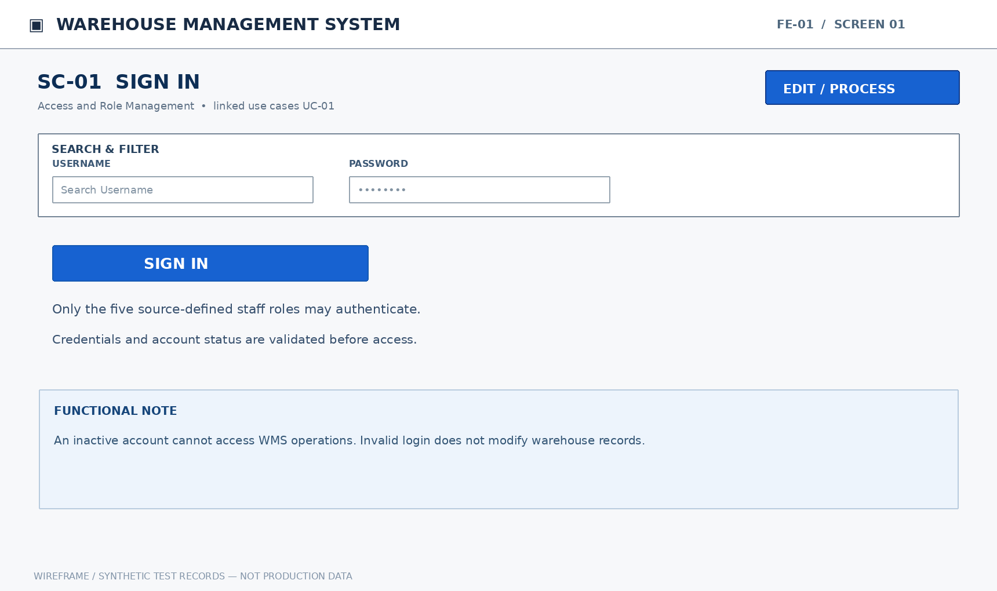
Mockup SC-01. Sign In — illustrative functional layout
Purpose: Access authorized functions according to the assigned account and role.
Linked use cases: UC-94.
UC | Authorized Actor(s) | Functional Behavior / Expected Outcome
UC-94 Sign in to the system | Store Owner: Use, Accountant: Use, Inventory Staff: Use, Sales Staff: Use, Administrator: Use | Access authorized functions according to the assigned account and role.  Enforce the detailed UC permission and current record state before executing this operation.

Field Description
Field Name | Description
Username | String. Entry: Required. Default: No automatic default; supply or select a value.  Validation: Account login identifier; trim surrounding whitespace and compare against existing usernames without creating duplicates.
Password | String (input only; hash persisted). Entry: Required. Default: No automatic default; supply or select a value.  Validation: Required masked credential; verify against a salted one-way hash. Never store plaintext or display it in activity logs.

1.2 Account List and Details

1.2.1 SC-02: Accounts and Permissions
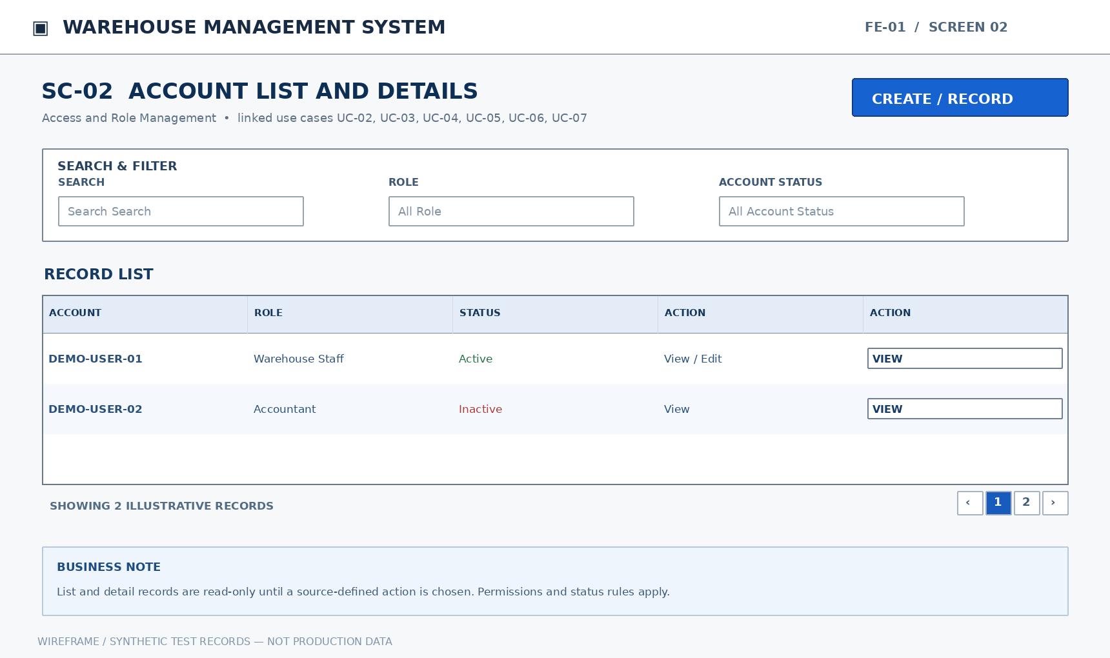
Mockup SC-02. Account List and Details — illustrative functional layout
Purpose: Search and filter accounts by name, role, and active status. Display the selected account's information, assigned role, and status. Create, update, activate or deactivate staff accounts; role assignment remains separately controlled. Configure view, create, edit, and transaction-recording permissions by role.
Linked use cases: UC-95, UC-96, UC-97, UC-98.
UC | Authorized Actor(s) | Functional Behavior / Expected Outcome
UC-95 View account list | Administrator: View | Search and filter accounts by name, role, and active status.  Enforce the detailed UC permission and current record state before executing this operation.
UC-96 View account details | Administrator: View | Display the selected account's information, assigned role, and status.  Enforce the detailed UC permission and current record state before executing this operation.
UC-97 Maintain Staff Account | Administrator: Perform | Create, update, activate or deactivate staff accounts; role assignment remains separately controlled.  Enforce the detailed UC permission and current record state before executing this operation.
UC-98 Assign roles and operation permissions | Administrator: Perform | Configure view, create, edit, and transaction-recording permissions by role.  Enforce the detailed UC permission and current record state before executing this operation.  Administrator assigns only the five approved roles and the operation permissions defined in this specification. It cannot create additional business roles, arbitrary business policies, approval chains or stock-posting rules, or perform business approvals through this administrative UC.

Field Description
Field Name | Description
Search | String (filter only). Entry: Optional filter. Default: unset (blank filter is ignored).  Validation: Optional keyword matched to the authorized list; no value is saved to a business record.
Role | ObjectId (reference). Entry: Required on account create / optional filter. Default: unset (blank filter is ignored).  Validation: Choose an existing authorized internal role; store its reference ID, not free text.
Account Status | Boolean (0=inactive; 1=active). Entry: System-controlled. Default: Assigned by the workflow (workflow-assigned default).  Validation: System-maintained activation flag; inactive accounts cannot authenticate and existing audit references remain.
Username | String. Entry: Required on account create. Default: No automatic default; supply or select a value.  Validation: Account login identifier; trim surrounding whitespace and compare against existing usernames without creating duplicates.
Permissions | Boolean per permission (role-operation junction). Entry: Required when assigning role rights. Default: No automatic default; supply or select a value.  Validation: Store the permitted role-to-operation flags; only the administrator may modify operation assignments.

2. Products and Lots (FE-02)

2.1 Product and Unit Conversion

2.1.1 SC-03: Products and Packaging
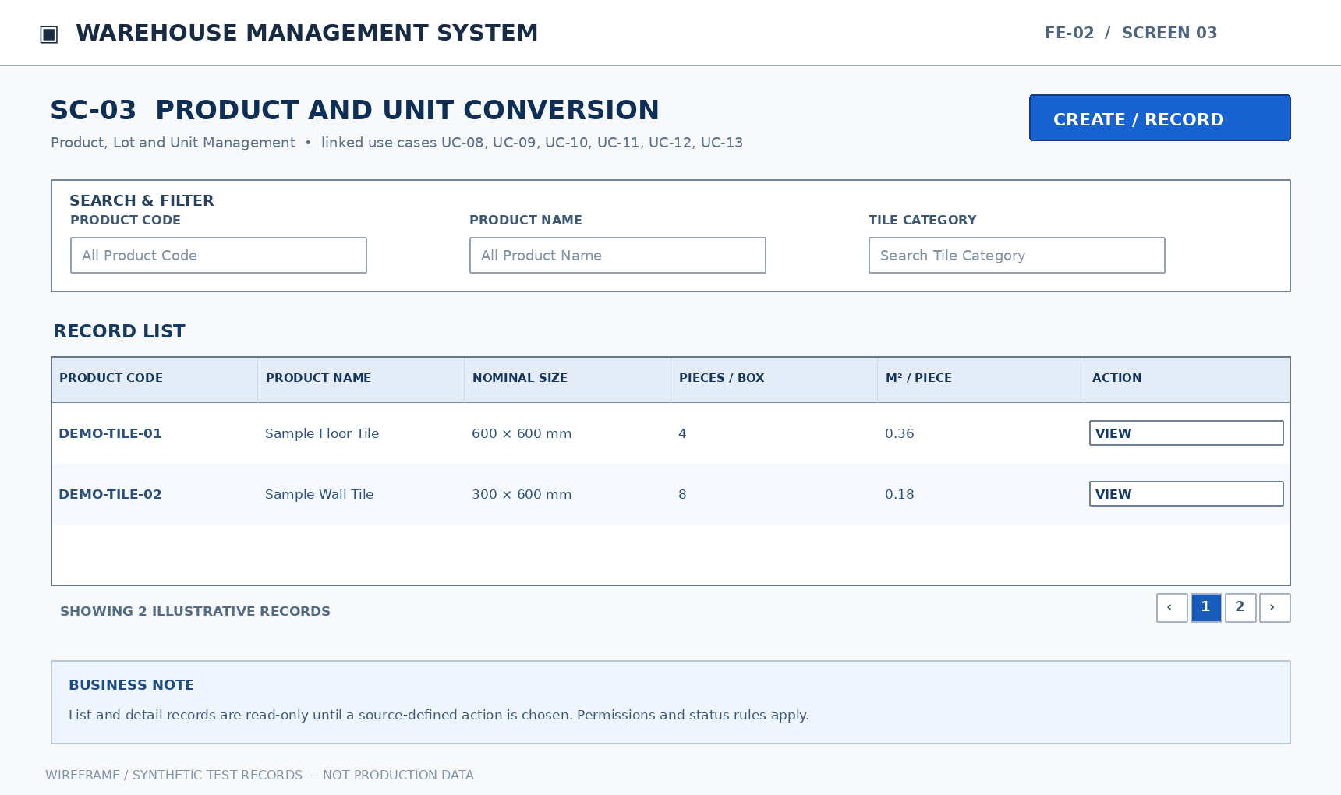
Mockup SC-03. Product and Unit Conversion — illustrative functional layout
Purpose: Search products by item code, name, size, and status. Display tile attributes, packaging specifications, and units of measure. Create, update or deactivate products and maintain their packaging/unit conversions.
Linked use cases: UC-11, UC-12, UC-13.
UC | Authorized Actor(s) | Functional Behavior / Expected Outcome
UC-11 View product list | Store Owner: View, Accountant: View, Inventory Staff: View, Sales Staff: View | Search products by item code, name, size, and status.  Enforce the detailed UC permission and current record state before executing this operation.
UC-12 View product details | Store Owner: View, Accountant: View, Inventory Staff: View, Sales Staff: View | Display tile attributes, packaging specifications, and units of measure.  Enforce the detailed UC permission and current record state before executing this operation.
UC-13 Maintain Product and Packaging | Store Owner: Perform | Create, update or deactivate products and maintain their packaging/unit conversions.  Enforce the detailed UC permission and current record state before executing this operation.

Field Description
Field Name | Description
Product Code | String. Entry: Required. Default: No automatic default; supply or select a value.  Validation: Business product identifier; required on product creation and unique across the product catalog.
Product Name | String. Entry: Required. Default: No automatic default; supply or select a value.  Validation: Descriptive tile name; required on product creation; trim whitespace and reject an empty value.
Tile Category | String. Entry: Required. Default: No automatic default; supply or select a value.  Validation: Select the tile functional category from the configured reference list.
Brand | String. Entry: Optional. Default: unset.  Validation: Optional brand name/reference associated with the product.
Material | String. Entry: Required. Default: No automatic default; supply or select a value.  Validation: Select the material classification for the tile product.
Nominal Size | String. Entry: Required. Default: No automatic default; supply or select a value.  Validation: Nominal tile dimension label, such as 600×600 mm; preserve it separately from lot actual calibre.
Pieces / Box | INT. Entry: Required when configuring conversion. Default: No automatic default; supply or select a value.  Validation: Whole pieces per package; must be greater than zero when configuring conversion.
m² / Piece | Decimal128. Entry: Required when configuring conversion. Default: No automatic default; supply or select a value.  Validation: Square-meter conversion factor per piece; must be greater than zero and used consistently in stock movements.
Status | String. Entry: System-controlled. Default: Assigned by the workflow (workflow-assigned default).  Validation: Workflow-dependent state; display the current status and accept only transitions authorized by the relevant UC.

Input and validation notes: MongoDB types and maximum lengths are the proposed implementation baseline. Reference inputs must resolve to existing eligible master/source records; quantities must respect the product unit conversion and current lot/location quality state. Read-only balances, audit details and approval actor/timestamps are system-populated. Failed validation must not partially post any inventory movement.

2.2 Lot List and Details

2.2.1 SC-04: Product Lots
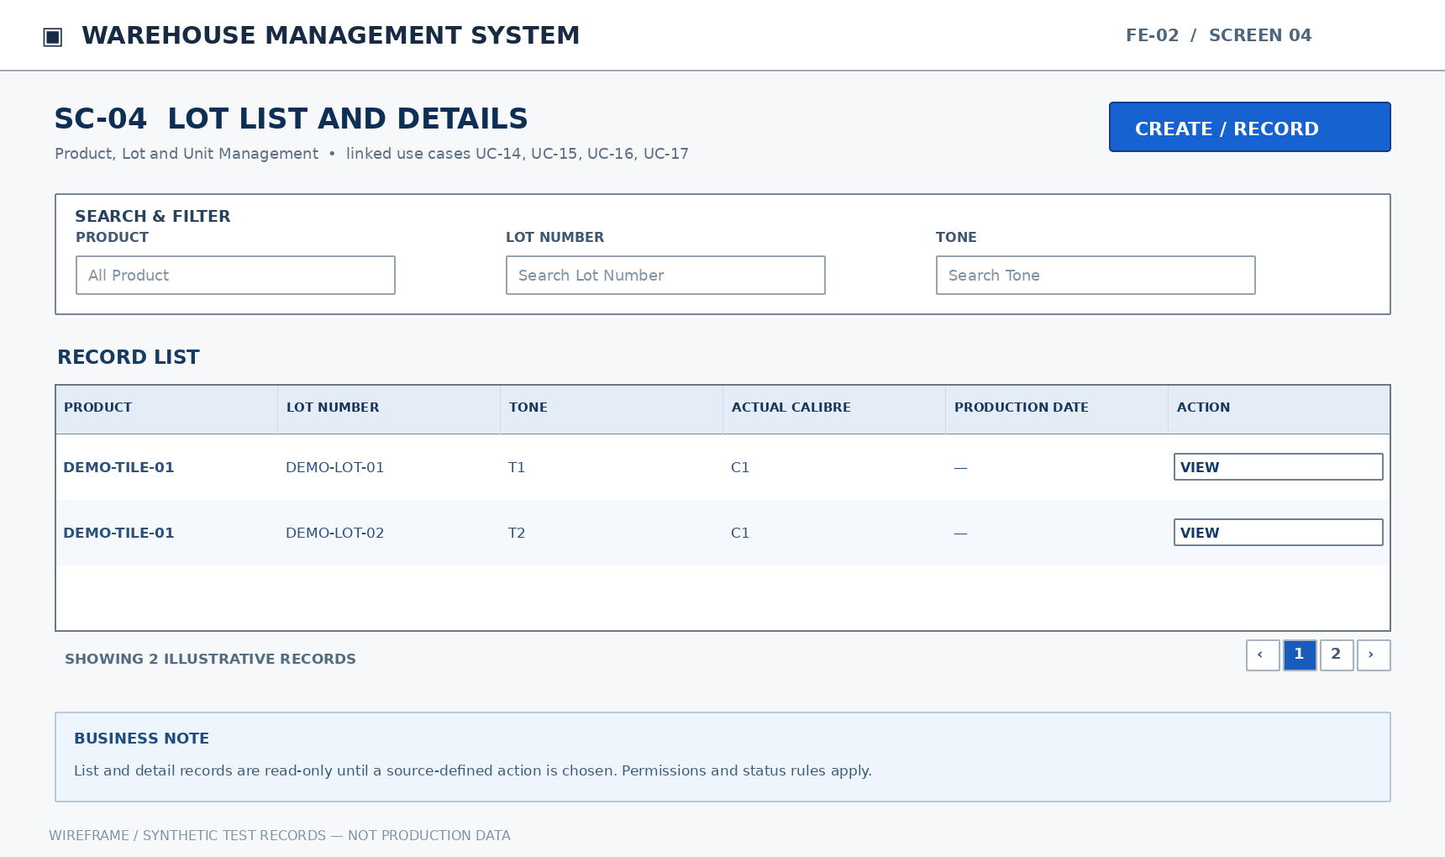
Mockup SC-04. Lot List and Details — illustrative functional layout
Linked use cases: UC-14, UC-15, UC-16.
UC | Authorized Actor(s) | Functional Behavior / Expected Outcome
UC-14 View lot list | Store Owner: View, Inventory Staff: View | Search lots by product, lot number, tone, and actual calibre.  Enforce the detailed UC permission and current record state before executing this operation.
UC-15 View lot details | Store Owner: View, Inventory Staff: View | Display production date, tone, actual calibre, and related transaction history.  Enforce the detailed UC permission and current record state before executing this operation.
UC-16 Maintain Product Lot | Store Owner: Create / Update, Inventory Staff: Create only | Create and update product-lot reference information.  Store Owner may create and update lot reference information. Inventory Staff may create a lot only; it may not update an existing lot or change its master status. Stock quality changes must use the authorized inspection or disposition workflow. Posted lot references and movement history cannot be overwritten.

Field Description
Field Name | Description
Product | ObjectId (reference). Entry: Required. Default: No automatic default; supply or select a value.  Validation: Existing product reference; selection must respect product activation and the current workflow.
Lot Number | String. Entry: Required. Default: No automatic default; supply or select a value.  Validation: Lot identifier; validate the source-defined product/lot/tone/calibre identity before creating a duplicate.
Tone | String. Entry: Required. Default: No automatic default; supply or select a value.  Validation: Actual lot shade/tone; required when registering a lot and used to distinguish physical stock.
Actual Calibre | String. Entry: Required. Default: No automatic default; supply or select a value.  Validation: Actual lot dimension/calibre value, independent of the product nominal size.
Production Date | DATE. Entry: Optional. Default: unset.  Validation: Optional actual manufacturing date; reject invalid calendar dates and never substitute a guessed date.
Transaction History | Derived result set (no standalone persisted document field). Entry: Read-only. Default: Derived from persisted data; not user-entered.  Validation: Read-only list of posted documents and movements relating to the selected lot; generated from audit records.

3. Supplier Master Data (FE-02)

3.1 Supplier List and Details

3.1.1 SC-05: Suppliers
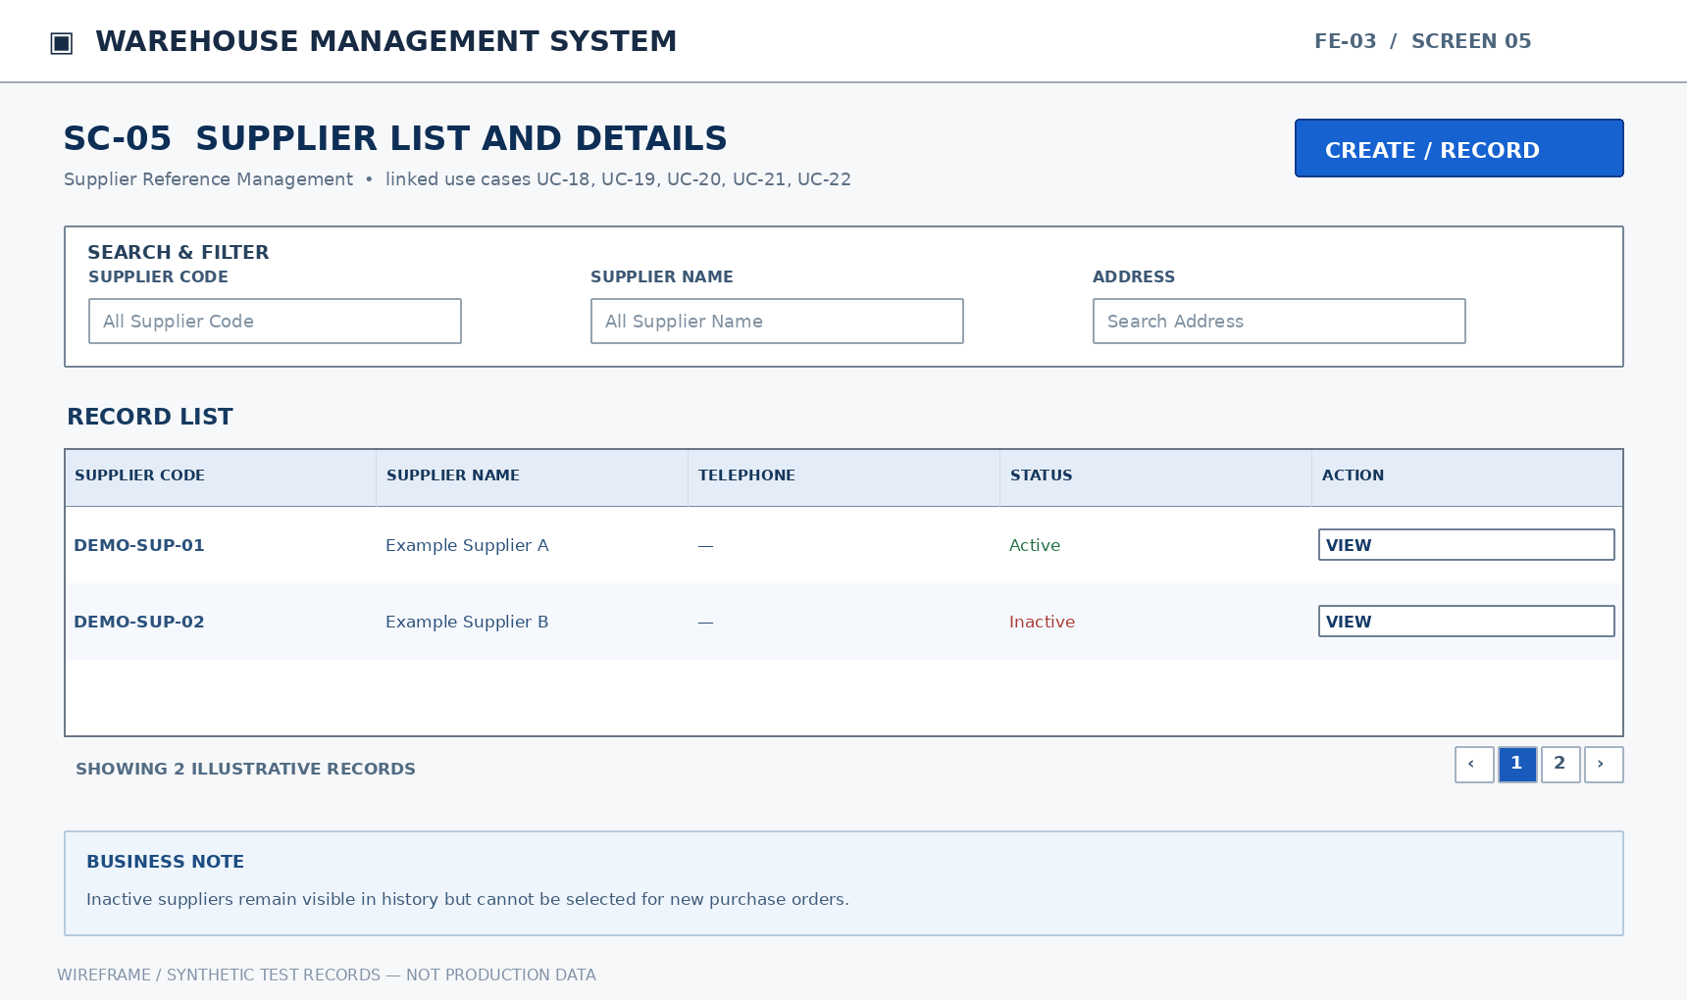
Mockup SC-05. Supplier List and Details — illustrative functional layout
Linked use cases: UC-17, UC-18, UC-19.
UC | Authorized Actor(s) | Functional Behavior / Expected Outcome
UC-17 View supplier list | Store Owner: View, Accountant: View | Search suppliers by code, name, and cooperation status.  Enforce the detailed UC permission and current record state before executing this operation.
UC-18 View supplier details | Store Owner: View, Accountant: View | Display contact information and related purchases, receipts, and returns.  Enforce the detailed UC permission and current record state before executing this operation.
UC-19 Maintain Supplier | Store Owner: Activate / Deactivate, Accountant: Create / Update | Maintain supplier identity/contact data and control supplier availability with separate operation permissions.  Accountant may create and update supplier identity/contact information, but cannot activate or deactivate a supplier. Store Owner may activate or deactivate an existing supplier, but does not acquire create/update rights through this merged UC. Historical references are retained; inactive suppliers cannot be selected for new purchase documents.

Field Description
Field Name | Description
Supplier Code | String. Entry: Required. Default: No automatic default; supply or select a value.  Validation: Required supplier identifier; enforce uniqueness in the supplier reference table.
Supplier Name | String. Entry: Required. Default: No automatic default; supply or select a value.  Validation: Required supplier business name; trim leading/trailing whitespace and reject blank names.
Address | String. Entry: Optional. Default: unset.  Validation: Optional supplier correspondence address; preserve Vietnamese/Unicode characters.
Telephone | String. Entry: Optional. Default: unset.  Validation: Optional contact phone; preserve leading zero and + sign; store as text, not a number.
Contact Person | String. Entry: Optional. Default: unset.  Validation: Optional representative/contact name for supplier communications.
Status | String. Entry: System-controlled. Default: Assigned by the workflow (workflow-assigned default).  Validation: Workflow-dependent state; display the current status and accept only transitions authorized by the relevant UC.

4. Purchasing (FE-01)

4.1 Replenishment Requests

4.1.1 SC-06: Replenishment Requests
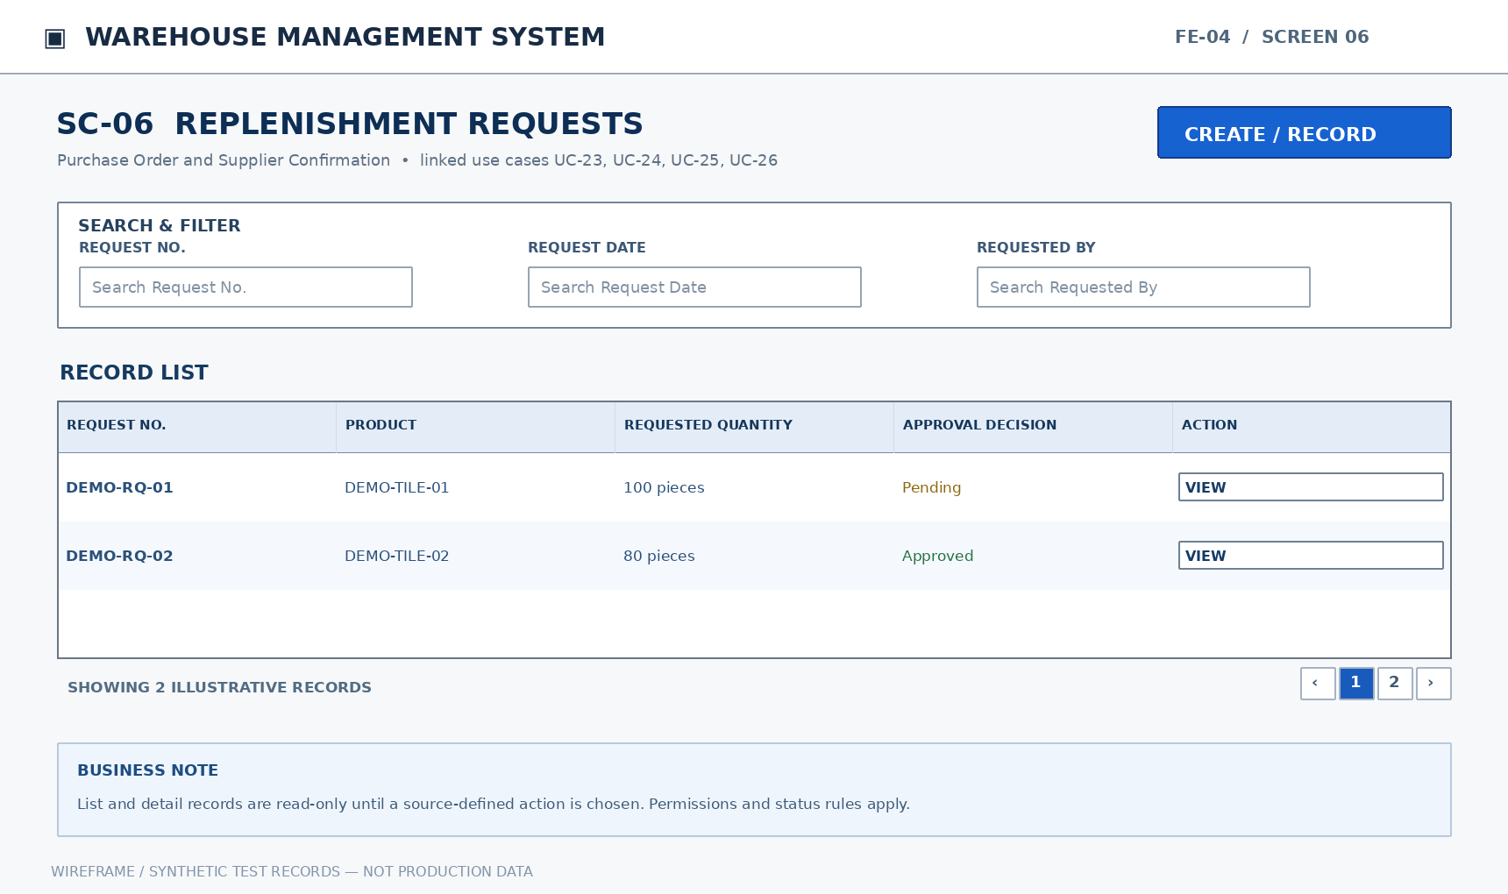
Mockup SC-06. Replenishment Requests — illustrative functional layout
Purpose: Search requests by status, date, creator, and approval decision. Display required products, reference stock, requested quantities, and approval history. Propose replenishment after checking stock and recording products, quantities, and reasons. Review the request and record decision, approver, time, and rejection reason.
Linked use cases: UC-01, UC-02, UC-03, UC-04.
UC | Authorized Actor(s) | Functional Behavior / Expected Outcome
UC-01 View replenishment request list | Store Owner: View, Accountant: View | Search requests by status, date, creator, and approval decision.  Enforce the detailed UC permission and current record state before executing this operation.
UC-02 View replenishment request details | Store Owner: View, Accountant: View | Display required products, reference stock, requested quantities, and approval history.  Enforce the detailed UC permission and current record state before executing this operation.
UC-03 Create replenishment request | Accountant: Perform | Propose replenishment after checking stock and recording products, quantities, and reasons.  Enforce the detailed UC permission and current record state before executing this operation.
UC-04 Approve or reject replenishment request | Store Owner: Approve | Review the request and record decision, approver, time, and rejection reason.  Enforce the detailed UC permission and current record state before executing this operation.

Field Description
Field Name | Description
Request No. | String. Entry: System-generated. Default: Assigned by the workflow (workflow-assigned default).  Validation: System-assigned replenishment request code; unique among replenishment documents and read-only after creation.
Request Date | DATE. Entry: System-generated. Default: Assigned by the workflow (workflow-assigned default).  Validation: Creation date of the request; system-populated and read-only.
Requested By | ObjectId (reference). Entry: System-generated. Default: Assigned by the workflow (workflow-assigned default).  Validation: Reference to the authenticated employee/account that submitted the document; system-populated.
Reference Stock | Decimal128. Entry: Read-only. Default: Derived from persisted data; not user-entered.  Validation: Read-only on-hand quantity for the relevant product/warehouse at request creation; never treated as an editable stock movement.
Product | ObjectId (reference). Entry: Required. Default: No automatic default; supply or select a value.  Validation: Existing product reference; selection must respect product activation and the current workflow.
Requested Quantity | Decimal128. Entry: Required. Default: No automatic default; supply or select a value.  Validation: Quantity requested on a replenishment or issue line; greater than zero on submission.
Reason | String. Entry: Required. Default: No automatic default; supply or select a value.  Validation: Business justification; required on requests and variance/return actions that explicitly require a reason.
Approval Decision | String. Entry: Required when deciding. Default: No automatic default; supply or select a value.  Validation: Approve or reject an eligible pending request; capture approver and decision time; rejection requires a reason.

4.2 Purchase Orders

4.2.1 SC-07: Purchase Orders
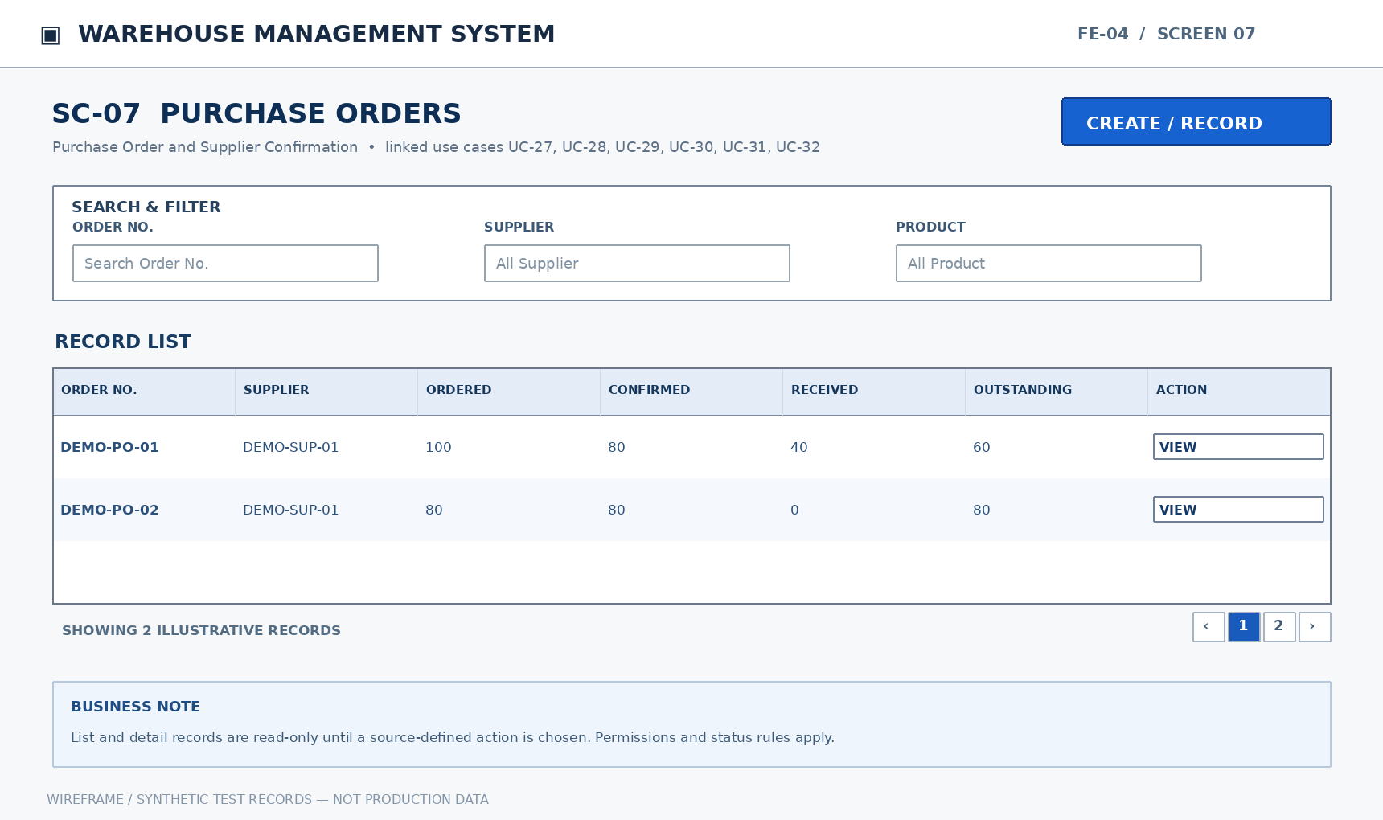
Mockup SC-07. Purchase Orders — illustrative functional layout
Purpose: Filter orders by supplier, date, status, and outstanding quantity. Display order lines, supplier confirmations, and partial receipt history. Display ordered, confirmed, received, accepted and outstanding quantities with source receipts. This is read-only, not a separate outstanding-quantity UC. Create or maintain a PO and record the external supplier confirmation in the same purchasing workflow.
Linked use cases: UC-05, UC-06, UC-07.
UC | Authorized Actor(s) | Functional Behavior / Expected Outcome
UC-05 View purchase order list | Store Owner: View, Accountant: View, Inventory Staff: View | Filter orders by supplier, date, status, and outstanding quantity.  Enforce the detailed UC permission and current record state before executing this operation.  Inventory Staff may view only the PO information needed for assigned-warehouse receiving: supplier/order reference, products, units, confirmed/outstanding quantities and delivery schedule. Purchase prices, financial information and PO modification are not granted by this view.
UC-06 View purchase order details | Store Owner: View, Accountant: View, Inventory Staff: View | Display order lines, supplier confirmations, and partial receipt history. Display ordered, confirmed, received, accepted and outstanding quantities with source receipts. This is read-only, not a separate outstanding-quantity UC.  Enforce the detailed UC permission and current record state before executing this operation.  Inventory Staff may view receiving-related PO detail only within assigned warehouses; direct detail/evidence access enforces the same restriction as the list. It cannot modify the PO or view purchasing financial data.
UC-07 Manage Purchase Order and Supplier Confirmation | Accountant: Perform | Create or maintain a PO and record the external supplier confirmation in the same purchasing workflow.  Enforce the detailed UC permission and current record state before executing this operation.

Field Description
Field Name | Description
Order No. | String. Entry: System-generated. Default: Assigned by the workflow (workflow-assigned default).  Validation: Unique purchase order document number, generated or assigned at PO creation and displayed read-only thereafter.
Supplier | ObjectId (reference). Entry: Required. Default: No automatic default; supply or select a value.  Validation: Existing supplier reference; a new purchase order may use only an active supplier.
Product | ObjectId (reference). Entry: Required. Default: No automatic default; supply or select a value.  Validation: Existing product reference; selection must respect product activation and the current workflow.
Ordered Quantity | Decimal128. Entry: Required. Default: No automatic default; supply or select a value.  Validation: Positive purchase order line quantity; not lower than quantity already received when edited.
Unit | String. Entry: Required. Default: No automatic default; supply or select a value.  Validation: Selected product unit of measure: piece, box, or m²; use the product-specific conversion factor.
Expected Receipt | DATE. Entry: Required. Default: No automatic default; supply or select a value.  Validation: Expected goods arrival date recorded on a purchase order; calendar date only.
Confirmed Quantity | Decimal128. Entry: Required at confirmation. Default: No automatic default; supply or select a value.  Validation: Supplier-confirmed line quantity; nonnegative and reconciled against the applicable ordered quantity.
Received Quantity | Decimal128. Entry: Read-only. Default: Derived from persisted data; not user-entered.  Validation: Actual quantity captured at a receiving checkpoint; nonnegative and linked to the source order.
Outstanding Quantity | Decimal128. Entry: Read-only. Default: Derived from persisted data; not user-entered.  Validation: Read-only remaining purchase quantity calculated from ordered and received quantities with relevant confirmation state.

5. Goods Receiving and Inspection (FE-01, FE-03)

5.1 Goods Receipts and Inspection

5.1.1 SC-08: Goods Receipt and Inspection
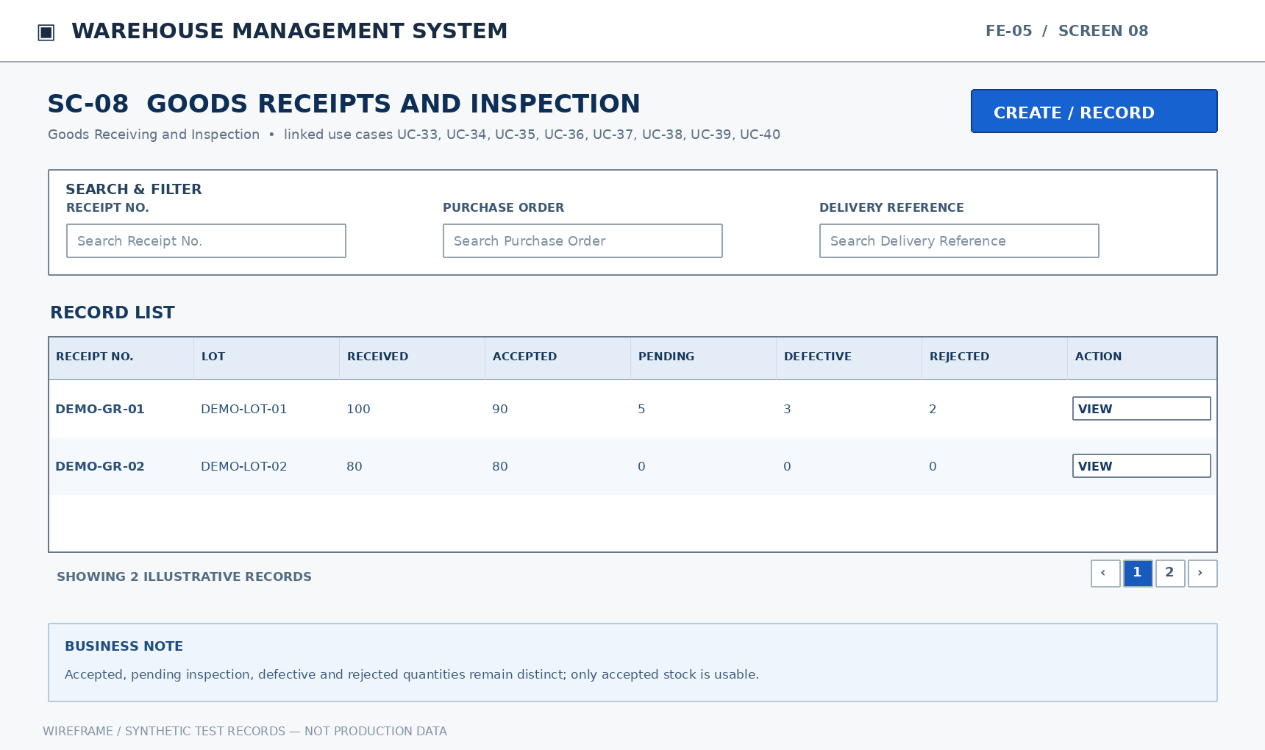
Mockup SC-08. Goods Receipts and Inspection — illustrative functional layout
Purpose: Search deliveries associated with purchase orders and their processing status. Display delivered, accepted, pending inspection, defective, and rejected quantities. Record each supplier delivery separately and link it to its purchase order. Inspect the draft receipt and post the actual accepted and segregated quantities in one inspection workflow. Create a put-away TO from posted goods receipt quantities. Confirm placement of received goods into their destination bins.
Linked use cases: UC-08, UC-09, UC-10, UC-26, UC-32, UC-33.
UC | Authorized Actor(s) | Functional Behavior / Expected Outcome
UC-08 View goods receipt list | Store Owner: View, Accountant: View, Inventory Staff: View | Search deliveries associated with purchase orders and their processing status.  Enforce the detailed UC permission and current record state before executing this operation.
UC-09 View goods receipt details | Store Owner: View, Accountant: View, Inventory Staff: View | Display delivered, accepted, pending inspection, defective, and rejected quantities.  Enforce the detailed UC permission and current record state before executing this operation.
UC-10 Create goods receipt from purchase order | Inventory Staff: Perform | Record each supplier delivery separately and link it to its purchase order.  Enforce the detailed UC permission and current record state before executing this operation.
UC-26 Inspect and Post Goods Receipt | Inventory Staff: Perform | Inspect the draft receipt and post the actual accepted and segregated quantities in one inspection workflow.  Enforce the detailed UC permission and current record state before executing this operation.
UC-32 Create Put-away Transfer Order | Inventory Staff: Perform | Create a put-away TO from posted goods receipt quantities.  Enforce the detailed UC permission and current record state before executing this operation.
UC-33 Confirm Put-away Transfer Order | Inventory Staff: Perform | Confirm placement of received goods into their destination bins.  Enforce the detailed UC permission and current record state before executing this operation.

Field Description
Field Name | Description
Receipt No. | String. Entry: System-generated. Default: Assigned by the workflow (workflow-assigned default).  Validation: Unique goods receipt document code; associates inspected goods with the source purchase order.
Purchase Order | ObjectId (reference). Entry: Required. Default: No automatic default; supply or select a value.  Validation: Source purchase order reference; must exist and remain linked to the receipt.
Delivery Reference | String. Entry: Required for external delivery identification. Default: No automatic default; supply or select a value.  Validation: External delivery note/reference for the shipment; check repeated reference against the relevant supplier and PO.
Product | ObjectId (reference). Entry: Required. Default: No automatic default; supply or select a value.  Validation: Existing product reference; selection must respect product activation and the current workflow.
Lot | ObjectId (reference). Entry: Required. Default: No automatic default; supply or select a value.  Validation: Existing lot record reference; lot/tone/calibre must match the selected product.
Tone | String. Entry: Required. Default: No automatic default; supply or select a value.  Validation: Actual lot shade/tone; required when registering a lot and used to distinguish physical stock.
Actual Calibre | String. Entry: Required. Default: No automatic default; supply or select a value.  Validation: Actual lot dimension/calibre value, independent of the product nominal size.
Boxes | INT. Entry: Conditional: quantity may be entered in boxes/pieces/m². Default: No automatic default; supply or select a value.  Validation: Nonnegative integer number of cartons/boxes physically received; converted using pieces per box.
Pieces | INT. Entry: Conditional: quantity may be entered in boxes/pieces/m². Default: No automatic default; supply or select a value.  Validation: Nonnegative integer quantity of individual pieces physically received; do not use floating-point units.
m² | Decimal128. Entry: Conditional: quantity may be entered in boxes/pieces/m². Default: No automatic default; supply or select a value.  Validation: Nonnegative measured square-meter quantity converted by the selected product conversion factors.
Accepted | Decimal128. Entry: Required at inspection. Default: No automatic default; supply or select a value.  Validation: Accepted goods quantity at inspection; must be nonnegative and included in the total received reconciliation.
Pending Inspection | Decimal128. Entry: Required at inspection. Default: No automatic default; supply or select a value.  Validation: Quantity awaiting inspection; cannot count toward usable stock.
Defective | Decimal128. Entry: Required at inspection. Default: No automatic default; supply or select a value.  Validation: Quantity determined defective during receipt inspection; cannot be included as accepted/usable stock.
Rejected | Decimal128. Entry: Required at inspection. Default: No automatic default; supply or select a value.  Validation: Quantity rejected on arrival; remain segregated from accepted inventory.
Location | ObjectId (reference). Entry: Required when posting accepted stock. Default: No automatic default; supply or select a value.  Validation: Existing location reference within the chosen warehouse; must be active/eligible for a new stock posting.
Classification quantities | Decimal128. Required at inspection: actual, accepted and nonusable quantities reconcile by line. Record lot, condition, classification and discrepancy evidence within UC-26; only the accepted eligible portion is released for put-away.

6. Warehouse and Storage Locations (FE-04)

6.1 Warehouse Locations

6.1.1 SC-09: Warehouse Locations
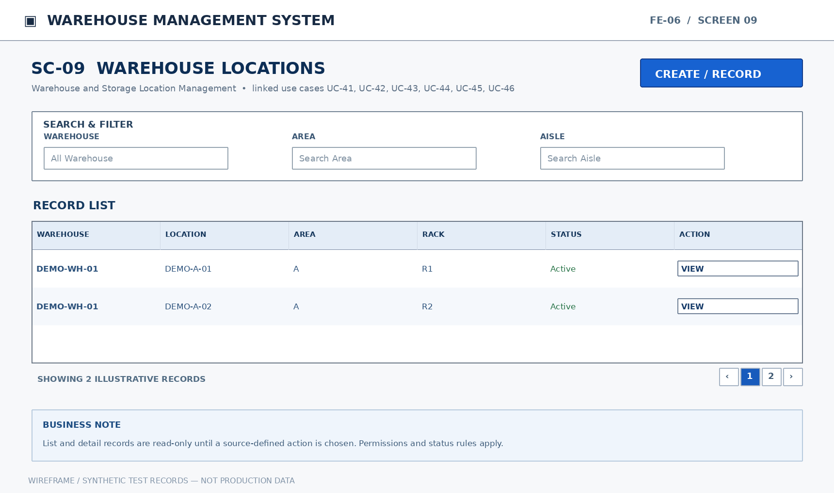
Mockup SC-09. Warehouse Locations — illustrative functional layout
Purpose: Search by warehouse, area, aisle, rack, and location code. Display capacity, status, and lot-level quantities at a location. Create, update or deactivate storage locations.
Linked use cases: UC-27, UC-28, UC-29.
UC | Authorized Actor(s) | Functional Behavior / Expected Outcome
UC-27 View warehouse and location list | Store Owner: View, Inventory Staff: View | Search by warehouse, area, aisle, rack, and location code.  Enforce the detailed UC permission and current record state before executing this operation.
UC-28 View storage location details | Store Owner: View, Inventory Staff: View | Display capacity, status, and lot-level quantities at a location.  Enforce the detailed UC permission and current record state before executing this operation.
UC-29 Maintain Storage Location | Store Owner: Perform | Create, update or deactivate storage locations.  Enforce the detailed UC permission and current record state before executing this operation.

Field Description
Field Name | Description
Warehouse | ObjectId (reference). Entry: Required. Default: No automatic default; supply or select a value.  Validation: Authorized warehouse reference; restrict the lookup to locations and operations permitted to the user.
Area | String. Entry: Optional. Default: unset.  Validation: Optional storage zone/area designation within the parent warehouse.
Aisle | String. Entry: Optional. Default: unset.  Validation: Optional aisle identifier within a warehouse area.
Rack | String. Entry: Optional. Default: unset.  Validation: Optional rack identifier within the storage area/aisle.
Location Code | String. Entry: Required. Default: No automatic default; supply or select a value.  Validation: Required unique location code within its parent warehouse.
Capacity | Decimal128. Entry: Optional. Default: unset.  Validation: Optional storage capacity; must be positive if configured and interpreted using the location capacity unit.
Status | String. Entry: System-controlled. Default: Assigned by the workflow (workflow-assigned default).  Validation: Workflow-dependent state; display the current status and accept only transitions authorized by the relevant UC.
Stock at Location | Decimal128. Entry: Read-only. Default: Derived from persisted data; not user-entered.  Validation: Read-only total balance in the selected location; calculated from posted lot/location movements.

7. Inventory and Defective Goods (FE-04, FE-07)

7.1 Inventory by Lot and Status

7.1.1 SC-10: Inventory by Lot and Status
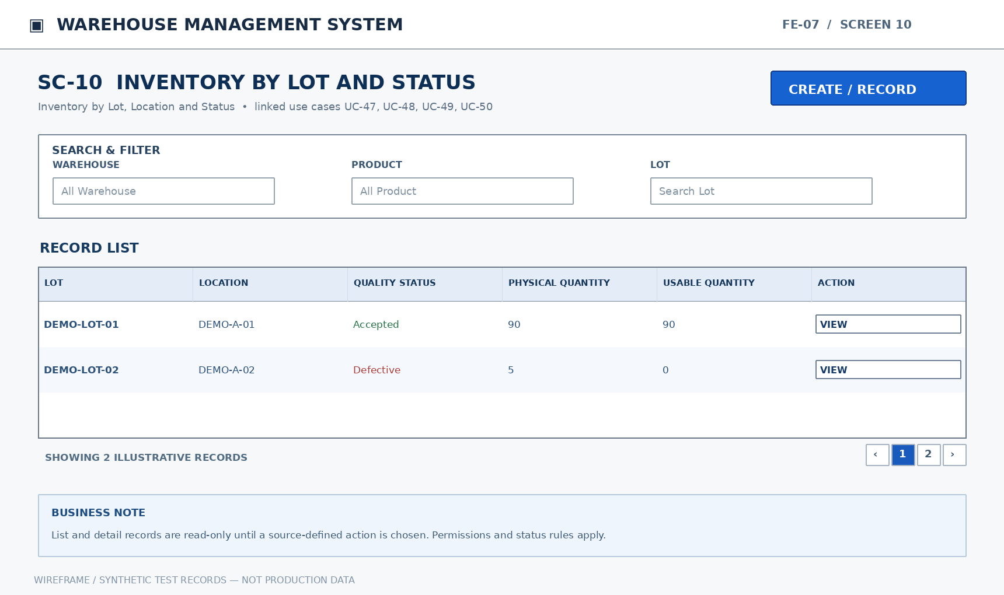
Mockup SC-10. Inventory by Lot and Status — illustrative functional layout
Purpose: Filter inventory by product, warehouse, lot, tone, calibre, and quality status. Display physical quantity, usable quantity, and source movement documents.
Linked use cases: UC-30, UC-31.
UC | Authorized Actor(s) | Functional Behavior / Expected Outcome
UC-30 View stock by lot, location, and quality status | Store Owner: View, Accountant: View, Inventory Staff: View, Sales Staff: Usable stock only | Filter inventory by product, warehouse, lot, tone, calibre, and quality status.  Store Owner and Inventory Staff may view stock within their authorized scope. Sales Staff may view usable availability only; purchase costs and unrestricted quarantine/defective balances are excluded.
UC-31 View inventory balance details | Store Owner: View, Inventory Staff: View | Display physical quantity, usable quantity, and source movement documents.  Enforce the detailed UC permission and current record state before executing this operation.

Field Description
Field Name | Description
Warehouse | ObjectId (reference). Entry: Read-only / optional filter. Default: unset (blank filter is ignored).  Validation: Authorized warehouse reference; restrict the lookup to locations and operations permitted to the user. Historical/inactive master records remain searchable where linked to authorized posted transactions.
Product | ObjectId (reference). Entry: Read-only / optional filter. Default: unset (blank filter is ignored).  Validation: Existing product reference; selection must respect product activation and the current workflow. Historical/inactive master records remain searchable where linked to authorized posted transactions.
Lot | ObjectId (reference). Entry: Read-only / optional filter. Default: unset (blank filter is ignored).  Validation: Existing lot record reference; lot/tone/calibre must match the selected product. Historical/inactive master records remain searchable where linked to authorized posted transactions.
Tone | String. Entry: Read-only / optional filter. Default: unset (blank filter is ignored).  Validation: Actual lot shade/tone; required when registering a lot and used to distinguish physical stock.
Actual Calibre | String. Entry: Read-only / optional filter. Default: unset (blank filter is ignored).  Validation: Actual lot dimension/calibre value, independent of the product nominal size.
Location | ObjectId (reference). Entry: Read-only / optional filter. Default: unset (blank filter is ignored).  Validation: Existing location reference within the chosen warehouse; must be active/eligible for a new stock posting. Historical/inactive master records remain searchable where linked to authorized posted transactions.
Quality Status | String. Entry: Read-only / optional filter. Default: unset (blank filter is ignored).  Validation: Stock quality category; only eligible accepted quantities are included in usable stock.
Physical Quantity | Decimal128. Entry: Read-only / optional filter. Default: unset (blank filter is ignored).  Validation: Read-only physical quantity held at the specified lot/location across its quality categories.
Usable Quantity | Decimal128. Entry: Read-only / optional filter. Default: unset (blank filter is ignored).  Validation: Read-only available-for-issue quantity; excludes pending, defective and quarantined amounts.

7.2 Defective Goods and Disposition

7.2.1 SC-11: Defective Goods and Disposition
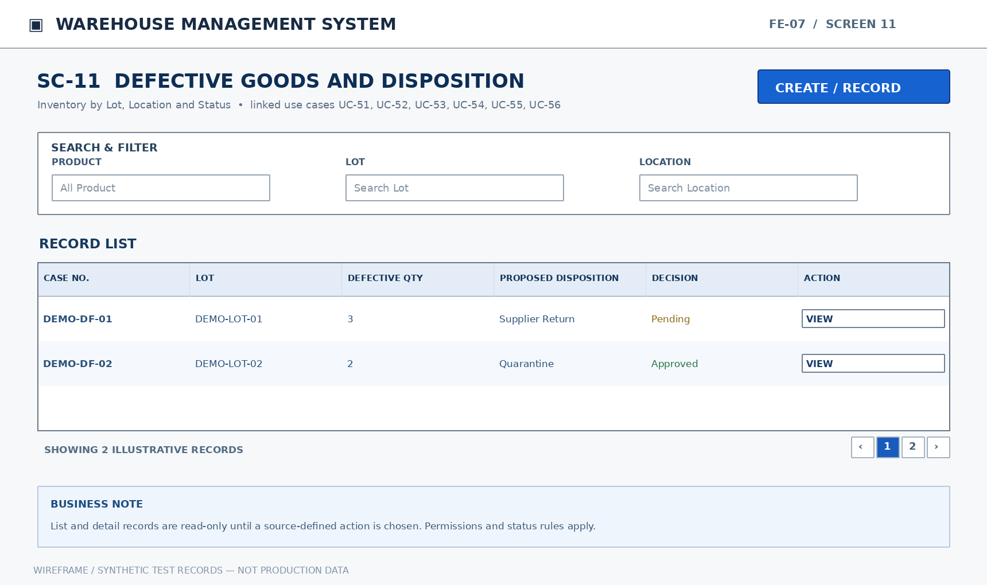
Mockup SC-11. Defective Goods and Disposition — illustrative functional layout
Linked use cases: UC-63, UC-64, UC-65, UC-66, UC-67.
UC | Authorized Actor(s) | Functional Behavior / Expected Outcome
UC-63 View defective goods list | Store Owner: View, Inventory Staff: View | Filter defective goods by product, lot, location, cause, status, and proposed disposition.  Enforce the detailed UC permission and current record state before executing this operation.
UC-64 View defective goods details | Store Owner: View, Inventory Staff: View | Display affected quantity, evidence, recorder, and related handling actions.  Enforce the detailed UC permission and current record state before executing this operation.
UC-65 Inspect Defective Goods and Submit Disposition | Inventory Staff: Perform | Record a defect or quarantined inspection and submit the proposed disposition as one workflow.  Enforce the detailed UC permission and current record state before executing this operation.
UC-66 Approve or reject defective goods disposition | Store Owner: Approve | Review cause and evidence and approve or reject the proposed handling.  Enforce the detailed UC permission and current record state before executing this operation.
UC-67 Record approved defective goods disposition | Inventory Staff: Perform | Update quantities and quality status according to the approved resolution.  Enforce the detailed UC permission and current record state before executing this operation.

Field Description
Field Name | Description
Product | ObjectId (reference). Entry: Required. Default: No automatic default; supply or select a value.  Validation: Existing product reference; selection must respect product activation and the current workflow.
Lot | ObjectId (reference). Entry: Required. Default: No automatic default; supply or select a value.  Validation: Existing lot record reference; lot/tone/calibre must match the selected product.
Location | ObjectId (reference). Entry: Required. Default: No automatic default; supply or select a value.  Validation: Existing location reference within the chosen warehouse; must be active/eligible for a new stock posting.
Defective Quantity | Decimal128. Entry: Required for new case. Default: No automatic default; supply or select a value.  Validation: Positive affected quantity when a new defective-goods case is recorded; cannot exceed eligible source quantity.
Cause | String. Entry: Required for new case. Default: No automatic default; supply or select a value.  Validation: Explain the discrepancy or damage cause; required for recorded defect/variance resolution where specified.
Evidence | String (storage object key). Entry: Optional. Default: unset.  Validation: Optional secure document or image reference attached to an incident/return; validate that the storage object belongs to the record.
Proposed Disposition | String. Entry: Required when submitting proposal. Default: No automatic default; supply or select a value.  Validation: Select the documented handling proposal for a defective case; save proposal separately from approval.
Approval Decision | String. Entry: Required when deciding. Default: No automatic default; supply or select a value.  Validation: Approve or reject an eligible pending request; capture approver and decision time; rejection requires a reason.

8. Location Movement and Warehouse Transfer (FE-04, FE-05)

8.1 Location Movements

8.1.1 SC-12: Location Movements
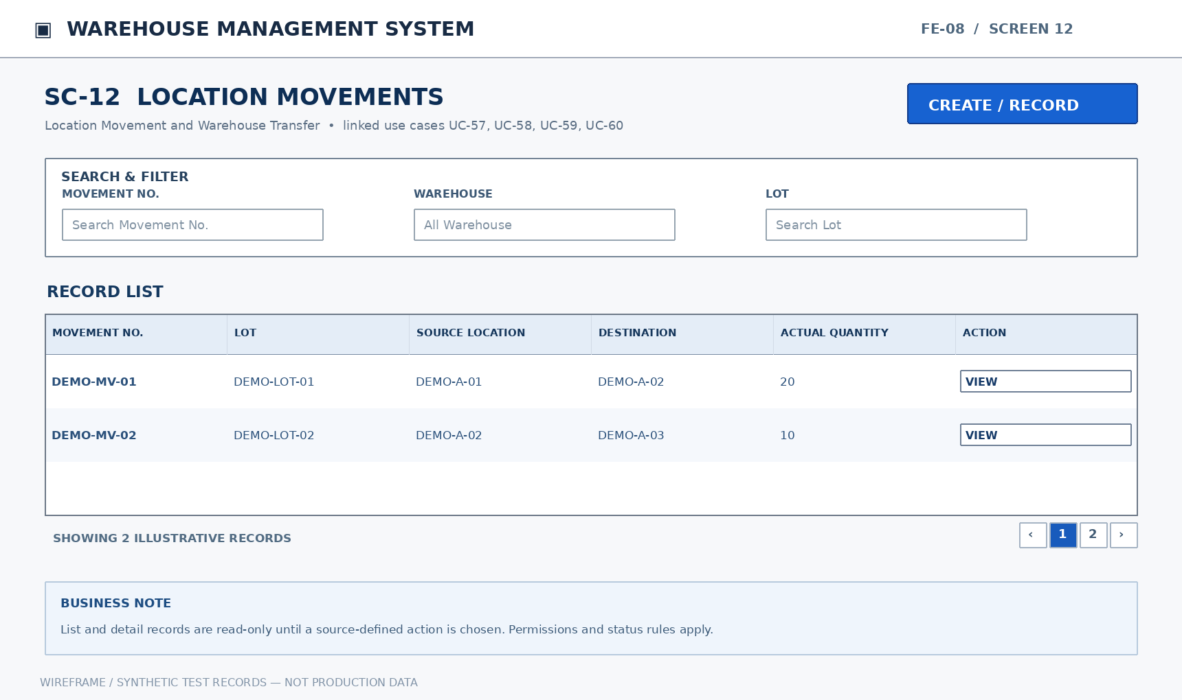
Mockup SC-12. Location Movements — illustrative functional layout
Purpose: Search same-warehouse movements by lot and status. Display source, destination, and actual transferred quantities. Specify lot, quantity, source and destination locations within the same warehouse. Decrease source-location quantity and increase destination-location quantity without changing warehouse total.
Linked use cases: UC-34, UC-35, UC-36, UC-37.
UC | Authorized Actor(s) | Functional Behavior / Expected Outcome
UC-34 View location movement list | Store Owner: View, Inventory Staff: View | Search same-warehouse movements by lot and status.  Enforce the detailed UC permission and current record state before executing this operation.
UC-35 View location movement details | Store Owner: View, Inventory Staff: View | Display source, destination, and actual transferred quantities.  Enforce the detailed UC permission and current record state before executing this operation.
UC-36 Create location movement | Inventory Staff: Perform | Specify lot, quantity, source and destination locations within the same warehouse.  Enforce the detailed UC permission and current record state before executing this operation.
UC-37 Confirm actual location movement | Inventory Staff: Perform | Decrease source-location quantity and increase destination-location quantity without changing warehouse total.  Enforce the detailed UC permission and current record state before executing this operation.

Field Description
Field Name | Description
Movement No. | String. Entry: System-generated. Default: Assigned by the workflow (workflow-assigned default).  Validation: Unique movement reference for a location transfer; generated when a movement record is created.
Warehouse | ObjectId (reference). Entry: Required. Default: No automatic default; supply or select a value.  Validation: Authorized warehouse reference; restrict the lookup to locations and operations permitted to the user.
Lot | ObjectId (reference). Entry: Required. Default: No automatic default; supply or select a value.  Validation: Existing lot record reference; lot/tone/calibre must match the selected product.
Source Location | ObjectId (reference). Entry: Required. Default: No automatic default; supply or select a value.  Validation: Existing origin location reference; must contain enough eligible stock for the movement.
Destination Location | ObjectId (reference). Entry: Required. Default: No automatic default; supply or select a value.  Validation: Existing destination location reference; must differ from source and belong to the selected transfer scope.
Planned Quantity | Decimal128. Entry: Required. Default: No automatic default; supply or select a value.  Validation: Requested movement quantity; must be greater than zero and not exceed eligible source stock.
Actual Moved Quantity | Decimal128. Entry: Required when confirming movement. Default: No automatic default; supply or select a value.  Validation: Positive actual moved quantity; reduces source balance and increases destination balance by the same amount.

8.2 Warehouse Transfers and Discrepancies

8.2.1 SC-13: Warehouse Transfers
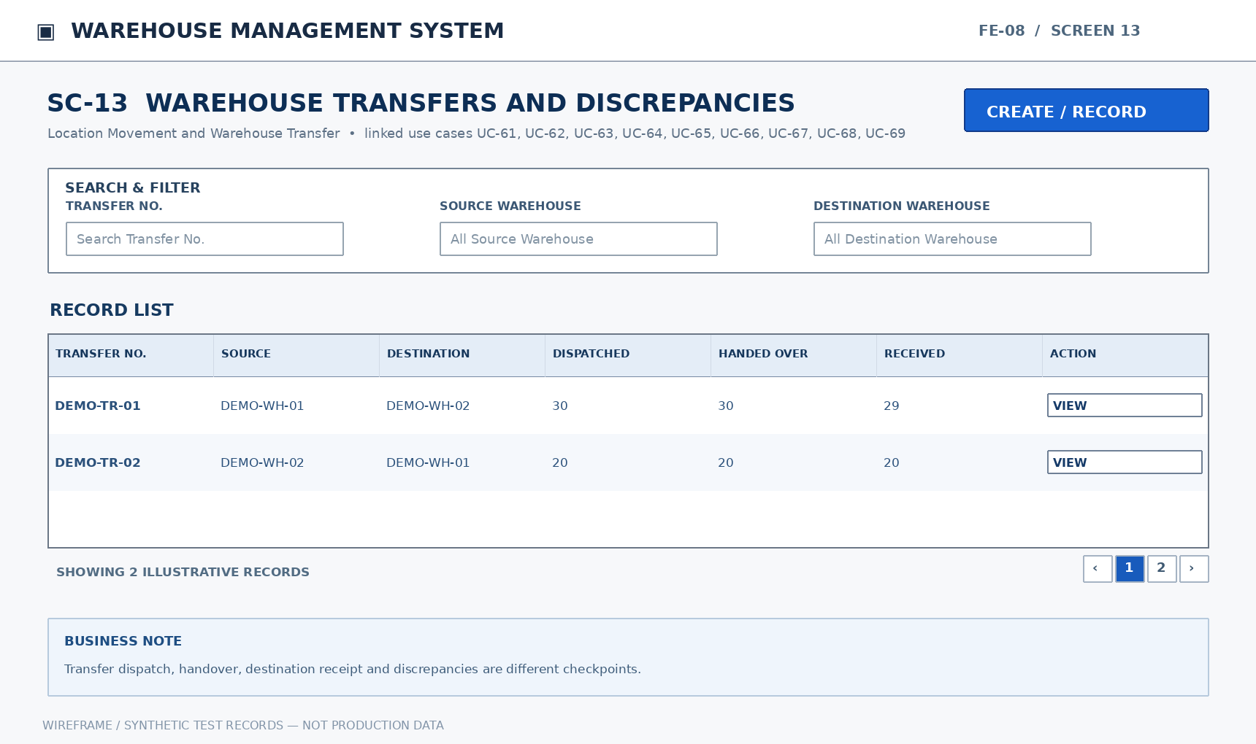
Mockup SC-13. Warehouse Transfers and Discrepancies — illustrative functional layout
Purpose: Search transfers by source/destination warehouse and in-transit/received status. Display dispatched, handed-over, and received quantities and discrepancies by lot. Create a warehouse transfer request (TR). Approve or reject the warehouse TR. Create the TO for an approved warehouse TR. Confirm actual warehouse transfer quantities and handle checkpoint differences within the same workflow. Approve or reject a discrepancy resolution submitted from TO confirmation.
Linked use cases: UC-38, UC-39, UC-40, UC-41, UC-42, UC-43, UC-44.
UC | Authorized Actor(s) | Functional Behavior / Expected Outcome
UC-38 View warehouse transfer list | Store Owner: View, Inventory Staff: View | Search transfers by source/destination warehouse and in-transit/received status.  Enforce the detailed UC permission and current record state before executing this operation.
UC-39 View warehouse transfer details | Store Owner: View, Inventory Staff: View | Display dispatched, handed-over, and received quantities and discrepancies by lot.  Enforce the detailed UC permission and current record state before executing this operation.
UC-40 Create Transfer Request | Inventory Staff: Perform | Create a warehouse transfer request (TR).  Enforce the detailed UC permission and current record state before executing this operation.
UC-41 Review Transfer Request | Store Owner: Approve | Approve or reject the warehouse TR.  Enforce the detailed UC permission and current record state before executing this operation.
UC-42 Create Warehouse Transfer Order | Inventory Staff: Perform | Create the TO for an approved warehouse TR.  Enforce the detailed UC permission and current record state before executing this operation.
UC-43 Confirm Warehouse Transfer Order | Inventory Staff: Perform | Confirm actual warehouse transfer quantities and handle checkpoint differences within the same workflow.  Enforce the detailed UC permission and current record state before executing this operation.
UC-44 Review Transfer Difference Resolution | Store Owner: Approve | Approve or reject a discrepancy resolution submitted from TO confirmation.  Enforce the detailed UC permission and current record state before executing this operation.

Field Description
Field Name | Description
Transfer No. | String. Entry: System-generated. Default: Assigned by the workflow (workflow-assigned default).  Validation: Unique warehouse transfer document reference.
Source Warehouse | ObjectId (reference). Entry: Required. Default: No automatic default; supply or select a value.  Validation: Source warehouse reference; cannot be the same as the destination for an inter-warehouse transfer.
Destination Warehouse | ObjectId (reference). Entry: Required. Default: No automatic default; supply or select a value.  Validation: Destination warehouse reference for the inter-warehouse transfer.
Lot | ObjectId (reference). Entry: Required. Default: No automatic default; supply or select a value.  Validation: Existing lot record reference; lot/tone/calibre must match the selected product.
Dispatched Quantity | Decimal128. Entry: Required at dispatch. Default: No automatic default; supply or select a value.  Validation: Quantity actually dispatched from source warehouse; greater than zero when dispatching.
Handed-over Quantity | Decimal128. Entry: Required at handover. Default: No automatic default; supply or select a value.  Validation: Physical quantity handed over in transit; must reconcile with transfer dispatch and evidence.
Received Quantity | Decimal128. Entry: Required at receipt. Default: No automatic default; supply or select a value.  Validation: Actual quantity captured at a receiving checkpoint; nonnegative and linked to the source order.
Discrepancy | Decimal128. Entry: System-calculated. Default: Assigned by the workflow (workflow-assigned default).  Validation: Calculated signed difference between expected/handover and actual received transfer quantities.
Evidence | String (storage object key). Entry: Optional. Default: unset.  Validation: Optional secure document or image reference attached to an incident/return; validate that the storage object belongs to the record.
Decision | String. Entry: Required when deciding resolution. Default: No automatic default; supply or select a value.  Validation: Approve/reject or documented workflow decision; capture authorizing user and action time.
Transfer Request and Transfer Order | ObjectId references. Required: Owner-reviewed TR, TO source/destination bins, lot and eligible quantity. UC-43 records actual execution checkpoints; unresolved differences remain open until UC-44 resolution is applied.

9. Stocktake and Inventory Adjustment (FE-08)

9.1 Stocktake and Counting

9.1.1 SC-14: Stocktake Sessions and Counts
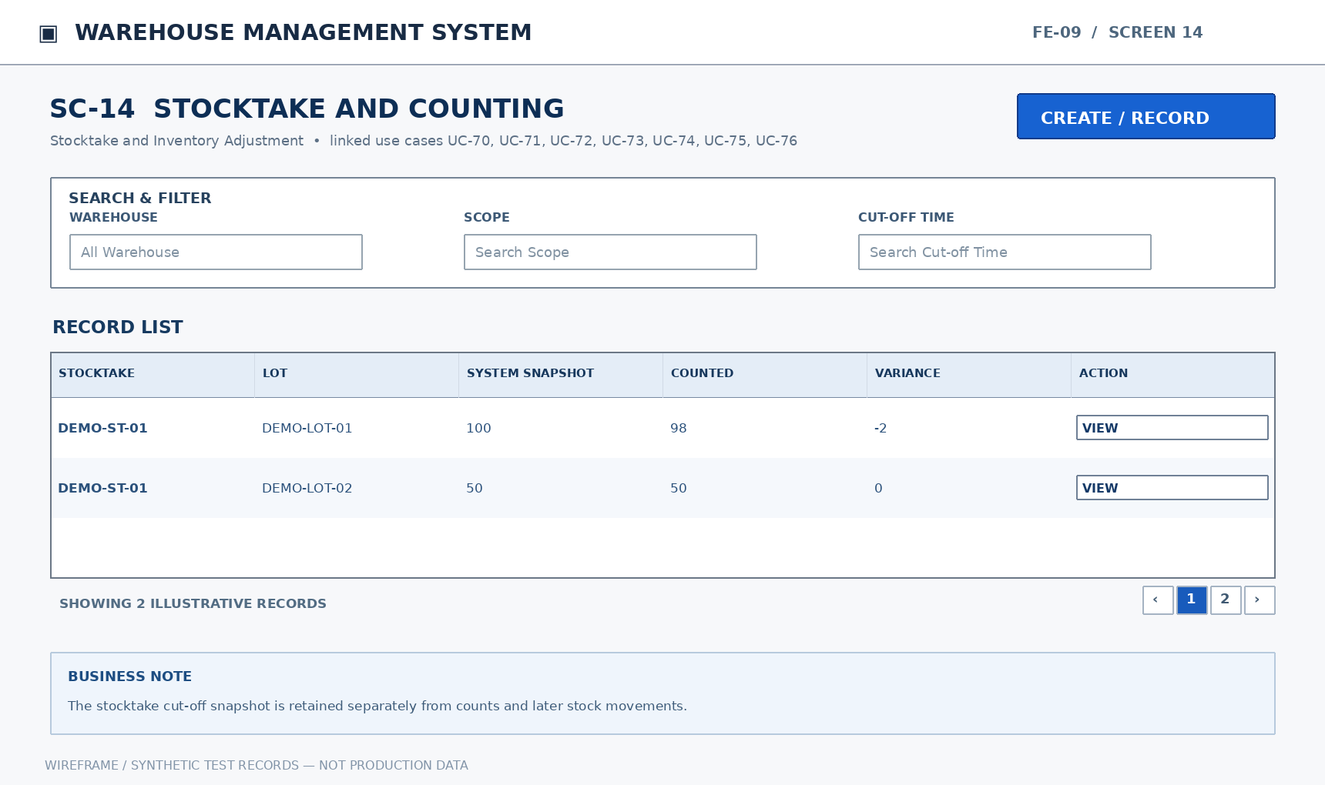
Mockup SC-14. Stocktake and Counting — illustrative functional layout
Purpose: Search stocktakes by warehouse, scope, cutoff time, and status. View included lots/locations, system snapshot, counted quantities, and variances. Plan the stocktake and create its session, covering business-flow steps 1 and 2. Freeze book quantity at count activation, perform physical counting and record results; count and recount share one UC with attempt history. Covers steps 3 and 4. Compare the finalized physical count with the frozen book quantity, investigate reasons and follow the discrepancy decision in step 5.
Linked use cases: UC-84, UC-85, UC-86, UC-87, UC-88.
UC | Authorized Actor(s) | Functional Behavior / Expected Outcome
UC-84 View stocktake list | Store Owner: View, Inventory Staff: View | Search stocktakes by warehouse, scope, cutoff time, and status.  Enforce the detailed UC permission and current record state before executing this operation.
UC-85 View stocktake details | Store Owner: View, Inventory Staff: View | View included lots/locations, system snapshot, counted quantities, and variances.  Enforce the detailed UC permission and current record state before executing this operation.
UC-86 Create Stocktake Session | Store Owner: Perform | Plan the stocktake and create its session, covering business-flow steps 1 and 2.  Enforce the detailed UC permission and current record state before executing this operation.
UC-87 Perform Stocktake Count and Record Results | Inventory Staff: Perform | Freeze book quantity at count activation, perform physical counting and record results; count and recount share one UC with attempt history. Covers steps 3 and 4.  Enforce the detailed UC permission and current record state before executing this operation.
UC-88 Reconcile Stocktake | Inventory Staff: Perform | Compare the finalized physical count with the frozen book quantity, investigate reasons and follow the discrepancy decision in step 5.  Enforce the detailed UC permission and current record state before executing this operation.

Field Description
Field Name | Description
Warehouse | ObjectId (reference). Entry: Required for stocktake. Default: No automatic default; supply or select a value.  Validation: Authorized warehouse reference; restrict the lookup to locations and operations permitted to the user.
Scope | String. Entry: Required for stocktake. Default: No automatic default; supply or select a value.  Validation: Selected stocktake scope (warehouse, applicable products/lots/locations); stored with the stocktake record.
Cut-off Time | Date (UTC). Entry: System-captured. Default: Assigned by the workflow (workflow-assigned default).  Validation: Snapshot timestamp for a stocktake; frozen balances use this precise point in time.
Lot | ObjectId (reference). Entry: Required on count line. Default: No automatic default; supply or select a value.  Validation: Existing lot record reference; lot/tone/calibre must match the selected product.
Location | ObjectId (reference). Entry: Required on count line. Default: No automatic default; supply or select a value.  Validation: Existing location reference within the chosen warehouse; must be active/eligible for a new stock posting.
System Snapshot | Decimal128. Entry: Read-only. Default: Derived from persisted data; not user-entered.  Validation: Read-only inventory quantity captured at the frozen stocktake cut-off.
Counted Quantity | Decimal128. Entry: Required for count line. Default: No automatic default; supply or select a value.  Validation: Actual physical count; zero is permitted and must be distinguished from no count submitted.
Recount Quantity | Decimal128. Entry: Optional recount. Default: unset.  Validation: Optional physical recount; retain original count and user/time rather than overwriting it.
Variance | Decimal128. Entry: System-calculated. Default: Assigned by the workflow (workflow-assigned default).  Validation: Signed difference between a physical amount and its comparison baseline; can be positive, zero or negative.
Cause | String. Entry: Required when documenting a variance. Default: No automatic default; supply or select a value.  Validation: Explain the discrepancy or damage cause; required for recorded defect/variance resolution where specified.
Count activation and movement reconciliation | Capture snapshot/cutoff once at count activation. Append attempt number, counter, UTC time and selected result for each count/recount. Preserve intervening movements; no unconditional reset or blanket transaction freeze.

9.2 Inventory Adjustment Requests

9.2.1 SC-15: Adjustment Requests and Clear Difference
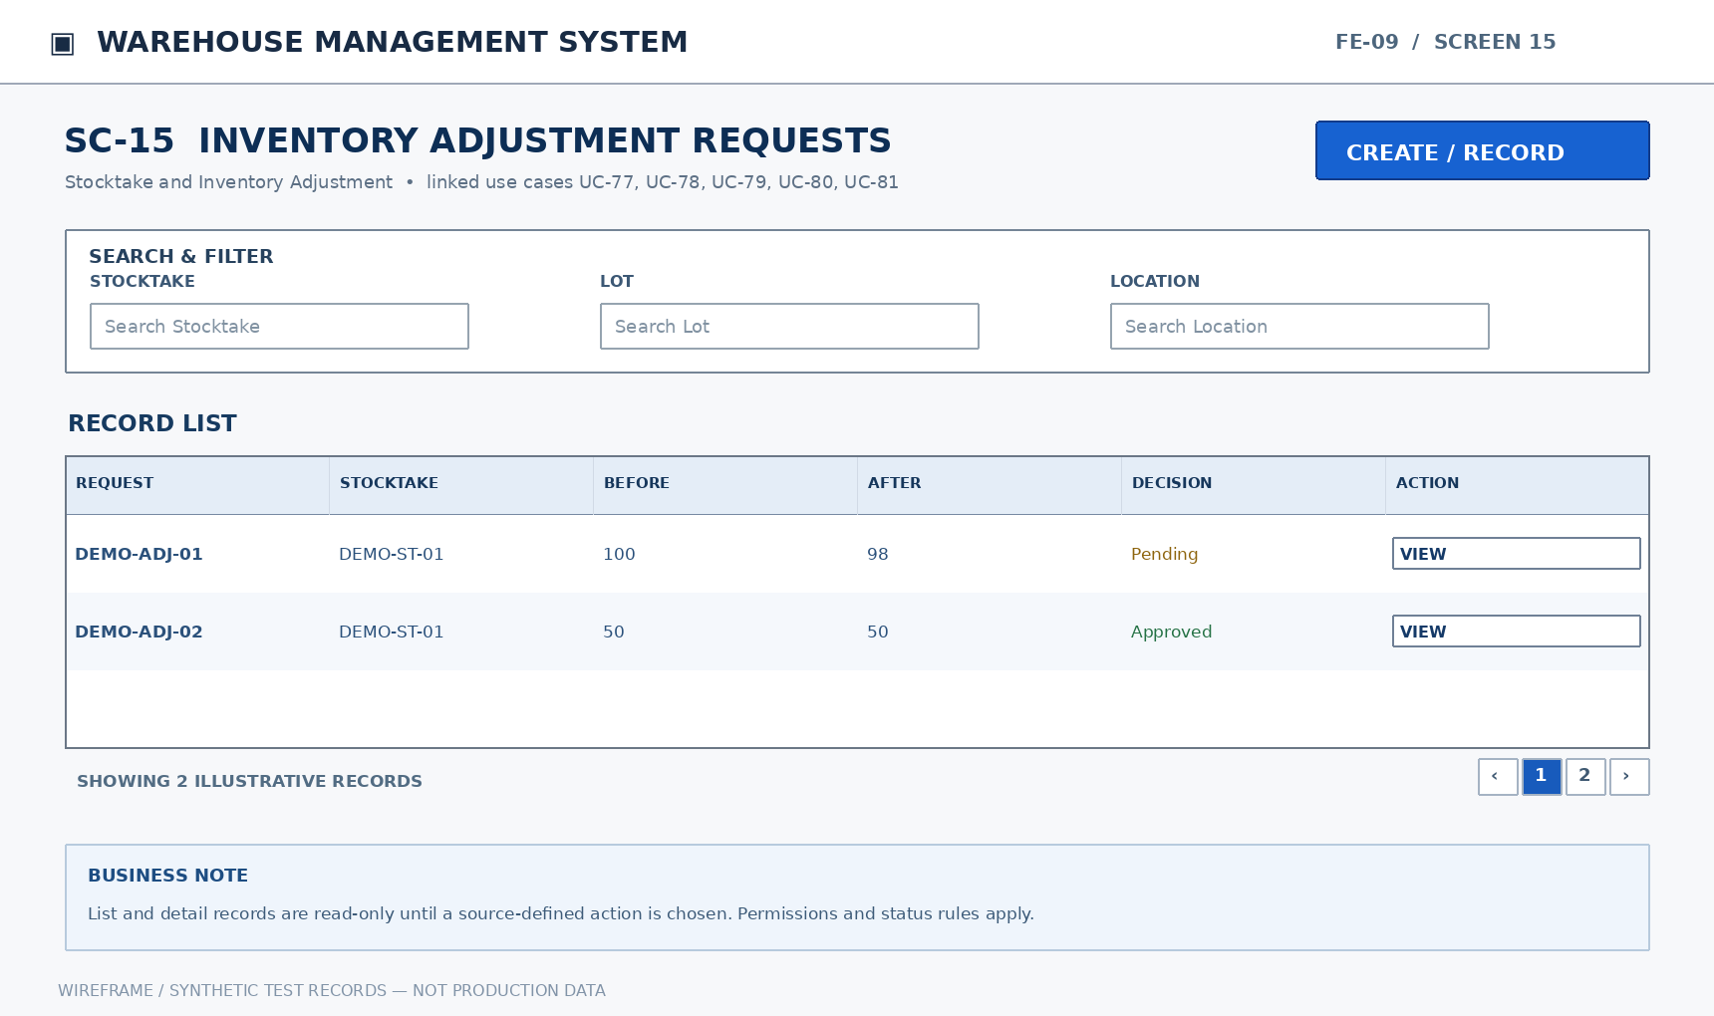
Mockup SC-15. Inventory Adjustment Requests — illustrative functional layout
Purpose: Search by stocktake, lot, location, variance reason, and approval status. Display before/after quantities, cause, creator, evidence, and approval decision. Create the step 6 request only for reconciled, nonzero stocktake differences. Review and approve the documented difference in step 7; approval does not clear stock. Execute step 8 by posting the approved difference and closing the reconciled stocktake.
Linked use cases: UC-89, UC-90, UC-91, UC-92, UC-93.
UC | Authorized Actor(s) | Functional Behavior / Expected Outcome
UC-89 View inventory adjustment request list | Store Owner: View, Inventory Staff: View | Search by stocktake, lot, location, variance reason, and approval status.  Enforce the detailed UC permission and current record state before executing this operation.
UC-90 View inventory adjustment request details | Store Owner: View, Inventory Staff: View | Display before/after quantities, cause, creator, evidence, and approval decision.  Enforce the detailed UC permission and current record state before executing this operation.
UC-91 Create Inventory Adjustment Request | Inventory Staff: Perform | Create the step 6 request only for reconciled, nonzero stocktake differences.  Enforce the detailed UC permission and current record state before executing this operation.
UC-92 Approve Inventory Adjustment | Store Owner: Approve | Review and approve the documented difference in step 7; approval does not clear stock.  Enforce the detailed UC permission and current record state before executing this operation.
UC-93 Clear Stocktake Difference | Store Owner: Perform | Execute step 8 by posting the approved difference and closing the reconciled stocktake.  Enforce the detailed UC permission and current record state before executing this operation.

Field Description
Field Name | Description
Stocktake | ObjectId (reference). Entry: Required. Default: No automatic default; supply or select a value.  Validation: Reference to an existing stocktake/snapshot; adjustments must link to a recorded stocktake.
Lot | ObjectId (reference). Entry: Required. Default: No automatic default; supply or select a value.  Validation: Existing lot record reference; lot/tone/calibre must match the selected product.
Location | ObjectId (reference). Entry: Required. Default: No automatic default; supply or select a value.  Validation: Existing location reference within the chosen warehouse; must be active/eligible for a new stock posting.
Before Quantity | Decimal128. Entry: Read-only. Default: Derived from persisted data; not user-entered.  Validation: Read-only balance prior to the relevant posted transaction; preserved in movement history.
After Quantity | Decimal128. Entry: Read-only. Default: Derived from persisted data; not user-entered.  Validation: Read-only balance after the transaction is posted; reconciled to the change amount.
Reason | String. Entry: Required. Default: No automatic default; supply or select a value.  Validation: Business justification; required on requests and variance/return actions that explicitly require a reason.
Evidence | String (storage object key). Entry: Optional. Default: unset.  Validation: Optional secure document or image reference attached to an incident/return; validate that the storage object belongs to the record.
Requested By | ObjectId (reference). Entry: System-generated. Default: Assigned by the workflow (workflow-assigned default).  Validation: Reference to the authenticated employee/account that submitted the document; system-populated.
Approved By | ObjectId (reference). Entry: System-generated on approval. Default: Assigned by the workflow (workflow-assigned default).  Validation: System-populated approver account reference when an approval decision is made.
Cleared By and Posting Reference | ObjectId and String, system-captured. Store Owner alone executes UC-93 for the approved reconciliation version. Save posting idempotency key and before/after quantities; approval in UC-92 makes no stock change.

10. Sales Orders and Goods Issue (FE-06)

10.1 Sales Orders

10.1.1 SC-16: Sales Orders
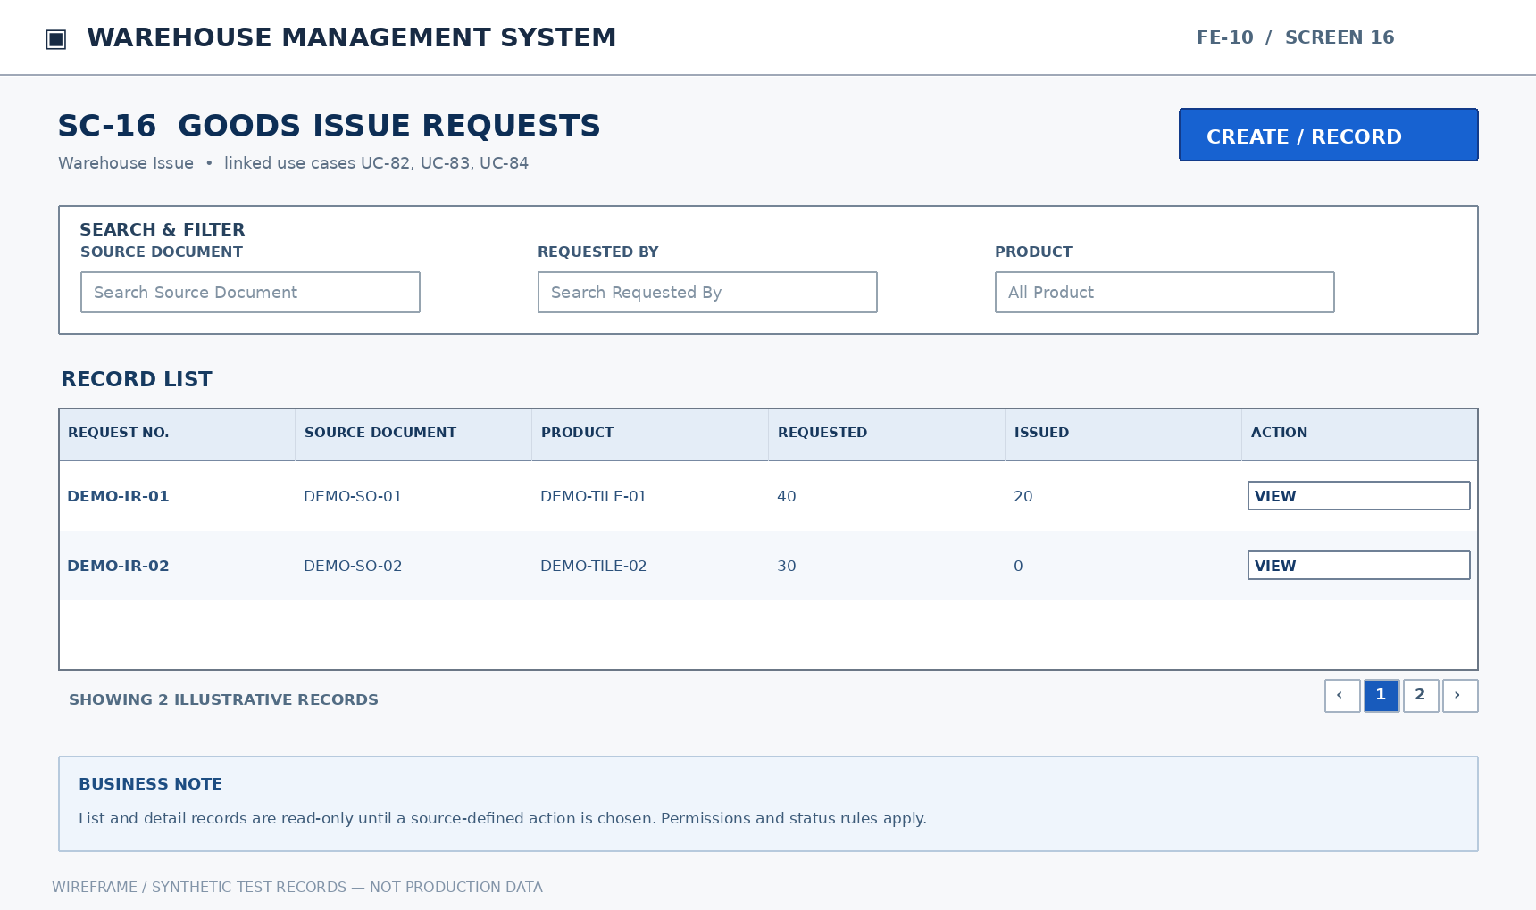
Mockup SC-16. Goods Issue Requests — illustrative functional layout
Purpose: Read-only sales order search and listing. Read-only sales order details. Create a sales order with customer, quantities and selling prices. Maintain an unfulfilled sales order or cancel its outstanding part.
Linked use cases: UC-45, UC-46, UC-47, UC-48.
UC | Authorized Actor(s) | Functional Behavior / Expected Outcome
UC-45 View Sales Order List | Store Owner: View, Sales Staff: View | Read-only sales order search and listing.  Enforce the detailed UC permission and current record state before executing this operation.
UC-46 View Sales Order Details | Store Owner: View, Sales Staff: View | Read-only sales order details.  Enforce the detailed UC permission and current record state before executing this operation.
UC-47 Create Sales Order | Sales Staff: Perform | Create a sales order with customer, quantities and selling prices.  Enforce the detailed UC permission and current record state before executing this operation.
UC-48 Update or Cancel Sales Order | Sales Staff: Perform | Maintain an unfulfilled sales order or cancel its outstanding part.  Enforce the detailed UC permission and current record state before executing this operation.

Field Description
Field Name | Description
Order Number | String. System-generated, unique; immutable after creation.
Customer | ObjectId. Required active customer; retain customer/contact snapshot for the order.
Order Lines | Embedded array. Required product, unit and positive Decimal128 quantity per line. Validate product/unit conversion and active reference.
Unit Selling Price | Decimal128. Enter the final price manually; compare to maintained reference and display applicable warning. No automatic external-margin formula is implemented.
Line and Order Amounts | Decimal128. Derive from stored quantities and entered prices using consistent rounding; no payment/debt balance is created.
Fulfilment Quantities | Decimal128, read-only. Ordered, allocated to deliveries, issued and outstanding quantities reconcile to source documents. Prevent over-allocation.
Status and Version | String and Int64, workflow-controlled. Sales Staff may update/cancel only the eligible unfulfilled portion; preserve posted delivery/issue/invoice references.
Audit | ObjectId actor and Date (UTC). Retain creation, changes, status history and notification event reference.

10.2 Goods Issue and Actual Dispatch

10.2.1 SC-17: Goods Issue
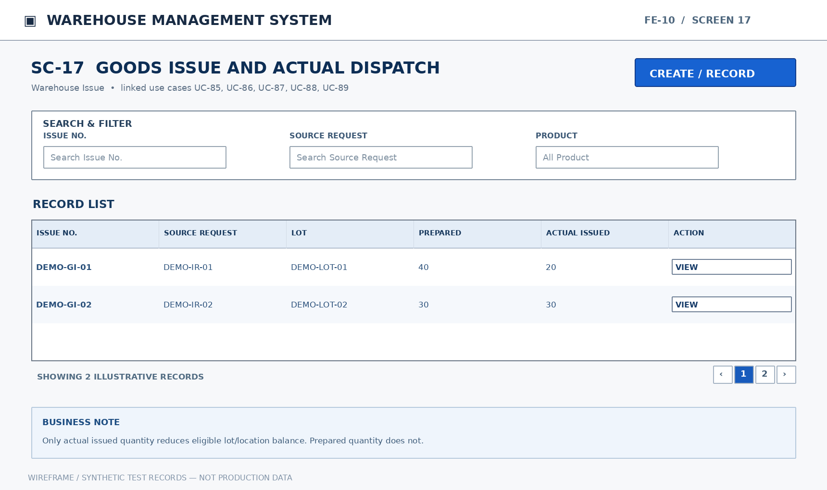
Mockup SC-17. Goods Issue and Actual Dispatch — illustrative functional layout
Linked use cases: UC-56, UC-57, UC-58.
UC | Authorized Actor(s) | Functional Behavior / Expected Outcome
UC-56 View goods issue list | Store Owner: View, Inventory Staff: View | Search by source request, issue date, and status.  Enforce the detailed UC permission and current record state before executing this operation.
UC-57 View goods issue details | Store Owner: View, Inventory Staff: View | Display lot, location, prepared quantity, and actual issued quantity by line.  Enforce the detailed UC permission and current record state before executing this operation.
UC-58 Post Goods Issue | Inventory Staff: Perform | Post actual outbound dispatch (PGI), separately from picking confirmation.  Enforce the detailed UC permission and current record state before executing this operation.

Field Description
Field Name | Description
Issue No. | String. Entry: System-generated. Default: Assigned by the workflow (workflow-assigned default).  Validation: Unique goods-issue document reference; generated per issue record.
Source Outbound Delivery | ObjectId. Required eligible Outbound Delivery reference with confirmed picking TO; retain outstanding dispatched quantities and prevent duplicate PGI.
Product | ObjectId (reference). Entry: Required. Default: No automatic default; supply or select a value.  Validation: Existing product reference; selection must respect product activation and the current workflow.
Lot | ObjectId (reference). Entry: Required. Default: No automatic default; supply or select a value.  Validation: Existing lot record reference; lot/tone/calibre must match the selected product.
Location | ObjectId (reference). Entry: Required. Default: No automatic default; supply or select a value.  Validation: Existing location reference within the chosen warehouse; must be active/eligible for a new stock posting.
Prepared Quantity | Decimal128. Entry: Optional until picking. Default: unset.  Validation: Quantity picked/prepared for issue; not a stock deduction until the actual issue is posted.
Actual Issued Quantity | Decimal128. Entry: Required at physical issue. Default: No automatic default; supply or select a value.  Validation: Quantity physically handed out; must be positive and no greater than available eligible stock.
Remaining Quantity | Decimal128. Entry: Read-only. Default: Derived from persisted data; not user-entered.  Validation: Read-only unissued quantity reconciled against requested and actual posted issue quantities.
Outbound Delivery and Confirmed Picking TO | ObjectId references, required. PGI is limited to confirmed staged quantity not already issued; source delivery and lot/bin remain traceable. Picking moves stock to staging; PGI alone deducts the warehouse total.

11. Customer and Supplier Returns (FE-07)

11.1 Customer Goods Returns

11.1.1 SC-18: Customer Returns
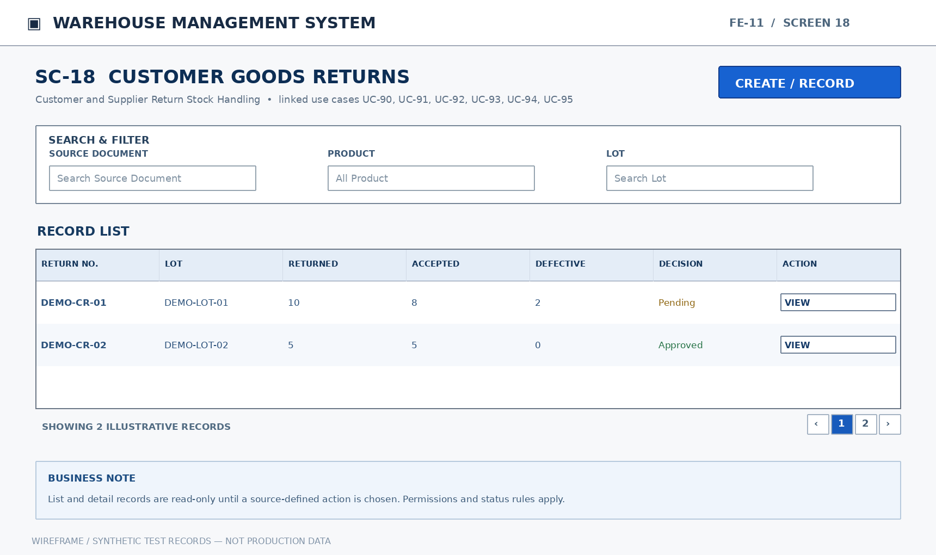
Mockup SC-18. Customer Goods Returns — illustrative functional layout
Purpose: Search returns by source, reason, and inspection status. Display lot, quantity, condition, and proposed resolution. Register a customer return linked to the original sale and actual issue. Accept or reject the request for return inspection; this is not refund approval. Receive, inspect and classify returned goods in one inspection UC. Post accepted returned quantities and complete their warehouse disposition.
Linked use cases: UC-68, UC-69, UC-70, UC-71, UC-72, UC-73.
UC | Authorized Actor(s) | Functional Behavior / Expected Outcome
UC-68 View customer return list | Store Owner: View, Accountant: View, Inventory Staff: View, Sales Staff: View | Search returns by source, reason, and inspection status.  Enforce the detailed UC permission and current record state before executing this operation.  Sales Staff may view only return cases related to its authorized sales records; neither unrestricted return records nor inspection/approval/posting rights are granted.
UC-69 View customer return details | Store Owner: View, Accountant: View, Inventory Staff: View, Sales Staff: View | Display lot, quantity, condition, and proposed resolution.  Enforce the detailed UC permission and current record state before executing this operation.  Sales Staff may view only the details and evidence of return cases related to its authorized sales records. Apply the same scope on direct requests and downloads; no return processing rights are granted.
UC-70 Create Customer Return Request | Inventory Staff: Perform | Register a customer return linked to the original sale and actual issue.  Enforce the detailed UC permission and current record state before executing this operation.
UC-71 Review Customer Return Request | Store Owner: Approve | Accept or reject the request for return inspection; this is not refund approval.  Enforce the detailed UC permission and current record state before executing this operation.
UC-72 Inspect Customer Return | Inventory Staff: Perform | Receive, inspect and classify returned goods in one inspection UC.  Enforce the detailed UC permission and current record state before executing this operation.
UC-73 Confirm Customer Return Receipt | Inventory Staff: Perform | Post accepted returned quantities and complete their warehouse disposition.  Enforce the detailed UC permission and current record state before executing this operation.

Field Description
Field Name | Description
Source Document | String. Entry: Required. Default: No automatic default; supply or select a value.  Validation: Originating business document code; no tax-invoice generation is implied by this warehouse reference.
Product | ObjectId (reference). Entry: Required. Default: No automatic default; supply or select a value.  Validation: Existing product reference; selection must respect product activation and the current workflow.
Lot | ObjectId (reference). Entry: Required. Default: No automatic default; supply or select a value.  Validation: Existing lot record reference; lot/tone/calibre must match the selected product.
Returned Quantity | Decimal128. Entry: Required. Default: No automatic default; supply or select a value.  Validation: Positive physical quantity returned by customer; held for inspection before eligible restocking.
Reason | String. Entry: Required. Default: No automatic default; supply or select a value.  Validation: Business justification; required on requests and variance/return actions that explicitly require a reason.
Condition | String. Entry: Required when inspected. Default: No automatic default; supply or select a value.  Validation: Inspection state of returned goods; recorded before proposing a disposition.
Accepted Quantity | Decimal128. Entry: Required for disposition. Default: No automatic default; supply or select a value.  Validation: Quantity accepted for reuse/restock after inspection and authorization; nonnegative.
Defective Quantity | Decimal128. Entry: Required for disposition. Default: No automatic default; supply or select a value.  Validation: Positive affected quantity when a new defective-goods case is recorded; cannot exceed eligible source quantity.
Disposition | String. Entry: Required when submitting disposal proposal. Default: No automatic default; supply or select a value.  Validation: Handling category for inspected return goods; posted only after the required approval.
Decision | String. Entry: Required on manager decision. Default: No automatic default; supply or select a value.  Validation: Approve/reject or documented workflow decision; capture authorizing user and action time.
Accepted Receipt and Refund Link | Link original Goods Issue/Sales Order and accepted inspected quantities. Refund is requested/approved/recorded separately through UC-76–UC-78 and cannot modify the issued invoice.

11.2 Supplier Return Requests

11.2.1 SC-19: Supplier Returns
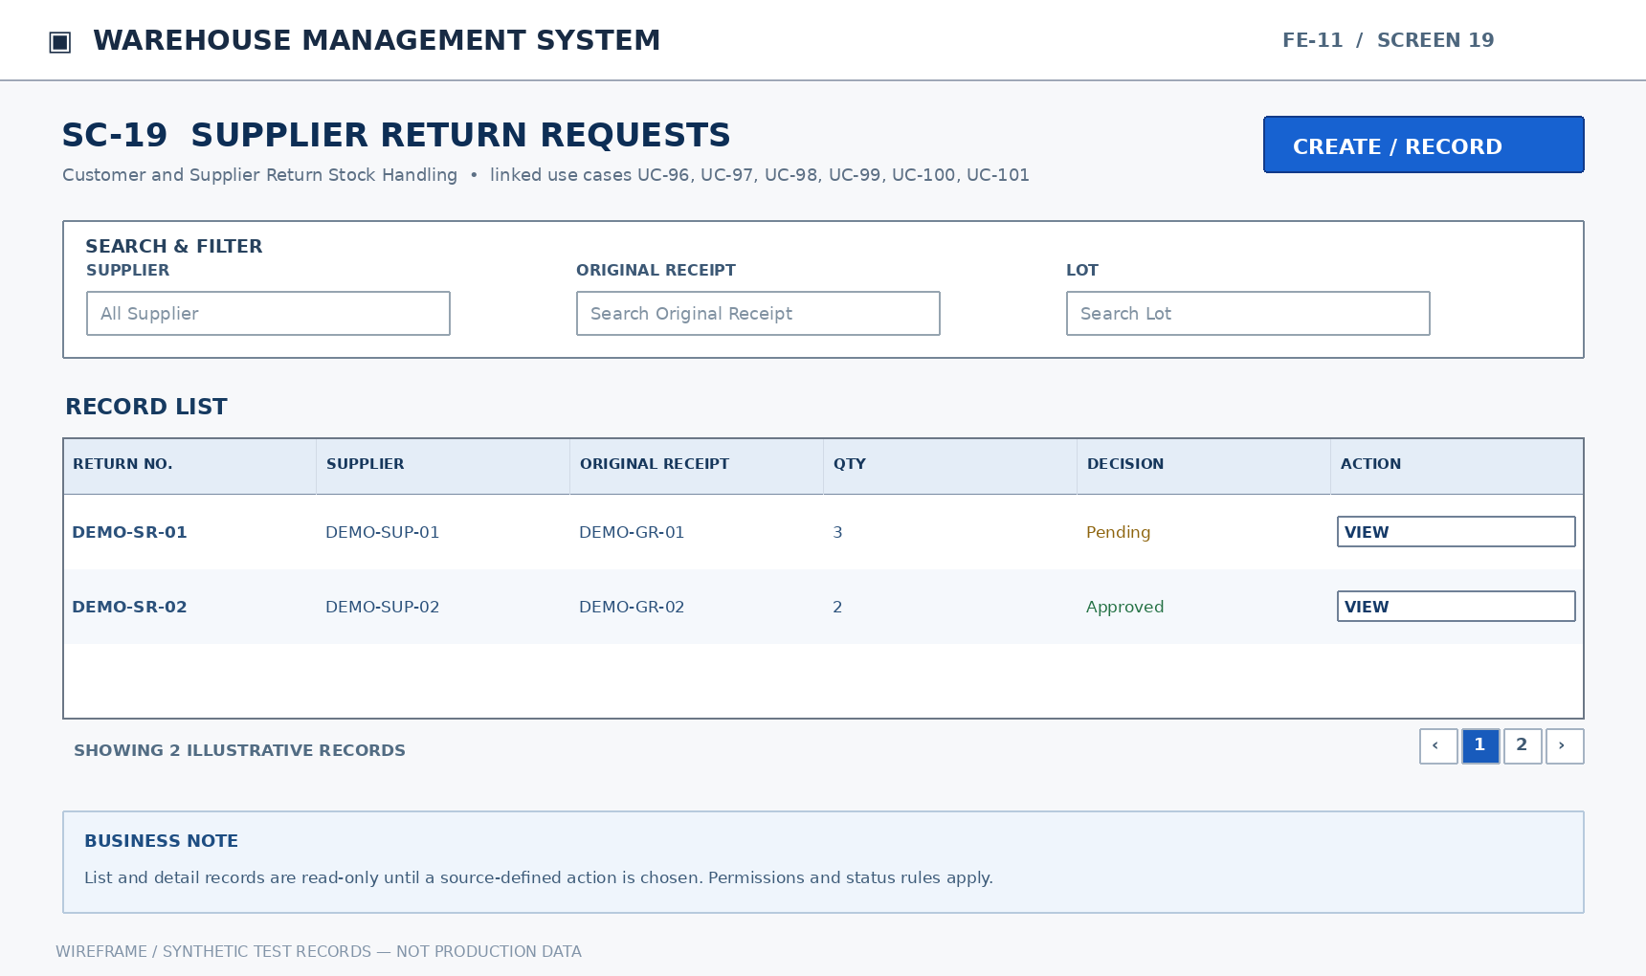
Mockup SC-19. Supplier Return Requests — illustrative functional layout
Purpose: Search by supplier, lot, reason, and approval status. Display lot, location, quantity, source receipt, evidence, and approval decision. Prepare a supplier return linked to original receipt/PO. Post actual return to supplier and record handover/acknowledgement. Review supplier acknowledgement and authorize closure.
Linked use cases: UC-79, UC-80, UC-81, UC-82, UC-83.
UC | Authorized Actor(s) | Functional Behavior / Expected Outcome
UC-79 View supplier return request list | Store Owner: View, Accountant: View, Inventory Staff: View | Search by supplier, lot, reason, and approval status.  Enforce the detailed UC permission and current record state before executing this operation.
UC-80 View supplier return request details | Store Owner: View, Accountant: View, Inventory Staff: View | Display lot, location, quantity, source receipt, evidence, and approval decision.  Enforce the detailed UC permission and current record state before executing this operation.
UC-81 Create Supplier Return Request | Inventory Staff: Perform | Prepare a supplier return linked to original receipt/PO.  Enforce the detailed UC permission and current record state before executing this operation.
UC-82 Confirm Supplier Return Dispatch | Inventory Staff: Perform | Post actual return to supplier and record handover/acknowledgement.  Enforce the detailed UC permission and current record state before executing this operation.
UC-83 Review Supplier Return Closure | Store Owner: Approve | Review supplier acknowledgement and authorize closure.  Enforce the detailed UC permission and current record state before executing this operation.

Field Description
Field Name | Description
Supplier | ObjectId (reference). Entry: Required. Default: No automatic default; supply or select a value.  Validation: Existing supplier reference; a new purchase order may use only an active supplier.
Original Receipt | ObjectId (reference). Entry: Required. Default: No automatic default; supply or select a value.  Validation: Reference to original supplier goods receipt; used to trace stock already posted or rejected.
Lot | ObjectId (reference). Entry: Required. Default: No automatic default; supply or select a value.  Validation: Existing lot record reference; lot/tone/calibre must match the selected product.
Location | ObjectId (reference). Entry: Required. Default: No automatic default; supply or select a value.  Validation: Existing location reference within the chosen warehouse; must be active/eligible for a new stock posting.
Return Quantity | Decimal128. Entry: Required. Default: No automatic default; supply or select a value.  Validation: Positive quantity proposed to return to the supplier; may not exceed eligible lot balance.
Reason | String. Entry: Required. Default: No automatic default; supply or select a value.  Validation: Business justification; required on requests and variance/return actions that explicitly require a reason.
Evidence | String (storage object key). Entry: Optional. Default: unset.  Validation: Optional secure document or image reference attached to an incident/return; validate that the storage object belongs to the record.
Quarantine Status | String. Entry: System-controlled. Default: Assigned by the workflow (workflow-assigned default).  Validation: Status of supplier-return segregation; quarantined quantities excluded from usable stock.
Decision | String. Entry: Required when deciding. Default: No automatic default; supply or select a value.  Validation: Approve/reject or documented workflow decision; capture authorizing user and action time.
Actual Dispatched Quantity | Decimal128. Entry: Required at dispatch. Default: No automatic default; supply or select a value.  Validation: Quantity actually sent to supplier after approval; may not exceed approved eligible quantity.
Supplier Acceptance and Closure | Store external acceptance, actual dispatch, acknowledgement, discrepancies and Owner closure. Prevent a second deduction of rejected goods that were never posted into inventory.

12. Operational Reports (FE-09)

12.1 Inventory Reports

12.1.1 SC-20: Operational Reports
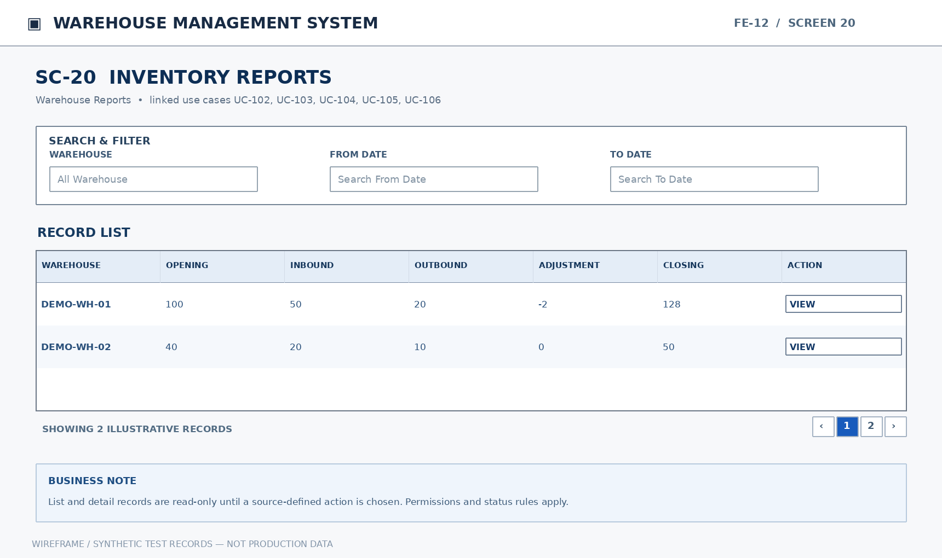
Mockup SC-20. Inventory Reports — illustrative functional layout
Purpose: Run authorized inventory, purchase/receipt, transfer and stocktake reports from one reporting workspace.
Linked use cases: UC-99.
UC | Authorized Actor(s) | Functional Behavior / Expected Outcome
UC-99 View Operational Reports | Store Owner: All report groups, Accountant: Movement; purchase/receipt, Inventory Staff: Movement; stock; transfer; stocktake | Run authorized inventory, purchase/receipt, transfer and stocktake reports from one reporting workspace.  Store Owner may view all five report groups. Accountant may view stock movement summaries and purchase/receipt reports only. Inventory Staff may view stock movement summaries, stock by lot/location, transfers and stocktake reports only, limited to assigned warehouses. Report selection, filters, detail links and exports enforce the same scope.

Field Description
Field Name | Description
Warehouse | ObjectId (reference). Entry: Optional filter. Default: unset (blank filter is ignored).  Validation: Authorized warehouse reference; restrict the lookup to locations and operations permitted to the user. Historical/inactive master records remain searchable where linked to authorized posted transactions.
From Date | DATE. Entry: Optional filter. Default: unset (blank filter is ignored).  Validation: Optional reporting period start; cannot be later than the end date if both provided.
To Date | DATE. Entry: Optional filter. Default: unset (blank filter is ignored).  Validation: Optional reporting period end; cannot be earlier than start date if both provided.
Product | ObjectId (reference). Entry: Optional filter. Default: unset (blank filter is ignored).  Validation: Existing product reference; selection must respect product activation and the current workflow. Historical/inactive master records remain searchable where linked to authorized posted transactions.
Lot | ObjectId (reference). Entry: Optional filter. Default: unset (blank filter is ignored).  Validation: Existing lot record reference; lot/tone/calibre must match the selected product. Historical/inactive master records remain searchable where linked to authorized posted transactions.
Location | ObjectId (reference). Entry: Optional filter. Default: unset (blank filter is ignored).  Validation: Existing location reference within the chosen warehouse; must be active/eligible for a new stock posting. Historical/inactive master records remain searchable where linked to authorized posted transactions.
Inbound | Decimal128. Entry: Read-only calculated. Default: Derived from persisted data; not user-entered.  Validation: Read-only sum of received/inbound posted movements for the reporting scope.
Outbound | Decimal128. Entry: Read-only calculated. Default: Derived from persisted data; not user-entered.  Validation: Read-only sum of issued/outbound posted movements for the reporting scope.
Opening Balance | Decimal128. Entry: Read-only calculated. Default: Derived from persisted data; not user-entered.  Validation: Read-only stock balance at the start of the selected reporting period.
Closing Balance | Decimal128. Entry: Read-only calculated. Default: Derived from persisted data; not user-entered.  Validation: Read-only balance at period end, reconciled with inbound/outbound/adjustment movements.
Variance | Decimal128. Entry: Read-only calculated. Default: Derived from persisted data; not user-entered.  Validation: Signed difference between a physical amount and its comparison baseline; can be positive, zero or negative.
Report Group Authorization | Store Owner may view all five report groups. Accountant may view stock movement summaries and purchase/receipt reports only. Inventory Staff may view stock movement summaries, stock by lot/location, transfers and stocktake reports only, limited to assigned warehouses. Report selection, filters, detail links and exports enforce the same scope.

13. Inventory Audit Trail (FE-09)

13.1 Stock Movement Log and Lot Trace

13.1.1 SC-21: Stock Movement and Lot Trace
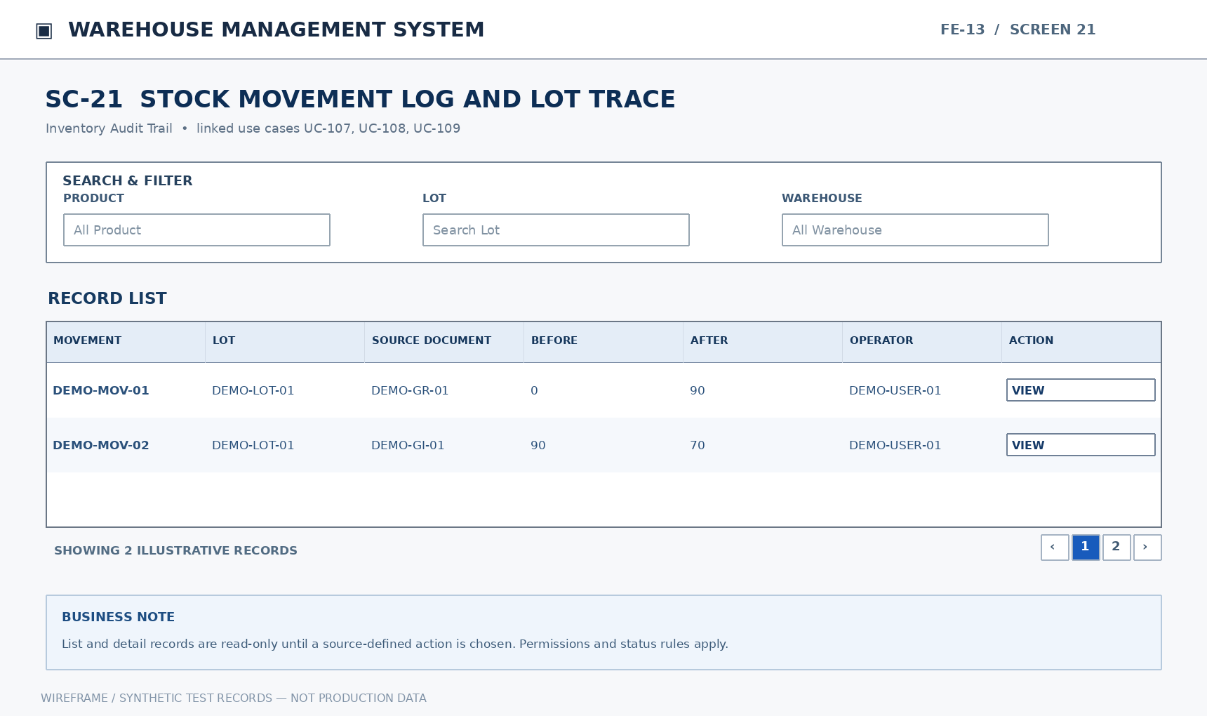
Mockup SC-21. Stock Movement Log and Lot Trace — illustrative functional layout
Purpose: Filter movements by product, lot, location, transaction type, and time. Display source document, before/after quantity, operator, time, and reason. Link a lot's receipts, movements, issues, returns, and inventory adjustments.
Linked use cases: UC-100, UC-101, UC-102.
UC | Authorized Actor(s) | Functional Behavior / Expected Outcome
UC-100 View stock movement log | Store Owner: View, Accountant: Purchase / supplier scope, Inventory Staff: View | Filter movements by product, lot, location, transaction type, and time.  Accountant may view purchasing/supplier-related stock movements only. Inventory Staff is limited to assigned warehouses. Store Owner has business audit access. List access grants no posting or correction permission.
UC-101 View stock movement details | Store Owner: View, Accountant: Purchase / supplier scope, Inventory Staff: View | Display source document, before/after quantity, operator, time, and reason.  Accountant may view purchasing/supplier-related movement details only; direct URLs and evidence access enforce the same scope as the list. Inventory Staff is limited to assigned warehouses. No actor may edit posted movement history here.
UC-102 Trace a product lot through source documents | Store Owner: View, Accountant: Purchase / supplier scope, Inventory Staff: View | Link a lot's receipts, movements, issues, returns, and inventory adjustments.  Accountant may trace purchasing/supplier-related history only. Inventory Staff is limited to assigned warehouses. Trace results and exports must not reveal otherwise unauthorized downstream records.

Field Description
Field Name | Description
Product | ObjectId (reference). Entry: Optional filter. Default: unset (blank filter is ignored).  Validation: Existing product reference; selection must respect product activation and the current workflow. Historical/inactive master records remain searchable where linked to authorized posted transactions.
Lot | ObjectId (reference). Entry: Optional filter. Default: unset (blank filter is ignored).  Validation: Existing lot record reference; lot/tone/calibre must match the selected product. Historical/inactive master records remain searchable where linked to authorized posted transactions.
Warehouse | ObjectId (reference). Entry: Optional filter. Default: unset (blank filter is ignored).  Validation: Authorized warehouse reference; restrict the lookup to locations and operations permitted to the user. Historical/inactive master records remain searchable where linked to authorized posted transactions.
Location | ObjectId (reference). Entry: Optional filter. Default: unset (blank filter is ignored).  Validation: Existing location reference within the chosen warehouse; must be active/eligible for a new stock posting. Historical/inactive master records remain searchable where linked to authorized posted transactions.
Transaction Type | String. Entry: Optional filter. Default: unset (blank filter is ignored).  Validation: Recorded movement classification used for audit filters; selected from logged transaction types.
Source Document | String. Entry: Optional filter. Default: unset (blank filter is ignored).  Validation: Originating business document code; no tax-invoice generation is implied by this warehouse reference.
Before Quantity | Decimal128. Entry: Read-only audit field. Default: Derived from persisted data; not user-entered.  Validation: Read-only balance prior to the relevant posted transaction; preserved in movement history.
After Quantity | Decimal128. Entry: Read-only audit field. Default: Derived from persisted data; not user-entered.  Validation: Read-only balance after the transaction is posted; reconciled to the change amount.
Operator | ObjectId (reference). Entry: Read-only audit field. Default: Derived from persisted data; not user-entered.  Validation: Read-only reference to the staff account that posted the movement.
Transaction Time | Date (UTC). Entry: Read-only audit field. Default: Derived from persisted data; not user-entered.  Validation: Read-only database timestamp of the recorded stock/audit event.
Trace and Evidence Scope | Accountant may trace purchasing/supplier-related history only. Inventory Staff is limited to assigned warehouses. Trace results and exports must not reveal otherwise unauthorized downstream records.

14. Outbound Deliveries

14.1 SC-22: Outbound Deliveries
UC | Authorized Actor(s) | Functional Behavior / Expected Outcome
UC-49 View Outbound Delivery List | Store Owner: View, Inventory Staff: View, Sales Staff: View | Read-only outbound delivery search and listing.
UC-50 View Outbound Delivery Details | Store Owner: View, Inventory Staff: View, Sales Staff: View | Read-only outbound delivery details.
UC-51 Create Outbound Delivery | Sales Staff: Perform | Create a delivery from outstanding Sales Order quantities.

Field Name | Description
Delivery Number | String; unique and generated.
Sales Order | ObjectId; required, eligible order. Customer and fulfilment information derive from the order.
Warehouse | ObjectId; required active fulfilment warehouse.
Delivery Lines | Product/order-line references and positive Decimal128 quantities; cannot exceed outstanding order quantity after other active deliveries.
Picked and Issued Quantities | Read-only Decimal128 totals from TO confirmations and PGIs. Preserve partial fulfilment history.
Status and Audit | Workflow-controlled status, version, creator and UTC timestamps; no stock deduction on creation.

15. Picking Transfer Orders

15.1 SC-23: Picking Transfer Orders
UC | Authorized Actor(s) | Functional Behavior / Expected Outcome
UC-52 View Picking Transfer Order List | Store Owner: View, Inventory Staff: View | Read-only picking transfer order search and listing.
UC-53 View Picking Transfer Order Details | Store Owner: View, Inventory Staff: View | Read-only picking transfer order details.
UC-54 Create Picking Transfer Order | Inventory Staff: Perform | Create a warehouse picking TO from an outbound delivery.
UC-55 Confirm Picking Transfer Order | Inventory Staff: Perform | Confirm actual picking into the staging location.

Field Name | Description
Picking TO Number | String; unique and generated.
Outbound Delivery | ObjectId; required delivery with outstanding quantity.
Source and Destination | ObjectId warehouse/bin/lot references. Source must have usable stock; destination is eligible staging.
Requested and Confirmed Quantity | Positive Decimal128 in the selected product unit; confirmation cannot exceed eligible allocated stock. Preserve actual quantity and differences.
Confirmation Evidence | Actor, UTC time and optional secure evidence reference, bound to this TO.
Posting Reference | Unique idempotency reference. Move source stock to staging once; do not deduct total warehouse stock before PGI.

16. Customers

16.1 SC-24: Customers
UC | Authorized Actor(s) | Functional Behavior / Expected Outcome
UC-20 View Customer List | Store Owner: View, Accountant: View, Sales Staff: View | Read-only customer search and listing.
UC-21 View Customer Details | Store Owner: View, Accountant: View, Sales Staff: View | Read-only customer details.
UC-22 Maintain Customer | Sales Staff: Perform | Create or update basic customer reference information.

Field Name | Description
Customer Code and Name | String. Unique code and required display name.
Contact Details | String phone, email and address as applicable; validate format when provided. Access limited to authorized business use.
Invoice Reference Details | Optional customer billing reference/name/address; snapshot at invoice issue rather than changing historical invoices.
Audit | Sales Staff create/update actor and UTC timestamps. No customer portal, loyalty, debt or full CRM module.

17. Selling Prices

17.1 SC-25: Selling Prices
UC | Authorized Actor(s) | Functional Behavior / Expected Outcome
UC-23 View Selling Price List | Store Owner: View, Accountant: View, Sales Staff: View | Read-only selling price search and listing.
UC-24 View Selling Price Details | Store Owner: View, Accountant: View, Sales Staff: View | Read-only selling price details.
UC-25 Maintain Selling Price | Store Owner: Perform | Maintain manually entered sale prices and optional externally calculated margin information.

Field Name | Description
Product and Unit | ObjectId product and valid packaging/unit reference; required.
Final Selling Price | Decimal128, required nonnegative entered amount. Do not derive it from an invented margin formula.
External Margin Reference | Optional Decimal128/text metadata for margin calculated outside WMSD; it is not a configurable pricing policy.
Effective Period and History | Date (UTC) effective start/end with valid chronology. Preserve prior prices and issued document snapshots.
Reference Price Warning | Show warning against maintained reference data during price entry; no arbitrary policy editor or unapproved hard threshold.
Maintained By | Store Owner; capture actor and UTC timestamps.

18. Internal Invoices

18.1 SC-26: Internal Invoices
UC | Authorized Actor(s) | Functional Behavior / Expected Outcome
UC-59 View Internal Invoice List | Store Owner: View, Accountant: View | Read-only internal invoice search and listing.
UC-60 View Internal Invoice Details | Store Owner: View, Accountant: View | Read-only internal invoice details.
UC-61 Create Internal Invoice | Accountant: Perform | Prepare an internal invoice from posted goods issue and the Sales Order.
UC-62 Issue Internal Invoice and Produce PDF | Accountant: Issue / Export / Print; Store Owner: Export / Print issued only | Issue the internal invoice and provide its PDF/print output.  Accountant may issue an eligible draft internal invoice and generate/export/print its PDF. Store Owner may export/print an already issued invoice only; it cannot create or issue an invoice. Permission checks are performed per requested sub-operation.

Field Name | Description
Source Goods Issue | ObjectId and source-line references; required posted, unbilled quantities only. Prevent duplicate billing across invoices.
Invoice Number and Status | Unique String assigned at issue; draft/issued workflow. Only Accountant creates/issues.
Customer and Line Snapshot | Immutable issued customer, product, quantity, unit price and amount values; preserve original source references.
Amounts | Decimal128 calculated from eligible quantities and prices. No sales-payment, deposit, receivable or debt fields.
PDF and Print Reference | Authenticated stored output from the issued snapshot. Owner/Accountant may view/export the issued representation.
Issued Audit and SMTP Event | Actor, Date (UTC) and deduplicated event reference. Failed email does not undo issue. No statutory e-invoice transmission.

19. Refund Requests

19.1 SC-27: Refund Requests
UC | Authorized Actor(s) | Functional Behavior / Expected Outcome
UC-74 View Refund Request List | Store Owner: View, Accountant: View | Read-only refund request search and listing.
UC-75 View Refund Request Details | Store Owner: View, Accountant: View | Read-only refund request details.
UC-76 Create Customer Return Refund Request | Accountant: Perform | Request an externally executed refund for an accepted customer return.
UC-77 Review Customer Return Refund Request | Store Owner: Approve | Approve or reject the proposed refund.
UC-78 Record Refund Completion | Accountant: Perform | Record evidence that the approved refund was paid outside the application.

Field Name | Description
Accepted Customer Return | ObjectId; required accepted receipt and original sale/invoice references.
Original External Payment Evidence | Secure evidence reference and supported amount; required to establish refund eligibility without implementing sales collection.
Refund Amounts | Decimal128 eligible/requested/approved/completed values. Requested amount must not exceed supported accepted-return value less prior or pending refunds.
Approval | Store Owner decision, approved version/amount, reason and Date (UTC). Accountant may request but may not approve.
External Completion Evidence | Required external transaction/evidence reference, completion amount/date and Accountant actor. Record only after approval; never execute a bank payment.
Status and Duplicate Protection | Workflow-controlled status/version and completion key; reject duplicate or excess refund completion. Preserve original issued invoice.

20. Background Job Inventory

20.1 Process Status Email Events
JOB-01 processes deduplicated order/invoice status email events after the business transaction commits. SMTP failures are recorded and retried without rolling back or repeating the business operation.
Trigger | Purpose | Processing Steps | Failure Behavior
Committed order/invoice status event | Send configured status notification | Create deduplicated event after commit; deliver through SMTP; record sent/failed result and retry attempts. | Keep the saved business document; retry within bounded deployment settings without duplicate successful delivery.

21. External API Inventory

21.1 SMTP Service
API-01 is the deployment-configured authenticated SMTP service for order and internal-invoice status messages. Credentials remain server-side. Payment gateways, banking execution, statutory e-invoice transmission and live MISA integration are excluded.
URL | Purpose | Caller | Auth
Deployment-configured SMTP endpoint | Order and invoice status email | Server-side notification worker | Deployment-configured secure SMTP authentication; never expose credentials in the client.

IV. Non-Functional Requirements

1. External Interfaces
Interface | Requirement | Acceptance / Verification
Web user interface | Responsive role-scoped screens with separate list, detail and processing actions. | Verify linked UCs and denied operations for every role.
MongoDB | Use real MongoDB with ObjectId references, UTC Date, Boolean and Decimal128 as applicable. | No relational-database type or dependency remains.
SMTP | Send configured order/invoice status events after commit. | Mail failure leaves the business transaction intact and creates a retryable failure record.
PDF/Print | Generate internal invoice output from the immutable issued snapshot. | Output values equal the issued invoice; no statutory tax transmission is implied.

2. Quality Attributes

2.1 Usability
Requirement | Specification | Verification
Screen consistency | Lists consistently show search, filters and results; details consistently display document references and transaction history. | Compare interactions across SC-02–SC-21.
Quality status clarity | Defective/pending goods must not appear as usable stock; ordered, confirmed, dispatched, handed-over and received quantities must have distinct headings. | Test UC-06, UC-30, UC-39 and UC-43.
Validation feedback | Unauthorized, invalid-state and excess-stock operations show a clear actionable message without committing a partial change. | Exercise the alternative paths in Part II and system messages in Appendix.
Data entry accuracy | Choose active master data rather than free-entering unrelated codes; display conversion assumptions for each product. | Test UC-13, UC-26, UC-87 and UC-55.

2.2 Performance
No source file provides a signed-off response-time SLA, simultaneous-user count, maximum inventory volume or availability percentage. Accordingly, this version specifies verifiable behavior while leaving numeric limits open for customer confirmation.
Requirement | Target / Behavior | Condition / Verification
List and filter behavior | Return correctly scoped results, report empty matches and prevent duplicate posting from repeated actions. | Test on representative customer-approved data sets when available.
Transaction consistency | Goods receipt, movement, issue, return and adjustment operations must not produce partially committed balances. | Reconcile UC-26, UC-37, UC-43, UC-43, UC-93, UC-58, UC-82 with movement records.
Report reconciliation | Closing quantity equals opening quantity plus applicable inbound, outbound and adjustment movements within the same reporting scope. | Cross-check UC-99 against stock movements UC-100.
Capacity and SLA | Numerical targets are not specified in supplied requirements. | Confirm measurable values during acceptance criteria review.

2.3 Security
Requirement | Description | Verification
Authentication | Only active authenticated accounts can access internal operations. | Test UC-94, UC-97 and UC-98.
Role-based authorization | Each data read and state change checks the assigned role/UC permission, not merely whether a UI button is visible. | Attempt direct requests for actions marked No in the permission matrix.
Credential protection | Credentials are not stored or logged in directly readable form. | Check stored data and event logs for plaintext passwords.
Audit integrity | Every change to stock records source document, operator, timestamp and original/resulting quantity. | Trace UC-100, UC-101, UC-102 back to affected documents.
Evidence access | Only roles assigned to the relevant business record may access discrepancy/defect evidence. | Test UC-26, UC-26, UC-66, UC-43, UC-43, UC-81 under allowed and denied roles.
Approval protection | Pending or rejected proposals cannot trigger an unauthorized quantity adjustment. | Test UC-65, UC-66, UC-91–81,95,100.

2.4 Reliability and Data Integrity
MongoDB is the persistence technology. Stock/document postings require atomic and idempotent outcomes and concurrency checks. Picking confirmation, PGI, receipt, transfer, refund recording and Clear Difference must not repeat their business effect when retried. Preserve posted movement and invoice snapshots.

2.5 Maintainability and Traceability
Each active UC maps to one of nine features, its screen, permission row and specification. Enforce permissions at operation and record/warehouse scope. Fixed business rules are implemented through the defined workflows; users do not create or edit arbitrary policies.

V. Requirement Appendix

1. Business Rules
GBR-ID | Rule Statement | Applies To | Rationale | Enforced By
GB-01 | Only a role explicitly authorized for a UC may read or perform its corresponding operation. | All UCs | Segregates responsibilities and protects transactions. | Enforce permissions on every request.
GB-02 | Inactive accounts, products, suppliers and locations cannot be used in new operations; history is preserved. | UC-97, UC-13, UC-19, UC-29 | Historical transactions remain explainable. | Validate master-record state when creating documents.
GB-03 | Convert boxes/pieces/square meters using the selected product configuration. | UC-13, UC-26, UC-87, UC-58 | Prevents conversion errors across tile products. | Use and verify the product-specific conversion factors.
GB-04 | Only inspected accepted quantities may increase usable inventory. | UC-26, UC-26, UC-26, UC-26, UC-65–50,92–95 | Prevents issue of pending or defective goods. | Reconcile accepted quality quantities before posting.
GB-05 | Partially received purchase orders can change only quantities not yet received. | UC-07, UC-07, UC-06 | Preserves source receipt history. | Check already posted receipt quantity.
GB-06 | Intra-warehouse location movement does not change total warehouse balance. | UC-36, UC-37 | Preserves inventory totals. | Post equal and opposite changes across locations.
GB-07 | Warehouse transfers distinguish dispatch, handover and receipt; variances require approved resolution. | UC-40, UC-43, UC-43, UC-43, UC-43, UC-43, UC-44 | Keeps in-transit stock accountable. | Reconcile three checkpoints and evidence.
GB-08 | Stocktake uses an immutable balance snapshot and records subsequent movements separately. | UC-86, UC-87, UC-87, UC-87, UC-88 | Prevents incorrect variance calculations. | Retain stocktake cut-off timestamp and original values.
GB-09 | An inventory adjustment requires approval and can be posted at most once. | UC-91, UC-92, UC-93 | Prevents unauthorized or duplicate stock changes. | Check approval and posted flag on each attempt.
GB-10 | Goods issue deducts only actual issued stock by lot and location. | UC-54, UC-55, UC-58 | Prevents incorrect or negative inventory. | Validate usable quantity before posting.
GB-11 | Customer returns require Store Owner review for inspection, Inventory Staff inspection/classification and separate accepted-receipt confirmation before eligible usable stock is released. | UC-70, UC-72, UC-72, UC-71 | Protects goods quality control. | Validate request review, inspection results, accepted quantity and quality status before receipt posting.
GB-12 | Goods rejected at original receipt cannot be deducted again when returned to supplier. | UC-26, UC-26, UC-82 | Prevents double deduction. | Reconcile original receipt inventory impact.
GB-13 | Every stock movement must link source document, user, time and before/after quantities. | UC-100, UC-101, UC-102 | Enables audit and lot traceability. | Store immutable posting metadata.
GB-NEW-01 | Only explicitly authorized operations are allowed; list/detail rights never grant write rights. | All UCs | Protect records and segregate duties. | Server authorization
GB-NEW-02 | Inventory Staff is restricted to assigned warehouses; Sales Staff stock view excludes cost and unrestricted quarantine data. | FE-04 to FE-08 | Limit operational scope. | Query and command authorization
GB-NEW-03 | Picking TO confirmation and PGI are different postings; stock is deducted from warehouse total only at PGI. | FE-06 | Prevent double deduction. | Posting service
GB-NEW-04 | An issued internal invoice is immutable and is not a statutory tax e-invoice or payment record. | FE-06 | Keep scope and evidence clear. | Invoice service
GB-NEW-05 | Refund completion records an externally executed payment and cannot exceed accepted return eligibility. | FE-07 | Prevent duplicate or excess refunds. | Refund service
GB-NEW-06 | Store Owner approves and clears a stocktake difference; Inventory Staff counts, reconciles and requests adjustment. | FE-08 | Match the approved Page 3 flow. | Stocktake service
GB-NEW-07 | The book snapshot is immutable; recounts append attempts and preserve prior results. | FE-08 | Support auditable reconciliation. | Stocktake service
GB-AUTH | Store Owner may create and update lot reference information. Inventory Staff may create a lot only; it may not update an existing lot or change its master status. Stock quality changes must use the authorized inspection or disposition workflow. Posted lot references and movement history cannot be overwritten.; Accountant may create and update supplier identity/contact information, but cannot activate or deactivate a supplier. Store Owner may activate or deactivate an existing supplier, but does not acquire create/update rights through this merged UC. Historical references are retained; inactive suppliers cannot be selected for new purchase documents.; Store Owner may view all five report groups. Accountant may view stock movement summaries and purchase/receipt reports only. Inventory Staff may view stock movement summaries, stock by lot/location, transfers and stocktake reports only, limited to assigned warehouses. Report selection, filters, detail links and exports enforce the same scope. | UC-16, UC-19, UC-99 | Merging UCs must not broaden role permissions. | Server-side operation and data-scope checks
GB-POLICY | General-purpose creation/editing of business policies is outside scope. Fixed validation, approval and authorization rules are implemented by the defined UCs. | All features | Preserve the agreed scope. | No policy-management screen or UC

2. System Messages
# | Message Code | Type | Context | Content
1 | MSG-01 | Information | Empty result | No records match the current filters.
2 | MSG-02 | Validation | Required input | Complete the highlighted required fields.
3 | MSG-03 | Validation | Quantity | The quantity is invalid or exceeds the eligible balance.
4 | MSG-04 | Authorization | Permission | You are not authorized for this operation or warehouse.
5 | MSG-05 | Conflict | Concurrent update | The record changed. Refresh and review the current version.
6 | MSG-06 | Posting | Duplicate request | This operation has already been completed; no duplicate posting was made.
7 | MSG-07 | Notification | SMTP failure | The business document was saved, but its email notification failed and is available for retry.

3. Other Requirements
General-purpose policy creation/editing is outside scope. The application implements only the specified fixed validations, workflow decisions and five-role operation permissions. Maintaining selling-price reference data or assigning existing permissions does not introduce a policy-management module. Sales payment collection, deposits, receivables, full accounting and statutory e-invoice transmission are excluded; accepted-return refunds are approved and recorded as externally completed transactions.

