**LAB3**

**I. Write SQL statements to create database “ProductOrders” as following:**

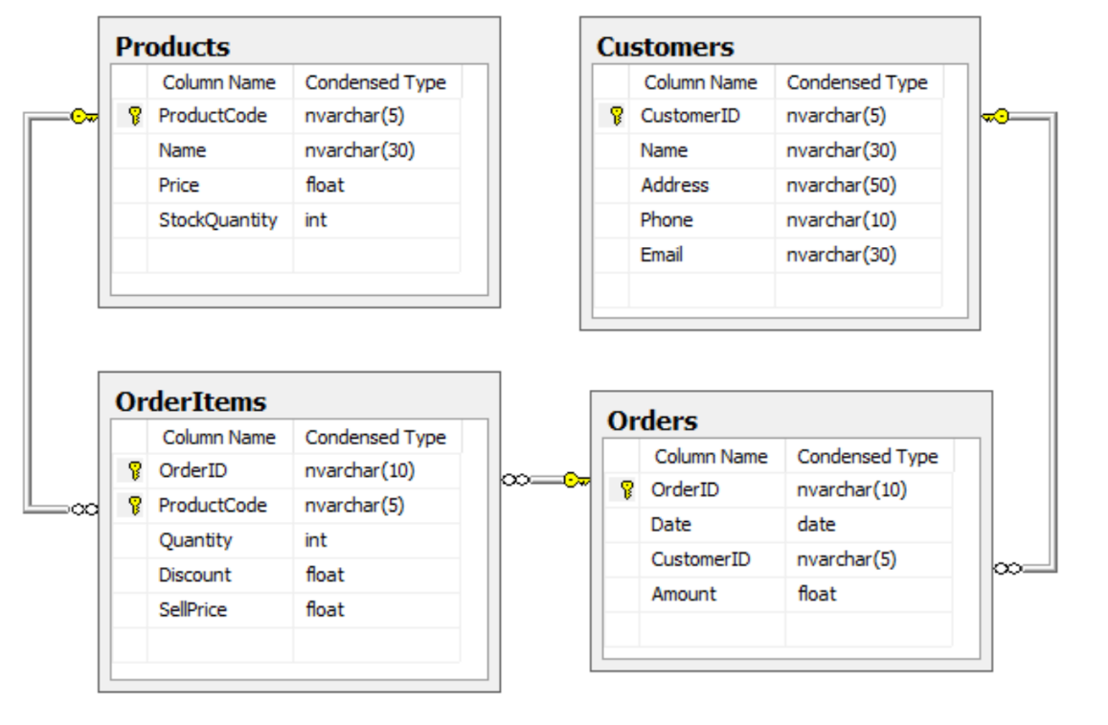

1. **Table: Customers**

**Name Type Size**

CustomerID Nvarchar 5

Name Nvarchar 30

Address Nvarchar 50

Phone Nvarchar 10

Email Nvarchar 30

**Constraints:** Name is not null.

1. **Table: Products**

**Name Type Size**

ProductCode Nvarchar 5

Name Nvarchar 30

Price float

StockQuantity int

**Constraints:** Name is not null, Price >0, Quantity >=0.

1. **Table: Orders**

**Name Type Size**

OrderID Nvarchar 10

Date Date

CustomerID Nvarchar 5

Amount float

**Constraints:** CustomerID is the foreign key referencing to Customer(CustomerID). The value of Date could be a date before the current date.

1. **Table: OrderItems**

**Name Type Size**

OrderID Nvarchar 10

ProductCode Nvarchar 5

Quantity int

Discount float

SellPrice float

**Ràng buộc:** OrderID is a foreign key referencing to Orders(OrderID), ProductCode is another foreign key referencing to Products(ProductCode);Quantity should be greater than 0.

**II. Write sql statements to insert the following records into the previous tables as follows:**

Table **Products**:

|  |  |  |  |
| --- | --- | --- | --- |
| **ProductCode** | **Name** | **Price** | **StockQuantity** |
| P01 | Paper A4 EPSON | 10 | 5000 |
| P02 | Keyboard | 15 | 480 |
| P03 | Mouse | 12 | 800 |
| P04 | 17’’ LCD Monitor | 119 | 800 |
| P05 | 21’’ LCD Monitor | 219 | 100 |
| P06 | USB 8G | 45 | 150 |
| P07 | USB 16G | 60 | 500 |

Table **Customers**:

|  |  |  |  |  |
| --- | --- | --- | --- | --- |
| **CustomerID** | **Name** | **Address** | **Phone** | **Email** |
| C01 | NGUYEN THI BE | TAN BINH | 08457895 | bnt@yahoo.com |
| C02 | LE HOANG NAM | BINH CHANH | 09878987 | namlehoang @abc.com.vn |
| C03 | TRAN THI CHIEU | TAN BINH | 08457895 |  |
| C04 | MAI THI QUE ANH | BINH CHANH |  |  |
| C05 | LE VAN SANG | QUAN 10 |  | sanglv@hcm.vnn.vn |
| C06 | TRAN HOANG KHAI | TAN BINH | 08457897 |  |

Table **Orders**:

|  |  |  |
| --- | --- | --- |
| **OrderID** | **Date** | **CustomerID** |
| Or001 | 12/05/2000 | C01 |
| Or002 | 25/05/2000 | C02 |
| Or003 | 25/05/2000 | C01 |
| Or004 | 25/05/2000 | C04 |
| Or005 | 26/05/2000 | C04 |
| Or006 | 02/06/2000 | C03 |
| Or007 | 22/06/2000 | C04 |
| Or008 | 25/06/2000 | C03 |
| Or009 | 15/08/2000 | C04 |
| Or010 | 30/09/2000 | C01 |
| Or011 | 27/12/2000 | C06 |
| Or012 | 27/12/2000 | C01 |

Table **OrderItems**:

|  |  |  |  |
| --- | --- | --- | --- |
| **OrderID** | **ProductCode** | **Quantity** | **SellPrice** |
| Or001 | P01 | 5 | 12 |
| Or001 | P05 | 10 | 300 |
| Or002 | P03 | 4 | 13 |
| Or003 | P02 | 20 | 16 |
| Or004 | P03 | 3 | 13 |
| Or004 | P04 | 10 | 120 |
| Or005 | P05 | 10 | 309 |
| Or005 | P06 | 15 | 46.6 |
| Or005 | P07 | 20 | 70 |
| Or006 | P04 | 10 | 120 |
| Or007 | P04 | 20 | 125 |
| Or008 | P01 | 2 | 11.5 |
| Or008 | P02 | 20 | 16 |
| Or009 | P02 | 25 | 17 |
| Or010 | P01 | 25 | 11.5 |
| Or011 | P01 | 20 | 12 |
| Or011 | P02 | 20 | 17 |
| Or012 | P01 | 20 | 12 |
| Or012 | P02 | 10 | 16.5 |
| Or012 | P03 | 1 | 13.5 |

**III. Modifications in SQL:**

In the database “ProductOrders” created in the above, write the following queries:

1. Insert a new Product(‘P08’, ‘Pen’, 0.25, 2000) where 0.25 is the Price and 2000 is the StockAmount of the product.
2. Create a table CustomerProducts(CustomerID: nvarchar(5), CustomerName: nvarchar(30), ProductCode: nvarchar(5), ProductName: nvarchar(30), TotalQuantity: int, TotalAmount:float) for storing the total quantity and the total amount of each product per customer. Insert the corresponding data into the table CustomerProducts.
3. Update Email of ’NGUYEN THI BE’ to [nguyenthibe@yahoo.com](mailto:nguyenthibe@yahoo.com)
4. Update Discount of OrderItems so that if 0<= Quantity < 5 then Discount = 0, if 5<= Quantity < 10 then Discount = 0.05, if 10<= Quantity < 20 then Discount = 0.1 and if 20<= Quantity < 900000 then Discount = 0.15 (create the table Discount for storing the corresponding information and use this table in the update statement).
5. Update the Amount of each order as the total amount of all products sold in the corresponding order. The Amount of each product in each order is calculated as (1-Discount)*SellPrice*Quantity.
6. Delete rows corresponding to customers ‘NGUYEN THI BE’ from table CustomerProducts.
7. Delete order ‘Or012’ from the table Orders.