**EXERCISE RESPONSIVE & BOOTSTRAP**

**Background:**

In this practice exam, you are given a folder “**Given**”. You are going to use page “index.html” to finish the exam.

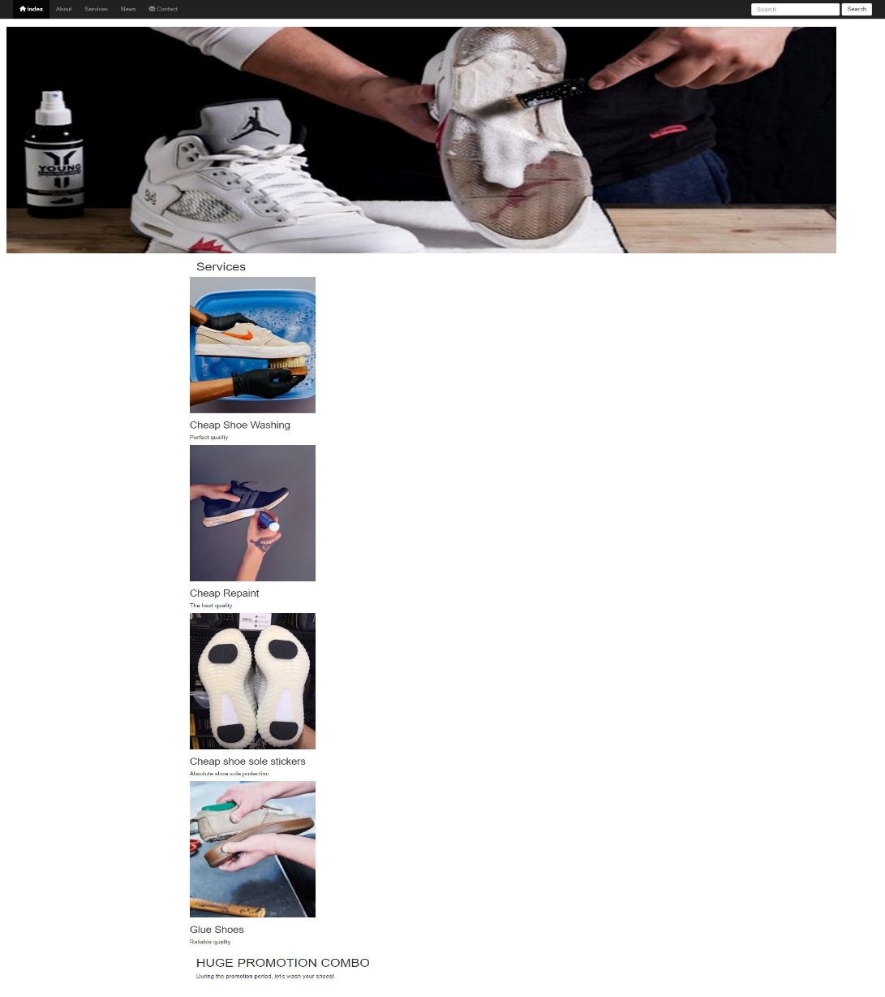**Before styling index.html page**

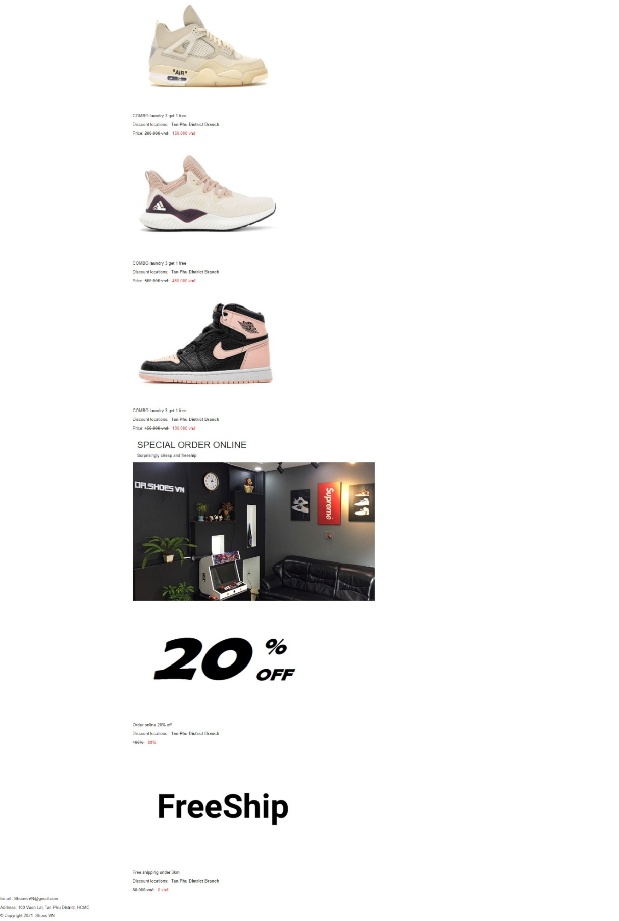

**After styling index.html page**



**The index.html page structure when users access by smartphone**



**Required:** Create a file called **styleindex.css** to format the index.html page and save it to the **Given folder**.

1. **HTML**

* Use Bootstrap's 12-column grid to present the content of the index.html page.
* Embed css file in their respective pages.

1. **CSS**

* Create classes for the divs to format the content of the index.html page.
* Use margin and padding to create the right spacing for the content.
* Use position,width, height to format the content.
* Use css to format the content as shown above when the user accesses by smartphone.
* The function show(): This function is used to show message when the user clicks on the button “Send”.

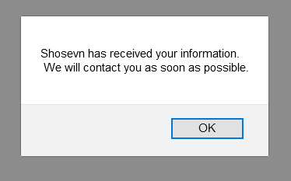

**(Students do not change the path of all files in the Resource folder)**