Q1: A research engineer for a tire manufacturer is investigating tire life for a new rubber compound and has built 16 tires and tested them to end-of-life in a road test. The sample mean and standard deviation are 60139.7 and 3645.94 kilometers. Find a 95% confidence interval on mean tire life. Assume that the population has a normal distribution and given t0.025,15 = 2.131; t0.025,16 = 2.120; t0.05,15 = 1.753; t0.05,16 = 1.746;

Answer:

This is CI ON µ OF A N(µ, σ2): σ2 UNKNOWN.

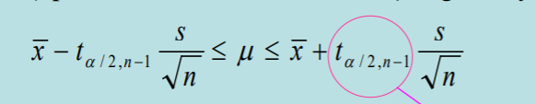We using t0.025,15 = 2.131 to calcualte. The formular is:

Where and . Therefore we using t0.025,15 = 2.131 to calcualte.

60139.7 – 2.131 x 3645.94/ = 58197.33

60139.7 + 2.131 x 3645.94/ = 62082.07

Conclusion: (58197.33; 62082.07)

Q2: A major tire manufacturer wishes to estimate the mean tread life in miles for one of their tires. A pilot sample of n = 50 tires showsed the sample mean and sample standard deviation equal to 69,500 and 4,000 miles. Find a 90% confidence interval on mean tread life. Let z0.05 = 1.645; z0.01 = 2.33; z0.1 = 1.28.

Answer:

This is CI ON µ OF A N(µ, σ2): σ2 KNOWN.

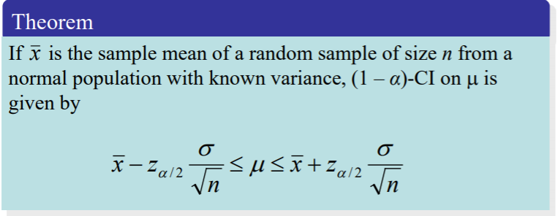The formular is:

Where and . Therefore we using z0.05 = 1.645 to calcualte.

69500 – 1.645 x 4000/ = 68569.45

69500 + 1.645 x 4000/ =70430.55

Conclusion: (68569.45; 70430.55)

Q3: 20 packages are randomly selected from packages received by a parcel service. The sample has a mean weight of 15.3 pounds and a standard deviation of 1.9 pounds. What is the 95 percent confidence interval for the true mean weight of all packages recceived by the parcel service? Assume that the popluation has a normal distribution and given t0.025,19 = 2.093; t0.05,19 = 1.729; t0.1,19 = 1.33

Answer:

This is CI ON µ OF A N(µ, σ2): σ2 UNKNOWN.

The formular is:



Where and . Therefore we using t0.025,19 = 2.093;to calcualte.

15.3 – 2.093 x 1.9 / = 14.41

15.3 + 2.093 x 1.9 / = 16.19

Conclusion: (14.41; 16.19)

Q4: The life in hours of 75-watt light bulb is known to be normally distributed with the standard deviation is 20 hours. Suppose that we wanted to be 95% two-sided confident that the error in estimating the mean life is less than five hours. What sample size should be used? Given z0.05 = 1.646;

Z0.025 = 1.96.

Answer:

Bài này sai số dựa trên mean và là two-sided nên ta dùng công thức sau:

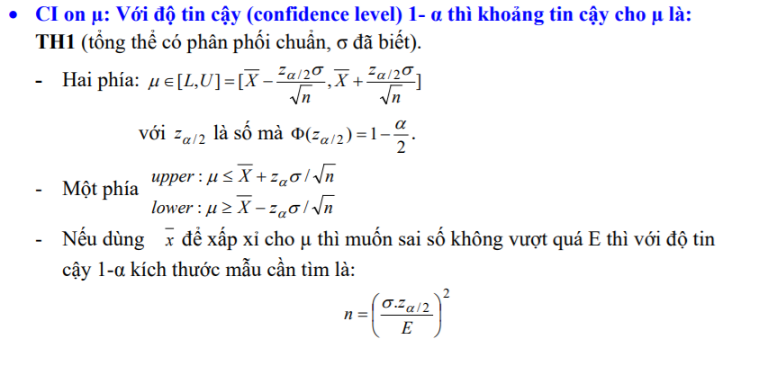

Do đó . Do đó lấy n = 62.

Q5: Suppose that 500 parts are tested in manufacturing and 10 are rejected. Test the hypothesis H0: p = 0,03 against H1: p < 0.03 at α = 0.05. Find P-value. Let P(Z < -1.31) = 0.095;

P(Z < -2.33) = 0.01.

Answer:

Ta có: p = 0.03. f = 10/500 = 0.02. Do đó ta tính được .=

Do đang xét H1: p < 0.03. Nên P-value = P(Z < F0). Do đó P(Z < -1.31) = 0.095.

Q6: Consider the test of H0: 2 = 5 against H1:2 < 5. What are the critical values for the test statistic the significance levels α = 0.01 and sample sizes n = 20? Let ;;;.

Answer:

Đây là test on variance and standard deviation of a normal distribution. Và test một phía bé hơn. Ta nhìn công thức sau: 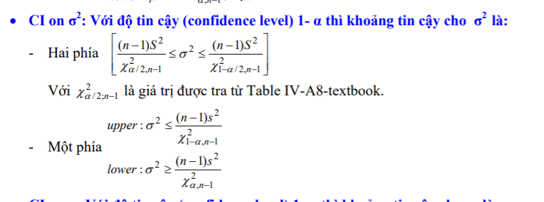

Vây ta xét 1 - α = 1- 0.01 = 0.99, và n – 1 = 20 -1 =19. Do đó ta xét. Vậy critical value là 7.63.

Q7: A researcher claims that more than 55% of votes favor gun control. Identify the null hypothesis and the alternative hypothesis.

A. H0: p < 55%, H1: p > 55 % C. H0: p = 55%, H1: p ≠ 55 %

B. H0: p = 55%, H1: p > 55 % D. H0: p > 55%, H1: p = 55 %

Anwser:

Ta có null hypothesis luôn là dấu =. Còn alternative hypothesis, do đề có từ “more than” nên đó là dấu >. Vậy chọn đáp án B

Q8: Assume that the data has a normal distribution and the number of observations is greater than fifty. Find the critical z value used to test null hypothesis with α = 0.02 for a upper-tailed test. Let P(Z<-2.05) = 0.02; P(Z<-2.33) = 0.01.

A. -2.05 B. -2.33 C. 2.05 D. 2.33

Answer:

Vì là upper-tailed, nên phần α = 0.02 0.02 ở phía bên phải. Do đó critical value = 1 - P(Z < -2.05) = P(Z > 2.05) => 2.05. Chọn C

Q9: The test statistic in a two-tailed test is z=1.43. Let P(Z<1.43) = 0.9236. Then the P-value is?

Anwser:

Vì là two-tailed test nên P-value =.

Q10: Of 346 items tested, 12 are found to be defective. Construct a 98% confidence interval for the percentage of all such items that are defective.

Anwser:

Ta có: p = 12/346 = 6/173. Do đó: . Do đó ta được N(p;).

Ta có: α = 1-0.98 = 0.02. Ta tính dựa theo α/2 vì là two tailed test.

Nên CI là: Do đó hai khoảng là =NORM.INV(0,01;6/173;SQRT(((6/173)*(1-6/173))/346)) và =NORM.INV(1-0,01;6/173;SQRT(((6/173)*(1-6/173))/346)).

Do đó ta được CI: (1.18%;5.76%)

Q11: Of 81 adults selected randomly from one town, 64 have health insurance. Find 90% low confidence bound for the percentage of all adults in the town who have health insurance.

Anwser:

Ta có: p = 64/81. Do đó: . Do đó ta được N(p;).

Vì là low-confidence nên là one-tailed test. Ta có α = 1-0.9 = 0.01. Do đó khoảng đó là:

=NORM.INV(0,1;64/81;SQRT(((64/81)*(1-64/81))/81)) ≈ 0.73

Q12: A study involves 634 randomly selected deaths, 29 of them caused by accidents. Construct a 98% confidence interval for the percentage of all deaths that are caused by accidents.

Anwser:

Ta có: p = 29/634. Do đó: . Do đó ta được N(p;).

Ta có: α = 1-0.98 = 0.02. Ta tính dựa theo α/2 vì là two tailed test.

Nên CI là: Do đó hai khoảng là =NORM.INV(0,01;29/634;SQRT(((29/634)*(1-29/634))/634)) và =NORM.INV(1-0,01; 29/634;SQRT(((29/634)*(1-29/634))/634)).

Do đó ta được CI: (2.64%;6.50%)

Q13: Find 98% upper-confidence bound for the percentage of all deaths that are caused by Accidents.

Anwser: Dựa theo bài trên ta giữ nguyên N(p;).

Vì là upper-confidence nên là one-tailed test, và tính theo 1- α. Trong đó α = 1-0.98 = 0.02

Do đó khoảng đó là:

=NORM.INV(1-0,02;29/634;SQRT(((29/634)*(1-29/634))/634)) ≈ 6.28%

Q14: In a survey of 5100 T.V viewers, 40% said they watch network news programs. Using the point estimate of p obtained from this sample, find the necessary sample size if we want to be 96% confident that the sample proportion of T.V viewers. Who watch network news programs is within 0.01 of that proportion of population.

Anwser: n = 5100 p = 0.4 CI = 0.96 α = 1-0.96 = 0.04 ; vì là two-sided => zα/2 = 2.05

Ta có : 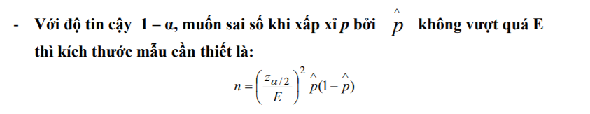

Do đó n = (2.05/0.01)2 x 0.4 x (1-0.4) = 10086.

Và ta có: 5100 x 0.4 =2040.

Vậy đáp án 10086 và 2048.

Q15: Thirty randomly selected students tool the calculus final. If the sample mean was 82 and the population standard deviation was 12.2. Assume that population has normal distribution. Construct a 99% confidence interval for the mean score of all students

Answer:

This is CI ON µ OF A N(µ, σ2): σ2 UNKNOWN.

The formular is : 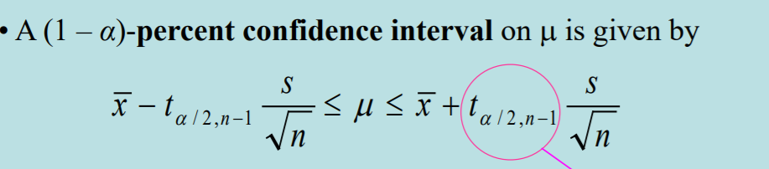

Ta có: α = 1-0.99 = 0.01. t­α/2,29 = T.INV.2T(0,01;29)= 2.756.

Do đó ta được CI là : 82 – 2.756 x (12.2/sqrt(30)); 82 + 2.756 x (12.2/sqrt(30)).

Hay: (75.86;88.14)

Q16: Thirty randomly selected students tool the calculus final. If the sample mean was 82 and the population standard deviation was 12.2, Assume that population has normal distribution. Find a 98% upper-confidence bound for the mean score of all students.

This is CI ON µ OF A N(µ, σ2): σ2 UNKNOWN. And upper-confidence.

The formular is : 

Ta có: α = 1-0.98 = 0.02. t­α,29 = T.INV (0,02;29) = 2.15.

Do đó đáp án là: 82 + 2.15 x (12.2/sqrt(30)) = 86.8

Q17: Among a sample of 65 students selected at random from one college, the mean number of siblings is 1.3 with a standard deviation of 1.1. Find a 95% confidence interval for the mean number of siblings for all students at this college.

Anwser:

This is This is CI ON µ OF A N(µ, σ2): σ2 KNOWN.

The formular is:

Where and . Therefore we using z0.025 = 1.96 to calcualte.

1.3 – 1.96x 1.1/ = 1.033

1.3 + 1.96x 1.1/ = 1.567

Conclusion: (1.033; 1.567)

Q:18

Among a sample of 65 students selected at random from one college, the mean number of siblings is 1.3 with a standard deviation of 1.1. Find a 95% lower-confidence bound for the mean number of siblings for all students at this college.

Answer:

This is This is CI ON µ OF A N(µ, σ2): σ2 KNOWN. And lower-confidence.

The formular is: 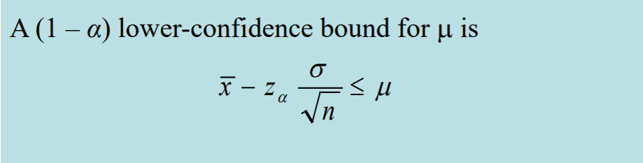

Where and . Therefore we using z0.05 = 1.645 to calcualte.

1.3 – 1.645x 1.1/ = 1.076

Q:19 The yield of chemical process is being studied. From previous experience yield is known to be normally distributed. The past five days of plant operation have resulted in the following percent yields: 91.6; 88.75, 90.8, 89.95, and 91.3. Find a 98% two-side confidence interval on the true mean yield.

Answer:

Ta có: = (91.6 + 88.75 +90.8 +89.95 +91.3) / 5 = 90.48.

= ((91.6 - )2 + (88.75 - )2+ (90.8 - )2 + (89.95 - )2 + (91.3- )2)/4= 5.303/4

* S = 1.151412

α = 1-0.98 = 0.02; n = 5 🡪 Z0.01 = 2.3263

A 98% CI on is 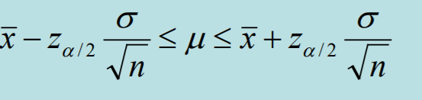

Do đó: (87.35 ; 93.61])

Q20:The breaking strenth of yarn used in manufacturing drapery material is required to be at least 100ps. Pats experience has indicated that breaking strenth is normally distributed and that = 2 psi. A random sample of nine specimens is tested and the average breaking strength is found to be 98psi. Find a 95% two-sided confidence interval on the true mean breaking strength.

Answer:

This is CI ON µ OF A N(µ, σ2): σ2 KNOWN.

Ta có: α = 1-0.95= 0.05; n = 9 🡪 Zα/2 = 1.96.

Ta có: 

Do đó: (98 - 1.96 x 2/sqrt(9); 98 + 1.96 x 2/sqrt(9))

Hay: (96,69;99,31)

Q:21

The percentage of titanium in an alloy used in aerospace castings is measured in 51 randomly selected parts. The sample standard deviation is s = 0.37. Construct a 95% twosided confidence interval for σ.

Answer:

This is CI ON σ2 OF A NORMAL.

The formular: 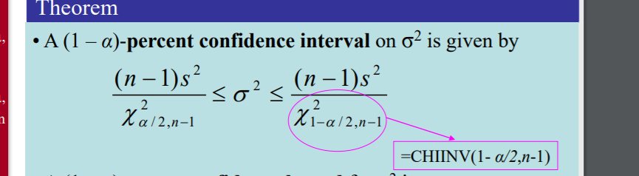

CHISQ.INV.RT(0,05/2;50)= 71.4202

 CHIINV(1-0,05/2;50)= 32.35736. Do đó ta được: 0.0958 σ2 0.2115.

Hay 0.31 σ 0.46

Q22: In an Accounteps survey of 150 senior executives, 47% said that the most common job interview mistake is to have little or no knowledge of the company. Construct a 99% confidence interval estimate of the proportions of all senior executives who have that same opinion.

Anwser:

Ta có: p = 0.47. Do đó: . Do đó ta được N(p;).

Ta có: α = 1-0.99 = 0.01. Ta tính dựa theo α/2 vì là two tailed test.

Nên CI là: Do đó hai khoảng là =NORM.INV(0,005;0,47;SQRT(((0,47)*(1-0,47))/150)) và =NORM.INV(1-0,005;0,47;SQRT(((0,47)*(1-0,47))/150)).

Do đó ta được CI: (0.365;0.575)

Q23: In an Accounteps survey of 150 senior executives, 47% said that the most common job interview mistake is to have little or no knowledge of the company. Construct a 95% lower confidence bound for the proportions of all senior executives who have that same opinion.

Ta có: p = 0.47. Do đó: . Do đó ta được N(p;).

Vì là low-confidence nên là one-tailed test. Ta có α = 1-0.95 = 0.05. Do đó khoảng đó là:

=NORM.INV(0,05;0,47;SQRT(((0,47)*(1-0,47))/150)) ≈ 0.40297

Q24: What sample size is needed to estimate the mean white blood cell count for the population of adults in the United States? Assume that you want 99% confidence that the sample mean is within 0.2 of the population mean. The population standard deviation is 2.5.

Anwser:

Bài này sai số dựa trên mean và là two-sided nên ta dùng công thức sau:



Do đó . α = 1-0.99 = 0.01. Z/2 = 2.5758 Trong đó Do đó lấy n = 1037.

Q25: A sociologist develops a test to measure attitudes about public transportation, and 27 randomly selected subjects are given the test. Their mean score is 76.2 and their standard deviation is 21.4. Construct the 95% confidence interval for the mean score of all such subjects. Assume that the population has a normal distribution.

Answer:

This is CI ON µ OF A N(µ, σ2): σ2 UNKNOWN.

The formular is : 

Ta có: α = 1-0.95 = 0.05. t­α/2,26 = T.INV.2T(0,05;26)= 2.055529.

Do đó ta được CI là : 76.2 – 2.055529 x (21.4/sqrt(27)); 76.2 + 2.055529 x (21.4/sqrt(27)).

Hay: (67.73;84.66)

Q26: A random sample of 23 movies with ratings of PG or PG-13 have lengths (in minutes) with a mean of 120,8 min and a standard deviation of 22,9 min. Construct a 95% confidence interval estimate of the standard deviation of the lengths of all movies.

Anwser:

This is CI ON σ2 OF A NORMAL.

The formular: 

CHISQ.INV.RT(0,025/2;22)= 36.78071

 CHIINV(1-0,025/2;50)= 10.98232. s2 = 22.92

Do đó ta được: 313.67 σ2 1050.51. Hay 17.71 σ 32.4

Q27: A random sample of 23 movies with ratings of PG or PG-13 have lengths (in minutes) with a mean of 120,8 min and a standard deviation of 22,9 min. Construct a 90% lower confidence bound for the standard deviation of the lengths of all movies.

This is CI ON σ2 OF A NORMAL.

The formular: 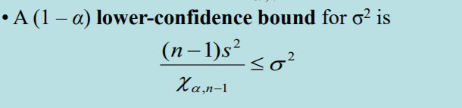

CHISQ.INV.RT(0,1;22)= 30.8133. s2 = 22.92

Do đó ta được: 374.42 σ2 . Hay 19.35 σ

Q28: A major tire manufacturer wishes to estimate the mean tread life in miles for one of their tires. They wish to develop a confidence interval estimate that would have a maximum sampling error of 500 miles with 90 percent confidence. Let population standard deviation equal to 4,000 miles. Based on this information and let the required sample size is: Z0.05 = 1.645

Answer:

Bài này sai số dựa trên mean và là two-sided nên ta dùng công thức sau:



Do đó . α = 1-0.90 = 0.1. Z/2 = 1.645 Trong đó Do đó lấy n = 174.

Q29: Given  

Answer:

This is CI ON σ2 OF A NORMAL.

The formular: 

α = 1-0.99 = 0.01.

Do đó ta được: 10.51 σ2 65.88.

Q30:

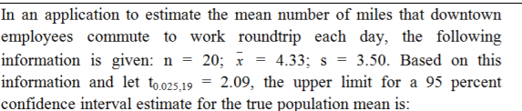

Answer:

This is CI ON σ2 OF A NORMAL. Because find upper limit. Therefore:

The formular:

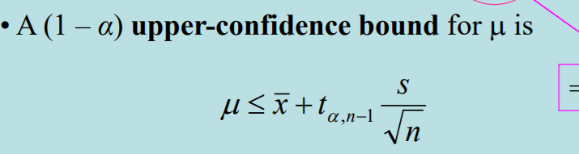

α = 1-0.95 = 0.05.

Do đó ta được: 4.33 + 2.09 x 3.5/sqrt(20) ≈ 5.97

Q31: 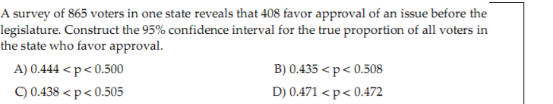

Ta có: p = 408/865. Do đó: . Do đó ta được N(p;).

Ta có: α = 1-0.95 = 0.05. Ta tính dựa theo α/2 vì là two tailed test.

Nên CI là: Do đó hai khoảng là =NORM.INV(0,05/2; 408/865;SQRT(((408/865)*(1-408/865))/865)) và =NORM.INV(1-0,05/2; 408/865;SQRT(((408/865)*(1-408/865))/865)).

Do đó ta được CI: (0.438;0.505) Do đó chọn C.

Q32: 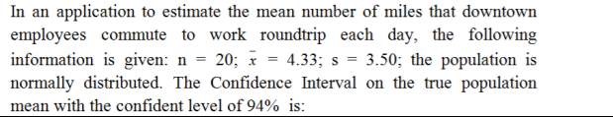

This is CI ON µ OF A N(µ, σ2): σ2 UNKNOWN.

The formular is : 

Ta có: α = 1-0.94 = 0.06. t­α/2,19 = T.INV.2T(0,06;19)= 2.00002.

Do đó ta được CI là : 4.33 – 2.00002 x (3.5/sqrt(20)); : 4.33 + 2.00002 x (3.5/sqrt(20));

Hay: (2.76;5.90)

Q33: 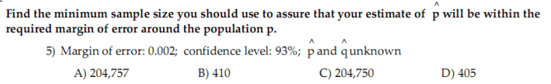

Answer:

The formular is : nmin=((Z)2x0.25)/E2). Ta có Ta có: α = 1-0.93 = 0.07. Z = 1.8119. E = 0.002.

Do đó kết quả là: ((1.81)2 x 0.25)/0.0022) = 204756.25. Nên chọn A

Q34:

Your statistics instructor claims that 60 percent of the students who take her Elementary Statistics class go through life feeling more enriched. For some reason that she can't quite figure out, most people don't believe her. You decide to check this out on your own. You randomly survey 64 of her past Elementary Statistics students and find that 34 feel more enriched as a result of her class. Which of the following states is true?

Assume the significant level 0.05 (Let z0.025 = 1.96; z0.05 =1.65)

Answer:

Ta có : α = 0.05; n = 64; p0 = 60% = 0.6. f=34/64 = 0.531

H0: p = 0.6; H < 0.6. F = (f- p0) / (sqrt(p0(1-p0)/n)) = -1.123

Vi Z α = 1.65 > F. Do đó The value of the test statistic is -1.123. There is sufficient evidence to support your statistic instructor's claim

Q35: According to an article in Newsweek, the natural ratio of girls to boys is 100:105. In Vietnam, the birth ratio is 100: 114 (46.7% girls). Suppose you don't believe the reported figures of the percent of girls born in Vietnam. You think that the percent of girls born in Vietnam is less than 46.7%. You conduct a study. In this study, you count the number of girls and boys born in 150 randomly chosen recent births. There are 60 girls and 90 boys born of the 150. Based on the results, draw your conclusion. Use α =2%. Let z0.01 = 2.33; z0.02 =2.05

Answer:

Ta có : α = 0.02; n = 150; p0 =0.467. f=60/150 = 0.4

H0: p = 0.467; H < 0.467. F = (f- p0) / (sqrt(p0(1-p0)/n)) = -1.6447. Vì F > - Zα (-1.6447 > -2.05)

Q36: When a new drug is created, the pharmaceutical company must subject it to testing before receiving the necessary permission from the Food and Drug Administration (FDA) to market the drug. Suppose the null hypothesis is "the drug is unsafe." What is the Type II Error?

Answer:

Type II is To claim the drug is unsafe when, in fact, it is safe.

Q37: An assembly line produces widgets with a mean weight of 10 and a standard deviation of 0.2. A new process supposedly will produce widgets with the same mean and a smaller standard deviation. A sample of 20 widgets produced by the new methoqsd has a sample standard deviation of 0.126

At a significant level of 10%, whaat is the test static ?

Answer:

This is TESTS ON THE VARIANCE AND STANDARD DEVIATION OF A NORMAL DISTRIBUTION

The formular:



Trong đó . S = 0.126. Do đó = (20-1) x 0.1262 / 0.22 = 7.54

Q38: The cost of a college education has increased at a much faster rate than costs in general over the past twenty years. In order to compensate for this, many students work part- or full-time in addition to attending classes. At one university, it is believed that the average hours students work per week exceeds 20.

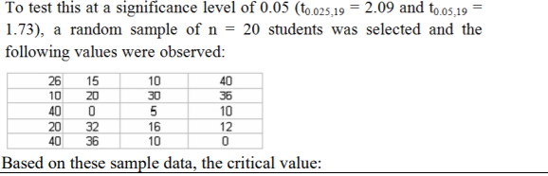

Answer:

Ta có : n = 20 H1 p0 = 20 Hα p > p0 Ta sử dụng α = 0.05 => dùng t0.05,19 = 1.73

Q39: 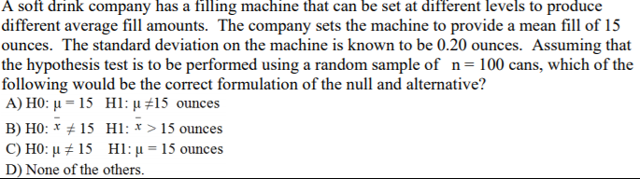

Answer:

Ta có null hypothesis luôn là dấu =. Còn alternative hypothesis, do đề có từ “difference levels” nên đó là dấu #. Vậy chọn đáp án A

Q40: A bank is interested in determining whether their customers' checking balances are linearly related to their savings balances. A sample of n = 20 customers was selected and the correlation was calculated to be +0.40. If the bank is interested in testing to see whether there is a significant linear relationship between the two variables using a significance level of 0.05, what is the value of the test statistic?

Answer:

Ta có: α/2 = 0.05/2 = 0.025 n = 20

Test on p: so test statistic =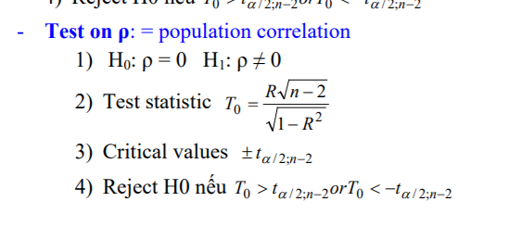

Do đó : 

Q41: A major department store chain is interested in estimating the average amount its credit card customers spent on their first visit to the chain’s new store in the mall. Fifteen credit card accounts were randomly sampled and analyzed with the following results. Construct a 95% confidence interval for the average amount its credit card customers spent on their first visit to the chain’s new store in the mall assuming that the amount spent follows a normal distribution. 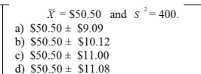

Answer:

This is CI ON µ OF A N(µ, σ2): σ2 UNKNOWN.

The formular is : 

Ta có: α = 1-0.95 = 0.05. t­α/2,14 = T.INV.2T(0,05;14)= 2.14479.

. t­α/2,14 x s /sqrt(n) = 2.14479 x 20 / sqrt(15) =11.08. Do đó chọn D

Q42: Private colleges and universities rely on money contributed by individuals and corporations for their operating expenses. Much of this money is put into a fund called an endowment, and the college spends only the interest earned by the fund. A recent survey of 8 private colleges in the United States revealed the following endowments (in millions of dollars): 60.2, 47.0, 235.1, 490.0, 122.6, 177.5, 95.4, and 220.0. 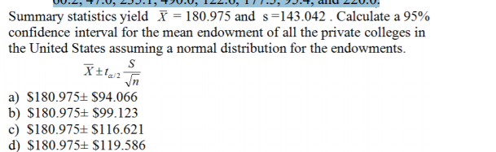

Answer:

This is CI ON µ OF A N(µ, σ2): σ2 UNKNOWN.

The formular is : 

Ta có: α = 1-0.95 = 0.05, n = 8. t­α/2,7 = T.INV.2T(0,05;7)= 2.36462.

. t­α/2,7 x s /sqrt(n) = 2.36462 x 143.042 / sqrt(8) =119.586. Do đó chọn D

Q43: A university dean is interested in determining the proportion of students who receive some sort of financial aid. Rather than examine the records for all students, the dean randomly selects 200 students and finds that 118 of them are receiving financial aid. If the dean wanted to estimate the proportion of all students receiving financial aid to within 3% with 99% reliability, how many students would need to be sampled?

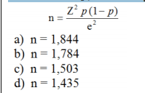

Answer:

Ta có α = 1-0.99 = 0.01

Thay e = 3% = 0.03. Z = Z α/2 = 2.576. p = 118/200.

Ta được: 2.5762x(118/200)((1-118/200)/0.032 = 1783.5. Do đó ta chọn n = 1784. Câu B

Q44: An economist is interested in studying the incomes of consumers in a particular region. The population standard deviation is known to be $1,000. A random sample of 50 individuals resulted in an average income of $15,000. What is the width of the 90% confidence interval? 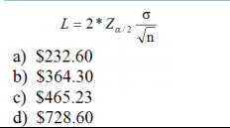

Answer:

Ta có α = 1-0.9 = 0.1. Z α/2 = Z0.05 = 1.645. = 1000, n = 50.

Ta được L = 2*1.645x 1000/sqrt(50) = 465.276. Vậy chọn C.

Q45: The head librarian at the Library of Congress has asked her assistant for an interval estimate of the mean number of books checked out each day. The assistant provides the following interval estimate: from 740 to 920 books per day. If the head librarian knows that the population standard deviation is 150 books checked out per day, and she asked her assistant to use 25 days of data to construct the interval estimate, what confidence level can she attach to the interval estimate?

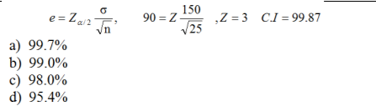

Answer:

Ta có:

Z = 3

Và ɸ(3) - ɸ(-3) = 0.9973 = 99.73% => Chọn A

Q46: A quality control engineer is interested in the mean length of sheet insulation being cut automatically by machine. The desired length of the insulation is 12 feet. It is known that the standard deviation in the cutting length is 0.15 feet. A sample of 70 cut sheets yields a mean length of 12.14 feet. This sample will be used to obtain a 99% confidence interval for the mean length cut by machine. The confidence interval goes from _____ to ____.

Ansswer:

This is CI ON µ OF A N(µ, σ2): σ2 KNOWN.

The formular is:

Where and . Therefore we using z0.005 = 2.576 to calcualte.

12.14 – 2.576 x 0.15/ = 12.09

12.14 + 2.576 x 0.15/ = 12.19

Conclusion: 12.09 to 12.19

Q47: A quality control engineer is interested in the mean length of sheet insulation being cut automatically by machine. The desired length of the insulation is 12 feet. It is known that the standard deviation in the cutting length is 0.15 feet. A sample of 70 cut sheets yields a mean length of 12.14 feet. This sample will be used to obtain a 99% confidence interval for the mean length cut by machine. Suppose the engineer had decided to estimate the mean length to within 0.03 with 99% confidence. Then the sample size would be ________.

Answer:

Bài này sai số dựa trên mean và là two-sided nên ta dùng công thức sau:



Do đó . Trong đó α = 1-0.99 = 0.01. Z/2 = 2.5758 Do đó lấy n = 166.

Q48: The actual voltages of power packs labeled as 12 volts are as follows: 11.77, 11.90, 11.64, 11.84, 12.13, 11.99, and 11.77. The critical value for a 99% confidence interval for this sample is __________.

Answer:

This is CI ON µ OF A N(µ, σ2): σ2 UNKNOWN.

Ta có α = 1-0.99 = 0.01. Từ đó critical value là t0.005,6 = 3.7073

Q49: The actual voltages of power packs labeled as 12 volts are as follows: 11.77, 11.90, 11.64, 11.84, 12.13, 11.99, and 11.77. A 99% confidence interval for the mean voltage of the power packs is from ____ to _____.

Answer:

Ta có α = 1-0.99 = 0.01. Từ đó critical value là t0.005,6 = 3.7073

Ta tính được: , σ = 0.1538

[𝑋̅ - tα/2 ; n -1 * σ / √𝑛 ; 𝑋̅ + tα/2 ; n -1* σ / √𝑛]

= [11.88314 - 3.7073∗ 0.1538 √7 ; 11.88314 + 3.7073∗ 0.1538 √7 ]

=[11.6367; 12.0891]

Q50: A hotel chain wants to estimate the average number of rooms rented daily in each month. The population of rooms rented daily is assumed to be normally distributed for each month with a standard deviation of 24 rooms. During February, a sample of 25 days has a sample mean of 37 rooms. Use this information to calculate a 92% confidence interval for the population mean.

Answer:

Answer:

This is CI ON µ OF A N(µ, σ2): σ2 KNOWN.

The formular is:

Where and . Therefore we using z0.04 = 1.751 to calcualte.

37 – 1.751 x 24/ = 28.60

37 + 1.751 x 24/ = 45.40

Conclusion: (28.60; 45.40)