WORKSHOP 1- **SERVLET**

**Exercise 1:** Create the HTML file, named Exercise1.html and servlet file execute the requests from HTML file.

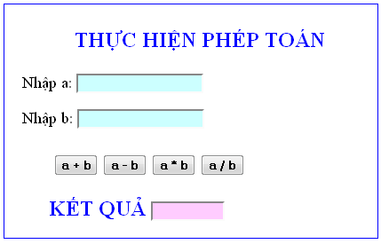

**Exercise 2:** Create the HTML file, named Exercise2.html and servlet file execute the requests from HTML file.

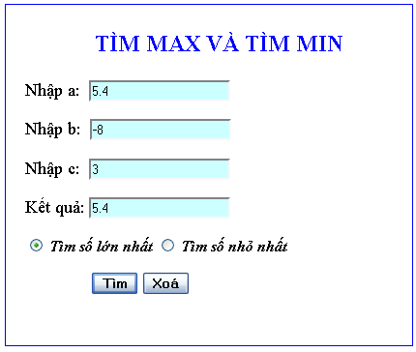

**Exercise 3:** Create the HTML file, named Exercise3.html and servlet file execute the requests from HTML file.

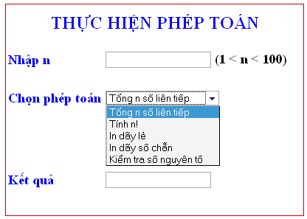

**Exercise 4:** Create the HTML file, named Exercise4.html and servlet file execute the requests from HTML file.

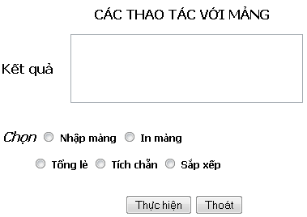

**Exercise 5:** Create the HTML file, named Exercise5.html and servlet file execute the requests from HTML file.

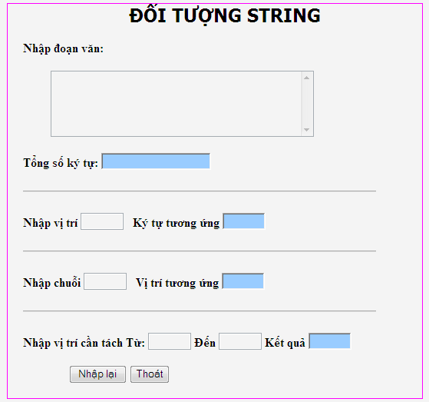

**Exercise 6:** Solve the equation: ax + b=0;

