JSP-Servlet Lesson 01

1. Given database script, named scrip_DB.sql and web page, named Lesson1.jsp.
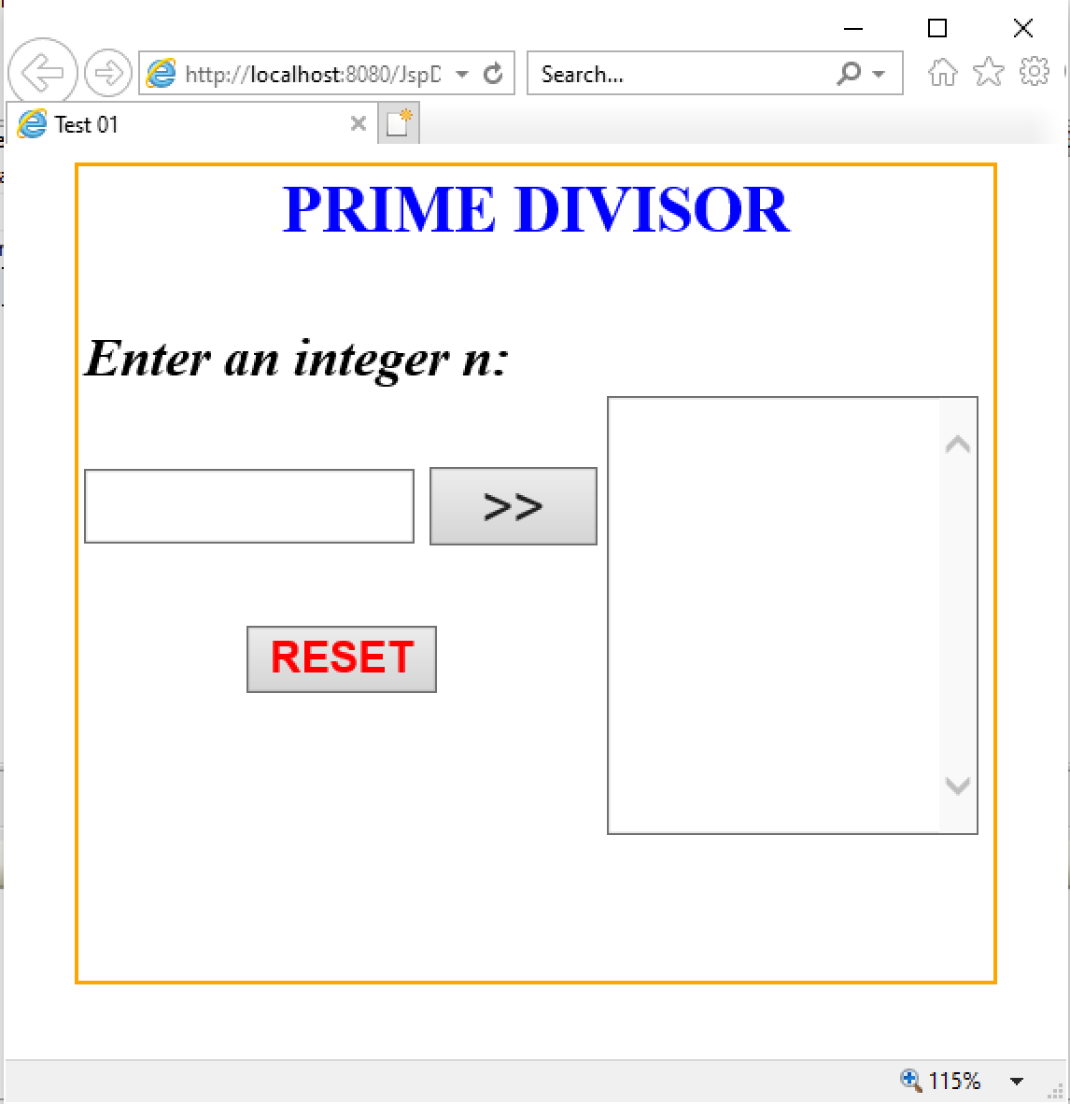

2. Requirement:
a. Click RESET button, set value of TextField and TextArea is empty.
b. Check input n is integer (n>0). If input fail, TextBox “Enter an integer n” is set empty and show error message.
c. When input an integer number, if that number exists in database, show information (n and result) of that number to TextArea. (possible to create a new button)
d. Click button >>:
d1. The prime divisor <10 of n will be added to the TextArea.
d2. Add information (n and result of d1) to tblNumber.

