JSP-Servlet Lesson 02

1. Given database script, named scrip_DB.sql and web page, named Lesson2.jsp.
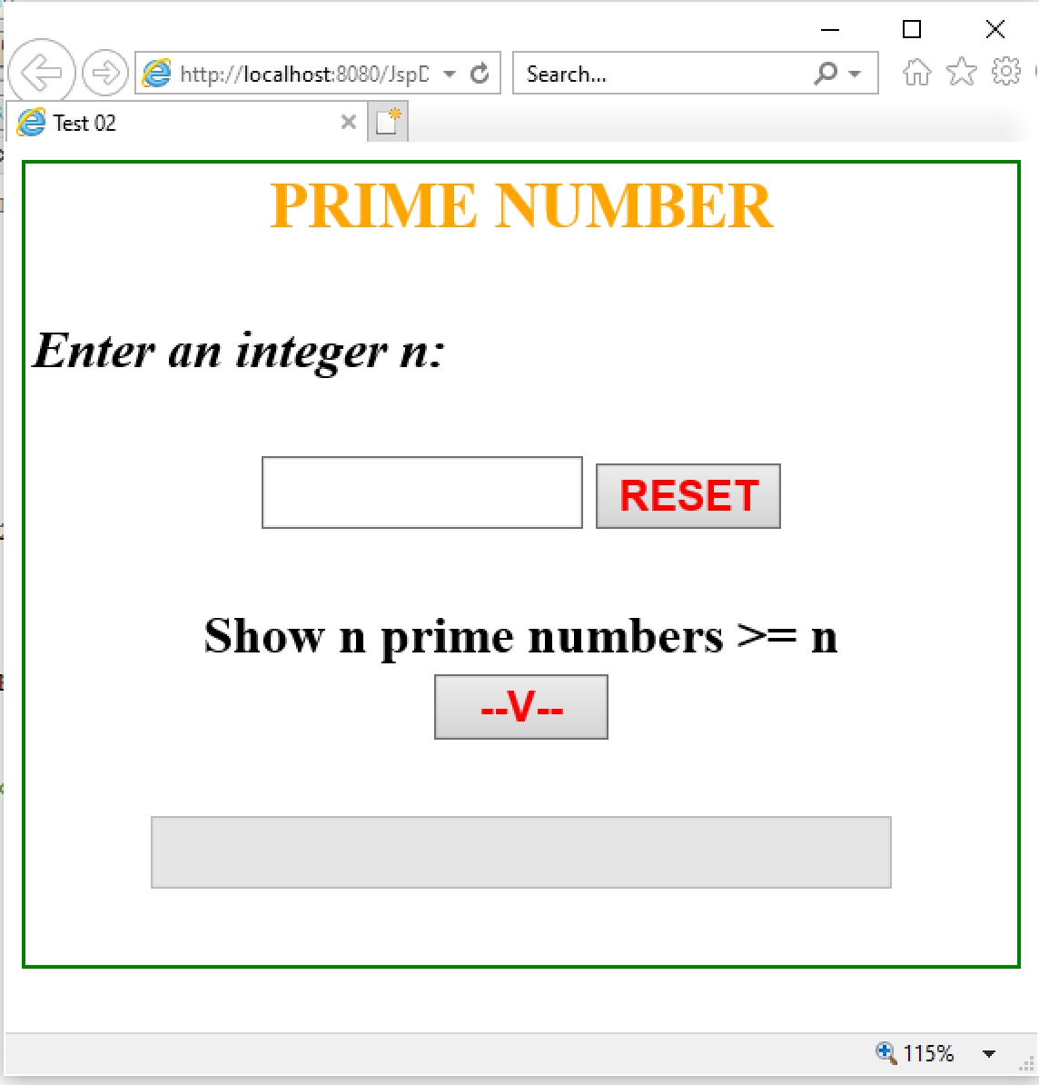

2. Requirement:
a. Click RESET button, set value of TextFields is empty.
b. Check input n is integer (n>2). If input fail, TextBox “Enter an integer n” is set empty and show error message.
c. When input a true integer number, if that number exists in database, show information (n and result) of that number to TextField. (possible to create a new button).
d. Click button V:
d1. Show n prime numbers >n to TextField. If have no result, show message “No results.”
d2. Add information (n and result of d1) to tblNumber.

