Assignment 1

WEEK 5

You are asked to create a Windows form app .NET core that allows the user to list all cars, add a new car or edit/delete the given car.

Only an administrator registered in file appsetings.json can create a new car or edit/delete the given car.

Your program output may be look like as below:

# Flow of forms

Confirm message “Delete”?

Click menu “Logout”

Click button “Delete”

Click button “Add a new”/”Edit”

Click button “Detail”

CarAddEditGUI

CarDetailGUI

CarGUI

Click menu “Login”

LoginGUI

# Forms:

## Form “CarGUI” for user

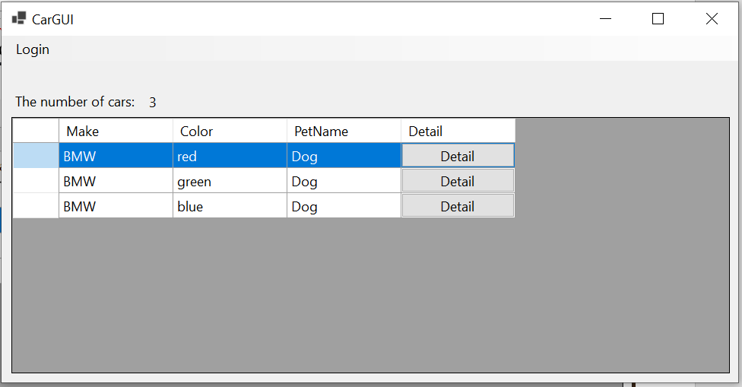

Requirements:

* List all cars (three properties: Make: string, Color: string, and Petname: string).
* Show car detail by clicking button “Detail” to open CarDetailGUI form as below

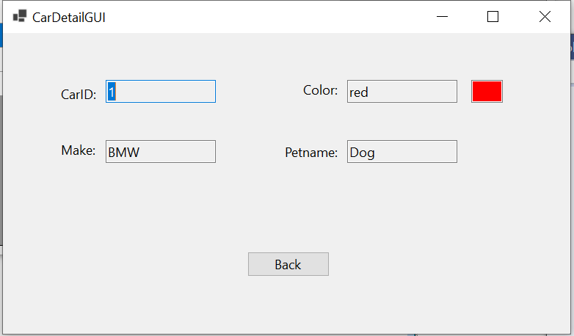

* Login as administrator by clicking menu “Login” to open LoginGUI form as below

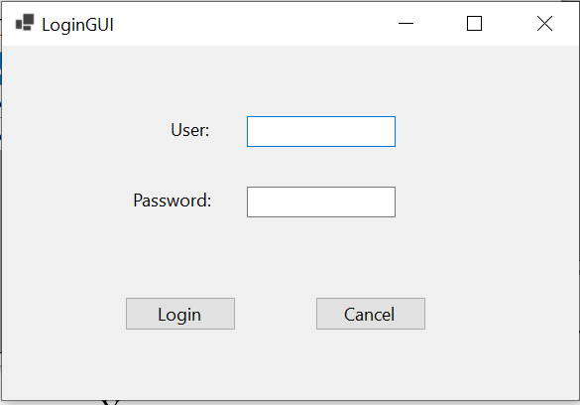

If the name and password are the same of administrator stored in appsettings.json file, form CarGUI for administrator will be displayed

## Form “CarGUI” for administrator

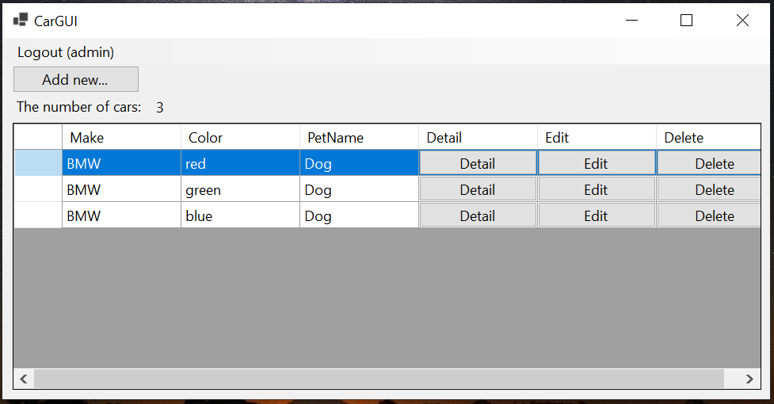

Requirements: Except functions for user, the administrator can:

* Logout
* Add a new car by clicking button “Add new” to open CarAddEditGUI form as below

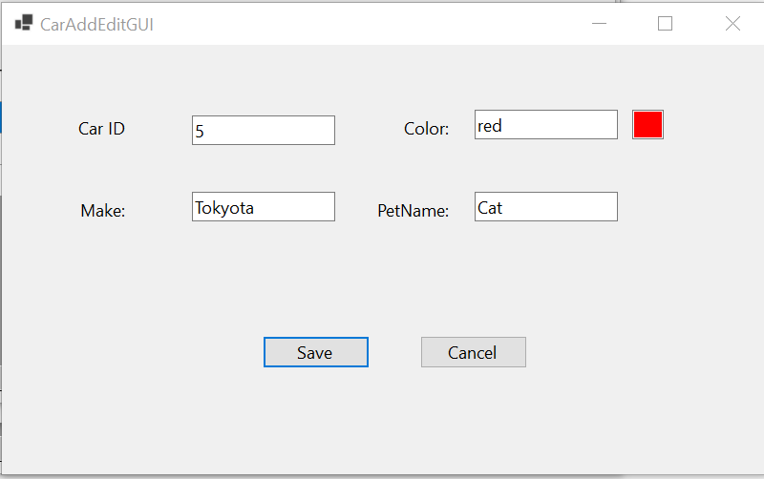

Requirements: Car ID: an integer >= 0 and unique.

Click button “Save” to add a new car into Database, then system will check

* + If car information is invalid, the following messages will be displayed

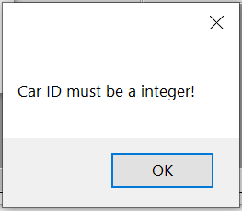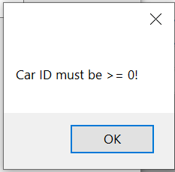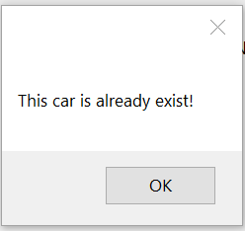

* + If car information is valid, a new car is added, the following message will be displayed

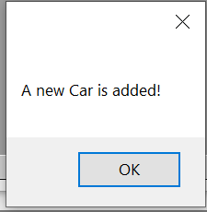

* Edit the given car by clicking button “Edit” to open CarAddEditGUI form as below

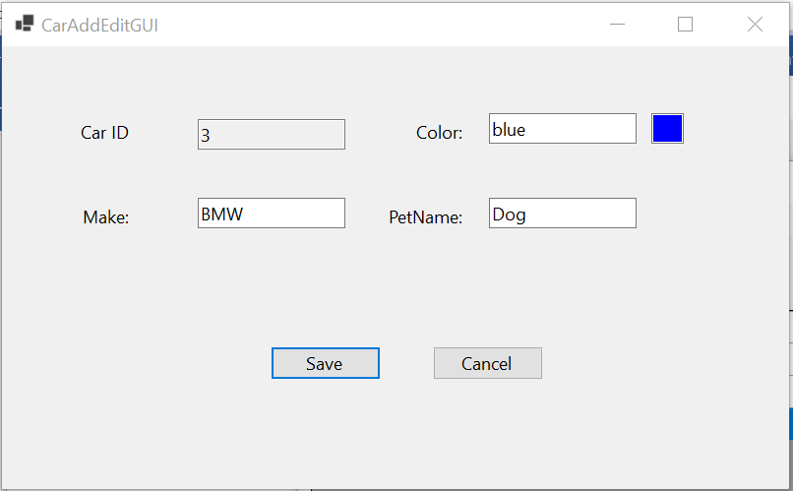

Click button “Save” to updated this car in Database and the following message will be displayed:

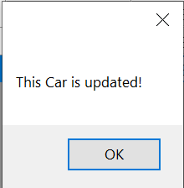

* Delete the given car by clicking button “Delete” to open the following confirm message

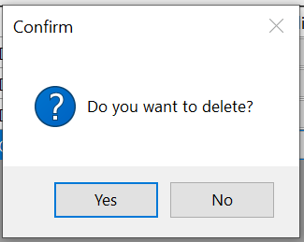

Click button “Yes” to delete this car from Database and the following message will be displayed

