**==========================================================**

**Windows forms Application**

**Assignment 2 (week 6)**

**Goals:**

The goal of Assignment 2 is to develop a Windows Forms Application .NET core named CinemaWin described in document “List of sample projects”.

**System description:**

Your system must have the following main functions:

1. Add/Edit/Delete a show (only for administrator).
2. Add/View/Delete a booking for the given show.

**Your program output may be look like:**

# Flow of forms

Logout Message

ShowAddEditGUI

Click button “Add a new”/”Edit”

Click button “Delete”

Click menu “Logout”

ShowGUI

Confirm Delete Message?

Click menu “Show”

MainGUI

Click button “Bookings”

Click menu “Login”

BookingGUI

LoginGUI

Click button “Delete”

Click button “Create a new booking”

Click button “Detail”

BookingDetailGUI

Confirm Delete Message?

BookingAddGUI

# MainGUI form

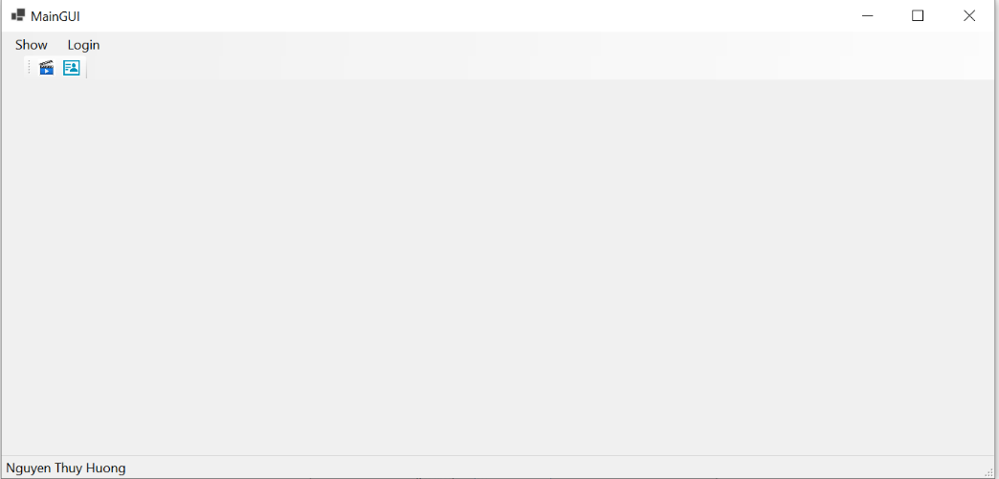

Requirements:

* Click menu “Login” to show LoginGUI form as below

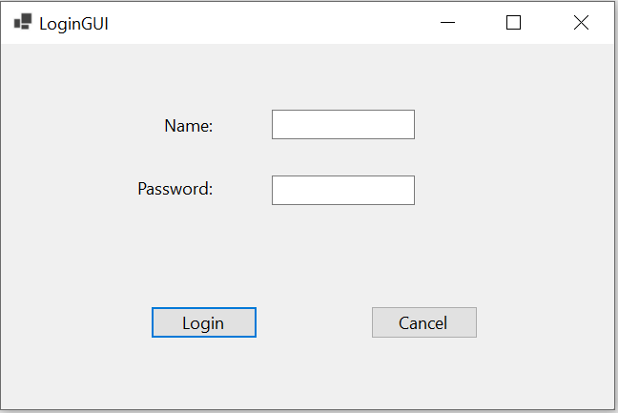

Enter name and password, then click button “Login” to compare with the information of the administrator stored in the file “appsetting.json”:

* + - If it is not the same, the following message will be displayed

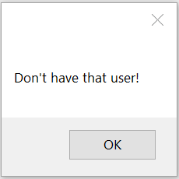

* + - If it is the same, the following message will be displayed:

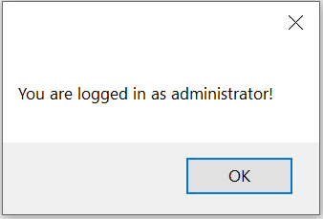

And the MaiGUI form will be displayed as below:

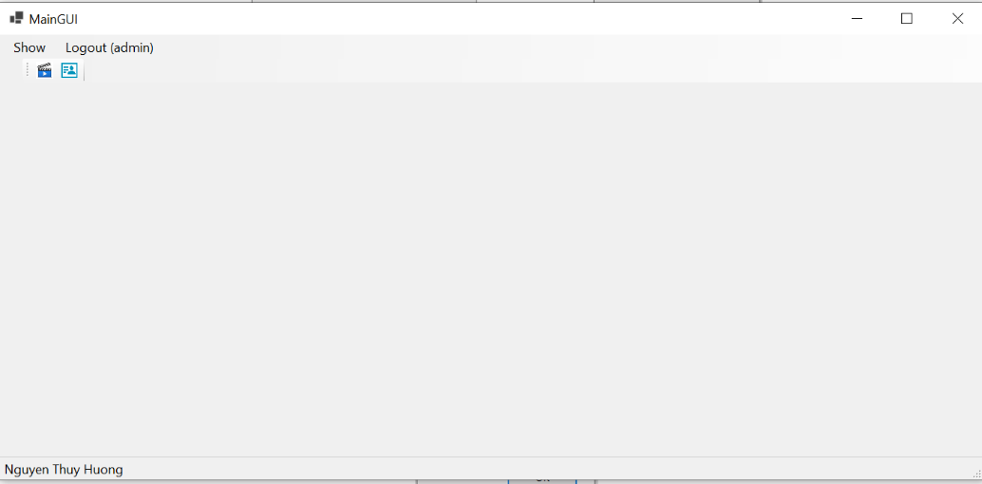

Click menu “Logout”, the following message will be displayed

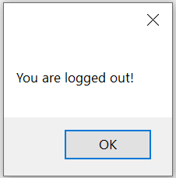

* Click menu “Show” to show ShowGUI form as below

# ShowGUI form

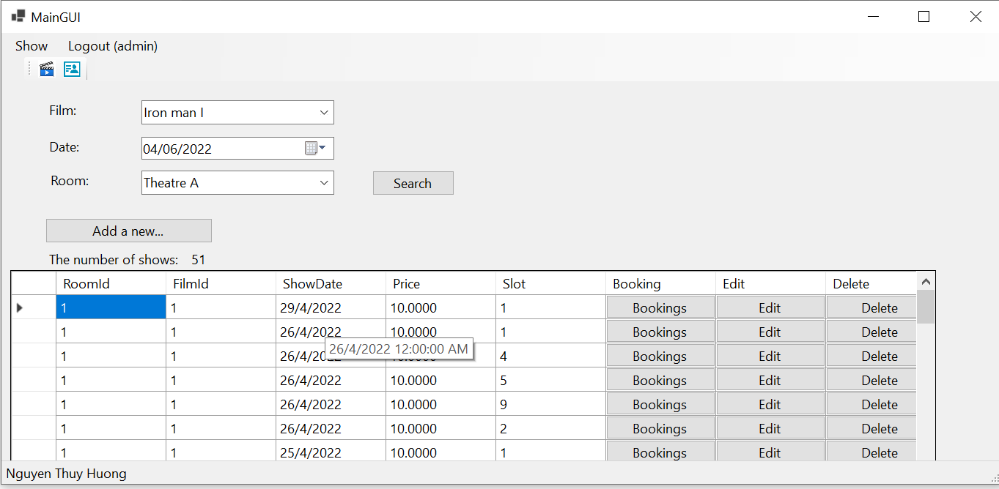

Requirements:

* List all shows. The user can search shows by film title/Date/Room. Buttons “Add a new..”, “Edit”, “Delete” are only visible if the user is logged in as the administrator.
* Click button “Delete” to delete the given show, and the following message will be displayed. Click button “Yes” to delete the given show from Database, and system will return to ShowGUI form.

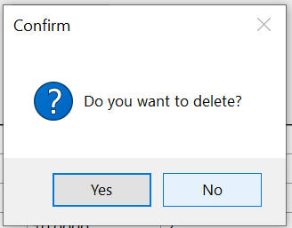

* Click button “Add a new”/ “Edit” to open ShowAddEditGUI form to Add/Edit a show as below

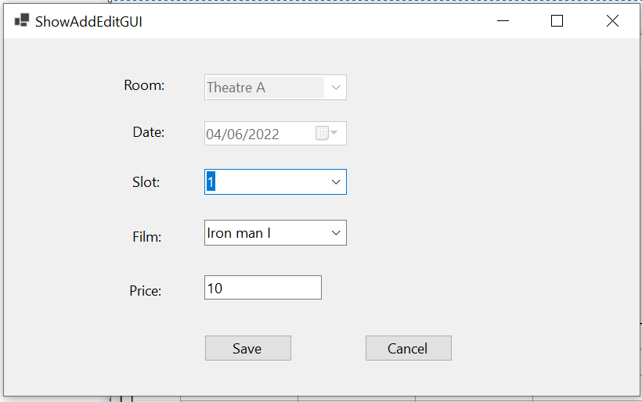

Then the user can:

* + - Select available Slots for the given room at the given day.
    - Enter Price (must be a double and > = 0)
    - Click button “Save” to save into Database. A message will be displayed
      * In the case of adding

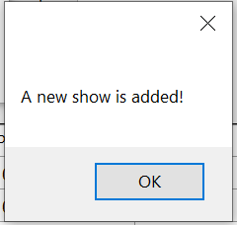

* + - * In the case of editing

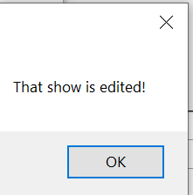

Then system will return to the ShowGUI form.

* Click button “Bookings” to show BookingGUI form that allows the user to book seats for the given show as below

# BookingGUI form

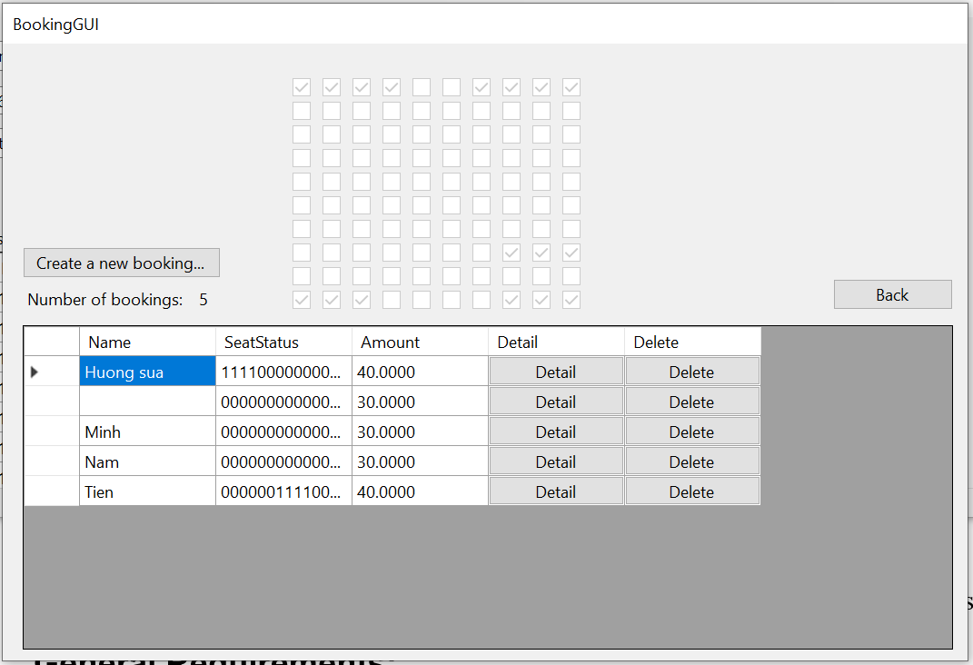

Requirements:

* Display all seats for the given show.
* List all bookings for the given show.
* Click button “Back” to return to ShowGUI form.
* Click button “Delete” and the following message will be displayed. Click button “Yes” to delete the given booking from Database, and system will return to BookingGUI form.

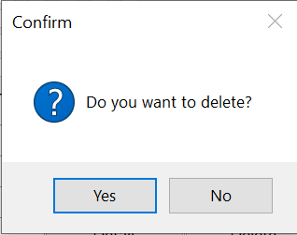

* Click button “Detail” to show BookingDetailGUI form as below:

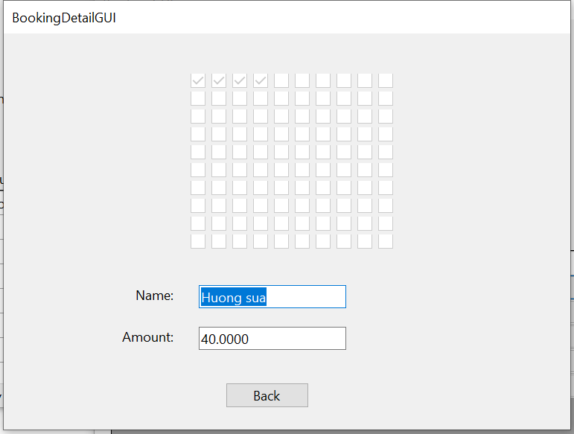

Click button “Back” to return to BookingGUI form.

* Click button “Create a new booking…” to show BookingAddGUI form as below:

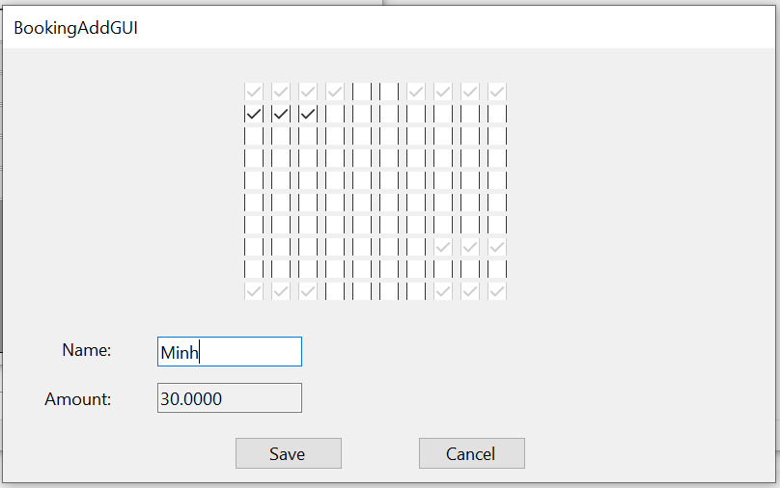

Select available seats and enter customer’s name, then click button “Save” to add a new booking into database, and system will return to BookingGUI form.

**General Requirements:**

* Display class ID, Group number and the member’s names in the status bas.
* Your system must follow all rules described in Cinema system (in document “List of sample projects”.
* Your system must check input data and allow the user to enter again.
* Use Database “Cinema” given in site “cms” and must use “localhost” for the name of DB server computer .
* Your solution name: ClassID_GroupN_A2.sln, and file name: ClassID_GroupN_A2.rar