**==========================================================**

**Windows forms Application**

**Assignment 2 (week 6)**

=====================================================================================

**Goals:**

The goal of Assignment 2 is to develop a Windows Forms Application .NET core named “Music Store” described in document “List of sample projects”.

**System description:**

Your system must have the following main functions:

1. Buy albums (view albums, add/remove an album to/from cart, and checkout)
2. Add/Edit/Delete an album (only for Administrator).

**Your program output may be look like:**

# Flow of forms

Logout Message

Click menu “Logout”

Click button “Delete”

Click menu “Shopping”

Click menu “Albums”

ShoppingGUI

Confirm Delete Message?

AlbumsGUI

Click menu “Login”

LoginGUI

MainGUI

Click button “Create a new” or “Edit”

Click menu “Cart”

CartGUI

AlbumAddEditGUI

# MainGUI form

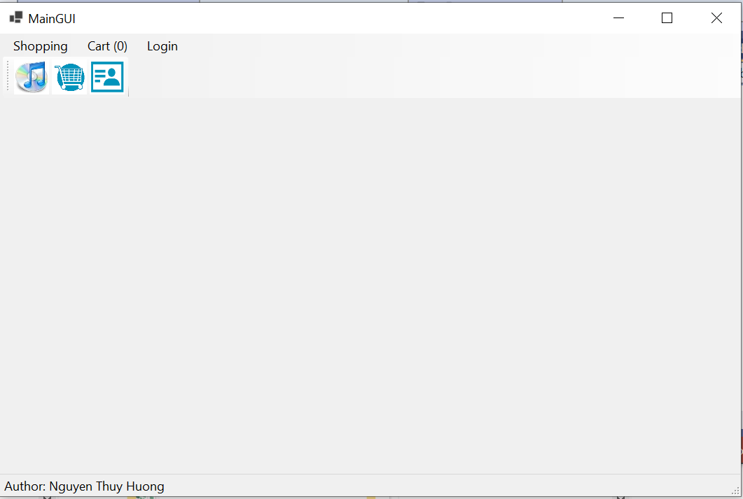

Requirements:

* Display Class ID and Group number and all member in the status bar.

# LoginGUI form

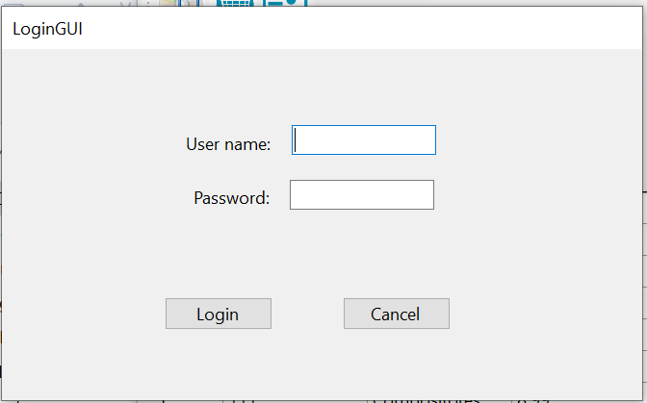

Requirements:

* Enter user name and password.
* Click the button “Login” and system will search this member in Database:
  + - If it is not found, the following message will be displayed

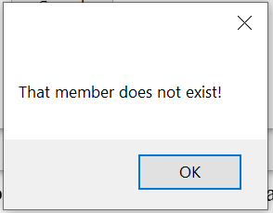

* + - If that member is found, and his/her role is administrator, the MainGUI form will be displayed as below

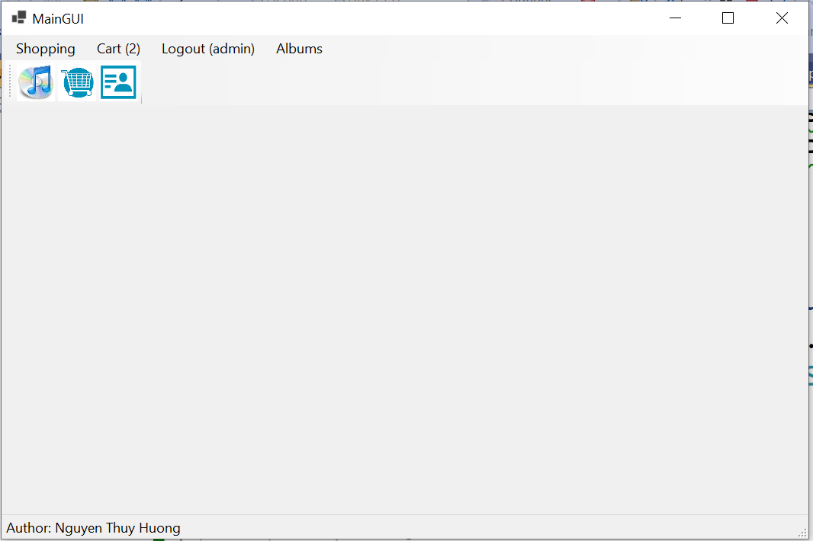

# ShoppingGUI form

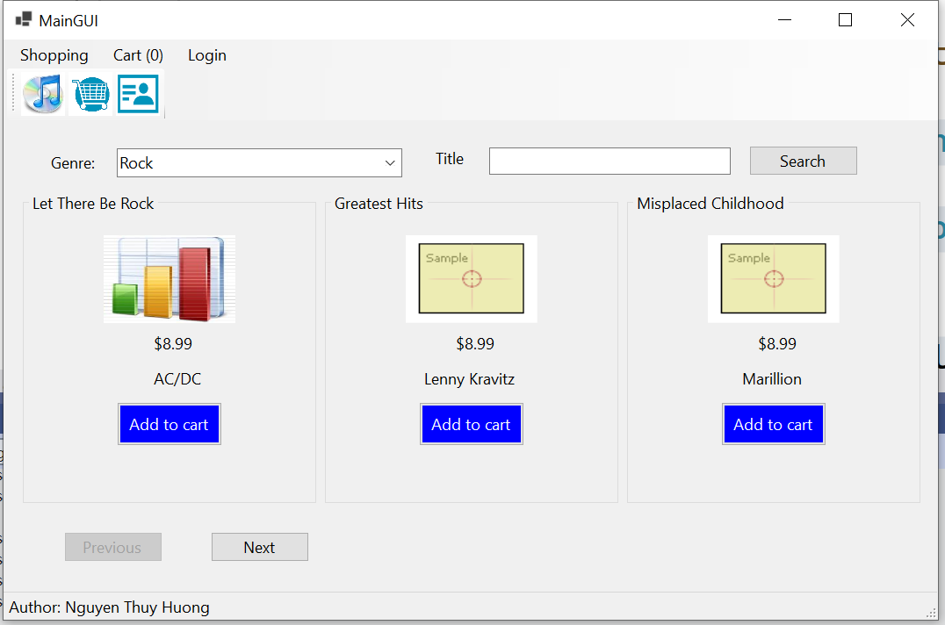

Requirements:

* List all albums for the selected genre, and the title of album. Each time only one page (maximum 3 albums) is displayed. Click button ‘Previous’/’Next’ to move to the previous/next page.
* Click button “Add to cart” to add that album to cart.

# CartGUI form

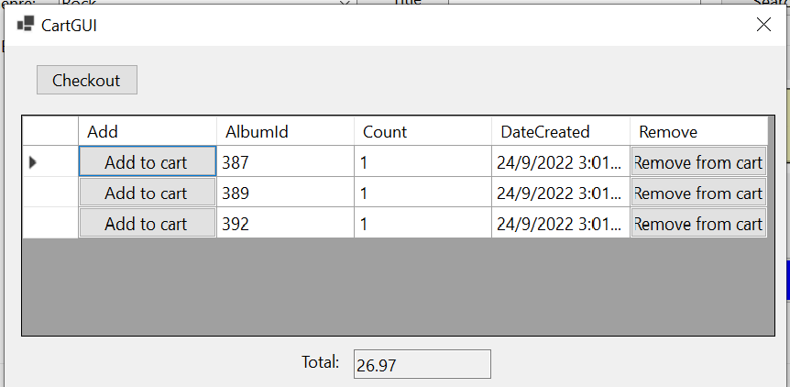

Requirements:

* Click the button “Add to cart” to add the given album to cart (count will be increased by 1).
* Click the button “Remove from cart” to remove the given album from cart (Count will be decreased by 1 if count > 1, or that album will be remove from cart if Count = 1).
* Click the button “Checkout”, to display the form “CheckoutGUI”.

Note: the button “Checkout” is only enabled if there is any album in cart and the user was logged in.

# CheckoutGUI form

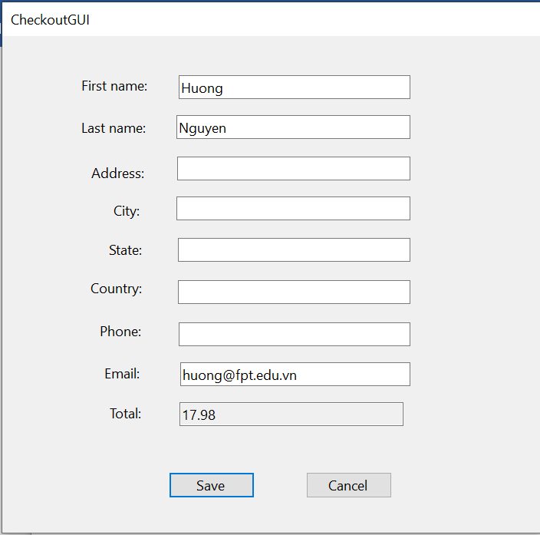

Requirements:

* Information of user logged in will be filled, and current system date will be considered as order date, the user can enter information as he/she wants.
* Click the button “Save” to save that order into Database, the following message will be displayed

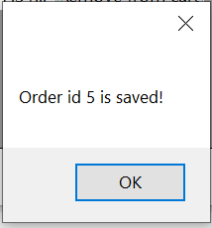

# AlbumGUI form

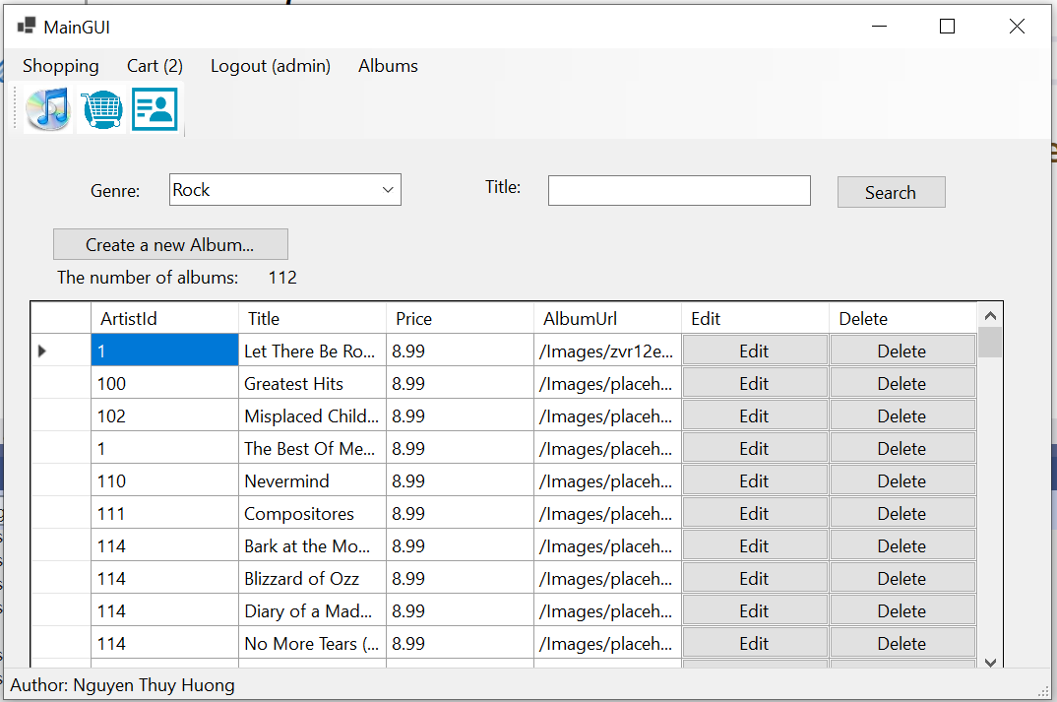

Requirements:

* List all albums for the selected genre and tittle.
* Click the button “Delete”, then the following message will be displayed

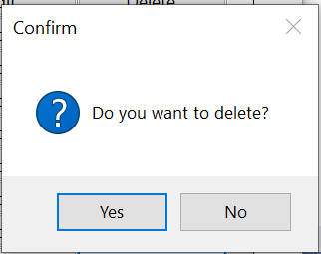

Click the button “Yes” to delete that album from Database, and the following message will be displayed

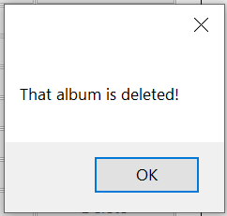

# AlbumAddEditGUI form

* For the case “Create a new”

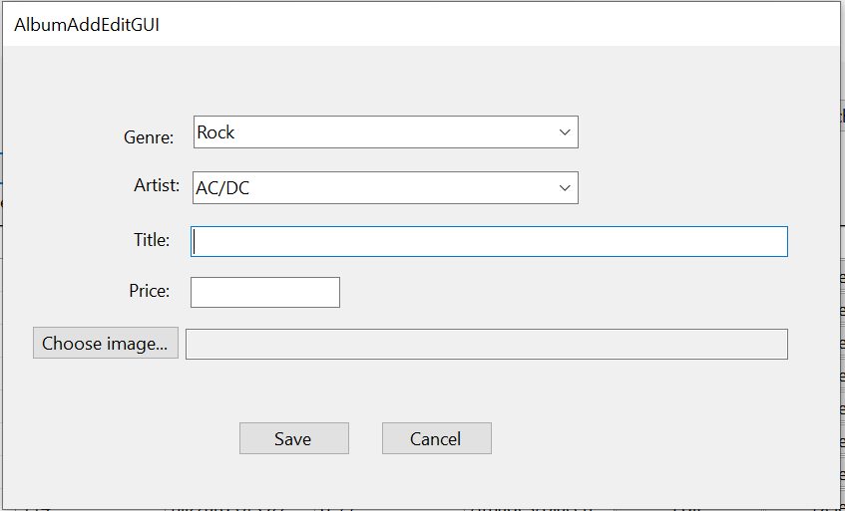

* For the case “Edit”

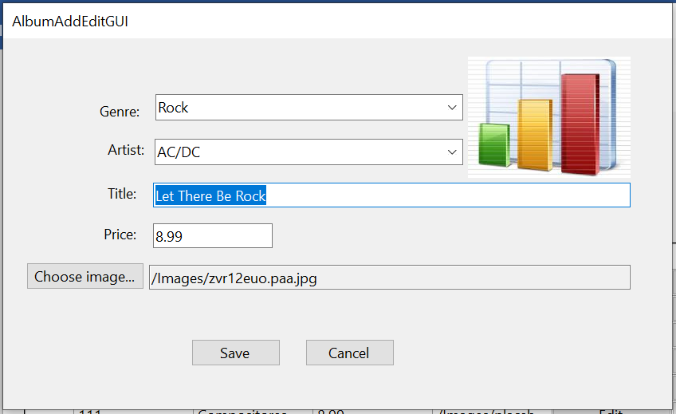

Requirements:

* Select genre name and artist name.
* Title is required.
* Price is required and must be a number.
* Click the button “Choose image” to open a dialog “OpenFileDialog” allows the user to select an image file (initial directory is the subdirectory “Images” of current directory)
* Click the button “Save” to save that album into Database.

**General Requirements:**

* Your system must follow all rules described in Music Store system (in document “List of sample projects”.
* Your system must check input data and allow the user to enter again.
* Use Database “MusicStore” given in site “cms” and must use “localhost” for the name of DB server computer .
* Your solution name: ClassID_GroupN_A2.sln, and file name: ClassID_GroupN_A2.rar