Question 1 (2 Point) Write a class named Fan that holds information of a fan.

Fan | Where:  - Fan() - Default Constructor.  - Fan(code:String, price:double) - Parameterized constructor, which sets values to code and price.  - getCode(): String – return code in uppercase format.  - getPrice(): double – return price.  - setPrice(price:double): void – update the value of price.
-code:String
-price:double
+Fan ()
+Fan(code:String, price:double)
+getCode():String
+getPrice():double
+setPrice(price:double):void
Do not format the result.
The program output might look something like:
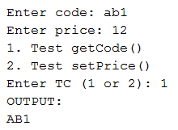 | 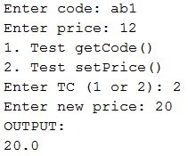

Question 2 (3 Point) Write a class named Car that holds information about a Car and class named VNCar which is derived from Car (i.e. Car is super class and VNCar is sub class).
Car | Where:  - getName(): String – return name.  - getPrice(): double – return price.  - setPrice(price:double): void – update price.  - toString():String – return the string of format:  name price
-name:String
-price:double
+Car()
+Car(name:String, price:double)
+getName():String
+getPrice():double
+toString():String

VNCar | Where:  - getSalePrice(): double – return the value price1=price+inc, where inc = 10% of price if series<300, = 0 otherwise.  - toString():String – return the string of format:  name price series
-series:int
+VNCar ()
+VNCar (name:String, price:double, series:int)
+getSalePrice():double
+toString():String
Do not format the result.

The program output might look something like:
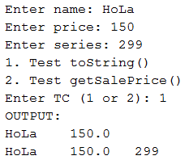 | 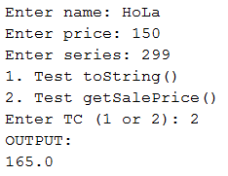 | 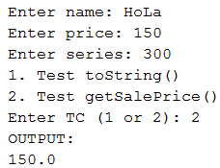

Question 3 (3 Point)
Write a class named Fan that holds information about a fan.
Fan | Where:  - getCode(): String – return code.  - getPrice(): double – return price.  - setCode(code:String): void – update code.  - setPrice(price:double): void – update price.  Do not format the result.
-code:String
-price:double
+Fan ()
+Fan (code:String, price:double)
+getCode():String
+getPrice():double
+setCode(code:String):void
+setPrice(price:double):void

The interface IFan below is already compiled and given in bytecode format, thus you can use it without creating IFan.java file.
import java.util.List;
public interface IFan {
public void f1(List<Fan> t, String xCode);
public int f2(List<Fan> t, double xPrice);
public void f3(List<Fan> t);
}

Write a class named MyFan, which implements the interface IFan. The class MyFan implements methods f1, f2 and f3 in IFan interface as below:
- f1: Increase the price by 10% for those fans (in the list t) having code starts with xCode (see sample output).
- f2: count and return the number of fans (in the list t) having price <= xPrice.
- f3: sort all fans (in the list t) ascendingly by price, in case their prices are the same, sort them ascendingly by their code alphabetically. The sorting must ignore case during the comparation.
In the main() function, the list t already contains some data and you can realize it from the output.
When running, the program output might look something like:
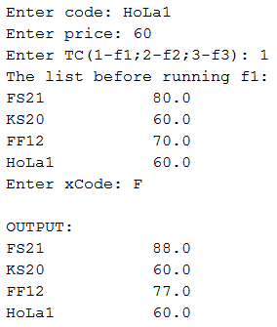 | 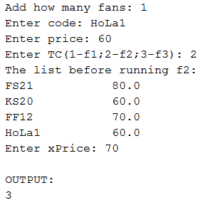 | 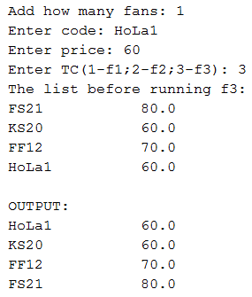

Question 4 (2 Point) The interface IString below is already compiled and given in bytecode format, thus you can use it without creating IString.java file.
public interface IString {
public int f1(String str);
public String f2(String str);
}

Write a class named MyString, which implements the interface IString. The class MyString implements methods f1 and f2 in IString interface as below:
- f1: calculate and return sum of all digits in str.
- f2: return the string s, which is obtained by reading all characters in str, if a character is a digit between 0 and 8 then increase it by 1 (others characters are unchanged). E.g., if str=”a01b2c8d9” then s = ”a12b3c9d9”

The program output might look something like:
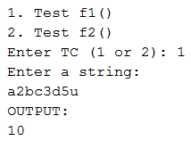 | 