**BOOKSTORE M.S REPORT**

***Group 19:***

*Bùi Quang Hà - BI10-052*

*Trần Hoàng Minh*

*Phạm Trung Kiên*

*Nguyễn Bá Ngọc Minh*

**Contents**

***1 Introduction***

1.1 What does it do? . . . . . . . . . . . . . . . . . . . . . . . . . . . . . . . . . . . . .

1.2 Advantages of this project . . . . . . . . . . . . . . . . . . . . . . . . . . . . .

***2 How we created it***

2.1 Database scheme . . . . . . . . . . . . . . . . . . . . . . . . . . . . . . . . . . . .

2.2 Python GUI, classes, function, modules, input output . . . . . . . ..

1 Introduction

**1.1 What does it do?**

These are the main functions of this system :

**Input the data**

The user can input the required data in the database table. Users can type the value into each box. When they are done they can click on the “Save” button according to each table that they want to “Save” the data.

**Save the data**

With the help of a database, the data will be stored. Also, reduce the time for storage checking by matching data across the database. The books information will be saved to the system and shown in the list box, one by one, defined by the order that the customer had typed in.

**Control the data**

The user can clear and update the data in the database for later use. Also, with the connection to the database, for each change, the data across the database will be implemented , reducing the time of inputting data. If the input is incorrect, the user can manually change the data in the database as much as they want.

**Search the data**

There is a very vital function is to search the book in the database, which has been stored. The user can get the data from each table out. For each table, we set up a searching module, that helps the user find the right exactly book from the database.

**1.2 Advantages of this system**

We are confident to say that with the following advantages, users will choose our coffee shop management system than the others

**Easy to use**

* This Bookstore management takes just a little time to get used to.
* Each feature is designed with a separate area, a space to typethe data in, and a button for each function.
* This doesn’t have many interface classes, so it is very easy for the customer in hurry situations.

**Back up and recovery**

* This management system is able to create and store data in a file.
* The user can store this data in many ways and forms: pack it into a zip file, push it into the internet cloud systems or store it in a USB for not losing the data.

**Privacy**

* This system works without the internet.
* Also, this application works in any device, so it is convenient and simple to carry the work abroad or something like that.

**Data consistency**

* All the data in the database appear consistent and stay the same for user viewing.
* No data redundancy.

**Adaptation**

* The database can easily change to adapt to the requirement.
* So for each Bookstore, the owner can set up their own database for use.
* This management system works flexibly in all situations and user requirements.

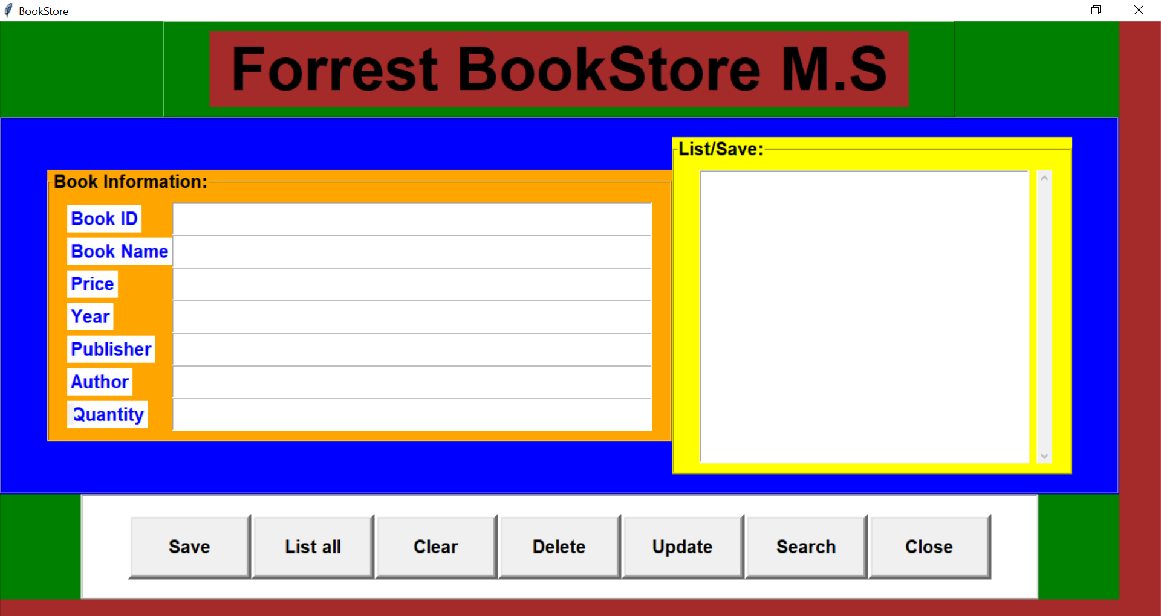

2 How we implemented it

**2.1 Database scheme**

- To keep information and to access the data easily, we created a database called “book management”

- There are 1 tables: Book

- Here is the database scheme

**2.2 Python UI, classes, function, modules, input,output:**

Firstly, WE create a “Class Book” which is the main class contain :

GUI, the variable, the function

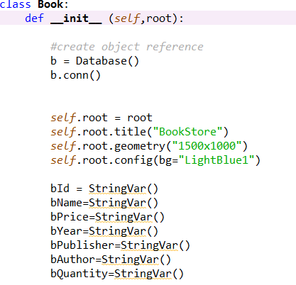

Then we created 3 Frame the main frame

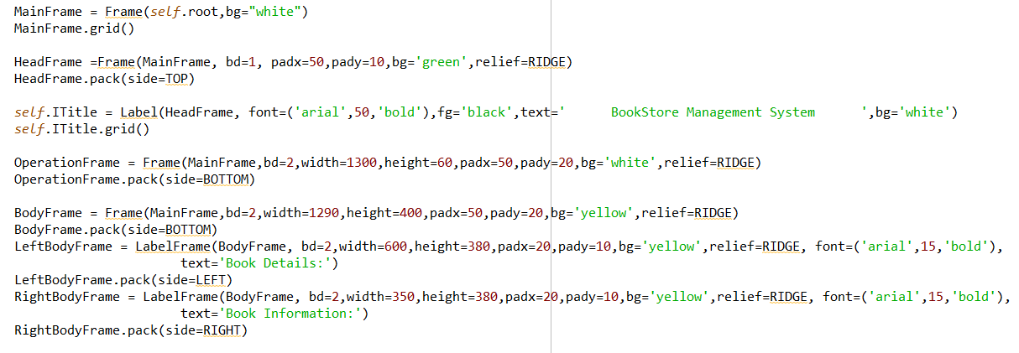

And now we add Buttons

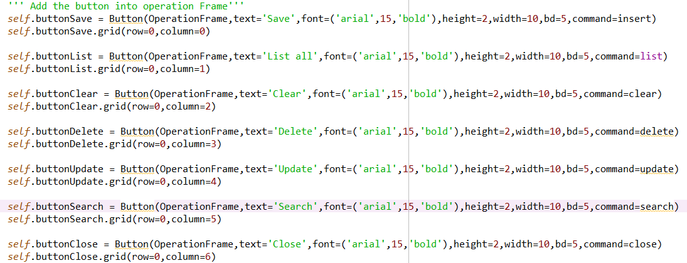

we prefer the button to stay vertical so we changed columns of each button one by one.To make Buttons works we create functions

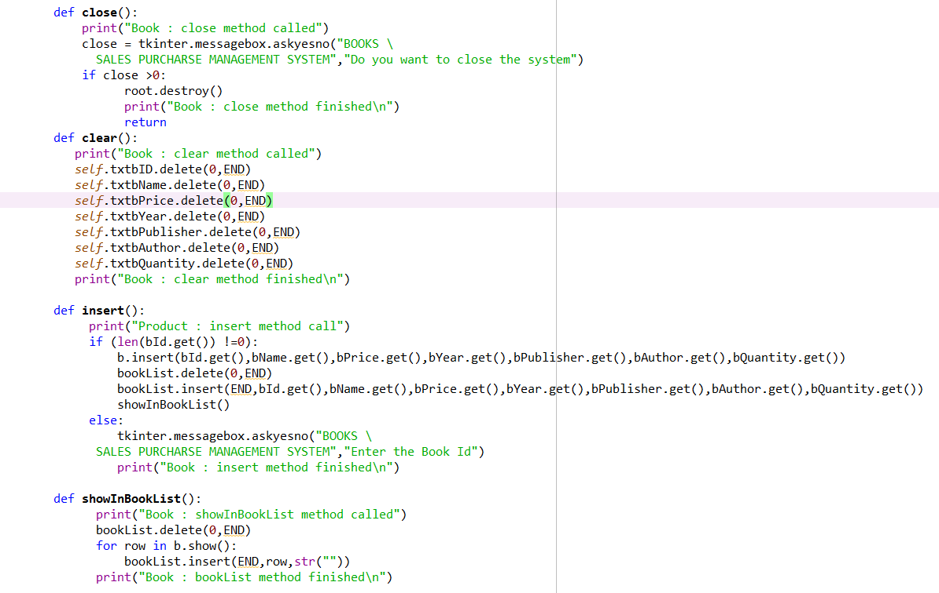

Now we make a new database class so that we can storage book’s data

