# Full name : Trần Hoàng Minh

# Student ID/Class : BI10-119 ICT

Final

Computer Network Report

**Problem Task**: Make a IPv6 tunnel through IPv4 network

Suppose we have the following network:

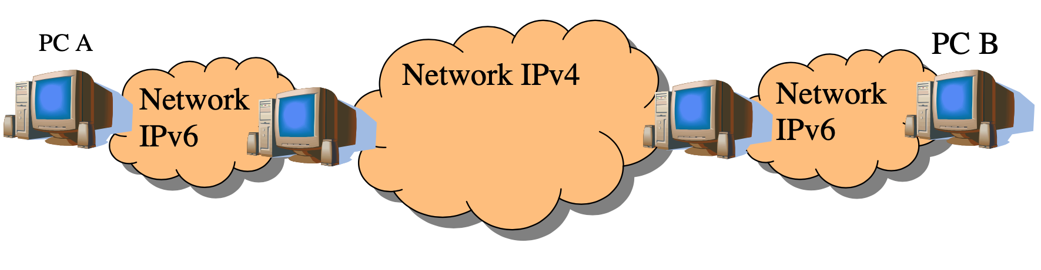

The network consists of 4 computers: PC A, PC B, Router A, and Router B, but the virtual machines are named PC-1, PC-2, Router-1, and Router-2 respectively in this emulation.

There is an IPv6 network between PC-1 and Router-1 as well as between PC-2 and Router-2. Between two routers, there is an IPv4 network. To connect PC-1 and PC-2, we need to configure an IPv6 tunnel between the two routers.

This report describes the procedure of emulating this network.

# IPv6 tunneling over IPv4

For this mission, this is the list of tools, softwares I used:

* Host: Window 10 Home (64-bit), Microsoft
* Cisco Packet Tracer

Since IPv4 and IPv6 are not compatible with each other we need strategies. One technique that we can use is tunneling. We encapsulate IPv6 packets into IPv4 packets (or the other way around) so that it can be routed. In this lesson I’ll show you how to configure IPv6 static tunneling over an IPv4 network.there are two methods:

* Manual tunnels
* GRE (Generic Routing Encapsulation) tunnels

The manual tunnels refer to RFC 4213 which defines how to encapsulate IPv6 packets in IPv4

**We have the following network topo:**

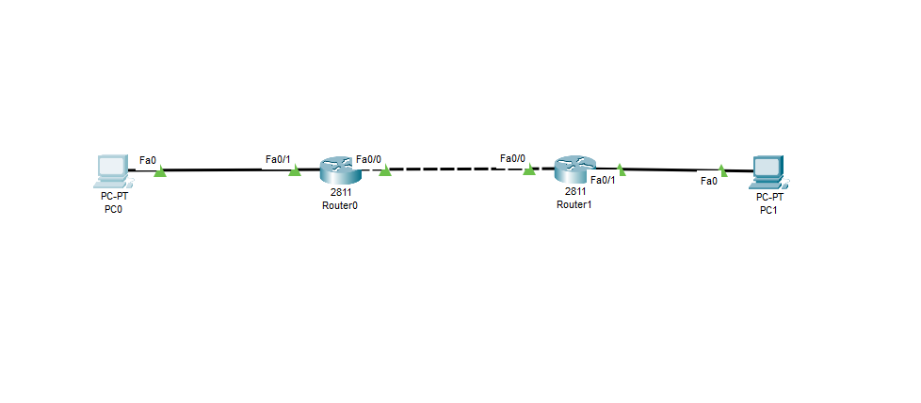

**And the configuration for each Router:**

Router0:

!

version 12.4

no service timestamps log datetime msec

no service timestamps debug datetime msec

no service password-encryption

!

hostname Router

!

!

!

!

!

!

!

!

ip cef

ipv6 unicast-routing

!

no ipv6 cef

!

!

!

!

!

!

!

!

!

!

!

!

spanning-tree mode pvst

!

!

!

!

!

!

interface Tunnel0

no ip address

mtu 1476

ipv6 address 1001::1/64

tunnel source FastEthernet0/0

tunnel destination 129.175.1.2

tunnel mode ipv6ip

!

!

interface FastEthernet0/0

ip address 129.175.1.1 255.255.255.0

duplex auto

speed auto

!

interface FastEthernet0/1

no ip address

duplex auto

speed auto

ipv6 address 2001:2::1/64

!

interface Vlan1

no ip address

shutdown

!

ip classless

!

ip flow-export version 9

!

ipv6 route 2001:3::/64 1001::2

!

!

!

!

!

!

!

line con 0

!

line aux 0

!

line vty 0 4

login

!

!

!

end

Router1:

!

version 12.4

no service timestamps log datetime msec

no service timestamps debug datetime msec

no service password-encryption

!

hostname Router

!

!

!

!

!

!

!

!

ip cef

ipv6 unicast-routing

!

no ipv6 cef

!

!

!

!

!

!

!

!

!

!

!

!

spanning-tree mode pvst

!

!

!

!

!

!

interface Tunnel0

no ip address

mtu 1476

ipv6 address 1001::2/64

tunnel source FastEthernet0/0

tunnel destination 129.175.1.1

tunnel mode ipv6ip

!

!

interface FastEthernet0/0

ip address 129.175.1.2 255.255.255.0

duplex auto

speed auto

!

interface FastEthernet0/1

no ip address

duplex auto

speed auto

ipv6 address 2001:3::1/64

!

interface Vlan1

no ip address

shutdown

!

ip classless

!

ip flow-export version 9

!

ipv6 route 2001:2::/64 1001::1

!

!

!

!

!

!

!

line con 0

!

line aux 0

!

line vty 0 4

login

!

!

!

end

PC0:

IPv6 Address: 2001:2::2/64

Link Local Address: FE80::20A:F3FF:FED3:BE74

IPv6 Gateway: 2001:2::1

PC1:

IPv6 Address: 2001:3::2/64

Link Local Address: FE80::2E0:F7FF:FE0A:7D32

IPv6 Gateway: 2001:3::1

**All you have to do now is ping from PC0 to PC1:**

PC0>ping 2001:3::2

