BUSINESS BLUEPRINT

Document information
Project Name | Employee cash advance process
Module | Financial Accounting and Controlling (FICO)
Created by | Nguyễn Thịnh Khang  Trần Phú Nguyên
Version | 01
Date | 17/02/2025

Change history
Changed date | Items have been changed | Changed content/ reason | Updated by | Type  (A/C/D) | Version
17/02/2025 |  | Create new | Nguyễn Thịnh Khang  Trần Phú Nguyên | A | 01
A - Create C - Change D - Delete

Advisor Signature
 | Full name & Role | Signature | Date | Note
Created by | Nguyễn Thịnh Khang - Functional Consultant | KhangNT
 | Trần Phú Nguyên - Functional Consultant | NguyenTP
Review by | Lê Thị Thu Hiền | HienLTT | 17/02/2025
Approved by | Lê Thị Thu Hiền | HienLTT | 17/02/2025

FU Signature
 | Full name & Role | Signature | Date | Note
Review by | Nguyễn Hoàng Linh  Võ Thị Thanh Vân | LinhNH55  VanVTT10 | 24/02/2025
Approved by | Nguyễn Hoàng Linh  Võ Thị Thanh Vân | LinhNH55  VanVTT10 | 24/02/2025

TABLE OF CONTENTS
1. OVERVIEW 2
1.1. Glossary 3
1.2. Flow chart shapes usage 6
2. ORGANISATION STRUCTURE 7
2.1. Introduction 7
2.2. Organization structure 8
3. BUSINESS PROCESS 12
3.1. Process Chart 12
3.2. Process description 14
4. Reports 19

1. OVERVIEW
SAP (Systems, Applications, and Products in Data Processing) is a comprehensive enterprise resource planning software that helps organizations optimize and automate business processes. SAP provides integrated solutions for functions such as finance, accounting, human resources, manufacturing, supply chain management, and many other areas. With its ability to connect and automate processes on a single platform, SAP helps businesses minimize errors, increase efficiency, and improve decision-making based on accurate data.

The employee cash advance process in SAP allows businesses to effectively manage advances, ensuring transparency and tight financial control. Employees submit their advance requests through the system, and these requests are automatically approved according to internal policies.

Once the task is completed, employees submit their actual expense documentation, and the system matches and clears the advance. SAP also helps track and report on the status of advances, ensuring financial control and regulatory compliance.

This process minimizes errors, enhances transparency, and improves the overall effectiveness of financial management.

1.1 Glossary
Term | Definition | Note
Company Code | The smallest legal entity in SAP FI where financial transactions are recorded and reported independently.
Chart of Accounts | A list of general ledger accounts used by one or multiple company codes to record financial transactions.
General Ledger Accounts | Accounts in the general ledger used to record, classify, and report financial transactions.
Cost Center | An organizational unit in SAP CO used to track and control costs by department, division, or project.
Controlling Area | An organizational unit in SAP CO that groups multiple Company Codes under the same cost control and internal reporting system.
Employee Master Data | Detailed employee information stored in SAP, including employee ID, department, salary, bank details, and other relevant data.
Client | The Client is the highest organizational unit in the SAP system. It represents the global environment in which all data and configurations are stored.
Bank Master Data | Contains information about the company's bank accounts, including bank details, account numbers, and payment methods for processing transactions.
Payment Method | Determines the payment procedure in financial transactions and specifies the methods of payment, such as cash, checks, or bank transfers.

1.2. Flowchart shapes usage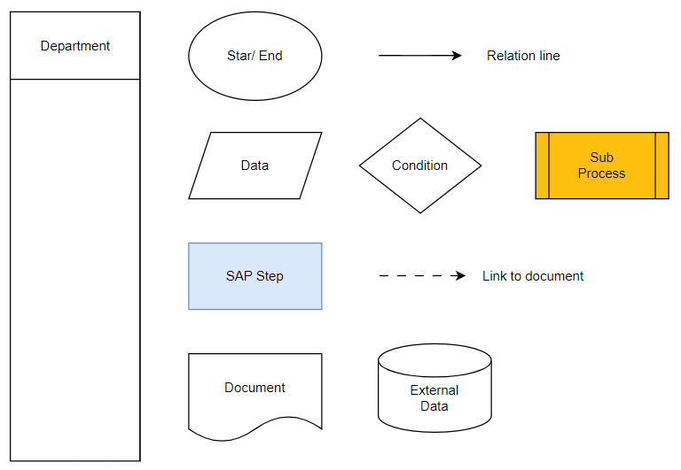

2. ORGANISATION STRUCTURE

2.1. Introduction
EY Vietnam is a member firm of Ernst & Young Global Limited, one of the world’s leading professional services organizations. With a strong presence in Vietnam for over 30 years, EY Vietnam provides high-quality services in assurance, tax, consulting, and strategy, serving both domestic and international clients across various industries.

To support employees in executing service-related tasks — such as client site visits, business trips, training sessions, and project coordination — EY Vietnam has implemented a structured and automated system for managing employee advance payments.

This system enables employees to initiate, receive, and settle cash advances in a transparent and timely manner. The process includes clear steps for approval, disbursement, and reconciliation, contributing to better financial control and adherence to internal compliance standards.

By integrating the advance management process into the company’s enterprise resource planning (ERP) system using SAP solutions, EY Vietnam ensures operational efficiency, cost transparency, and accountability, while providing employees with the necessary financial support to fulfill their responsibilities effectively in a service-driven environment.

2.2 Organization structure
This document covers the SAP FI elements pertaining to Organization structure. Following are the FI organizational elements covered:
+ Client
+ Company Code
+ Chart of Accounts
+ Controlling Area

2.2.1 Organization Structure Diagram

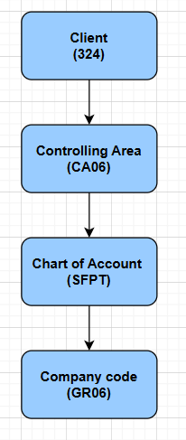

- Controlling Area
Represents an organizational unit in controlling, used for internal cost tracking and financial reporting across company codes. In the cash advance process, it ensures the cost related to advances is tracked for accurate internal financial reporting. Assigned to code: CA06
Controlling Area | Description
CA06 | Controlling Area 06

- Chart of Accounts
A list of all G/L accounts used in the company, providing a structure for financial transactions and reporting. In the employee cash advance process, it defines which accounts will be used to record the advances and repayments. Assigned to code: SFPT
Chart of Accounts | Description
SFPT | Hệ thống tài khoản kế toán EYVN

- Company Code
Represents an independent legal entity within the organization, used for financial accounting and reporting. In the context of employee cash advances, it determines which legal entity will process the advance transactions. Assigned to code: GR06
Company Code | Description
GR06 | EY Vietnam​

2.3. Master Data
A. Employee Master Data
Contains essential information about employees, including personal details, employment history, and payment information. In the context of employee cash advances, it ensures accurate processing of advance requests and repayments, linking the employee's payment method and accounting details.
- Payment Method
Defines how payments are made to employees, such as via bank transfer, check, or cash. In the employee cash advance process, it determines the method used for disbursing the cash advance to the employee.
- Cost Center
Represents an organizational unit within the company where costs are incurred and tracked. In the employee cash advance process, it is used to allocate the cost of the advance to the appropriate department or unit for internal cost tracking and reporting.

BUSINESS PROCESS

Process Chart

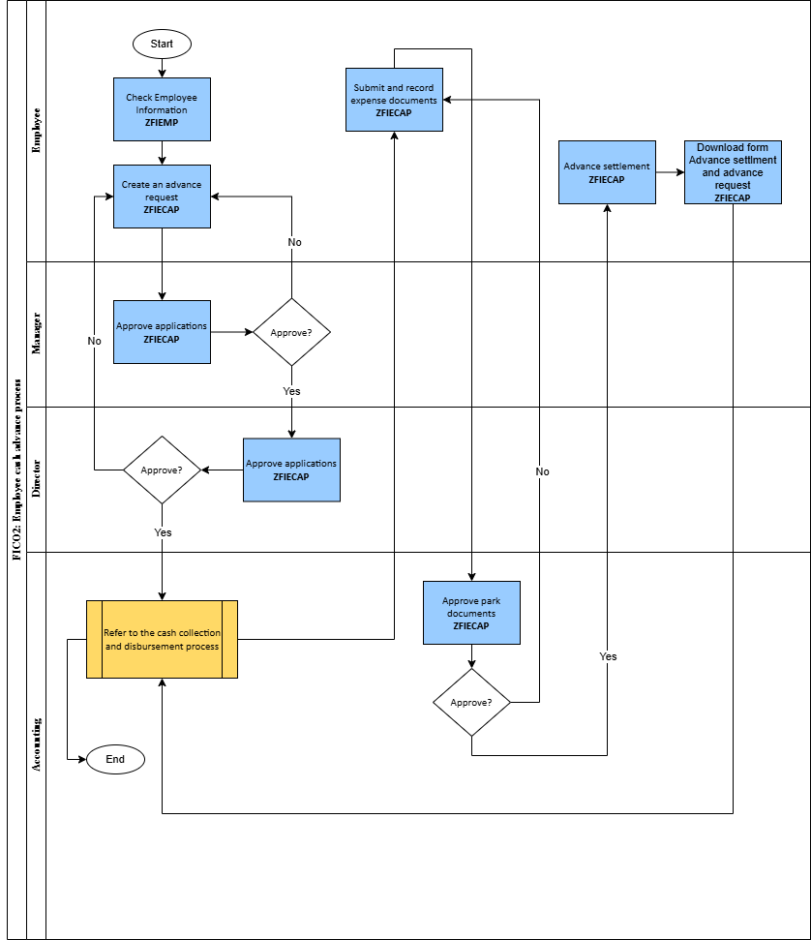

3.2. Process description

Step # | Step Name | Detailed Description | Role
0 | Start |  | -
1 | Check Employee Information | - Use ZFIEMP to check Advance limit before create advance request.  - Require data:  + Company Code  + Employee ID  + Position  + Department | Employee
2 | Create employee advance request | - Use ZFIECAP to create an employee advance request.  - Each employee level has a designated budget.  - If an employee creates a request exceeding the - budget, creation will not be allowed.  If the request is within the allowed budget, proceed to the next step.  - Required Input Data:  + Amount: The amount required.  + Payment method.  + Document Date  + Payment Due Date: required date.  + Advance Reason  + Description: Reason for advance. | Employee
3 | Approve ? | - Use ZFIECAP to Approve or Reject the request and provide a reason. Detailed review (reason, documents, policy compliance).  - If approved, proceed to the next step.  - If rejected, return to the employee step and notify the reason for rejection.  - Required Input Data: Reject Reason | Manager
4 | Approve ? | - Use ZFIECAP to Approve or Reject the request and provide a reason. Overall review (priority level, high-level policy compliance)  - If approved, proceed to the next step.  - If rejected, return to the employee step and notify the reason for rejection.  - Required Input Data: Reject Reason | Director
5 | Refer to the cash collection and disbursement process | Disburse funds to employee for advance payment.  + Debit Employee Advances Account (141)  + Credit Company’s Cash or Bank Account (111, 112) | Accounting
6 | Submit and record expense documents | - Use ZFIECAP to record the expense and parked documents.  - Required Input Data:  + Address  + Supplier Name  + Invoice date  + Invoice Symbol  + Posting Date  + VAT Registration  + Amount  + Currency  + Tax code  + Tax %  + Tax Amount  + Cost Type  + Cost Name  +Text  + Link to send the document in text form.  - The accounting entries related to employee advances are as follows:  + Debit 641 or 642  + Credit 141 | Employee
7 | Approve parked documents | - Use ZFIECAP to check the documents  - If approved, go to the next step the documents will be posted in the system.  - If not approved then input Reject Reason and go back to the employee step, ask the employee to settle the payment and resend the documents. | Accounting
8 | Advance settlements | - Use ZFIECAP to clear liabilities | Employee
9 | Download smart form advance settlement and advance request | -Use ZFIECAP to download the advance settlement report form and advance request form.  - The employee downloads the form to submit it with the company's signature in order to proceed with either reimbursing the company or receiving reimbursement from the company. | Employee
10 | Refer to the cash collection and disbursement process | - The accountant receives the excess money or reimburses the employee.  - After advance settlements :  - If the expense, after using the employee's advance, exceeds the initial amount, the accounting team will request the cashier to reimburse the employee.  * The journal entry:  + Debit 141 - Employee advances  + Credit 111, 112 - Company’s Cash or Bank Account  - If the expense, after using the employee's advance, is less than the initial amount, the accounting team will request the cashier to collect the excess amount from the employee.  * The journal entry:  + Debit 111, 112 (Company's Cash or Bank)  + Credit 141 (Employee Advances) | Accounting
11 | End |  | -

4. Relavant reports

No. | Description | T-Code
1 | Create Vendor Down Payment Request  - Used to create a request for an advance payment to a vendor. This transaction records the expected down payment but does not execute the actual payment yet. | ZFIECAP
2 | Display Vendor Line Items  - Allows users to view all accounting entries related to a vendor, including outstanding payable, cleared items, and pending payments. Users can filter data by vendor, document status, etc. | FBL1N
3 | Displaying General Ledger Line Items in SAP  - Both transactions are used to retrieve detailed financial transactions in the General Ledger. FAGLL03 operates in SAP ECC, using old data tables (BSIS, BSAS), which may result in slow queries for large datasets. In contrast, FAGLL03H is an upgraded version for SAP S/4HANA, utilizing the Universal Journal (ACDOCA table) and SAP HANA technology, enabling faster data processing and enhanced reporting capabilities. | FAGLL03/FAGLL03H
4 | Employee Information  - The ZFIEMP T-code allows users to retrieve employee information in SAP FI. Filters include company code, employee ID, department, and position. Results are displayed in ALV format, showing personal details, contact info, advance limits, balances, etc. | ZFIEMP

