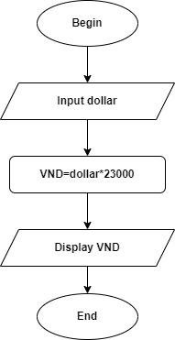 Begin

Input Dollar

VND = Dollar\*23000

Display VND

End