Begin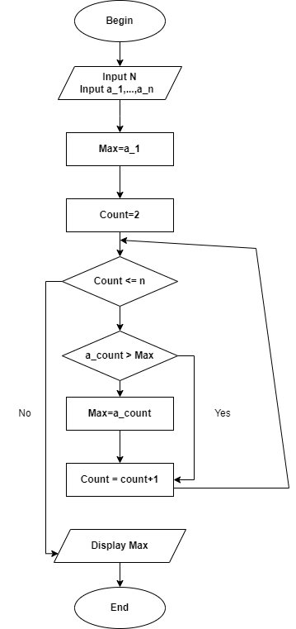

Input N

InPut a_1,....,a_n

Max = a_1

Count = 2

While ( count <= n )

Do

IF a_count > Max

Max = a_count

End IF

Count = count + 1

End Do

Display Max

End