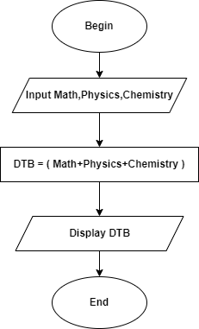 Begin

Input Math,Physics,Chemistry

DTB = ( Math+Physics+Chemistry )

Display DTB

End