** MINISTRY OF EDUCATION AND TRAINING**

**FPT UNIVERSITY**

Capstone Project Document

**Laptop Reviews**

|  |  |
| --- | --- |
| **Group 1** | |
| **Group member** | Vo Thi Minh Chau – Team Leader – SE60931  Nguyen Van Hon – Team Member - 60390  Dinh Huu Toan – Team Member - SE60871  Nguyen Manh Khuong – Team Member - 60455 |
| **Supervisor** | Mr. Kieu Trong Khanh |
| **Ext. Supervisor** | N/A |
| **Capstone Project code** | LRA |

-Ho Chi Minh City, ***05/2015***-

*This page is intentionally left blank*

***ACKNOWLEDGEMENTS***

We wish to thank various people for their contribution to this project: Our teachers for their advice and participation in the final review, our friends for their valuable technical support.

Special thanks should be given to Mr.Kiều Trọng Khánh, our research supervisor for his professional guidance and the useful, constructive recommendations throughout the course of this project.

# Table of Contents

Table of Contents 4

List of Tables 5

List of Figures 6

Definitions, Acronyms, and Abbreviations 7

Report No.3 Software Requirement Specification 8

1. User Requirement Specification 8

1.1 Guest Requirement 8

1.2 Staff Requirement 8

1.3 Admin Requirement 8

1.4 System Requirement 8

1.5 Member Requirement 8

2. System Requirement Specification 8

2.1 External Interface Requirement 8

2.2 System Overview Use Case 9

2.3 List of Use Case 11

3. Software System Attribute 29

3.1 Usability 29

3.2 Reliability 29

3.3 Availability 29

3.4 Security 30

3.5 Maintainability 30

3.6 Portability 30

3.7 Performance 30

4. Conceptual Diagram 31

# List of Tables

Table 1: <Admin> Configure System 11

Table 2: <Admin> Make Statistics 12

Table 3: <Admin> Create User 14

Table 4: <Admin> Update User 15

Table 5: <Admin> Activate User 16

Table 6: <Admin> Deactivate User 17

Table 7: <Admin> Force Parse Data 19

Table 8: <System> Auto Parse Data 20

Table 9: <Staff> Create Market 23

Table 10: <Staff> Update Market 25

Table 11: <Staff> Deactivate Market 26

Table 12: <Staff> Activate Market 28

Table 13: <Staff> Import File 30

Table 14: <Staff> Manually Input 32

Table 15: <Staff> Update Product 33

Table 16: <Staff> Deactivate Product 34

Table 17: <Staff> Activate Product 36

Table 18: <Member> Ask For System Suggestion 37

Table 19: <Member> Search Product and View Product Price 39

Table 20: <Member> Add Product To Cart 40

Table 21: <Member> Propose Price 41

Table 22: <Member> Save Product History 42

Table 23: <Member> Logout 43

Table 24: <Guest> Login 45

Table 25: <Guest> Register 47

# List of Figures

Figure 1: System Overview Use Case 9

Figure 2: <Admin> Overview use case 10

Figure 3: <Admin> Configure System 10

Figure 4: <Admin> Make Statistics 11

Figure 5: <Admin> Create User 12

Figure 6: <Admin> Update User 14

Figure 7: <Admin> Active User 15

Figure 8: <Admin> Deactivate User 16

Figure 9: <Admin> Force Parse Data 18

Figure 10: <System> Overview Use Case 19

Figure 11: <System> Auto Parse Data 19

Figure 12: <Staff> Overview Use Case 21

Figure 13: <Staff> Create Market 21

Figure 14: <Staff> Update Market 23

Figure 15: <Staff> Deactivate Market 25

Figure 16: <Staff> Activate Market 27

Figure 17: <Staff> Import File 28

Figure 18: <Staff> Manually Input 30

Figure 19: <Staff> Update Product 32

Figure 20: <Staff> Deactivate Product 33

Figure 21: <Staff> Activate Product 35

Figure 22: <Member> Overview Use Case 36

Figure 23: <Instructor> Ask For System Suggestion 36

Figure 24: <Member> Search Product and View Product Price 37

Figure 25: <Member> Add Product To Cart 39

Figure 26: <Member> Propose Price 40

Figure 27: <Member> Save Product History 41

Figure 28: <Member> Logout 43

Figure 29: <Guest> Overview Use Case 44

Figure 30: <Guest> Login 44

Figure 31: <Guest> Register 45

Figure 35: ERD - Conceptual Diagram 49

# Definitions, Acronyms, and Abbreviations

|  |  |
| --- | --- |
| LRA | Laptop Review |

# Report No.3 Software Requirement Specification

## User Requirement Specification

### Guest Requirement

Guests is a person who doesn’t have access to the system. Guest can use some functions in the system. These are some functions guest can use:

Guests are normal users who don’t have access to the system. Guests can use almost functions but the systems functions. Here are things guests can do with our website:

* Search products and their reviews.
* View products details with all useful information.
* Ask for not available products.
* Ask for notification when asked products are available.

### Staff Requirement

Staff is a person whose work is maintaining the system. Staff will be able to do following things:

* Update dictionary manually or through importing Excel file.
* Modify parser function.
* Train the system so that it can handle some tasks such as managing duplicated products.
* Configure the system
* Force parsing data

### Admin Requirement

Admin is the one who manage the overall system. Admin can do all Staff’s function plus:

* Manage users.

### System Requirement

System is also an actor help run the website. System will handle these works:

* Auto parse the data
* Auto find synonyms and antonyms
* Save not available laptops that request by guests

### Member Requirement

Member will be able to do following things:

* Edit profile
* Change password

## System Requirement Specification

### External Interface Requirement

#### User Interface

* + The interface of the website should be clear, easy to understand that does not require much time to learn to use.
  + The error, warning messages must be clear and should not contain technical words that may annoy users.

#### Hardware Interface

* + The system will use the standard hardware and data communication resources that can be easily found on any normal computers.

#### Software Interface

* + Web browsers such as Firefox, Chromes with Resolution (1024*768) or bigger that support JavaScript and HTML5.

#### Communication Protocol

* Website using HTTP protocol for communication between the web browser and the web server.

### System Overview Use Case

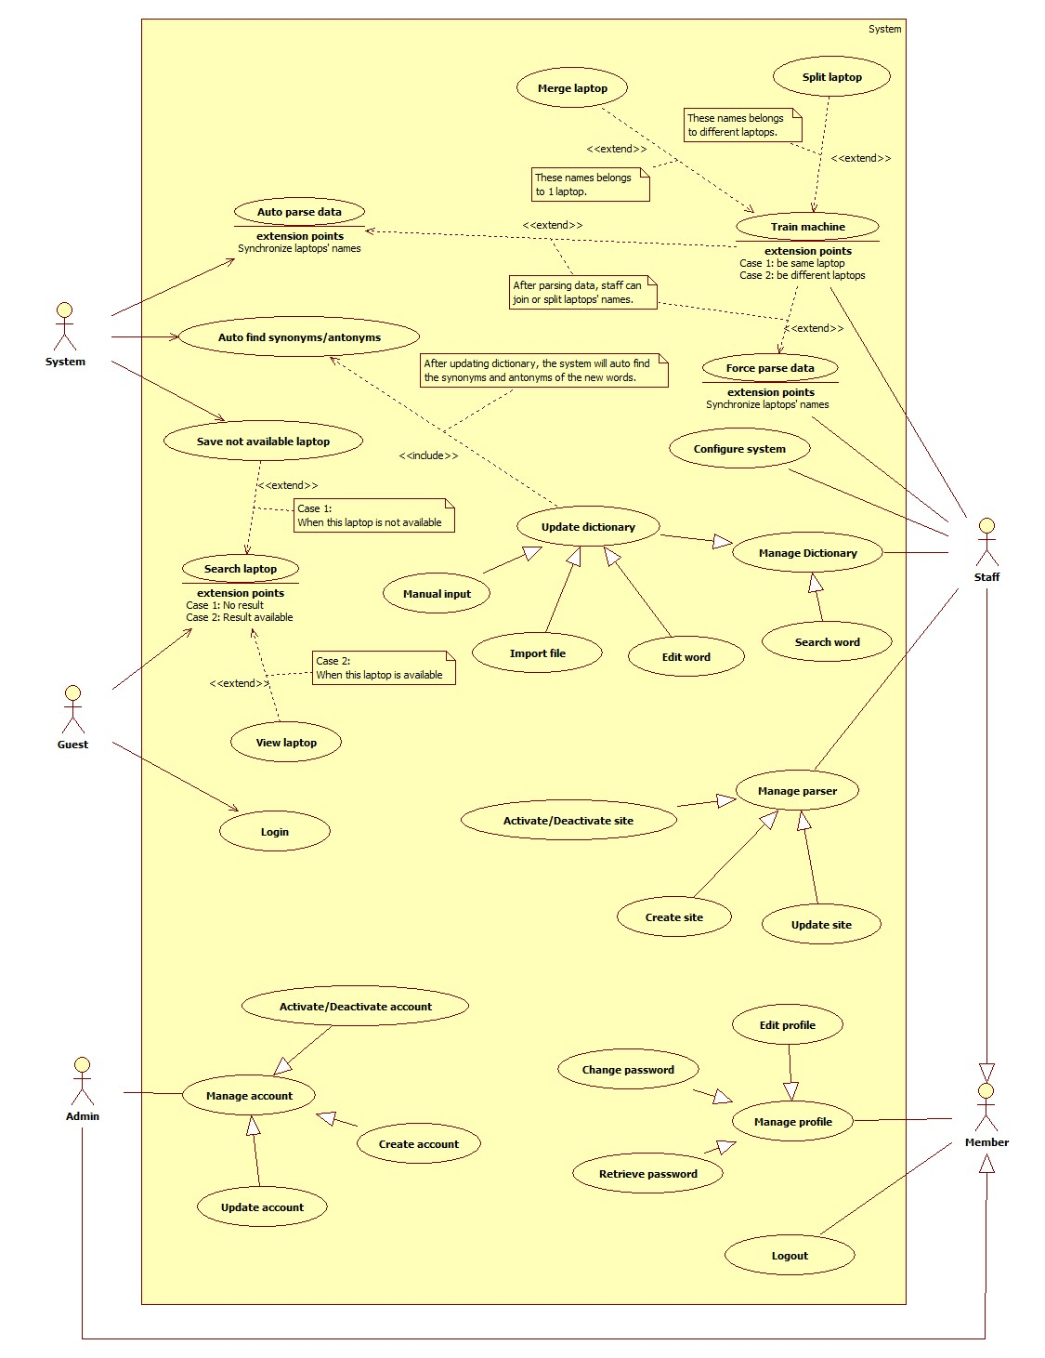

Figure 1: System Overview Use Case

### List of Use Case

#### <System> Overview Use Case

##### <System> Auto Parse Data

##### <System> Auto Find Synonyms/Antonyms

##### <System> Save Not Available Laptop

#### <Guest> Overview Use Case

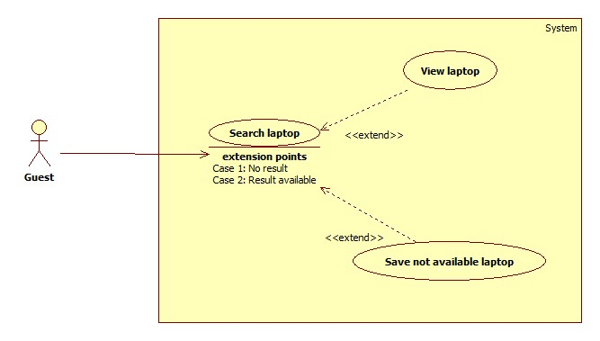

##### <Guest> Search Laptop

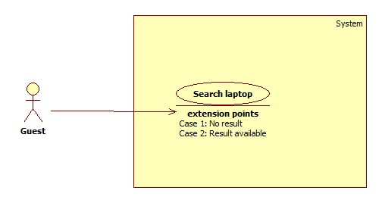

|  |  |  |  |
| --- | --- | --- | --- |
| **USE CASE – LRA004** | | | |
| **Use Case No.** | LRA004 | **Use Case Version** | 2.0 |
| **Use Case Name** | Search Laptop | | |
| **Author** | Dinh Huu Toan | | |
| **Date** | 18/05/2015 | **Priority** | High |
| **Actor:**   * Guests   **Summary:**   * This use case allows guest to search and view laptops brief information.   **Goal:**   * A list of appropriate laptops will be shown to user.   **Triggers:**   * Guest wants to search for laptops’ information. * Guest can choose brand of the laptops to maximize the search result. * Input laptop name into search textbox then click “Search”.   **Preconditions:**   * N/A.   **Post Conditions:**   * **Success:** A list of appropriate laptops is shown along with laptops’ information: name and percentage of positive comments. * **Fail:** Show an error message.   **Main Success Scenario:**   |  |  |  | | --- | --- | --- | | Step | Actor Action | System Response | | 1 | Guest inputs the laptop’s name into textbox, choose the brand or they can leave it the default value.  (Guest provide laptop information such as name) |  | | 2 | Guest clicks “Search” button  (Guest sends Search command) | * System will show a list of appropriate laptops as a grid which contains 3 laptops in one row.[Alternative 1] * A laptop will show in a square frame with following information: * Laptop’s image * Name * Percentage of positive comments |   **Alternative Scenario:**   |  |  |  | | --- | --- | --- | | No | Actor Action | System Response | | 1 | System cannot find searched laptops | System will show a pop-up. In that pop-up include: a message: “This laptop is not available. Would you like to receive information about this laptop when it’s available?”, a textbox for inputting email, and “Submit”/”No, Thanks!” buttons (command) |   **Exceptions:** N/A  **Relationships:** N/A  **Business Rules:**   * Guest can leave the search textbox empty, then all laptops available in the database should be listed. * Guest can choose Brand when searching to maximize the result. * ( Tieu chi search, sau khi search k co thi he thong se lam gi …) | | | |

##### <Guest> View Laptop Detail through Search

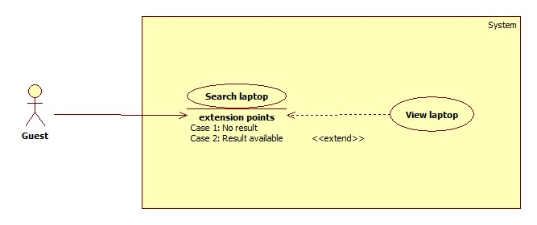

|  |  |  |  |
| --- | --- | --- | --- |
| **USE CASE – LRA005** | | | |
| **Use Case No.** | LRA005 | **Use Case Version** | 2.0 |
| **Use Case Name** | View laptop detail | | |
| **Author** | Dinh Huu Toan | | |
| **Date** | 18/05/2015 | **Priority** | High |
| **Actor:**   * Guests   **Summary:**   * This use case allows guests to read laptop full details.   **Goal:**   * Show detail information of choosing laptop.   **Triggers:**   * Guest wants to read laptop details includes: name, reviews, specifications and images * Click “Details” link on each result found.   **Preconditions:**   * N/A.   **Post Conditions:**   * **Success:** Navigate to new page shows laptops’ information: name, reviews statistic, and images. * **Fail:** Show an error message.   **Main Success Scenario:**   |  |  |  | | --- | --- | --- | | Step | Actor Action | System Response | | 1 | Guest clicks “Detail” link on one result | * Navigate to “Detail” page with following information:   + Name of laptop   + Image slide show   + Specifications   + Statistic: number of Positive/Negative/Neutral reviews   + Reviews which are ordered by Positive/Negative and Neutral   + Suggested laptops |   **Alternative Scenario:** N/A  **Exceptions:** N/A  **Relationships:** Search Laptop  **Business Rules:**   * Details of laptop should be well-organized so that guest can easily read them. | | | |

##### <Guest> Login

#### <Member> Overview Use Case

##### <Member> Edit Profile

##### <Member> Change Password

##### <Member> Retrieve Password

##### <Member> Log out

#### <Staff> Overview Use Case

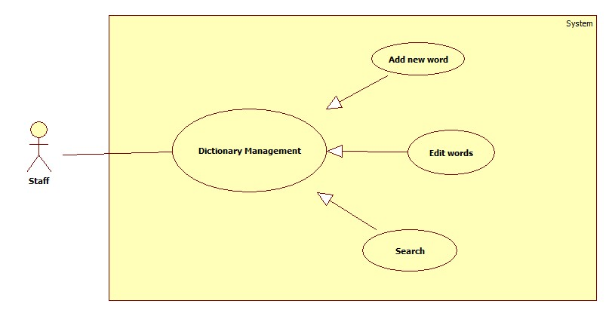

##### <Staff> Search Word

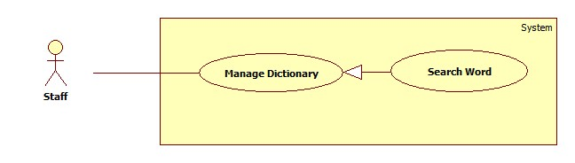

|  |  |  |  |
| --- | --- | --- | --- |
| **USE CASE – LRA003** | | | |
| **Use Case No.** | LRA003 | **Use Case Version** | 2.0 |
| **Use Case Name** | Search Dictionary | | |
| **Author** | Dinh Huu Toan | | |
| **Date** | 03/06/2015 | **Priority** | High |
| **Actor:**   * Staff   **Summary:**   * This use case helps staff to search for available word in dictionary   **Goal:**   * Show appropriate word to staff.   **Triggers:**   * Staff want to search words in dictionary for editing or viewing. * Click “Dictionary”, then “Dictionary Management” then input the word they want to search into search textbox   **Preconditions:**   * User should login to the system under Staff role.   **Post Conditions:**   * **Success:** Show list of appropriate words with definition field when pointing to each word. * **Fail:** Show an error message.   **Main Success Scenario:**   |  |  |  | | --- | --- | --- | | Step | Actor Action | System Response | | 1 | Staff click “Dictionary”, then “Dictionary Management” | * Navigate to “Dictionary Management” page with following information:   + Search textbox (free text input)   + Add button   + Edit button (command)   + List of words   + Definition of selected word include: definition, synonyms, antonyms, type of word (Pros/Cons/Neural) | | 2 | Input search string into search textbox | * The list of words will be filtered and show only words that match search string. [Alternative 1] |   **Alternative Scenario:**   |  |  |  | | --- | --- | --- | | No | Actor Action | System Response | | 1 | System cannot find word match search string | System will show a pop-up. In that pop-up include: a message: “This word is not available in the dictionary. Do you want to add it to dictionary?”, and “Add”/”No, Thanks!” buttons |   **Exceptions:** N/A  **Relationships:** Dictionary Management  **Business Rules:**   * The list should be filtered at the same time (Moi lan go mot ky tu thi search hay go 3 ky tu tro len moi search) the search string is inputted * The list is sorted by alphabet order. | | | |

##### <Staff> Manual Input

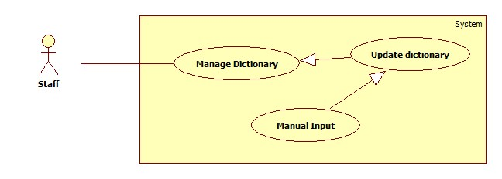

|  |  |  |  |
| --- | --- | --- | --- |
| **USE CASE – LRA004** | | | |
| **Use Case No.** | LRA004 | **Use Case Version** | 2.0 |
| **Use Case Name** | Add new word | | |
| **Author** | Dinh Huu Toan | | |
| **Date** | 03/06/2015 | **Priority** | High |
| **Actor:**   * Staff   **Summary:**   * This use case help staff to add new word to dictionary   **Goal:**   * New word is added to dictionary   **Triggers:**   * Staff want to add word to dictionary. * Click “Dictionary”, then “Dictionary Management” then click “Add” button   **Preconditions:**   * User should login to the system under Staff role.   **Post Conditions:**   * **Success:** New word is added to dictionary. * **Fail:** Show an error message.   **Main Success Scenario:**   |  |  |  | | --- | --- | --- | | Step | Actor Action | System Response | | 1 | Staff click “Dictionary”, then “Dictionary Management” | * Navigate to “Dictionary Management” page with following information:   + Search textbox   + Add button   + Edit button   + List of words   + Definition of selected word include: definition, synonyms, antonyms, type of word (Pros/Cons/Neural) | | 2 | Click “Add” button | * A pop-up appear with the following fields: * Word: input the characters of that word * Type: Choose whether this word is Pros/Cons or Neutral * Synonyms: Input word’s synonyms. Each synonym is separated by “,” * Antonyms: Input word’s antonyms. Each antonyms is separated by “,” * Add button | | 3 | Staff fill in all fields and click “Add” | * New word is added to the dictionary. Show success message [Alternative 1] |   **Alternative Scenario:**   |  |  |  | | --- | --- | --- | | No | Actor Action | System Response | | 1 | Added word is already in dictifonary | System will show a pop-up. In that pop-up include: a message: “This word is already in the dictionary. Do you want to edit it?”, and “Edit”/”No, Thanks!” buttons | | 2 |  |  |   **Exceptions:** N/A  **Relationships:** Dictionary Management  **Business Rules:**   * After successfully add new word, system will show that word definition field for staff to check again. | | | |

##### <Staff> Edit Word

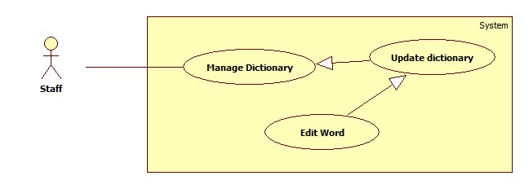

|  |  |  |  |
| --- | --- | --- | --- |
| **USE CASE – LRA005** | | | |
| **Use Case No.** | LRA005 | **Use Case Version** | 2.0 |
| **Use Case Name** | Edit word | | |
| **Author** | Dinh Huu Toan | | |
| **Date** | 03/06/2015 | **Priority** | High |
| **Actor:**   * Staff   **Summary:**   * This use case help staff to edit word in dictionary.   **Goal:**   * Selected word is edited.   **Triggers:**   * Staff want to edit word in dictionary. * Click “Dictionary”, then “Dictionary Management”. Staff will search for the word they want to edit and then click “Edit”   **Preconditions:**   * User should login to the system under Staff role. * That word should be available in the dictionary.   **Post Conditions:**   * **Success:** Edited information will be saved. * **Fail:** Show an error message.   **Main Success Scenario:**   |  |  |  | | --- | --- | --- | | Step | Actor Action | System Response | | 1 | Staff click “Dictionary”, then “Dictionary Management” | * Navigate to “Dictionary Management” page with following information:   + Search textbox   + Add button   + Edit button   + List of words   + Definition of selected word include: definition, synonyms, antonyms, type of word (Pros/Cons/Neural) | | 2 | Search for the word they want to edit | * The list of words will be filtered and show only words that match search string. [Alternative 1] | | 3 | Staff click “Edit” | * A pop-up appear with the following fields: * Word: characters of that word. Staff can edit this word * Type: Staff can choose new type of the word * Synonyms: show all the synonyms of the words. Staff can add, edit or delete these synonyms. * Antonyms: show all the antonyms of the words. Staff can add, edit or delete these antonyms. * Edit button |   **Alternative Scenario:**   |  |  |  | | --- | --- | --- | | No | Actor Action | System Response | | 1 | System cannot find word match search string | System will show a pop-up. In that pop-up include: a message: “This word is not available in the dictionary. Do you want to add it to dictionary?”, and “Add”/”No, Thanks!” buttons |   **Exceptions:** N/A  **Relationships:** Search Dictionary  **Business Rules:**   * After successfully edit word, system will show that word definition field for staff to check again. | | | |

##### <Staff> Import File

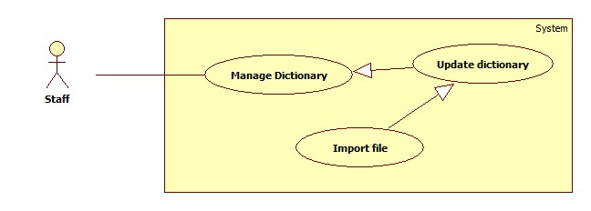

|  |  |  |  |
| --- | --- | --- | --- |
| **USE CASE – LRA014** | | | |
| **Use Case No.** | **LRA014** | **Use Case Version** | 1.0 |
| **Use Case Name** | Import Excel File | | |
| **Author** | Nguyen Manh Khuong | | |
| **Date** | 3/06/2015 | **Priority** | High |
| **Actor:**   * Staff.   **Summary:**   * This use case allows staff to import new words into dictionary database by using excel file.   **Goal:**   * New words will be insert into dictionary database.   **Triggers:**   * Staff wants to import lot of new words in an excel file. * From the sidebar:   + Choose “Manage Dictionary” tag.   + Choose “Import Excel File” tag from dropdown list.   **Preconditions:**   * User must log in the system with Staff role.   **Post Conditions:**   * **Success:** new words will be saved to dictionary database. * **Fail:** Nothing is saved to dictionary database.   **Main Success Scenario:**   |  |  |  | | --- | --- | --- | | Step | Actor Action | System Response | | 1 | Click at “Import Excel File” tag. | Show “Import Excel File” page which contains:   * “Choose file”: button. * “Submit”: button. | | 2 | Click on “Choose file” button. | Show “Open” dialog box. | | 3 | Staff select a file and click “Open” button or double-click on that file. | Show “Import Excel File” page which contains that filename next to “Choose file”: button. | | 4 | Click on “Submit” button.  [Alternative 1],  [Alternative 2],  [Alternative 3] | Read excel file, add words are contained in file to a list, check spelling each words.  Show list of new words in table with 3 columns:   * + Select: checkbox. (allow to choose or not one value to …)   + “Word”: textbox.   + “Type”: dropdown list.(list of values for customer to choose such as Pros, Cons, Neutral …)   + “Save to Database”: button.   Words already existed in database will be removed from list.  Misspelled words will be indicated by red colour in textbox.  Correct spelling words will be unchangeable and checked “Select” checkbox. (business rule) | | 5 | Click “Save to Database” button. | Save selected word to database. Find synonyms and antonyms of each word.  [Exception 2] |   **Alternative Scenario:**   |  |  |  | | --- | --- | --- | | No | Actor Action | System Response | | 1 | No file is chosen | Show message: “Please upload a file!” | | 2 | File upload is not an excel extension. | Show message: “Please upload an excel file! (.xls or xlsx)” | | 3 | Excel file is not correct structure. | Show message: “Excel file is not valid format!” |   **Exceptions:**   |  |  |  | | --- | --- | --- | | No | Actor Action | System Response | | 1 | Connection to database error. | Show error message: “Cannot save to database! Please try again later.” |   **Relationships:** Dictionary Management  **Business Rules:**   * Excel file structure must be properly. * Excel file must have at least 1 row data. * Valid file format: (title, word, type ….) as example – right and wrong * File extension is excel (.xls/.xlsx) | | | |

Table3: < Staff > Import Excel File

##### <Staff> Create Site

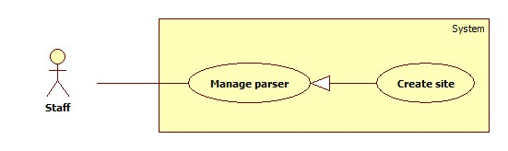

|  |  |  |  |
| --- | --- | --- | --- |
| **USE CASE – LRA015** | | | |
| **Use Case No.** | LRA015 | **Use Case Version** | 1.0 |
| **Use Case Name** | Create Site | | |
| **Author** | Vo Thi Minh Chau | | |
| **Date** | 02/06/2015 | **Priority** | High |
| **Actor:**   * Staff.   **Summary:**   * This use case allows staff to create new site for parser.   **Goal:**   * New site will be created.   **Triggers:**   * Staffs want to create a new site to get data from a website. * Staff clicks “Parser” tag then clicks “Create new site” sub menu.   **Preconditions:**   * User has logged in with staff role.   **Post Conditions:**   * **Success**: New site is added to the system. Show success message. * **Fail:** Show error message.   **Main Success Scenario:**   |  |  |  | | --- | --- | --- | | Step | Actor Action | Sstem Response | | 1 | Staff clicks “Parser” tag in menu bar. | Show sub menu which includes:   * Create New Site: submenu. * Parser Management: submenu. | | 2 | Staff clicks “Create New Site” sub menu. | Show “Create New Site” page which includes:   * Url of site: text box, min length: 1, max length: 300, required. * View: button | | 3 | Staff enters a link and click “View” button. | Show “Create New Site” page which includes:   * Url of product: displays entered value. * View: button. * Wizard to create site. * “Preview” panel: shows staff’s selected page. * “Step of creating site” panel includes a wizard to create a parser with 6 steps and the 1st step is selected. * “Xpath of product’s name” textbox: will show the xpath of selected element. * “Next” button: goes to next step.   [Alternative 1] | | 4 | At steps 1: “Product’s name”, staff clicks the mouse at the area which include product’s name in “Preview” panel | “Xpath of product’s name” textbox will be filled with the xpath string, required. | | 5 | Staff clicks “Next” button. | Show “Create New Site” page which includes:   * Url of product: displays entered value. * View: button. * Wizard to create site. * “Preview” panel: shows staff’s selected page. * “Step of creating site” panel includes a wizard to create a parser with 6 steps and the 2nd step is selected. * “Xpath of brand” textbox: will show the xpath of selected element. * “Next” button: goes to next step. * “Back” button: goes to previous step.   [Alternative 2] | | 6 | At steps 2: “Product’s brand”, staff clicks the mouse at the area which include product’s brand in “Preview” panel. | “Xpath of brand” textbox will be filled with the xpath string, required. | | 7 | Staff clicks “Next” button. | Show “Create New Site” page which includes:   * Url of product: displays entered value. * View: button. * Wizard to create site. * “Preview” panel: shows staff’s selected page. * “Step of creating site” panel includes a wizard to create a parser with 6 steps and the 3rd step is selected. * “Xpath of image” textbox: will show the xpath of selected element. * “Next” button: goes to next step. * “Back” button: goes to previous step.   [Alternative 3] | | 8 | At step 3: “Image”, staff clicks the mouse at the area which include image information in “Preview” panel. | “Xpath of image” textbox will be filled with the xpath string. | | 9 | Staff clicks “Next” button. | Show “Create New Site” page which includes:   * Url of product: displays entered value. * View: button. * Wizard to create site. * “Preview” panel: shows staff’s selected page. * “Step of creating site” panel includes a wizard to create a parser with 6 steps and the 4th step is selected. * “Xpath of description” textbox: will show the xpath of selected element. * “Next” button: goes to next step. * “Back” button: goes to previous step. | | 10 | At step 4:”Description”, staff click the mouse at the area which includes product’s description in “Preview” panel. | “Xpath of description” textbox will be filled with the xpath string, required. | | 11 | Staff clicks “Next” button. | Show “Create New Site” page which includes:   * Url of product: displays entered value. * View: button. * Wizard to create site. * “Preview” panel: shows staff’s selected page. * “Step of creating site” panel includes a wizard to create a parser with 6 steps and the 5th step is selected. * “Xpath of commented date” textbox: will show the xpath of selected element. * “Next” button: goes to next step. * “Back” button: goes to previous step.   [Alternative 4] | | 12 | At step 5:”Commented date”, staff click the mouse at the area which include commented date in “Preview” panel. | “Xpath of commented date” textbox will be filled with the xpath string, required. | | 13 | Staff clicks “Next” button. | Show “Create New Site” page which includes:   * Url of product: displays entered value. * View: button. * Wizard to create site. * “Preview” panel: shows staff’s selected page. * “Step of creating site” panel includes a wizard to create a parser with 6 steps and the 6th step is selected. * “Xpath of comment’s content” textbox: will show the xpath of selected element. * “Next” button: goes to next step. * “Back” button: goes to previous step.   [Alternative 5] | | 14 | At step 6: “Comment’s content”, staff click the mouse at the area which include comment’s content in “Preview” panel. | “Xpath of comment’s content” textbox will be filled with the xpath string, required. | | 15 | Staff clicks “Next” button. | Show “Create New Site” page which includes:   * Url of product: displays entered value. * View: button. * Wizard to create site. * “Preview” panel: shows staff’s selected page. * “Step of creating site” panel includes a wizard to create a parser with 6 steps and the last step is selected. * The message: “Are you sure with your selected items? You can click “Preview” button to see the information of product which will be parsed.” * “Finish” button: finishes the process of creating new site. * “Back” button: goes to previous step.   [Alternative 6] | | 16 | Staff clicks “Finish” button. | Send request to the parsed link.  Fetch data from the response based on the inputted XPaths.  Validate data.  If data is valid, insert to database.  [Exception 1]  [Alternative 7] |   **Alternative Scenario:**   |  |  |  | | --- | --- | --- | | Step | Actor Action | System Response | | 1 | “Url of product” is blank. | Show message error: “Please input url of product which will be parsed”. | | 2 | “Xpath of product’s name” is blank. | Show message error: “Please select name of product which will be parsed”. | | 3 | “Xpath of brand” is blank. | Show message error: “Please select brand of product which will be parsed”. | | 4 | “Xpath of description” is blank. | Show message error: “Please select description of product which will be parsed”. | | 5 | “Xpath of commented date” is blank. | Show message error: “Please select name of product which will be parsed”. | | 6 | “Xpath of comment’s content” is blank. | Show message error: “Please select name of product which will be parsed”. | | 7 | At the last step, staff clicks “Preview” | A popup with these elements will be shown:  - Title “Preview Product’s Information”.  - The name, brand and description of this products.  - A panel with all images of this product.  - All comments with commented date of this product.  - “Close” button. |   **Exceptions:**   |  |  |  | | --- | --- | --- | | Step | Actor Action | System Response | | 1 | Data is not valid. | Do not insert to database. |   **Relationships:** N/A  **Business Rules:**   * The data display structure of that page should be for a specified product. | | | |

##### <Staff> Update Site

##### <Staff> Activate/Deactivate Site

##### <Staff> Configure System

##### <Staff> Force Parse Data

##### <Staff> Merge Laptop

##### <Staff> Split Laptop

#### <Admin> Overview Use Case

##### <Admin> Create Account

##### <Admin> Update Account

##### <Admin> Activate/Deactivate Account

## Software System Attribute

### Usability

#### Graphic User Interface

* All the texts, labels and should be written in Vietnamese.

#### Usability

* Admin, staff should need less than one week of training to be productive with the system.
* Guest and member can use the system easily without training.

#### Installation

* The system must be easy to deploy. Customer can deploy successfully and learn to configure, maintain the system within one day of training.
* The mobile app must be easy to install. Compatible with almost Android Phone.
* The attached manual guide must be clear. User can read and do themselves without developer’s help.

### Reliability

* The system can analyze almost comments, classify them base on dictionary with above 80% accuracy.

### Availability

* N/A

### Security

* Privacy: Each role of user has a specific permission to interact with system.
* System always checks authorization and authenticated before doing anything.
* Only admin can grant permission to staff.

### Maintainability

* Dictionary data is easy to change and update.

### Portability

* The web application can be used anywhere, where has Internet Connection, by Smart phones or PC.

### Performance

* Server responses in 3 seconds for normal progresses, in 10 seconds for complex progresses.
* The page resources are lightly to reduce loading time.

## Conceptual Diagram

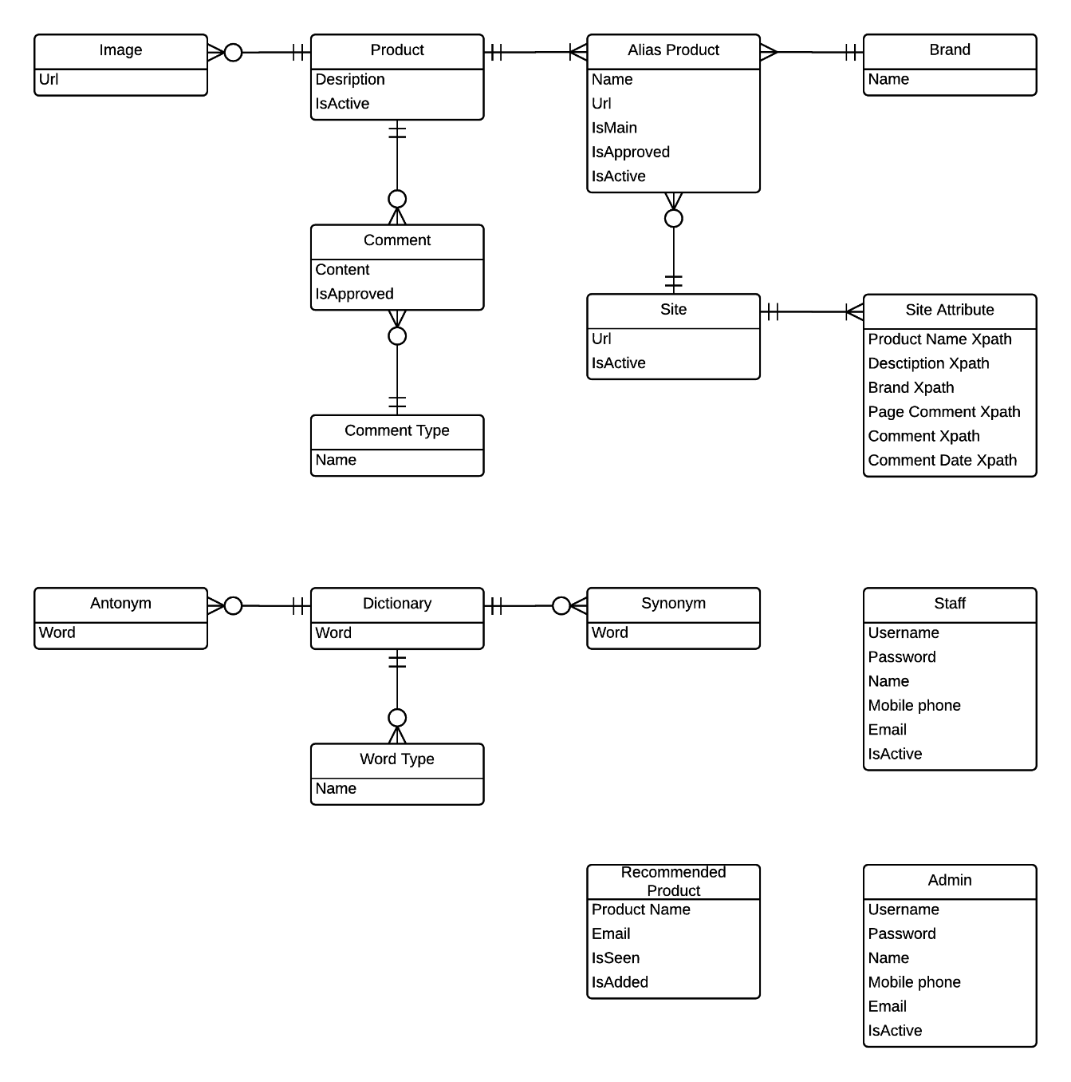

Figure 2: Conceptual Diagram

Data Dictionary

|  |  |
| --- | --- |
| **Entity Data dictionary: describe content of all entities** | |
| **Entity Name** | **Description** |
| Image | Describe all image link that product is included. |
| Product | Describe all products in the system. |
| Alias Product | Describe all alias name of product in the system. |
| Brand | Describe all brand that product is included. |
| Comment | Describe all comment of products. |
| Comment Type | Describe all type of comments. |
| Site | Describe all site parse data. |
| Site Attribute | Describe all Xpatch to parser attributes of site |
| Dictionary | Describe all words |
| Antonym | Describe all antonyms of each word in Dictionary. |
| Synonym | Describe all synonym of each word in Dictionary. |
| Word Type | Describe all type of words in Dictionary. |
| RecommendProduct | Describe the product that user recommend for system. |
| Staff | Describe all information of staff. |
| Admin | Describe all information of admin. |