

**Project Report 3**

Project report

November 2021

Software Engineering

**ABSTRACT**

Tampereen ammattikorkeakoulu

Tampere University of Applied Sciences

Software Engineering

Minh Dang

Contact detail: [minh.dang@tuni.fi](mailto:minh.dang@tuni.fi), 0402579988

Arming score: 5

Project report 3

Programing Language 3 report 13 pages

November 2021

The purpose of this report was to summary solutions for project 3.

Key words:

**Table of Contents**

ABSTRACT 1

INTRODUCTION 3

Building Project 3

Program structure design 3

METHOD 6

Diagram 6

Test cases for Group 1: 7

Test cases for Group 2: 8

Test cases for Group 3: 8

RESULTS 8

WORKING HOURS 12

REFERENCE 12

# INTRODUCTION

* The project was written by C++ and used GNU C++ compiler.

## Building Project

* For running this project, there are 2 options:
  + Using GNU:
    - Installed g++ on your system first.
    - Command:
      * g++ *.cpp -o p && ./p
  + Using Meson[1]:

The source code included Meson build configuration and tutorial on this GitHub repository:

<https://github.com/minhdangphuoc/Searching-and-Sorting-Testped-Program>

## **Program structure design**

- I organizes Main() variations inside a namespace “Programs”

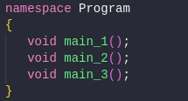

- Option Picker

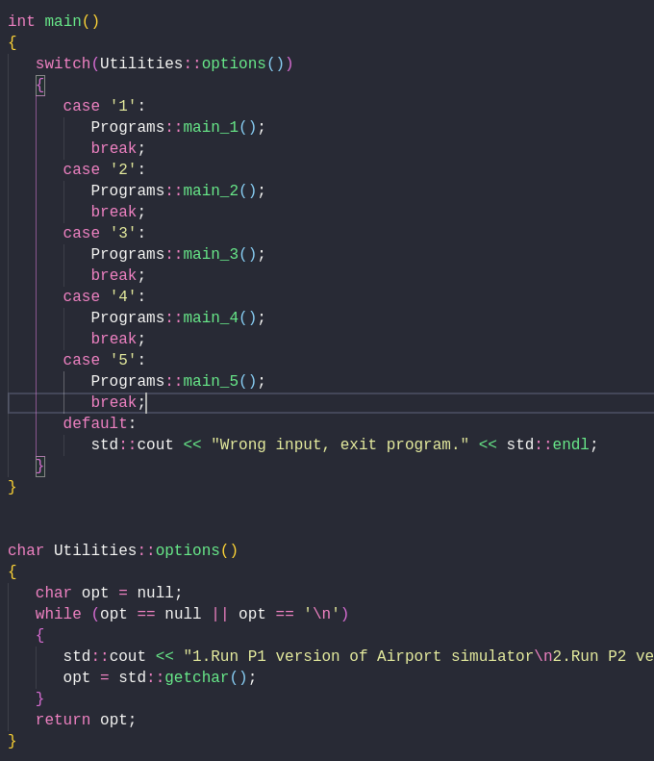

- Main() function

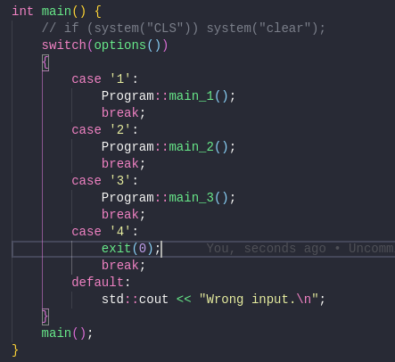

- Main_1() function

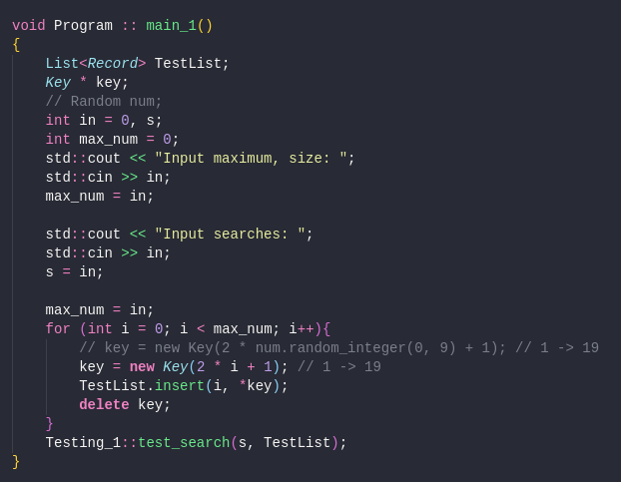

- Main_2() function

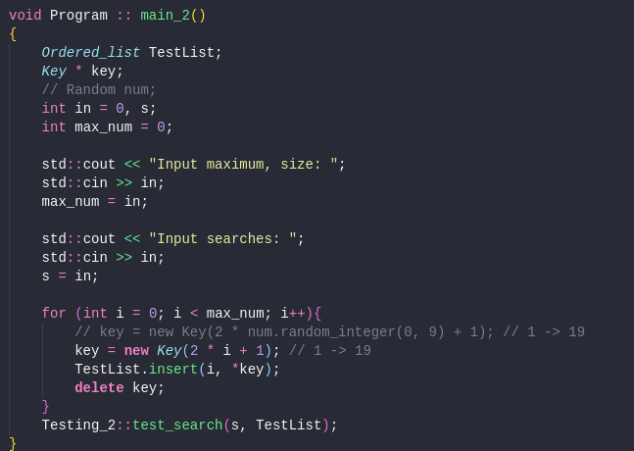

- Main_3() function

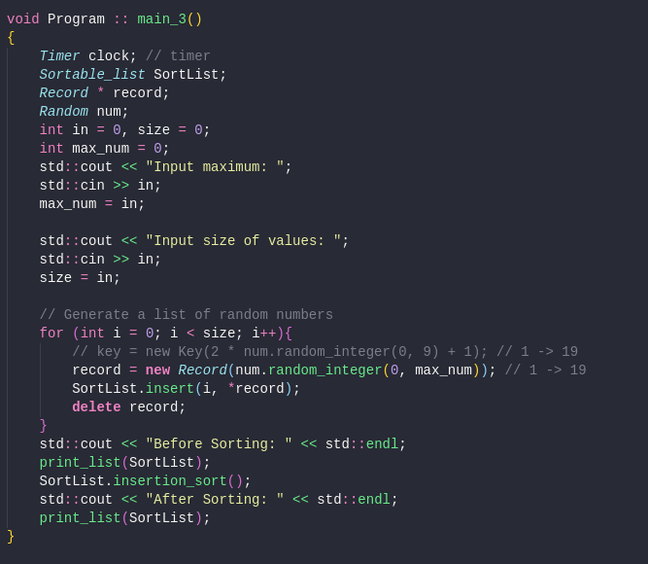

# METHOD

## **Diagram**

1. Group 1

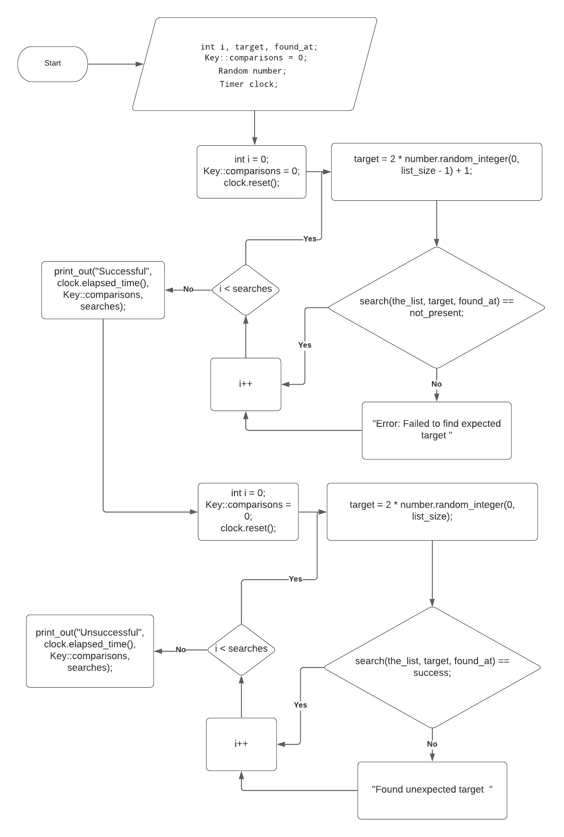

1. Group 2

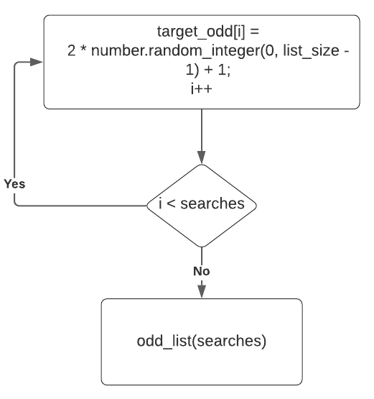

1. Group 3
   1. Input maximum value and size of list

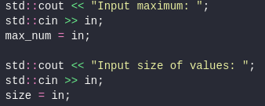

* 1. Processing part

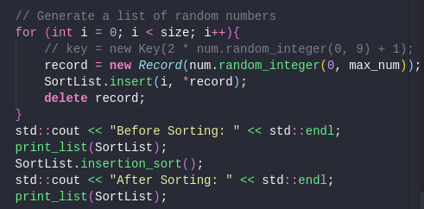

Using test cases for solving and testing algorithms for each programs.

## Test cases for Group 1:

|  |  |  |
| --- | --- | --- |
|  | Sizes | Searches |
| Test 1 | 100 | 10 |
| Test 2 | 1000 | 10 |
| Test 3 | 10000 | 20 |

## Test cases for Group 2:

|  |  |  |
| --- | --- | --- |
|  | Sizes | Searches |
| Test 1 | 100 | 10 |
| Test 2 | 1000 | 20 |
| Test 3 | 10000 | 30 |

## Test cases for Group 3:

|  |  |  |
| --- | --- | --- |
|  | Sizes | Maximum |
| Test 1 | 500 | 10000 |
| Test 2 | 1000 | 10000 |
| Test 3 | 2000 | 10000 |

# RESULTS

1. Group 1
   1. Test 1

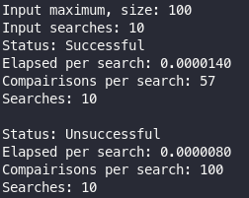

* 1. Test 2

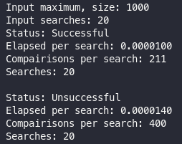

* 1. Test 3

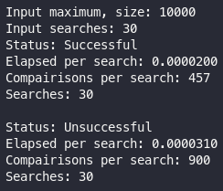

1. Group 2
   1. Test 1

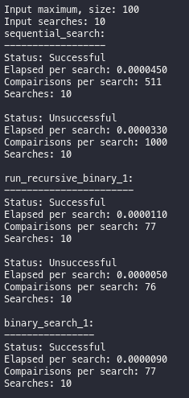 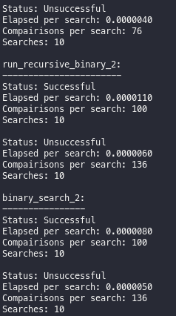

* 1. Test 2

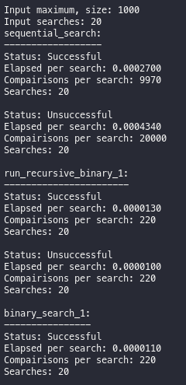 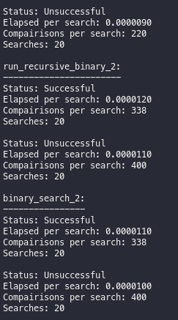

* 1. Test 3

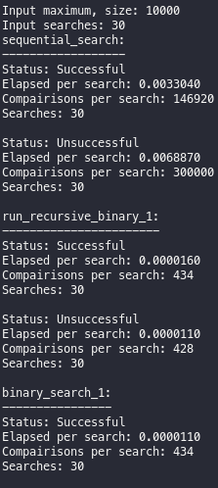 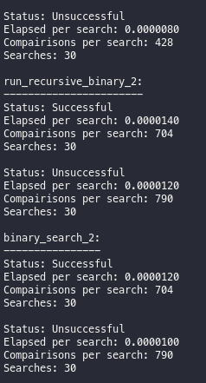

1. Group 3
   1. Test 1

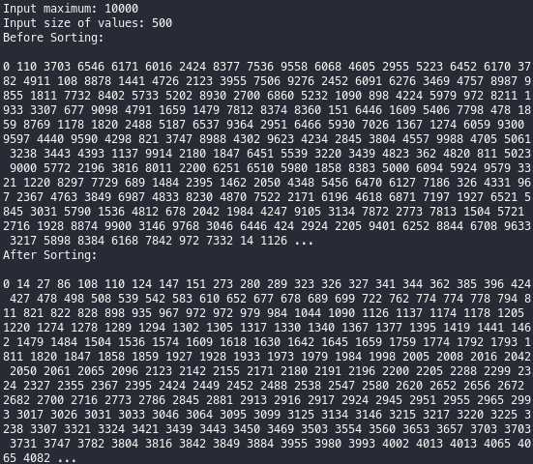

* 1. Test 2

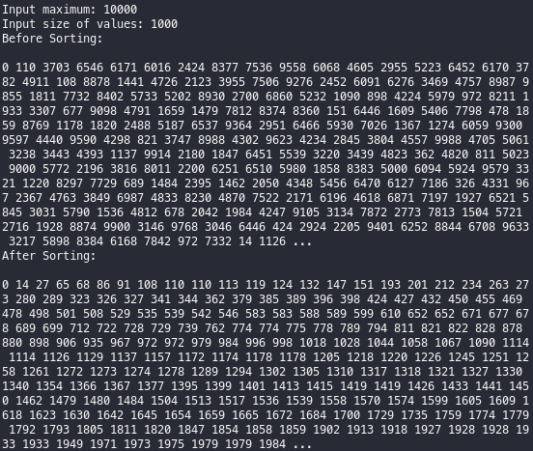

* 1. Test 3

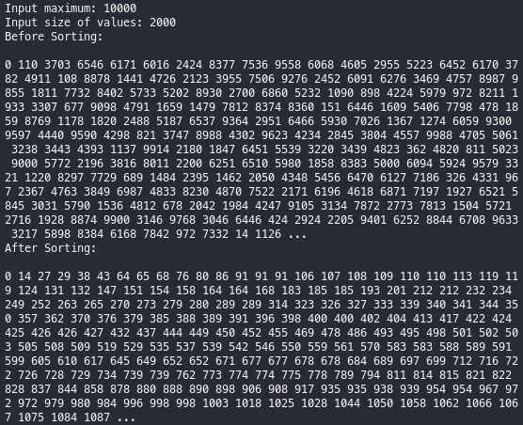

# WORKING HOURS

|  |  |  |
| --- | --- | --- |
| Date | Task | Duration |
| 29/11/2021 | Download Source Code on Moodle | 10m |
| 29/11/2021 | Edited base code and library for the first requirement. | 1h |
| 29/11/2021 | Finished first requirement | 20m |
| 4/12/2021 | Edited base code and library for the 2nd requirement. | 30m |
| 4/12/2021 | Coding and add modifications | 30m |
| 4/12/2021 | First search running | 5m |
| 5/12/2021 | Finished second requirement | 30m |
| 12/12/2021 | Edited base code and library for the 2nd requirement. | 15m |
| 12/12/2021 | Finished third requirement | 60m |

# REFERENCE

[1] [Meson C++ Build](https://mesonbuild.com/)