**Question 1:**

Run command: python MSCDA_Question_1.py

**Case 1**: n = 5

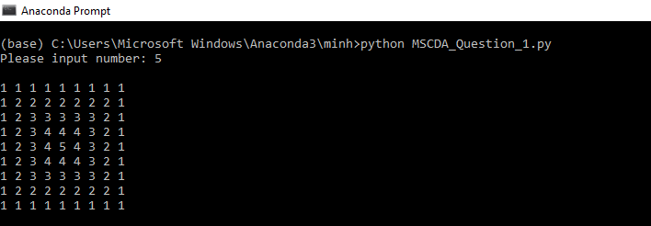

**Case 2**: n = 8

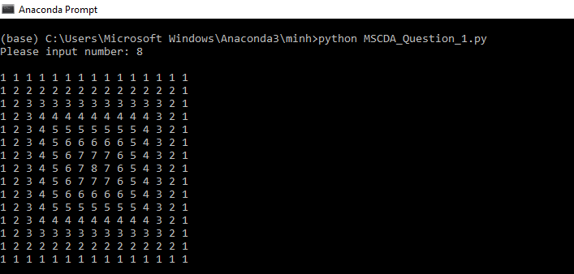

**Case 3**: n = 9

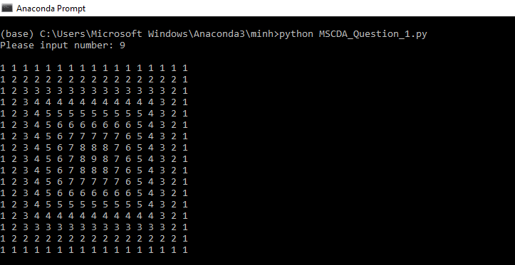

**Question 2:**

Run command: python MSCDA_Question_2.py

**Case 1:** n = 3

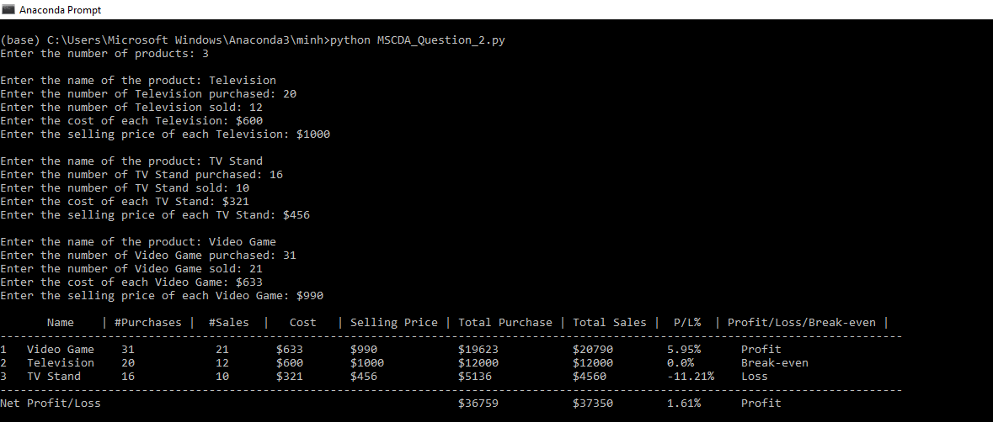

**Case 2:** n = 4

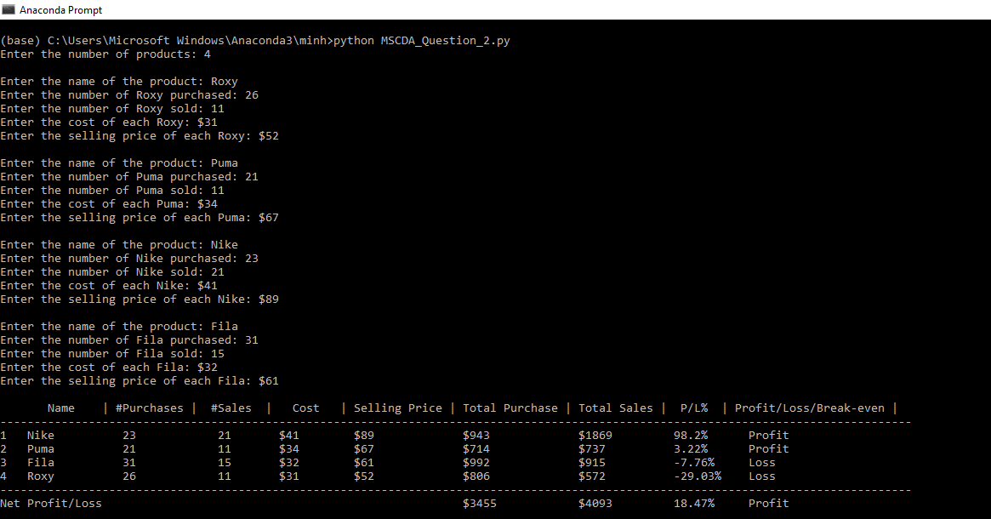

**Case 3:** n = 5

