GENERALCONFEDERATION OF LABOR OF VIETNAM

**TON DUC THANG UNIVERSITY**

**FACULTY OF INFORMATION TECHNOLOGY**



**SOFTWARE ENGINEERING FINAL PROJECT**

**Garage Management**

*Instructor* : M.**S. ĐẶNG MINH THẮNG**

*Performer* : **TRƯƠNG VÕ NGỌC CHÂU - 518H0142**

**KHẤU MINH HÀ - 518H0172**

**NGUYỄN HUY - 518H0509**

Class **: 18H50202**

Course  **: 22**

**HO CHI MINH City, 2020**

GENERALCONFEDERATION OF LABOR OF VIETNAM

**TON DUC THANG UNIVERSITY**

**FACULTY OF INFORMATION TECHNOLOGY**



**SOFTWARE ENGINEERING FINAL PROJECT**

**Garage Management**

*Instructor* : M.**S. ĐẶNG MINH THẮNG**

*Performer* : **TRƯƠNG VÕ NGỌC CHÂU - 518H0142**

**KHẤU MINH HÀ - 518H0172**

**NGUYỄN HUY - 518H0509**

Class **: 18H50202**

Course  **: 22**

**HO CHI MINH City, 2020**

**THANK YOU**

In the process of researching the topic, I have received enthusiastic suggestions and help from the teachers, so this sincere thanks will be sent to:

- First of all, I would like to express my sincere gratitude to my supervising teacher - Mr. Đặng Minh Thắng, who taught and imparted experience to me directly during the learning process and conducting the research process. this.

- Besides, I am very grateful to all the teachers of the Faculty of Information Technology at Ton Duc Thang University for giving me the opportunity to study and interact with my major.

**PROJECT IS COMPLETED AT TON DUC THANG UNIVERSITY**

I assure you that this is my own project and under the guidance of M.S. Đặng Minh Thắng ;. The research contents and results in this topic are honest and have not been published in any previous forms. The figures in the tables serving the analysis, comments and assessments were collected by the author himself from different sources specified in the references.

In addition, the project also uses a number of comments, assessments as well as data of other authors, other organizations and agencies that have cited and annotated the origin.

**If any fraud is detected, I am fully responsible for the content of my project**. Ton Duc Thang University is not related to copyright and copyright infringement caused by me during the implementation process (if any).

*TP Ho Chi Minh City, Septemper 25, 2020*

*Author*

*(sign and clearly state full name)*

*Trương Võ Ngọc Châu*

*Khấu Minh Hà*

*Nguyễn Huy*

**PARTY CERTIFICATION AND ASSESSMENT OF THE TEACHERS**

**The certification part of the instructor**

_______________________________________________________________________________________________________________________________________________________________________________________________________________________________________________________________________________________________________________________________________________________________________________________________________________

Ho Chi Minh City, Septemper 25, 2020

(sign and clearly state full name)

**The evaluation part of the teacher rated**

_______________________________________________________________________________________________________________________________________________________________________________________________________________________________________________________________________________________________________________________________________________________________________________________________________________

Ho Chi Minh City, Septemper 25, 2020

(sign and clearly state full name)

CONTENT OF TABLE

THANK YOU i

PARTY CERTIFICATION AND ASSESSMENT OF THE TEACHERS iii

CONTENT OF TABLE 1

LIST OF PICTURE 2

CHAPTER I : Introduce and Requirements engineering 3

1) Enterprise system introduction 3

2) Requirements engineering 3

2.1) Non-functional requirements: 3

2.2) functional requirements: 4

3) Analyze customer requirements, interview, collect forms 5

CHAPTER II : OVERVIEW 6

1) Use case 6

1.1) Use case diagram 6

1.2 Use case specification 7

2) Class Diagram 10

3) Activity and sequence diagrams 10

3.1) Activity Diagram 10

3.2) Sequence Diagram 12

4) Entity Relationship Diagram 15

CHAPTER III: UNIT TEST, TEST CASE 15

CHAPTER IV: SVN/GIT 15

LIST OF PICTURE

Picture 1 : Use case Garage Management 7

Picture 2 : Class Diagram of Garage Management 11

Picture 3 : Activity Diagram of Parking Management 11

Picture 4 : Activity Diagram of Ticket Management 12

Picture 5 : Activity Diagram of Book Tickets 12

Picture 6 : Activity Diagram of Schedule Management 13

Picture 7 : Sequence Diagram of Parking Management 13

Picture 8 : Sequence Diagram of Schedule Management 14

Picture 9 : Sequence Diagram of Ticket Management 15

Picture 10 : Entity Relationship Diagram 16

CHAPTER I : Introduce and Requirements engineering

1. Enterprise system introduction

A overview of how the enterprise system works:

- Passenger car management system specializes in providing passenger cars (ordinary and VIP) for the following routes:

* Routes from Ho Chi Minh City and vice versa: Ho Chi Minh city - Da Lat, Ho Chi Minh City - Nha Trang, Ho Chi Minh City - Phan Thiet, Ho Chi Minh city - Da Nang, Ho Chi Minh City - Hue, Ho Chi Minh City - Vung Tau, Ho Chi Minh city - Cambodia, Ho Chi Minh city - Phu Quoc.
* Routes from Hue and vice versa: Hue - Da Nang, Hue - Nha Trang, Hue - Quy Nhon, Hue - Hoi An, Hue - Quang Ngai, Hue - Ho Chi Minh city.

- The bus will start at the main time points: 7:00, 10:30, 12:00, 15:30, 19:00, 22:00

- Vehicles will be scheduled initially by default, then based on the survey of passenger demand after trips will change the schedule and add suitable routes.

- Passengers buy tickets at the counter or call the garage, provide information about departure time, vehicle type (normal or VIP) and tourist destination.

- The booking department will use this information to find a car with a suitable schedule and make payment.

- At the parking lot, the car will be mobilized to move according to the schedule.

1. **Requirements engineering**

**2.1) Non-functional requirements:**

- Good service system, capable of working well 24/24 hours and 7 days a week

- Smart search function: find by origin - destination, schedule, running date ...

- Ticket booking, repair, cancellation, payment functions must be accurate and confidential.

- The system is operated by customers and enterprises. Negative external impacts are always prevented by business and by law.

- System quality requirements:

* Rightness
* Scientific
* Reliability
* Adaptability

**2.2) functional requirements:**

**Parking management:**

* Save vehicle information of the garage: vehicle color, number plate, paint color, ...
* Add new, search, update or delete passenger vehicle information
* When mobilizing the car for departure, the staff enter vehicle information and departure time

**Schedule management:**

* Add new, search, update or delete schedule information.
* Add new, update and delete routes,
* Add new, search, update, delete information of bus stations, bus stops, pick up and drop off places, destination ...
* Time management for each specific schedule.
* Check the detailed seat layout for each vehicle in each vehicle schedule.

**Ticket management:**

* Manage fixed fares. Adjust prices during the holidays, or increase or decrease ticket prices according to the correct cycle.
* Add new, search, update, delete bus ticket information ...
* Book tickets, cancel tickets, update ticket information for customers who call, cancel tickets that are overdue
* Payment support according to the displayed amount
* Save, update and edit the revenue report every month

1. **Analyze customer requirements, interview, collect forms**

|  |  |
| --- | --- |
| **Request** | **Feedback** |
| Displays the total number of seats in the car, how many tickets have been sold and the number of seats remaining on that vehicle. | Agree |
| Displays the number of vehicles transported in 1 day, month, year. | Agree |
| Displays the number of tickets sold in 1 day and the name of the seller. | Agree |
| Current status of the car has picked up passengers or not. | Agree |
| Display the time frame of the routes. | Agree |
| Every customer can see each other's personal information. | Disagree . Because some personal information of customers must be kept confidential  Example: ID card, address, ... |

CHAPTER II : OVERVIEW

1. Use case
   1. Use case diagram

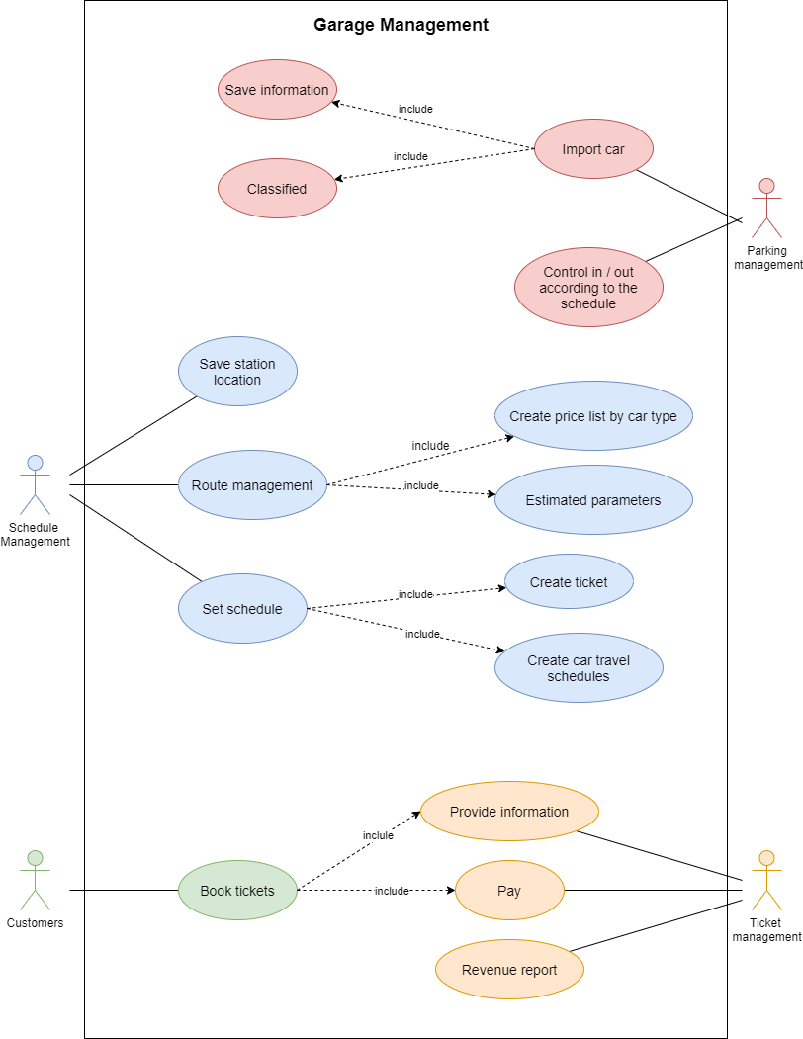

**Picture 1****: Use case Garage Management**

**1.2 Use case specification**

**a) Use case for parking management:**

|  |  |
| --- | --- |
| **Objects of use** | * Parking management staff |
| **Describe** | * When the garage receives more vehicles, the staff saves all the vehicle information in the system with the vehicle classification, the time and location of the imported vehicle. * The import operation includes clicking "Add vehicle", the system will display the input form, save information by clicking "Save vehicle information". * The imported vehicle information will be added to the management interface. * When mobilizing the car for departure, the staff enter vehicle information and departure time |
| **Illegal** | * Enter missing or incorrect information in the form. * Number plates overlap. |

**b) Use case for the route management :**

|  |  |
| --- | --- |
| **Objects of use** | * Schedule manager |
| **Describe** | * Linking the stations to form certain routes for the vehicle to run, staff need to enter estimated parameters of the distance, average time. Based on these figures, the convention is to set the fare for the route. * The route import operation includes: click "View route information", click Add route, the input form will appear, select the stations you want to link and the above information. Complete the entry by clicking "Save route information". * Then the system will check if there is a reverse route and show the question "Enter more return route". Select Yes to enter, select No to exit. * The imported route information will be added to the management interface. |
| **Illegal** | * Enter missing or incorrect information in the form. |

**c) Use case for scheduling:**

|  |  |
| --- | --- |
| **Objects of use** | * Schedule manager |
| **Describe** | * From the existing routes and vehicles, the staff will schedule the ride. * The system will support creating the schedule: * The system will check which vehicle is currently at the starting point for selected staff. * From the selected vehicle, the system will limit the number of tickets that can be sold by the vehicle's capacity * The vehicle's possible departure date and time will also be updated after vehicle selection. * The schedule input operation includes: Click "Add schedule", the input form will appear. Enter / Select in order: Add a route to the chain => Select a vehicle => Select the chain's departure date and time, number of tickets sold and the time period for which it is applied (if any). |
| **Illegal** | * Enter / Select missing information in the form. |

**d) Use case for booking:**

|  |  |
| --- | --- |
| **Objects of use** | * Ticket management staff |
| **Describe** | * The ticket sales interface will show the schedules within 1 week. Staff will take over the request to find the appropriate schedule. Then enter guest information and pay. * The system will display the available ticket number of the schedule and the price according to the number of tickets booked. * Operation includes: click on "Book" at the appropriate schedule line. Enter the information provided in the form. Then based on the amount currently paid. After the payment is complete, Click "Confirm payment". * Information just entered will appear in the ticketing details of the schedule. The remaining ticket number of the schedule will also be updated. |
| **Illegal** | * Enter / Select missing or wrong information in the form. * The number of tickets booked is greater than the remaining number of tickets. |

**e) Use case for report revenue:**

|  |  |
| --- | --- |
| **Objects of use** | * Ticket management staff |
| **Describe** | * The sales report will show the sales of each route as well as each type of ticket. * Operation to create reports: Click "Create revenue report" => Select the time of recording start - end revenue => Click "View". |
| **Illegal** | * Enter / Select an end date earlier than the start date. |

1. **Class Diagram**

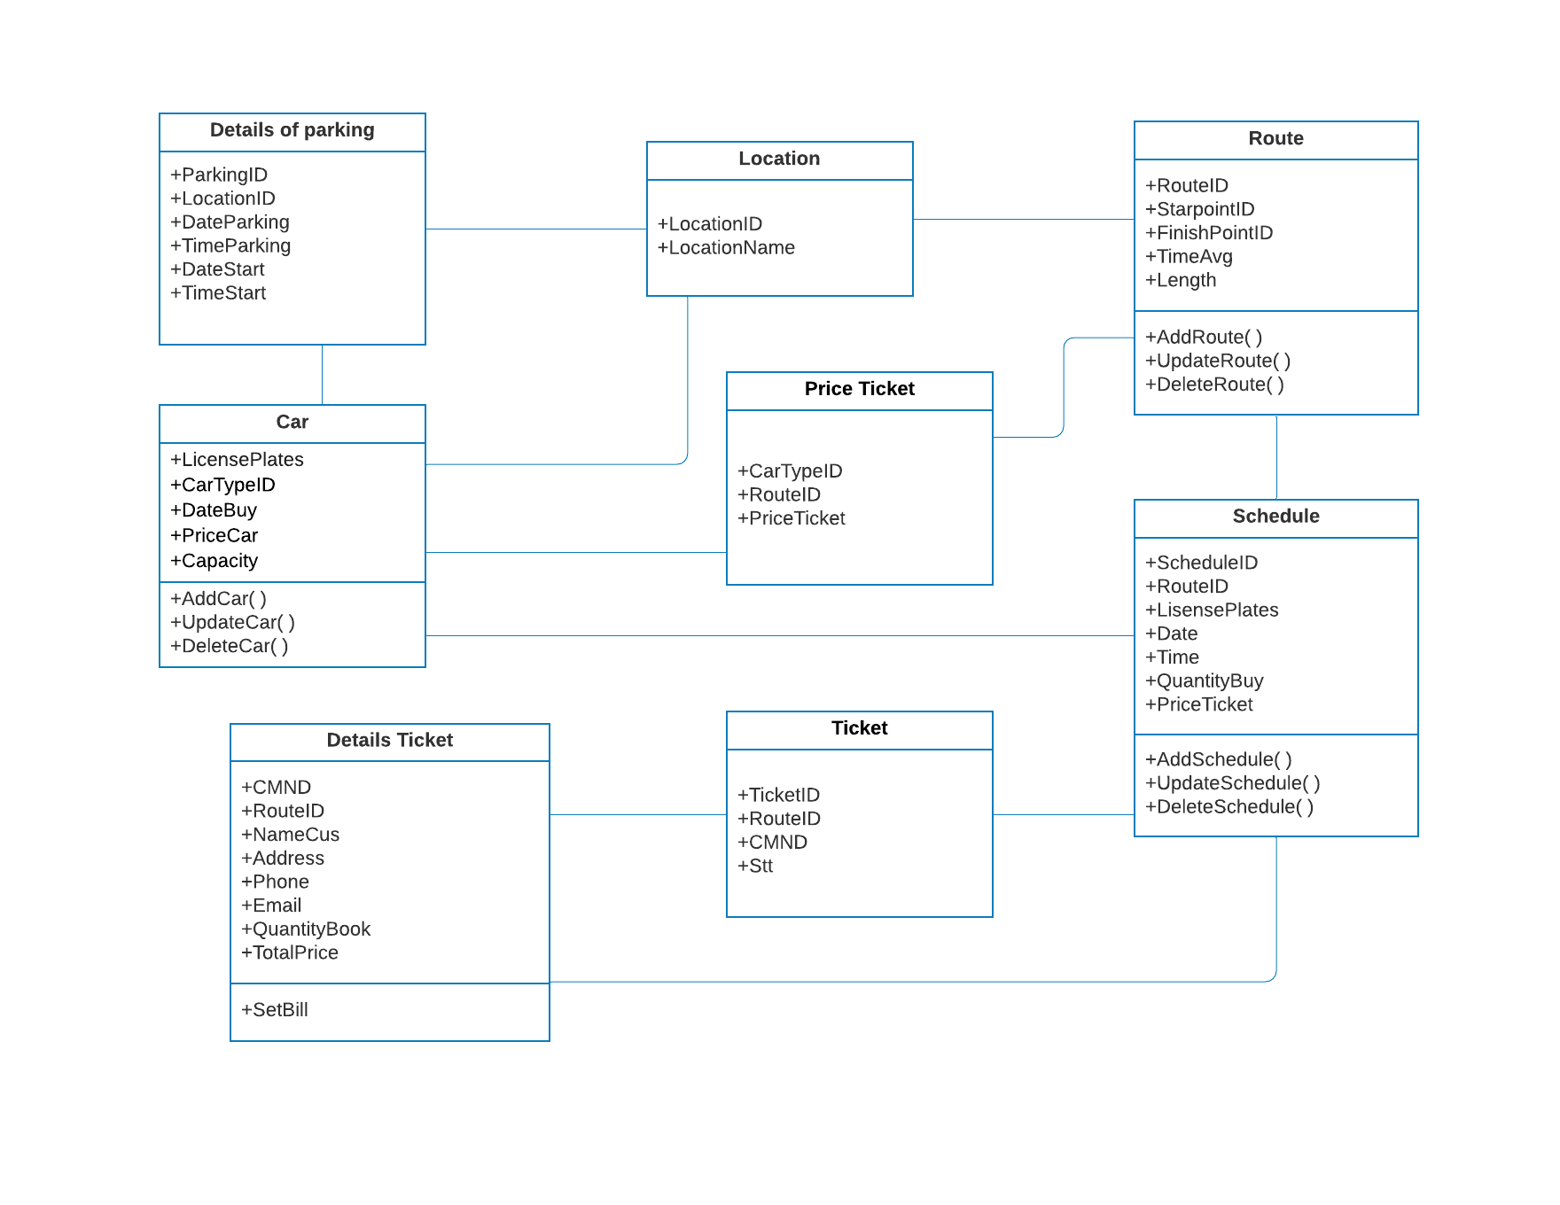

**Picture 2****: Class Diagram of Garage Management**

1. **Activity and sequence diagrams**
   1. **Activity Diagram**

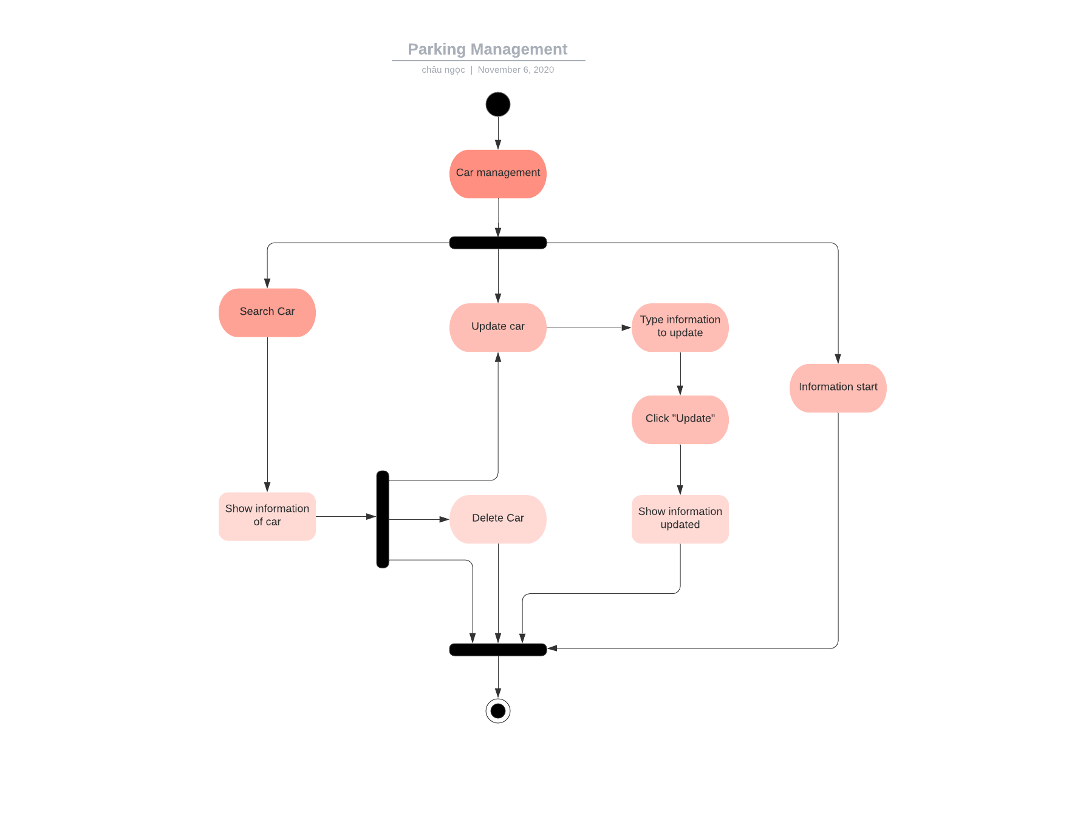

**Picture 3****: Activity Diagram of Parking Management**

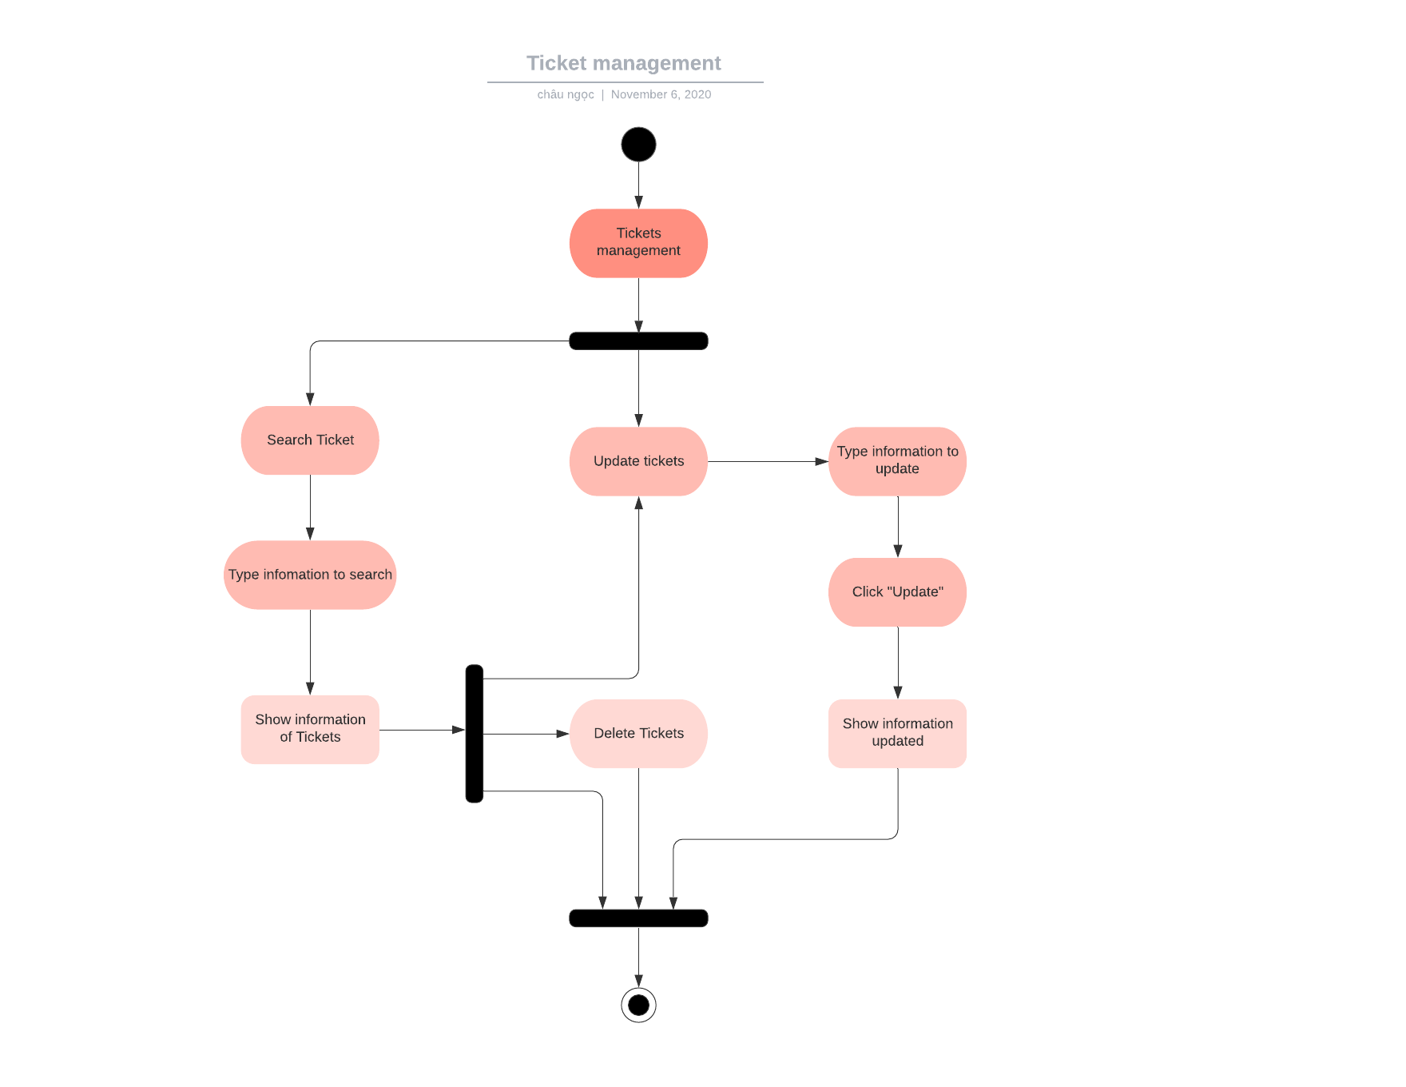

**Picture 4****: Activity Diagram of Ticket Management**

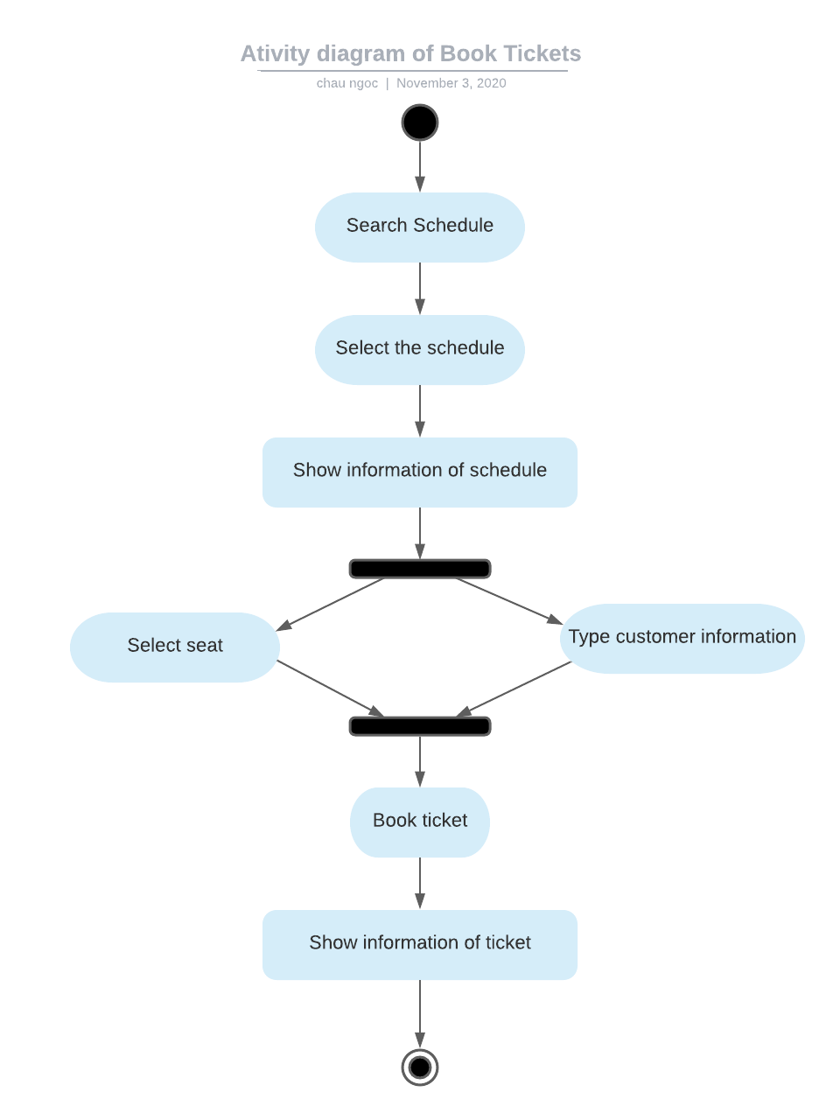

**Picture 5****: Activity Diagram of Book Tickets**

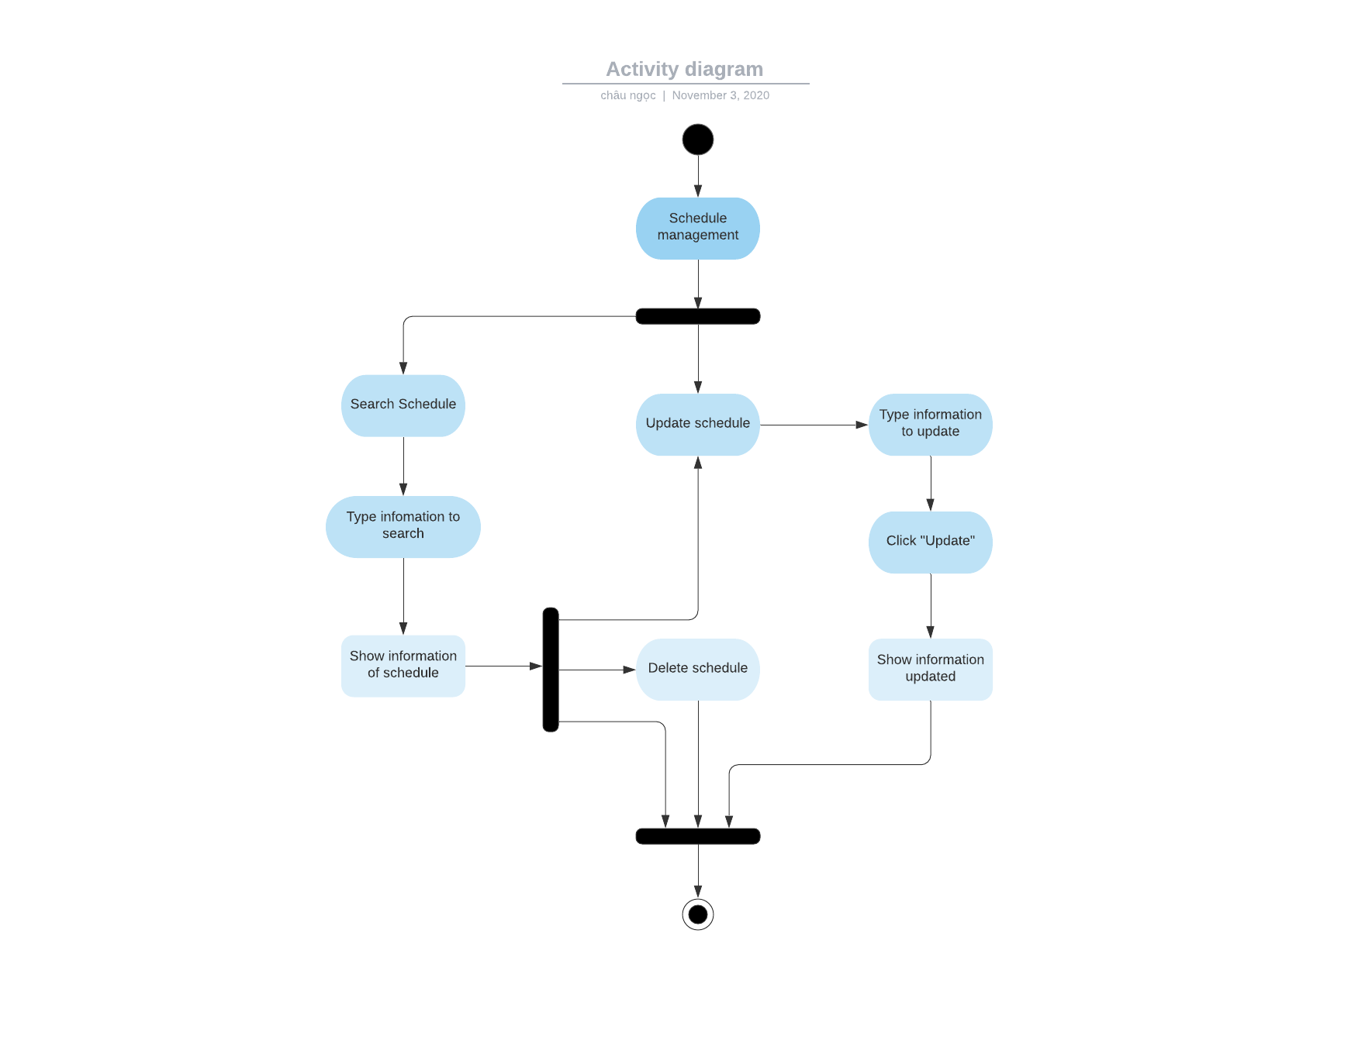

**Picture 6****: Activity Diagram of Schedule Management**

* 1. **Sequence Diagram**

1. **Parking management**

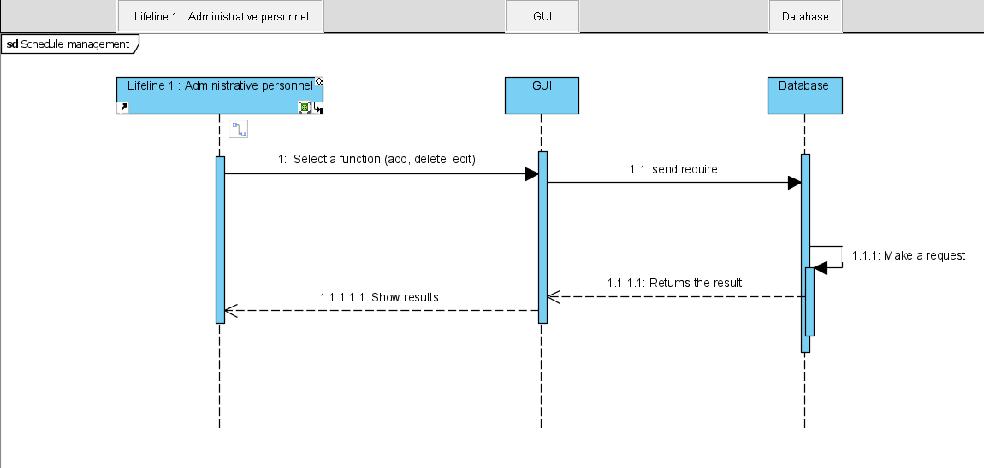

**Picture 7****: Sequence Diagram of Parking Management**

1. **Schedule management**

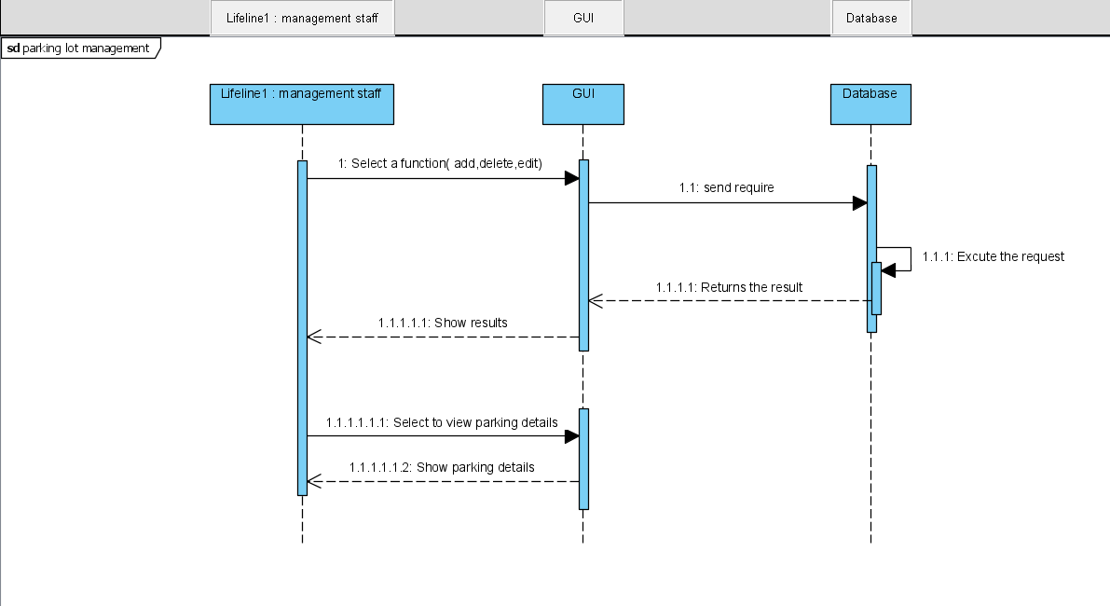

**Picture 8****: Sequence Diagram of Schedule Management**

1. **Ticket management**

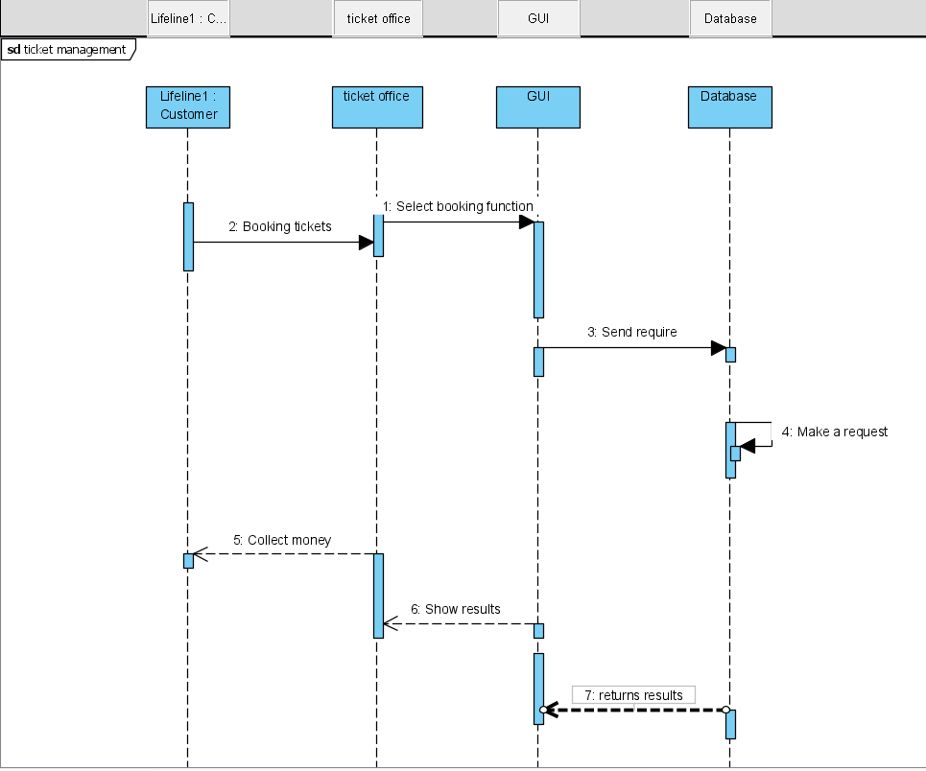

**Picture 9****: Sequence Diagram of Ticket Management**

1. **Entity Relationship Diagram**

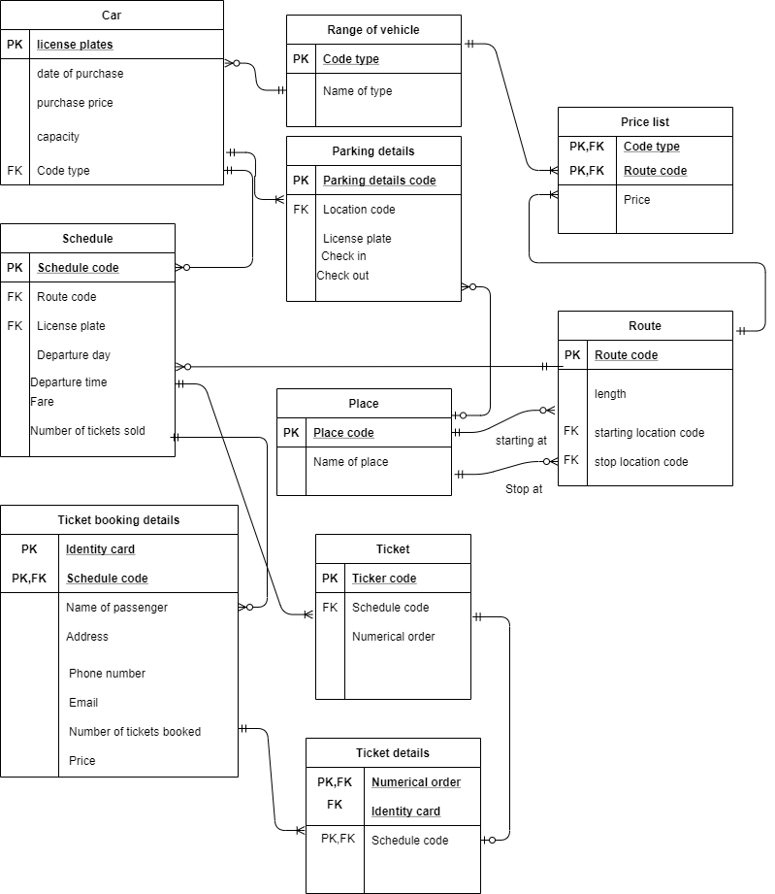

**Picture 10****: Entity Relationship Diagram**

**CHAPTER III: UNIT TEST, TEST CASE**

**CHAPTER IV: SVN/GIT**