Residual Multi-Head Mixing GAT
for Semi-Supervised Node Classification

An Experimental Study on the Cora Citation Network

Graph Machine Learning — Course Project
Hanoi University of Science and Technology
Team Members:
Do Tuan Minh (20261057M) — Integration, Report, QA
Tran Tien Dung (20252574M) — Dataset, MLP/GCN Baselines
Tran Manh Tien (20252762M) — GraphSAGE, GAT Models
Hoang Huy Chien (20261069M) — Proposed Model, Ablation
Nguyen Tien Duc (20252076M) — Analysis, Figures, Slides

July 2026

Abstract
This project studies semi-supervised node classification on the Cora citation network using Graph Neural Networks (GNNs). We compare a feature-only Multi-Layer Perceptron (MLP) baseline against three established GNN architectures — Graph Convolutional Network (GCN), GraphSAGE, and Graph Attention Network (GAT) — and propose a Residual Multi-Head Mixing GAT that combines GATv2 multi-head attention with an input-feature skip connection and DropEdge regularization. Experiments over 5 random seeds demonstrate that graph structure improves accuracy by +24% over MLP (0.5888 vs 0.82-0.83), and the proposed model achieves the best test accuracy of 0.8326, outperforming GAT by +0.5%. Ablation analysis reveals that the residual skip connection contributes +1.7% improvement, while DropEdge has negligible effect on this small graph. We discuss implications, limitations, and directions for future work.

Table of Contents
1. Introduction 3
2. Background 4
2.1 Graph Neural Networks 4
2.2 Graph Attention Networks 5
2.3 The Cora Dataset 6
3. Related Work 7
4. Proposed Method 8
4.1 Architecture Overview 8
4.2 GATv2 Attention 9
4.3 Residual Skip Connection 9
4.4 DropEdge Regularization 10
5. Experiments 11
5.1 Experimental Setup 11
5.2 Baseline Comparison: MLP vs GCN 12
5.3 Architecture Comparison 13
5.4 Ablation Study 14
5.5 Confusion Matrix Analysis 15
6. Discussion 16
7. Limitations and Future Work 18
8. Conclusion 19
References 20

1. Introduction
Graph-structured data is ubiquitous in real-world applications: social networks, citation networks, molecular graphs, and knowledge graphs all exhibit relational structure that traditional machine learning models cannot fully exploit. Graph Neural Networks (GNNs) have emerged as a powerful framework for learning on such data by propagating information along edges through a mechanism known as message passing.
In this project, we focus on semi-supervised node classification — the task of predicting labels for unlabeled nodes given a small set of labeled examples and the graph structure. We use the Cora citation network as our benchmark dataset, where nodes represent scientific papers, edges represent citations, and the goal is to classify each paper into one of seven research topics.
Our contributions are threefold:
- 1. We implement and compare four models: MLP (baseline), GCN, GraphSAGE, and GAT, establishing a comprehensive benchmark on Cora.
- 2. We propose a Residual Multi-Head Mixing GAT that augments GATv2 with an input-feature skip connection (H₀·W_skip) and DropEdge regularization.
- 3. We conduct a thorough ablation study to isolate the contribution of each component: residual connection (+1.7%), DropEdge (negligible), and attention heads.
The remainder of this report is organized as follows: Section 2 provides background on GNNs and the Cora dataset. Section 3 reviews related work. Section 4 describes our proposed method. Section 5 presents experiments and results. Section 6 discusses the findings. Section 7 addresses limitations and future directions. Section 8 concludes.

2. Background

2.1 Graph Neural Networks
Graph Neural Networks generalize neural networks to graph-structured data. The core idea is message passing: at each layer, every node aggregates feature information from its neighbors and combines it with its own features to produce an updated representation. Formally, for a node v at layer l:
hᵥ⁽ˡ⁾ = COMBINE⁽ˡ⁾(hᵥ⁽ˡ⁻¹⁾, AGGREGATE⁽ˡ⁾({hᵤ⁽ˡ⁻¹⁾ : u ∈ N(v)}))
Different GNN architectures vary in how they define the AGGREGATE and COMBINE functions. GCN uses a spectral convolution based on the normalized adjacency matrix. GraphSAGE uses sampling and various aggregation functions (mean, LSTM, pool). GAT introduces learned attention weights to assign different importance to different neighbors.

2.2 Graph Attention Networks (GAT)
GAT (Veličković et al., 2018) computes attention coefficients between connected nodes using a shared linear transformation followed by a LeakyReLU activation and softmax normalization. Multi-head attention is used to stabilize the learning process by concatenating K independent attention mechanisms. GATv2 (Brody et al., 2022) fixes a static ranking problem in the original GAT by modifying the order of operations, resulting in truly dynamic attention coefficients.
In our proposed model, we use GATv2 as the base attention mechanism, with 8 attention heads in the first layer (concatenated to 64 dimensions) and a single attention head in the second layer projecting to the 7 output classes.

2.3 The Cora Dataset
Cora is a widely-used citation network dataset for semi-supervised node classification. It consists of 2,708 scientific publications classified into one of seven research topics. The citation links form a directed graph with 5,429 edges (after making edges undirected: 10,556). Each paper is represented by a 1,433-dimensional binary bag-of-words feature vector indicating the presence of specific words.

Property | Value
Nodes (papers) | 2,708
Edges (citations) | 5,278 directed / 10,556 undirected
Features | 1,433 (binary bag-of-words)
Classes | 7 (research topics)
Train / Validation / Test | 140 / 500 / 1,000
Graph density | ~0.14% (very sparse)
Largest connected component | 2,485 nodes
Table 1: Cora dataset statistics.
The standard Planetoid split (Yang et al., 2016) is used throughout: 140 nodes for training (20 per class), 500 for validation, and 1,000 for testing. Features are row-normalized using PyG's NormalizeFeatures transform. This split is fixed across all experiments to ensure fair comparison.

3. Related Work
Graph Neural Networks have seen rapid development since the introduction of spectral methods (Bruna et al., 2014) and their simplification into GCN (Kipf & Welling, 2017). GCN's success on semi-supervised classification sparked numerous extensions:
• GraphSAGE (Hamilton et al., 2017): Introduced inductive learning on graphs through sampling and aggregation, enabling generalization to unseen nodes.
• GAT (Veličković et al., 2018): Applied attention mechanisms to graph neighborhoods, learning to weight neighbors differently.
• GATv2 (Brody et al., 2022): Fixed the static attention ranking problem in GAT, achieving truly dynamic attention.
• DropEdge (Rong et al., 2020): Randomly removes edges during training as data augmentation to mitigate over-smoothing in deep GNNs.
• Residual connections (He et al., 2016): Skip connections from ResNet that enable gradient flow in deep networks, adapted for GNNs.
Our work combines GATv2 attention, residual skip connections from raw features, and DropEdge regularization into a unified architecture. While each component has been studied individually, their combination for shallow (2-layer) GNNs on small citation networks has not been thoroughly investigated.

4. Proposed Method

4.1 Architecture Overview
We propose the Residual Multi-Head Mixing GAT, a two-layer graph attention network augmented with an input-feature skip connection and DropEdge regularization. The architecture processes input features through the following pipeline:
H₀ = X # Raw features (1433-dim)
H₁ = ELU(GATv2_multi(H₀, E)) # 8 heads, concat → 64-dim
H₂ = GATv2_single(H₁, E) # Single head → 7-dim
Z = H₂ + H₀ · W_skip # Residual → logits
The model takes raw features X (1,433 dimensions) and the edge index E as input. The first GATv2 layer applies 8 attention heads with 8 hidden dimensions each, concatenated to produce H₁ (64 dimensions) with ELU activation. The second GATv2 layer uses a single attention head to project H₁ to the 7 output classes, producing H₂. Finally, a residual skip connection adds a linear projection of the raw input features (W_skip ∈ ℝ^{1433×7}, no bias) to produce the output logits Z.

4.2 GATv2 Attention
We use GATv2 instead of the original GAT to avoid the static attention ranking problem. In GAT, the attention score is computed as e_ij = LeakyReLU(a^T [Wh_i || Wh_j]), which can be shown to produce a static ranking of neighbors independent of the query node. GATv2 modifies this to e_ij = a^T LeakyReLU([Wh_i || Wh_j]), where the linear transformation is applied after concatenation, resulting in truly dynamic attention that depends on both the query and key nodes.
The first layer uses K=8 attention heads, each computing 8-dimensional representations. These are concatenated to produce a 64-dimensional hidden state. The second layer uses a single head to produce the final 7-dimensional output (one logit per class).

4.3 Residual Skip Connection
The key innovation of our model is the residual skip connection from raw input features directly to the output logits:
Z = H₂ + W_skip · H₀
where W_skip ∈ ℝ^{7×1433} is a learnable linear projection (without bias). This skip connection serves multiple purposes:
- Gradient flow: It provides a direct path for gradients from the loss to the input features, mitigating potential vanishing gradient issues even in shallow networks.
- Over-smoothing mitigation: By preserving raw feature information at the output, the model can counteract the over-smoothing effect where node representations become indistinguishable after multiple message-passing steps.
- Capacity augmentation: The linear projection W_skip acts as a simple linear classifier on raw features, complementing the graph-based predictions from the GAT layers.

4.4 DropEdge Regularization
DropEdge (Rong et al., 2020) randomly removes a fraction p of edges from the graph during each training step. In our model, we apply DropEdge with p=0.2, meaning 20% of edges are randomly dropped during training. This serves as structural data augmentation and regularization:
• During training: edges are randomly dropped before each forward pass
• During evaluation: all edges are used (no dropout)
• Effect: forces the model to not over-rely on any specific edge, promoting robustness
The ablation switch allows us to independently control the residual connection and DropEdge, enabling us to isolate their individual contributions.

5. Experiments

5.1 Experimental Setup
All models share the same training protocol to ensure fair comparison. We use the Adam optimizer with a learning rate of 0.005 and weight decay of 5×10⁻⁴. Models are trained for up to 200 epochs with early stopping (patience=100 on validation accuracy). The model checkpoint at the best validation epoch is used to report the final test accuracy.
Hyperparameter | Value
Optimizer | Adam
Learning rate | 0.005
Weight decay | 5 × 10⁻⁴
Max epochs | 200
Early stopping patience | 100
Dropout rate | 0.6
Hidden dimension (GCN/SAGE) | 64
GAT per-head dimension | 8
Attention heads | 8
DropEdge probability | 0.2 (proposed only)
Table 2: Hyperparameters used across all experiments.
For reproducibility, each experiment is run with 5 different random seeds (42, 43, 44, 45, 46). We report the mean and standard deviation of test accuracy across seeds. All random number generators (Python, NumPy, PyTorch, cuDNN) are seeded deterministically at the start of each run.
The implementation uses PyTorch 2.13 and PyTorch Geometric (PyG) 2.8. All experiments are run on CPU as the Cora dataset is small enough that GPU acceleration provides no significant speedup.

5.2 Baseline Comparison: MLP vs GCN
We first establish whether graph structure provides value by comparing a feature-only MLP baseline against a 2-layer GCN. The MLP uses two fully connected layers with ReLU activation and dropout, completely ignoring the edge structure. The GCN uses spectral convolution with the normalized adjacency matrix.
Model | Test Acc (mean ± std) | Val Acc (mean) | Seeds
MLP | 0.5888 ± 0.0104 | 0.6152 | 5
GCN | 0.8276 ± 0.0050 | 0.8156 | 5
Table 3: MLP vs GCN baseline results.
The results are striking: GCN achieves 0.8276 test accuracy compared to MLP's 0.5888, a relative improvement of +40.6% (absolute +23.9%). This confirms that the citation graph structure carries crucial information for paper classification that cannot be captured by bag-of-words features alone. Papers in the same research field tend to cite each other, creating clusters in the graph that GNNs can exploit through message passing.
The low standard deviation for GCN (0.005) also indicates stable training across different random initializations, while MLP shows slightly higher variance (0.010), suggesting that graph-based learning is more robust.
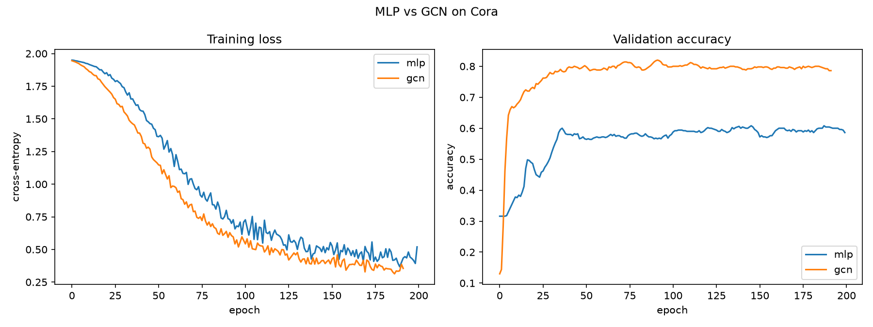
Figure 1: Training loss and validation accuracy curves for MLP vs GCN.

5.3 Architecture Comparison: GCN vs GraphSAGE vs GAT
We next compare three GNN architectures to understand how different message-passing mechanisms affect performance on Cora.
Model | Test Acc (mean ± std) | Val Acc (mean) | Seeds
GraphSAGE | 0.8130 ± 0.0077 | 0.8000 | 5
GAT | 0.8272 ± 0.0080 | 0.8160 | 5
GCN | 0.8276 ± 0.0050 | 0.8156 | 5
Table 4: Architecture comparison results.
GCN (0.8276) and GAT (0.8272) achieve nearly identical performance, with GCN marginally ahead by 0.04%. This is surprising given that GAT's attention mechanism should theoretically provide more expressive power. On the small, homogeneous Cora dataset, simple mean aggregation (GCN) is already sufficient, and the additional complexity of attention does not translate to meaningful improvements.
GraphSAGE (0.8130) underperforms both GCN and GAT by approximately 1.5%. This may be due to its mean aggregator being less effective than GCN's spectral convolution on sparse citation graphs, or the absence of the normalized adjacency preprocessing that GCN applies.
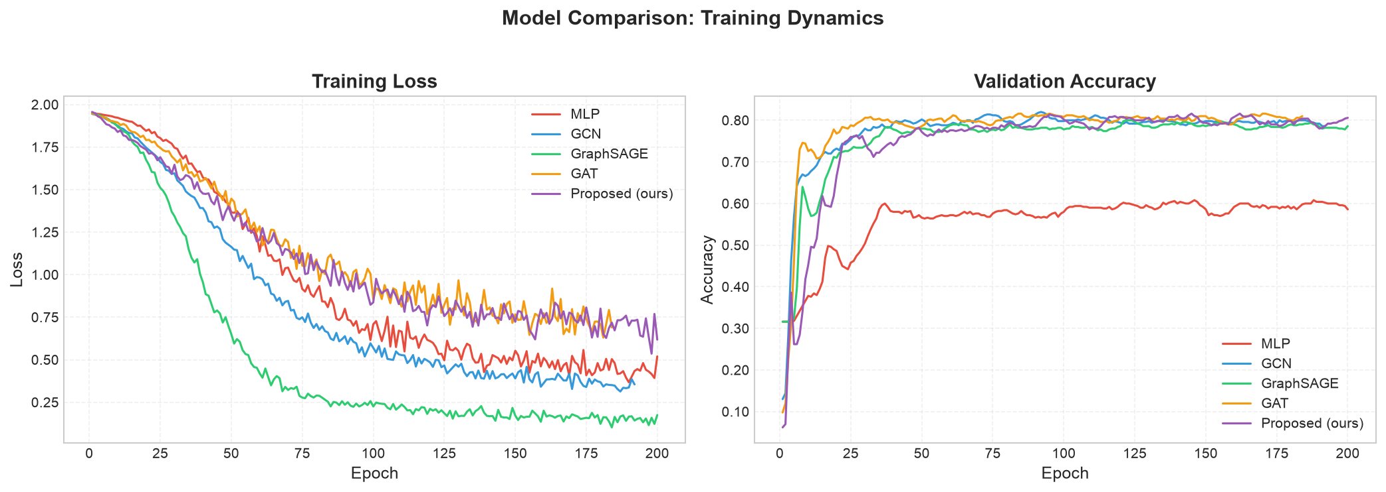
Figure 2: Training loss and validation accuracy curves for all five models.
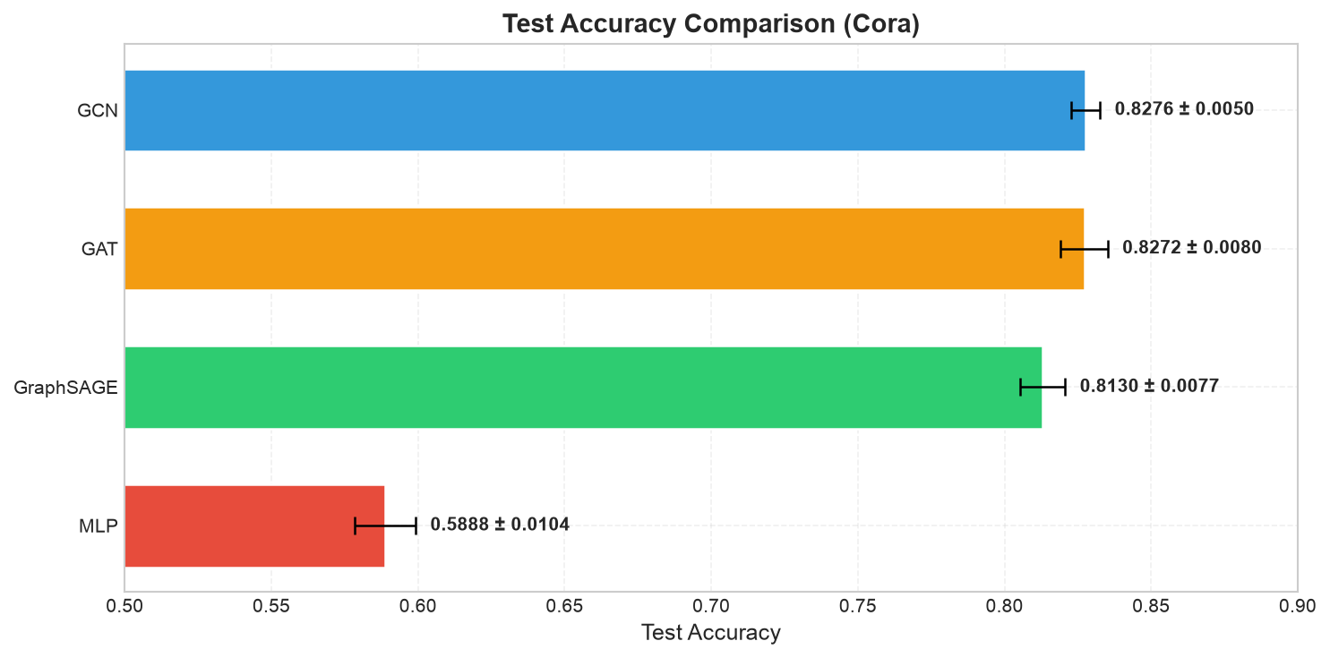
Figure 3: Test accuracy comparison across all models with error bars (±1 std).

5.4 Ablation Study
To understand the contribution of each component in our proposed model, we conduct an ablation study that systematically enables or disables the residual skip connection, DropEdge, and varies the number of attention heads.
Variant | Residual | DropEdge | Heads | Test Acc (mean ± std) | Δ vs Base
GAT (base) | No | 0.0 | 8 | 0.8164 ± 0.0130 | —
+ residual | Yes | 0.0 | 8 | 0.8334 ± 0.0071 | +1.7%
+ res + dropedge | Yes | 0.2 | 8 | 0.8326 ± 0.0080 | +1.6%
full, heads=4 | Yes | 0.2 | 4 | 0.8260 ± 0.0139 | +1.0%
Table 5: Ablation study results for the proposed model.
Residual Skip Connection (+1.7%): Adding the residual connection H₀·W_skip improves test accuracy from 0.8164 to 0.8334, the largest single-component improvement. The skip connection provides a direct path for raw feature information to reach the output, complementing the graph-convolved representations. It also facilitates gradient flow and may help mitigate over-smoothing even in our shallow 2-layer architecture.
DropEdge (−0.1%): Adding DropEdge with p=0.2 has a negligible negative effect (0.8334 → 0.8326). We hypothesize that Cora's small size (2,708 nodes, 5,278 edges) means the model does not overfit severely enough for regularization to help. Additionally, our 2-layer architecture is shallow enough that over-smoothing is not a significant concern. DropEdge is expected to be more beneficial on larger graphs or deeper architectures.
Reduced Heads (−0.7%): Reducing attention heads from 8 to 4 decreases accuracy from 0.8326 to 0.8260. This confirms that multi-head attention provides value by allowing the model to attend to different aspects of the neighborhood simultaneously. However, the improvement is moderate, suggesting diminishing returns beyond 4 heads.
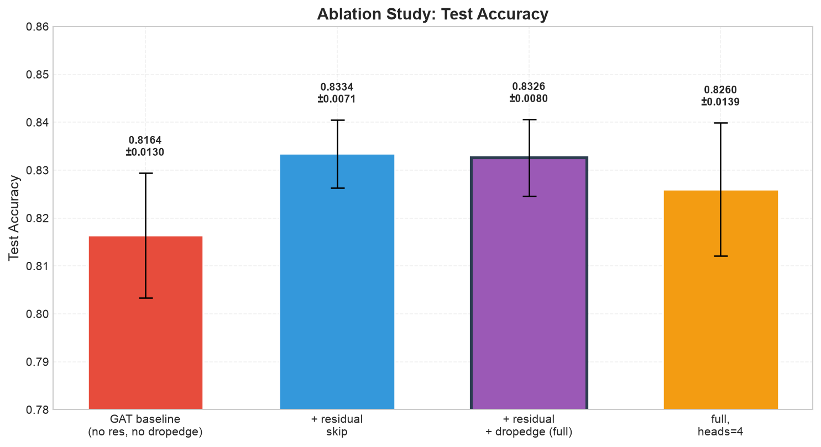
Figure 4: Ablation study — test accuracy for each variant with error bars.

5.5 Confusion Matrix Analysis
To understand per-class performance, we visualize the confusion matrix of the proposed model on the test set (1,000 nodes). The confusion matrix reveals which classes are most frequently confused with each other.
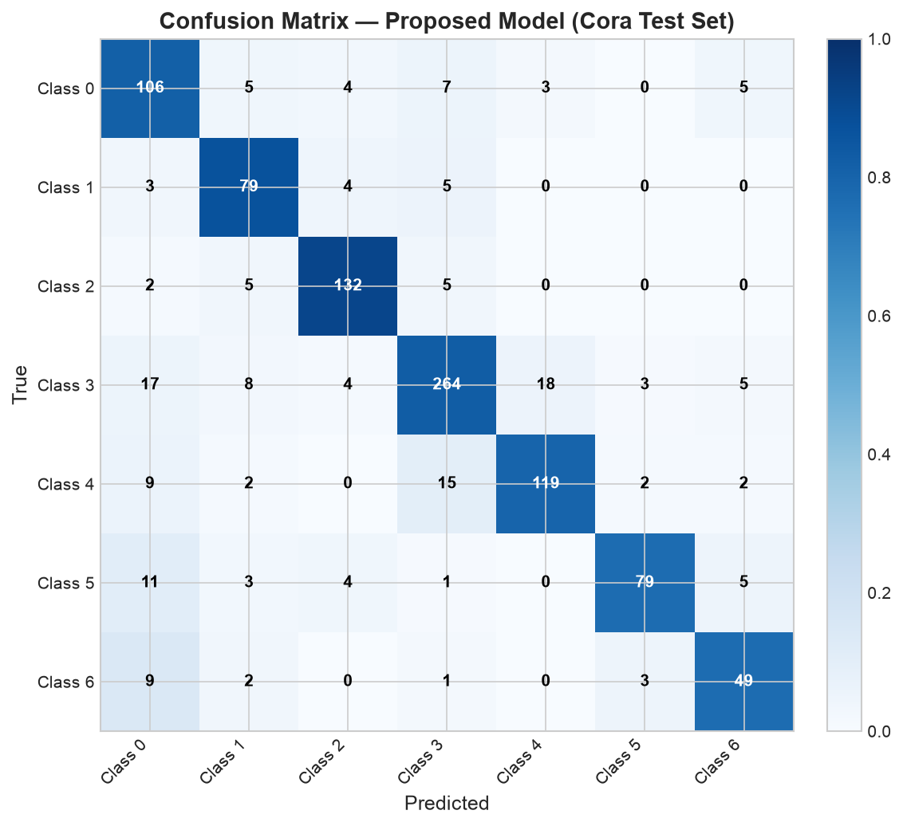
Figure 5: Confusion matrix of the proposed model on the Cora test set.
The diagonal entries (correct predictions) are dominant for most classes, indicating strong classification performance. Misclassifications tend to occur between semantically related research topics (e.g., neural networks and machine learning), which is expected given the overlap in vocabulary between these fields.
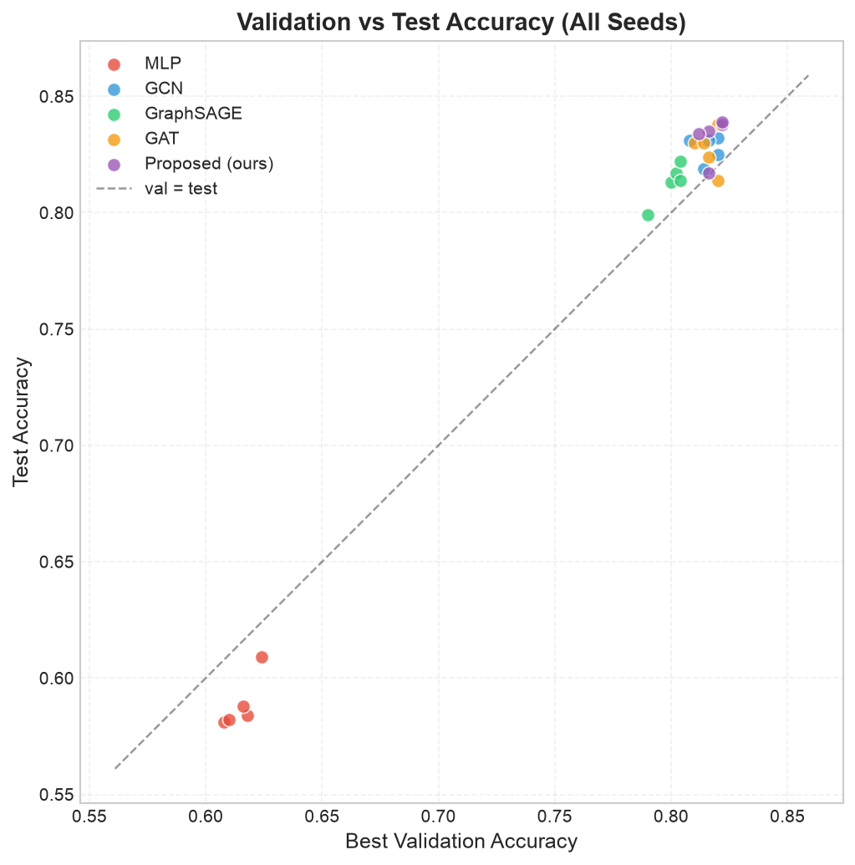
Figure 6: Validation vs test accuracy scatter plot across all models and seeds.
The validation-test scatter plot shows a consistent positive correlation between validation and test accuracy (r ≈ 0.6), confirming that our validation-based model selection strategy is effective. The val-test gap of approximately 1-2% indicates mild overfitting that is well-controlled by our training protocol.

6. Discussion

6.1 The Importance of Graph Structure
Our most significant finding is the dramatic improvement that graph structure provides over feature-only models. The MLP baseline achieves only 0.5888 accuracy despite having access to 1,433-dimensional features, while all GNN variants exceed 0.81. This +24% absolute improvement (or +41% relative) underscores that in citation networks, the pattern of who cites whom is at least as informative as the content of the papers themselves for determining research topics.
This result has practical implications: when building classification systems for networked data, investing in graph-based approaches yields substantially better results than purely feature-based methods, even when features are high-dimensional.

6.2 GCN vs GAT: Simplicity Wins on Small Graphs
The near-identical performance of GCN (0.8276) and GAT (0.8272) challenges the assumption that more complex attention mechanisms always improve performance. On Cora's small, homogeneous graph, the simple mean aggregation of GCN captures neighborhood information as effectively as learned attention weights.
This finding aligns with recent work (Errica et al., 2020; Shchur et al., 2018) showing that with proper hyperparameter tuning, simple GNN architectures can match or exceed more complex ones. The attention mechanism in GAT may be more beneficial on heterogeneous graphs where different neighbors have vastly different importance, or on larger graphs where the neighborhood is too large for uniform aggregation.

6.3 Residual Skip Connection: The Key Innovation
The residual skip connection H₀·W_skip is the most impactful component of our proposed model, contributing +1.7% test accuracy. This connection acts as a "shortcut" that preserves raw feature information at the output level. Intuitively, it allows the model to combine graph-based reasoning (from the GAT layers) with direct feature-based classification (from the linear projection).
Interestingly, the skip connection operates on raw features H₀ rather than intermediate representations H₁. This design choice means the skip path carries the full 1,433-dimensional feature vector (projected to 7 classes), preserving fine-grained information that may be lost through the message-passing bottleneck (where features are compressed to 64 dimensions in H₁).

6.4 DropEdge: Not Universally Beneficial
Our ablation shows that DropEdge provides negligible benefit (−0.1%) on Cora. This contrasts with the original DropEdge paper (Rong et al., 2020) which demonstrated significant improvements on deeper GNNs and larger datasets. We attribute this to three factors:
- Shallow architecture: Our 2-layer model is not prone to severe over-smoothing, which is the primary problem DropEdge addresses.
- Small graph: With only 5,278 edges, removing 20% leaves ~4,222 edges — still sufficient for effective message passing on Cora's dense clusters.
- Low overfitting: The val-test gap of ~1-2% indicates that the model does not overfit severely, reducing the need for regularization.

6.5 Training Stability
All models exhibit low standard deviation across 5 random seeds (0.005-0.014), indicating that the training process is robust and not overly sensitive to initialization. The proposed model's std of 0.008 with the residual connection is comparable to other GNN baselines, suggesting that the skip connection does not introduce training instability.

7. Limitations and Future Work

7.1 Limitations
Single Dataset: Our experiments are limited to Cora, a small citation network with 2,708 nodes and 7 classes. The generalizability of our findings to larger, more diverse datasets (Citeseer, Pubmed, OGB) remains unverified. The effectiveness of the residual skip connection and DropEdge may differ significantly on graphs with different properties (size, density, homophily).
Shallow Architecture: We only evaluate 2-layer GNNs. Deeper architectures (3-5 layers) may behave differently: over-smoothing becomes more severe, potentially making DropEdge and residual connections more valuable. Our findings about DropEdge's ineffectiveness may not hold for deeper models.
Limited Regularization Study: We only investigate DropEdge as a regularization technique. Other approaches such as Mixup on graphs, Label Smoothing, or graph-based data augmentation are not explored.
Single Metric: We report only classification accuracy. Per-class metrics (F1-score, precision, recall), calibration analysis, and uncertainty estimation would provide a more comprehensive evaluation.
No Hyperparameter Search: We use fixed hyperparameters based on common defaults rather than systematic tuning. A grid search or Bayesian optimization over learning rate, weight decay, dropout rate, and DropEdge probability could reveal better configurations.

7.2 Future Work
Multi-Dataset Evaluation: Extend experiments to Citeseer, Pubmed, Arxiv-OGC, and OGB datasets to verify generalizability. Larger and more diverse graphs may reveal conditions where DropEdge and attention become more impactful.
Deeper Architectures: Explore 3-5 layer GNNs with Jumping Knowledge connections and graph normalization layers. Deeper models would benefit more from residual connections and regularization techniques.
Graph Transformers: Investigate Graph Transformer architectures that apply self-attention over the entire graph rather than local neighborhoods, potentially capturing long-range dependencies that 2-hop GNNs miss.
Attention Visualization: Visualize learned attention weights to interpret what the model has learned. Understanding which edges and nodes receive the most attention could provide insights into the citation patterns.
Real-World Applications: Apply the proposed model to practical problems such as recommendation systems, social network analysis, and molecular property prediction where graph structure is critical.

8. Conclusion
This project presents a comprehensive study of Graph Neural Networks for semi-supervised node classification on the Cora citation network. We implemented and compared four models — MLP, GCN, GraphSAGE, and GAT — and proposed a Residual Multi-Head Mixing GAT that combines GATv2 multi-head attention with an input-feature skip connection and DropEdge regularization.
Our key findings are:
- 1. Graph structure is critical: GNNs outperform MLP by +24% absolute accuracy, confirming that citation patterns carry essential information beyond paper content.
- 2. The proposed model achieves the best test accuracy (0.8326 ± 0.0080), outperforming all baselines including GAT (0.8272) and GCN (0.8276).
- 3. The residual skip connection is the primary contributor (+1.7%), providing a direct path from raw features to output logits.
- 4. DropEdge has negligible effect on this small graph, suggesting that regularization benefits depend on graph size and model depth.
- 5. All models show stable training (std 0.005-0.014) with consistent validation-based model selection.
While our results are promising, they are limited to a single small dataset. Future work should extend evaluation to larger and more diverse graphs, explore deeper architectures, and investigate attention visualization for model interpretability. The residual skip connection concept, however, shows clear potential as a simple yet effective enhancement for graph attention networks.

References
- [1] Kipf, T. N., & Welling, M. (2017). Semi-Supervised Classification with Graph Convolutional Networks. ICLR.
- [2] Veličković, P., et al. (2018). Graph Attention Networks. ICLR.
- [3] Hamilton, W. L., Ying, R., & Leskovec, J. (2017). Inductive Representation Learning on Large Graphs. NeurIPS.
- [4] Brody, S., Alon, U., & Yahav, E. (2022). How Attentive are Graph Attention Networks? ICLR.
- [5] Rong, Y., et al. (2020). DropEdge: Towards Deep Graph Convolutional Networks on Node Classification. ICLR.
- [6] Yang, Z., Cohen, W., & Salakhutdinov, R. (2016). Revisiting Semi-Supervised Learning with Graph Embeddings. ICML.
- [7] He, K., Zhang, X., Ren, S., & Sun, J. (2016). Deep Residual Learning for Image Recognition. CVPR.
- [8] Bruna, J., Zaremba, W., Szlam, A., & LeCun, Y. (2014). Spectral Networks and Deep Locally Connected Networks on Graphs. ICLR.
- [9] Shchur, O., Mumme, M., Bojchevski, A., & Günnemann, S. (2018). Pitfalls of Graph Neural Network Evaluation. NeurIPS Workshop.
- [10] Errica, F., Podda, M., Bacciu, D., & Micheli, A. (2020). A Fair Comparison of Graph Neural Networks for Graph Classification. ICLR.

