An Interpretable Machine Learning Pipeline for Deforestation Risk Prediction in Vietnam at 1 km Resolution

Abstract
Deforestation monitoring requires both historical mapping and actionable risk signals to support timely interventions. This study presents a reproducible, district-scale pipeline for deforestation risk prediction in Gia Lai Province, Vietnam, using K’Bang District for pipeline development and Mang Yang District for area-based generalization testing. We integrate public datasets including Hansen Global Forest Change baseline canopy and annual forest loss history (treecover2000 and lossyear-derived labels, 2001–2024), SRTM terrain (mean elevation and slope), and CHIRPS precipitation (recent 12‑month totals and long-run annual means). Using a 1 km grid sampling design, we construct a master feature table and compare a simple baseline risk score with an interpretable logistic regression model and a stronger random forest model. Performance is evaluated using (i) a provided train/test split and (ii) cross-district transfer tests, and is reported with AUC, average precision, precision, recall, F1, and an operational capture-rate metric (the top X% highest-risk cells contain Y% of observed loss events).

Keywords
deforestation; Vietnam; Gia Lai; risk mapping; Global Forest Change; SRTM; CHIRPS; interpretable machine learning; random forest; logistic regression

1. Introduction
Vietnam’s forest landscapes provide critical ecosystem services, including biodiversity conservation, watershed protection, climate regulation, and livelihoods. Forest loss and degradation remain persistent challenges, especially where accessibility, land-use change, and economic pressures interact. Operational forest protection benefits from (i) reliable characterization of historical forest loss and (ii) near-real-time or forward-looking risk signals that indicate where monitoring and enforcement should be prioritized.
This paper develops a reproducible workflow that can be expanded from a district pilot to broader deployment. Our contributions are: (1) a reproducible pipeline that constructs a 1 km grid-based master table integrating historical loss labels and interpretable drivers; (2) a warning-zone framework that converts continuous risk scores into actionable ranked monitoring zones; (3) baseline versus machine learning comparisons using a provided train/test split and a cross-district transfer test; and (4) explainable outputs (logistic regression coefficients and random forest feature importance) suitable for stakeholder interpretation.

2. Study Area and Data

2.1. Study Area
This study focuses on Gia Lai Province in Vietnam’s Central Highlands. We adopt a two-district design: K’Bang District for pipeline development and primary reporting, and Mang Yang District for area-based generalization testing. All outputs are produced at 1 km resolution to balance interpretability and computational feasibility.

2.2. Datasets
Table 1 summarizes the public datasets used and their roles.

Table 1. Datasets used and roles.
Dataset | Layers/Variables | Native resolution | Time span | Role in pipeline
Hansen Global Forest Change (v1.12) | treecover2000, lossyear-derived loss labels | 30 m | 2000 baseline; loss 2001–2024 | Forest baseline + historical loss labels
SRTM | mean_elevation_m, mean_slope_deg | 30–90 m | Static | Terrain predictors
CHIRPS daily (aggregated) | rain_last12m_total_mm, rain_mean_annual_2000_2024_mm | ~5 km | 2000–2025 | Rainfall predictors

3. Materials and Methods

3.1. Sampling design and master table
A regular 1 km grid is defined over each district boundary. Grid cells (or their centroids) are used as the common spatial unit for feature extraction. For this pilot dataset, a stratified sample of grid locations is used to ensure sufficient representation of loss and no-loss cases for model training and evaluation.

3.2. Outcome definition (Hansen historical loss)
The main outcome is a binary historical loss indicator derived from Hansen lossyear and treecover2000 products. We define loss_any_2001_2024 = 1 if any forest loss is observed in the cell during 2001–2024, and 0 otherwise. We also retain loss_first_year, the earliest loss year observed within the cell, for descriptive analyses and for future time-based evaluation.

3.3. Predictor features
Predictors include baseline canopy cover (treecover2000), terrain variables (mean elevation and mean slope), and rainfall features (recent 12‑month totals and long-run annual means). These variables are selected to preserve interpretability while capturing broad drivers of accessibility and environmental context.

3.4. Models
We compare: (i) a baseline risk score constructed from standardized interpretable features; (ii) logistic regression (with class-weighting) for interpretable coefficients; and (iii) random forest for nonlinear relationships and interactions.

3.5. Validation and metrics
Performance is evaluated using (i) the provided train/test split and (ii) area-based transfer tests (train on one district and test on the other). We report AUC, average precision, precision, recall, F1, and capture-rate metrics at 5% and 10% (top-ranked cells).

4. Results

4.1. Dataset summary
The pilot dataset contains 6000 sampled 1 km locations, including 4000 in K’Bang and 2000 in Mang Yang. Using Hansen labels, overall loss prevalence is 0.554, with 0.417 in K’Bang and 0.827 in Mang Yang.

Table 2. Summary statistics by district.
district | n_samples | n_train | n_test | pos_rate_label_std | treecover2000_mean | treecover2000_std | treecover2000_median | mean_elevation_m_mean | mean_elevation_m_std | mean_elevation_m_median | mean_slope_deg_mean | mean_slope_deg_std | mean_slope_deg_median | rain_last12m_total_mm_mean | rain_last12m_total_mm_std | rain_last12m_total_mm_median | rain_mean_annual_2000_2024_mm_mean | rain_mean_annual_2000_2024_mm_std | rain_mean_annual_2000_2024_mm_median | loss_first_year_mean | loss_first_year_std | loss_first_year_median
KBang | 4000.000 | 3200.000 | 800.000 | 0.500 | 84.425 | 16.950 | 90.000 | 880.693 | 217.590 | 861.000 | 13.643 | 8.314 | 12.028 | 3230.439 | 258.711 | 3179.511 | 2640.560 | 194.513 | 2607.922 | 891.674 | 1002.002 | 0.000
MangYang | 2000.000 | 1588.000 | 412.000 | 0.500 | 65.348 | 28.372 | 72.000 | 783.779 | 150.441 | 774.000 | 11.652 | 7.297 | 10.488 | 2996.835 | 259.994 | 2937.223 | 2520.717 | 214.016 | 2491.310 | 1957.186 | 344.343 | 2021.000

4.2. Model performance
Under the provided split, the best AUC is achieved by RF (AUC=0.892, AP=0.912). In cross-district transfer (K’Bang→Mang Yang), the best AUC is achieved by Baseline (AUC=0.869, AP=0.964). In the reverse transfer (Mang Yang→K’Bang), the best AUC is achieved by Baseline (AUC=0.573, AP=0.501). Transfer results indicate that model ranking may not generalize symmetrically across districts without recalibration or additional covariates.

Table 3. Model performance (label = Hansen loss_any_2001_2024).
Scenario | Model | AUC | AP | Precision | Recall | F1 | Capture@5% | Capture@10% | Threshold(F1-train) | N_test | N_pos_test
Split (provided), label=Hansen loss_any | Baseline | 0.563 | 0.620 | 0.579 | 0.974 | 0.726 | 0.067 | 0.122 | 0.337 | 1212 | 686
Split (provided), label=Hansen loss_any | LogReg | 0.788 | 0.853 | 0.663 | 0.851 | 0.745 | 0.087 | 0.176 | 0.333 | 1212 | 686
Split (provided), label=Hansen loss_any | RF | 0.892 | 0.912 | 0.806 | 0.856 | 0.830 | 0.086 | 0.175 | 0.526 | 1212 | 686
Area transfer KBang->MangYang, label=Hansen loss_any | Baseline | 0.869 | 0.964 | 0.899 | 0.933 | 0.916 | 0.060 | 0.117 | 0.358 | 2000 | 1654
Area transfer KBang->MangYang, label=Hansen loss_any | LogReg | 0.066 | 0.647 | 0.771 | 0.690 | 0.729 | 0.005 | 0.010 | 0.435 | 2000 | 1654
Area transfer KBang->MangYang, label=Hansen loss_any | RF | 0.409 | 0.807 | 0.805 | 0.321 | 0.459 | 0.050 | 0.100 | 0.556 | 2000 | 1654
Area transfer MangYang->KBang, label=Hansen loss_any | Baseline | 0.573 | 0.501 | 0.421 | 0.981 | 0.589 | 0.077 | 0.143 | 0.337 | 4000 | 1668
Area transfer MangYang->KBang, label=Hansen loss_any | LogReg | 0.291 | 0.307 | 0.416 | 0.994 | 0.587 | 0.025 | 0.050 | 0.182 | 4000 | 1668
Area transfer MangYang->KBang, label=Hansen loss_any | RF | 0.428 | 0.368 | 0.417 | 1.000 | 0.589 | 0.038 | 0.077 | 0.503 | 4000 | 1668

Figure 3. ROC curves.
Provided split.
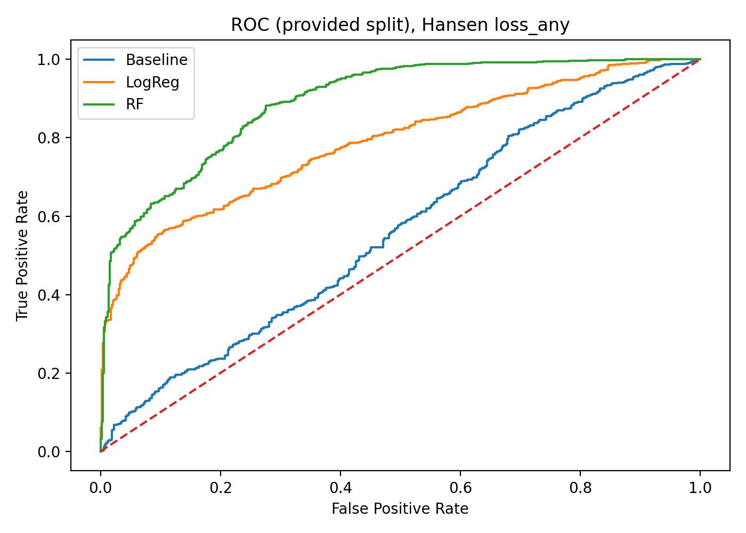
Train K’Bang, test Mang Yang.
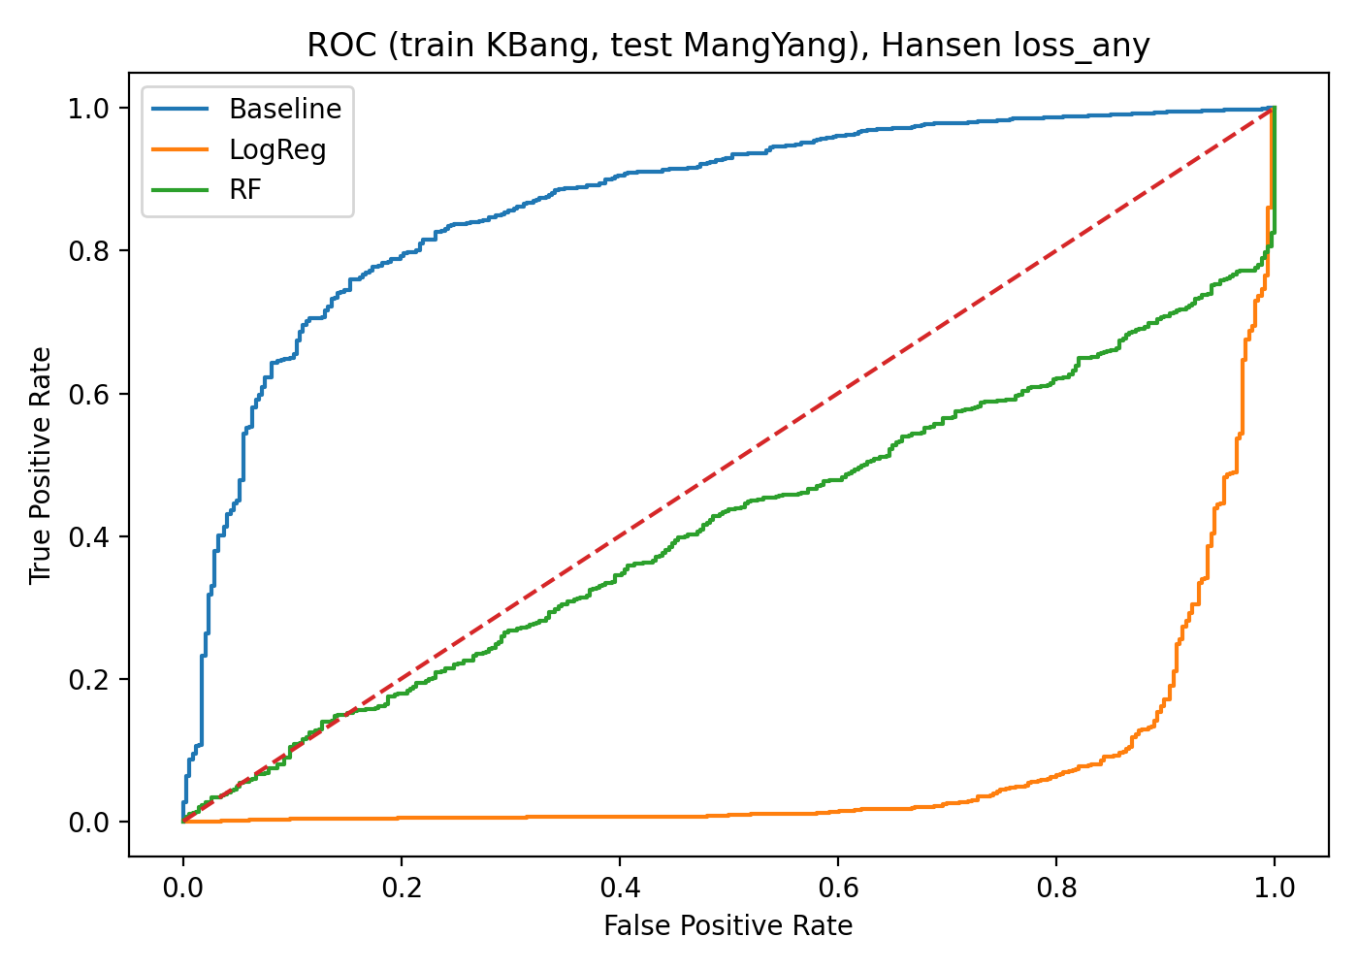
Train Mang Yang, test K’Bang.
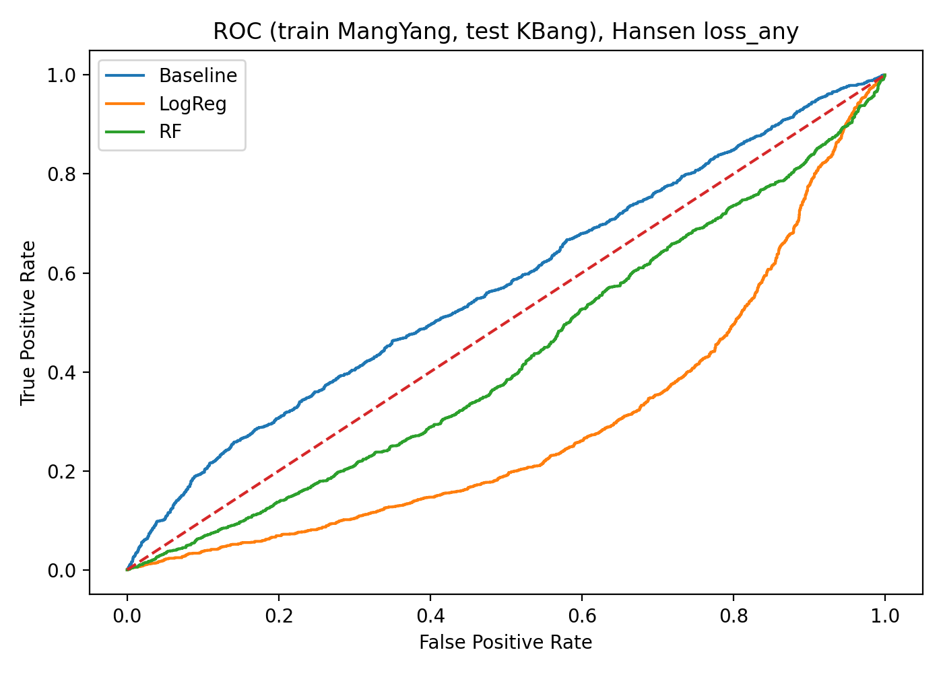

4.3. Explainability outputs
Figure 6 summarizes random forest feature importance and logistic regression coefficient directions.
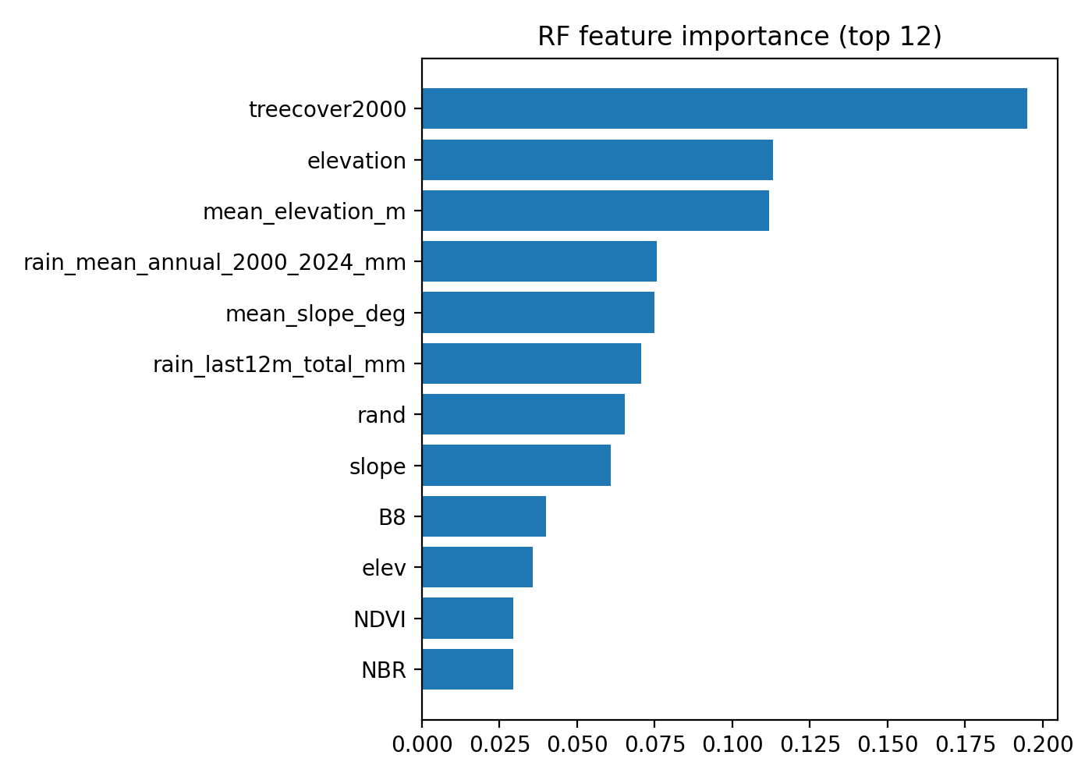
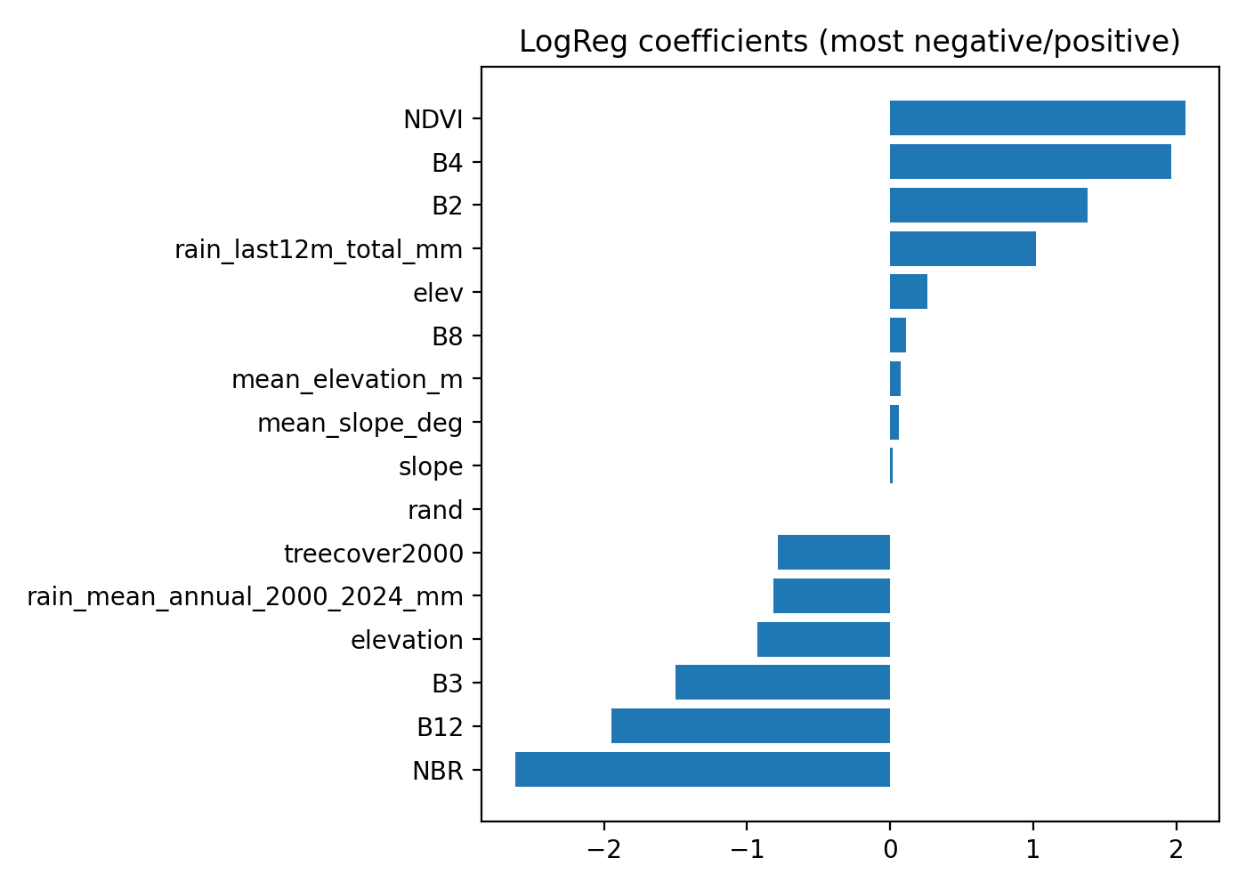

5. Discussion
The results show that interpretable drivers combined with machine learning can yield strong discrimination under within-split evaluation, with random forest providing the best overall performance. However, cross-district transfer performance is inconsistent, indicating that risk relationships and feature distributions differ between K’Bang and Mang Yang. This suggests that practical deployment should consider district-level calibration, additional covariates (e.g., road proximity, settlements, protected areas), and temporal alignment of predictors.
Limitations include potential sampling bias (the pilot uses a stratified sample of locations rather than a full-coverage grid), uncertainty in label attribution at 1 km aggregation, and potential temporal mismatch among predictors. These limitations can be addressed by exporting full-grid predictions and adding time-based validation once stable lossyear rules and full time-series features are available.

6. Conclusions
This study provides a reproducible pipeline and a research-ready master dataset for deforestation risk modeling in Gia Lai Province, Vietnam. The two-district design supports evaluation of area-based generalization, while explainability outputs help interpret predicted risk drivers. The resulting dataset and workflow are intended to support student research and future scaling to broader monitoring systems.

Author Contributions
Conceptualization, M.F.; methodology, M.F.; software, M.F.; validation, M.F. and [Student Initials]; formal analysis, M.F.; data curation, M.F. and [Student Initials]; writing—original draft preparation, M.F.; writing—review and editing, M.F. and [Student Initials]; visualization, M.F.; supervision, M.F.

Funding
This research received no external funding.

Data Availability Statement
The derived master tables (CSV) and model outputs are generated from the reproducible Google Earth Engine export and downstream modeling scripts. An open repository (GitHub/Zenodo) with a DOI will be prepared upon submission.

Conflicts of Interest
The authors declare no conflict of interest.

References
Hansen, M.C.; Potapov, P.V.; Moore, R.; et al. High-Resolution Global Maps of 21st-Century Forest Cover Change. Science 2013.
Funk, C.; Peterson, P.; Landsfeld, M.; et al. The Climate Hazards Infrared Precipitation with Stations—A New Environmental Record for Monitoring Extremes. Sci. Data 2015.
Farr, T.G.; Rosen, P.A.; Caro, E.; et al. The Shuttle Radar Topography Mission. Rev. Geophys. 2007.
Haklay, M.; Weber, P. OpenStreetMap: User-Generated Street Maps. IEEE Pervasive Comput. 2008.

