**MINISTRY OF EDUCATION AND TRAINING**

**FPT UNIVERSITY**

Capstone Project Report 3

**Building the laboratory tests management system**

|  |  |
| --- | --- |
| **Group 6** | |
| **Group members** | Bạch Minh Đức – SE61791  Châu Minh Ý– SE61419  Trần Tuấn Dũng – SE61982  Nguyễn Hữu Lâm – SE61234 |
| **Supervisor** | Hồ Hoàn Kiếm |
| **Ext. Supervisor** | N/A |
| **Capstone Project Code** | eLTMS |

- Ho Chi Minh City, 14 September 2018 -

# Table of Contents

Table of Contents 2

List of Tables 3

List of Figures 3

Software Requirement Specification 5

1. User Requirement Specification 5

1.1. Guest Requirement: 5

1.2. Auctioneer Requirement 5

1.3. Bidder Requirement 5

1.4. Admin Requirement 6

2. System Requirement Specification 6

2.1. External Interface Requirement 6

2.1.1. User Interface 6

2.1.2. Hardware Interface 6

2.1.3. Software Interface 6

2.1.4. Communication Protocol 7

2.2. System Overview Use Case 7

2.3. List of Use Case 7

2.3.1. Guest Overview Use Case 7

2.3.1.1. Guest Login 8

2.3.1.2. Guest Register 9

2.3.1.3. Guest Search Auctions 11

2.3.1.4. Guest View Auction’s Details 13

2.3.1.5. Guest View Bid Transactions 15

2.3.1.6. Guest View Suggested Auctions 17

2.3.2. Administrator Overview Use Case 18

2.3.2.1. Administrator View List of Auctions 19

2.3.2.2. Administrator Accept Pending Auction 21

2.3.2.3. Administrator Reject Pending Auction 22

2.3.2.4. Administrator Search Auctions 24

2.3.2.5. Administrator Search Users 26

2.3.2.6. Administrator Activate Users 27

2.3.2.7. Administrator Restrict Users 28

2.3.2.8. Administrator View Statistics 30

2.3.3. Auctioneer Overview Use Case 32

2.3.3.1. Auctioneer Create Auction 32

2.3.3.2. Auctioneer View Selling History 34

2.3.3.3. Auctioneer View Winner Contact Information 36

2.3.4. Bidder Overview Use Case 38

2.3.4.1. Bidder Place Bid 38

2.3.4.2. Bidder View Bidding History 40

2.3.4.3. Bidder View Seller Contact Information 42

2.3.5. Authorized User Overview Use Case 44

2.3.5.1. Authorized User Logout 44

2.3.5.2. Authorized Add Address 45

3. Software System Attribute 47

3.1. Usability 47

3.2. Reliability 47

3.3. Availability 47

3.4. Security 47

3.5. Maintainability 47

3.6. Portability 47

3.7. Portability 47

4. Conceptual Diagram 48

# List of Tables

Table 1 - Conceptual diagram data dictionary 48

# List of Figures

Figure 1 - System Overview Use Case 7

Figure 2 - <Guest>Overview Use Case 8

Figure 3 - < Guest > Login 8

Figure 4 - < Guest > Register 10

Figure 5 - < Guest > Search Auctions 11

Figure 6 - < Guest > View Auction’s Details 13

Figure 7 - < Administrator > Overview Use Case 15

Figure 8 - < Guest > View Bid Transactions 16

Figure 9 - < Guest > View Suggested Auctions 17

Figure 10 - < Administrator > Overview Use Case 19

Figure 11 - < Administrator > View List of Auctions 19

Figure 12 - < Administrator > Accept Auction 21

Figure 13 - < Administrator > Reject Auction 23

Figure 14 - < Administrator > Search Auctions 24

Figure 15 - < Administrator > Search Users 26

Figure 16 - < Administrator > Activate Users 27

Figure 17 - < Administrator > Restrict Users 28

Figure 18 - < Auctioneer> Overview Use Case 30

Figure 19 - < Administrator > View Statistic 30

Figure 20 - < Auctioneer> Overview Use Case 32

Figure 21 - < Auctioneer> Create Auction 32

Figure 22 - < Auctioneer> View Selling History 34

Figure 23 - < Auctioneer> View Winner Contact Information 36

Figure 24 - < Bidder > Overview Use Case 38

Figure 25 - < Bidder > Place Bid 38

Figure 26 - < Bidder > View Bidding History 40

Figure 27 - < Bidder > View Seller Contact Information 42

Figure 28 - <Authorized User> Overview Use Case 44

Figure 29 - < Authorized User> Logout 44

Figure 30 - <Authorized User> Add Address 45

Figure 31 - Conceptual Diagram 48

# Software Requirement Specification

## User Requirement Specification

### Guest Requirement:

Guest is a person who wants to use functions of the system. He/she must login or register to use more functions. He/she can use the following functions:

* Login
* Register
* Search auctions
  + Search by keyword
  + Search by category
  + Sort by time interval: ending soonest, newly list
  + Sort by price: lowest first, highest first
  + Sort by number of bidders: fewest first, most first
  + Filter by range of price
* View auction’s information
  + Basic information: name, current item’s price, seller, current highest bidder…
  + Bidding transactions
  + Suggested auctions

### Auctioneer Requirement

Auctioneer is a member of system who is able to create auctions for selling their items, track selling history. He/she can use the following functions:

* + Post an auction
  + Update ship address
  + View selling history
  + View winner’s contact information
  + Get notified when:
    - Admin accepted or refused his/her submitted auction
    - His/her auction is ending soon in 1 day, 1 hour
    - His/her auction ended and its result

### Bidder Requirement

Bidder is a member of system who can take part in auction, place bid, track bidding history. He/she can use the following functions:

* Update shipping address
* Place a bid
* View bidding history
* View contact information of won item’s seller
* Get notified when:
  + He/she is outbid by higher maximum bidder
  + He/she has bid at an auction successfully
  + Auction is ending soon in 1 day, 1 hour
  + Auction ended and its result

### Admin Requirement

Admin is a member of system who has the highest role, he/she controls system and manages its components to make sure it works in the best and the most convenient way. He/she can use the following function:

* Manage auctions
  + View list of auctions
  + Search auctions
  + Accept/reject pending auctions
* Manage users
  + Search users
  + Activate/restrict users
* View statistics about auctions, users

## System Requirement Specification

### External Interface Requirement

#### User Interface

* The user interface must be friendly and easy to use.
* All functions are arranged and displayed clearly.
* The interface design is an iterated process includes design, sketching and user assessment.

#### Hardware Interface

* The system will use the standard hardware and data communications resources of a standard computer.
* Desktop, laptop, smartphone or tablet has the ability to connect to the Internet.

#### Software Interface

* The website work with Chrome (v25 or above), Firefox (v46.1).
* The mobile application work on Android devices whose version is 4.4.2 or above.

#### Communication Protocol

* Use the HTTP, HTTPS protocol for communication between web browser and web server, between mobile device and web server.

### System Overview Use Case

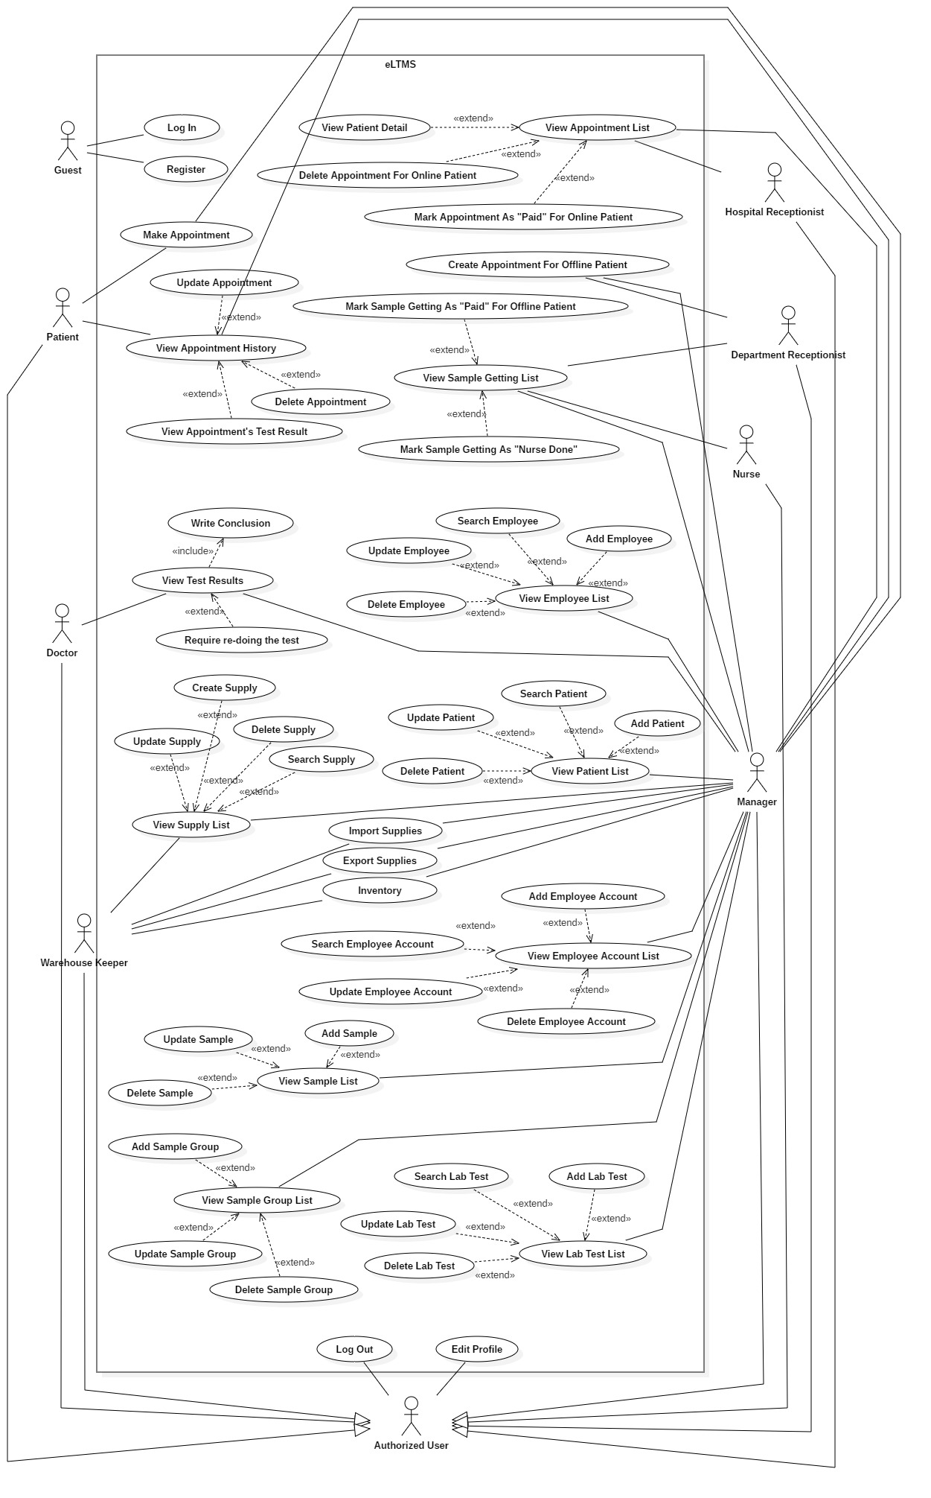

Figure 1 - System Overview Use Case

### List of Use Case

#### Guest Overview Use Case

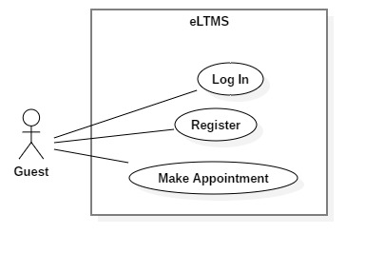

Figure 2 - <Guest>Overview Use Case

##### <Guest> Login

**Use Case Diagram**

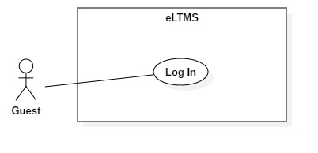

Figure 3 - < Guest > Login

**Use Case Specification**

|  |  |  |  |
| --- | --- | --- | --- |
| USE CASE - UC_01 | | | |
| Use Case No. | 01 | **Use Case Version** | 1.0 |
| Use Case Name | Login | | |
| Author |  | | |
| Date | 1/10/2018 | **Priority** | Normal |
| Actor:   * Guest.   Summary:   * This use case allows Guest to login to the system.   Goal:   * Guests are authorized as their role.   Triggers:   * User clicks “Đăng nhập” button.   Preconditions:   * User has an account.   Post Conditions:   * Success: User logs into the system successfully and gets redirected to a specified page depends on user’s role. * Fail: System shows error message.   Main Success Scenario:   |  |  |  | | --- | --- | --- | | Step | Actor Action | System Response | | 1 | User goes to Login page. | System requires information:   * Phone: text input. * Password: password input. | | 2 | User inputs information.  User clicks “Đăng Nhập” button. | User will login to the system with roles of this account.  [Exception 1,2,3,4] |   Exceptions:   |  |  |  | | --- | --- | --- | | No | Cause | System Response | | 1 | Phone is invalid length. | Show error message. | | 2 | Password is invalid length. | Show error message. | | 3 | Phone and password does not match with any accounts. | Show error message. |   Relationships: N/A  Business Rules:   * Patient can only log in to user-web. * Employee (Hospital Receptionist, Department Receptionist, Nurse, Doctor, Warehouse Keeper, Manager) can only log in to admin-web. | | | |

##### <Guest> Register

**Use Case Diagram**

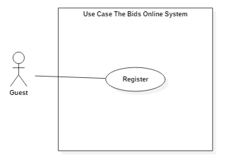

Figure 4 - < Guest > Register

**Use Case Specification**

|  |  |  |  |
| --- | --- | --- | --- |
| USE CASE - UC_02 | | | |
| Use Case No. | 02 | **Use Case Version** | 1.0 |
| Use Case Name | Register | | |
| Author |  | | |
| Date | 1/10/2018 | **Priority** | Normal |
| Actor:   * Guest.   Summary:   * This use case allows Guest to register account.   Goal:   * Create a new account for guest.   Triggers:   * User clicks “Đăng ký” button.   Preconditions:   * N/A   Post Conditions:   * Success: System saves account on database and shows success message. * Fail: System shows error message.   Main Success Scenario:   |  |  |  | | --- | --- | --- | | Step | Actor Action | System Response | | 1 | User goes to “Đăng ký” page. | System requires information:   * Phone: text input. * Password: password input. * Confirm password: password input * Full name: text input. * Date of birth: date input. * Email: text input. * Home address: text input. * Company address: text input. | | 2 | User inputs all required field.  Then clicks “Đăng ký” button. | User will register the system with roles of this account.  [Exception from 1 to 8]. |   Alternative Scenario: N/A  Exceptions:   |  |  |  | | --- | --- | --- | | No | Cause | System Response | | 1 | Phone is invalid. | Show error message. | | 2 | Password is invalid. | Show error message. | | 3 | Confirm password does not match | Show error message. | | 4 | Full name is empty. | Show error message. | | 5 | Date of birth is invalid | Show error message. | | 6 | Email is invalid. | Show error message. | | 7 | Home address is invalid. | Show error message. | | 8 | Company address is invalid. | Show error message. |   Relationships: N/A  Business Rules:   * Guest can only register as patient. * Phone is not null and must be verified by code. * Email is not null, correct email format. * Password is not null, in range of 8-255 characters, includes at least one digit and includes both lowercase and uppercase letters. * Date of birth is not null and not over the current date. * Full name is not null, in range of 5-50 characters. | | | |

##### <Guest, Patient> Make Appointment

**Use Case Diagram**

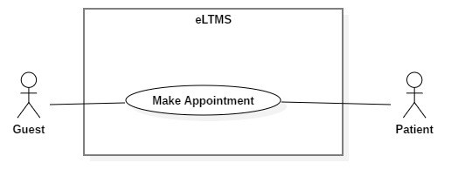

Figure 11 - < Guest, Patient > Make Appointment

**Use Case Specification**

|  |  |  |  |
| --- | --- | --- | --- |
| **USE CASE - UC_07** | | | |
| **Use Case No.** | 07 | **Use Case Version** | 1.0 |
| **Use Case Name** | Make Appointment | | |
| **Author** |  | | |
| **Date** | 1/10/2018 | **Priority** | Normal |
| **Actor:**   * Patient   **Summary:**   * Patient makes appointment with personal information, types of LabTest, date and time.   **Goal:**   * A new appointment of the patient is made.   **Triggers:**   * User clicks on “Đặt lịch hẹn” menu item on the website or “Đặt lịch” button on mobile app.   **Preconditions:**   * N/A.   **Post Conditions:**   * **Success:** Show success message. * **Fail:** Show error message.   **Main Success Scenario:**   |  |  |  | | --- | --- | --- | | Step | Actor Action | System Response | | 1 | User clicks on “Đặt lịch hẹn”. | System requires information input:   * Full name * Phone number | | 2 | User clicks on “Bước 2”. | System displays a checkbox list of LabTest types for user to select. | | 3 | User clicks on “Bước 3”. | System displays a table that shows the selected LabTests and requires input date and time for each of them. | | 4 | User clicks on “Đặt lịch”. | System show message on a popup (success/error). |   **Exceptions:**   |  |  |  | | --- | --- | --- | | No | Cause | System Response | | 1 | Full name or phone number is empty. | Show error message. | | 2 | No LabTests are selected. | Show error message. | | 3 | A date or time is empty. | Show error message. | | 4 | Two date-times intersects. | Show error message. |   **Relationships:** N/A  **Business Rules:**   * User cannot book a Sample twice or more on the same day. * Number of bookings of a Sample-Group, on the same day, at the same slot cannot exceed the number of tables of that Sample-Group. * User cannot make an appointment with date-time in the past. * User cannot book 2 date-times which intersects each other. | | | |

#### Patient Overview Use Case

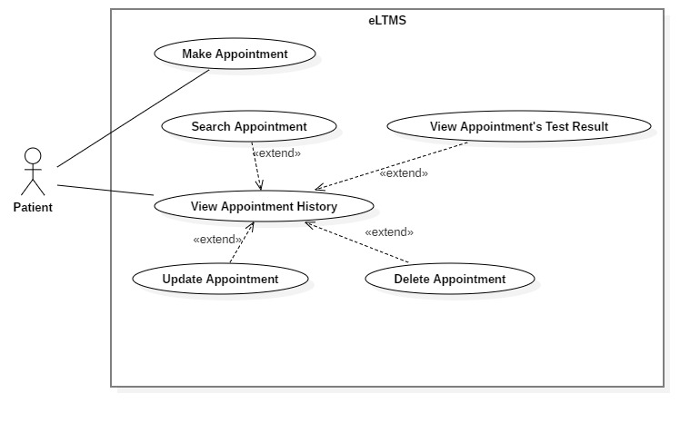

Figure 10 - < Administrator > Overview Use Case

##### <Patient> View Appointment History

**Use Case Diagram**

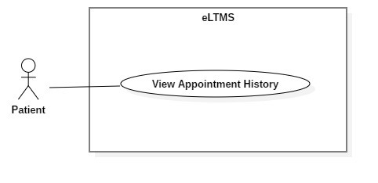

Figure 12 - <Patient> View Appointment History

**Use Case Specification**

|  |  |  |  |
| --- | --- | --- | --- |
| USE CASE - UC_07 | | | |
| Use Case No. | 07 | **Use Case Version** | 1.0 |
| Use Case Name | View Appointment History | | |
| Author |  | | |
| Date | 1/10/2018 | **Priority** | Normal |
| Actor:   * Patient   Summary:   * Patient views his/her appointment history including new appointment, being processed appointment and done appointment.   Goal:   * A list of appointments of the patient, with search, filter and pagination controls, is shown.   Triggers:   * User clicks on “Danh sách cuộc hẹn” on the Website/Mobile App.   Preconditions:   * User is logged in as Patient.   Post Conditions:   * Has data: Show a list of appointments of the patient with search, filter and pagination controls. * Has no data: Show “Bạn chưa có cuộc hẹn nào.” text.   Main Success Scenario:   |  |  |  | | --- | --- | --- | | Step | Actor Action | System Response | | 1 | User clicks on “Danh sách cuộc hẹn” on the Website or Mobile App. | System shows a list of appointments of the patient with search, filter and pagination controls. |   Alternative Scenario:   |  |  |  | | --- | --- | --- | | Step | Actor Action | System Response | | 1 | User clicks on “Danh sách cuộc hẹn” on the Website or Mobile App. | System shows a text: “Bạn chưa có cuộc hẹn nào.” |   Exceptions: N/A  Relationships: N/A.  Business Rules:   * In this list, each appointment has 3 status:   + “mới tạo”: User can edit and delete on Web. User can view detail (selected Samples, LabTests, date, time and price), edit and delete on Mobile App.   + “đang xử lý”: User can do nothing   + “hoàn tất”: User can view result on Web. User can view detail and view result on Mobile App. | | | |

##### <Patient> Update Appointment

**Use Case Diagram**

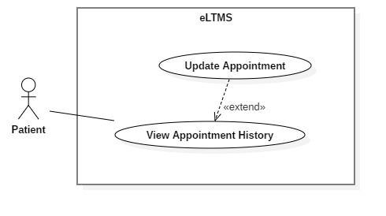

Figure 13 - < Patient >Update Appointment

**Use Case Specification**

|  |  |  |  |
| --- | --- | --- | --- |
| USE CASE - UC_08 | | | |
| Use Case No. | 08 | **Use Case Version** | 1.0 |
| Use Case Name | Update Appointment | | |
| Author |  | | |
| Date | 1/10/2018 | **Priority** | Normal |
| Actor:   * Patient   Summary:   * Update an appointment’s LabTest types, date and time.   Goal:   * LabTest types, date and time of an appointment are updated.   Triggers:   * User clicks Edit Button in the appointment row.   Preconditions:   * User is logged in as Patient.   Post Conditions:   * Success: A success message is shown. * Fail: An error message is shown.   Main Success Scenario:   |  |  |  | | --- | --- | --- | | Step | Actor Action | System Response | | 1 | User clicks on Edit Button in the appointment row. | System redirect to Edit page. Old values of LabTests are set on a checkbox list. | | 2 | User re-selects new LabTests. Then, user clicks “Bước 2” | System show a table of Samples with date and time. | | 3 | User re-selects date and time. Then, user clicks “Cập Nhật” | System processes and return message. |   Alternative Scenario: N/A  Exceptions: N/A  Relationships: Extended from View Appointment History use case.  Business Rules:   * User cannot book a Sample twice or more on the same day. * Number of bookings of a Sample-Group, on the same day, at the same slot cannot exceed the number of tables of that Sample-Group. * User cannot make an appointment with date-time in the past. * User cannot book 2 date-times which intersects each other. | | | |

##### <Patient> View Appointment’s Test Result

**Use Case Diagram**

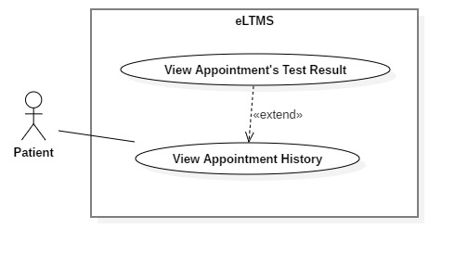

Figure 14 - < Patient > View Appointment’s Test Result

**Use Case Specification**

|  |  |  |  |
| --- | --- | --- | --- |
| **USE CASE - UC_10** | | | |
| **Use Case No.** | 10 | **Use Case Version** | 1.0 |
| **Use Case Name** | View Appointment’s Test Result | | |
| **Author** |  | | |
| **Date** | 1/10/2018 | **Priority** | Normal |
| **Actor:**   * Patient   **Summary:**   * Patient views appointment’s test result.   **Goal:**   * Patient views appointment’s test result, a soft version of result paper.   **Triggers:**   * Patient clicks View Result Button in the appointment row.   **Preconditions:**   * User is logged in as Patient.   **Post Conditions:**   * The test result is shown.   **Main Success Scenario:**   |  |  |  | | --- | --- | --- | | Step | Actor Action | System Response | | **1** | User clicks on View Result Button on the appointment row. | System redirects to View Result page which shows:   * Test results indexes: Name, value, status (normal/low/high), result, unit * “Tải tập tin PDF” button. | | **2** | User clicks on “Tải tập tin PDF”. | A PDF version is downloaded and opened on browser. |   **Exceptions:** N/A  **Relationships:** Extended from View Appointment History use-case.  **Business Rules:**   * In the test result grid: the rows has high or low status must be highlighted (bold, italic and underlined). If high, the result number marked “H” and righ-aligned. If low, the result number marked “L” and left-aligned. | | | |

##### <Patient> Delete Appointment

**Use Case Diagram**

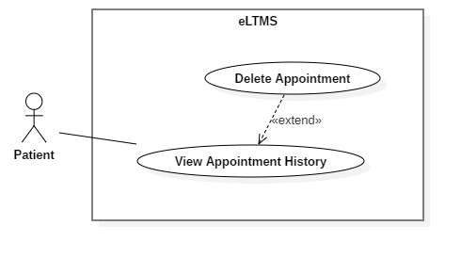

Figure 15 - < Administrator > Search Users

**Use Case Specification**

|  |  |  |  |
| --- | --- | --- | --- |
| **USE CASE - UC_12** | | | |
| **Use Case No.** | 12 | **Use Case Version** | 1.0 |
| **Use Case Name** | Delete Appointment | | |
| **Author** |  | | |
| **Date** | 1/10/2018 | **Priority** | Normal |
| **Actor:**   * Patient   **Summary:**   * Delete (cancel) an appointment that patient made.   **Goal:**   * Help patients can flexibly delete the appointments that they cannot come.   **Triggers:**   * Patient clicks on Delete Button on the appointment row.   **Preconditions:**   * User is logged in as Patient.   **Post Conditions:**   * Show success message.   **Main Success Scenario:**   |  |  |  | | --- | --- | --- | | Step | Actor Action | System Response | | 1 | User clicks on Delete Button on the appointment row. | System show a confirm popup with message: “Bạn có chắc chắn muốn hủy cuộc hẹn này không?” | | 2 | User clicks “Có”. | System deletes the appointment and show popup: “Cuộc hẹn đã được hủy thành công.” |   **Alternative Scenario:**   |  |  |  | | --- | --- | --- | | Step | Actor Action | System Response | | 1 | User clicks on Delete Button on the appointment row. | System show a confirm popup with message: “Bạn có chắc chắn muốn hủy cuộc hẹn này không?” | | 2 | User clicks “Không”. | System closes the popup and come back to the appointment history list. |   **Exceptions:**   |  |  |  | | --- | --- | --- | | No | Cause | System Response | | 1 | The appointment have been deleted before user confirmed “Có”. It is deleted from another device (maybe web or mobile). | Show error message. |   **Relationships:** Extended from View Appointment History List.  **Business Rules:** N/A | | | |

#### <Hospital Receptionist> Overview Use Case

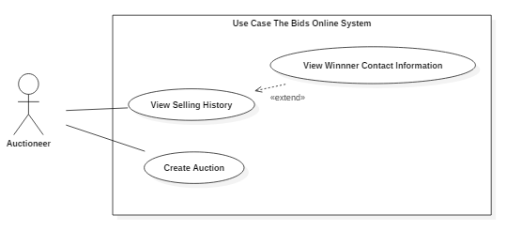

Figure 20 - < Auctioneer> Overview Use Case

##### <Hospital Receptionist> View Appointment List

**Use Case Diagram**

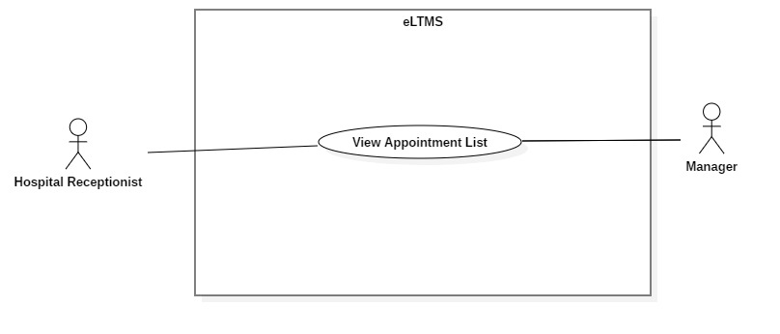

Figure 21 - < Hospital Receptionise> View Appointment List

**Use Case Specification**

|  |  |  |  |
| --- | --- | --- | --- |
| USE CASE - UC_10 | | | |
| Use Case No. | 10 | **Use Case Version** | 1.0 |
| Use Case Name | View Appointment List | | |
| Author |  | | |
| Date | 1/10/2018 | **Priority** | Normal |
| Actor:   * Auctioneer.   Summary:   * Hospital Receptionist views a list of appointments to guide patients coming to the hospital.   Goal:   * Hospital Receptionist can view all appointments, search by appointment code and filter by date.   Triggers:   * After Hospital Receptionist logged in successfully or clicks on “Quản lý cuộc hẹn” menu item.   Preconditions:   * User logged in as Hospital Receptionist.   Post Conditions:   * A list of appointments is shown, with search, filter and pagination controls.   Main Success Scenario:   |  |  |  | | --- | --- | --- | | Step | Actor Action | System Response | | 1 | User clicks on “Quản lý cuộc hẹn” menu item. | A list of appointments is shown, with search, filter and pagination controls. |   Alternative Scenario: N/A  Exceptions:   |  |  |  | | --- | --- | --- | | No | Cause | System Response | | 1 | Appointment table has no data. | Show message: “Chưa có cuộc hẹn nào” |   Relationships: N/A  Business Rules:   * Initially, all IsPaid Switches are set to OFF. | | | |

##### <Hospital Receptionist> View Appointment Detail

**Use Case Diagram**

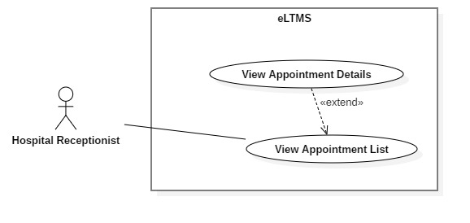

Figure 23 - < Hospital Receptionist> View Appointment Details

**Use Case Specification**

|  |  |  |  |
| --- | --- | --- | --- |
| USE CASE - UC_11 | | | |
| Use Case No. | 11 | **Use Case Version** | 1.0 |
| Use Case Name | View Appointment Details | | |
| Author |  | | |
| Date | 1/10/2018 | **Priority** | Normal |

|  |  |  |  |  |  |  |
| --- | --- | --- | --- | --- | --- | --- |
| Actor:   * Hospital Receptionist.   Summary:   * This use-case allows Hospital Receptionist to view appointment details.   Goal:   * Appointment details, includes patient’s information and a list of booked Sample-Getting of the appointment, are shown.   Triggers:   * User clicks on “Xem chi tiết” button on the appointment row.   Preconditions:   * User logged in as Hospital Receptionist. * User is at View Appointment List page.   Post Conditions:   * Success: A pop up with appointment details is shown.   Main Success Scenario:   |  |  |  | | --- | --- | --- | | Step | Actor Action | System Response | | 1 | User clicks on on “Xem chi tiết” button on the appointment row. | A pop up appears and shows these information:   * Patient profile: Full name, phone number, gender, date of birth, email, home address, company address. * A list of booked Sample-Getting. |   Alternative Scenario: N/A  Exceptions: N/A  Relationships: Extend from View Appointment List use case  Business Rules: N/A. |

##### <Hospital Receptionist> Delete Sample Getting

**Use Case Diagram**

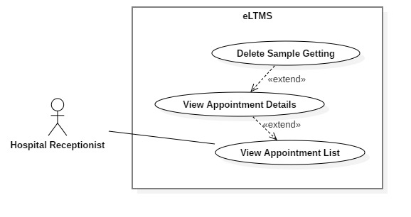

Figure 22 - <Hospital Receptionist> Delete Sample Getting

**Use Case Specification**

|  |  |  |  |
| --- | --- | --- | --- |
| **USE CASE - UC_10** | | | |
| **Use Case No.** | 10 | **Use Case Version** | 1.0 |
| **Use Case Name** | Delete Sample Getting | | |
| **Author** |  | | |
| **Date** | 1/10/2018 | **Priority** | Normal |
| **Actor**:   * Hospital Receptionist   **Summary**:   * This use-case allows Hospital Receptionist to delete Sample-Getting for online patient.   **Goal**:   * Sample-Getting of online patient is deleted.   **Triggers**:   * Hospital Receptionist clicks on Delete Button on the Sample-Getting row.   **Preconditions**:   * User logged in as Hospital Receptionist. * User is at Appointment Detail Popup.   **Post** **Conditions**:   * **Success**: Show success message. * **Fail:** Show error message.   **Main Success Scenario:**   |  |  |  | | --- | --- | --- | | Step | Actor Action | System Response | | 1 | User clicks on Delete Button on the Sample-Getting row. | System shows a popup: “Bạn có chắc chắn muốn xóa ca lấy mẫu này không?” | | 2 | User clicks “Có”. | System deleted the Sample-Getting and shows pop up: “Ca lấy mẫu đã được xóa.” |   Alternative Scenario 1:   |  |  |  | | --- | --- | --- | | Step | Actor Action | System Response | | 1 | User clicks on Delete Button on the Sample-Getting row. | System shows a popup: “Bạn có chắc chắn muốn xóa ca lấy mẫu này không?” | | 2 | User clicks “Không”. | System closes the popup and come back to the Sample-Getting list. |   **Exceptions**: N/A  **Relationships**: N/A  **Business** **Rules**:   * Price should be displayed as VND currency format. * Date should be displayed as Vietnamese date format. * For active auctions: user can sort the result by active time (newly listed/ending soon), number of bids (asc/desc), current price (asc/desc). User also can click on the row to visit auction’s detail page. * For ended auctions: user can sort the result by ended time (asc/desc), number of bids (asc/desc), current price (asc/desc). Each row provides a Contact icon for user can click and view seller’s contact information if the auction has a winner. | | | |

##### <Hospital Receptionist> Mark Appointment As "Paid"

**Use Case Diagram**

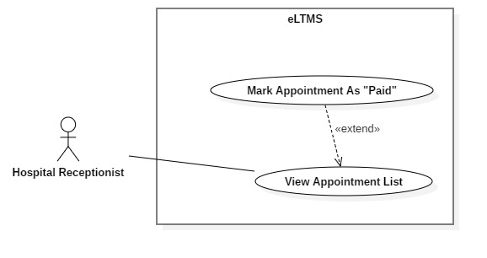

Figure 22 - <Hospital Receptionist> Mark Appointment As Paid

**Use Case Specification**

|  |  |  |  |
| --- | --- | --- | --- |
| **USE CASE - UC_10** | | | |
| **Use Case No.** | 10 | **Use Case Version** | 1.0 |
| **Use Case Name** | Mark Appointment As Paid | | |
| **Author** |  | | |
| **Date** | 1/10/2018 | **Priority** | Normal |
| **Actor**:   * Hospital Receptionist   **Summary**:   * This use-case allows Hospital Receptionist to mark the appointment as Paid.   **Goal**:   * Appointment is marked as Paid.   **Triggers**:   * User clicks on “Thanh toán” switch on the appointment row.   **Preconditions**:   * User logged in as Hospital Receptionist. * User is at Appointment List page.   **Post** **Conditions**:   * **Success**: Show success message. * **Fail:** Show error message.   **Main Success Scenario:**   |  |  |  | | --- | --- | --- | | Step | Actor Action | System Response | | 1 | User clicks on “Thanh toán” switch on the appointment row. | System show a pop up with a price list of all LabTests, and ask: “Bạn có chắc chắn muốn thanh toán không?” | | 2 | User clicks “Có”. | System processes and push notification to Nurses: “Đã thanh toán”. |   Alternative Scenario 1:   |  |  |  | | --- | --- | --- | | Step | Actor Action | System Response | | 1 | User clicks on “Thanh toán” switch on the appointment row. | System show a pop up with a price list of all LabTests, and ask: “Bạn có chắc chắn muốn thanh toán không?” | | 2 | User clicks “Không”. | Come back to Appointment List page. |   **Exceptions**: N/A  **Relationships**: N/A  **Business** **Rules**: N/A | | | |

#### Bidder Overview Use Case

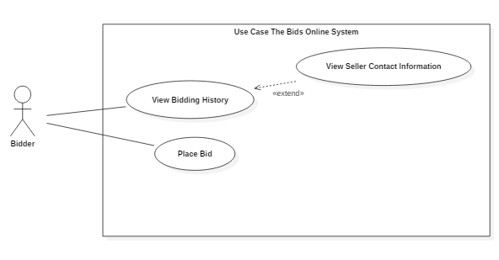

Figure 24 - < Bidder > Overview Use Case

##### Bidder Place Bid

**Use Case Diagram**

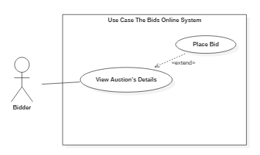

Figure 25 - < Bidder > Place Bid

**Use Case Specification**

|  |  |  |  |
| --- | --- | --- | --- |
| USE CASE - UC_12 | | | |
| Use Case No. | 12 | **Use Case Version** | 1.0 |
| Use Case Name | Place Bid | | |
| Author | Hà Trung Kiên | | |
| Date | 1/10/2018 | **Priority** | Normal |
| Actor:   * Bidder .   Summary:   * This use case allows Bidder to place bid at an auctions.   Goal:   * Bidder can place bid at an auction.   Triggers:   * Bidder clicks on “Đấu giá” button.   Preconditions:   * User must log into the system with Bidder role. * Bidder’s at “Thông tin phiên đấu giá” page.   Post Conditions:   * Success: System saves bid on database and shows success message, auction’s information and table of bidding transactions is updated on UI directly. * Fail: System shows error message.   Main Success Scenario:   |  |  |  | | --- | --- | --- | | Step | Actor Action | System Response | | 1 | Bidder clicks on any link of auction’s details page. | Redirect user to “Thông tin phiên đấu giá” displaying the auction’s information. | | 2 | Bidder inputs price in text input. | System formats input as currency format. | | 3 | Bidder clicks “Đấu giá” button. | System shows confirmation popup. | | 4 | Bidder clicks “Đồng ý” button on the popup. | System shows success message.  System updates auction’s information: current price, current minimum bid, current highest bidder’s username on UI.  System updates table of bidding transactions on UI.  System sends notification to bidder to confirm he/she is the highest bidder or not. |   Alternative Scenario: N/A  Exceptions:   |  |  |  | | --- | --- | --- | | No | Cause | System Response | | 1 | Bidder inputs price on their own products. | System shows “Bạn không thể đấu giá trên sản phẩm của mình” message. | | 2 | Bidder inputs reserve price that not divisible for 500. | System shows “Giá của bạn phải chia hết cho 500đ” message. | | 3 | Bidder inputs price too high comparing to item’s current price. | System shows “Giá của bạn nhập quá cao” message. | | 4 | Bidder inputs price lower than minimum bid. | System shows “Giá đấu của bạn phải bằng hoặc lớn hơn giá tối thiểu” message. |   Relationships: Extend from View Auction’s Details  Business Rules:   * The bid bidder types is not null, greater than 1000 and less than 200000000 and divisible for 500. * The bid bidder types needs to equal or be higher than the current minimum bid. * Automatic bidding system is provided to current highest bidder to bid on his/her behalf. See more at Algorithms section. * UI will be updated immediately after bidder places bid successfully without reloading the page. (real-time updating). | | | |

##### Bidder View Bidding History

**Use Case Diagram**

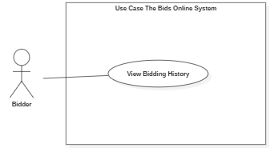

Figure 26 - < Bidder > View Bidding History

**Use Case Specification**

|  |  |  |  |
| --- | --- | --- | --- |
| **USE CASE - UC_13** | | | |
| **Use Case No.** | 13 | **Use Case Version** | 1.0 |
| **Use Case Name** | View Bidding History | | |
| **Author** | Hà Trung Kiên | | |
| **Date** | 1/10/2018 | **Priority** | Normal |
| **Actor**:   * Bidder.   **Summary**:   * This use case allows Bidder view bidding history.   **Goal**:   * Bidder can view bidding history.   **Triggers**:   * Bidder clicks on “Đấu giá hiện tại” tab.   **Preconditions**:   * User must be login to the system with Bidder role. * User’s at “Lịch sử đấu giá” page.   **Post Conditions**:   * Success: Bidder can view bidding history in the system.   **Main Success Scenario**:   |  |  |  | | --- | --- | --- | | Step | Actor Action | System Response | | 1 | Bidder goes to “Lịch sử đấu giá” page and clicks “Hiện tại” tab. | System shows list of bidding auction which includes following information:   * Item’s name * Item’s current price * Auction’s status * Auction’s number of bids * Seller username * Ended date time |   **Alternative Scenario 1:**   |  |  |  | | --- | --- | --- | | **Step** | **Actor Action** | **System Response** | | 1 | Bidder goes to “Lịch sử đấu giá” page and clicks “Đã thắng” tab. | System shows list of won auction which includes following information:   * Item’s name * Item’s final price * Auction’s status * Auction’s number of bids * Seller username * Ended date time |   **Alternative Scenario 2:**   |  |  |  | | --- | --- | --- | | Step | Actor Action | System Response | | 1 | Bidder goes to “Lịch sử đấu giá” page and clicks “Đã thua” tab. | System shows list of lost auction which includes following information:   * Item’s name * Item’s final price * Auction’s status * Auction’s number of bids * Seller username * Ended date time |   **Exceptions:** N/A  **Relationships:** N/A  **Business Rules:**   * Price should be displayed as VND currency format. * Date should be displayed as Vietnamese date format. * For bidding auctions: user can sort the result by active time (newly listed/ending soon), number of bids (asc/desc), current price (asc/desc). User also can click on the row to visit auction’s detail page. * For won and lost auctions: user can sort the result by ended time (asc/desc), number of bids (asc/desc), current price (asc/desc). For won auctions, each row provides a Contact icon for user can click and view seller’s contact information. | | | |

##### Bidder View Seller Contact Information

**Use Case Diagram**

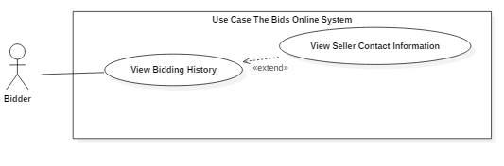

Figure 27 - < Bidder > View Seller Contact Information

**Use Case Specification**

|  |  |  |  |
| --- | --- | --- | --- |
| USE CASE - UC_13 | | | |
| Use Case No. | 13 | **Use Case Version** | 1.0 |
| Use Case Name | View Seller Contact Information | | |
| Author | Hà Trung Kiên | | |
| Date | 1/10/2018 | **Priority** | Normal |

|  |  |  |  |  |  |  |  |  |  |
| --- | --- | --- | --- | --- | --- | --- | --- | --- | --- |
| Actor:   * Bidder.   Summary:   * This use case allows Bidder to view seller’s contact information of won item.   Goal:   * Bidder can view seller contact information.   Triggers:   * Bidder clicks on “Contact” icon displayed on a bidding history record.   Preconditions:   * User must log into the system with Bidder role. * User has at least one won auction.   Post Conditions:   * Success: Bidder can view seller contact information in the system.   Main Success Scenario:   |  |  |  | | --- | --- | --- | | Step | Actor Action | System Response | | 1 | Bidder goes to “Lịch sử đấu giá” page and clicks “Đã thắng” tab. | System shows list of ended auction which includes following information:   * Item’s name * Item’s final price * Auction’s status * Auction’s number of bids * Seller username * Ended date time | | 2 | Bidder clicks Contact icon in any record. | System show seller’s contact information including:   * Full name * Phone number * Address |   Alternative Scenario: N/A  Exceptions: N/A  Relationships: Extend from View selling history use case  Business Rules: N/A |

#### Authorized User Overview Use Case

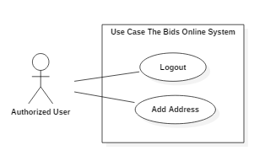

Figure 28 - <Authorized User> Overview Use Case

##### Authorized User Logout

**Use Case Diagram**

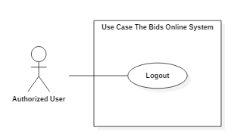

Figure 29 - < Authorized User> Logout

**Use Case Specification**

|  |  |  |  |
| --- | --- | --- | --- |
| USE CASE - UC_14 | | | |
| Use Case No. | 14 | **Use Case Version** | 1.0 |
| Use Case Name | Logout | | |
| Author | Hà Trung Kiên | | |
| Date | 1/10/2018 | **Priority** | Normal |
| Actor:   * Authorized User.   Summary:   * This use case allows user to log out.   Goal:   * User can log out.   Triggers:   * User clicks “Đăng xuất” button.   Preconditions:   * User must have logged into system.   Post Conditions:   * Success: System reloads page.   Main Success Scenario:   |  |  |  | | --- | --- | --- | | Step | Actor Action | System Response | | 1 | User clicks “Đăng xuất” button. | Reload current page. |   Alternative Scenario: N/A  Exceptions: N/A  Relationships: N/A  Business Rules: N/A | | | |

##### Authorized Add Address

**Use Case Diagram**

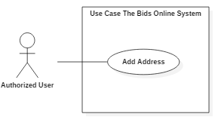

Figure 30 - <Authorized User> Add Address

**Use Case Specification**

|  |  |  |  |
| --- | --- | --- | --- |
| USE CASE - UC_15 | | | |
| Use Case No. | 15 | **Use Case Version** | 1.0 |
| Use Case Name | Add Address | | |
| Author | Hà Trung Kiên | | |
| Date | 1/10/2018 | **Priority** | Normal |
| Actor:   * Authorized User.   Summary:   * This use case allows User to add address.   Goal:   * User can add address information.   Triggers:   * User clicks on “Cập nhật” button.   Preconditions:   * User must log into the system.   Post Conditions:   * Success: System saves address on database and shows success message. * Fail: System shows error message.   Main Success Scenario:   |  |  |  | | --- | --- | --- | | Step | Actor Action | System Response | | 1 | User goes to “Đăng ký” page. | System requires information:   * Name: text input. * Phone: text input. * Address Line: text input. * District: text input. * City: password input. | | 2 | User inputs all required field.  Then clicks “Cập nhật” button. | User will register the system with roles of this account.  [Exception 1,2,3,4,5,6,7] |   Alternative Scenario: N/A  Exceptions:   |  |  |  | | --- | --- | --- | | No | Cause | System Response | | 1 | Name is empty. | Show error message. | | 2 | Phone is empty. | Show error message. | | 3 | Address Line is empty. | Show error message. | | 4 | District is empty. | Show error message. | | 5 | City is empty. | Show error message. |   Relationships: N/A  Business Rules:   * Name is not null, in range of 5-50 characters. * Phone is not null, follows phone format. * Address Line is not null, maximum length is 100 characters. * District is not null, maximum length is 30 characters. * City is not null, maximum length is 30 characters. | | | |

## Software System Attribute

### Usability

* The system usability is easy to use. It takes about 8 hours to get acquainted and use the system.
* Icons that indicate the actions should be easy to understand and users will not meet any troubles to recognize the feature of page.

### Reliability

* The rate of failure occurrence shall be 1/200 (1 occurrence in 200 days).
* The number of sending notification failure is 1 time per 200 notifications.
* Timer tasks run at configured time with 100% execution rate.
* The data should be backed up every day.

### Availability

* System is divided into modules, if a module is down, it will not affect others.
* The system can be adapted for a large number of request.

### Security

* Privacy: Each role of user has a specific permission to interact with system.
* System always checks authorization and authentication before doing anything.
* Only admin can grant permission to other roles.

### Maintainability

* The system is divided into separate modules.
* The code is easy to maintain and upgrade.

### Portability

* The web application is running on Windows 7 or above.
* The mobile application is running on Android 4.4.2 or above
* Providing easy installation.

### Portability

* All requests are handling in maximum time of 12 seconds.

## Conceptual Diagram

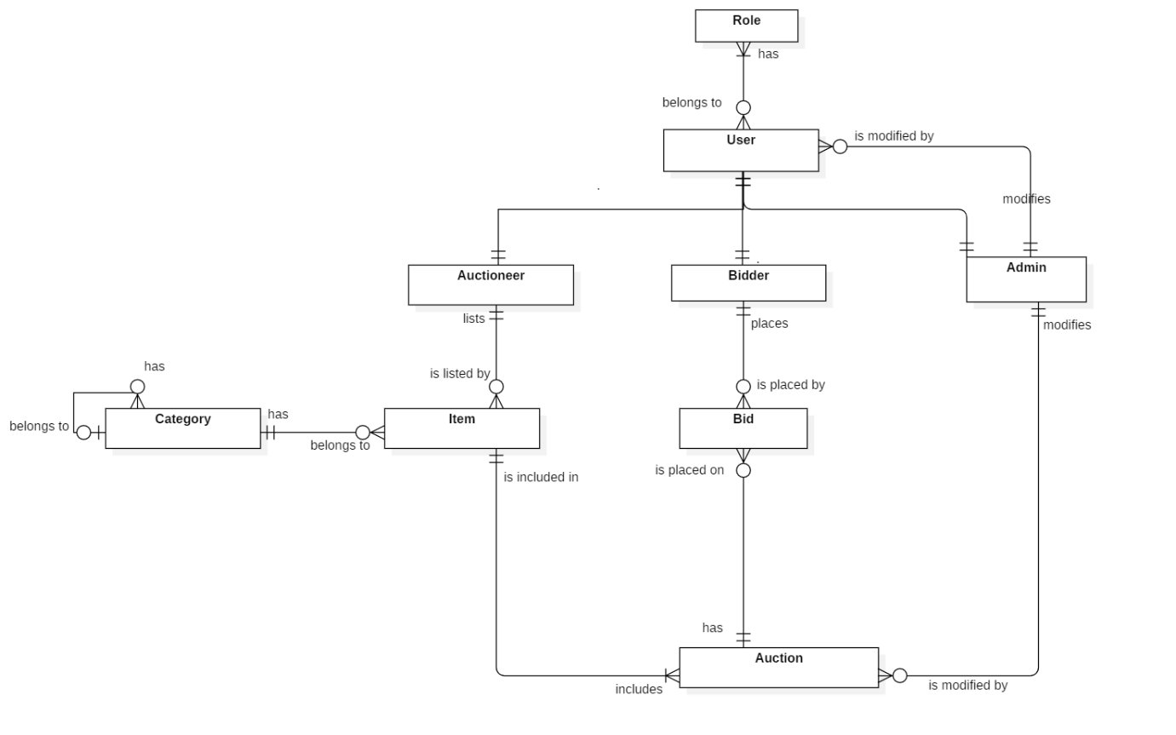

Figure 31 - Conceptual Diagram

**Data Dictionary**

|  |  |
| --- | --- |
| Entity Data dictionary: describe all content of all entities | |
| Entity Name | **Description** |
| Admin | Contain the administrator information. |
| Auction | Contain the auction information. |
| Auctioneer | Contain the auctioneer report information. |
| Bid | Contain the bid information |
| Bidder | Contain the bidder information. |
| Category | Contain the category information |
| Role | Contain the user role information. |
| User | Contain the user information. |

Table 1 - Conceptual diagram data dictionary