**MINISTRY OF EDUCATION AND TRAINING**

**FPT UNIVERSITY**

Capstone Project Report 6

**The Laboratory Test Management System**

|  |  |
| --- | --- |
| **Group 6** | |
| **Group members** | Bạch Minh Đức – SE61791  Châu Minh Ý– SE61419  Trần Tuấn Dũng – SE61982  Nguyễn Hữu Lâm – SE61234 |
| **Supervisor** | Hồ Hoàn Kiếm |
| **Ext. Supervisor** | N/A |
| **Capstone Project Code** | eLTMS |

- Ho Chi Minh City, 14 September 2018 -

# Table of Contents

Table of Contents 3

List of Tables 4

List of Figures 4

Software User’s Manual 5

1. Installation Guide 5

1.1. Setting up environment: 5

1.1.1. Hardware requirement 5

1.1.2. Software requirement 5

1.2. Deployment at Server side: 5

1.2.1. Prepare deployment package: 5

1.2.2. Configure Server before deploy. BMD 5

1.2.3. Deploy Server 5

1.3. Deployment at Client side: 5

1.3.1. Prepare deployment package: BMD 5

1.3.2. Deploy Mobile Application: BMD 5

1.3.3. Deploy Web Application: BMD 5

2. User Guide 5

2.1. Admin web application 5

2.1.1. Login 5

2.1.2. View Hospital Receptionist Page 6

2.1.3. View Department Receptionist Page 8

2.1.4. View Nurse Page 11

2.1.5. View Laboratory Technician Page 12

2.1.6. View Doctor Page 14

2.2. User web application 17

2.2.1. Login 17

2.2.2. Sign up 18

2.2.3. Logout 19

2.2.4. Home page 20

2.2.5. View Book Appointment 21

2.2.6. View list of Booked Appoinments 22

2.2.7. View Testing Result 24

2.3. Mobile application for all user 26

2.3.1. View Login Page 26

2.3.2. View Register Page 26

2.3.3. View Home Page 27

2.3.4. View Book Appointment Page 28

2.3.5. View Testing Result Page 30

# List of Tables

Table 1 - Hardware requirement for Server 6

Table 2 - Hardware requirement for web development 6

Table 3 - Hardware requirement for mobile development 6

Table 4 - Software requirement 6

Table 5 - Admin web application Guide <Login> 7

Table 6 - Admin web application Guide <View Hospital Receptionist> 9

Table 7 - Admin web application Guide <View user management> 12

Table 8 - Admin web application Guide <View Nurse> 13

Table 9 - Admin web application Guide <Laboratory Technician> 15

Table 13 - User web application Guide <Log out> 20

Table 15 - User web application Guide < Submit Auction > 23

Table 16 - User web application Guide <View list of Booked Appoinments> 25

# List of Figures

Figure 1 - Admin web application Guide <Login> 5

Figure 2 - Admin web application Guide <View Hospital Receptionist> 6

Figure 17 – User web application Guide <Login> 17

Figure 18 – User web application Guide <Sign up> 18

Figure 19 - User web application Guide <Log out> 19

Figure 20 - User web application Guide <Home page> 20

Figure 21 - User web application Guide <Home page - Menu bar and Categories> 20

Figure 28 - User web application Guide <View Testing Result> 24

# Software User’s Manual

## Installation Guide

### Setting up environment:

#### Hardware requirement

* For server

|  |  |  |
| --- | --- | --- |
| Hardware | Minimum Requirements | Recommended |
| Internet Connection | Cable, Wi-Fi (6 Mbps) | Cable, Wi-Fi (16 Mbps) |
| Operating System | Window Server 2012 | Window Server 2012 |
| Computer Processor | Intel® Core i3-8100 (3.6Ghz/6MB martCache) | Intel® Core  i7-8850H (2.6Ghz/9MB martCache) |
| Computer Memory | 8GB RAM | 16GB RAM |

Table 1 - Hardware requirement for Server

* For web development:

|  |  |  |
| --- | --- | --- |
| * **Hardware** | Minimum Requirements | Recommended |
| Internet Connection | Cable, Wi-Fi (4 Mbps) | Cable, Wi-Fi (8 Mbps) |
| Operating System | Windows 7 or above | Windows 7 or above |
| Computer Processor | Intel® Core  i3-6300 (3.8Ghz/4MB martCache) | Intel® Core i5-6500 (3.6Ghz/6MB martCache) |
| Computer Memory | 4GB RAM | 8GB RAM |

Table 2 - Hardware requirement for web development

* For mobile development:

|  |  |  |
| --- | --- | --- |
| * **Hardware** | Minimum Requirements | Recommended |
| Internet Connection | Wi-Fi (2 Mbps),3G-4G | Wi-Fi (4 Mbps), 3G-4G |
| Operating System | Android 4.4.2 | Android 6.0 |
| Memory | 4GB RAM | 8GB RAM |

Table 3 - Hardware requirement for mobile development

#### Software requirement

|  |  |
| --- | --- |
| Software | Name / Version |
| Operating system | Windows 7 or above |
| Environment | C#.NET, Spring framework, JQuery, Bootstrap |
| Modeling tool | Offline: WhiteStartUML  Online: draw.io |
| IDE | Visual Studio 2017, Android studio |
| DBMS | SQL Server 2014 |
| Source control | SourceTree, Git |
| Web browser | Chrome 42 or above |

Table 4 - Software requirement

### Deployment at Server side:

#### Prepare deployment package

* Install JDK 8.0
* Install IntelliJ IDEA, Spring plugin
* Install Visual Studio 2017
* Install Android Studio
* Install SQL Server and restore database “eLTMS”

#### Configure Server before deploy

Open file application.properties in folder eBOS-backend\src\main\resources\  
+ Edit your database’s url at property “spring.datasource.url”.  
+ Edit your username to MySQL “spring.datasource.username”.  
+ Edit your password to MySQL “spring.datasource.password”.

#### Deploy Server

Open terminal in the root of project directory and type *mvn spring-boot:run* or Open project in Intellj IDEA and click  button.

### Deployment at Client side

#### Prepare deployment package

* For mobile: Install JDK 8.0, Android SDK, Gradle, Node.js.
* For web: Install Surge.
* Install Visual Studio 2017.

#### Deploy Mobile Application

* Build apk
  + Open terminal in the root of project directory.
  + Type: *react-native bundle --dev false --platform android --entry-file index.android.js --bundle-output ./android/app/build/intermediates/assets/debug/index.android.bundle --assets-dest ./android/app/build/intermediates/res/merged/debug.*
  + Type: *cd android/ &&* *./gradlew assembleDebug.*
  + Then apk will be generated, type following command to get where apk is: *cd app/build/outputs/apk/*
* Install apk on device
  + Open terminal in the root of project directory.
  + Check that device is the only connected device with: *adb devices.*
  + Install the apk with: *cd android && ./gradlew installDebug.*
* Now, mobile application is installed on the device.

#### Deploy Web Application

* Setup deployment configuration.
  + Open terminal in the root of project directory.
  + Type: *surge.*
  + Type email.
  + Type password*.*
  + Hit Enter when confirming project path.
  + Type domain.
  + Hit Enter when everything is OK, Surge will deploy the web application to the domain.
* Use the web.
  + Open web browser and type the domain on url bar, then hit Enter.

## User Guide

### Admin web application

#### Login

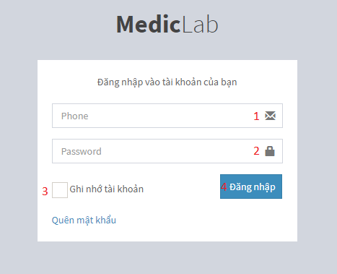

Figure 1 - Admin web application Guide <Login>

|  |  |
| --- | --- |
| **Step** | **Description** |
| 1 | Enter phone number |
| 2 | Enter password |
| 3 | Check “Ghi nhớ tài khoản”checkbox (optional) |
| 4 | Click on “Đăng nhập” button to sign in |

Table 5 - Admin web application Guide <Login>

#### View Hospital Receptionist Page

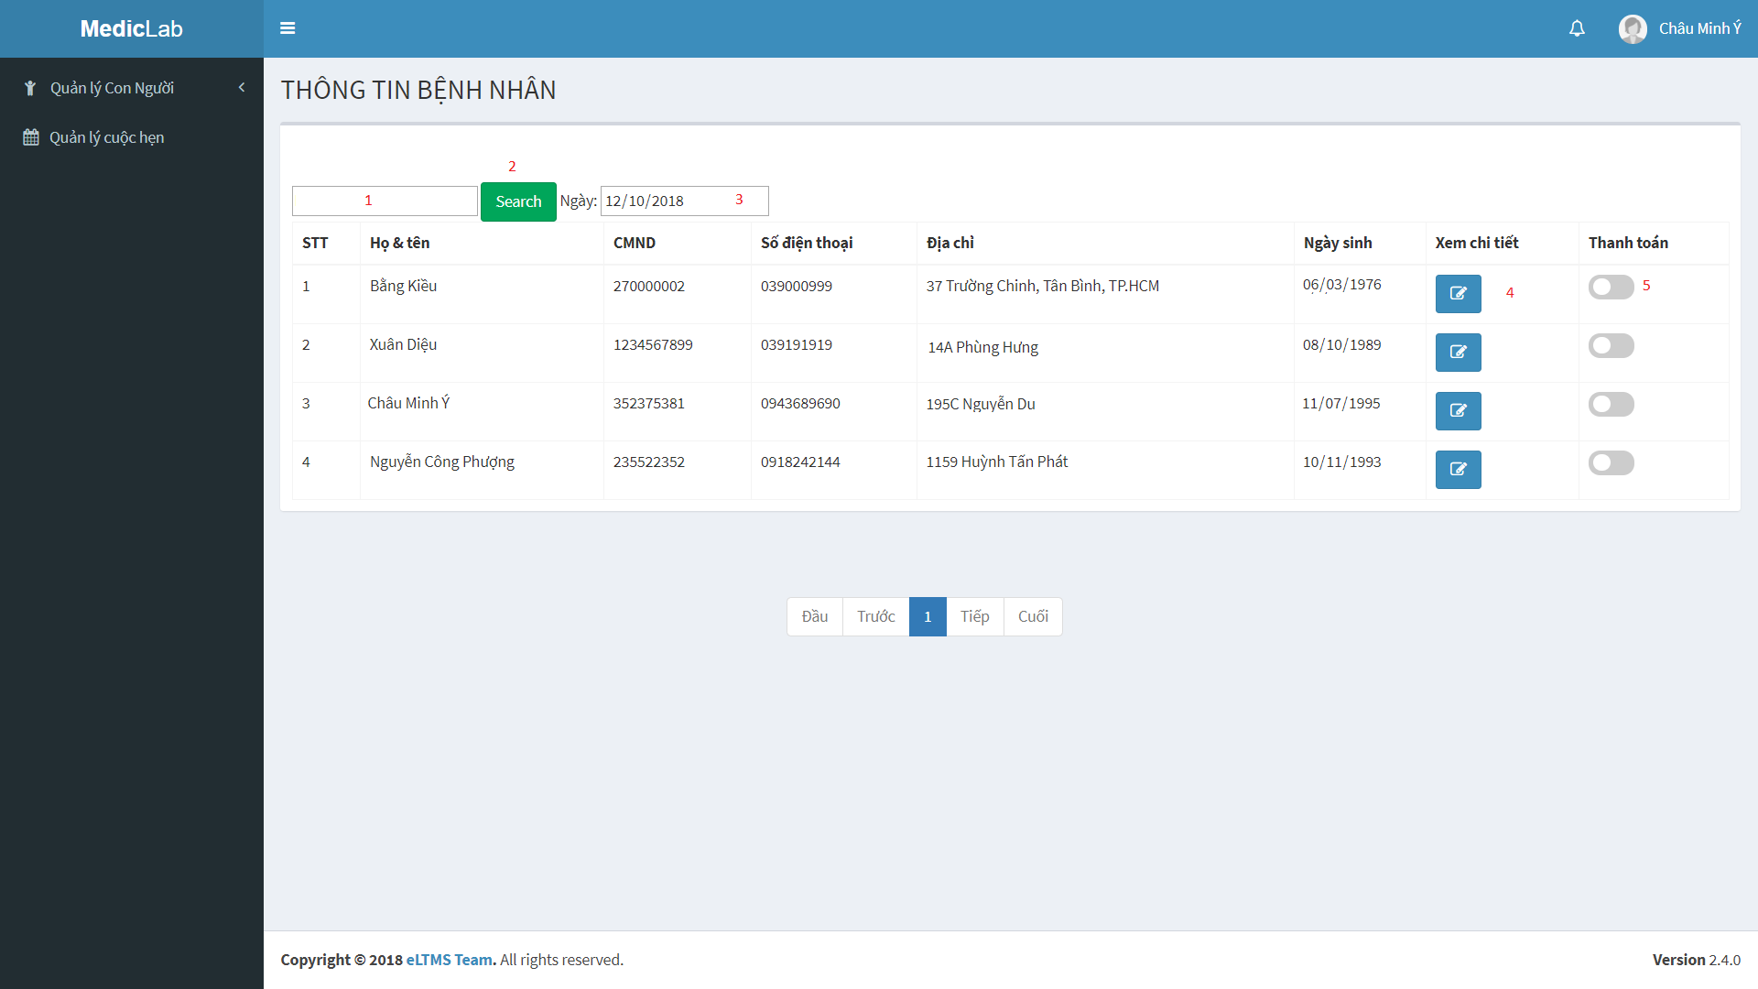

Figure 2 - Admin web application Guide <View Hospital Receptionist>

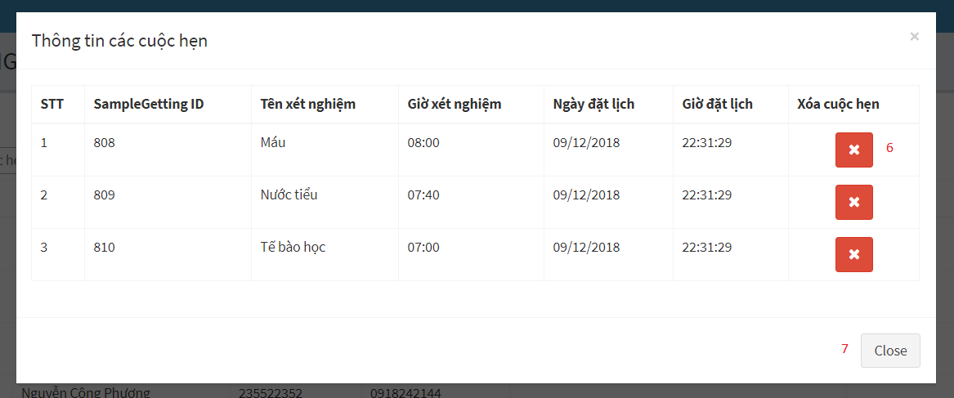

Figure 3 - Admin web application Guide <View Hospital Receptionist>

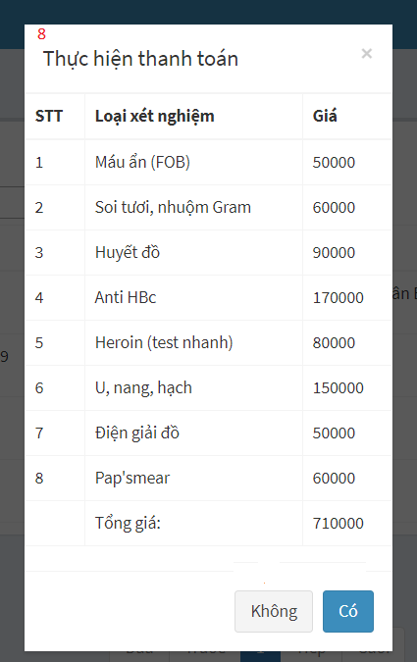

Figure 4 - Admin web application Guide <View Hospital Receptionist>

|  |  |
| --- | --- |
| **Step** | **Description** |
| 1 | Type keyword at textbox area to find patient by keyword |
| 2 | Click on “Search” button to perform action |
| 3 | Click on date area and choose date which you want to show list of patient |
| 4 | Click on blue button at “Xem chi tiết” column to view patient’s details of appointment |
| 5 | Click on switch checkbox at “Thanh toán” column to change status of appointment when patient pay the bill |
| 6 | After clicking on blue button in step 5, the popup will show patient’s details of appointment. You can click red button to delete a appointment |
| 7 | Click “close” button to close popup |
| 8 | After clicking on switch checkbox at “Thanh toán” column, the popup will show the bill. You can click “Có” button to pay the bill or “Không” button to cancel |

Table 6 - Admin web application Guide <View Hospital Receptionist>

#### View Department Receptionist Page

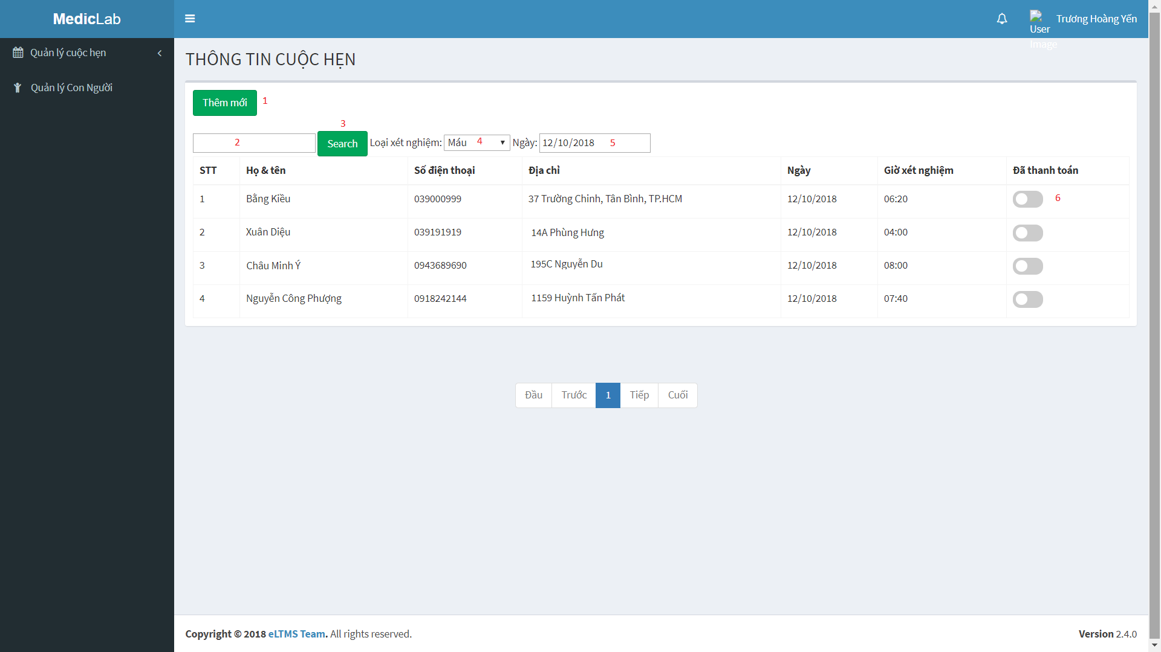

Figure 5 - Admin web application Guide <View Department Receptionist>

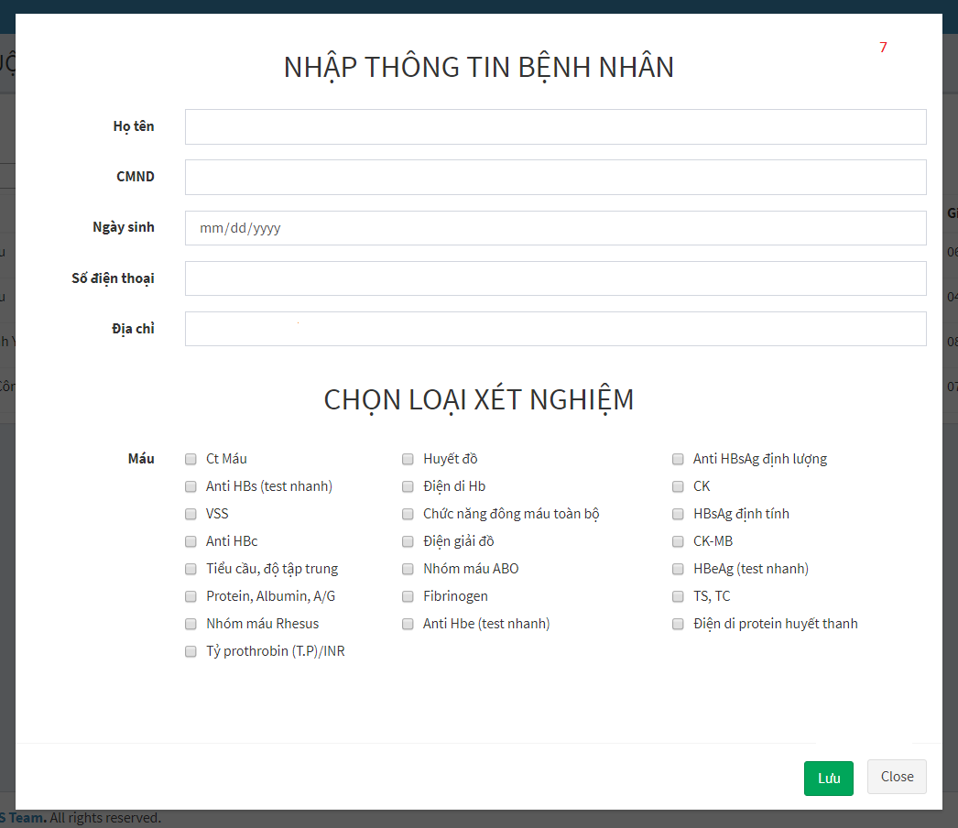

Figure 6 - Admin web application Guide <View Department Receptionist>



Figure 7 - Admin web application Guide <View Department Receptionist>

|  |  |
| --- | --- |
| **Step** | **Description** |
| 1 | Click on “Thêm mới” button to book a new appointment for patient who has no booking before |
| 2 | Type keyword at textbox area to find appointment by keyword |
| 3 | Click on “Search” button to perform action |
| 4 | Click and choose sample name which is used to filter appointment |
| 5 | Click on date area and choose date which you want to show list of appointment |
| 6 | Click on switch checkbox at “Thanh toán” column to change status of appointment when patient pay the bill |
| 7 | After click on “Thêm mới” button in step 1. You have to fill all of patient’s information and choose labtest. Then, click on “Lưu” button to create a new appointment or “Close” to cancel. |
| 8 | After clicking on switch checkbox at “Thanh toán” column, the popup will show the bill. You can click “Có” button to pay the bill or “Không” button to cancel |

Table 7 - Admin web application Guide <View user management>

#### View Nurse Page

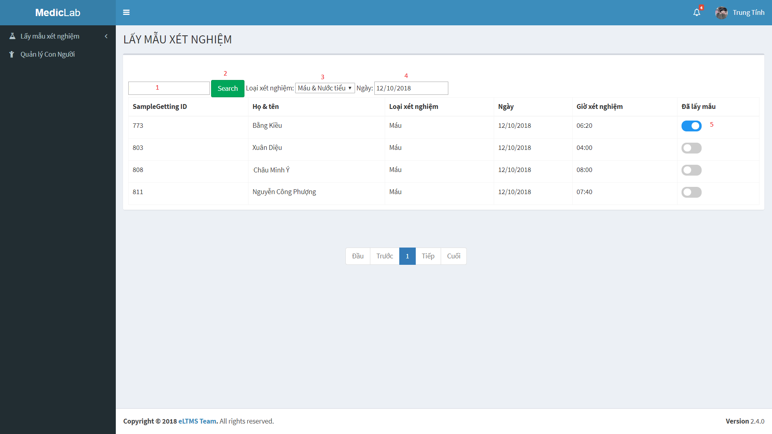

Figure 8 - Admin web application Guide <View Nurse>

x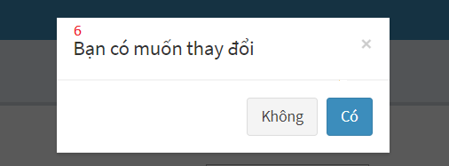

Figure 9 - Admin web application Guide <View Nurse>

|  |  |
| --- | --- |
| **Step** | **Description** |
| 1 | Type keyword at textbox area to find appointment by keyword |
| 2 | Click on “Search” button to perform action |
| 3 | Click and choose sample group which is used to filter appointment |
| 4 | Click on date area and choose date which you want to show list of appointment |
| 5 | Click on switch checkbox at “Đã lấy mẫu” column to change status of appointment when nurse got specimen |
| 6 | After clicking on switch checkbox at “Đã lấy mẫu” column, the popup to confirm action. You can click “Có” button to change status of appointment or “Không” button to cancel |

Table 8 - Admin web application Guide <View Nurse>

#### View Laboratory Technician Page

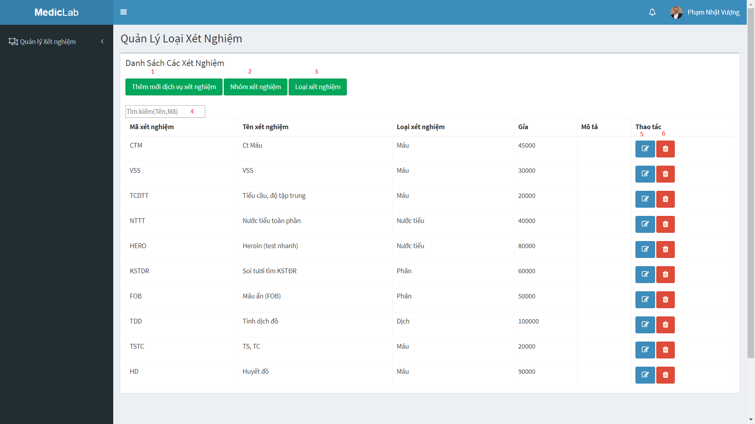

Figure 10 - Admin web application Guide <View Laboratory Technician>

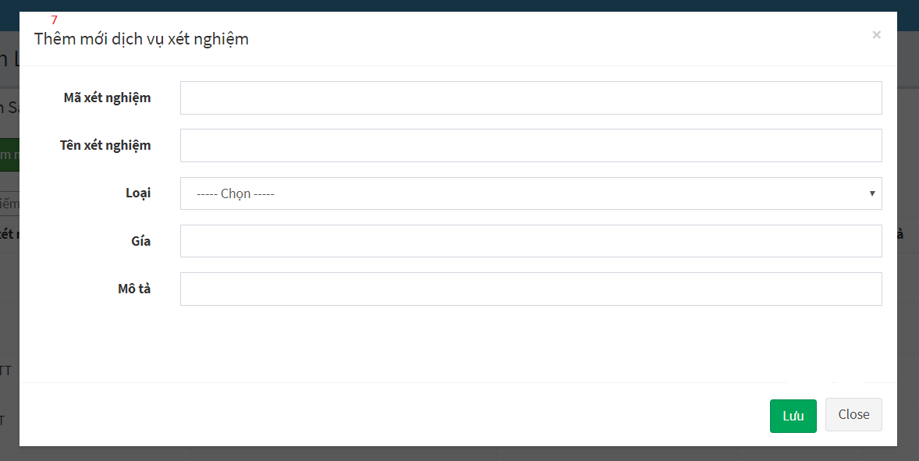

Figure 11 - Admin web application Guide <Laboratory Technician>

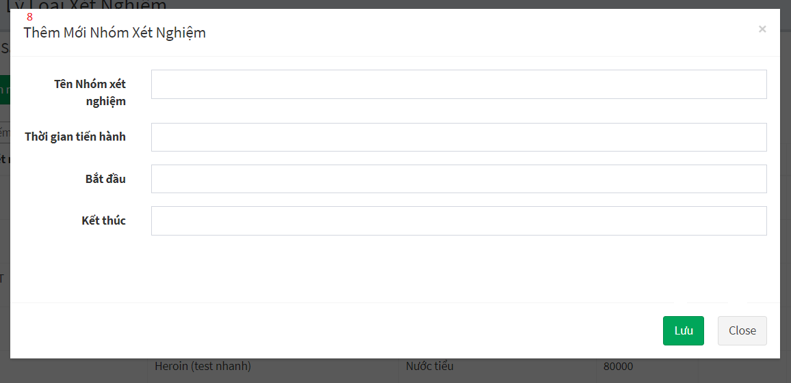

Figure 12 - Admin web application Guide <View Laboratory Technician>

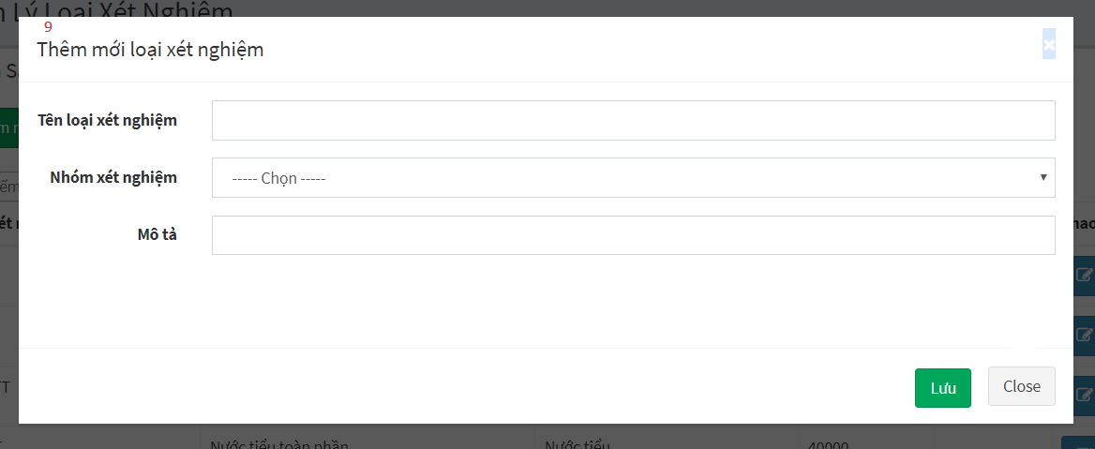

Figure 13 - Admin web application Guide <View Laboratory Technician>

|  |  |
| --- | --- |
| **Step** | **Description** |
| 1 | Click on “Thêm mới dịch vụ xét nghiệm” button to add new labtest |
| 2 | Click on “Nhóm xét nghiệm” button to add new sample group |
| 3 | Click on “Loại xét nghiệm” button to add new sample |
| 4 | Type keyword at textbox area to find labtest by keyword |
| 5 | Click on blue button at “Thao tác” column to edit labtest’s information |
| 6 | Click on red button at “Thao tác” column to delete a labtest |
| 7 | After clicking on “Thêm mới dịch vụ xét nghiệm” button in step 1, you have to fill all of labtest’s information. Then, click on “Lưu” button to add a new labtest or “Close” button to cancel |
| 8 | After clicking on “Nhóm xét nghiệm” button in step 2, you have to fill all of sample group’s information. Then, click on “Lưu” button to add a new sample group or “Close” button to cancel |
| 9 | After clicking on “Loại xét nghiệm” button in step 3, you have to fill all of sample’s information. Then, click on “Lưu” button to add a new sample or “Close” button to cancel |

Table 9 - Admin web application Guide <Laboratory Technician>

#### View Doctor Page

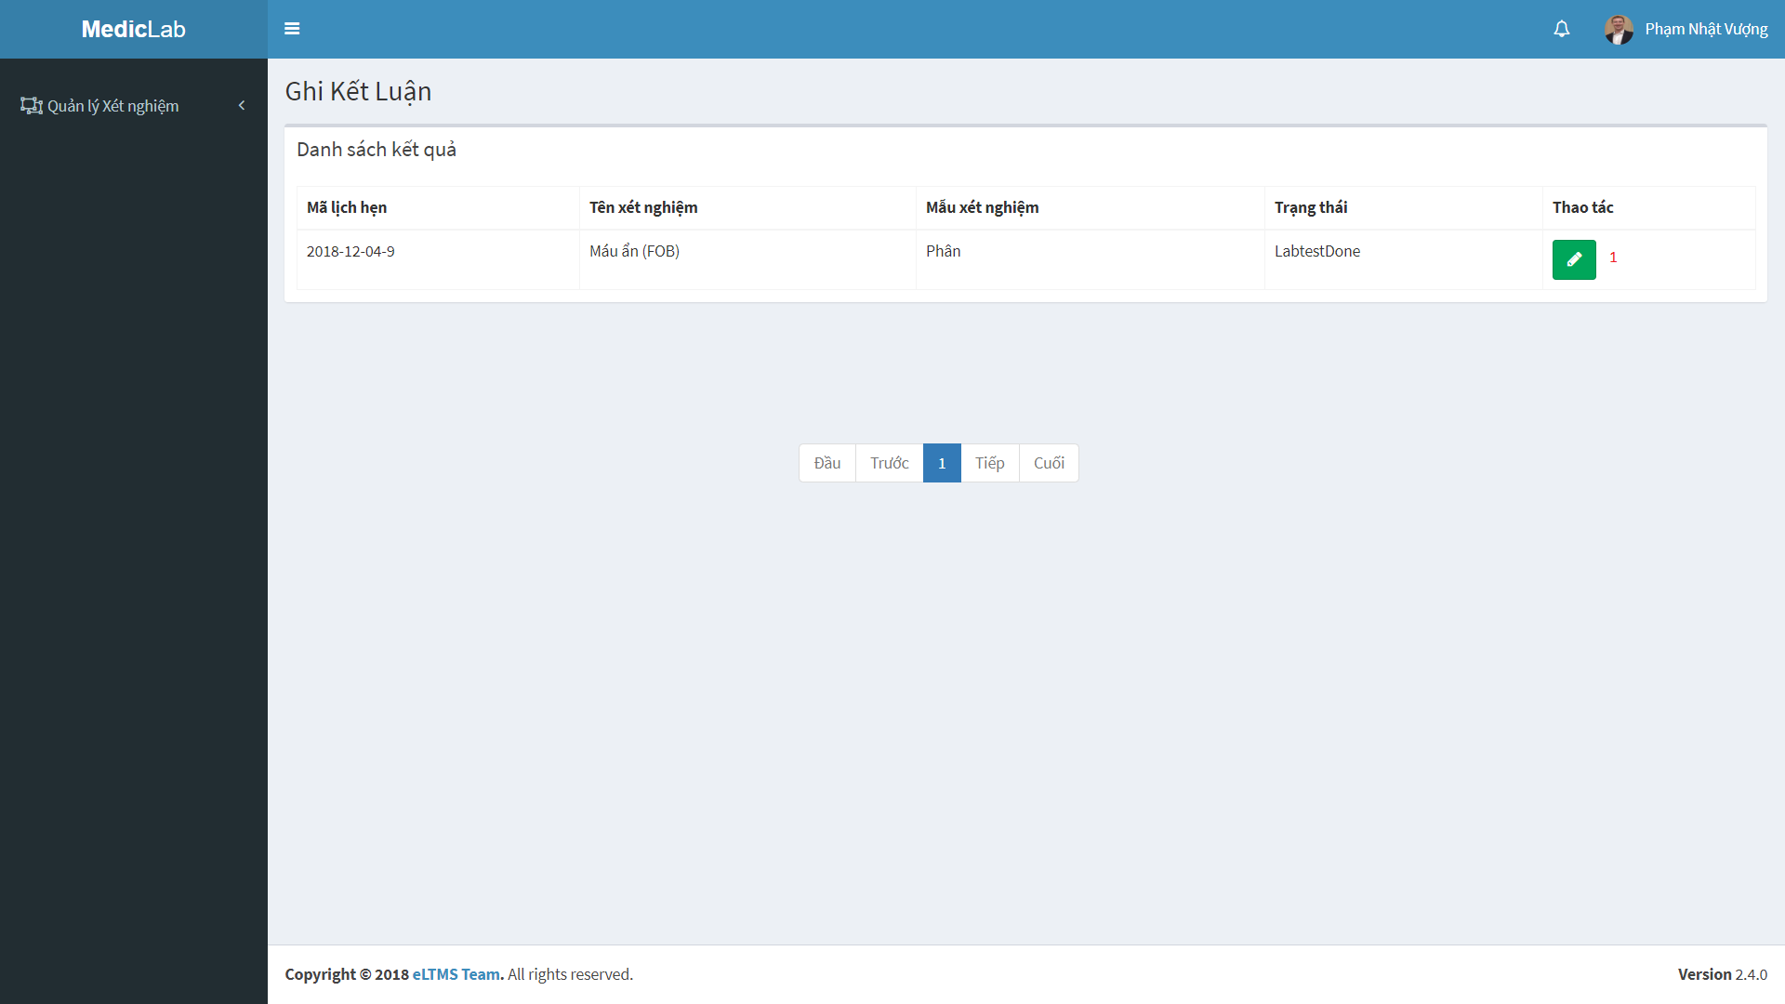

Figure 14 - Admin web application Guide <View Doctor>

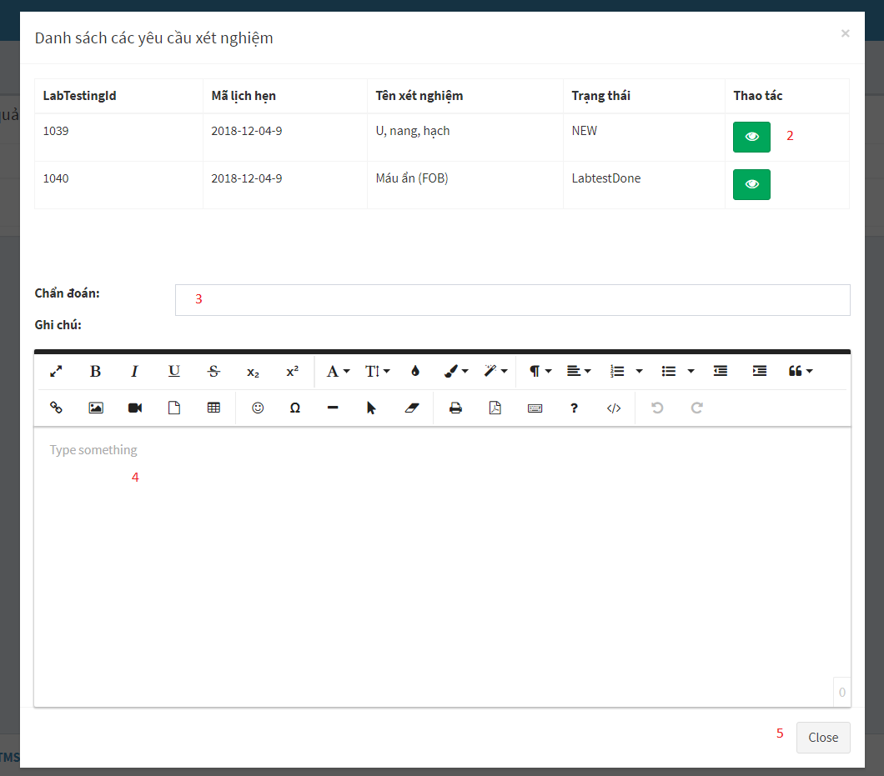

Figure 15 - Admin web application Guide <View Doctor>

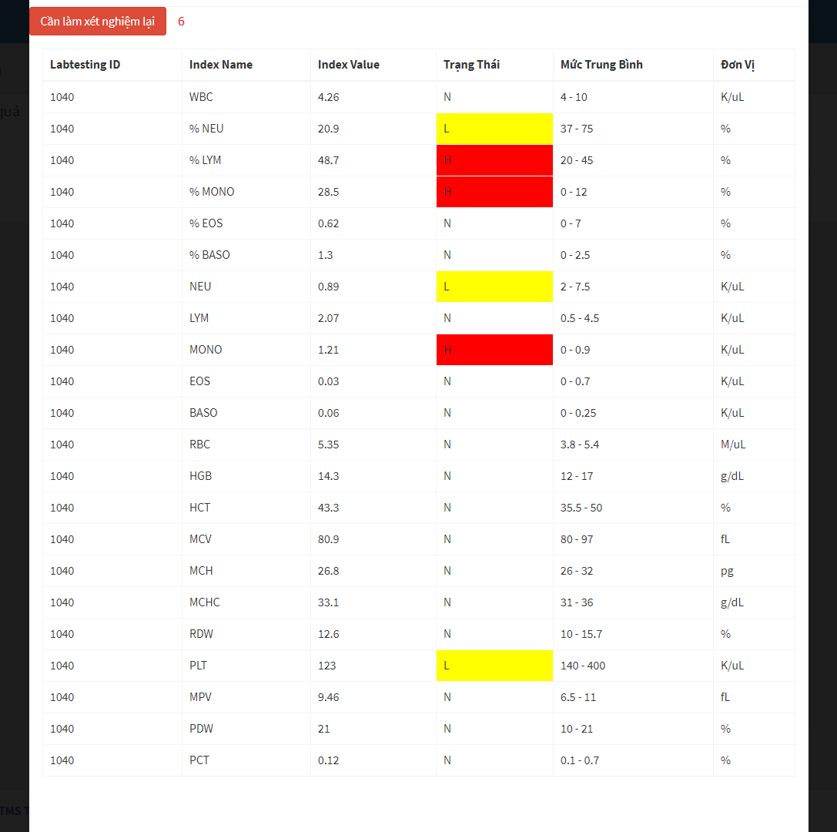

Figure 16 - Admin web application Guide <View Doctor>

|  |  |
| --- | --- |
| **Step** | **Description** |
| 1 | Click on green button at “Thao tác” column to view testing result, write note and conclusion |
| 2 | Click on green button at “Thao tác” column to view details of testing result |
| 3 | Type text conclusion at textbox area |
| 4 | Write note (Advise for patient) at textbox area |
| 5 | Click on “Close” button cancel |
| 6 | After clicking on green button at “Thao tác” column to view details of testing result in step 2, you can request re-testing when you see something wrong about testing result |

Table 10 - Admin web application Guide <View Doctor>

### User web application

#### Login



Figure 17 – User web application Guide <Login>

|  |  |
| --- | --- |
| **Step** | **Description** |
| 1 | Enter phone number |
| 2 | Enter password |
| 3 | Check “Ghi nhớ tài khoản”checkbox (optional) |
| 4 | Click on “Đăng nhập” button to sign in |

Table 11 – User web application Guide <Login>

#### Sign up

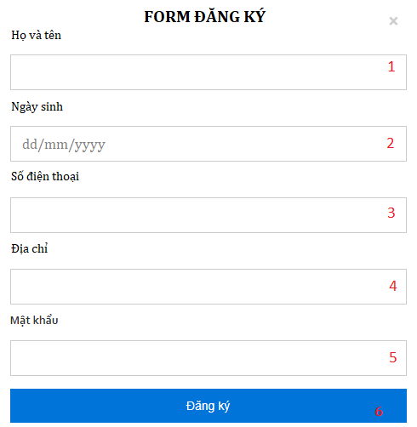

Figure 18 – User web application Guide <Sign up>

|  |  |
| --- | --- |
| **Step** | **Description** |
| 1 | Fill username into field: “Họ và tên”. |
| 2 | Pick birthdate from field: “Ngày sinh”. |
| 3 | Fill phone in field: “Số điện thoại”. |
| 4 | Fill full address in field: “Địa chỉ”. |
| 5 | Fill password in field: “Mật khẩu”. |
| 6 | Click on “Đăng ký” button to sign up. |

Table 12 – User web application Guide <Sign up>

#### Logout

Figure 19 - User web application Guide <Log out>

|  |  |
| --- | --- |
| **Step** | **Description** |
| 1 | Click on username on top right of the page. |
| 2 | Click on button “Đăng xuất ” to log out. |

Table 13 - User web application Guide <Log out>

#### Home page

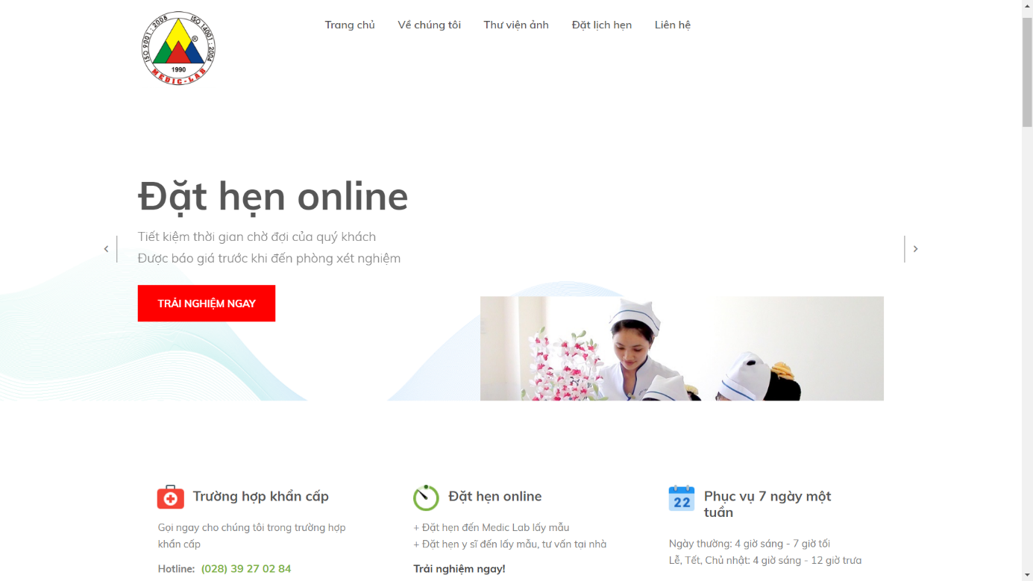

Figure 20 - User web application Guide <Home page>

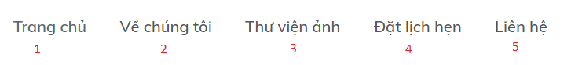

Figure 21 - User web application Guide <Home page - Menu bar and Categories>

|  |  |
| --- | --- |
| **Step** | **Description** |
| 1 | Click to navigate to “Trang chủ” to load Home page |
| 2 | Click to navigate to “Về chúng tôi” to view our information |
| 3 | Click to navigate to “Thư viện ảnh” to go to Photo Library Page |
| 4 | Click to navigate to “Đặt lịch hẹn” to book appointment |
| 5 | Click to navigate to “Liên hệ“ to view our contact |

Table 14 - User web application Guide <Home page>

#### View Book Appointment

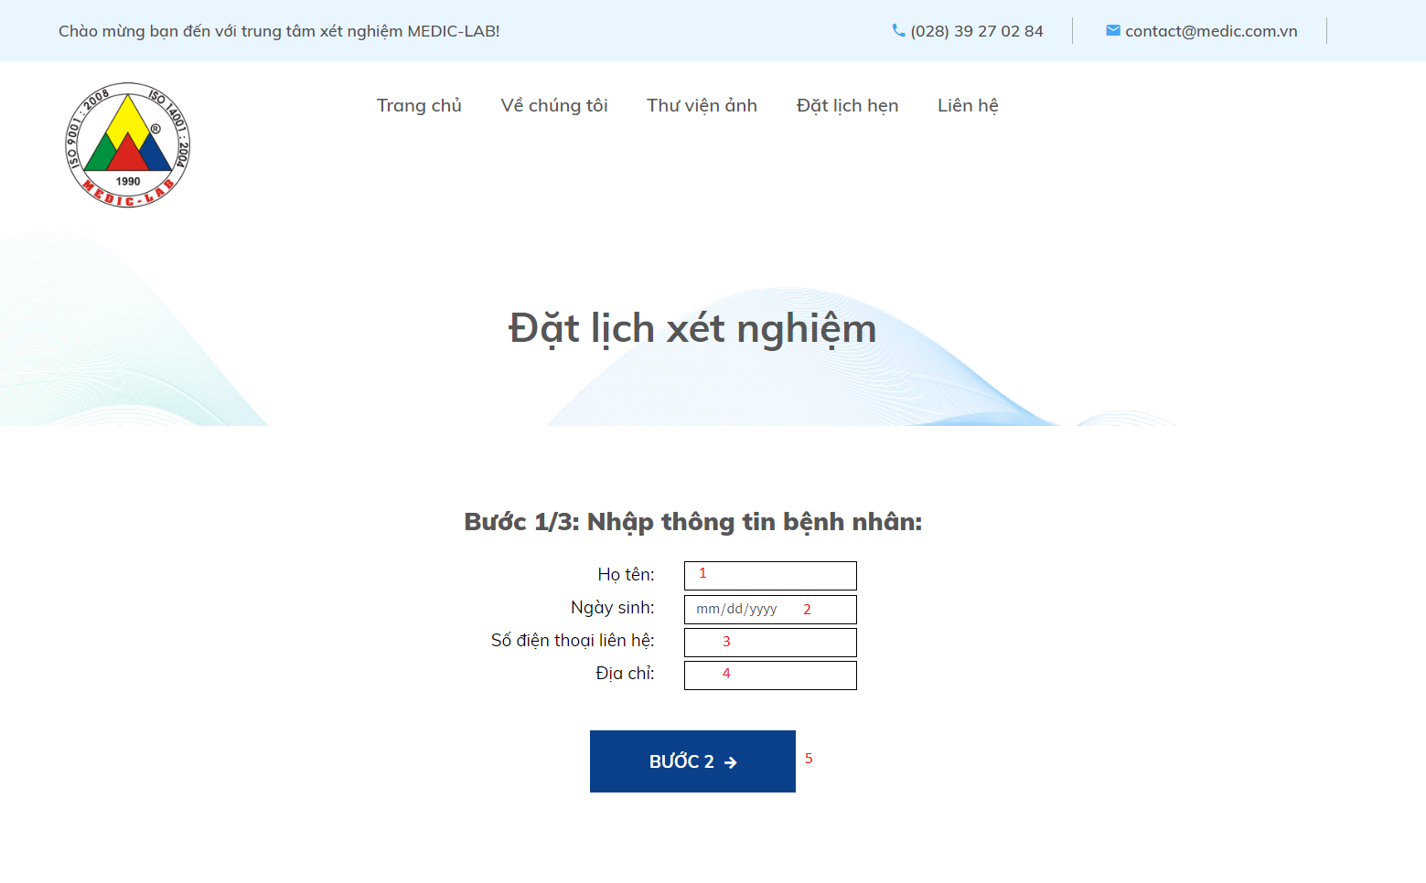

Figure 22 - User web application Guide <Book appointment>

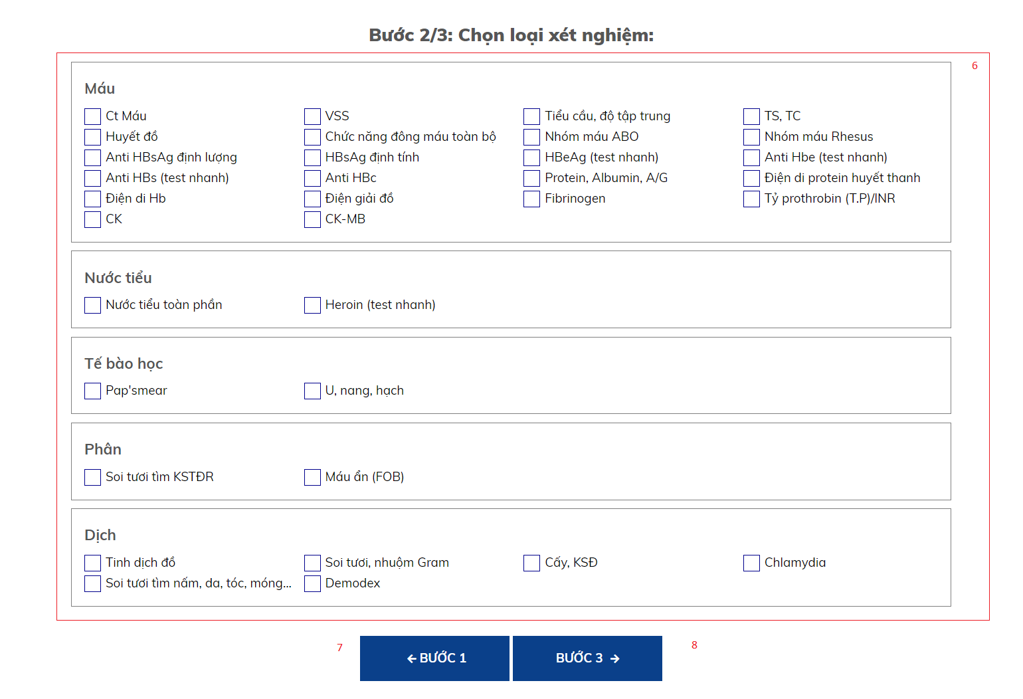

Figure 23 - User web application Guide <Book appointment>

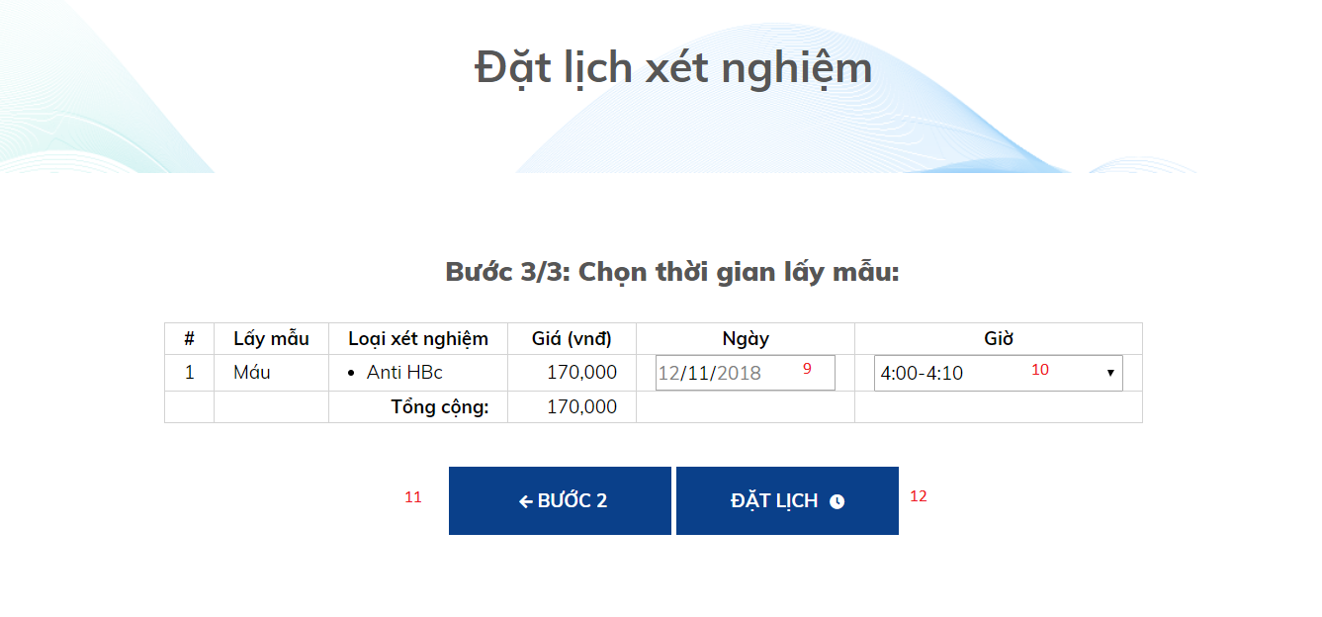

Figure 24 - User web application Guide <Book appointment>

|  |  |
| --- | --- |
| **Step** | **Description** |
| 1 | Fill username into field: “Họ tên”. |
| 2 | Pick birthdate from field: “Ngày sinh”. |
| 3 | Fill phone in field: “Điện thoại liên hệ”. |
| 4 | Fill full address in field: “Địa chỉ”. |
| 5 | Click on “Bước 2” button to go to step 2 |
| 6 | Choose labtest which you want to test |
| 7 | Click on “Bước 1” button to go back to step 1 |
| 8 | Click on “Bước 3” button to go to step 3 |
| 9 | Choose appropriate time that you want to test |
| 10 | Choose appropriate time that you want to test |
| 11 | Click on “Bước 2” button to go back to step 2 |
| 12 | Click on “Đặt lịch” button book appointment |

Table 15 - User web application Guide < Submit Auction >

#### View list of Booked Appoinments



Figure 25 - User web application Guide <View list of Booked Appoinments>

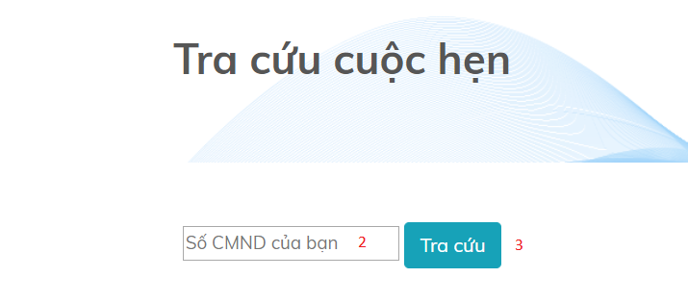

Figure 26 - User web application Guide <View list of Booked Appoinments>

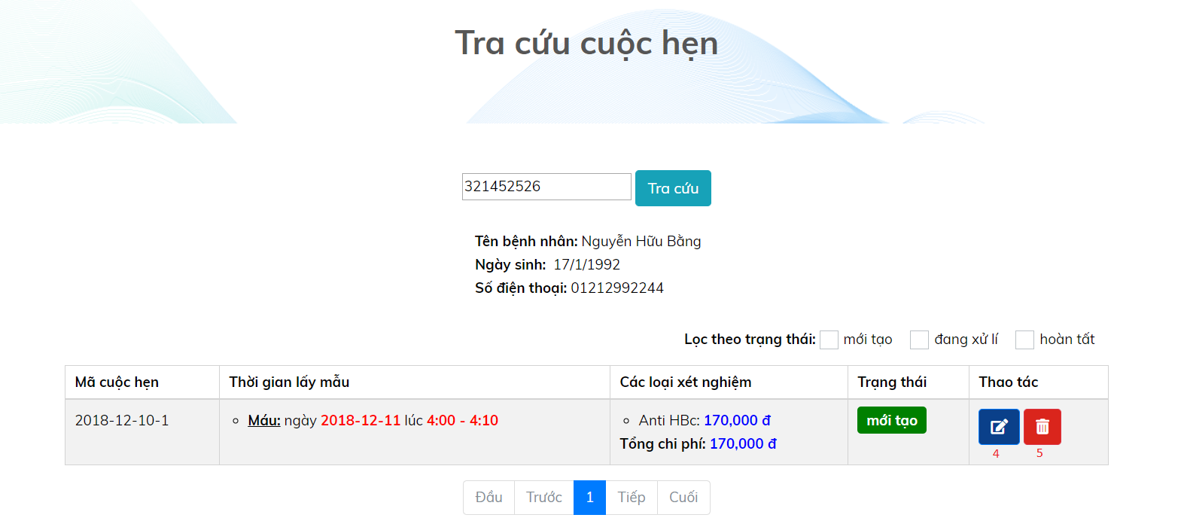

Figure 27 - User web application Guide <View list of Booked Appoinments>

|  |  |
| --- | --- |
| **Step** | **Description** |
| 1 | When you book appointment successfully, system will show notification to you. In order to view list of booked appointments, choose “Xem danh sách lịch hẹn” button in popup |
| 2 | Fill your identify number into field: “Số CMND của bạn” |
| 3 | Click on “Tra cứu” button |
| 4 | After clicking on “Tra cứu” button, you will go to View Appointment page. You can click on blue button at “Thao tác” column to edit time, sample, labtest for your appointment |
| 5 | After clicking on “Tra cứu” button, you will go to View Appointment page. You can click on red button at “Thao tác” column to delete your appointment |

Table 16 - User web application Guide <View list of Booked Appoinments>

#### View Testing Result

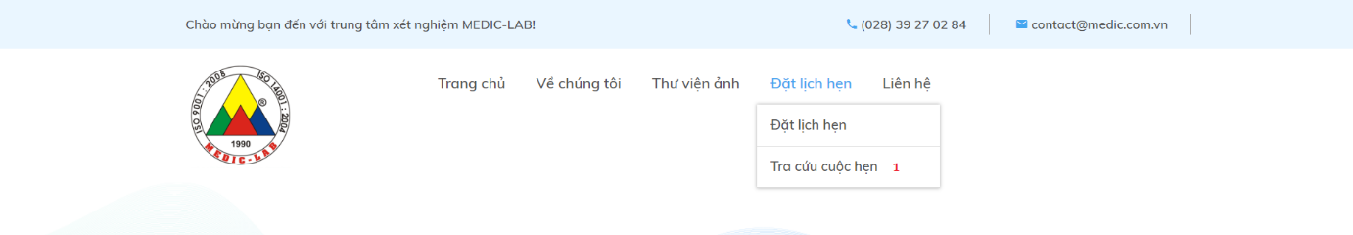

Figure 28 - User web application Guide <View Testing Result>

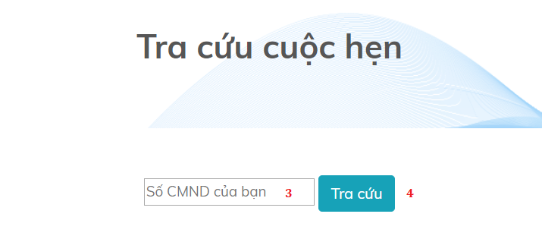

Figure 29 - User web application Guide <View Testing Result>

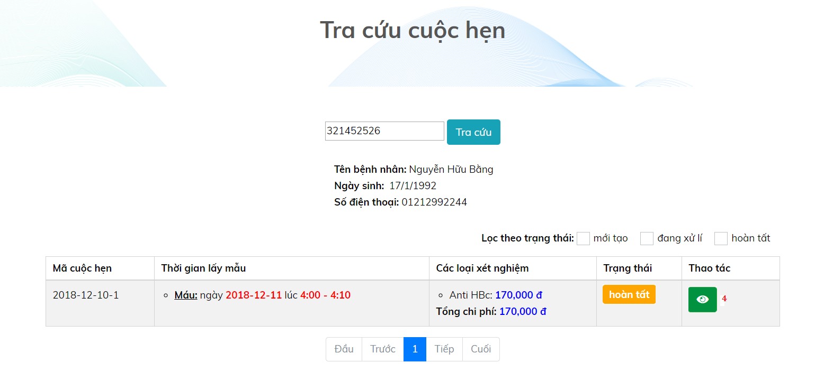

Figure 30 - User web application Guide <View Testing Result>

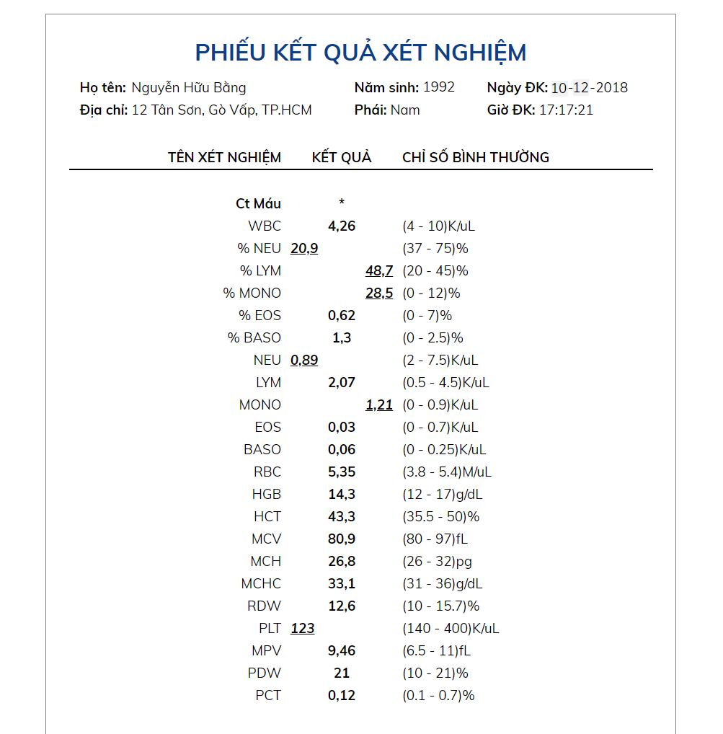

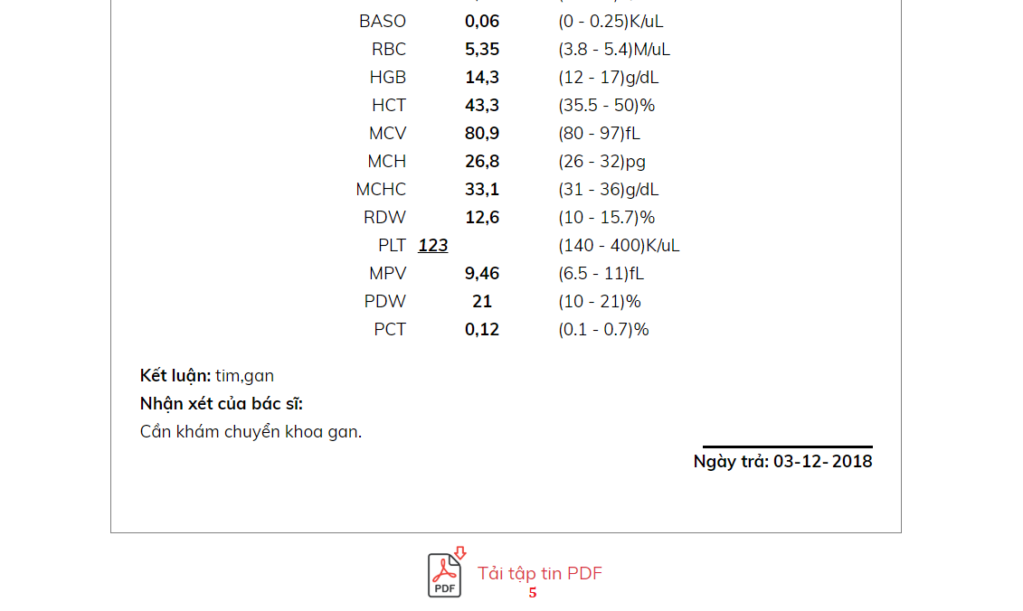

Figure 31 - User web application Guide <View Testing Result>

|  |  |
| --- | --- |
| **Step** | **Description** |
| 1 | At the Home page, you can choose “Tra cứu cuộc hẹn” option in “Đặt lịch hẹn” |
| 2 | Fill your identify number into field: “Số CMND của bạn” |
| 3 | Click on “Tra cứu” button |
| 4 | After clicking on “Tra cứu” button, you will go to View Appointment Page. When status of appointment is “Hoàn tất”, you can click on green button at “Thao tác” column to view testing result |
| 5 | At the Result Appointment page, you can view details of testing result. If you want to download this form, you can click on “Tải tập tin PDF” button below the form |

Table 17 - User web application Guide <View Testing Result>

### Mobile application for all user

#### View Login Page

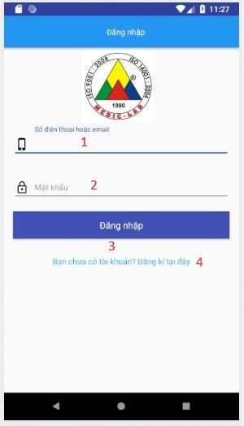

Figure 32 - User mobile application Guide <Login>

|  |  |
| --- | --- |
| **Step** | **Description** |
| 1 | Enter your phone |
| 2 | Enter your password |
| 3 | Click on “Đăng nhập” to login |
| 4 | Click on “Đăng kí tại đây’ to go to Register page |

Table 18 – User mobile application Guide <Login>

#### View Register Page



Figure 33 - User mobile application Guide <View Register>

|  |  |
| --- | --- |
| **Step** | **Description** |
| 1 | Enter your fullname |
| 2 | Pick your birthday |
| 3 | Enter your phone number |
| 4 | Enter your address |
| 5 | Enter your password |
| 6 | Click on “Đăng kí” to create new account |

Figure 19 - User mobile application Guide <View Register>

#### View Home Page

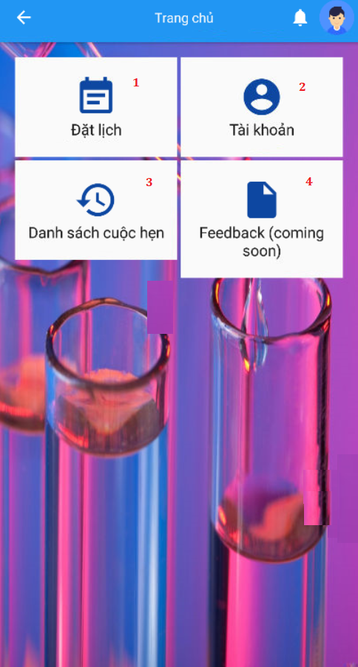

Figure 34 - User mobile application Guide <Home page>

|  |  |
| --- | --- |
| **Step** | **Description** |
| 1 | Click on “Đặt lịch” tab to book appointment |
| 2 | Click on “Tài khoản” tab to view or edit profile |
| 3 | Click on “Danh sách cuộc hẹn“ tab to view appointment history and testing result |
| 4 | Click on “Feedback” tab to write feedback (Coming soon) |

Table 20 – User mobile application Guide <Home page>

#### View Book Appointment Page

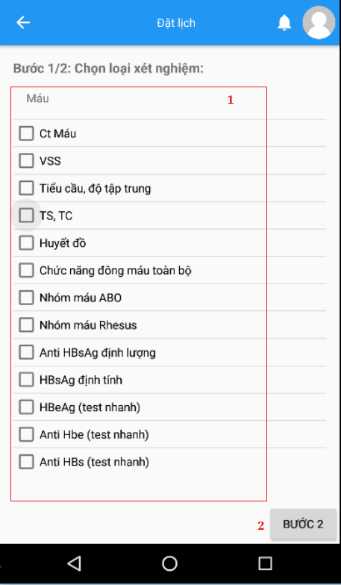

Figure 35 - User mobile application Guide <View Book Appointment>

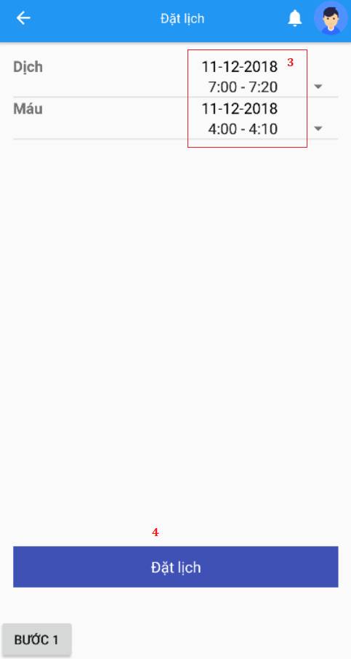

Figure 36 - User mobile application Guide <View Book Appointment>

|  |  |
| --- | --- |
| **Step** | **Description** |
| 1 | After clicking “Đặt lịch” tab at Home page, choose labtest which you want to test |
| 2 | Click on “Bước 2” button to go to step 2 |
| 3 | Choose appropriate time that you want to test |
| 4 | Click on “Đặt lịch” button book appointment |

Table 21 – User mobile application Guide <View Book Appointment>

#### View Testing Result Page

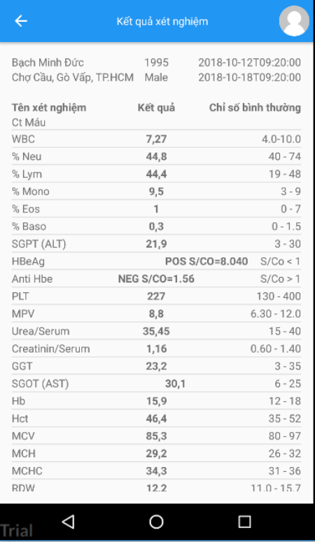

Figure 37 - User mobile application Guide <View Testing Result>

|  |  |
| --- | --- |
| **Step** | **Description** |
| 1 | After clicking “Kết quả xét nghiệm” tab at Home page, choose an appointment you want to view testing result |

Table 22 – User mobile application Guide <View Testing Result>