BÁO CÁO CHUẨN ĐOÁN TÌNH TRẠNG THIẾT BỊ

# Cài đặt

**Người chuẩn đoán:** ....................................................................................................

**Kiểu máy:** ...............................................................................................................

**Công suất (kW)**..........................................................

**Tốc độ(RPM)**..........................................................

**Đường kính trục:** ..........................................................

**Kiểu đo:** ..........................................................

**Cảm biến:** ..........................................................

**Gắn cảm biến:** ..........................................................

**Vị trí sensor:** ..........................................................

**Mã vòng bi:** ..........................................................

**Đường kính trục:** ..........................................................

**Số răng bánh răng:**..........................................................

**Khác:** ........................................................................................................................................................

# Kết luận

................................................................................................................................................................................................

................................................................................................................................................................................................

................................................................................................................................................................................................

................................................................................................................................................................................................

................................................................................................................................................................................................

................................................................................................................................................................................................

................................................................................................................................................................................................

................................................................................................................................................................................................

................................................................................................................................................................................................

................................................................................................................................................................................................

................................................................................................................................................................................................

................................................................................................................................................................................................

................................................................................................................................................................................................

................................................................................................................................................................................................

# Chi tiết

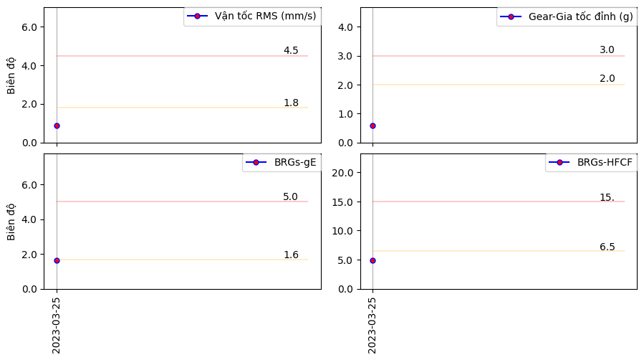

*Hình 1: Xu hướng dao động.*

................................................................................................................................................................................................

................................................................................................................................................................................................

................................................................................................................................................................................................

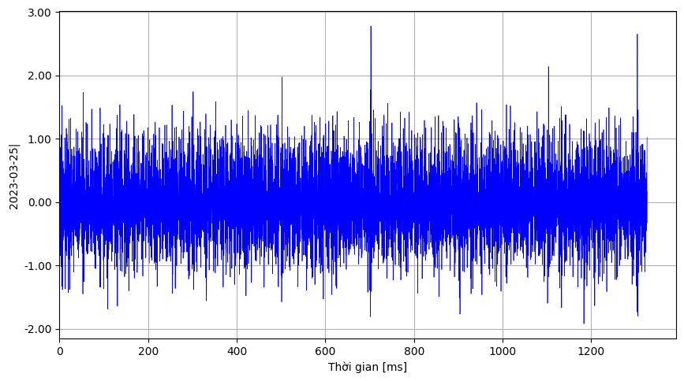

*Hình 2: Độ rung trong miền thời gian.*

................................................................................................................................................................................................

................................................................................................................................................................................................

................................................................................................................................................................................................

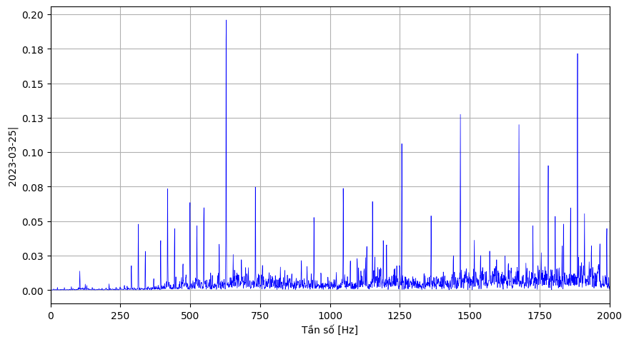

*Hình 3: Phổ tần số*

................................................................................................................................................................................................

................................................................................................................................................................................................

................................................................................................................................................................................................

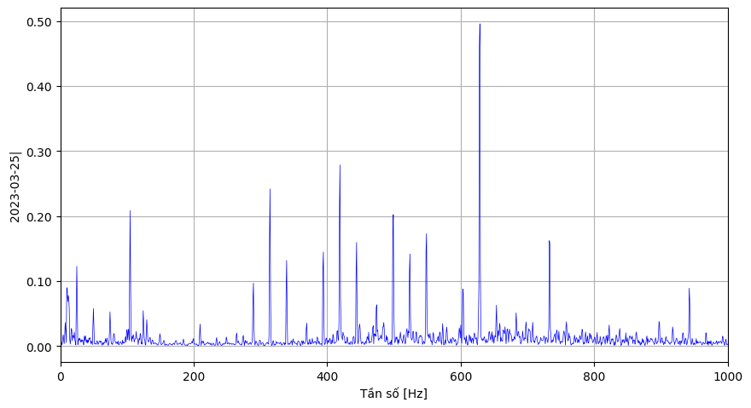

*Phổ tần số vận tốc*

................................................................................................................................................................................................

................................................................................................................................................................................................

................................................................................................................................................................................................

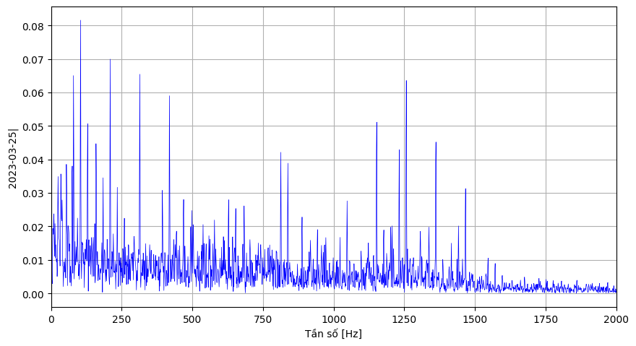

*Hình 5: Phổ đường bao*

................................................................................................................................................................................................

................................................................................................................................................................................................

................................................................................................................................................................................................