**1.1 Quiz Answer**

**Question 1)**

**Which of these factors has NOT contributed to the rapidly-increasing commercial interest in multi-rotor vehicles?**

* Mechanical simplicity
* Ability to hover in mid air
* Inexpensive components
* Efficiency in forward flight

**Question 2)**

[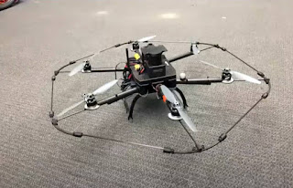](https://blogger.googleusercontent.com/img/a/AVvXsEhWNjuuzTSOoG34mV6KR4vtKBlLl0PfMApNV3eLV7Z2e0aelkpoK32mxwegu2qYJVCSu1S-2SN-XYk8SiGuWtMM2TCljZMVskVLazUdd0Tt9fTsRJPilEQtmFnPY0xaPgMKWMm3HRmchyvU94lc7HO1T8jxJ1c20DwnNXcVv--7iodj3cBFAD72I-H1Vw=s1123)

**In how many ways can you translate and rotate this robot in free space? Enter your answer as a numeric value (e.g. 1 instead of one).**

Answer: 6

**Question 3)  
How many independent control inputs does the vehicle shown above have?**

* 6, because a rigid body has six degrees of freedom
* 6, because there are six motors
* 4, since it is similar to a quadrotor, except with more motors

**Question 4)  
Based on the lecture content in this course, which of these components are incorporated in commercial products mentioned in lecture such as the DJI Phantom or the Parrot Bebop? (Select all that apply.)**

* State estimation
* Mapping
* Planning to avoid obstacles
* Autonomous control

**Question 5)  
An Inertial Measurement Unit (IMU) is an important sensor used in aerial robotics. A typical IMU will contain an accelerometer and a rate gyro. Which of the following information does a robot get from an IMU? (Select all that apply. Choose only quantities that are directly reported by the IMU. Do not include quantities that can be computed from the IMU measurements but cannot be obtained directly. Additional research to find information about IMUs is allowed and encouraged!) (Select all that apply)**

* Position
* Orientation
* Linear velocity
* Angular velocity
* Linear acceleration
* Angular acceleration

**Question 6)  
What does Simultaneous Localization And Mapping (SLAM) software do? (Select all that applies.)**

* Controls the robot's flight through the environment
* Estimates the location of features in the environments
* Navigates the robot in a cluttered environment
* Causes the robot to avoid obstacles in the environment
* Estimates the position and orientation of the robot with respect to the environment

__________________________________________________________________________________

**1.2 Quiz Answer**

**Question 1)**

**You observe the response of a system shown in the figure below**

[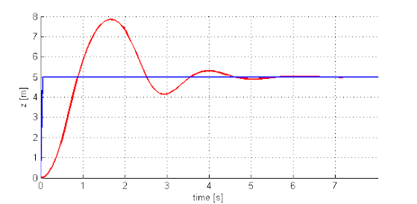](https://blogger.googleusercontent.com/img/b/R29vZ2xl/AVvXsEipbNgFJyWkR1nJ9IJd4MCSCKsqhVzep5Z-uhEDAZiGARigrzAKWvVotDmVfK9X33vKb8fAA6TxoaBg-pWLL0LMs4S1EONekEXQCigH0Dql4rGOsxgtlFh8IW6d3pw-RubzfCzunLJNhx-Vzg1r7Cb6O_WHdizi2CpbiKFwqSOZ31VynvLlAoZSwIN0rQ/s605/lkn.png)

**What should you do to decrease the oscillations in the response?**

* Decrease the proportional gain (Kp)
* Increase the derivative gain (Kp)
* Increase the proportional gain (Kp)
* Increase the integral gain (Kp)

**Question 2**

**Download the simulation GUI attached below and unzip the contents into a folder of your choice. This is NOT the same GUI that was used in the in-video questions.**

**Note: If the GUI plots do not show up and you are currently running MATLAB on Chrome, try running the GUI on a different browser (e.g. Firefox, Edge).**

Open MATLAB in the directory where the unzipped files are and type "runsim" in the MATLAB Command Window to start the GUI.

Given that the derivative gain K_v=5K

v=5, find the proportional gain K_pK p (up to two decimal places) such that the rise time is less than 1s and overshoot less than 5%.

Answer:   12

**Question 3)**

**Assuming we are using the F550 + E310 + 4 cell battery with a 200g onboard computer and a laser (270g), what is the thrust to weight ratio of the platform? (We use the term "weight" and "thrust" loosely. Except for Thrust/Weight and Propeller, all units are in grams)**

[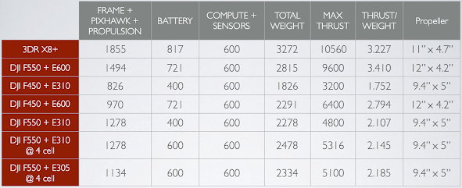](https://blogger.googleusercontent.com/img/b/R29vZ2xl/AVvXsEg523q5KrWZ9TXykuxnfJd_ZTmWUj2VaM3DAeo2_8EnEVp6LMrUGgCcdTB-bR6oevJvHJwE7aH_usnwTkiGlOX_uroXu62E7n4deelnVulyr4OX70hK2X9wE3mzk59plqs4nVuiqJd7OMm5oftkD-ub2ek_jb-jWdUM_esv6k_CL4HaldMmqbBo0AeeqA/s2116/hgvik.png)

Answer:  2.264

**Question 4)**

**Why don’t all the rotors of a quadrotor spin in the same direction?**

* Spinning all rotors in the same direction does not allow the quadrotor to fly upside down.
* Spinning all rotors in the same direction uses more battery power.
* Spinning all rotors in the same direction will cause the robot to constantly rotate.

**Question 5)**

**Given that a quadrotor consumes 200 W to carry a mass of 1kg, which component contributes more to the quadrotor's total power consumption?**

A 100g computer that consumes 30W for operation or a 200g laser which consumes 20W for operation?

* The computer.
* The laser.
* Both contribute the same to the power consumption.