- **Description of your program**: Your task is to move the dinosaur by clicking on it overcome the obstacles cactus to the finish. Scores will be counted as players overcome obstacles 1 cactus, if not pass you will lose.

- **The GUI:**

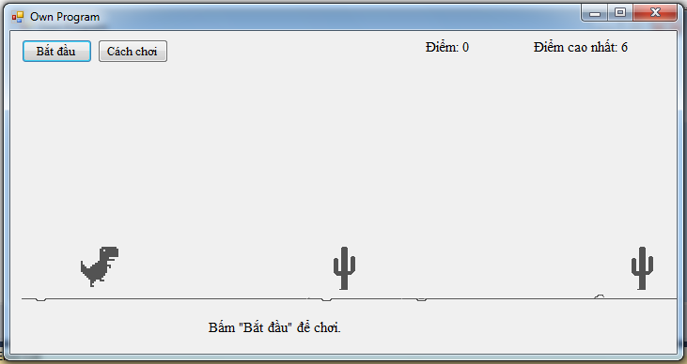

**Figure 1**

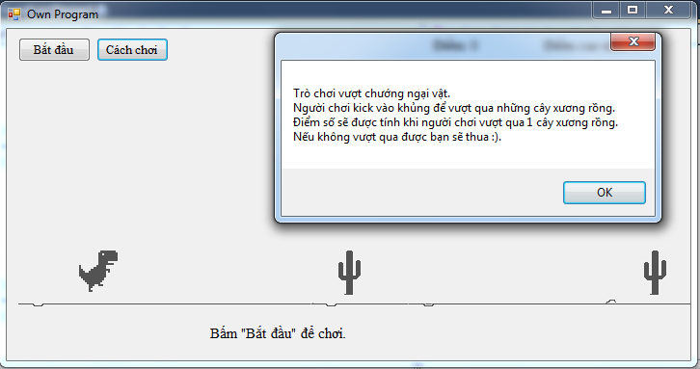

**Figure 2**

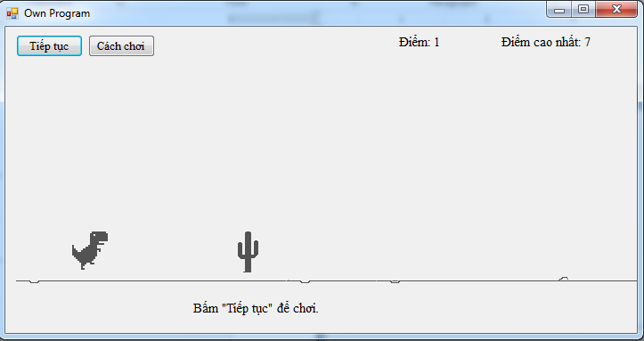

**Figure 3**

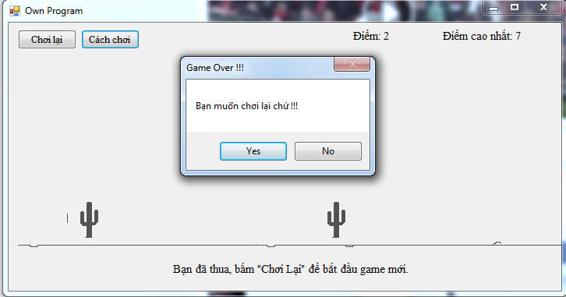

**Figure 4**

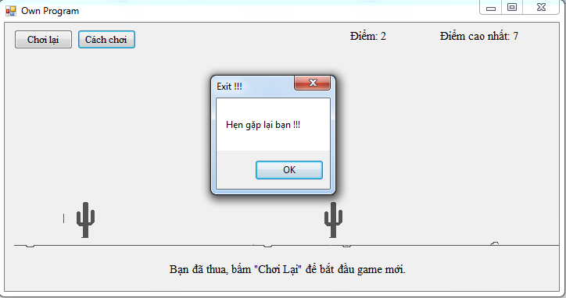

**Figure 5**