I Requirement

1.1

|  |  |  |
| --- | --- | --- |
| Object | Role | Functionalities |
| Human Object | Student | -Check Timetable  -View Profile  -See attenance |
| Instructor | -Check attendace  -View timetable  -View grade |
| Non Human Object | Group | Each student will be in 1 class |
| Course | The student attend the course |
| Lecture/Session | The student attend the lecture |
| Room | Where the student attend the lecutre |
|  |  |  |

1.2 Actor

Student

Instructor

1.3 Functionalitites

-Login/Log out

-Check time table

-Check attendance

-View grade

- Check profile

1.4 Detail attribute

-Student: Rollnumber, Firstname , Lastname, DOB ,gender, address , telephone , email , specialization , campus

-Instructor: Rollnumber, Firstname , Lastname, DOB ,gender, address , telephone , email , Department

- Group: ID, groupname

-Course: ID, Course name

-Lecture:ID , Timeslot , Course

-Room: ID, Room name

asdfasdf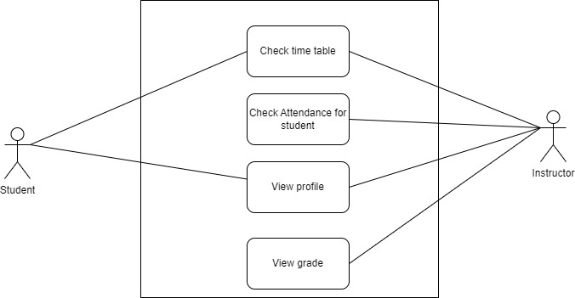

Table

Student(ID, Rollnumber, Firstname , Lastname, DOB ,gender, address , telephone , email , specialization , campus)

Group(GroupID , Name , InstructorID)

Belongto(StudentID , GroupdID)

Attend(StudentID , LectureID)

Lecture(LectureID , Date , GroupID,RoomID , TimeSlotID , CourseID)

Course(CourseID , CourseName )

GroupxCourse(GroupID , CourseID)