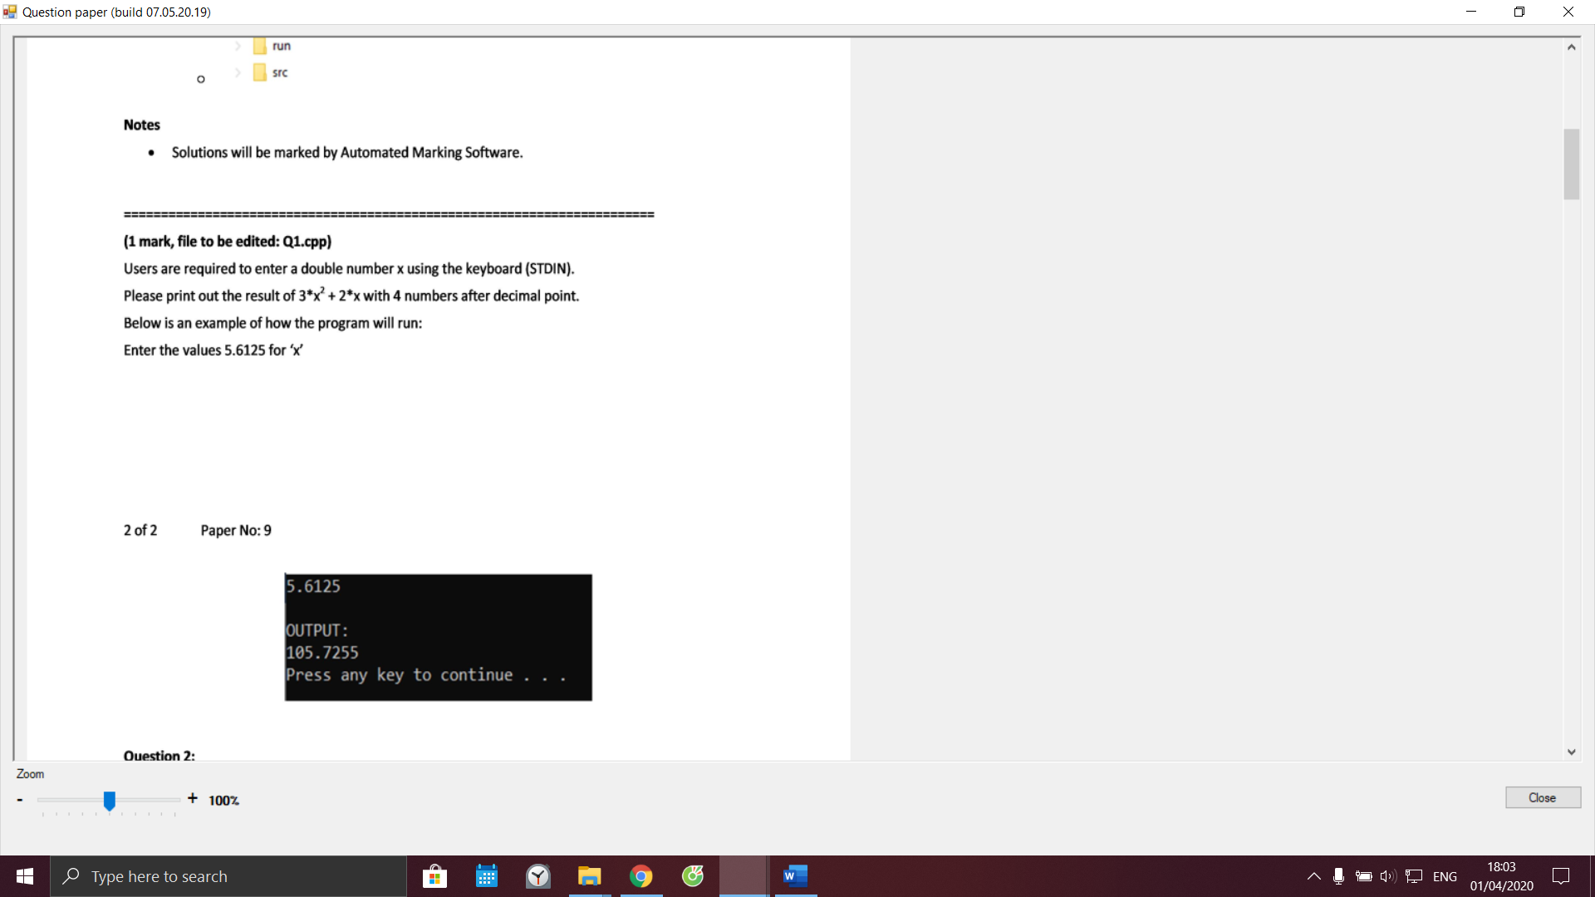

Code câu 1:

#include <stdio.h>

#include <stdlib.h>

#include <string.h>

#include <math.h>

int main() {

system("cls");

//INPUT - @STUDENT:ADD YOUR CODE FOR INPUT HERE:

// Fixed Do not edit anything here.

printf("\nOUTPUT:\n");

//@STUDENT: WRITE YOUR OUTPUT HERE:

//--FIXED PART - DO NOT EDIT ANY THINGS HERE

printf("\n");

system ("pause");

return(0)

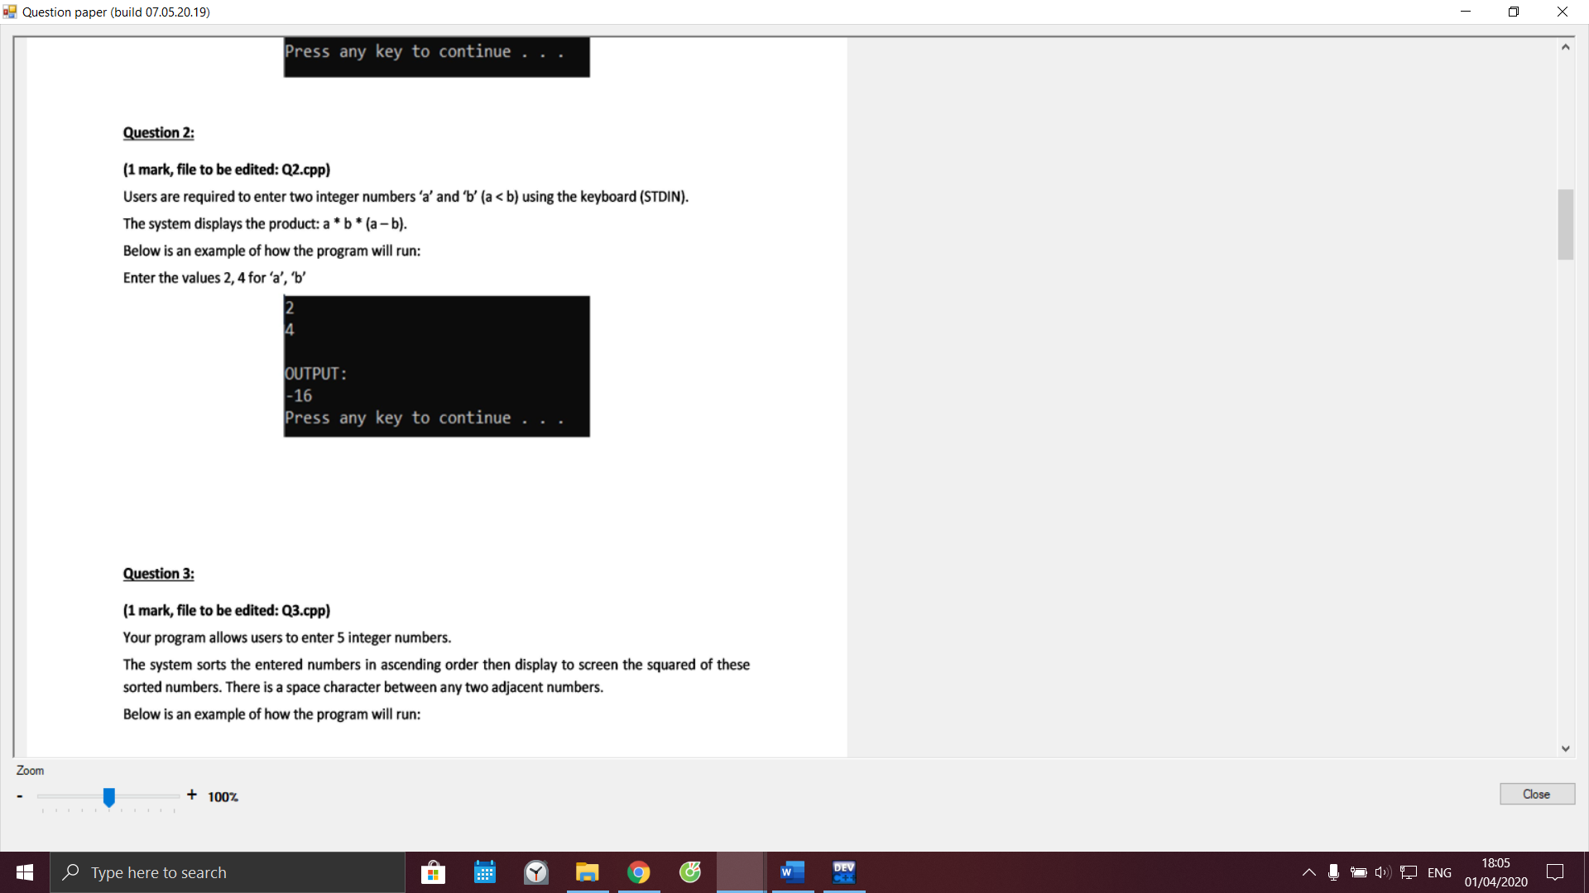

Code câu 2:

#include <stdio.h>

#include <stdlib.h>

#include <string.h>

#include <math.h>

int main() {

system("cls");

//INPUT - @STUDENT:ADD YOUR CODE FOR INPUT HERE:

// Fixed Do not edit anything here.

printf("\nOUTPUT:\n");

//@STUDENT: WRITE YOUR OUTPUT HERE:

//--FIXED PART - DO NOT EDIT ANY THINGS HERE

printf("\n");

system ("pause");

return(0);

}

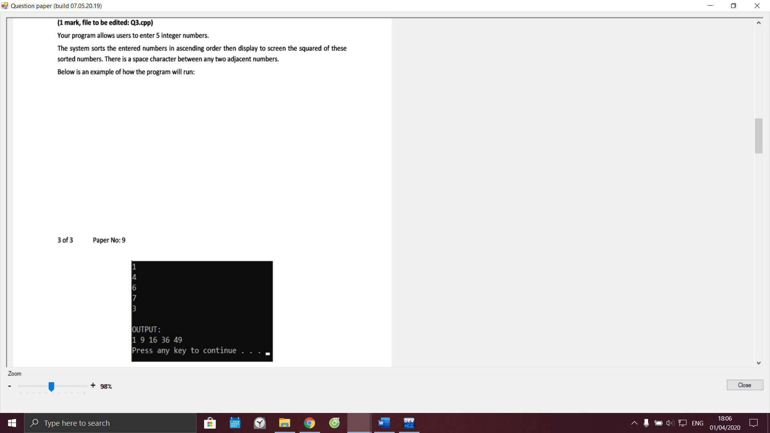

Code câu 3:

#include <stdio.h>

#include <stdlib.h>

#include <string.h>

#include <math.h>

int main() {

system("cls");

//INPUT - @STUDENT:ADD YOUR CODE FOR INPUT HERE:

// Fixed Do not edit anything here.

printf("\nOUTPUT:\n");

//@STUDENT: WRITE YOUR OUTPUT HERE:

//--FIXED PART - DO NOT EDIT ANY THINGS HERE

printf("\n");

system ("pause");

return(0);

}

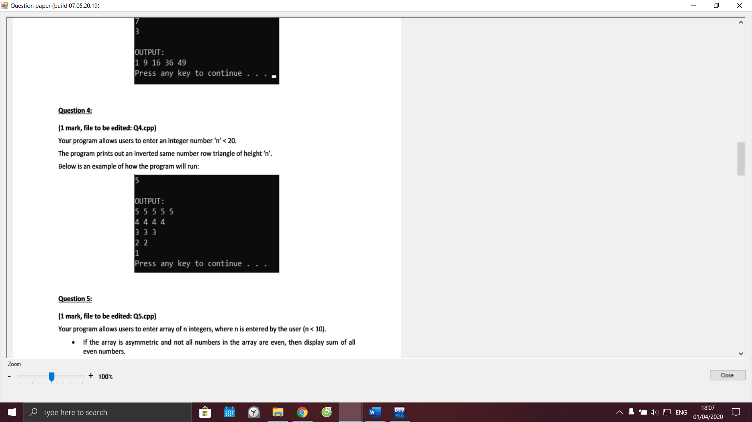

Code câu 4:

#include <stdio.h>

#include <stdlib.h>

#include <string.h>

#include <math.h>

int main() {

system("cls");

//INPUT - @STUDENT:ADD YOUR CODE FOR INPUT HERE:

// Fixed Do not edit anything here.

printf("\nOUTPUT:\n");

//@STUDENT: WRITE YOUR OUTPUT HERE:

//--FIXED PART - DO NOT EDIT ANY THINGS HERE

printf("\n");

system ("pause");

return(0);

}

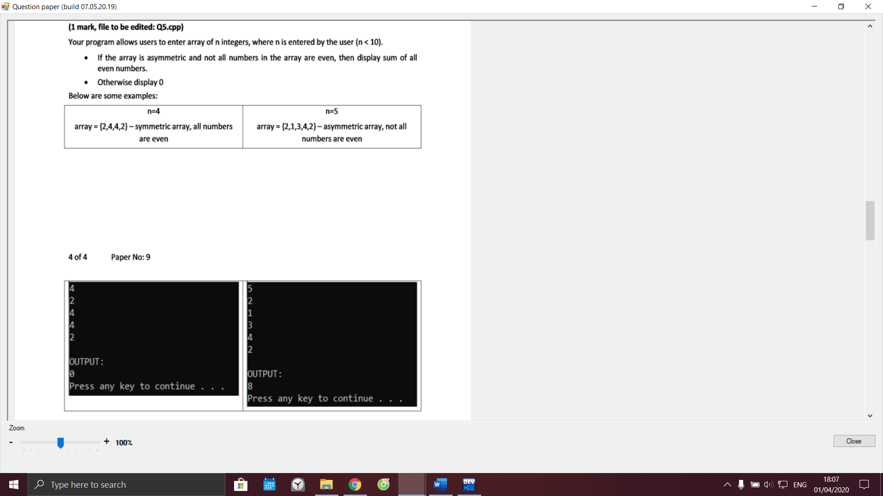

Code câu 5:

#include <stdio.h>

#include <stdlib.h>

#include <string.h>

#include <math.h>

int main() {

system("cls");

//INPUT - @STUDENT:ADD YOUR CODE FOR INPUT HERE:

// Fixed Do not edit anything here.

printf("\nOUTPUT:\n");

//@STUDENT: WRITE YOUR OUTPUT HERE:

//--FIXED PART - DO NOT EDIT ANY THINGS HERE

printf("\n");

system ("pause");

return(0);

}

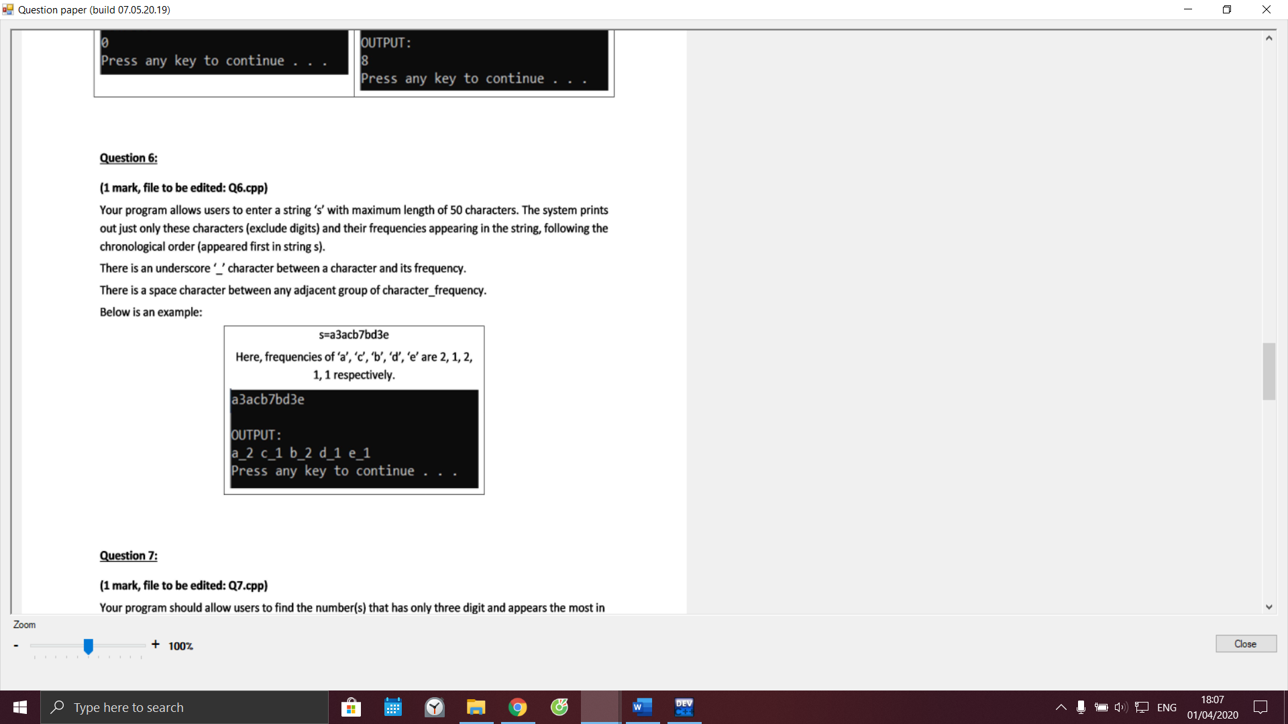

Code câu 6:

#include <stdio.h>

#include <stdlib.h>

#include <string.h>

#include <math.h>

int main() {

system("cls");

//INPUT - @STUDENT:ADD YOUR CODE FOR INPUT HERE:

// Fixed Do not edit anything here.

printf("\nOUTPUT:\n");

//@STUDENT: WRITE YOUR OUTPUT HERE:

//--FIXED PART - DO NOT EDIT ANY THINGS HERE

printf("\n");

system ("pause");

return(0);

}

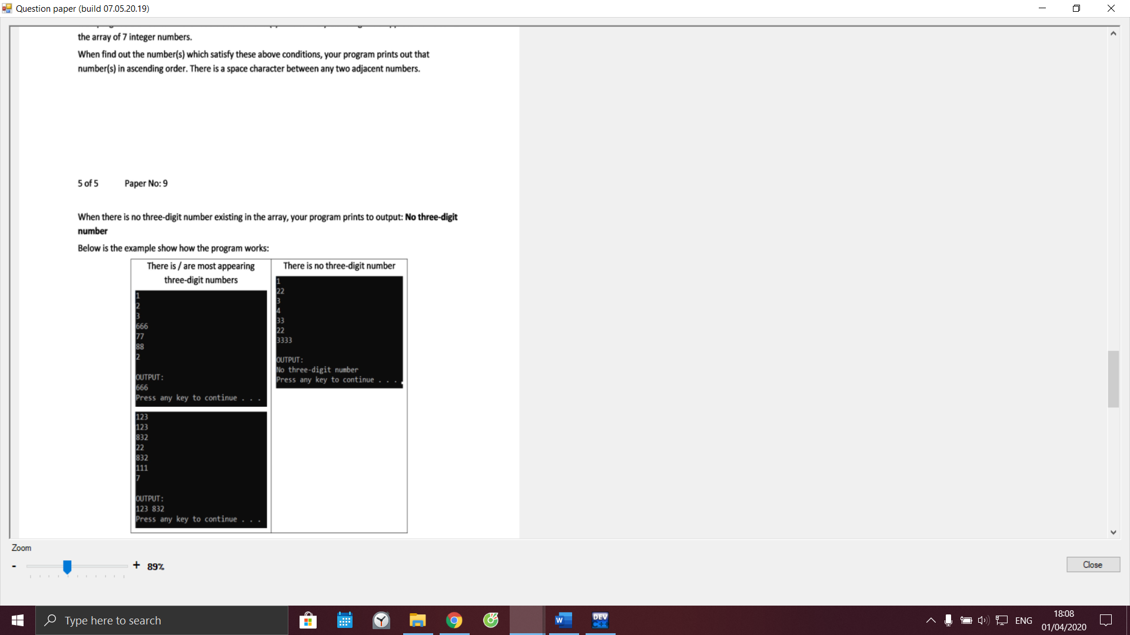

Code câu 7:

#include <stdio.h>

#include <stdlib.h>

#include <string.h>

#include <math.h>

int main() {

system("cls");

//INPUT - @STUDENT:ADD YOUR CODE FOR INPUT HERE:

// Fixed Do not edit anything here.

printf("\nOUTPUT:\n");

//@STUDENT: WRITE YOUR OUTPUT HERE:

//--FIXED PART - DO NOT EDIT ANY THINGS HERE

printf("\n");

system ("pause");

return(0);

}

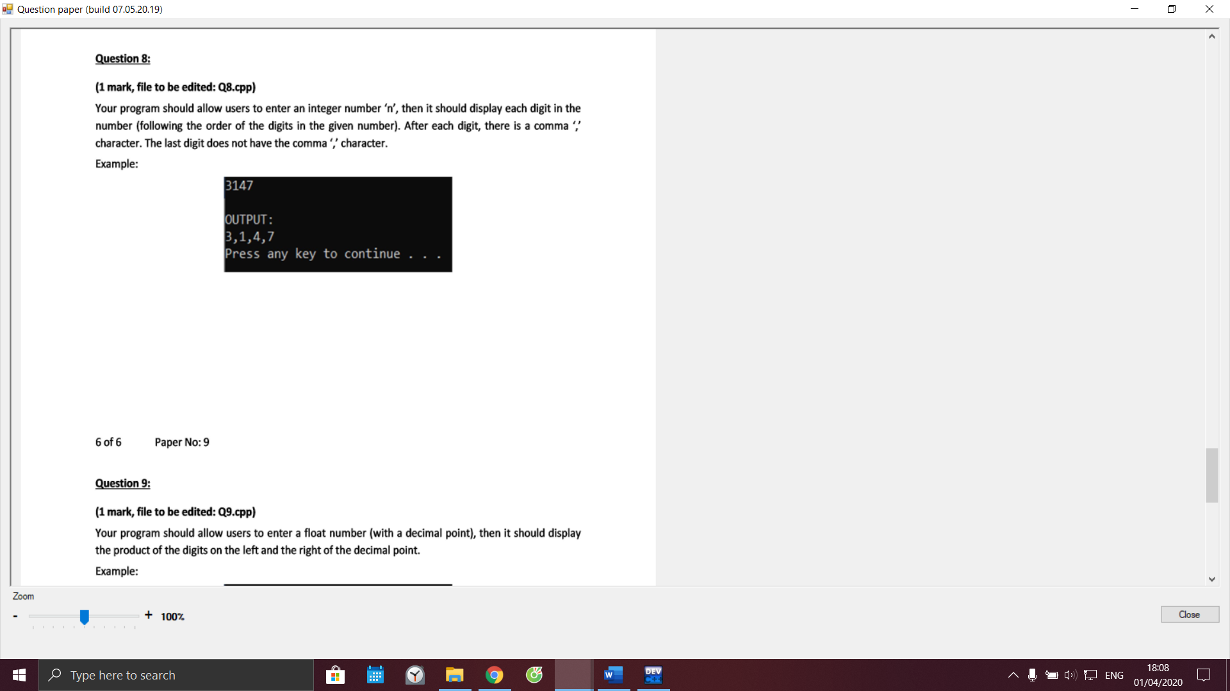

Code câu 8:

#include <stdio.h>

#include <stdlib.h>

#include <string.h>

#include <math.h>

int main() {

system("cls");

//INPUT - @STUDENT:ADD YOUR CODE FOR INPUT HERE:

// Fixed Do not edit anything here.

printf("\nOUTPUT:\n");

//@STUDENT: WRITE YOUR OUTPUT HERE:

//--FIXED PART - DO NOT EDIT ANY THINGS HERE

printf("\n");

system ("pause");

return(0);

}

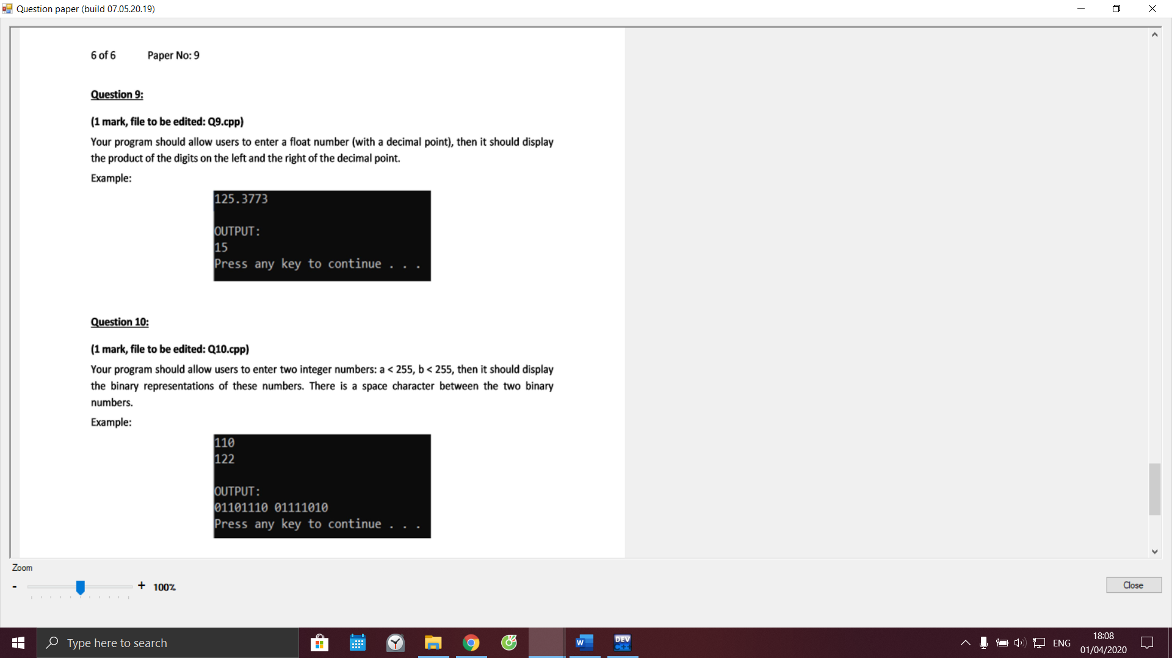

Code câu 9:

#include <stdio.h>

#include <stdlib.h>

#include <string.h>

#include <math.h>

int main() {

system("cls");

//INPUT - @STUDENT:ADD YOUR CODE FOR INPUT HERE:

// Fixed Do not edit anything here.

printf("\nOUTPUT:\n");

//@STUDENT: WRITE YOUR OUTPUT HERE:

//--FIXED PART - DO NOT EDIT ANY THINGS HERE

printf("\n");

system ("pause");

return(0);

}

Code câu 10:

#include <stdio.h>

#include <stdlib.h>

#include <string.h>

#include <math.h>

int main() {

system("cls");

//INPUT - @STUDENT:ADD YOUR CODE FOR INPUT HERE:

// Fixed Do not edit anything here.

printf("\nOUTPUT:\n");

//@STUDENT: WRITE YOUR OUTPUT HERE:

//--FIXED PART - DO NOT EDIT ANY THINGS HERE

printf("\n");

system ("pause");

return(0);

}