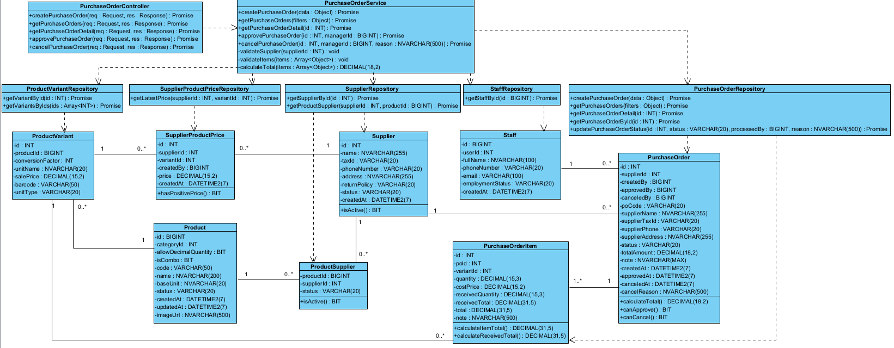

Figure IV-33. Implementation class diagram for the Purchase Order Management component.

Class | Attributes | Methods | Description
PurchaseOrderController | — | +createPurchaseOrder(req: Request, res: Response): Promise  +getPurchaseOrders(req: Request, res: Response): Promise  +getPurchaseOrderDetail(req: Request, res: Response): Promise  +approvePurchaseOrder(req: Request, res: Response): Promise  +cancelPurchaseOrder(req: Request, res: Response): Promise | Receives PO creation, view, approval and cancellation requests.
PurchaseOrderService | — | +createPurchaseOrder(data: Object): Promise  +getPurchaseOrders(filters: Object): Promise  +getPurchaseOrderDetail(id: INT): Promise  +approvePurchaseOrder(id: INT, managerId: BIGINT): Promise  +cancelPurchaseOrder(id: INT, managerId: BIGINT, reason: NVARCHAR(500)): Promise  -validateSupplier(supplierId: INT): void  -validateItems(items: Array<Object>): void  -calculateTotal(items: Array<Object>): DECIMAL(18,2) | Validates PO data, calculates totals and handles status transitions.
PurchaseOrderRepository | — | +createPurchaseOrder(data: Object): Promise  +getPurchaseOrders(filters: Object): Promise  +getPurchaseOrderDetail(id: INT): Promise  +getPurchaseOrderById(id: INT): Promise  +updatePurchaseOrderStatus(id: INT, status: VARCHAR(20), processedBy: BIGINT, reason: NVARCHAR(500)): Promise | Stores and queries POs and their items.
SupplierRepository | — | +getSupplierById(id: INT): Promise  +getProductSupplier(supplierId: INT, productId: BIGINT): Promise | Look up supplier and product-supplier relationships.
SupplierProductPriceRepository | — | +getLatestPrice(supplierId: INT, variantId: INT): Promise | Retrieves the latest purchase price.
ProductVariantRepository | — | +getVariantById(id: INT): Promise  +getVariantsByIds(ids: Array<INT>): Promise | Look up selected product variants.
StaffRepository | — | +getStaffById(id: BIGINT): Promise | Retrieves creator, approver or canceler information.
PurchaseOrder | -id: INT  -poCode: VARCHAR(20)  -supplierId: INT  -supplierName: NVARCHAR(255)  -supplierTaxId: VARCHAR(20)  -supplierPhone: VARCHAR(20)  -supplierAddress: NVARCHAR(255)  -status: VARCHAR(20)  -totalAmount: DECIMAL(18,2)  -note: NVARCHAR(MAX)  -createdBy: BIGINT  -createdAt: DATETIME2(7)  -approvedBy: BIGINT  -approvedAt: DATETIME2(7)  -canceledBy: BIGINT  -canceledAt: DATETIME2(7)  -cancelReason: NVARCHAR(500) | +calculateTotal(): DECIMAL(18,2)  +canApprove(): BIT  +canCancel(): BIT | Purchase order header, lifecycle and supplier snapshot.
PurchaseOrderItem | -id: INT  -poId: INT  -variantId: INT  -quantity: DECIMAL(15,3)  -costPrice: DECIMAL(15,2)  -receivedQuantity: DECIMAL(15,3)  -receivedTotal: DECIMAL(31,5)  -total: DECIMAL(31,5)  -note: NVARCHAR(500) | +calculateItemTotal(): DECIMAL(31,5)  +calculateReceivedTotal(): DECIMAL(31,5) | Ordered variant, price snapshot and received quantities.
Supplier | -id: INT  -name: NVARCHAR(255)  -taxId: VARCHAR(20)  -phoneNumber: VARCHAR(20)  -address: NVARCHAR(255)  -returnPolicy: VARCHAR(20)  -status: VARCHAR(20)  -createdAt: DATETIME2(7) | +isActive(): BIT | Supplier profile and return policy.
SupplierProductPrice | -id: INT  -supplierId: INT  -variantId: INT  -price: DECIMAL(15,2)  -createdAt: DATETIME2(7)  -createdBy: BIGINT | +hasPositivePrice(): BIT | Supplier purchase-price record.
ProductSupplier | -productId: BIGINT  -supplierId: INT  -status: VARCHAR(20) | +isActive(): BIT | Supplier–product link and its status.
Product | -id: BIGINT  -code: VARCHAR(50)  -name: NVARCHAR(200)  -categoryId: INT  -baseUnit: NVARCHAR(20)  -allowDecimalQuantity: BIT  -isCombo: BIT  -status: VARCHAR(20)  -createdAt: DATETIME2(7)  -updatedAt: DATETIME2(7)  -imageUrl: NVARCHAR(500) | — | Product master data.
ProductVariant | -id: INT  -productId: BIGINT  -unitName: NVARCHAR(20)  -conversionFactor: INT  -salePrice: DECIMAL(15,2)  -barcode: VARCHAR(50)  -unitType: VARCHAR(20) | — | Stock-managed product variant.
Staff | -id: BIGINT  -userId: INT  -fullName: NVARCHAR(100)  -phoneNumber: VARCHAR(20)  -email: VARCHAR(100)  -employmentStatus: VARCHAR(20)  -createdAt: DATETIME2(7) | — | Employee identity for audit fields.

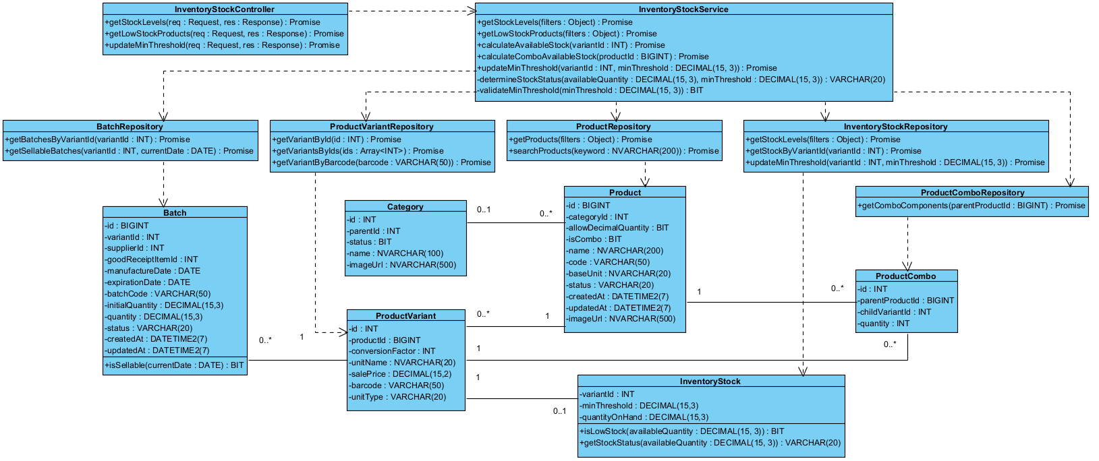
Figure IV-34. Implementation class diagram for the Inventory Stock & Threshold Management component.

Class | Attributes | Methods | Description
InventoryStockController | — | +getStockLevels(req: Request, res: Response): Promise  +getLowStockProducts(req: Request, res: Response): Promise  +updateMinThreshold(req: Request, res: Response): Promise | Handles stock lookup, low-stock list and threshold update requests.
InventoryStockService | — | +getStockLevels(filters: Object): Promise  +getLowStockProducts(filters: Object): Promise  +calculateAvailableStock(variantId: INT): Promise  +calculateComboAvailableStock(productId: BIGINT): Promise  +updateMinThreshold(variantId: INT, minThreshold: DECIMAL(15,3)): Promise  -determineStockStatus(availableQuantity: DECIMAL(15,3), minThreshold: DECIMAL(15,3)): VARCHAR(20)  -validateMinThreshold(minThreshold: DECIMAL(15,3)): BIT | Computes sellable stock and low-stock states.
InventoryStockRepository | — | +getStockLevels(filters: Object): Promise  +getStockByVariantId(variantId: INT): Promise  +updateMinThreshold(variantId: INT, minThreshold: DECIMAL(15,3)): Promise | Queries inventory quantities and updates thresholds.
ProductRepository | — | +getProducts(filters: Object): Promise  +searchProducts(keyword: NVARCHAR(200)): Promise | Queries product data for the inventory list.
ProductVariantRepository | — | +getVariantById(id: INT): Promise  +getVariantsByIds(ids: Array<INT>): Promise  +getVariantByBarcode(barcode: VARCHAR(50)): Promise | Queries product variants and barcodes.
BatchRepository | — | +getBatchesByVariantId(variantId: INT): Promise  +getSellableBatches(variantId: INT, currentDate: DATE): Promise | Retrieves batches and sellable quantities.
ProductComboRepository | — | +getComboComponents(parentProductId: BIGINT): Promise | Looks up combo component variants.
InventoryStock | -variantId: INT  -quantityOnHand: DECIMAL(15,3)  -minThreshold: DECIMAL(15,3) | +isLowStock(availableQuantity: DECIMAL(15,3)): BIT  +getStockStatus(availableQuantity: DECIMAL(15,3)): VARCHAR(20) | Quantity on hand and alert threshold by variant.
Product | -id: BIGINT  -code: VARCHAR(50)  -name: NVARCHAR(200)  -categoryId: INT  -baseUnit: NVARCHAR(20)  -allowDecimalQuantity: BIT  -isCombo: BIT  -status: VARCHAR(20)  -createdAt: DATETIME2(7)  -updatedAt: DATETIME2(7)  -imageUrl: NVARCHAR(500) | — | Product master data.
ProductVariant | -id: INT  -productId: BIGINT  -unitName: NVARCHAR(20)  -conversionFactor: INT  -salePrice: DECIMAL(15,2)  -barcode: VARCHAR(50)  -unitType: VARCHAR(20) | — | Stock-managed product variant.
Category | -id: INT  -name: NVARCHAR(100)  -parentId: INT  -status: BIT  -imageUrl: NVARCHAR(500) | — | Product category used for filtering.
Batch | -id: BIGINT  -batchCode: VARCHAR(50)  -variantId: INT  -supplierId: INT  -goodReceiptItemId: INT  -manufactureDate: DATE  -expirationDate: DATE  -initialQuantity: DECIMAL(15,3)  -quantity: DECIMAL(15,3)  -status: VARCHAR(20)  -createdAt: DATETIME2(7)  -updatedAt: DATETIME2(7) | +isSellable(currentDate: DATE): BIT | Batch quantity, expiry dates and status.
ProductCombo | -id: INT  -parentProductId: BIGINT  -childVariantId: INT  -quantity: INT | — | Product combo component and required quantity.

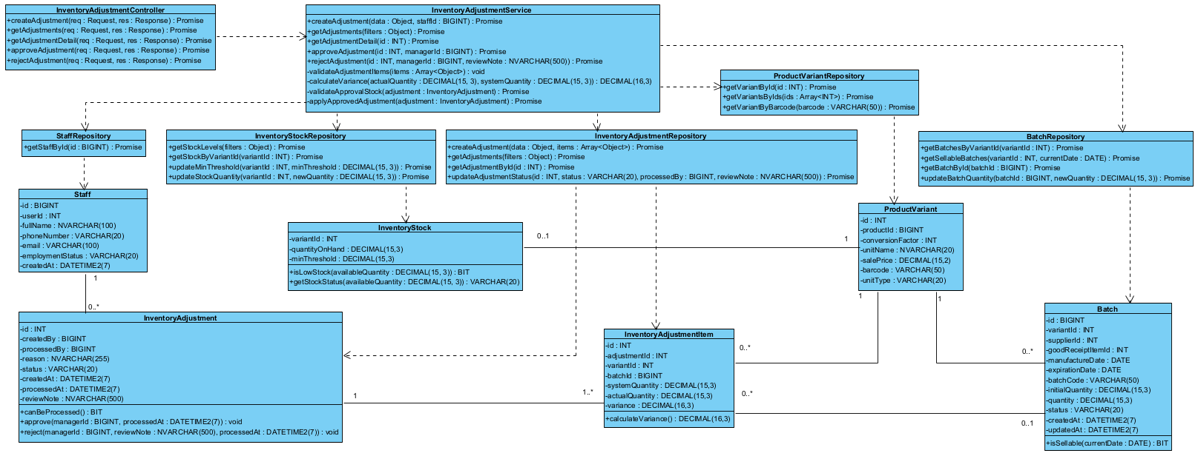
Figure IV-35. Implementation class diagram for the Stock Adjustment Management component.

Class | Attributes | Methods | Description
InventoryAdjustmentController | — | +createAdjustment(req: Request, res: Response): Promise  +getAdjustments(req: Request, res: Response): Promise  +getAdjustmentDetail(req: Request, res: Response): Promise  +approveAdjustment(req: Request, res: Response): Promise  +rejectAdjustment(req: Request, res: Response): Promise | Handles stock adjustment requests and review actions.
InventoryAdjustmentService | — | +createAdjustment(data: Object, staffId: BIGINT): Promise  +getAdjustments(filters: Object): Promise  +getAdjustmentDetail(id: INT): Promise  +approveAdjustment(id: INT, managerId: BIGINT): Promise  +rejectAdjustment(id: INT, managerId: BIGINT, reviewNote: NVARCHAR(500)): Promise  -validateAdjustmentItems(items: Array<Object>): void  -calculateVariance(actualQuantity: DECIMAL(15,3), systemQuantity: DECIMAL(15,3)): DECIMAL(16,3)  -validateApprovalStock(adjustment: InventoryAdjustment): Promise  -applyApprovedAdjustment(adjustment: InventoryAdjustment): Promise | Calculates variance and applies only approved stock changes.
InventoryAdjustmentRepository | — | +createAdjustment(data: Object, items: Array<Object>): Promise  +getAdjustments(filters: Object): Promise  +getAdjustmentById(id: INT): Promise  +updateAdjustmentStatus(id: INT, status: VARCHAR(20), processedBy: BIGINT, reviewNote: NVARCHAR(500)): Promise | Stores adjustment requests and lines.
InventoryStockRepository | — | +getStockLevels(filters: Object): Promise  +getStockByVariantId(variantId: INT): Promise  +updateMinThreshold(variantId: INT, minThreshold: DECIMAL(15,3)): Promise  +updateStockQuantity(variantId: INT, newQuantity: DECIMAL(15,3)): Promise | Reads and updates variant stock quantity.
BatchRepository | — | +getBatchesByVariantId(variantId: INT): Promise  +getSellableBatches(variantId: INT, currentDate: DATE): Promise  +getBatchById(batchId: BIGINT): Promise  +updateBatchQuantity(batchId: BIGINT, newQuantity: DECIMAL(15,3)): Promise | Reads and adjusts batch quantity.
ProductVariantRepository | — | +getVariantById(id: INT): Promise  +getVariantsByIds(ids: Array<INT>): Promise  +getVariantByBarcode(barcode: VARCHAR(50)): Promise | Validates variants in adjustment lines.
StaffRepository | — | +getStaffById(id: BIGINT): Promise | Looks up requester and reviewer.
InventoryAdjustment | -id: INT  -createdBy: BIGINT  -reason: NVARCHAR(255)  -status: VARCHAR(20)  -createdAt: DATETIME2(7)  -processedBy: BIGINT  -processedAt: DATETIME2(7)  -reviewNote: NVARCHAR(500) | +canBeProcessed(): BIT  +approve(managerId: BIGINT, processedAt: DATETIME2(7)): void  +reject(managerId: BIGINT, reviewNote: NVARCHAR(500), processedAt: DATETIME2(7)): void | Request header, reason and approval state.
InventoryAdjustmentItem | -id: INT  -adjustmentId: INT  -variantId: INT  -batchId: BIGINT  -systemQuantity: DECIMAL(15,3)  -actualQuantity: DECIMAL(15,3)  -variance: DECIMAL(16,3) | +calculateVariance(): DECIMAL(16,3) | Counted stock and calculated variance per line.
InventoryStock | -variantId: INT  -quantityOnHand: DECIMAL(15,3)  -minThreshold: DECIMAL(15,3) | +isLowStock(availableQuantity: DECIMAL(15,3)): BIT  +getStockStatus(availableQuantity: DECIMAL(15,3)): VARCHAR(20) | Quantity on hand and alert threshold by variant.
Batch | -id: BIGINT  -batchCode: VARCHAR(50)  -variantId: INT  -supplierId: INT  -goodReceiptItemId: INT  -manufactureDate: DATE  -expirationDate: DATE  -initialQuantity: DECIMAL(15,3)  -quantity: DECIMAL(15,3)  -status: VARCHAR(20)  -createdAt: DATETIME2(7)  -updatedAt: DATETIME2(7) | +isSellable(currentDate: DATE): BIT | Batch quantity, expiry dates and status.
ProductVariant | -id: INT  -productId: BIGINT  -unitName: NVARCHAR(20)  -conversionFactor: INT  -salePrice: DECIMAL(15,2)  -barcode: VARCHAR(50)  -unitType: VARCHAR(20) | — | Stock-managed product variant.
Staff | -id: BIGINT  -userId: INT  -fullName: NVARCHAR(100)  -phoneNumber: VARCHAR(20)  -email: VARCHAR(100)  -employmentStatus: VARCHAR(20)  -createdAt: DATETIME2(7) | — | Employee identity for audit fields.

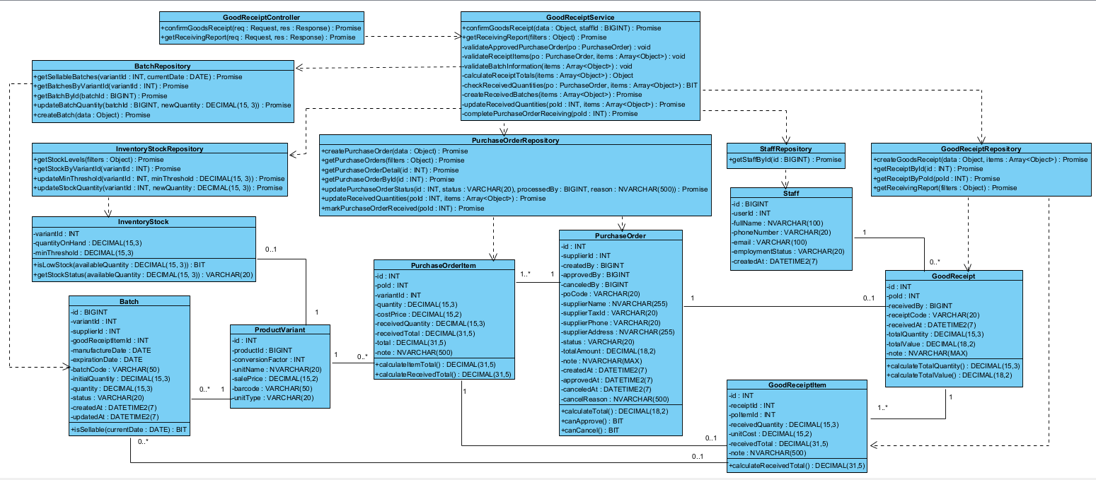
Figure IV-36. Implementation class diagram for the Goods Receiving Management component.

Class | Attributes | Methods | Description
GoodReceiptController | — | +confirmGoodsReceipt(req: Request, res: Response): Promise  +getReceivingReport(req: Request, res: Response): Promise | Handles goods receipt confirmation and receiving reports.
GoodReceiptService | — | +confirmGoodsReceipt(data: Object, staffId: BIGINT): Promise  +getReceivingReport(filters: Object): Promise  -validateApprovedPurchaseOrder(po: PurchaseOrder): void  -validateReceiptItems(po: PurchaseOrder, items: Array<Object>): void  -validateBatchInformation(items: Array<Object>): void  -calculateReceiptTotals(items: Array<Object>): Object  -checkReceivedQuantities(po: PurchaseOrder, items: Array<Object>): BIT  -createReceivedBatches(items: Array<Object>): Promise  -updateReceivedQuantities(poId: INT, items: Array<Object>): Promise  -completePurchaseOrderReceiving(poId: INT): Promise | Records actual received quantities, batch details and PO completion.
GoodReceiptRepository | — | +createGoodsReceipt(data: Object, items: Array<Object>): Promise  +getReceiptById(id: INT): Promise  +getReceiptByPoId(poId: INT): Promise  +getReceivingReport(filters: Object): Promise | Stores receipts and queries receiving reports.
PurchaseOrderRepository | — | +createPurchaseOrder(data: Object): Promise  +getPurchaseOrders(filters: Object): Promise  +getPurchaseOrderDetail(id: INT): Promise  +getPurchaseOrderById(id: INT): Promise  +updatePurchaseOrderStatus(id: INT, status: VARCHAR(20), processedBy: BIGINT, reason: NVARCHAR(500)): Promise  +updateReceivedQuantities(poId: INT, items: Array<Object>): Promise  +markPurchaseOrderReceived(poId: INT): Promise | Retrieves approved POs and records actual received quantities.
BatchRepository | — | +getBatchesByVariantId(variantId: INT): Promise  +getSellableBatches(variantId: INT, currentDate: DATE): Promise  +getBatchById(batchId: BIGINT): Promise  +updateBatchQuantity(batchId: BIGINT, newQuantity: DECIMAL(15,3)): Promise  +createBatch(data: Object): Promise | Creates batches from received goods.
InventoryStockRepository | — | +getStockLevels(filters: Object): Promise  +getStockByVariantId(variantId: INT): Promise  +updateMinThreshold(variantId: INT, minThreshold: DECIMAL(15,3)): Promise  +updateStockQuantity(variantId: INT, newQuantity: DECIMAL(15,3)): Promise | Updates total stock after receipt confirmation.
StaffRepository | — | +getStaffById(id: BIGINT): Promise | Looks up receiving staff.
GoodReceipt | -id: INT  -receiptCode: VARCHAR(20)  -poId: INT  -receivedBy: BIGINT  -receivedAt: DATETIME2(7)  -totalQuantity: DECIMAL(15,3)  -totalValue: DECIMAL(18,2)  -note: NVARCHAR(MAX) | +calculateTotalQuantity(): DECIMAL(15,3)  +calculateTotalValue(): DECIMAL(18,2) | Receipt header linked to an approved PO.
GoodReceiptItem | -id: INT  -receiptId: INT  -poItemId: INT  -receivedQuantity: DECIMAL(15,3)  -unitCost: DECIMAL(15,2)  -receivedTotal: DECIMAL(31,5)  -note: NVARCHAR(500) | +calculateReceivedTotal(): DECIMAL(31,5) | Actual quantity and value received against each PO item.
PurchaseOrder | -id: INT  -poCode: VARCHAR(20)  -supplierId: INT  -supplierName: NVARCHAR(255)  -supplierTaxId: VARCHAR(20)  -supplierPhone: VARCHAR(20)  -supplierAddress: NVARCHAR(255)  -status: VARCHAR(20)  -totalAmount: DECIMAL(18,2)  -note: NVARCHAR(MAX)  -createdBy: BIGINT  -createdAt: DATETIME2(7)  -approvedBy: BIGINT  -approvedAt: DATETIME2(7)  -canceledBy: BIGINT  -canceledAt: DATETIME2(7)  -cancelReason: NVARCHAR(500) | +calculateTotal(): DECIMAL(18,2)  +canApprove(): BIT  +canCancel(): BIT | Purchase order header, lifecycle and supplier snapshot.
PurchaseOrderItem | -id: INT  -poId: INT  -variantId: INT  -quantity: DECIMAL(15,3)  -costPrice: DECIMAL(15,2)  -receivedQuantity: DECIMAL(15,3)  -receivedTotal: DECIMAL(31,5)  -total: DECIMAL(31,5)  -note: NVARCHAR(500) | +calculateItemTotal(): DECIMAL(31,5)  +calculateReceivedTotal(): DECIMAL(31,5) | Ordered variant, price snapshot and received quantities.
ProductVariant | -id: INT  -productId: BIGINT  -unitName: NVARCHAR(20)  -conversionFactor: INT  -salePrice: DECIMAL(15,2)  -barcode: VARCHAR(50)  -unitType: VARCHAR(20) | — | Stock-managed product variant.
Batch | -id: BIGINT  -batchCode: VARCHAR(50)  -variantId: INT  -supplierId: INT  -goodReceiptItemId: INT  -manufactureDate: DATE  -expirationDate: DATE  -initialQuantity: DECIMAL(15,3)  -quantity: DECIMAL(15,3)  -status: VARCHAR(20)  -createdAt: DATETIME2(7)  -updatedAt: DATETIME2(7) | +isSellable(currentDate: DATE): BIT | Batch quantity, expiry dates and status.
InventoryStock | -variantId: INT  -quantityOnHand: DECIMAL(15,3)  -minThreshold: DECIMAL(15,3) | +isLowStock(availableQuantity: DECIMAL(15,3)): BIT  +getStockStatus(availableQuantity: DECIMAL(15,3)): VARCHAR(20) | Quantity on hand and alert threshold by variant.
Staff | -id: BIGINT  -userId: INT  -fullName: NVARCHAR(100)  -phoneNumber: VARCHAR(20)  -email: VARCHAR(100)  -employmentStatus: VARCHAR(20)  -createdAt: DATETIME2(7) | — | Employee identity for audit fields.

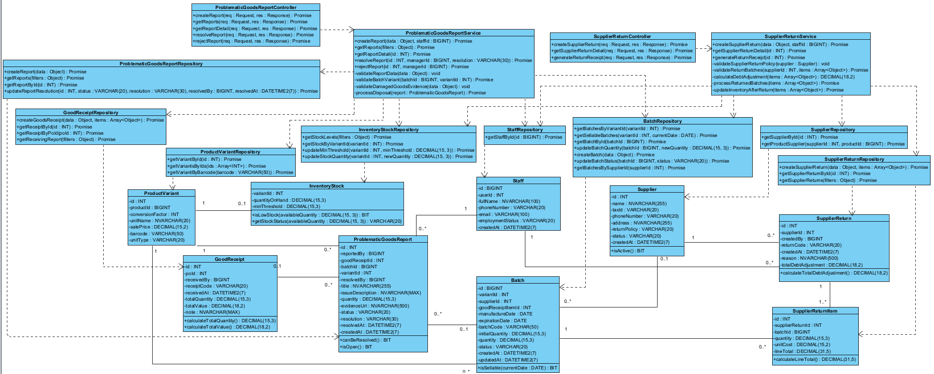
Figure IV-37. Implementation class diagram for the Goods Issue & Supplier Return Management component.

Class | Attributes | Methods | Description
ProblematicGoodsReportController | — | +createReport(req: Request, res: Response): Promise  +getReports(req: Request, res: Response): Promise  +getReportDetail(req: Request, res: Response): Promise  +resolveReport(req: Request, res: Response): Promise  +rejectReport(req: Request, res: Response): Promise | Receives goods-issue reports and review actions.
SupplierReturnController | — | +createSupplierReturn(req: Request, res: Response): Promise  +getSupplierReturnDetail(req: Request, res: Response): Promise  +generateReturnReceipt(req: Request, res: Response): Promise | Handles return document creation and retrieval.
ProblematicGoodsReportService | — | +createReport(data: Object, staffId: BIGINT): Promise  +getReports(filters: Object): Promise  +getReportDetail(id: INT): Promise  +resolveReport(id: INT, managerId: BIGINT, resolution: VARCHAR(30)): Promise  +rejectReport(id: INT, managerId: BIGINT): Promise  -validateReportData(data: Object): void  -validateBatchVariant(batchId: BIGINT, variantId: INT): Promise  -validateDamagedGoodsEvidence(data: Object): void  -processDisposal(report: ProblematicGoodsReport): Promise | Validates damaged goods evidence and manages report resolution.
SupplierReturnService | — | +createSupplierReturn(data: Object, staffId: BIGINT): Promise  +getSupplierReturnDetail(id: INT): Promise  +generateReturnReceipt(id: INT): Promise  -validateSupplierReturnPolicy(supplier: Supplier): void  -validateReturnBatches(supplierId: INT, items: Array<Object>): Promise  -calculateDebtAdjustment(items: Array<Object>): DECIMAL(18,2)  -processReturnedBatches(items: Array<Object>): Promise  -updateInventoryAfterReturn(items: Array<Object>): Promise | Checks supplier return policy, records returns and adjusts stock.
ProblematicGoodsReportRepository | — | +createReport(data: Object): Promise  +getReports(filters: Object): Promise  +getReportById(id: INT): Promise  +updateReportResolution(id: INT, status: VARCHAR(20), resolution: VARCHAR(30), resolvedBy: BIGINT, resolvedAt: DATETIME2(7)): Promise | Persists goods-issue reports and review outcomes.
SupplierReturnRepository | — | +createSupplierReturn(data: Object, items: Array<Object>): Promise  +getSupplierReturnById(id: INT): Promise  +getSupplierReturns(filters: Object): Promise | Stores supplier returns and line items.
SupplierRepository | — | +getSupplierById(id: INT): Promise  +getProductSupplier(supplierId: INT, productId: BIGINT): Promise | Provides supplier profile and return policy.
BatchRepository | — | +getBatchesByVariantId(variantId: INT): Promise  +getSellableBatches(variantId: INT, currentDate: DATE): Promise  +getBatchById(batchId: BIGINT): Promise  +updateBatchQuantity(batchId: BIGINT, newQuantity: DECIMAL(15,3)): Promise  +createBatch(data: Object): Promise  +updateBatchStatus(batchId: BIGINT, status: VARCHAR(20)): Promise  +getBatchesBySupplierId(supplierId: INT): Promise | Queries and updates returned or disposed of batches.
InventoryStockRepository | — | +getStockLevels(filters: Object): Promise  +getStockByVariantId(variantId: INT): Promise  +updateMinThreshold(variantId: INT, minThreshold: DECIMAL(15,3)): Promise  +updateStockQuantity(variantId: INT, newQuantity: DECIMAL(15,3)): Promise | Adjusts inventory totals after return/disposal.
ProductVariantRepository | — | +getVariantById(id: INT): Promise  +getVariantsByIds(ids: Array<INT>): Promise  +getVariantByBarcode(barcode: VARCHAR(50)): Promise | Retrieves affected variants.
GoodReceiptRepository | — | +createGoodsReceipt(data: Object, items: Array<Object>): Promise  +getReceiptById(id: INT): Promise  +getReceiptByPoId(poId: INT): Promise  +getReceivingReport(filters: Object): Promise | References existing receipts for issue reports.
StaffRepository | — | +getStaffById(id: BIGINT): Promise | Retrieves reporter, resolver or return creator.
ProblematicGoodsReport | -id: INT  -title: NVARCHAR(255)  -issueDescription: NVARCHAR(MAX)  -reportedBy: BIGINT  -goodReceiptId: INT  -batchId: BIGINT  -variantId: INT  -quantity: DECIMAL(15,3)  -evidenceUrl: NVARCHAR(500)  -status: VARCHAR(20)  -resolution: VARCHAR(30)  -resolvedBy: BIGINT  -resolvedAt: DATETIME2(7)  -createdAt: DATETIME2(7) | +canBeResolved(): BIT  +isOpen(): BIT | Issue report for damaged or defective goods.
SupplierReturn | -id: INT  -returnCode: VARCHAR(20)  -supplierId: INT  -createdBy: BIGINT  -createdAt: DATETIME2(7)  -reason: NVARCHAR(500)  -totalDebtAdjustment: DECIMAL(18,2) | +calculateTotalDebtAdjustment(): DECIMAL(18,2) | Supplier return document and debt adjustment.
SupplierReturnItem | -id: INT  -supplierReturnId: INT  -batchId: BIGINT  -quantity: DECIMAL(15,3)  -unitCost: DECIMAL(15,2)  -lineTotal: DECIMAL(31,5) | +calculateLineTotal(): DECIMAL(31,5) | Returned batch and line value.
Supplier | -id: INT  -name: NVARCHAR(255)  -taxId: VARCHAR(20)  -phoneNumber: VARCHAR(20)  -address: NVARCHAR(255)  -returnPolicy: VARCHAR(20)  -status: VARCHAR(20)  -createdAt: DATETIME2(7) | +isActive(): BIT | Supplier profile and return policy.
Batch | -id: BIGINT  -batchCode: VARCHAR(50)  -variantId: INT  -supplierId: INT  -goodReceiptItemId: INT  -manufactureDate: DATE  -expirationDate: DATE  -initialQuantity: DECIMAL(15,3)  -quantity: DECIMAL(15,3)  -status: VARCHAR(20)  -createdAt: DATETIME2(7)  -updatedAt: DATETIME2(7) | +isSellable(currentDate: DATE): BIT | Batch quantity, expiry dates and status.
InventoryStock | -variantId: INT  -quantityOnHand: DECIMAL(15,3)  -minThreshold: DECIMAL(15,3) | +isLowStock(availableQuantity: DECIMAL(15,3)): BIT  +getStockStatus(availableQuantity: DECIMAL(15,3)): VARCHAR(20) | Quantity on hand and alert threshold by variant.
ProductVariant | -id: INT  -productId: BIGINT  -unitName: NVARCHAR(20)  -conversionFactor: INT  -salePrice: DECIMAL(15,2)  -barcode: VARCHAR(50)  -unitType: VARCHAR(20) | — | Stock-managed product variant.
GoodReceipt | -id: INT  -receiptCode: VARCHAR(20)  -poId: INT  -receivedBy: BIGINT  -receivedAt: DATETIME2(7)  -totalQuantity: DECIMAL(15,3)  -totalValue: DECIMAL(18,2)  -note: NVARCHAR(MAX) | +calculateTotalQuantity(): DECIMAL(15,3)  +calculateTotalValue(): DECIMAL(18,2) | Receipt header linked to an approved PO.
Staff | -id: BIGINT  -userId: INT  -fullName: NVARCHAR(100)  -phoneNumber: VARCHAR(20)  -email: VARCHAR(100)  -employmentStatus: VARCHAR(20)  -createdAt: DATETIME2(7) | — | Employee identity for audit fields.

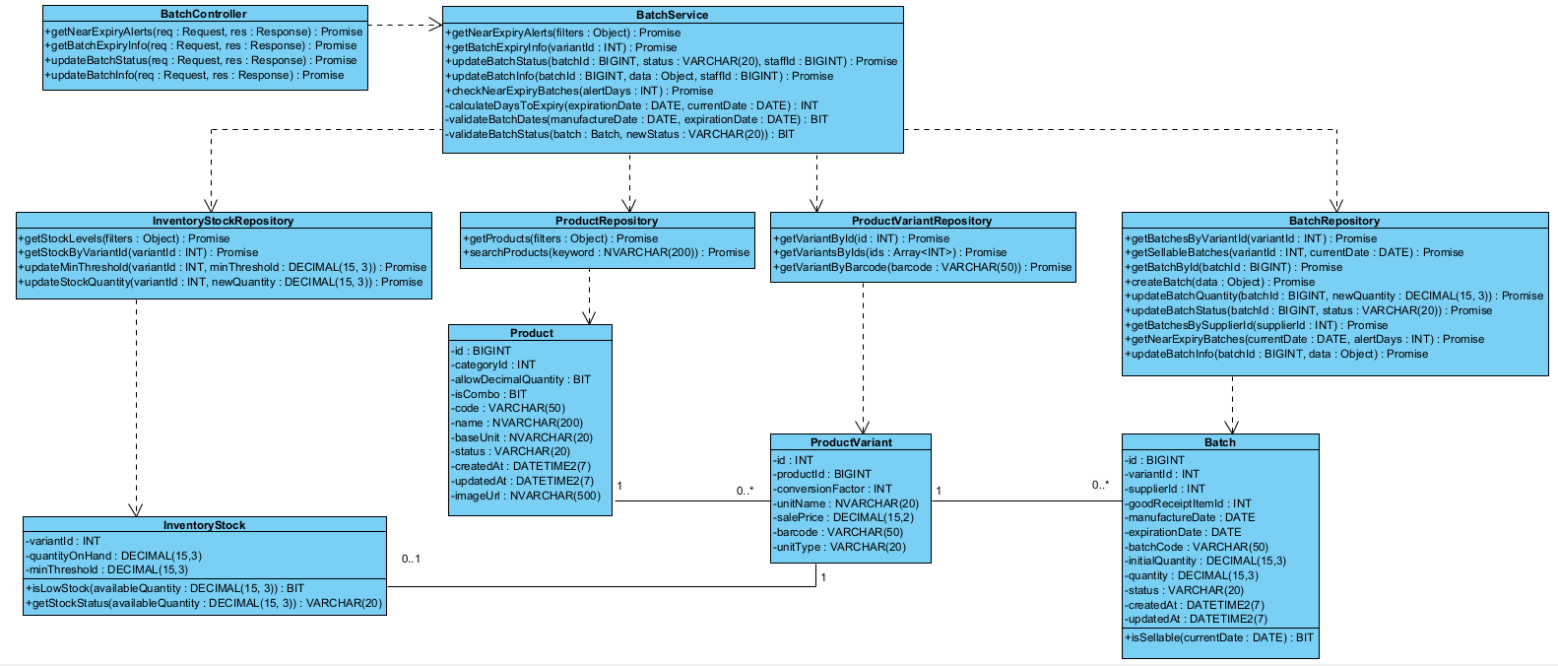
Figure IV-38. Implementation class diagram for the Batch & Expiry Management component.

Class | Attributes | Methods | Description
BatchController | — | +getNearExpiryAlerts(req: Request, res: Response): Promise  +getBatchExpiryInfo(req: Request, res: Response): Promise  +updateBatchStatus(req: Request, res: Response): Promise  +updateBatchInfo(req: Request, res: Response): Promise | Handles expiry alerts and batch information requests.
BatchService | — | +getNearExpiryAlerts(filters: Object): Promise  +getBatchExpiryInfo(variantId: INT): Promise  +updateBatchStatus(batchId: BIGINT, status: VARCHAR(20), staffId: BIGINT): Promise  +updateBatchInfo(batchId: BIGINT, data: Object, staffId: BIGINT): Promise  +checkNearExpiryBatches(alertDays: INT): Promise  -calculateDaysToExpiry(expirationDate: DATE, currentDate: DATE): INT  -validateBatchDates(manufactureDate: DATE, expirationDate: DATE): BIT  -validateBatchStatus(batch: Batch, newStatus: VARCHAR(20)): BIT | Identifies near-expiry batches and validates status or date updates.
BatchRepository | — | +getBatchesByVariantId(variantId: INT): Promise  +getSellableBatches(variantId: INT, currentDate: DATE): Promise  +getBatchById(batchId: BIGINT): Promise  +updateBatchQuantity(batchId: BIGINT, newQuantity: DECIMAL(15,3)): Promise  +createBatch(data: Object): Promise  +updateBatchStatus(batchId: BIGINT, status: VARCHAR(20)): Promise  +getBatchesBySupplierId(supplierId: INT): Promise  +getNearExpiryBatches(currentDate: DATE, alertDays: INT): Promise  +updateBatchInfo(batchId: BIGINT, data: Object): Promise | Queries expiry windows and updates batch metadata.
ProductVariantRepository | — | +getVariantById(id: INT): Promise  +getVariantsByIds(ids: Array<INT>): Promise  +getVariantByBarcode(barcode: VARCHAR(50)): Promise | Retrieves variants associated with batches.
ProductRepository | — | +getProducts(filters: Object): Promise  +searchProducts(keyword: NVARCHAR(200)): Promise | Retrieves product names and codes.
InventoryStockRepository | — | +getStockLevels(filters: Object): Promise  +getStockByVariantId(variantId: INT): Promise  +updateMinThreshold(variantId: INT, minThreshold: DECIMAL(15,3)): Promise  +updateStockQuantity(variantId: INT, newQuantity: DECIMAL(15,3)): Promise | Retrieves inventory quantities for batch views.
Batch | -id: BIGINT  -batchCode: VARCHAR(50)  -variantId: INT  -supplierId: INT  -goodReceiptItemId: INT  -manufactureDate: DATE  -expirationDate: DATE  -initialQuantity: DECIMAL(15,3)  -quantity: DECIMAL(15,3)  -status: VARCHAR(20)  -createdAt: DATETIME2(7)  -updatedAt: DATETIME2(7) | +isSellable(currentDate: DATE): BIT | Batch quantity, expiry dates and status.
ProductVariant | -id: INT  -productId: BIGINT  -unitName: NVARCHAR(20)  -conversionFactor: INT  -salePrice: DECIMAL(15,2)  -barcode: VARCHAR(50)  -unitType: VARCHAR(20) | — | Stock-managed product variant.
Product | -id: BIGINT  -code: VARCHAR(50)  -name: NVARCHAR(200)  -categoryId: INT  -baseUnit: NVARCHAR(20)  -allowDecimalQuantity: BIT  -isCombo: BIT  -status: VARCHAR(20)  -createdAt: DATETIME2(7)  -updatedAt: DATETIME2(7)  -imageUrl: NVARCHAR(500) | — | Product master data.
InventoryStock | -variantId: INT  -quantityOnHand: DECIMAL(15,3)  -minThreshold: DECIMAL(15,3) | +isLowStock(availableQuantity: DECIMAL(15,3)): BIT  +getStockStatus(availableQuantity: DECIMAL(15,3)): VARCHAR(20) | Quantity on hand and alert threshold by variant.

