Table of Contents

**Overview** 2

**Prerequisites** 2

**The pipeline's high-level structure** 3

**Setting up a CI/CD Pipeline and deploying applications on AWS EKS** 4

# **Overview**

* Provisioning AWS services using Terraform.
* Setting up Jenkins CI and using GitOps for the CD pipeline.
* Setting up Monitoring Prometheus and Grafana.

Git Repositories

* MSA Application:
  + <https://github.com/minhhai8x/sd3957_msa>
* Infrastructure:
  + <https://github.com/minhhai8x/sd3957_aws_infrastructure>

# **Prerequisites**

* Have an AWS account
* AWS CLI installed
* Terraform installed
* Kubectl installed
* Helm installed

# **The pipeline's high-level structure**

# **Setting up a CI/CD Pipeline and deploying applications on AWS EKS**

**AWS configuration**

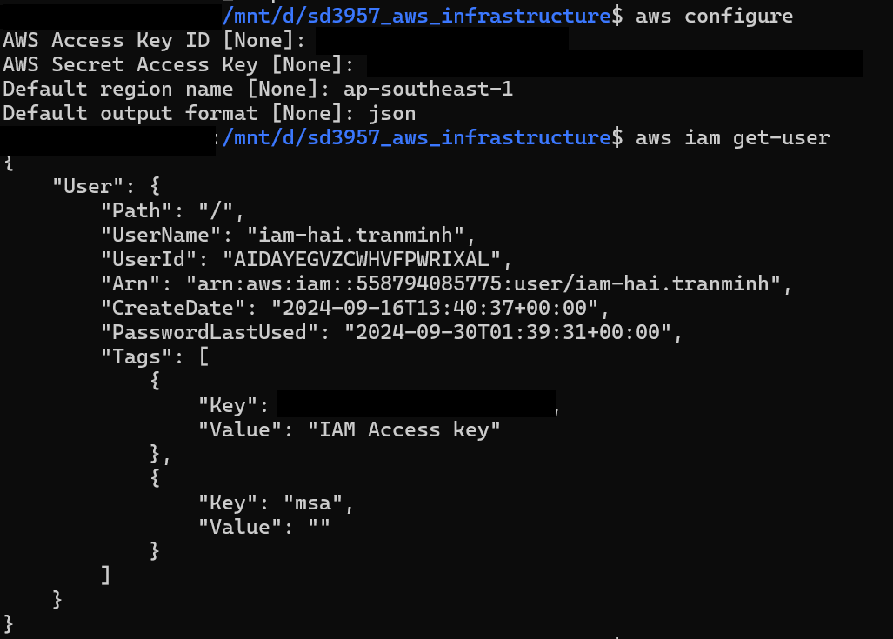

**Initialize Terraform**

|  |
| --- |
| *$ terraform init* |

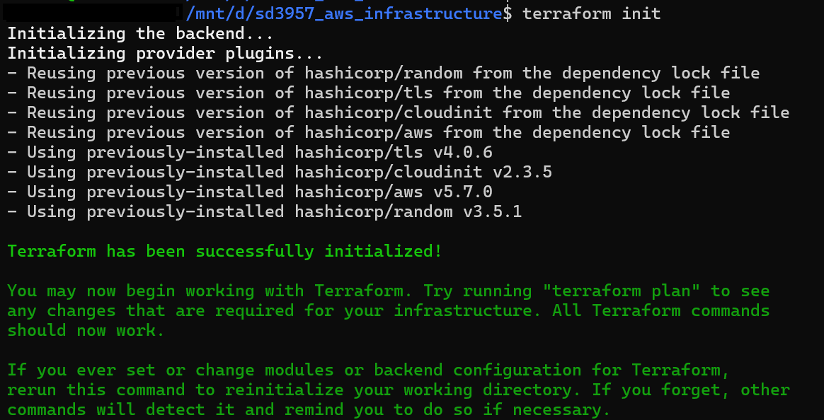

**Validate Terraform manifests**

|  |
| --- |
| *$ terraform validate* |



**Review the Terraform Plan**

|  |
| --- |
| *$ terraform plan* |

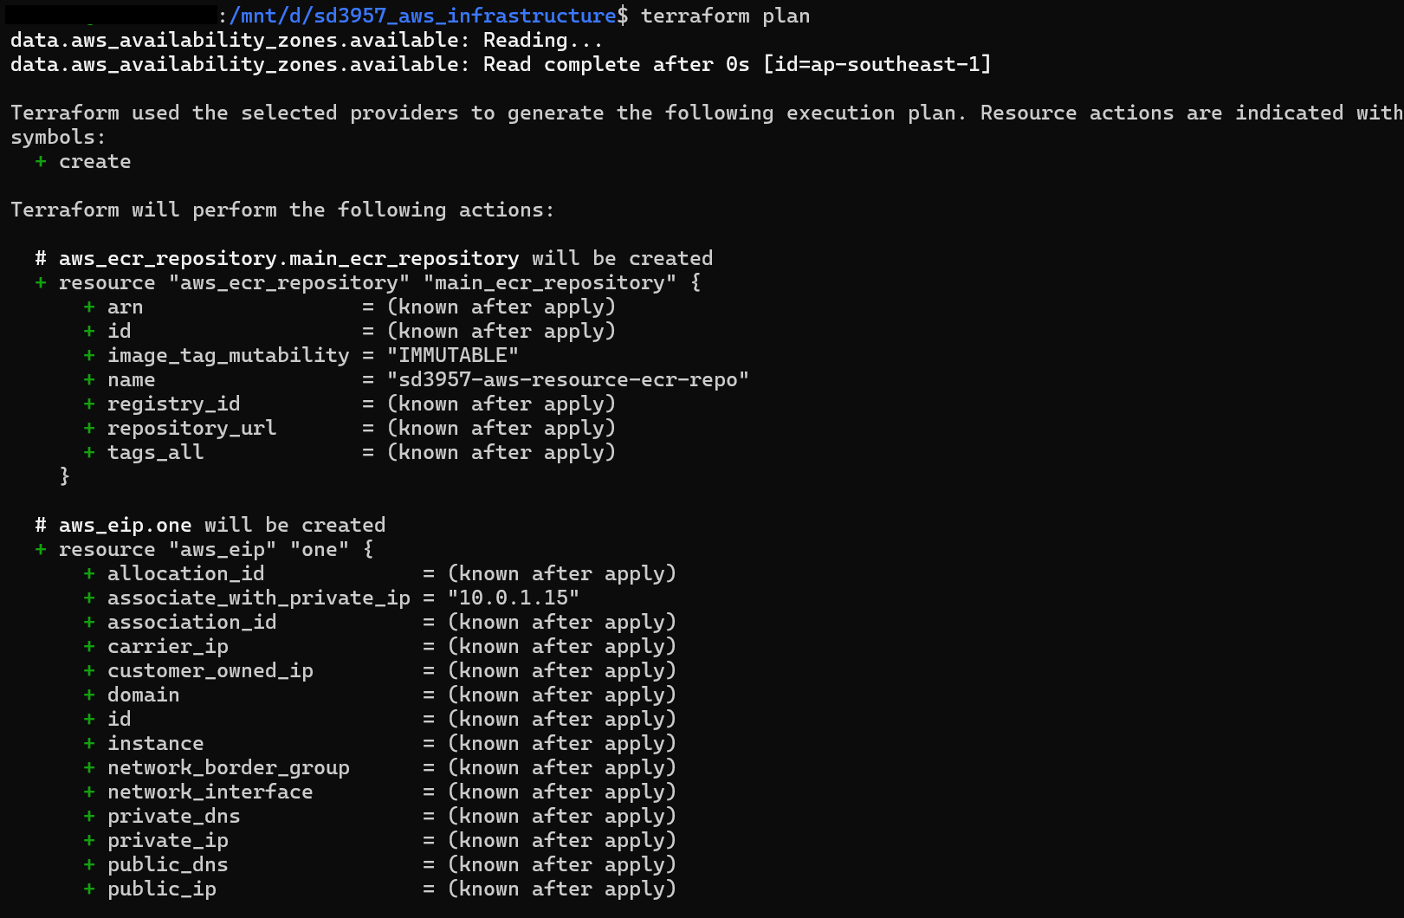

**Apply Terraform configuration to create AWS resources**

|  |
| --- |
| *$ terraform apply* |

**Verify AWS resources are provisioned by Terraform**

**VPC**

**EKS**

**EC2 instances**

# **Install Docker and Jenkins servers on EC2**