Table of Contents

**Overview** 2

**Prerequisites** 2

**The pipeline's high-level structure** 3

**Setting up a CI/CD Pipeline and deploying applications on Azure AKS** 4

# **Overview**

* Provisioning Azure services using Terraform.
* Setting Azure DevOps Pipeline for the CI/CD.
* Set up Prometheus and Grafana to monitor AKS resources and default AKS resource metric.

Git Repositories

* MSA Application:
  + <https://github.com/minhhai8x/sd3957_msa>
* Infrastructure:
  + <https://github.com/minhhai8x/sd3957_azure_infrastructure>

# **Prerequisites**

* Azure CLI installed
* Terraform installed
* Kubectl installed

# **The pipeline's high-level structure**

# **Setting up a CI/CD Pipeline and deploying applications on Azure AKS**

**Configure Azure CLI and login**

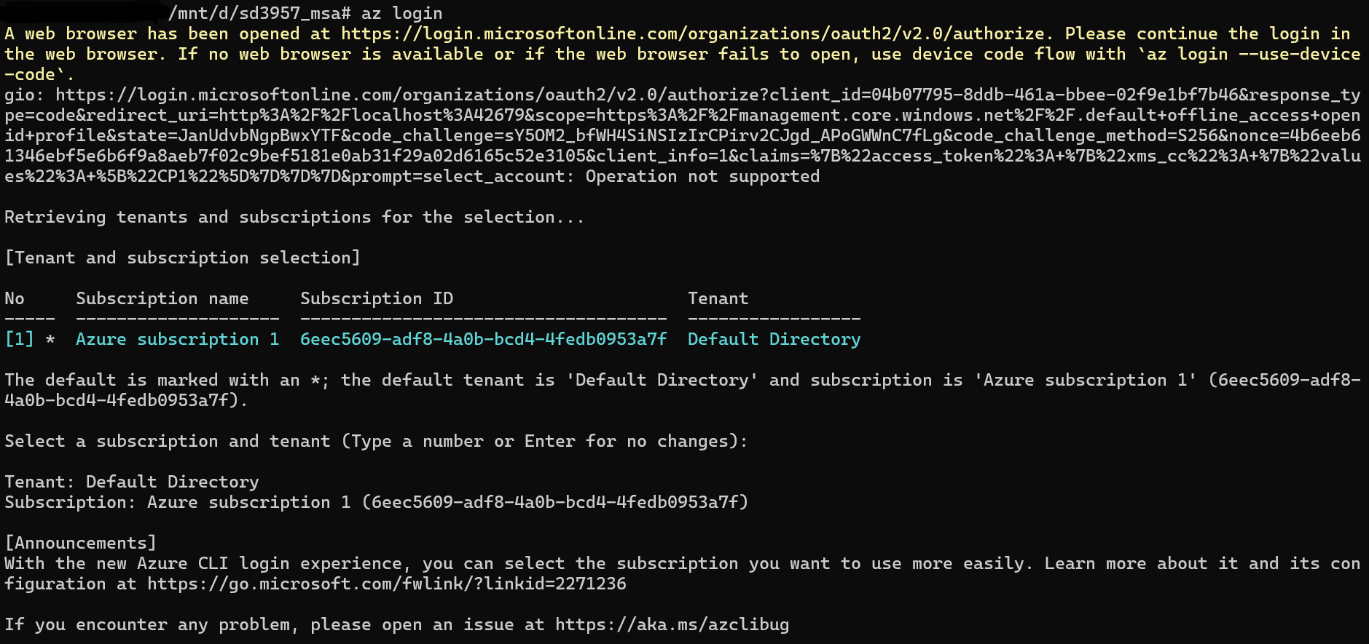

**Push Docker images to Azure container registry**

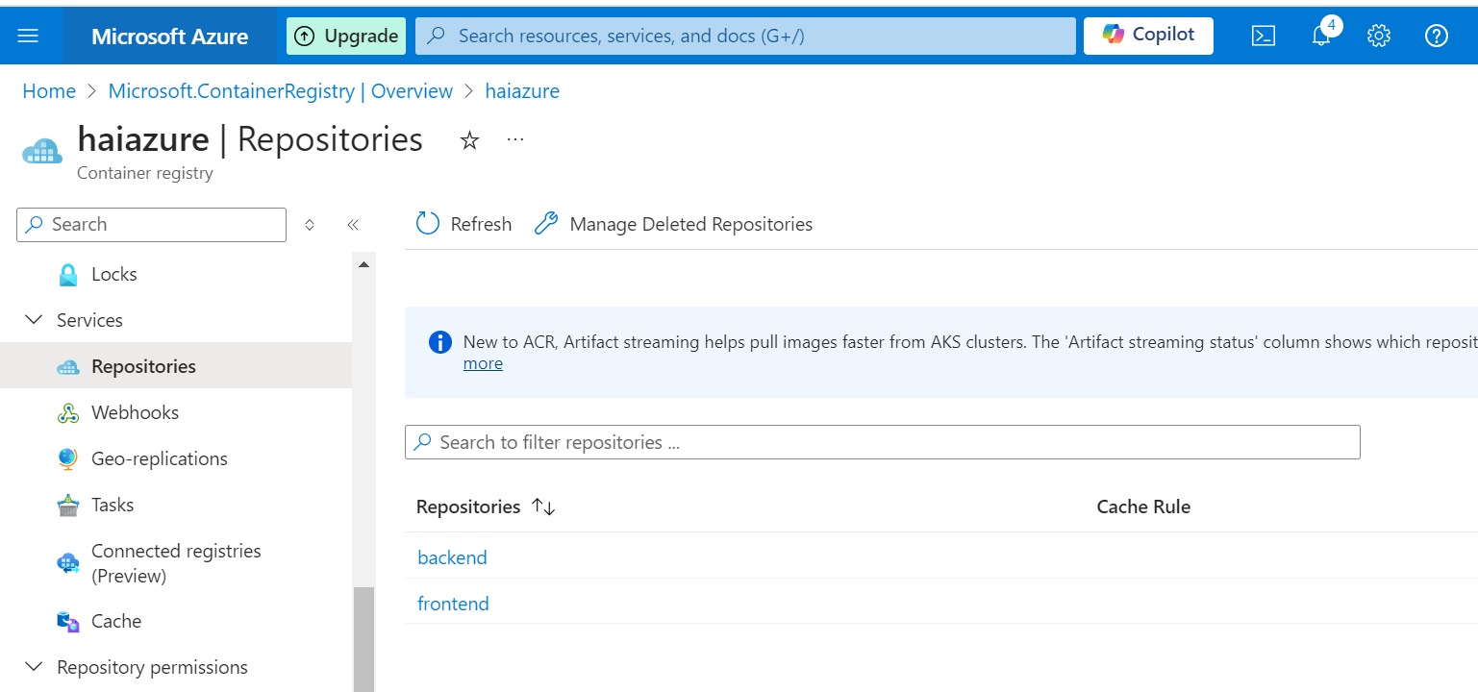

**Initialize Terraform**

|  |
| --- |
| *$ terraform init* |

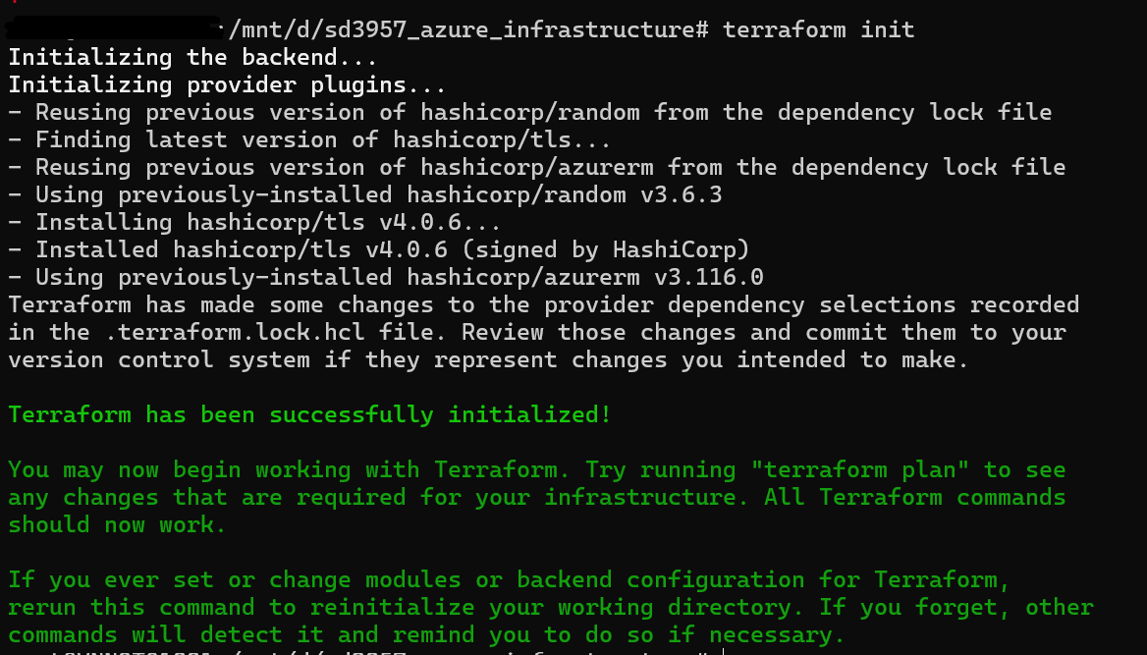

**Validate Terraform manifests**

|  |
| --- |
| *$ terraform validate* |



**Review the Terraform Plan**

|  |
| --- |
| *$ terraform plan* |

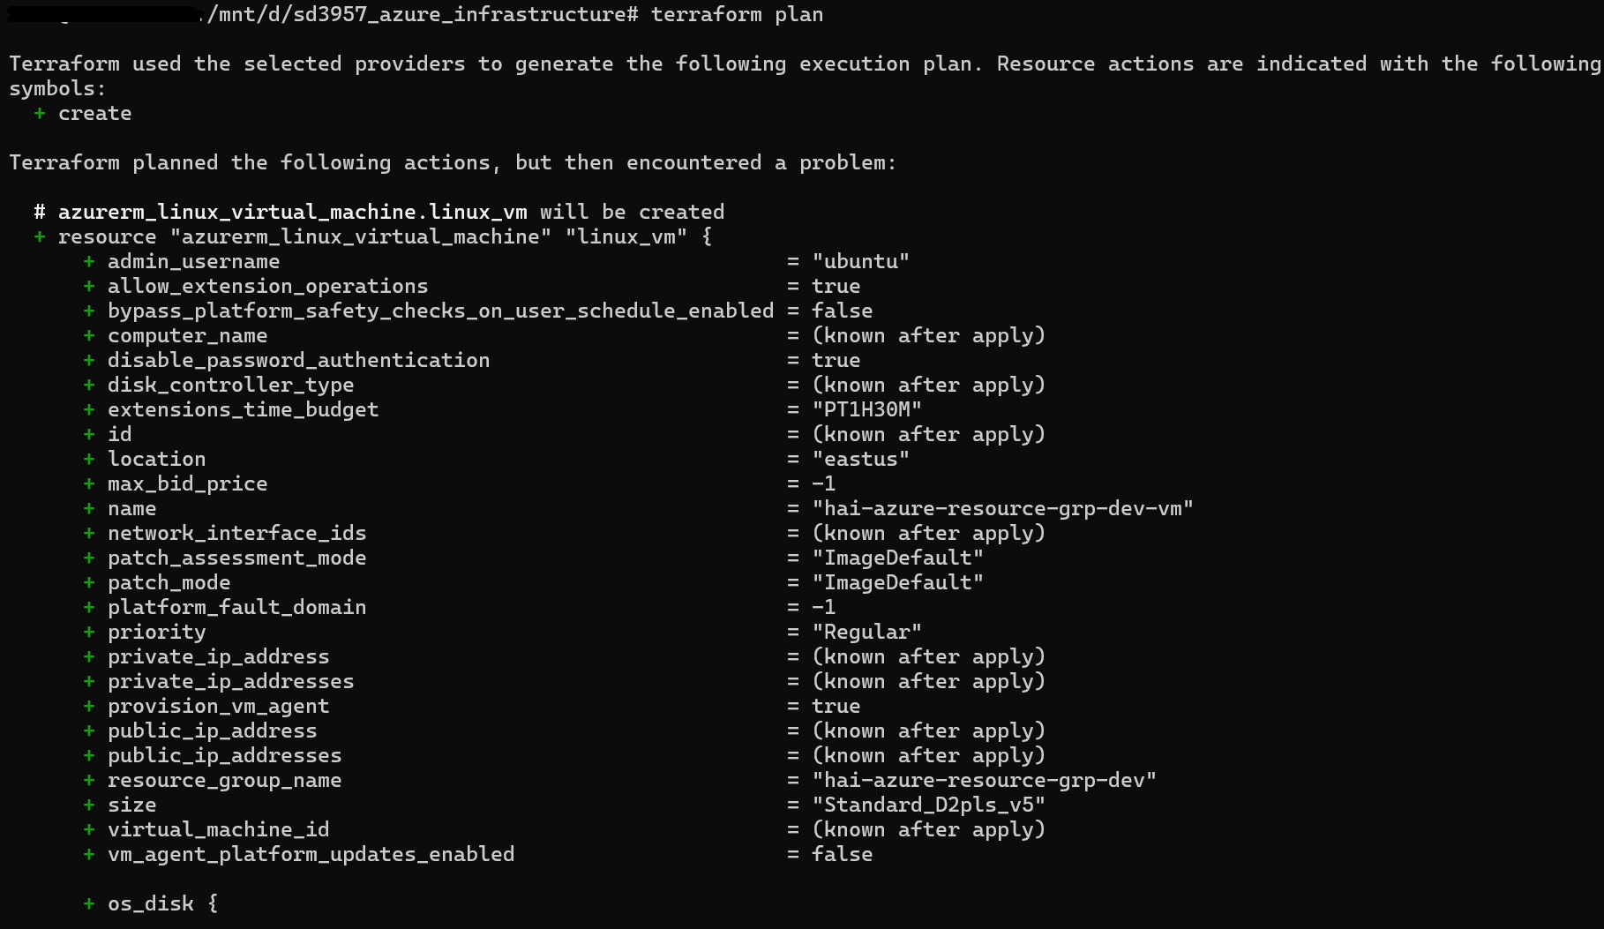

**Deploy Terraform manifests**

|  |
| --- |
| *$ terraform apply* |

**Verify Azure resources are provisioned on Azure Portal**

