National Economics University
Faculty of Mathematical Economics



BACHELOR THESIS
TOPIC: The Causal Effect of Policy Sales Channel Assignment on Customer Response: Evidence from Insurance Cross-Selling

Student : Phùng Minh Hằng
Student’s ID : 11222120
Specialized : Actuarial Science
Supervisor : MSc. Nguyen Quoc Thanh

Hanoi, May 2026

ACKNOWLEDGEMENTS
I would like to express my sincere gratitude to my supervisor, Nguyen Quoc Thanh, for his guidance, constructive feedback, and continued encouragement throughout the preparation of this thesis. His comments on causal identification, counterfactual interpretation, diagnostic checking, and treatment effect heterogeneity helped sharpen both the research design and the interpretation of the results.
I also thank the lecturers of the program for providing the analytical, statistical, and methodological foundation that made this research possible.

EXECUTIVE SUMMARY
This thesis investigates whether policy sales channel assignment affects customer response in an insurance cross-selling setting. Using the Health Insurance Cross Sell dataset, the analysis focuses on two large coded channels, channel 26 and channel 124. Channel 26 is treated as the treatment condition, channel 124 as the control condition, and the outcome of interest is whether the customer responds to the vehicle insurance offer.
The core counterfactual question is straightforward: for a customer in the analysis sample, how would the probability of response change if that customer were assigned to channel 26 rather than channel 124? Framing the problem in this way moves the analysis beyond pure prediction and places it within a causal inference setting. The main estimand is the Average Treatment Effect (ATE). Propensity Score Matching (PSM) is reported as an ATT-oriented supporting comparison, while causal forest is used to study heterogeneous treatment effects and potential targeting value.
The empirical strategy adjusts for observed pre-treatment covariates, including gender, age, region code, previously insured status, vehicle age, vehicle damage, log annual premium, and vintage. The identification logic is summarized by a directed acyclic graph (DAG) and checked formally using dagitty. This check supports the proposed adjustment set under the stated graph, although the study still acknowledges that hidden confounding may remain because the data are observational.
The main AIPW estimate suggests that assignment to channel 26 rather than channel 124 is associated with an increase in response probability of about 2.64 percentage points under the selection-on-observables assumption. IPW and causal forest estimates are directionally consistent with this result. Additional diagnostics, including trimmed AIPW, a negative-control outcome check, an E-value sensitivity analysis, and a permutation-based pipeline sanity check, support the overall stability of the empirical pipeline. Causal forest diagnostics, RATE/Qini results, and targeting analysis further indicate that customers originally assigned to channel 124 can be ranked by their predicted incremental gain from reassignment to channel 26.
Overall, the thesis suggests that policy sales channel assignment may matter for insurance cross-selling performance. At the same time, the results should be interpreted cautiously because the dataset is observational and the possibility of hidden confounding cannot be fully eliminated.

ABBREVIATIONS
Abbreviation | Meaning
AIPW | Augmented Inverse Probability Weighting
ATE | Average Treatment Effect
ATT | Average Treatment Effect on the Treated
CATE | Conditional Average Treatment Effect
CI | Confidence Interval
DAG | Directed Acyclic Graph
HTE | Heterogeneous Treatment Effect
IPW | Inverse Probability Weighting
LPM | Linear Probability Model
PSM | Propensity Score Matching
RATE | Rank Average Treatment Effect
SMD | Standardized Mean Difference
SUTVA | Stable Unit Treatment Value Assumption

Table of Contents
ACKNOWLEDGEMENTS 2
EXECUTIVE SUMMARY 3
ABBREVIATIONS 4
CHAPTER 1. INTRODUCTION 7
1.1. Background of the Study 7
1.2. Research Problem 8
1.3. Research Objectives and Questions 8
1.4. Scope and Contributions 9
1.5. Thesis Structure 10
CHAPTER 2. THEORETICAL BACKGROUND 11
2.1. Insurance Cross-Selling and Sales Channel Effectiveness 11
2.2. Prediction versus Causal Inference 11
2.3. Potential Outcomes and Confounding 12
2.4. Propensity Score, AIPW and Causal Forest 13
2.5. Sensitivity analysis and E-value 14
2.6. Summary 14
CHAPTER 3. DATA AND CAUSAL RESEARCH DESIGN 15
3.1. Data Source and Sample Construction 15
3.2. Variable Definition 19
3.3. Descriptive Statistics and Baseline Differences 21
3.4. Causal Research Design and DAG Check 25
CHAPTER 4. METHODOLOGY 30
4.1. Empirical Strategy and Estimands 30
4.2. Identification Assumptions 31
4.3. Benchmark and Propensity Score Model 33
4.4. Treatment Effect Estimators 34
4.5. Diagnostics and Heterogeneity Methods 36
CHAPTER 5. EMPIRICAL RESULTS AND DISCUSSION 38
5.1. Descriptive Results and Baseline Imbalance 38
5.2. Propensity Score and Overlap Diagnostics 40
5.3. Main Causal Estimates 43
5.4. Robustness and Diagnostic Checks 45
5.5. Causal Forest and Heterogeneity Analysis 48
5.6. Targeting Analysis among Channel 124 Customers 51
5.7. Discussion 54
CHAPTER 6. CONCLUSION 57
6.1. Summary of Main Findings 57
6.2. Managerial Implications 57
6.3. Limitations 58
6.4. Future Research Directions 58
REFERENCES 60
APPENDICES 61
Appendix A. Suggested figures to insert from R 61
Appendix B. Notes on interpretation 61

CHAPTER 1. INTRODUCTION

1.1. Background of the Study
In insurance marketing, cross-selling is an important strategy for increasing customer value and improving campaign efficiency. Rather than focusing only on acquiring new customers, insurers can also offer additional products to customers who already have an existing relationship with the firm. A customer who has previously purchased or considered one insurance product may also have potential demand for a related product, such as vehicle insurance. In this context, customer response to a cross-selling offer becomes a meaningful indicator of campaign performance.
A common way to study cross-selling performance is to build a customer response prediction model. Prediction is useful because it helps firms identify customers who are more likely to respond to an offer. However, prediction alone does not answer a more managerial and intervention-oriented question: would the same customer respond differently if the firm used another sales channel? This distinction matters because some customers may respond regardless of channel, while others may respond only when approached through a more suitable one.
Sales channel allocation is a business decision that can, at least in principle, be changed. Different policy sales channels may differ in communication quality, trust, convenience, product explanation, and persuasive ability. For that reason, a sales channel may be more than a descriptive marker of response; it may also be one factor associated with incremental response. From the firm’s perspective, the relevant question is not only which customers are likely to respond, but also which channel can generate additional response.
This thesis applies a causal inference framework to examine the effect of policy sales channel assignment on customer response in an insurance cross-selling setting. Using the Health Insurance Cross Sell dataset, the analysis focuses on customers assigned to policy sales channel 26 and policy sales channel 124. Channel 26 is treated as the treatment group, while channel 124 serves as the control group. The outcome of interest is whether the customer responds positively to the vehicle insurance offer.
The central counterfactual question is therefore the following: for a customer in the analysis sample, how would the probability of response change if that customer were assigned to channel 26 instead of channel 124? Once stated in this way, the study moves from a purely predictive exercise to a causal one.

1.2. Research Problem
Although customer response prediction is useful, it is not sufficient for evaluating sales channel effectiveness. A predictive model can estimate which customers are more likely to respond, but it cannot determine whether assigning a customer to a particular channel actually changes that probability. This limitation matters when the business objective is to evaluate or improve channel allocation rather than merely to forecast response.
The main challenge is that the dataset used in this thesis is observational. Customers were not randomly assigned to policy sales channels. As a result, customers in channel 26 and channel 124 may differ systematically before response is observed. Variables such as age, region, previous insurance status, vehicle age, vehicle damage, annual premium, and vintage may plausibly influence both channel assignment and customer response.
Because treatment assignment is non-random, the raw difference in response rates between channel 26 and channel 124 cannot be interpreted directly as a causal effect. The observed difference may partly reflect the effect of the channel, but it may also capture differences in customer composition. A simple comparison of response rates is therefore likely to be biased.
The research problem of this thesis is how to estimate the effect of policy sales channel assignment on customer response using observational insurance data while adjusting for observed confounding factors. To address this problem, the study combines benchmark models, propensity score methods, doubly robust estimation, diagnostic checks, and causal forest analysis.
At the same time, the thesis recognizes that the data are not generated by a randomized experiment. The policy sales channel variable is a coded category in a public dataset, and the exact business logic behind channel assignment is unobserved. Accordingly, the findings should be interpreted under the selection-on-observables assumption rather than as evidence equivalent to a randomized controlled trial.

1.3. Research Objectives and Questions
The general objective of this thesis is to estimate the effect of policy sales channel assignment on customer response in a vehicle insurance cross-selling context. More specifically, the study examines whether customers assigned to policy sales channel 26 have a different probability of responding positively than customers assigned to policy sales channel 124 after adjustment for observed pre-treatment customer characteristics.
The specific objectives are:
- To define the treatment, outcome, analysis sample, and adjustment variables clearly and consistently.
- To examine baseline differences and overlap between customers assigned to channel 26 and channel 124.
- To estimate the average treatment effect using IPW and AIPW, with AIPW treated as the main estimator.
- To use PSM as a supporting ATT-oriented comparison.
- To evaluate robustness through common-support trimming, a negative-control outcome diagnostic, an E-value sensitivity analysis, and a permutation-based pipeline sanity check.
- To explore heterogeneous treatment effects using causal forest.
- To assess whether customers originally assigned to channel 124 can be ranked by predicted incremental gain under reassignment to channel 26.
This thesis addresses three research questions.
First, what is the estimated average effect of assignment to policy sales channel 26 rather than channel 124 on customer response after adjusting for observed pre-treatment customer characteristics? The main estimand is the Average Treatment Effect:
$$ATE=E\left[Y_{i}\left(1\right)-Y_{i}\left(0\right)\right]$$
Second, are the estimated effects consistent across different causal inference methods and diagnostic checks?
Third, does the effect of policy sales channel assignment vary across customer segments, and which customers originally assigned to channel 124 are predicted to gain the most from reassignment to channel 26?

1.4. Scope and Contributions
This thesis uses the Health Insurance Cross Sell dataset, in which each observation represents one customer. The analysis focuses only on customers assigned to policy sales channel 26 and policy sales channel 124. Restricting the sample in this way allows the study to define a clear binary treatment variable and to apply standard causal inference methods in a transparent setting.
The treatment is assignment to channel 26, while the control condition is assignment to channel 124. The outcome is customer response, coded as 1 if the customer responds positively and 0 otherwise. The analysis adjusts for observed pre-treatment covariates, including gender, age, region code, previously insured status, vehicle age, vehicle damage, log annual premium, and vintage.
The thesis contributes in three ways. First, it applies causal inference to the problem of insurance cross-selling and shifts the focus from pure prediction to intervention-oriented evaluation. Second, it combines multiple causal tools, including DAG-based adjustment, propensity score methods, AIPW, E-value sensitivity analysis, a negative-control diagnostic, and causal forest. Third, it extends the analysis from average treatment effects to heterogeneous treatment effects and targeting analysis among customers originally assigned to channel 124.

1.5. Thesis Structure
The thesis is organized as follows.
Chapter 2 reviews the theoretical background for insurance cross-selling, causal inference, propensity score methods, AIPW, and causal forest.
Chapter 3 presents the data and causal research design, including the dataset, treatment definition, analysis sample, pre-treatment covariates, DAG check, and identification logic.
Chapter 4 sets out the methodology and formal estimators.
Chapter 5 reports the empirical results and discusses their substantive implications. Chapter 6 concludes the thesis by summarizing the main findings, managerial implications, limitations, and directions for future research.

CHAPTER 2. THEORETICAL BACKGROUND

2.1. Insurance Cross-Selling and Sales Channel Effectiveness
Cross-selling refers to the practice of offering additional products or services to existing customers. In insurance and other financial services, cross-selling is important because firms already possess some information about their customers, such as demographic characteristics, product ownership, and previous interactions. Compared with acquiring new customers, cross-selling can be more efficient because the firm does not need to build the customer relationship from the beginning.
In insurance, customers often have multiple protection needs. A customer who already holds one insurance product may also be interested in another product if the offer is relevant to that customer’s risk profile, vehicle ownership, financial situation, or personal characteristics. Customer response to a cross-selling offer is therefore an important outcome for evaluating marketing effectiveness.
Sales channels are central to insurance distribution because they determine how products are introduced, explained, and delivered to customers. In practice, insurance products may be distributed through agents, brokers, direct channels, digital platforms, bancassurance arrangements, or other internal sales channels. Each channel may differ in customer access, communication quality, trust, cost, and persuasive capacity.
A sales channel may affect customer response through several mechanisms. Different channels may provide different levels of product explanation, generate different degrees of trust, and impose different levels of convenience or transaction cost. Some channels may also be better suited to particular customer segments.
Evaluating sales channel effectiveness with observational data is therefore difficult. Customers are rarely assigned to channels at random, and firms may allocate them according to customer profile, region, campaign rules, agent availability, or predicted sales potential. If these factors also affect response, then a simple comparison of response rates across channels will be confounded.

2.2. Prediction versus Causal Inference
Prediction and causal inference answer different kinds of questions. Prediction asks what is likely to happen. In customer response modelling, the predictive question is which customers are more likely to respond to an insurance offer. The main objective of predictive modelling is accuracy rather than intervention-oriented interpretation.
Causal inference asks what would happen if an intervention were changed. In this thesis, the causal question is how a customer’s probability of response would change if that customer were assigned to channel 26 instead of channel 124. This is a counterfactual question because it compares two potential treatment states for the same customer.
The associational comparison can be written as:
$$P\left(Y_{i}=1∣T_{i}=1\right)-P\left(Y_{i}=1∣T_{i}=0\right)$$
The causal comparison can be written as:
$$P\left(Y_{i}=1∣do\left(T_{i}=1\right)\right)-P\left(Y_{i}=1∣do\left(T_{i}=0\right)\right)$$
The first quantity compares observed outcomes across customers in different channels. The second represents an intervention that changes channel assignment. In observational data, these two quantities need not coincide because treatment assignment may be confounded.
This distinction is central to the thesis. A higher response rate in channel 26 does not by itself imply that channel 26 causes higher response. The observed difference may reflect underlying customer characteristics. For that reason, the thesis uses causal inference methods to adjust for observed pre-treatment covariates and to estimate treatment effects under explicit assumptions.

2.3. Potential Outcomes and Confounding
The potential outcomes framework provides a formal language for defining causal effects. For each customer i, there are two potential outcomes:$Y_{i}\left(1\right)$, the response that would be observed if the customer were assigned to channel 26, and $Y_{i}\left(0\right)$, the response that would be observed if the same customer were assigned to channel 124.
The individual treatment effect is:
$$τ_{i}=Y_{i}\left(1\right)-Y_{i}\left(0\right)$$
However, the individual treatment effect cannot be observed directly because each customer is seen under only one treatment condition. This is the fundamental problem of causal inference. For this reason, the thesis focuses on average and conditional treatment effects.
The Average Treatment Effect is:
$$ATE=E\left[Y_{i}\left(1\right)-Y_{i}\left(0\right)\right]$$
The Average Treatment Effect on the Treated is:
$$ATT=E\left[Y_{i}\left(1\right)-Y_{i}\left(0\right)∣T_{i}=1\right]$$
The Conditional Average Treatment Effect is:
$$CATE\left(X_{i}\right)=E\left[Y_{i}\left(1\right)-Y_{i}\left(0\right)∣X_{i}\right]$$
In this thesis, ATE is the main estimand, ATT is used for PSM as a supporting estimate, and CATE is used for heterogeneity and targeting analysis.
Confounding arises when a variable affects both treatment assignment and the outcome. In the present study, characteristics such as age, region, previous insurance status, vehicle age, vehicle damage, annual premium, and vintage may influence both policy sales channel assignment and customer response. These variables can therefore open back-door paths between treatment and outcome.
A simplified confounding structure can be written as:
$$X_{i}→T_{i}, X_{i}→Y_{i}$$
DAGs are useful because they make causal assumptions explicit. In this thesis, the DAG is used as a formal identification device and checked through the back-door criterion. Nevertheless, DAG-based checking does not prove that the specified DAG is the true data-generating process.

2.4. Propensity Score, AIPW and Causal Forest
Propensity score methods are widely used in observational studies to adjust for observed differences between treatment and control groups. The propensity score is the probability of receiving treatment conditional on observed covariates.
The propensity score is defined as:
$$e\left(X_{i}\right)=P\left(T_{i}=1∣X_{i}\right)$$
In this thesis, e(X_i) is the probability that customer i is assigned to channel 26 given observed customer characteristics. Propensity scores are used for matching, weighting, and overlap diagnostics. PSM matches treated customers to similar control customers, while IPW uses propensity-score-based weights to construct a more balanced pseudo-population.
Average treatment effects summarize the overall effect of treatment, but they can conceal important differences across customer segments. For that reason, this thesis also studies heterogeneous treatment effects using causal forest, which estimates how the effect of channel 26 relative to channel 124 varies with customer characteristics.

2.5. Sensitivity analysis and E-value
In observational causal inference, even after adjustment for observed covariates, hidden confounding may still remain. For this reason, a sensitivity analysis is needed to assess how strong an unobserved confounder would have to be in order to explain away the estimated treatment effect. One widely used measure is the E-value.
The E-value is defined as the minimum strength of association that an unobserved confounder would need to have with both treatment and outcome, conditional on the observed covariates, to fully account for the estimated causal effect. A larger E-value indicates that the empirical finding is more robust to hidden confounding, while a smaller E-value suggests that the result may be more sensitive to omitted-variable bias.
In this thesis, the E-value is used as a supporting sensitivity metric for the main AIPW result. It does not prove that hidden confounding is absent, but it provides an interpretable summary of how much unobserved bias would be required to move the estimated effect to the null.

2.6. Summary
This chapter has reviewed the theoretical background for the empirical analysis. Insurance cross-selling was introduced as a marketing problem in which customer response is a key outcome. The discussion then distinguished predictive modelling from causal inference: prediction asks which customers are likely to respond, whereas causal inference asks whether changing the sales channel would change response probability.
The potential outcomes framework defines the causal estimands used in the thesis, especially ATE, ATT, and CATE. DAGs are used to make identification assumptions explicit and to justify the observed adjustment set. Propensity score methods, doubly robust estimation, and causal forest provide the methodological foundation for estimating average and heterogeneous treatment effects. The next chapter presents the data and the causal research design in detail.

CHAPTER 3. DATA AND CAUSAL RESEARCH DESIGN

3.1. Data Source and Sample Construction

3.1.1. Dataset overview
This thesis uses the Health Insurance Cross Sell Prediction dataset from Kaggle. The dataset contains customer-level information related to a vehicle insurance cross-selling campaign. Each observation represents one customer, and the main outcome is whether the customer responded positively to a vehicle insurance offer.
The original dataset contains 381,109 observations and 12 variables. These variables include customer demographic characteristics, insurance history, vehicle-related information, annual premium, policy sales channel, customer vintage, and response outcome. The response variable is binary, where 1 indicates that the customer responded positively and 0 indicates no response.
The dataset is suitable for this thesis because it contains both a response outcome and a policy sales channel variable. However, because the dataset is observational, policy sales channel assignment should not be interpreted as randomized assignment. In the full dataset, the overall response rate is approximately 12.26%. No missing values are detected in the main variables used in the analysis.
Table 3.1. Original dataset overview
Item | Value
Number of observations | 381,109
Number of variables | 12
Missing values in main variables | 0
Response cases | 46,710
Non-response cases | 334,399
Overall response rate | 12.26%
Source: Calculation from the Health Insurance Cross Sell dataset.
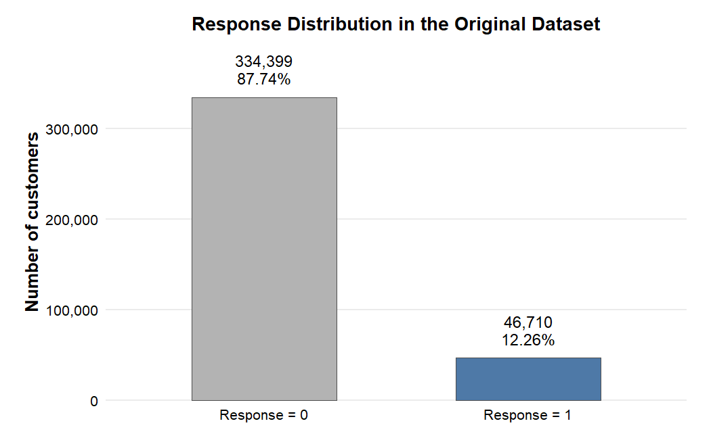Figure 3.1. Response distribution in the original dataset
Source: Calculation from the original dataset.
This figure shows the imbalance of the response outcome in the original dataset. The dominance of non-response cases motivates careful interpretation of customer response and provides initial context for the empirical analysis.
The variable Policy_Sales_Channel contains multiple coded channel categories. Since the dataset does not provide detailed business descriptions of each channel code, this thesis does not assign specific business names to the channels. Instead, channel 26 and channel 124 are treated as two observed policy sales channel categories in the public dataset.

3.1.2. Treatment selection
The original dataset includes many policy sales channels. If all channels were used as a multi-treatment setting, the research design would become more complex and difficult to interpret within the scope of this thesis. Therefore, the study simplifies the setting into a binary treatment comparison.
This thesis focuses on policy sales channel 26 and policy sales channel 124. These two channels are selected because both have large sample sizes, relatively balanced group sizes, and sufficiently comparable response rates. This makes the comparison suitable for estimating the effect of one channel relative to another.
Customers assigned to channel 26 are defined as the treated group. Customers assigned to channel 124 are defined as the control group. This design allows the study to estimate the effect of being assigned to channel 26 rather than channel 124.
The choice of a two-channel design is also motivated by interpretability. In a multi-channel setting, each channel would represent a separate treatment condition, and the estimand would no longer be a simple comparison between two potential outcomes. Such a design may require multinomial treatment models, generalized propensity scores, or pairwise causal comparisons. These approaches are useful but would make the thesis less focused. By concentrating on channel 26 and channel 124, the study can formulate a clear counterfactual question and apply well-established binary treatment effect estimators.
Another reason for using a restricted sample is comparability. Some sales channels in the original dataset may serve very different customer groups. Comparing channels with extremely different baseline profiles may increase the risk of weak overlap and severe confounding. The selected pair preserves a large sample size while keeping the empirical design manageable. This does not mean that channel 26 and channel 124 are identical at baseline. Instead, it means that the comparison is sufficiently supported by the data to proceed with overlap diagnostics, matching, weighting, and doubly robust estimation.
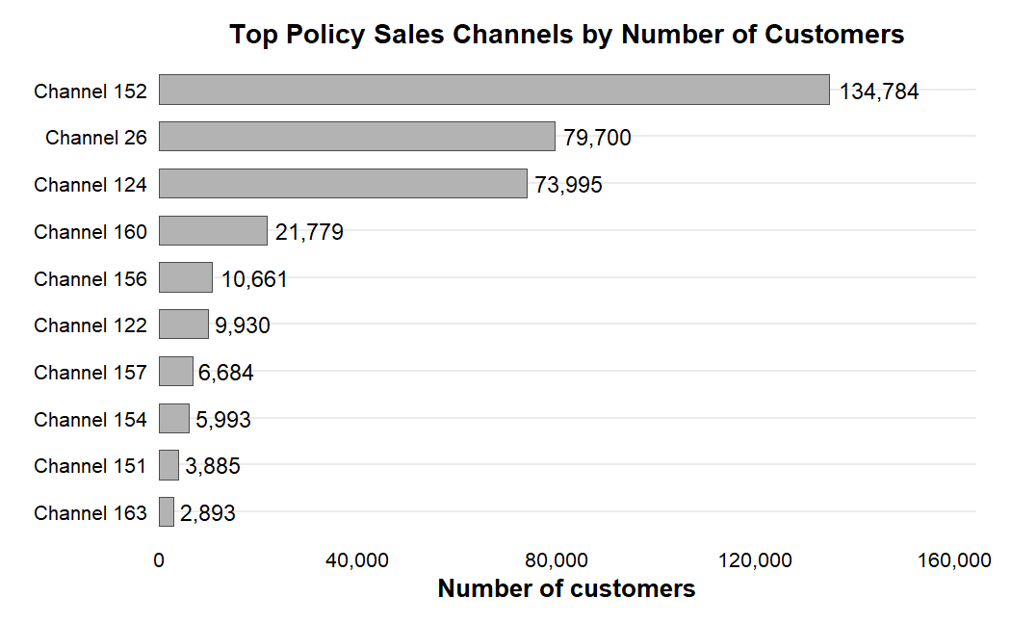Figure 3.2. Top policy sales channels by number of customers
Source: Calculation from the original dataset.
This figure justifies the focus on channel 26 and channel 124. Showing the largest channel groups helps demonstrate that the selected comparison has sufficient sample size for causal estimation.
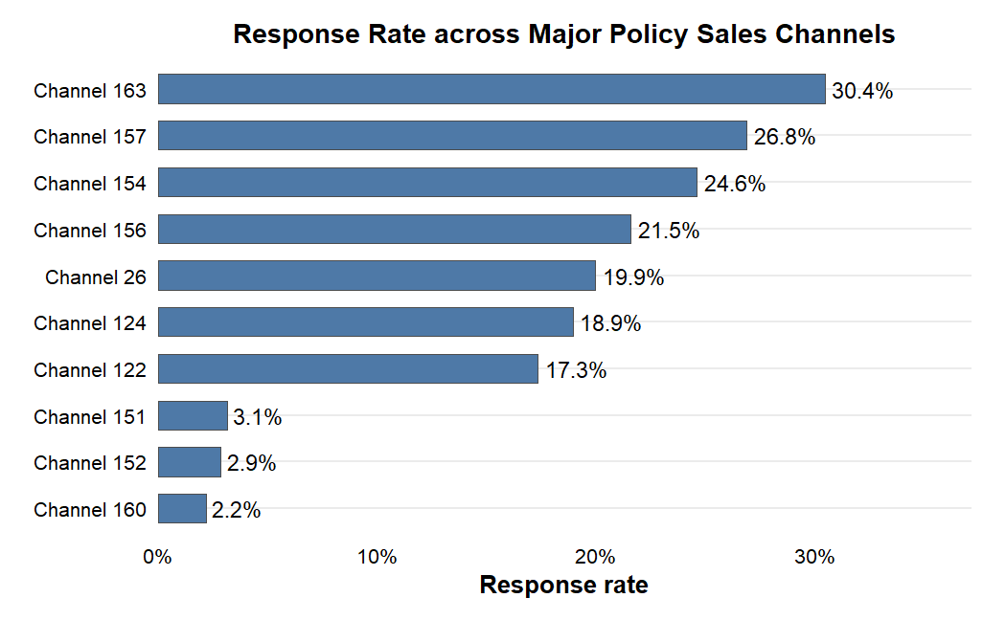
Figure 3.3. Response rate across major policy sales channels
Source: Calculation from the original dataset.
Differences in response rates across channels suggest that sales channel assignment is related to customer response, but they do not establish a causal effect because customers are not randomly assigned to channels.

3.1.3. Final analysis sample
After restricting the dataset to customers assigned to channel 26 and channel 124, the final analysis sample contains 153,695 observations. Among them, 79,700 customers are assigned to channel 26 and 73,995 customers are assigned to channel 124.
Table 3.2. Analysis sample construction
Step | Description | Observations
Original dataset | All customers | 381,109
Channel filtering | Keep only channel 26 and channel 124 | 153,695
Treatment group | Channel 26 | 79,700
Control group | Channel 124 | 73,995
Source: Calculation from the dataset.
The final sample remains large enough for matching, weighting, doubly robust estimation, and causal forest analysis. More importantly, it allows the research question to be expressed as a clear counterfactual comparison between two channel assignments.
It is also important to separate the analysis sample from the full dataset. The full dataset is useful for understanding the overall cross-selling context, but the causal estimand in this thesis is defined only for the restricted sample containing channel 26 and channel 124. Therefore, all treatment effect estimates should be interpreted for this analysis sample rather than for all possible policy sales channels in the original dataset. This prevents overgeneralization and keeps the interpretation aligned with the empirical design.

3.2. Variable Definition

3.2.1. Outcome and treatment variables
The outcome variable is customer response to the vehicle insurance offer. It is coded as 1 if the customer responds positively and 0 otherwise. The outcome variable is binary:
$$Y_{i}∈\{0,1\}$$
where $Y_{i}=1$ represents a positive customer response and $Y_{i}=0$represents no response.
The treatment variable is constructed from Policy_Sales_Channel. Customers assigned to channel 26 are coded as treated customers, while customers assigned to channel 124 are coded as control customers. The treatment variable is defined as:
$$T_{i}=\left\{\begin{matrix}1, & \text{if customer }i\text{ is assigned to channel 26} \\ 0, & \text{if customer }i\text{ is assigned to channel 124}\end{matrix}\right.$$
Thus, the main comparison is between channel 26 and channel 124.

3.2.2. Pre-treatment covariates
The observed covariates used for adjustment are gender, age, region_code, previously_insured, vehicle_age, vehicle_damage, log_annual_premium, and vintage. These variables are treated as observed pre-treatment covariates. They are customer-level characteristics that plausibly exist before the response outcome is observed and may affect both channel assignment and customer response.
For example, age, region, previous insurance status, vehicle characteristics, and premium level may influence both how customers are assigned to sales channels and how likely they are to respond. Because the dataset does not provide a detailed timestamp for each step of channel allocation, the pre-treatment interpretation is based on the business meaning of the variables and the dataset description.
The original variable annual_premium is highly right-skewed. Therefore, it is transformed into log_annual_premium. The log transformation is defined as:
$$log_annual_premium_{i}=log\left(1+annual_premium_{i}\right)$$
This transformation reduces the influence of extreme values and improves the stability of regression-based models.
The interpretation of annual premium also requires caution. Premium may reflect vehicle characteristics, customer risk profile, or internal pricing rules. In a predictive model, the raw premium value could be used directly if it improves accuracy. In a causal adjustment model, however, extreme values may create instability in regression and propensity score estimation. The log transformation therefore serves a practical modeling purpose: it preserves the ranking information in premium while reducing the influence of very large observations.
The pre-treatment status of the adjustment variables is important for the validity of the causal design. Variables that occur after treatment assignment should not be included in the adjustment set because they may mediate the treatment effect or introduce post-treatment bias. In this study, the selected variables are interpreted as customer characteristics available before the response outcome is observed. They describe who the customer is, what insurance and vehicle characteristics the customer has, and how long the customer has been associated with the company. This is why they are treated as plausible pre-treatment covariates.
The variable driving_license is not included in the core adjustment set because it is nearly constant in the selected analysis sample and provides little discriminatory information. Including variables with almost no variation may add complexity without improving adjustment quality. The final adjustment set therefore focuses on covariates that are both theoretically meaningful and empirically informative.
Table 3.3. Variable description and role
Variable | Description | Role
response | Customer response to the vehicle insurance offer | Outcome
policy_sales_channel | Coded policy sales channel | Treatment source
treat_num | 1 for channel 26, 0 for channel 124 | Treatment
gender | Customer gender | Pre-treatment covariate
age | Customer age | Pre-treatment covariate
region_code | Customer region code | Pre-treatment covariate
previously_insured | Whether the customer was previously insured | Pre-treatment covariate
vehicle_age | Age category of the vehicle | Pre-treatment covariate
vehicle_damage | Whether the vehicle had prior damage | Pre-treatment covariate
annual_premium | Original annual premium | Original financial variable
log_annual_premium | Log-transformed annual premium | Pre-treatment covariate
vintage | Number of days associated with the company | Pre-treatment covariate
Source: Synthesis from the dataset.

3.3. Descriptive Statistics and Baseline Differences

3.3.1. Descriptive statistics
The final analysis sample has an overall response rate of approximately 19.45%, which is higher than the response rate in the full dataset. This is because the analysis sample focuses only on channel 26 and channel 124, which are relatively active channels.
The average age in the analysis sample is approximately 48.9 years. The annual premium variable is strongly right-skewed, which supports the use of the log-transformed premium variable. The variable vintage is relatively widely distributed, showing variation in customer relationship length.
Table 3.4. Descriptive statistics of the analysis sample
Variable | Value
Number of observations | 153,695
Overall response rate | 19.45%
Mean age | 48.9
Mean vintage | 154.2
Male proportion | 63.14%
Previously insured proportion | 29.46%
Vehicle damage = Yes | 67.64%
Source: Calculation from the analysis sample.
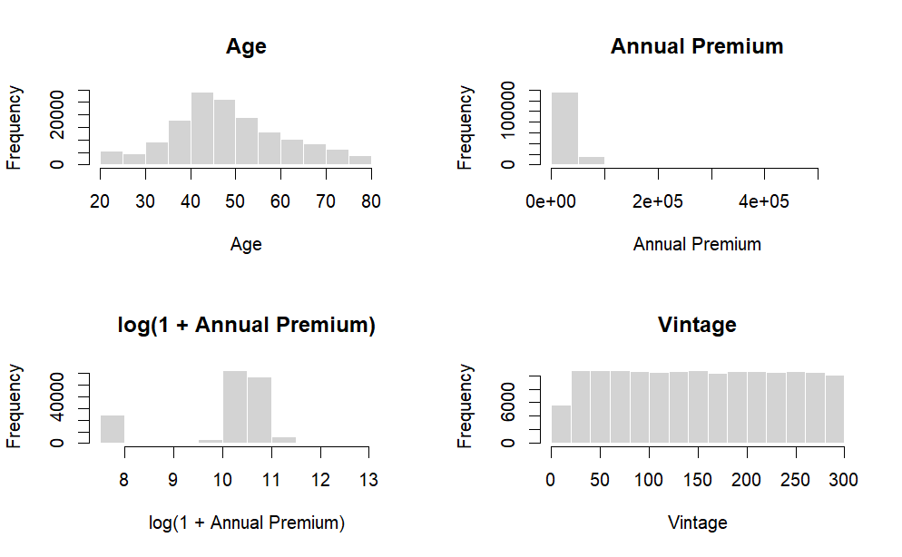Figure 3.4. Distribution of key numerical variables in the analysis sample
Source: Calculation from the analysis sample.
This figure shows the distributions of age, annual premium, log annual premium, and vintage. It is used to summarize important numerical covariates and to justify the log transformation for annual premium.
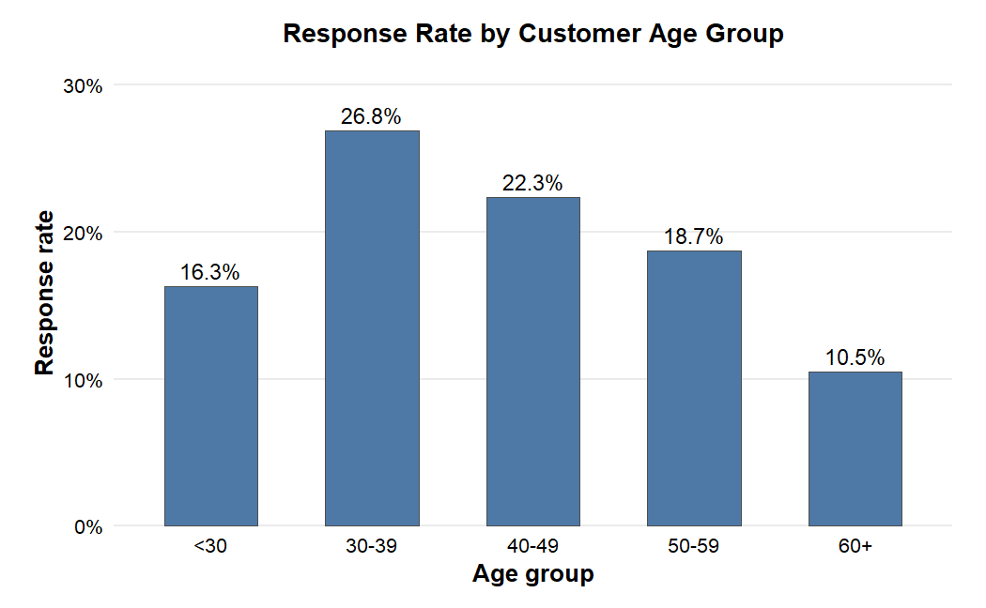Figure 3.5. Response rate by customer age group
Source: Calculation from the analysis sample.
This figure shows that customer response varies across age groups. This supports the inclusion of age as a pre-treatment covariate in the adjustment set.
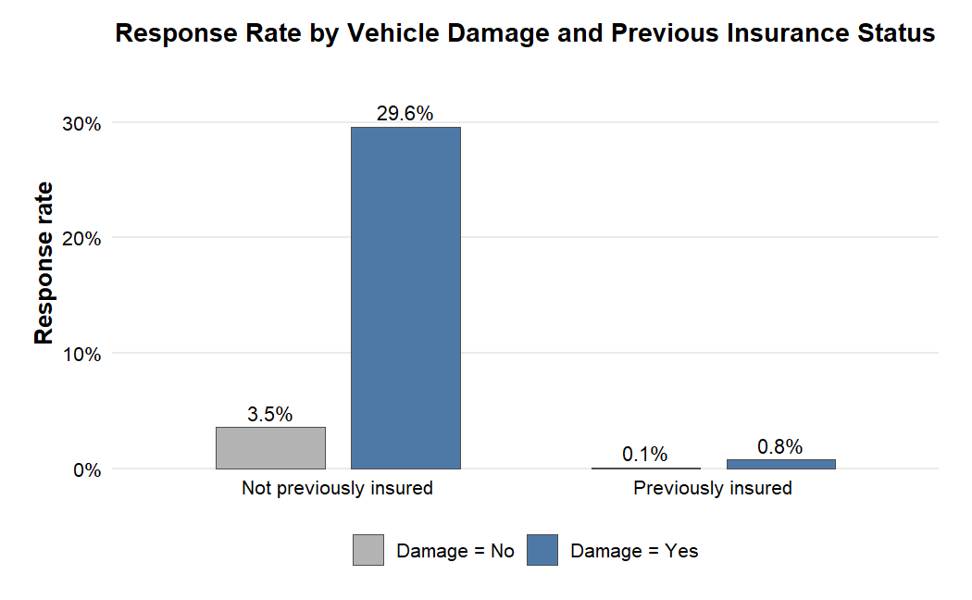Figure 3.6. Response rate by vehicle damage and previous insurance status
Source: Calculation from the analysis sample.
This figure illustrates how response patterns differ by vehicle damage and previous insurance status. These differences provide descriptive support for including these variables in the treatment assignment and outcome models.

3.3.2. Response rate by treatment group
In the analysis sample, channel 26 has a response rate of approximately 19.94%, while channel 124 has a response rate of approximately 18.91%. The raw difference is therefore about 1.02 percentage points in favor of channel 26.
The raw response rate difference is:
$$Δ_{raw}=μ_{Y,1}-μ_{Y,0}$$
where $Y,1$ is the average response rate in the treatment group and $Y,0$is the average response rate in the control group. However, this raw difference is descriptive only. It should not be interpreted as a causal effect because customers in the two channel groups may differ in their characteristics.
The raw difference can be useful as a starting point because it shows what a naive comparison would suggest. Nevertheless, it should be separated clearly from the causal estimand. If the treatment and control groups differ systematically in age, region, vehicle characteristics or insurance history, the raw difference combines both channel-related differences and customer composition differences. This is why the empirical analysis proceeds from descriptive comparison to covariate balance assessment and then to adjusted causal estimators.
Table 3.5. Response rate by treatment group
Group | Sample size | Number of responses | Response rate
Channel 124 | 73,995 | 13,996 | 18.91%
Channel 26 | 79,700 | 15,891 | 19.94%
Source: Calculation from the analysis sample.

3.3.3. Baseline imbalance
Before estimating treatment effects, it is necessary to examine whether the treatment and control groups are comparable. Since policy sales channel assignment is not randomized, customers in channel 26 and channel 124 may differ before adjustment. Baseline imbalance is assessed using standardized mean differences.
The standardized mean difference is defined as:
$$SMD=\frac{μ_{X,1}-μ_{X,0}}{s_{pooled}}$$
where X,1 is the mean of covariate (X) in the treatment group, X,0 is the meanof covariate (X) in the control group, and $s_{pooled}$ is the pooled standard deviation. In practice, an absolute SMD below 0.1 is often interpreted as a low level of imbalance, while larger values indicate stronger baseline differences.
In this study, the largest imbalance appears in age, region code, and vehicle age. This confirms that adjustment is necessary before interpreting the difference in response rates as a causal effect.
Table 3.6. Baseline characteristics by treatment group
Variable | Channel 124 | Channel 26
Sample size | 73,995 | 79,700
Response rate | 18.91% | 19.94%
Mean age | 46.9 | 50.7
Mean annual premium | 31,710 | 33,654
Mean vintage | 154.0 | 154.0
Female proportion | 35.29% | 38.31%
Previously insured proportion | 28.50% | 30.34%
Vehicle damage = Yes | 67.90% | 67.39%
Vehicle age < 1 year | 4.91% | 6.17%
Vehicle age 1-2 years | 89.36% | 85.00%
Vehicle age > 2 years | 5.73% | 8.83%
Source: Calculation from the analysis sample.

3.4. Causal Research Design and DAG Check

3.4.1. The Role of Directed Acyclic Graphs
A directed acyclic graph is used to make the identification logic explicit. Following Pearl’s causal inference framework, the DAG specifies the assumed relationships among observed covariates, policy sales channel assignment, and customer response. In this thesis, policy sales channel assignment is the treatment, customer response is the outcome, and observed customer characteristics are treated as pre-treatment covariates.
The purpose of using a DAG is not only to visualize the research design, but also to clarify which variables should be adjusted for. A DAG helps avoid common adjustment mistakes, such as controlling for post-treatment variables or colliders, which may open non-causal paths and introduce spurious associations.
To make the identification strategy transparent, the causal design is divided into two layers. The first layer is the Observable DAG, which includes only variables observed in the dataset and is used for formal adjustment-set checking. The second layer is the Conceptual DAG, which introduces a latent unobserved factor U to acknowledge the possible limitation of hidden confounding. This two-layer presentation allows the thesis to formally check the adjustment strategy while still recognizing the limitations of observational data.

3.4.2. Observable DAG and Back-door Criterion Check
Under the selection-on-observables framework, the Observable DAG includes the treatment, the outcome, and the observed pre-treatment covariates available in the dataset. The treatment is assignment to policy sales channel 26 rather than channel 124, and the outcome is customer response.
The adjustment set is defined as:
$$X_{i}=\{G_{i},A_{i},R_{i},PI_{i},VA_{i},VD_{i},LP_{i},V_{i}\}$$
where $G_{i}$is gender, $A_{i}$ is age, $R_{i}$ is region code, $PI_{i}$ is previously insured status, $VA_{i}$ is vehicle age, $VD_{i}$ is vehicle damage, $LP_{i}$ is log annual premium, and $V_{i}$ is vintage.
This adjustment set is used consistently in benchmark models, propensity score estimation, PSM, IPW, AIPW, and causal forest. The purpose is to adjust for observed differences between customers assigned to channel 26 and channel 124.
The Observable DAG is formally checked using dagitty. The purpose of this check is to evaluate whether the selected pre-treatment covariates block all observed back-door paths between policy sales channel assignment and customer response. Specifically, the back-door criterion is applied to the observed-variable structure, not to the conceptual graph that includes latent confounding.
The dagitty check indicates that the proposed adjustment set blocks all observed back-door paths under the Observable DAG. This result supports the adjustment logic under the selection-on-observables framework. It should not be interpreted as proving that all confounders are observed or that hidden confounding is absent.
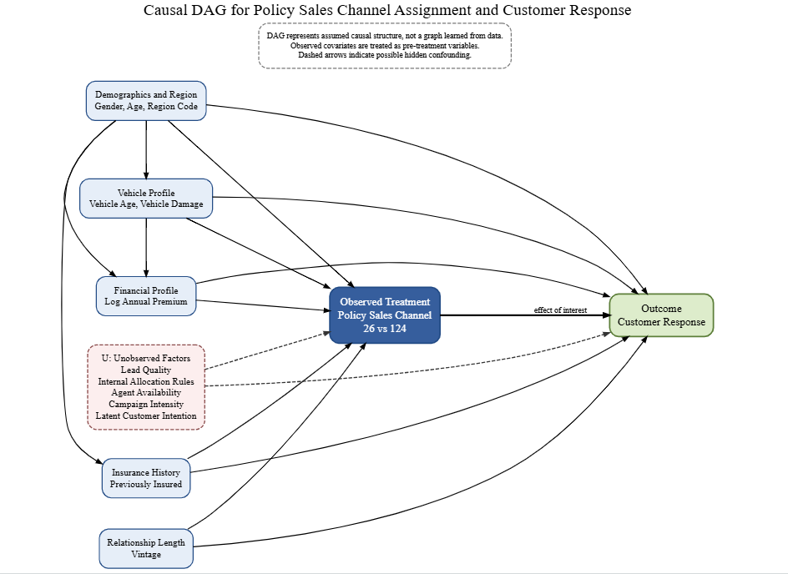Figure 3.7. Observable and conceptual DAG for policy sales channel assignment and customer response
Source: Author’s illustration.
Table 3.7. Observable DAG validation and adjustment check
Check | Purpose | Result / Interpretation
DAG specification | Define the causal graph used for identification | Observable DAG containing only measured variables
Exposure | Define treatment variable | Policy sales channel 26 vs 124
Outcome | Define outcome variable | Customer response
Back-door criterion | Check whether observed covariates block non-causal paths | Blocks all observed back-door paths under the Observable DAG
Adjustment set | Identify covariates used for adjustment | gender, age, region_code, previously_insured, vehicle_age, vehicle_damage, log_annual_premium, vintage
Interpretation | Clarify meaning of DAG check | Supports the adjustment logic under the Observable DAG; causal interpretation still relies on selection-on-observables
Source: Author’s calculation using dagitty.

3.4.3. Conceptual DAG and Hidden Confounding Limitation
Although the Observable DAG supports the formal adjustment strategy, this result depends on the selection-on-observables assumption. Because the dataset is observational and the exact business logic behind policy sales channel assignment is not observed, hidden confounding may still exist.
To transparently acknowledge this limitation, the study introduces a Conceptual DAG that includes a latent unobserved factor U. This factor represents possible hidden variables such as lead quality, internal channel allocation rules, agent availability, campaign intensity, or latent customer purchase intention.
The hidden confounding structure is expressed as:
$$U→T_{i}, U→Y_{i}$$
This structure means that an unobserved factor may affect both policy sales channel assignment and customer response. If such a factor is important, an unblocked back-door path remains:
$$T_{i}←U→Y_{i}$$
In this case, the back-door path through U remains unblocked, and the causal effect cannot be fully identified using observed covariates alone. Therefore, the formal dagitty check should be interpreted as a check of the observed adjustment strategy under the Observable DAG, not as proof that hidden confounding is absent.
Table 3.8. Conceptual DAG and hidden confounding interpretation
Check | Result
Latent confounder included | Yes, in the Conceptual DAG
Meaning of U | Lead quality, internal allocation rules, agent availability, campaign intensity, latent customer intention
Is the observed adjustment set strictly sufficient if U exists? | No
Interpretation | If U affects both treatment and outcome, the effect is not fully identified using observed covariates only
Source: Illustration based on the specified DAG.
In summary, the causal research design combines observed covariate adjustment, formal DAG-based checking, and explicit recognition of hidden confounding limitations. The Observable DAG is used to check that the selected adjustment set blocks all observed back-door paths. The Conceptual DAG then clarifies that this check is conditional on the assumption that important confounders are observed or adequately proxied by observed covariates. This approach strengthens the transparency of the empirical design while avoiding an overstatement of causal certainty.

CHAPTER 4. METHODOLOGY

4.1. Empirical Strategy and Estimands

4.1.1. Central counterfactual question
The empirical strategy is organized around the central counterfactual question of the thesis: for a customer in the analysis sample, how would the probability of response change if that customer were assigned to policy sales channel 26 instead of policy sales channel 124?
This question is counterfactual because the same customer cannot be observed under both channel assignments simultaneously. The dataset contains only one realized outcome for each customer. A customer assigned to channel 26 reveals the response under channel 26, while the response that would have occurred under channel 124 is unobserved; the same logic applies in reverse for customers assigned to channel 124.
The empirical strategy compares treated and control customers after adjustment for observed pre-treatment covariates. The same adjustment set is used throughout the benchmark models, propensity score estimation, PSM, IPW, AIPW, and causal forest analysis so that differences across estimators reflect estimation strategy rather than changes in covariate definition.
The workflow is layered. Descriptive statistics and SMDs summarize initial group differences; benchmark models contrast raw and adjusted associations; the propensity score model is used for overlap assessment and matching/weighting; PSM, IPW, and AIPW are then estimated and compared; robustness checks evaluate common support, negative-control behaviour, E-value sensitivity, and permutation-based sanity; finally, causal forest is used to study heterogeneity and targeting value.

4.1.2. Estimand hierarchy
The thesis distinguishes among ATE, ATT, and CATE because these estimands answer related but substantively different questions.
The main estimand is the Average Treatment Effect:
$$ATE=E\left[Y_{i}\left(1\right)-Y_{i}\left(0\right)\right]$$
ATE represents the average change in response probability if customers in the analysis sample were assigned to channel 26 rather than channel 124. AIPW is selected as the main estimator for this estimand.
The ATT is defined as:
$$ATT=E\left[Y_{i}\left(1\right)-Y_{i}\left(0\right)∣T_{i}=1\right]$$
ATT focuses on customers who were actually assigned to channel 26. In this thesis, PSM is reported mainly as an ATT-oriented supporting comparison.
The CATE is defined as:
$$CATE\left(X_{i}\right)=E\left[Y_{i}\left(1\right)-Y_{i}\left(0\right)∣X_{i}\right]$$
CATE is used to examine treatment effect heterogeneity and potential targeting value. In particular, it helps identify which customers in channel 124 may have larger predicted incremental response if reassigned to channel 26.
Table 4.1. Estimands used in the thesis
Estimand | Formula | Main role in this thesis
ATE | E[Y(1)-Y(0)] | Main estimand for average causal effect
ATT | E[Y(1)-Y(0) | T=1]
CATE | E[Y(1)-Y(0) | X]
Source: Author’s synthesis.

4.2. Identification Assumptions

4.2.1. Consistency assumption
The consistency assumption states that the observed outcome corresponds to the potential outcome under the treatment actually received. In this study, if a customer is assigned to channel 26, the observed response is interpreted as the potential outcome under channel 26; if a customer is assigned to channel 124, the observed response is interpreted as the potential outcome under channel 124.
Consistency is written as:
$$Y_{i}=T_{i}Y_{i}\left(1\right)+\left(1-T_{i}\right)Y_{i}\left(0\right)$$
This assumption requires the treatment categories to be sufficiently well defined. In the public dataset, channel 26 and channel 124 are treated as stable coded channel categories. Because the dataset does not provide richer operational descriptions of these channels, this limitation should be kept in mind when interpreting the results.

4.2.2. Conditional exchangeability assumption
Conditional exchangeability assumes that, after adjustment for observed covariates, treatment assignment is independent of potential outcomes. In other words, among customers with the same observed covariates, assignment to channel 26 rather than channel 124 is assumed not to depend on unobserved differences in potential response.
Conditional exchangeability is written as:
$$\left(Y_{i}\left(1\right),Y_{i}\left(0\right)\right)⊥T_{i}∣X_{i}$$
This is the key identification assumption of the thesis. It cannot be verified directly using observational data. The assumption is supported only indirectly through the choice of pre-treatment covariates, the DAG-based adjustment check, and empirical diagnostics such as balance assessment, the negative-control outcome diagnostic, and the E-value sensitivity analysis. Hidden confounding, however, cannot be fully ruled out.

4.2.3. Positivity assumption
The positivity assumption requires that customers with similar observed characteristics have a positive probability of being assigned to either channel 26 or channel 124. If certain customer profiles appear only in one channel, then there is no empirical basis for estimating the counterfactual response under the other channel.
The positivity assumption is written as:
$$0<P\left(T_{i}=1∣X_{i}\right)<1$$
Equivalently, in terms of the propensity score:
$$0<e\left(X_{i}\right)<1$$
This assumption is examined through propensity score overlap and common-support diagnostics. When overlap is weak, matching and weighting estimators may become unstable. For that reason, common-support trimming is used as an additional robustness check.

4.2.4. SUTVA and observational data limitation
The Stable Unit Treatment Value Assumption requires that one customer’s response is not affected by another customer’s treatment assignment and that there are no multiple hidden versions of the treatment. In this thesis, SUTVA means that a customer’s response is assumed to depend on that customer’s own channel assignment rather than the assignments of other customers.
Because the dataset is observational, all identification assumptions must be interpreted carefully. The thesis does not claim that channel assignment is randomized. Instead, it estimates treatment effects under the DAG-based identification logic and the selection-on-observables framework.
Given the retail nature of individual vehicle insurance, spillover effects across unrelated customers are unlikely to be important. It is therefore reasonable, though not provable, to assume that assigning one customer to a particular channel does not directly alter another customer’s response decision.

4.3. Benchmark and Propensity Score Model

4.3.1. Raw difference in means
The first benchmark is the raw difference in response rates between the treatment and control groups. This comparison is simple and transparent, but it does not adjust for differences in customer characteristics.
The raw difference is defined as:
$$Δ_{raw}=μ_{Y,1}-μ_{Y,0}$$
The raw difference is used only as a descriptive benchmark. It is not interpreted as a causal effect because treatment assignment is non-random and the two groups differ in observed covariates.

4.3.2. Linear Probability Model
The Linear Probability Model is used as an adjusted benchmark. It estimates the association between treatment and response after controlling for the observed covariates.
The model is specified as:
$$Y_{i}=α+τT_{i}+X_{i}'β+ε_{i}$$
where Y_i is the binary response outcome, T_i is the treatment indicator, and X_i is the vector of observed covariates. The coefficient tau represents the adjusted difference in response probability associated with assignment to channel 26. The LPM is easy to interpret, but it is not the main causal estimator in the thesis.

4.3.3. Logistic regression benchmark
Because the outcome is binary, logistic regression is also used as a benchmark model. The logistic specification is:
$$P\left(Y_{i}=1∣T_{i},X_{i}\right)=\frac{exp\left(α+τT_{i}+X_{i}'β\right)}{1+exp\left(α+τT_{i}+X_{i}'β\right)}$$
The odds ratio for treatment is:
$$OR=exp\left(τ\right)$$
An odds ratio greater than 1 indicates that channel 26 is associated with higher odds of response than channel 124 after conditioning on observed covariates. To express the logistic result in probability terms, predicted probabilities can also be computed under two counterfactual treatment states.
The corresponding g-computation style difference is:
$$τ_{gcomp}=\frac{1}{n}\sum_{i=1}^{n}{\left[\hat{μ}\left(1,X_{i}\right)-\hat{μ}\left(0,X_{i}\right)\right]}$$

4.3.4. Propensity score model
The propensity score is the probability of being assigned to channel 26 conditional on observed covariates.
$$e\left(X_{i}\right)=P\left(T_{i}=1∣X_{i}\right)$$
In this thesis, the propensity score is estimated using logistic regression:
$$logit\left(e\left(X_{i}\right)\right)=α+X_{i}'γ$$
The estimated propensity score is then used for overlap diagnostics, PSM, IPW, AIPW, and common-support trimming.

4.4. Treatment Effect Estimators

4.4.1. Propensity Score Matching
Propensity Score Matching compares treated customers with control customers who have similar estimated propensity scores. The goal is to construct a comparison group that resembles the treated group with respect to observed covariates.
For each treated customer, the nearest-neighbor matching rule is:
$$j\left(i\right)=arg\min_{j:T_{j}=0}\left|\hat{e}\left(X_{i}\right)-\hat{e}\left(X_{j}\right)\right|$$
The PSM estimator for ATT is:
τPSM=1NTi:Ti=1​Yi-Yji
where N_T is the number of treated customers. PSM is intuitive and useful as a robustness-oriented comparison, but it may discard observations and primarily targets the treated population.

4.4.2. Inverse Probability Weighting
Inverse Probability Weighting uses propensity scores to create a weighted pseudo-population in which treatment assignment is less dependent on observed covariates. The method retains all observations, although it can be sensitive to extreme propensity scores.
The stabilized inverse probability weight is defined as:
$$w_{i}=\left\{\begin{matrix}\frac{p}{\hat{e}\left(X_{i}\right)}, & \text{if }T_{i}=1 \\ \frac{1-p}{1-\hat{e}\left(X_{i}\right)}, & \text{if }T_{i}=0\end{matrix}\right.$$
The IPW estimator is the weighted treated mean outcome minus the weighted control mean outcome.
$${\hat{τ}}_{IPW}=\frac{\sum_{i=1}^{n}{w_{i}}T_{i}Y_{i}}{\sum_{i=1}^{n}{w_{i}}T_{i}}-\frac{\sum_{i=1}^{n}{w_{i}}\left(1-T_{i}\right)Y_{i}}{\sum_{i=1}^{n}{w_{i}}\left(1-T_{i}\right)}$$
IPW is used as an ATE-oriented estimator and provides a useful comparison with AIPW.

4.4.3. Augmented Inverse Probability Weighting
AIPW is the main estimator in this thesis because it combines a propensity score model with an outcome model. This doubly robust structure is attractive in observational studies, where model misspecification is a genuine concern.
Let the outcome model be:
$$μ_{t}\left(X_{i}\right)=E\left[Y_{i}∣T_{i}=t,X_{i}\right]$$
The AIPW score for each observation is:
$$ψ_{i}={\hat{μ}}_{1}\left(X_{i}\right)-{\hat{μ}}_{0}\left(X_{i}\right)+\frac{T_{i}\left(Y_{i}-{\hat{μ}}_{1}\left(X_{i}\right)\right)}{\hat{e}\left(X_{i}\right)}-\frac{\left(1-T_{i}\right)\left(Y_{i}-{\hat{μ}}_{0}\left(X_{i}\right)\right)}{1-\hat{e}\left(X_{i}\right)}$$
The AIPW estimator is:
$${\hat{τ}}_{AIPW}=\frac{1}{n}\sum_{i=1}^{n}{ψ_{i}}$$
The standard error is calculated from the empirical variation of the AIPW scores:
$$SE\left({\hat{τ}}_{AIPW}\right)=\frac{sd\left(ψ_{i}\right)}{\sqrt{n}}$$
The 95% confidence interval is:
$${\hat{τ}}_{AIPW}±1.96×SE\left({\hat{τ}}_{AIPW}\right)$$
AIPW is treated as the central estimate because it directly targets the ATE and combines information from both the treatment model and the outcome model.

4.5. Diagnostics and Heterogeneity Methods

4.5.1. Common support trimming
Common-support trimming is used to assess whether the main AIPW estimate is sensitive to observations with weak overlap. Customers with very low or very high propensity scores may have poorly supported counterfactual outcomes. The 1%-99% trimming rule is:
$$q_{0.01}≤\hat{e}\left(X_{i}\right)≤q_{0.99}$$
The AIPW estimator is recalculated on the trimmed sample. If the trimmed estimate remains close to the full-sample estimate, this suggests that the main result is not driven by weak-overlap observations.

4.5.2. Negative-control outcome diagnostic
A negative-control outcome diagnostic is used to check whether the empirical pipeline produces a spurious effect on a variable that should not be affected by treatment. In this thesis, gender is used as the negative-control outcome because policy sales channel assignment cannot causally change a customer’s gender.
Let Y_i^{NC} denote the negative-control outcome. The expected diagnostic result is:
$$τ_{NC}≈0$$
If the estimated effect of channel assignment on the negative-control outcome is close to zero and statistically insignificant, this supports the internal coherence of the empirical pipeline. However, this diagnostic does not prove that hidden confounding is absent.

4.5.3. Permutation-based pipeline sanity check
The permutation-based check is used as a pipeline sanity check rather than as definitive proof of causality. In this procedure, the treatment assignment is randomly permuted while the outcome and covariates are kept unchanged.
For permutation iteration b, the permuted treatment is:
$$T_{i}^{perm,b}=π_{b}\left(T_{i}\right)$$
${\hat{τ}}_{perm}^{\left(b\right)}, b=1,…,B$The estimator is recalculated under each permuted treatment assignment to obtain a placebo estimate. In the final implementation, the permutation-based check was executed with 300 random permutations (B =300) to construct a stable placebo distribution.
This check evaluates whether the estimation pipeline generates near-zero effects when treatment labels are randomized. It does not rule out hidden confounding and should not be interpreted as proof of causal validity.

4.5.4. E-value sensitivity analysis
To evaluate sensitivity to hidden confounding, the thesis computes the E-value for the main AIPW estimate. The E-value is interpreted as the minimum strength of association, on the risk-ratio scale, that an unobserved confounder would need to have with both treatment assignment and the outcome, conditional on the observed covariates, in order to explain away the observed causal effect. In this study, the E-value is reported for both the point estimate and the lower bound of the 95% confidence interval. The point-estimate E-value indicates how strong unobserved confounding would have to be to reduce the estimated effect to the null. The lower-bound E-value is also reported because it is a more conservative sensitivity metric: it asks how strong an unobserved confounder would need to be to move the lower confidence bound to the null. This conservative interpretation is useful because it focuses on the weakest effect size still compatible with the data at the 95% confidence level.

4.5.5. Causal forest, RATE and Qini analysis
Causal forest is used to estimate heterogeneous treatment effects. The main quantity of interest is the Conditional Average Treatment Effect (CATE):
$$τ\left(X_{i}\right)=E\left[Y_{i}\left(1\right)-Y_{i}\left(0\right)∣X_{i}\right]$$
The causal forest produces individual-level treatment effect estimates:
$$\hat{τ}\left(X_{i}\right)$$
The average causal forest estimate is:
$${\hat{τ}}_{CF}=\frac{1}{n}\sum_{i=1}^{n}{\hat{τ}}\left(X_{i}\right)$$
RATE and Qini diagnostics are used to evaluate whether the CATE ranking has practical targeting value. If customers with higher predicted CATE also generate larger incremental gains, the ranking is informative for targeting. In this thesis, the targeting analysis focuses on customers originally assigned to channel 124.

CHAPTER 5. EMPIRICAL RESULTS AND DISCUSSION

5.1. Descriptive Results and Baseline Imbalance

5.1.1. Descriptive statistics by treatment group
The first empirical step compares the two channel groups before any adjustment. The analysis sample contains 79,700 customers in channel 26 and 73,995 in channel 124. Their response rates are 19.94% and 18.91%, respectively, implying a raw gap of 1.02 percentage points in favour of channel 26.
This raw difference is economically visible but not large. Descriptive statistics also show systematic baseline differences: customers in channel 26 are older on average (50.7 versus 46.9 years), pay slightly higher annual premiums (33,654 versus 31,710), and differ in vehicle-age composition, while vintage is nearly identical at about 154 days in both groups.
These patterns matter because the 1.02-point raw gap mixes channel differences with customer-composition differences. It is therefore useful as a benchmark, but it is smaller than the adjusted estimates reported later and should not be interpreted as the causal effect.
Table 5.1. Descriptive statistics by treatment group
Variable | Channel 124 | Channel 26 | Interpretation
Sample size | 73,995 | 79,700 | Groups are large and balanced
Response rate | 18.91% | 19.94% | Raw difference favors channel 26
Mean age | 46.9 | 50.7 | Treated customers are older
Mean annual premium | 31,710 | 33,654 | Treated customers pay slightly more
Mean vintage | 154.0 | 154.0 | Very similar relationship length
Previously insured | 28.50% | 30.34% | Slight difference
Vehicle damage = Yes | 67.90% | 67.39% | Very similar
Source: Calculation from the analysis sample.

5.1.2. Standardized Mean Difference analysis
Standardized Mean Differences confirm that imbalance is concentrated in a few covariates rather than spread uniformly across all variables. The largest pre-adjustment gaps are age (SMD = 0.301), region code (0.239), and vehicle age (0.135), whereas gender and log annual premium are both much smaller at about 0.063.
Table 5.2. Baseline SMD before adjustment
Variable | Approximate SMD | Interpretation
Age | 0.301 | Meaningful imbalance
Region code | 0.239 | Meaningful imbalance
Vehicle age | 0.135 | Moderate imbalance
Gender | 0.063 | Low imbalance
Log annual premium | 0.063 | Low imbalance
Previously insured | 0.040 | Low imbalance
Vehicle damage | 0.011 | Very low imbalance
Vintage | 0.002 | Very low imbalance
Source: Calculation from the analysis sample.
The diagnostic therefore points to a clear source of confounding: channel 26 and channel 124 differ not only in channel assignment, but also in customer age profile, geography, and vehicle characteristics. These are precisely the kinds of pre-treatment variables that can affect both allocation and response.
A useful feature of SMD is that it is scale-free and not dominated by sample size. In a dataset of more than 150,000 observations, almost any small difference can become statistically significant, whereas SMD highlights whether the magnitude of the imbalance is substantively important. In this thesis, the SMD pattern shows that adjustment is necessary mainly because a small set of meaningful covariates is misaligned before treatment-effect estimation begins.

5.1.3. Love plot before adjustment
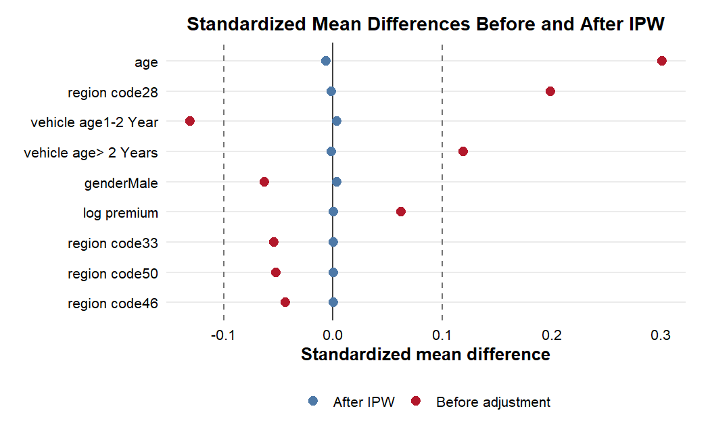Figure 5.1. Standardized mean differences before and after IPW
Source: Calculation from balance diagnostics.
The love plot makes the same point visually. Before adjustment, age, region code, and vehicle age stand out as the largest imbalances, and several covariates lie above the conventional 0.1 benchmark. After IPW, those differences are pulled much closer to zero, indicating that the weighted sample is substantially more comparable than the raw sample.

5.2. Propensity Score and Overlap Diagnostics

5.2.1. Propensity score overlap distribution
The propensity score model estimates each customer's probability of being assigned to channel 26 given the observed covariates. The resulting distributions show broad overlap between the two channels, which is essential because treatment effects are only credible where treated and control customers are genuinely comparable.
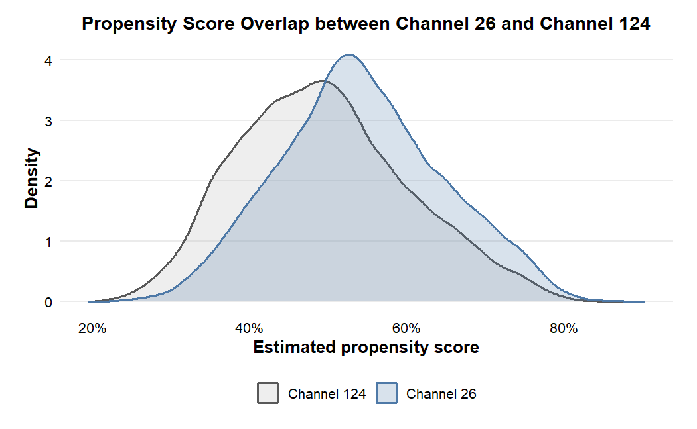Figure 5.2. Propensity score overlap between channel 26 and channel 124
Source: Calculation from the analysis sample.
Most of the mass of the two distributions lies in the same middle region rather than in disconnected supports. This matters empirically because it means the analysis is not relying on a very narrow matched subset; instead, the main ATE is identified on a large common-support region.
At the same time, some observations remain in the tails, so it is still important to check whether they influence the results disproportionately. That is the role of the trimming exercise reported in the next subsection.

5.2.2. Common support and trimmed sample
The 1%-99% trimming rule retains 150,621 of 153,695 observations, or 98.00% of the analysis sample. Only 3,074 observations are removed, so the main design loses very little information when attention is restricted to the strongest common-support region.
Table 5.3. Common support and trimmed sample
Sample | Observations | Share | Treated rate | Interpretation
Full sample | 153,695 | 100.00% | 51.86% | Reference sample
Kept in common support | 150,621 | 98.00% | 52.0% | Main common-support sample
Trimmed out | 3,074 | 2.00% | 45.9% | Weak-overlap observations
Source: Calculation from propensity score diagnostics.
This is an important quantitative result, not just a procedural check. The trimmed-out group accounts for only 2.00% of the sample, has a lower response rate (18.2%), a lower treated share (45.9%), an older age profile (50.4 years), and a lower mean annual premium than the kept group. Because the weak-overlap segment is both small and compositionally distinct, the later similarity between full-sample and trimmed estimates is strong evidence that the main result is not being created by a thin tail of poorly comparable observations.

5.2.3. Covariate balance after adjustment
After adjustment, the largest baseline gaps shrink sharply. The diagnostics show substantial improvement for age, region code, and vehicle age, while variables that were already close before adjustment, such as vintage, remain stable.
Variable | Before adjustment | After matching/weighting | Interpretation
Age | High imbalance | Substantially reduced | Adjustment successful
Region code | High imbalance | Substantially reduced | Adjustment successful
Vehicle age | Moderate imbalance | Reduced | Adjustment improves balance
Log annual premium | Low imbalance | Near zero | Stable
Vintage | Near zero | Near zero | Already balanced
Source: Calculation from balance diagnostics.
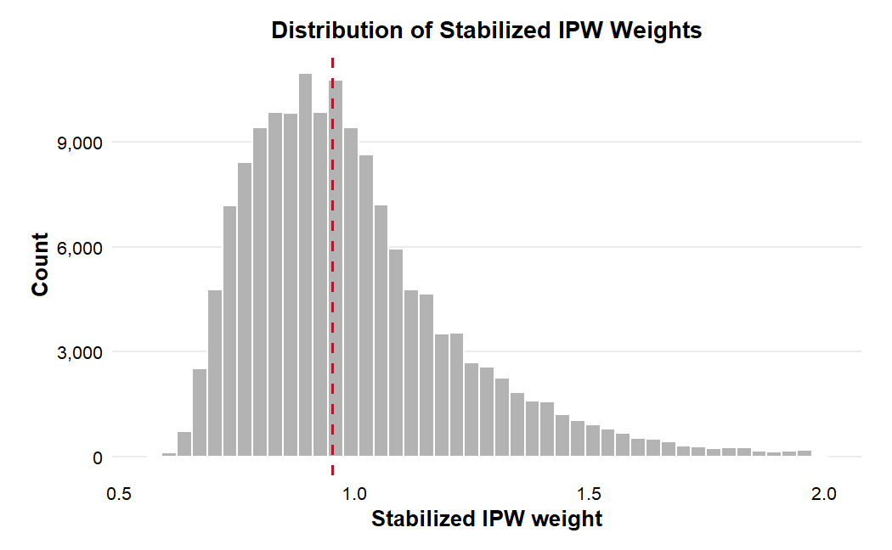Figure 5.3. Distribution of stabilized inverse probability weights
Source: Calculation from the analysis sample.
The weight distribution is also informative. Because the stabilized weights are not dominated by a small set of extreme values, the IPW-based estimates are less likely to be driven by a handful of influential observations. Taken together with the love plot, this suggests that the weighted pseudo-population is much closer to the comparability required by the ATE estimators.

5.3. Main Causal Estimates

5.3.1. Benchmark model results
The benchmark models provide a useful bridge from raw association to causal adjustment. The raw response-rate gap is 1.02 percentage points, but the adjusted Linear Probability Model raises the treatment coefficient to 2.36 percentage points, and logistic g-computation yields an adjusted probability difference of 2.65 percentage points. The simple logistic benchmark also reports an odds ratio of 1.219, consistent with a higher response propensity in channel 26.
Table 5.5. Benchmark model results
Model | Quantity reported | Estimate | Interpretation
Raw difference | Response rate difference | 0.0102 | Descriptive only
LPM | Adjusted treatment coefficient | 0.0236 | Positive adjusted association
Logistic regression | Odds ratio | 1.219 | Channel 26 associated with higher odds
Logistic g-computation | Probability difference | 0.0265 | Positive adjusted probability difference
Source: Calculation from benchmark models.
The direction of change is important. Adjustment does not attenuate the raw difference; it increases it. This means the naive comparison is not exaggerating the effect of channel 26. Instead, the observed composition of the two groups appears to suppress part of the underlying channel difference.
For that reason, the benchmark section should be read as evidence that a positive effect survives covariate adjustment before the analysis moves to formal treatment-effect estimators. It does not establish causality on its own, but it prepares the ground for the ATE results reported below.

5.3.2. Main treatment effect estimates
The main treatment-effect estimates are reported using PSM, IPW, and AIPW. Quantitatively, the PSM ATT is 0.69 percentage points, the IPW ATE is 2.38 percentage points, and the AIPW ATE is 2.64 percentage points.
Table 5.6. Main causal estimates
Method | Estimand | Estimate | Standard error | 95% CI | Percentage points
PSM | ATT | 0.0069 | 0.0021 | [0.0029, 0.0109] | 0.69 pp
IPW | ATE | 0.0238 | 0.0021 | [0.0198, 0.0278] | 2.38 pp
AIPW | ATE | 0.0264 | 0.0019 | [0.0227, 0.0302] | 2.64 pp
Source: Calculation from PSM, IPW and AIPW estimators.
The AIPW estimate is the main result of the thesis. Under the stated adjustment strategy and the selection-on-observables assumption, reassignment from channel 124 to channel 26 is associated with an average increase of 2.64 percentage points in response probability, with a 95% confidence interval of [2.27, 3.02] percentage points. Two aspects are notable. First, AIPW is very close to IPW and to logistic g-computation, which suggests that the positive effect is not an artefact of one estimator. Second, the adjusted AIPW estimate is more than twice as large as the raw 1.02-point gap, which again indicates that customer composition suppresses the naive comparison rather than inflating it.

5.3.3. Confidence interval comparison
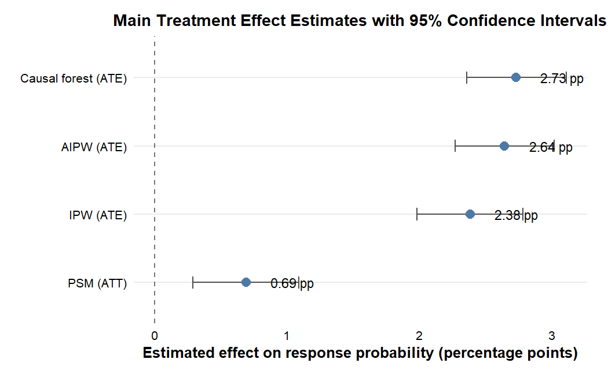Figure 5.4. Main treatment effect estimates with 95% confidence intervals
Source: Calculation from PSM, IPW and AIPW estimators.
The confidence-interval comparison sharpens this interpretation. PSM remains positive but much smaller, at 0.69 percentage points with a 95% confidence interval of [0.29, 1.09] percentage points, whereas IPW and AIPW cluster between 2.38 and 2.64 percentage points. This is not necessarily contradictory. PSM primarily targets the ATT among customers already assigned to channel 26, while IPW and AIPW target the ATE over the full analysis sample. A smaller ATT suggests that customers already in channel 26 may have less additional room for improvement than some customers currently assigned to channel 124, a pattern that is consistent with the later targeting results.

5.4. Robustness and Diagnostic Checks

5.4.1. Full sample versus trimmed sample AIPW
The trimmed AIPW analysis asks whether the main result depends on the small set of tail observations with weaker overlap. After trimming the 1%-99% propensity-score region, the ATE changes from 2.64 to 2.69 percentage points.
Table 5.7. Full sample versus trimmed sample AIPW
Sample | Observations | ATE | Standard error | 95% CI
Full sample | 153,695 | 0.0264 | 0.0019 | [0.0227, 0.0302]
Trimmed 1%-99% support | 150,621 | 0.0269 | 0.0019 | [0.0231, 0.0307]
Source: Calculation from AIPW robustness diagnostics.
This 0.05-point difference is economically negligible relative to the size of the effect itself, and the confidence intervals remain nearly identical. The implication is that the main estimate is stable inside and outside the trimmed specification. In other words, the positive channel effect is not being manufactured by extreme-propensity observations.

5.4.2. Negative-control outcome results
A negative-control outcome diagnostic is conducted using gender as the pseudo-outcome. Because policy sales channel assignment cannot causally change a customer's gender, any sizeable estimated effect would signal serious misspecification or residual imbalance in the empirical pipeline.
Table 5.8. Negative-control outcome diagnostic
Diagnostic | Pseudo-outcome | Estimator | Estimate | Standard error | 95% CI | p-value
Negative-control outcome | Gender = Male | AIPW | 0.0016 | 0.0025 | [-0.0034, 0.0066] | 0.527
Source: Calculation from negative-control diagnostic.
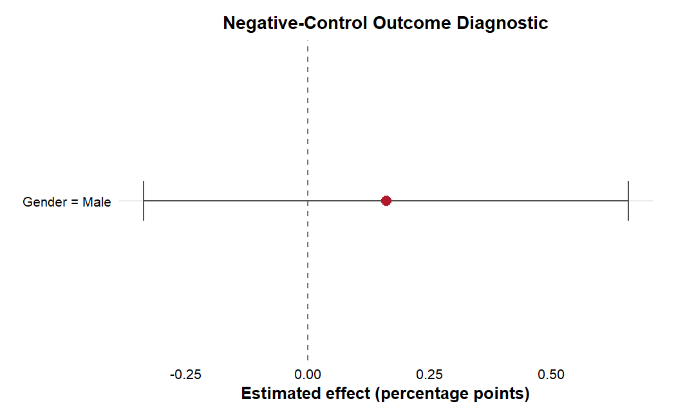Figure 5.5. Negative-control outcome diagnostic
Source: Calculation from negative-control diagnostic.
Figure 5.5 shows exactly the pattern desired from a validity check of this kind: the point estimate is very close to zero and the confidence interval spans zero.
Numerically, the AIPW estimate for the negative-control outcome is 0.0016, with a 95% confidence interval of [-0.0034, 0.0066] and p = 0.527. This does not prove that all hidden confounding has been removed, but it is reassuring evidence that the pipeline is not mechanically generating treatment effects even when the outcome is known to be pre-treatment.

5.4.3. Permutation-based pipeline sanity check results
The permutation-based pipeline sanity check randomly reshuffles treatment labels while keeping outcomes and covariates fixed. If the estimation pipeline were mechanically producing a positive result, the permuted estimates would still tend to drift away from zero. Instead, the final diagnostic based on 300 permutations produces a null distribution centred close to zero, while the true AIPW estimate remains far outside that centre.

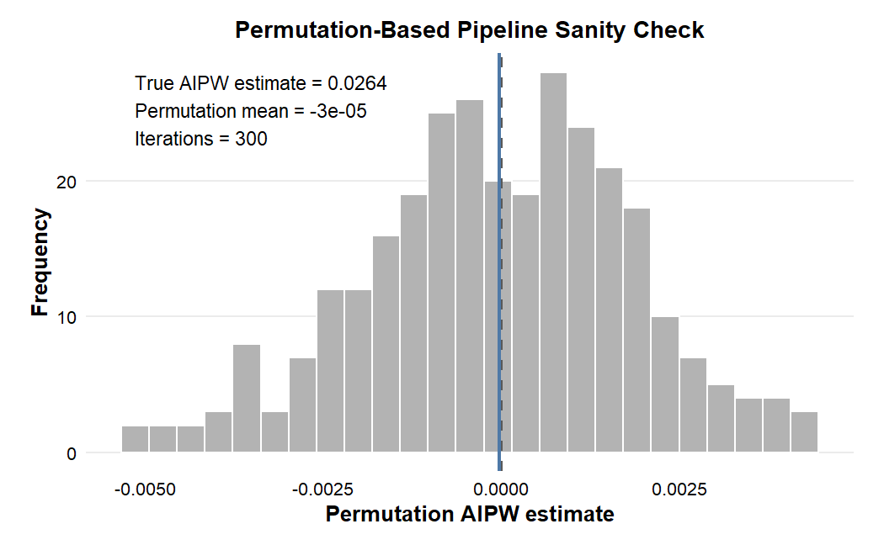Figure 5.6. Permutation-based pipeline sanity check distribution
Source: Calculation from permutation diagnostics.
This is an important falsification-style check. It shows that the empirical pipeline reacts to the actual treatment assignment structure in the data rather than generating positive effects by construction. At the same time, the permutation exercise should be interpreted as a sanity check on the estimator, not as a substitute for the causal identification assumptions.

5.4.4. E-value sensitivity analysis
To assess how vulnerable the main AIPW result is to hidden confounding, the thesis also reports the E-value.
Using the main AIPW estimate, the implied risk ratio is 1.146842 with a 95% confidence interval of [1.124734; 1.169385]. The corresponding E-value is 1.557213 for the point estimate and 1.499289 for the lower confidence limit. Interpreted substantively, if the true causal effect were actually null, an unobserved confounder would need to be associated with both treatment assignment and customer response by risk ratios of at least about 1.56 each, conditional on the observed covariates, to fully explain away the point estimate. The lower-bound E-value is more conservative: it shows that associations of roughly 1.50 with both treatment and outcome would still be required to move the lower 95% confidence limit to the null.
These values imply moderate rather than overwhelming robustness. The result is not so fragile that a trivially weak omitted variable would erase it, but neither is it strong enough to dismiss hidden confounding entirely. A practical reading is that an arbitrary unobserved confounder weaker than about 1.50-fold in its associations with treatment and outcome would not be sufficient to explain away even the conservative lower-bound effect.
Estimator | Risk ratio | 95% CI | E-value (point) | E-value (CI bound)
AIPW ATE | 1.146842 | [1.124734; 1.169385] | 1.557213 | 1.499289

5.5. Causal Forest and Heterogeneity Analysis

5.5.1. Average Treatment Effect by target sample
Causal forest is used to examine whether the effect of channel 26 varies across customer characteristics. Before interpreting heterogeneity, it is useful to compare the forest-based average effects with the AIPW benchmark.
Table 5.9. Causal forest ATE by target sample
Target sample | Estimate | Standard error | 95% CI | Percentage points
All | 0.0273 | 0.0019 | [0.0236, 0.0311] | 2.73 pp
Treated | 0.0305 | 0.0019 | [0.0268, 0.0342] | 3.05 pp
Control | 0.0239 | 0.0020 | [0.0200, 0.0278] | 2.39 pp
Overlap | 0.0271 | 0.0019 | [0.0234, 0.0308] | 2.71 pp
Source: Calculation from causal forest.
The forest estimates are very close to the main AIPW result. The ATE is 2.73 percentage points for the full sample, 3.05 for the treated group, 2.39 for the control group, and 2.71 for the overlap sample. This proximity matters because it shows that once the forest is aggregated back to an average effect, it reproduces the same positive signal found by the simpler ATE estimators. Heterogeneity is therefore being estimated on top of a stable positive average effect rather than in place of it.

5.5.2. Calibration test
The calibration test evaluates whether the forest predictions contain genuine treatment-effect information. The key coefficient is the differential forest prediction term, which asks whether the model captures variation beyond the mean effect.
Table 5.10. Causal forest calibration test
Term | Estimate | Standard error | t-value | p-value | Interpretation
Mean forest prediction | 0.9853 | 0.0685 | 14.38 | <0.001 | Average prediction calibrated
Differential forest prediction | 0.9579 | 0.0530 | 18.09 | <0.001 | Heterogeneity signal significant
Source: Calculation from causal forest calibration test.
Both components of the calibration test are strong. The mean forest prediction is 0.9853 (p < 0.001), showing good calibration of the average effect, and the differential forest prediction is 0.9579 (p < 0.001), indicating that the forest is not merely reproducing the global ATE. It is extracting systematic heterogeneity from the covariates.

5.5.3. CATE distribution
The estimated CATE distribution confirms that treatment effects are not identical across customers. The mean CATE is 2.79 percentage points, the median is 1.89, the 75th percentile is 5.37, and the 95th percentile reaches 10.10 percentage points. At the lower tail, the 1st percentile is -7.03 and the 5th percentile is -2.54 percentage points.
Table 5.11. Distribution of estimated CATE
Statistic | Value
Mean | 0.0279
Standard deviation | 0.0417
1st percentile | -0.0703
5th percentile | -0.0254
25th percentile | 0.0003
Median | 0.0189
75th percentile | 0.0537
95th percentile | 0.1010
99th percentile | 0.1520
Source: Calculation from causal forest predictions.
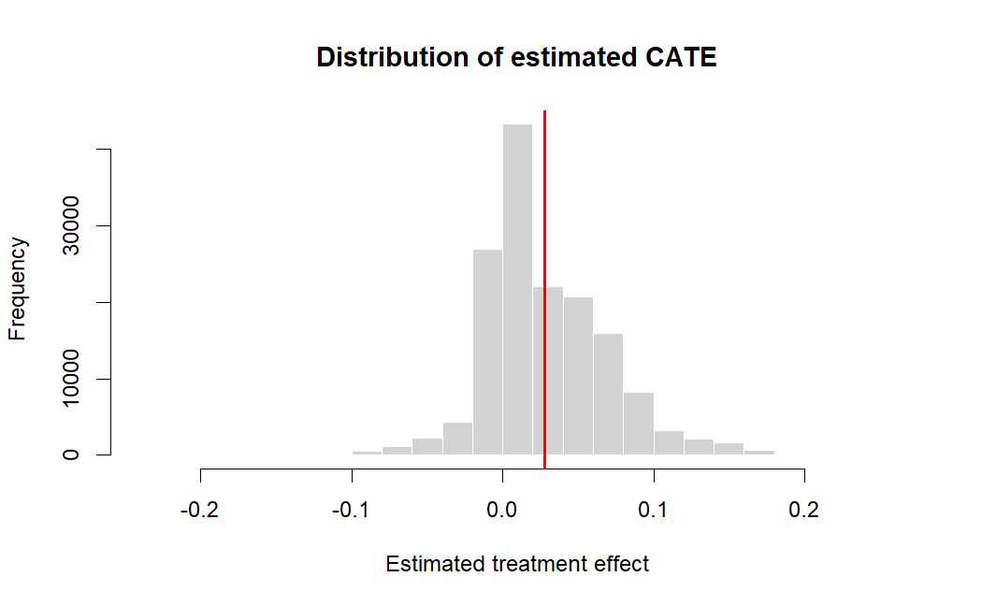Figure 5.7. Distribution of estimated CATE
Source: Calculation from causal forest.
Figure 5.7 visualises this dispersion. Most customers cluster around small positive effects, but the right tail is economically meaningful: the 95th percentile is almost four times the average effect. This is exactly the pattern that makes heterogeneity operationally useful, because the gain from reallocation is concentrated in a subset rather than spread evenly across all customers.

5.5.4. Variable importance analysis
Variable-importance analysis indicates which covariates are most relevant for explaining treatment-effect heterogeneity. The ranking is led by vehicle age above two years, vehicle damage, age, previously insured status, log annual premium, region code, and vintage. The pattern is substantively plausible: variables linked to risk exposure, insurance need, and customer history are exactly the variables one would expect to shape which customers benefit most from channel 26.
Table 5.12. Causal forest variable importance
Rank | Variable | Interpretation
1 | Vehicle age > 2 years | Older vehicles strongly related to heterogeneity
2 | Vehicle damage = Yes | Damage history differentiates treatment response
3 | Age | Older customers respond differently
4 | Previously insured | Insurance history matters
5 | Log annual premium | Premium level contributes to heterogeneity
6 | Region code | Geographic/customer segment differences
7 | Vintage | Relationship length adds information
Source: Calculation from causal forest.
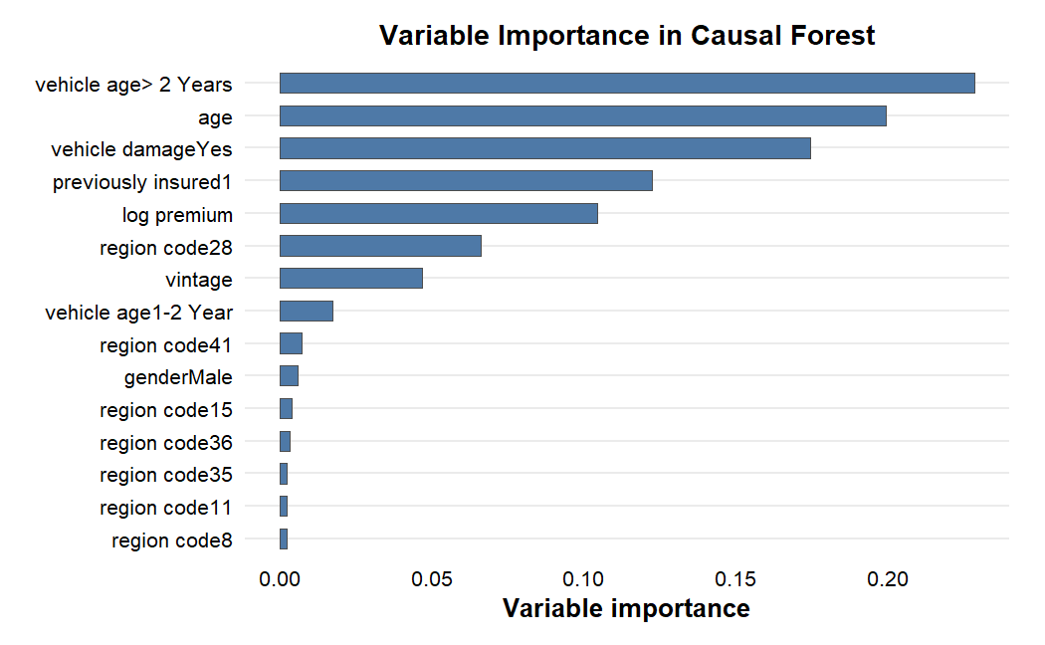Figure 5.8. Variable importance in causal forest
Source: Calculation from causal forest.

5.6. Targeting Analysis among Channel 124 Customers

5.6.1. RATE and Qini diagnostic results
RATE and Qini diagnostics evaluate whether ranking customers by estimated CATE generates targeting value rather than random sorting.
Table 5.13. RATE and Qini targeting diagnostic
Metric | Estimate | Standard error | 95% CI | p-value | Interpretation
AUTOC | 0.0383 | 0.0022 | [0.0339, 0.0426] | <0.001 | Positive targeting value
Qini | 0.0106 | 0.0005 | [0.0096, 0.0116] | <0.001 | Positive targeting value
Source: Calculation from causal forest RATE/Qini diagnostics.
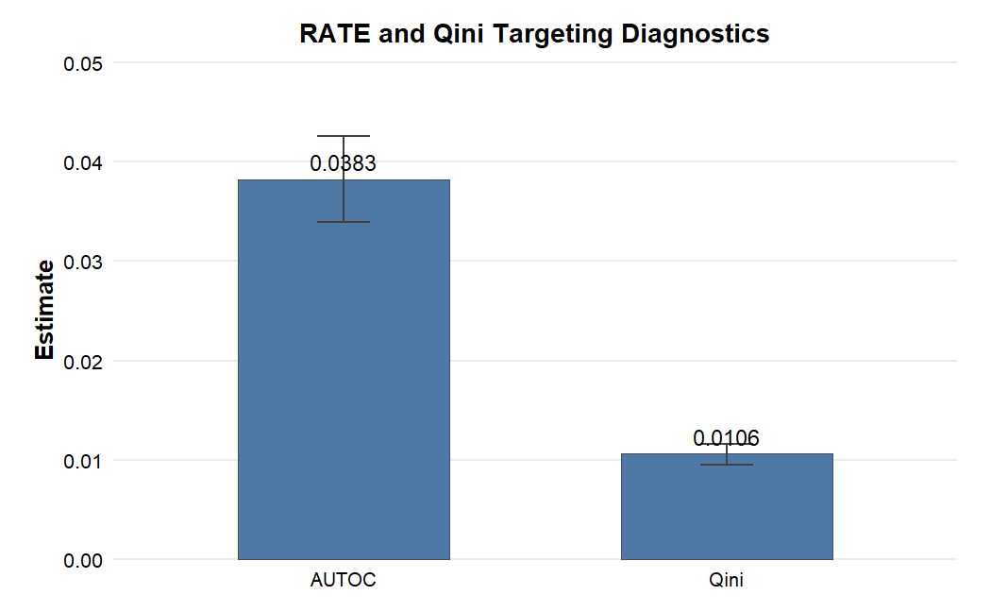Figure 5.9. RATE and Qini targeting diagnostics
Source: Calculation from causal forest RATE/Qini diagnostics.
Figure 5.9 summarises the ranking performance of the forest-based policy score. The fact that both metrics are positive and precisely estimated means that higher-ranked customers truly deliver larger gains on average.
Quantitatively, AUTOC equals 0.0383 (SE = 0.0022, 95% CI [0.0339, 0.0426], p < 0.001) and Qini equals 0.0106 (SE = 0.0005, 95% CI [0.0096, 0.0116], p < 0.001). These are not just statistically significant results. They show that the CATE ranking contains actionable information for identifying which channel 124 customers are most likely to benefit from reassignment.

5.6.2. Mean CATE by customer decile
Among customers originally assigned to channel 124, individuals are ranked by estimated CATE and divided into deciles. Higher deciles correspond to larger predicted incremental response under reassignment to channel 26.
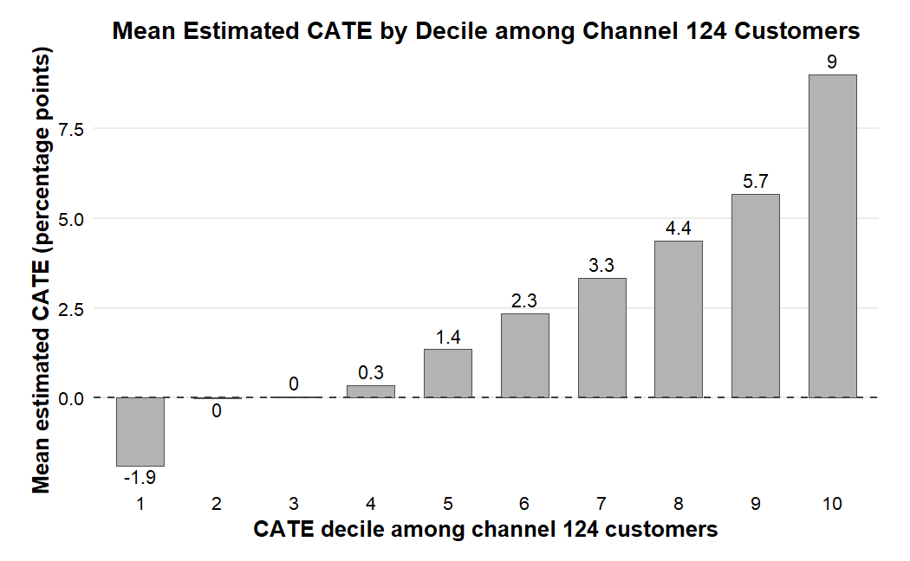Figure 5.10. Mean estimated CATE by decile among channel 124 customers
Source: Calculation from causal forest.
The decile plot shows a strong monotonic pattern, culminating in a mean CATE of about 10.1 percentage points in the highest decile. This is economically large: the top decile effect is almost four times the full-sample AIPW estimate of 2.64 percentage points. The managerial implication is clear: the value of channel 26 is not uniform, and the biggest gains come from a relatively small, high-potential subgroup.

5.6.3. Top 10% predicted-gain customer profile
The top 10% predicted-gain group among channel 124 customers contains about 7,400 customers. Their average estimated CATE is approximately 10.1 percentage points, implying roughly 750 expected incremental responses if this segment were reassigned from channel 124 to channel 26.
The profile of this group is highly informative. Fully 100.0% of these customers have prior vehicle damage, compared with only 64.3% in the rest of the channel 124 sample. This is not a trivial compositional difference; it suggests a concrete mechanism for heterogeneity. Customers with damage history are likely to be more risk-aware and more immediately receptive to insurance messaging, but their latent demand may not convert equally well under every channel. The forest results imply that channel 26 is especially effective for activating this high-risk, high-attention segment. The 10.1-point gain in the top decile is therefore not just statistically interesting; it is the clearest evidence that the main business value of the causal model lies in selective reassignment rather than uniform channel switching.
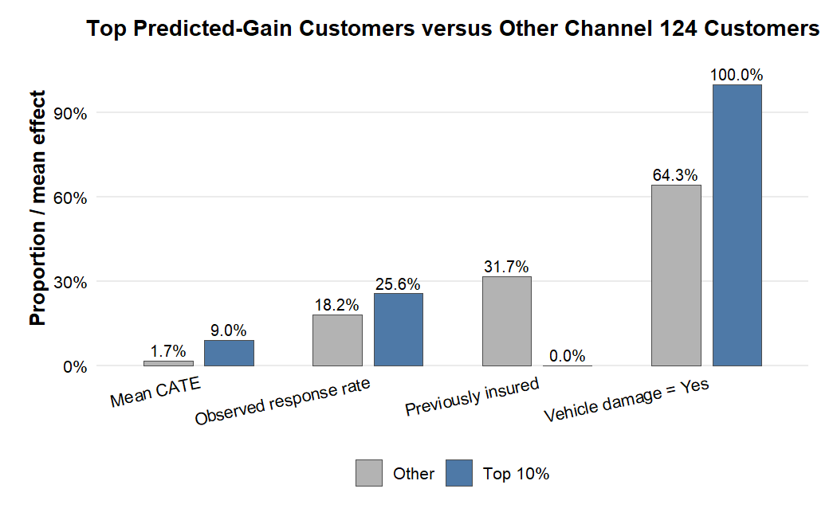
Figure 5.11. Top 10% predicted-gain customers versus other channel 124 customers
Source: Calculation from causal forest.

5.7. Discussion

5.7.1. Research Question 1: Average Treatment Effect
The first research question asks whether assignment to channel 26 rather than channel 124 affects response after adjustment for observed pre-treatment covariates. The answer from the main estimator is yes: the AIPW ATE is 2.64 percentage points, with a 95% confidence interval of [2.27, 3.02] percentage points.
This estimate is materially larger than the raw difference of 1.02 percentage points. That contrast is substantive because it shows that simple descriptive comparisons understate, rather than overstate, the adjusted effect of channel 26. The benchmark LPM (2.36 pp), logistic g-computation (2.65 pp), and IPW (2.38 pp) all point in the same direction, which strengthens the interpretation that channel 26 is associated with a real incremental response advantage under the selection-on-observables framework.
However, the conclusion remains conditional on the identifying assumptions. The dataset does not reveal the full operational logic behind channel assignment, so unobserved factors may still influence both allocation and response. The thesis therefore supports a cautious causal interpretation, not a claim equivalent to experimental proof.

5.7.2. Research Question 2: Robustness across estimators
The second research question asks whether the result is robust across estimators and diagnostics. The answer is broadly yes, but with informative differences in magnitude. PSM yields a smaller ATT of 0.69 percentage points, whereas IPW and AIPW produce ATEs of 2.38 and 2.64 percentage points, respectively. Because these estimators target different populations, the gap is more informative than problematic: it suggests that the largest counterfactual gains may lie among customers currently outside channel 26 rather than among those already assigned to it.
The robustness checks reinforce this reading. Trimming weak-overlap observations changes the AIPW estimate only from 2.64 to 2.69 percentage points. The negative-control outcome estimate is essentially zero (0.0016, p = 0.527), which reduces concern that the pipeline mechanically creates treatment effects. The permutation distribution is centred near zero while the true estimate remains clearly separated from it, so random relabelling does not reproduce the observed result.
The E-value provides the main caution. With an E-value of 1.557 for the point estimate and 1.499 for the lower confidence bound, the finding is moderately robust to hidden confounding but not invulnerable. Taken together, the diagnostics support the stability of the empirical pipeline, yet they do not remove the need for cautious interpretation.

5.7.3. Research Question 3: Value of heterogeneity-based targeting
The third research question asks whether heterogeneity can be exploited for targeting. The evidence here is especially strong. The forest ATE remains close to the AIPW benchmark, the calibration test shows a significant differential prediction term, and RATE/Qini diagnostics are both positive and highly significant. This combination indicates that heterogeneity is not random noise layered on top of the average effect.
In practical terms, the model is valuable because it ranks channel 124 customers by incremental gain. The top decile has an average CATE of 10.1 percentage points and contains about 7,400 customers, implying roughly 750 expected additional responses under reassignment to channel 26. This is far more informative than a one-size-fits-all recommendation. It suggests that the best use of channel 26 is targeted deployment toward customers whose profiles, especially those with prior vehicle damage, indicate much larger than average gains.

5.7.4. Limitations and hidden confounding
The results should still be interpreted with care. First, the analysis relies on observational data and a selection-on-observables design. Although balance improves sharply after adjustment and the diagnostics are reassuring, unobserved factors such as lead quality, campaign timing, agent assignment rules, or latent customer purchase intent could still confound the estimated channel effect.
Second, the channel codes in the public dataset do not come with detailed business descriptions, channel costs, or operational protocols. The thesis can therefore compare channels statistically, but it cannot isolate the exact mechanism, whether advice quality, trust, follow-up intensity, or something else, through which channel 26 outperforms channel 124. Likewise, the outcome is response rather than profit, so a higher response rate does not automatically imply higher net business value.
Third, the heterogeneity and targeting results should be read as decision support under the maintained assumptions, not as a fully validated deployment policy. The E-value shows only moderate robustness to hidden confounding, and the targeting rule has not been tested in a live randomized campaign. A field experiment or A/B reassignment test would therefore be the appropriate next step before turning the CATE ranking into an operational rule.

CHAPTER 6. CONCLUSION

6.1. Summary of Main Findings
This thesis studies the effect of policy sales channel assignment on customer response in an insurance cross-selling setting. The analysis focuses on customers assigned to channel 26 and channel 124 in the Health Insurance Cross Sell dataset, with channel 26 treated as the treatment condition and channel 124 as the control condition.
The main result is that channel 26 is associated with a higher response probability than channel 124 after adjustment for observed pre-treatment covariates. The main AIPW estimate is approximately 2.64 percentage points. IPW and causal forest estimates are close to the AIPW estimate, while PSM provides a smaller but still positive ATT-oriented comparison.
Robustness and diagnostic checks support the empirical pipeline. The trimmed AIPW result remains close to the full-sample result. The negative-control outcome diagnostic using gender produces an insignificant effect close to zero. The E-value suggests moderate, rather than strong, robustness to hidden confounding. The permutation-based pipeline sanity check shows that the true estimate lies far from the distribution obtained when treatment labels are randomly permuted.

6.2. Managerial Implications
The findings suggest that insurance firms should not rely only on predicted response probability when allocating sales channels. A customer with a high predicted response may respond regardless of the channel used. From a managerial perspective, the more relevant question is which channel assignment is associated with incremental response.
The average treatment effect results suggest that channel 26 may be more effective than channel 124 on average under the identification assumptions of the study. However, the heterogeneity results also show that the effect is not uniform across all customers. Some customers are predicted to benefit much more from channel 26 than others.
This has practical implications for channel allocation, but the recommendation remains conditional because the dataset contains coded channel identifiers rather than the underlying business processes or cost structures. Firms could use estimated CATE scores to prioritize customers who are expected to gain the most from assignment to channel 26. In practice, any operational decision should be evaluated against return on investment: a higher-CATE customer is most valuable when the expected incremental revenue from the additional response exceeds the marginal cost difference between channel 26 and channel 124.
A further implication is that causal analysis can complement rather than replace predictive modelling. Predictive models remain useful for identifying customers who are likely to respond, whereas causal analysis asks whether the channel decision itself is associated with incremental response. If channel 26 is low-cost or similar in cost to channel 124, the positive estimated effect supports broader use. If channel 26 is materially more expensive, reassignment should be concentrated on customers with larger predicted gains.

6.3. Limitations
This thesis has several limitations. First, the dataset is observational. Customers were not randomly assigned to channel 26 or channel 124, so the causal interpretation relies on the selection-on-observables assumption.
Second, the public dataset does not provide detailed business descriptions or cost information for the policy sales channel codes. As a result, channel 26 and channel 124 are treated as coded channel categories rather than named business channels, and the managerial implications must be interpreted conditionally on unknown channel cost structures.
Third, the DAG is formally checked using dagitty, but this check only supports the claim that the proposed adjustment set blocks the observed back-door paths under the stated observable DAG. It does not prove that the DAG is the true data-generating process. Hidden confounding may still remain, and the E-value suggests only moderate robustness to such bias.

6.4. Future Research Directions
Future research can extend this thesis in several directions. First, randomized experiments or A/B tests would provide stronger evidence on sales channel effectiveness. Second, firm-level data with detailed business descriptions of each channel would allow a richer managerial interpretation. Third, future studies could move beyond a binary treatment setting and analyse multiple channels simultaneously. Fourth, later work could evaluate profit-based outcomes rather than response alone.
Despite these limitations, the thesis shows how causal inference can improve the evaluation of insurance cross-selling strategies. By combining average treatment effect estimation, robustness diagnostics, sensitivity analysis, and heterogeneous treatment effect analysis, the study provides a structured framework for moving from response prediction to intervention-oriented channel allocation.
The findings also suggest a broader lesson for insurance analytics. When firms evaluate marketing actions using observational data, they should avoid relying only on predictive scores or raw conversion rates. A structured causal design can help clarify whether a marketing action is associated with incremental response. Even when causal certainty is not achievable, transparent assumptions, diagnostics, and robustness checks can make the analysis more informative for decision-making.

REFERENCES
Athey, S. and Imbens, G. W. (2016), ‘Recursive partitioning for heterogeneous causal effects’, Proceedings of the National Academy of Sciences, 113(27), pp. 7353-7360.
Pearl, J. and Mackenzie, D. (2018), The Book of Why: The New Science of Cause and Effect, Basic Books, New York.
Molak, A. (2023), Causal Inference and Discovery in Python: Machine Learning and Pearlian Perspective, Packt Publishing, Birmingham.
Athey, S., Tibshirani, J. and Wager, S. (2019), ‘Generalized random forests’, The Annals of Statistics, 47(2), pp. 1148-1178.
Austin, P. C. (2011), ‘An introduction to propensity score methods for reducing the effects of confounding in observational studies’, Multivariate Behavioral Research, 46(3), pp. 399-424.
Breiman, L. (2001), ‘Random forests’, Machine Learning, 45(1), pp. 5-32.
Hernan, M. A. and Robins, J. M. (2020), Causal Inference: What If, Chapman & Hall/CRC, Boca Raton.
Imbens, G. W. and Rubin, D. B. (2015), Causal Inference for Statistics, Social, and Biomedical Sciences: An Introduction, Cambridge University Press, Cambridge.
Pearl, J. (2009), Causality: Models, Reasoning and Inference, 2nd edn, Cambridge University Press, Cambridge.
Rosenbaum, P. R. and Rubin, D. B. (1983), ‘The central role of the propensity score in observational studies for causal effects’, Biometrika, 70(1), pp. 41-55.
Robins, J. M., Rotnitzky, A. and Zhao, L. P. (1994), ‘Estimation of regression coefficients when some regressors are not always observed’, Journal of the American Statistical Association, 89(427), pp. 846-866.
Wager, S. and Athey, S. (2018), ‘Estimation and inference of heterogeneous treatment effects using random forests’, Journal of the American Statistical Association, 113(523), pp. 1228-1242.
Kaggle (2020), Health Insurance Cross Sell Prediction, Kaggle dataset, available at: https://www.kaggle.com/datasets/anmolkumar/health-insurance-cross-sell-prediction (Accessed: 28 April 2026).

APPENDICES

Appendix A. Suggested figures to insert from R
Figure | Description
Figure 3.1 | Response distribution in the original dataset
Figure 3.2 | Top policy sales channels by sample size
Figure 3.3 | Response rate across major policy sales channels
Figure 3.7 | Observable and conceptual DAG with latent U
Figure 5.2 | Propensity score overlap plot
Figure 5.6 | Permutation-based pipeline sanity check
Figure 5.7 | Zoomed CATE distribution
Figure 5.10 | Mean CATE by decile among channel 124 customers

Appendix B. Notes on interpretation
All empirical results should be interpreted under the DAG-based identification assumptions and the selection-on-observables framework. The reported estimates should not be read as equivalent to experimental effects. Rather, they represent observationally identified causal estimates under explicit assumptions, supported by balance diagnostics, negative-control checks, sensitivity analysis, and permutation-based sanity checks.

