# Thực hiện dự án

## Tạo giao diện với Swing

### Cửa sổ Loading

**Giao diện**

**Đặt tên các điều khiển**

|  |  |  |  |
| --- | --- | --- | --- |
| TT | Điều khiển | Tên | Giá trị |
| 1 | JDialog | name | Loading |
|  |  | title | Loading |
| 2 | JLabel | name | lblImage |
|  |  | icon |  |
| 2.1 | JLabel | name | lblLoad |
|  |  | text | Loading… |
| 2.2 | JLable | name | lblWait |
|  |  | text | Please feel free to wait forever ! |
| 2.3 | JLabel | name | pgbLoad |
|  |  | text | 0% |

### Các cửa sổ quản lý

#### Cửa sổ Login

**Giao diện**

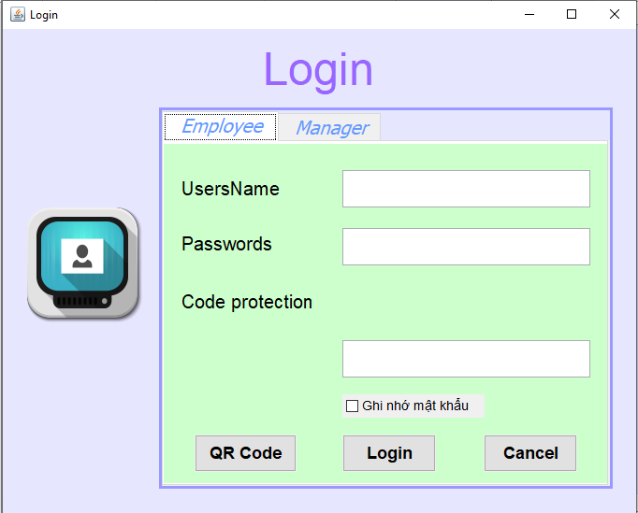

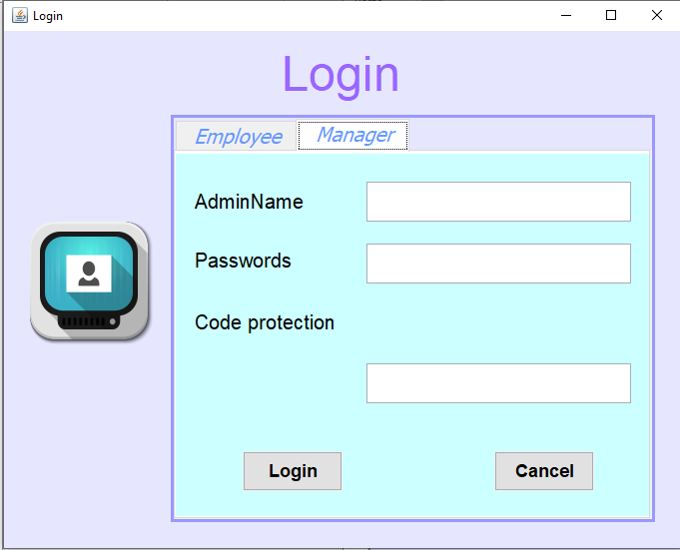

**Đặt tên các điều khiển**

|  |  |  |  |
| --- | --- | --- | --- |
| **TT** | **Điều khiển** | **Tên** | **Giá trị** |
| 1 | JDialog | name | Login |
|  |  | title | Login |
| 2 | JPanel | name | JPanel1 |
| 2.1 | JLabel | name | lblLogin |
|  |  | Text | Login |
| 2.1.1 | JLabel | name | lblImage |
|  |  | icon | Login1.png |
| 2.2 | JTabbedPane | name | LVR |
| 2.2.1 | JPanel | name | dangnhapU |
| 2.2.1.1 | JLabel | name | lblUserNameEmployee |
|  |  | Text | UserName |
| 2.2.1.2 | JTextField | name | txtUserNameEmployee |
| 2.2.1.3 | JLabel | name | lblPasswordsEmployee |
|  |  | Text | Passwords |
| 1.2.1.4 | JPasswordField | name | txtPasswordsEmployee |
| 1.2.1.5 | JLabel | name | lblCodeProtectionEmployee |
|  |  | Text | Code Protection |
| 1.2.1.6 | JLabel | name | macapuser |
| 1.2.1.7 | JTextField | name | txtCodeProtectionEmployee |
| 1.2.1.8 | JCheckBox | name | remember |
| 1.2.1.9 | JButton | name | btnloginEmployee |
|  |  | Text | Login |
|  |  | Icon | login_1.png |
| 1.2.1.10 | JButton | name | btncancelEmployee |
|  |  | Text | Cancel |
|  |  | Icon | Cancel_1.png |
| 1.2.1.11 | JButton | name | btnloginQR |
|  |  | Text | QR Code |
|  |  | Icon | QR.png |
| 1.2.2 | JPanel | name | dangnhapM |
| 1.2.2.1 | JLabel | name | lblUserNameManager |
|  |  | Text | AdminName |
| 1.2.2.2 | JTextField | name | txtUserNameManager |
| 1.2.2.3 | JLabel | name | lblPasswordsManager |
|  |  | Text | Passwords |
| 1.2.2.4 | JTextField | name | txtPasswordsManager |
| 1.2.2.5 | JLabel | name | lblCodeProtectionManager |
|  |  |  | Code Protection |
| 1.2.2.6 | JLabel | name | macapadmin |
| 1.2.2.7 | JTextField | name | txtCodeProtectionManager |
| 1.2.2.8 | JButton | name | btnloginManager |
|  |  | Text | Login |
|  |  | Icon | login_1.png |
| 1.2.2.9 | JButton | name | btncancelManager |
|  |  | Text | Cancel |
|  |  | Icon | Cancel_1.png |

#### Cửa sổ Change Password

**Giao diện**

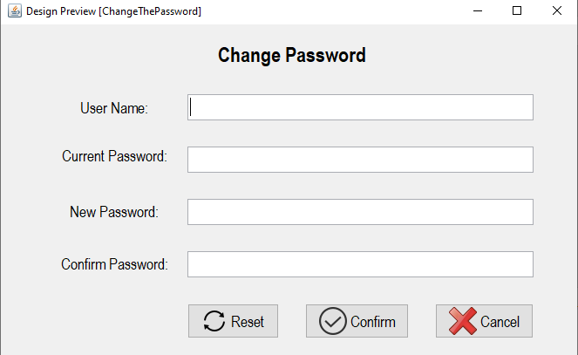

**Đặt tên các điều khiển**

|  |  |  |  |
| --- | --- | --- | --- |
| TT | Điều khiển | Tên | Giá trị |
| 1 | JDialog | name | ChangeThePassword |
|  |  | title | ChangeThePassword |
| 2 | JLabel | name | lblUserName |
|  |  | Text | UserName |
| 3 | JTextField | name | txtUserName |
| 4 | JLabel | name | lblCurrentPassword |
|  |  | Text | Current Password |
| 5 | JPasswordField | Text | txtCurrentPassword |
| 6 | JLabel | name | lblNewPassword |
|  |  | Text | NewPassword |
| 7 | JPasswordField | Text | txtNewPassword |
| 8 | JLabel | name | lblConfirmPassword |
|  |  | Text | ConfirmPassword |
| 9 | JPasswordField | Text | txtConfirmPassword |
| 10 | JButton | name | btnReset |
|  |  | Text | Reset |
|  |  | Icon | Reset.png |
| 11 | JButton | name | btnConfirm |
|  |  | Text | Confirm |
|  |  | Icon | Confirm.png |
| 12 | JButton | name | btnCancel |
|  |  | Text | Cancel |
|  |  | Icon | Cancel_1.png |

#### Cửa sổ Employee

**Giao diện**

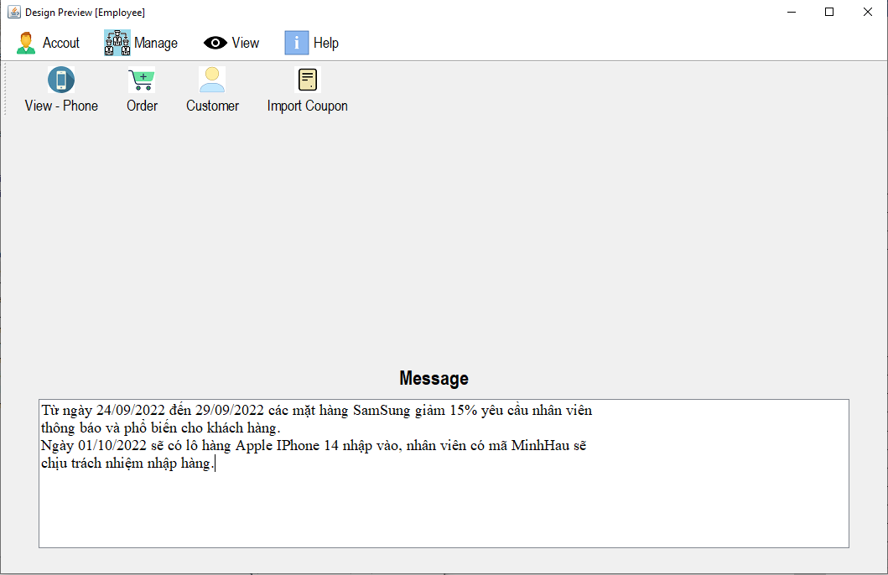

**Đặt tên các điều khiển**

|  |  |  |  |
| --- | --- | --- | --- |
| **TT** | **Điều khiển** | **Tên** | **Giá trị** |
| 1 | JTabbedPane | name | Employee |
| 1.1 | JMenuBar | name | JMenuBar1 |
| 1.1.1 | JMenu | name | mnuAccount |
|  |  | Text | Account |
|  |  | Icon | accout.png |
| 1.1.1.1 | JMenuItem | name | mniLogin |
|  |  | Text | Login |
|  |  | Icon | login_1.png |
| 1.1.1.2 | JMenuItem | name | mniLogout |
|  |  | Text | Logout |
|  |  | Icon | logout.png |
| 1.1.1.3 | JMenuItem | name | mniChangePassword |
|  |  | Text | ChangePassword |
|  |  | Icon | ChangePassword.png |
| 1.1.1.4 | JMenuItem | name | MniExit |
|  |  | Text | Exit |
|  |  | Icon | Exit.png |
| 1.1.2 | JMenu | name | mnuManage |
|  |  | Text | Manage |
|  |  | Icon | manage01.png |
| 1.1.2.1 | JMenuItem | name | mniInformationPhone |
|  |  | Text | InformationPhone |
|  |  | Icon | dienthoai.png |
| 1.1.2.2 | JMenuItem | name | mniInfomationCustomer |
|  |  | Text | InfomationCustomer |
|  |  | Icon | customer.png |
| 1.1.2.3 | JMenuItem | name | mniOrder |
|  |  | Text | Order |
|  |  | Icon | order.png |
| 1.1.2.4 | JMenuItem | name | mniImportCoupon |
|  |  | Text | mportCoupon |
|  |  | Icon | ImportCoupon.png |
| 1.1.3 | JMenu | name | mnuView |
|  |  | Text | View |
|  |  | Icon | view.png |
| 1.1.3.1 | JMenuItem | name | mniStorePhone |
|  |  | Text | StorePhone |
|  |  | Icon | StorePhone.png |
| 1.1.4 | JMenu | name | mnuHelp |
|  |  | Text | Help |
|  |  | Icon | help.png |
| 1.1.4.1 | JMenuItem | name | mniUserManual |
|  |  | Text | UserManual |
|  |  | Icon | UserManual.png |
| 1.1.5 | JLabel | name | lblTitle |
|  |  | Text | Message |
| 1.1.6 | JScrollPane | name | jScrollPane1 |
| 1.1.6.1 | JTextArea | Name | txtMassage |
|  |  | Text | Từ ngày 24/09/2022 đến 29/09/2022 các mặt hàng SamSung giảm 15% yêu cầu nhân viên  thông báo và phổ biến cho khách hàng.  Ngày 01/10/2022 sẽ có lô hàng Apple IPhone 14 nhập vào, nhân viên có mã MinhHau sẽ  chịu trách nhiệm nhập hàng. |
| 1.1.7 | JToolBar | name | jToolBar1 |
| 1.1.7.1 | JButton | name | btnView_phone |
|  |  | Text | View - Phone |
|  |  | Icon | dienthoai.png |
| 1.1.7.2 | JButton | Name | btnOrder |
|  |  | Text | Order |
|  |  | Icon | order.png |
| 1.1.7.3 | JButton | Name | btnCustomer |
|  |  | Text | Customer |
|  |  | Icon | customer.png |
| 1.1.7.4 | JButton | Name | btnImprotCoupon |
|  |  | Text | Import Coupon |
|  |  | Icon | ImportCoupon.png |
| 1.1.8 | JLabel | name | lblImage |

#### Cửa sổ Manage Customer

**Giao diện**

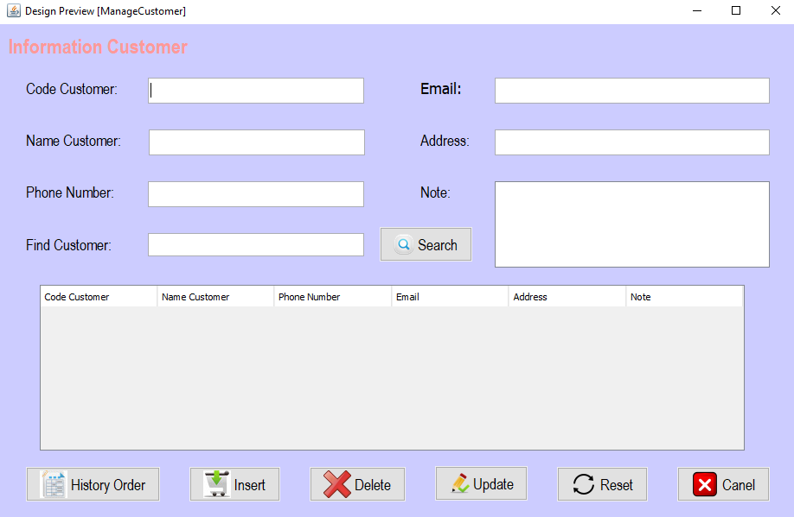

**Đặt tên các điều khiển**

|  |  |  |  |
| --- | --- | --- | --- |
| **TT** | **Điều khiển** | **Tên** | **Giá trị** |
| 1 | JPanel | name | PanelNen |
| 1.1 | JLabel | name | lblCodeCustomer |
|  |  | Text | Code Customer |
| 1.2 | JLabel | name | lblNameCustomer |
|  |  | Text | Name Customer |
| 1.3 | JLabel | name | lblPhoneNumber |
|  |  | Text | Phone Number |
| 1.4 | JLabel | name | lblEmail |
|  |  | Text | Email |
| 1.5 | JLabel | name | lblAddress |
|  |  | Text | Address |
| 1.6 | JLabel | name | lblNote |
|  |  | Text | Note |
| 1.7 | JLabel | name | lblFindCustomer |
|  |  | Text | Find Customer |
| 1.8 | JTextField | name | txtFindCustomer |
| 1.9 | JButton | name | btnSearch |
|  |  | Text | Search |
|  |  | Icon | Search_1.png |
| 1.10 | JTextArea | name | txtNote |
| 1.11 | JTextField | name | txtAddress |
| 1.12 | JTextField | name | txtEmail |
| 1.13 | JTextField | name | txtCodeCustomer |
| 1.14 | JTextField | name | txtNameCustomer |
| 1.15 | JTextField | name | txtPhoneNumber |
| 1.16 | JTable | name | tblnformationCustomer |
|  |  | Text | Code Customer, Name Customer, Phone Number, Email, Address, Note |
| 1.17 | JButton | name | btnHistoryOrder |
|  |  | Text | History Order |
|  |  | Icon | HistoryOrder.png |
| 1.18 | JButton | name | btnInsert |
|  |  | Text | Insert |
|  |  | Icon | insert.png |
| 1.19 | JButton | name | btnDelete |
|  |  | Text | Delete |
|  |  | Icon | delete.png |
| 1.20 | JButton | name | btnUpdate |
|  |  | Text | Update |
|  |  | Icon | Update.png |
| 1.21 | JButton | name | btnReset |
|  |  | Text | Reset |
|  |  | Icon | Reset.png |
| 1.22 | JButton | name | btnCancel |
|  |  | Text | Cancel |
|  |  | Icon | Cancel_1.png |
| 1.23 | JLabel | name | lblInformationCustomer |
|  |  | Text | Information Customer |

#### Cửa sổ Manage Import

**Giao diện**

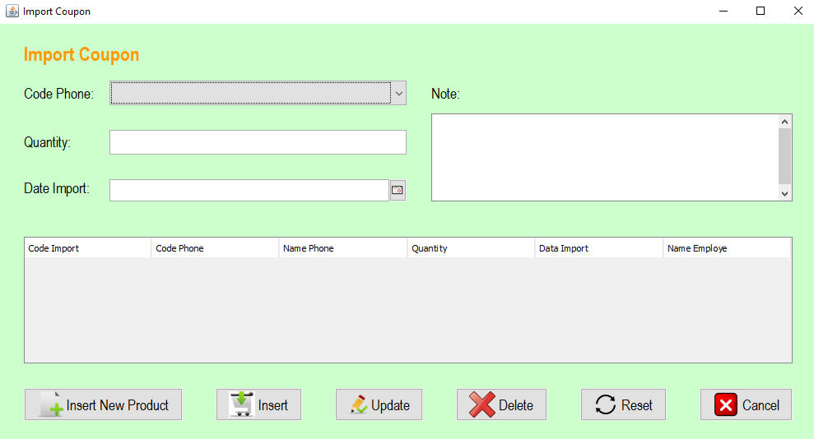

**Đặt tên các điều khiển**

|  |  |  |  |
| --- | --- | --- | --- |
| **TT** | **Điều khiển** | **Tên** | **Giá trị** |
| 1 | JPanel | name | Panelnen |
| 2 | JLabel | name | lblCodePhone |
|  |  | Text | Code Phone |
| 3 | JLabel | name | lblQuantity |
|  |  | Text | Quantity |
| 4 | JLabel | name | lblDateImport |
|  |  | Text | Date Import |
| 5 | JComboBox | name | cboCodePhone |
| 6 | JTextField | name | txtQuantity |
| 7 | JLabel | name | lblNote |
|  |  | Text | Note |
| 8 | JTextArea | name | txtNote |
| 9 | JTable | name | tblImportCoupon |
|  |  | Text | Code Import, Code Phone, Name Phone, Quantity, Data Import, Name Employe |
| 10 | JButton | Name | btnNewProduct |
|  |  | Text | New Product |
|  |  | Icon | New.png |
| 11 | JButton | Name | btnInsert |
|  |  | Text | Insert |
|  |  | Icon | insert.png |
| 12 | JButton | Name | btnUpdate |
|  |  | Text | Update |
|  |  | Icon | Update.png |
| 13 | JButton | Name | btnDelete |
|  |  | Text | Delete |
|  |  | Icon | delete.png |
| 14 | JButton | Name | btnReset |
|  |  | Text | Reset |
|  |  | Icon | Reset.png |
| 15 | JButton | Name | btnCancel |
|  |  | Text | Cancel |
|  |  | Icon | Cancel_1.png |
| 16 | JLabel | Name | lblImportCoupon |
|  |  | Text | Import Coupon |
| 17 | JDateChooser | Name | txtDateImport |

#### Cửa sổ Manage Order

**Giao Diện**

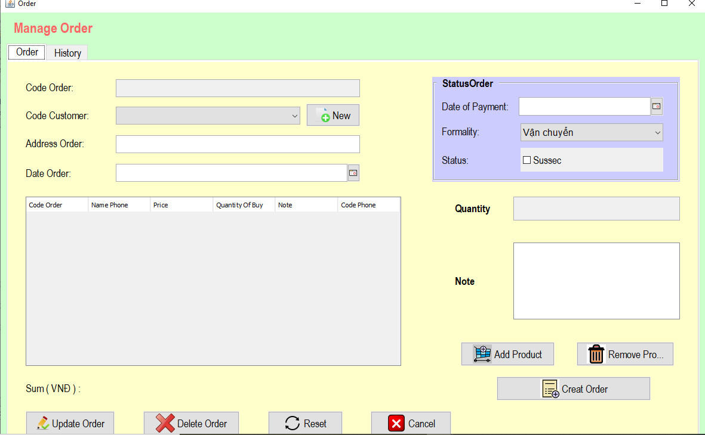

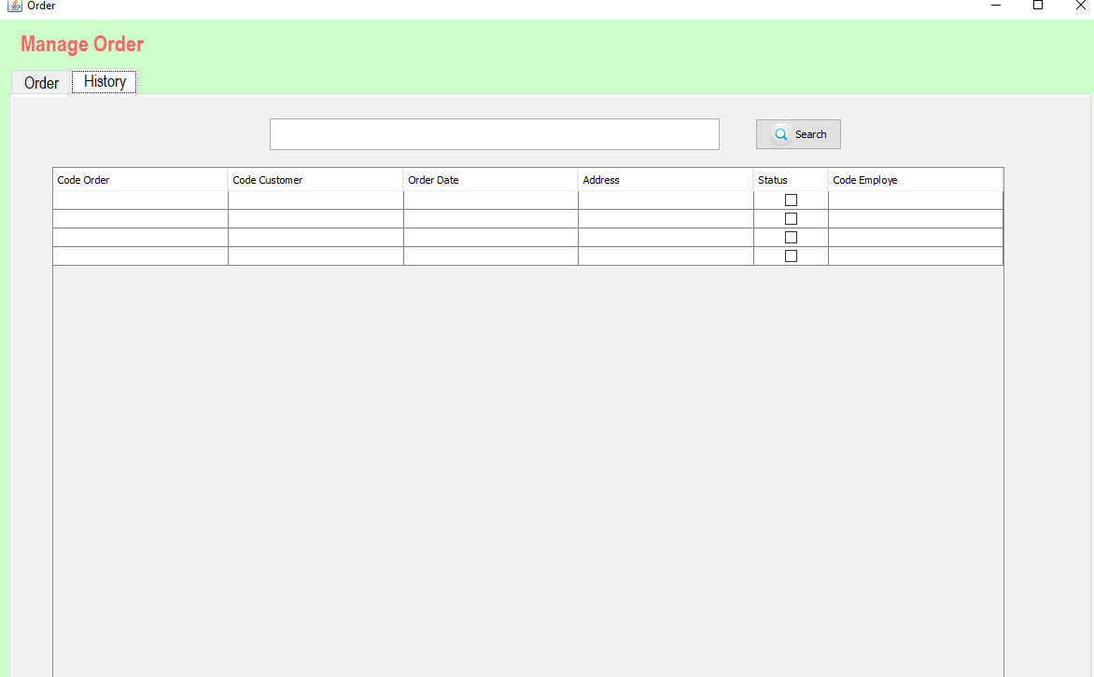

**Đặt tên các điều khiển**

|  |  |  |  |
| --- | --- | --- | --- |
| **TT** | **Điều khiển** | **Tên** | **Giá trị** |
| 1 | JPanel | name | PanelNen |
| 1.1 | JTabbedPane | name | tab |
| 1.1.1 | JPanel | name | tabOrder |
| 1.1.1.1 | JLabel | name | lblCodeOrder |
|  |  | Text | Code Order |
| 1.1.1.2 | JLabel | name | lblAddressOrder |
|  |  | Text | Address Order |
| 1.1.1.3 | JTextField | name | txtCodeOrder |
| 1.1.1.4 | JTextField | name | txtAddressOrder |
| 1.1.1.5 | JLabel | name | lblCodeEmployee |
|  |  | Text | Code Customer |
| 1.1.1.6 | JLabel | Name | lblDateOrder |
|  |  | Text | Date Order |
| 1.1.1.7 | JButton | name | btnCreatOrder |
|  |  | Text | Creat Order |
|  |  | Icon | CreateOrder.png |
| 1.1.1.8 | JButton | name | btnDeleteOrder |
|  |  | Text | Delete Order |
|  |  | Icon | delete.png |
| 1.1.1.9 | JButton | name | btnCancelOrder |
|  |  | Text | Cancel |
|  |  | Icon | Cancel_1.png |
| 1.1.1.10 | JButton | Name | btnUpdateOrder |
|  |  | Text | Update Order |
|  |  | Icon | Update.png |
| 1.1.1.11 | JDateChooser | name | txtDateOrder |
| 1.1.1.12 | JComboBox | name | cboCustomer |
| 1.1.1.13 | JButton | Name | btnNewCustomer |
|  |  | Text | New |
|  |  | Icon | New.png |
| 1.1.1.14 | JButton | Name | btnResetOrder |
|  |  | Text | Reset |
|  |  | Icon | Reset.png |
| 1.1.1.15 | JTable | Name | tblDetail |
|  |  | Text | Code Order, Name Phone, Price, Quantity Of Buy, Note, Code Phone |
| 1.1.1.16 | JButton | Name | btnRemove |
|  |  | Text | Remove Product |
|  |  | Icon | Delete_1.png |
| 1.1.1.17 | JPanel | Name | PanelStatus |
| 1.1.1.18 | JLabel | name | lblDatePay |
|  |  | Text | Date of Payment |
| 1.1.1.19 | JDateChooser | name | txtDatePay |
| 1.1.1.20 | JComboBox | name | cbFormality |
| 1.1.1.21 | JLabel | name | lblFormality |
|  |  | Text | Formality |
| 1.1.1.22 | JLabel | name | lblStatus |
|  |  | Text | Status |
| 1.1.1.23 | JComboBox | name | chkstatus |
|  |  | Text | Sussec |
| 1.1.1.24 | JTextArea | name | txtNote |
| 1.1.1.25 | JLabel | name | txtSum |
| 1.1.1.26 | JLabel | name | lblSum |
|  |  | Text | Sum ( VNĐ ) |
| 1.1.1.27 | JLabel | Name | lblQuantity |
|  |  | Text | Quantity |
| 1.1.1.28 | JLabel | Name | lblNote |
|  |  | Text | Note |
| 1.1.1.29 | JButton | Name | btnAddProduct |
|  |  | Text | Add Product |
|  |  | Icon | AddProduct.png |
| 1.1.2 | JPanel | Name | tabHistory |
| 1.1.2.1 | JTable | Name | tblHistory |
|  |  | Text | Code Order, Code Customer, Order Date, Address, Status, Code Employe |
| 1.1.2.2 | JTextField | Name | txtFind |
|  |  | Text | Insert |
| 1.1.2.3 | JButton | Name | btnSearch |
|  |  | Text | Search |
|  |  | Icon | Search_1.png |
| 1.2 | JLabel | Name | lblManageOrder |
|  |  | Text | Manage Order |

#### Cửa sổ Manage Phone

Giao Diện

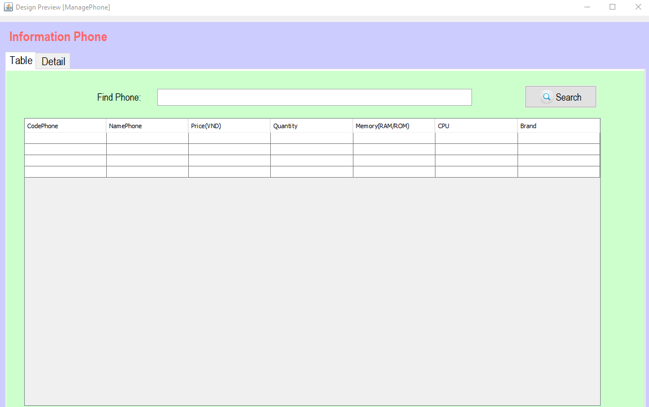

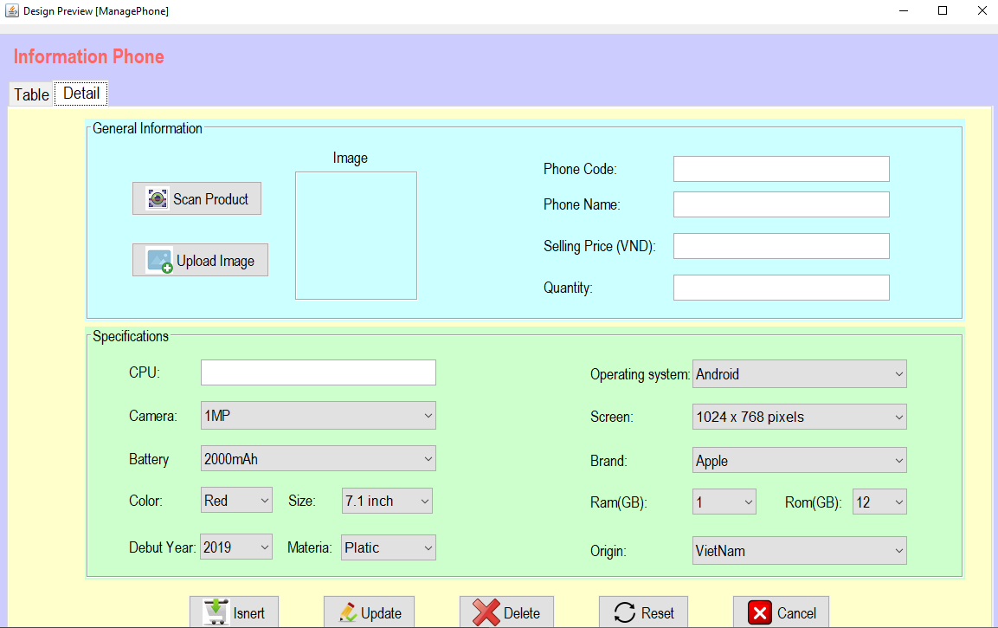

**Đặt tên các điều khiển**

|  |  |  |  |
| --- | --- | --- | --- |
| **TT** | **Điều khiển** | **Tên** | **Giá trị** |
| 1 | JPanel | name | panelnen |
| 1.1 | JTabbedPane | name | TabPanel |
| 1.1.1 | JPanel | name | tabTable |
| 1.1.1.1 | JTable | name | tblPhone |
|  |  | Text | CodePhone, NamePhone, Price(VND), Quantity, Memory(RAM/ROM), CPU, Brand |
| 1.1.1.2 | JLabel | name | lblFindPhone |
|  |  | Text | Find Phone |
| 1.1.1.3 | JTextField | name | txtFindPhone |
| 1.1.1.4 | JButton | name | btnSearch |
|  |  | Text | Search |
|  |  | Icon | Search_1.png |
| 1.1.2 | JPanel | name | tabDetail |
| 1.1.2.1 | JPanel | name | TabGeneral |
| 1.1.2.1.1 | JButton | name | btnScanProduct |
|  |  | Text | Scan Product |
|  |  | Icon | scan_1.png |
| 1.1.2.1.2 | JButton | name | btnUploadImage |
|  |  | name | Upload Image |
|  |  | Icon | Upload Image.png |
| 1.1.2.1.3 | JLabel | Name | lblImage |
| 1.1.2.1.4 | JTextField | Name | txtPhoneCode |
| 1.1.2.1.5 | JTextField | Name | txtPhoneName |
| 1.1.2.1.6 | JTextField | Name | txtSellingPrice |
| 1.1.2.1.7 | JTextField | Name | txtQuantity |
| 1.1.2.1.8 | JLabel | name | lblPhoneCode |
|  |  | Text | Phone Code |
| 1.1.2.1.9 | JLabel | name | lblPhoneName |
|  |  | Text | Phone Name |
| 1.1.2.1.10 | JLabel | name | lblSellingPrice |
|  |  | Text | Selling Price (VND) |
| 1.1.2.1.11 | JLabel | name | lblQuantity |
|  |  | Text | Quantity |
| 1.1.2.1.12 | JLabel | name | lblImage1 |
|  |  | Text | Image |
| 1.1.2.2 | JPanel | name | tabSpecification |
| 1.1.2.2.1 | JLabel | name | lblCPU |
|  |  | Text | CPU |
| 1.1.2.2.2 | JLabel | name | lblOperatingSystem |
|  |  | Text | Operating system |
| 1.1.2.2.3 | JLabel | name | lblScreen |
|  |  | Text | Screen |
| 1.1.2.2.4 | JLabel | name | lblBrand |
|  |  | Text | Brand |
| 1.1.2.2.5 | JLabel | name | lblCamera |
|  |  | Text | Camera |
| 1.1.2.2.6 | JLabel | name | lblBattery |
|  |  | Text | Battery |
| 1.1.2.2.7 | JTextField | Name | txtCPU |
|  | JLabel | name | lblColor |
|  |  | Text | Color |
| 1.1.2.2.8 | JLabel | name | lblSize |
|  |  | Text | Size |
| 1.1.2.2.9 | JLabel | name | lblRam |
|  |  | Text | Ram(GB) |
| 1.1.2.2.10 | JLabel | name | lblRom |
|  |  | Text | Rom(GB) |
| 1.1.2.2.11 | JLabel | name | lblDebutYear |
|  |  | Text | Debut Year |
| 1.1.2.2.12 | JLabel | name | lblMateria |
|  |  | Text | Materia |
| 1.1.2.2.13 | JLabel | name | lblOrigin |
|  |  | Text | Origin |
| 1.1.2.2.14 | JComboBox | name | cboRam |
| 1.1.2.2.15 | JComboBox | Name | cboRom |
| 1.1.2.2.16 | JComboBox | Name | cbooperatingSystem |
| 1.1.2.2.17 | JComboBox | Name | cboBrand |
| 1.1.2.2.18 | JComboBox | Name | cboYear |
| 1.1.2.2.19 | JComboBox | Name | cboColor |
| 1.1.2.2.20 | JComboBox | Name | cboMateria |
| 1.1.2.2.21 | JComboBox | Name | cboScreen |
| 1.1.2.2.22 | JComboBox | name | cboSize |
| 1.1.2.2.23 | JComboBox | Name | cboCamera |
| 1.1.2.2.24 | JComboBox | Name | cboBattery |
| 1.1.2.2.25 | JComboBox | Name | cboOrigin |
| 1.1.2.3 | JButton | Name | btnInsert |
|  |  | Text | Isnert |
|  |  | Icon | insert.png |
| 1.1.2.4 | JButton | Name | btnUpdate |
|  |  | Text | Update |
|  |  | Icon | Update.png |
| 1.1.2.5 | JButton | Name | btnDelete |
|  |  | Text | Delete |
|  |  | Icon | delete.png |
| 1.1.2.6 | JButton | Name | btnReset |
|  |  | Text | Reset |
|  |  | Icon | Reset.png |
| 1.1.2.7 | JButton | Name | btnCancel |
|  |  | Text | Cancel |
|  |  | Icon | Cancel_1.png |
| 1.2 | JLabel | name | lblInformationPhone |
|  |  | Text | Information Phone |

#### Cửa sổ Manager

**Giao Diện**

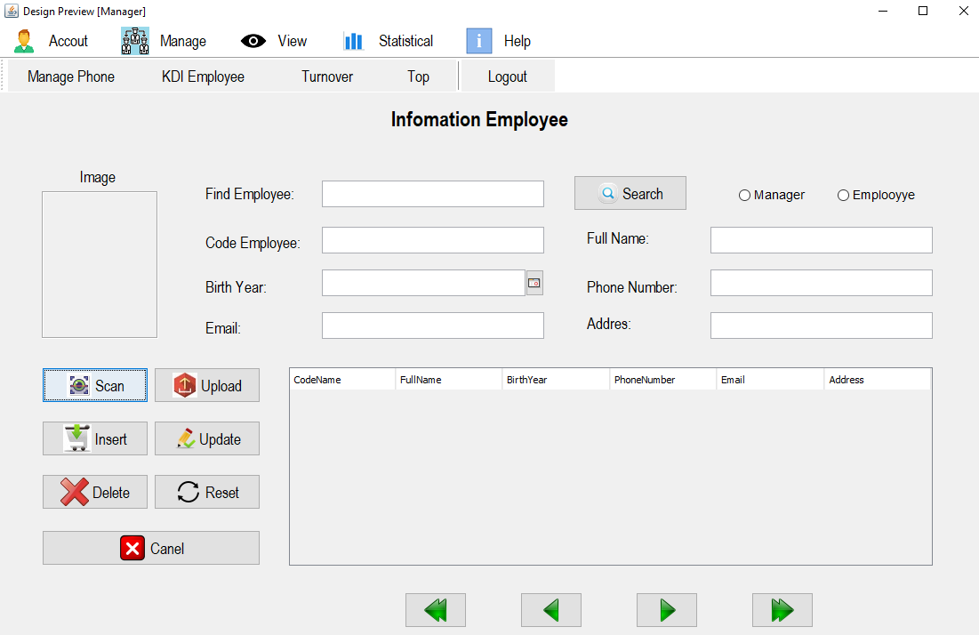

**Đặt tên các điều khiển**

|  |  |  |  |
| --- | --- | --- | --- |
| **TT** | **Điều khiển** | **Tên** | **Giá trị** |
| 1 | JMenuBar | name | mnumanager |
| 1.1 | JMenu | name | mnuAccout |
|  |  | Text | Accout |
|  |  | Icon | accout.png |
| 1.1.1 | JMenuItem | name | mItemLogin |
|  |  | Text | Login |
|  |  | Icon | login_1.png |
| 1.1.2 | JMenuItem | name | mItemLogout |
|  |  | Text | Logout |
|  |  | Icon | logout.png |
| 1.1.3 | JMenuItem | name | mItemChangePass |
|  |  | Text | Change Password |
|  |  | Icon | ChangePassword.png |
| 1.1.4 | JMenuItem | name | mitemBack |
|  |  | Text | Exit |
|  |  |  | Exit.png |
| 1.2 | JMenu | name | mnuManage |
|  |  | Text | Manage |
|  |  | Icon | manage01.png |
| 1.2.1 | JMenuItem | name | mniInformationPhone |
|  |  | Text | InformationPhone |
|  |  | Icon | dienthoai.png |
| 1.2.2 | JMenuItem | name | mniInfomationCustomer |
|  |  | Text | InfomationCustomer |
|  |  | Icon | customer.png |
| 1.2.3 | JMenuItem | name | mniOrder |
|  |  | Text | Order |
|  |  | Icon | order.png |
| 1.2.4 | JMenuItem | name | mniImportCoupon |
|  |  | Text | mportCoupon |
|  |  | Icon | ImportCoupon.png |
| 1.3 | JMenu | name | mnuView |
|  |  | Text | View |
|  |  | Icon | view.png |
| 1.3.1 | JMenuItem | name | mniStorePhone |
|  |  | Text | StorePhone |
|  |  | Icon | StorePhone.png |
| 1.4 | JMenu | name | mnuStatistical |
|  |  | Text | Statistical |
|  |  | Icon | help.png |
| 1.4.1 | JMenuItem | name | mItemTurnover |
|  |  | Text | TurnOver |
|  |  | Icon | TurnOver.png |
| 1.4.2 | JMenuItem | name | mItem Debt |
|  |  | Text | Debt |
|  |  |  | Debt.png |
| 1.4.3 | Separator | name | spt |
| 1.4.4 | JMenuItem | name | mItemKDI |
|  |  | Text | KPI Product |
|  |  | Icon | KDI Employee.png |
| 1.5 | JMenu | name | mnuHelp |
|  |  | Text | Help |
|  |  | Icon | help.png |
| 1.5.1 | JMenuItem | name | mItemUse |
|  |  | Text | UserManual |
|  |  | Icon | UserManual.png |
| 1.5.2 | JMenuItem | name | mItemAbout |
|  |  | Text | About |
|  |  | Icon | about.png |
| 1.5.3 | JMenuItem | name | mItemExit |
|  |  | Text | Exit |
|  |  | Icon | Exit.png |
| 2 | JPanel | name | Main |
| 3 | JToolBar | name | tlbmanager |
| 3.1 | JButton | name | btnmanagePhone |
|  |  | Text | Manage Phone |
| 3.2 | JButton | name | btnKDI |
|  |  | Text | KDI Employee |
| 3.3 | JButton | name | btnTurnover |
|  |  | Text | Turnover |
| 3.4 | JButton | name | btnTop |
|  |  | Text | Top |
| 3.5 | Separator | name | spll |
| 3.6 | JButton | name | btnLogout |
|  |  | Text | Logout |
| 4 | JLabel | name | lblInfomationEmployee |
|  |  | Text | Infomation Employee |
| 5 | JPanel | name | panelMain |
| 5.1 | JLabel | name | lblimage |
| 5.2 | JLabel | name | lblcodeEmpoloyee |
|  |  | Text | Code Employee |
| 5.3 | JLabel | name | lblFind |
|  |  | Text | Find Employee |
| 5.4 | JTextField | Text | txtSearch |
| 5.5 | JButton | name | btnSearch |
|  |  | Text | Search |
|  |  | Icon | Search_1.png |
| 5.6 | JTextField | Text | txtCodeEmployee |
| 5.7 | JLabel | name | lblYear |
|  |  | Text | Birth Year |
| 5.8 | JLabel | name | lblemail |
|  |  | Text | Email |
| 5.9 | JTextField | Text | txtEmail |
| 5.10 | JLabel | name | lblname |
|  |  | Text | Full Name |
| 5.11 | JLabel | name | lblPhone |
|  |  | Text | Phone Number |
| 5.12 | JLabel | name | lblAddress |
|  |  | Text | Addres |
| 5.13 | JTextField | Text | txtFullName |
| 5.14 | JTextField | Text | txtPhoneNumber |
| 5.15 | JTextField | Text | txtAddress |
| 5.16 | JButton | Name | btnScan |
|  |  | Text | Scan |
|  |  | Icon | scan_1.png |
| 5.17 | JButton | Name | btnUpload |
|  |  | Text | Upload |
|  |  | Icon | upload.png |
| 5.18 | JTable | name | tblEmployee |
|  |  | Text | CodeName, FullName, BirthYear, PhoneNumber, Email, Address |
| 5.19 | JButton | Name | btnInsert |
|  |  | Text | Insert |
|  |  | Icon | insert.png |
| 5.20 | JButton | Name | btnUpdate |
|  |  | Text | Update |
|  |  | Icon | Update.png |
| 5.21 | JButton | Name | btnDelete |
|  |  | Text | Delete |
|  |  | Icon | delete.png |
| 5.22 | JButton | Name | btnReset |
|  |  | Text | Reset |
|  |  | Icon | Reset.png |
| 5.23 | JButton | Name | btnCancel |
|  |  | Text | Cancel |
|  |  | Icon | Cancel_1.png |
| 5.24 | JButton | Name | btnLeftEnd |
|  |  | Icon | lefy1.png |
| 5.25 | JButton | Name | btnLeft |
|  |  | Icon | left.png |
| 5.26 | JButton | Name | btnRight |
|  |  | Icon | next.png |
| 5.27 | JButton | Name | btnRightEnd |
|  |  | Icon | right1.png |
| 5.28 | JLabel | Name | image |
|  |  | Text | Image |
| 5.29 | JDateChooser | Name | txtDataBirth |
| 5.30 | JRadioButton | Name | rdoemployye |
|  |  | Text | Emplooyye |
| 5.31 | JRadioButton | Name | rdomanager |
|  |  | Text | Manager |

#### Cửa sổ StorePhone

**Giao diện**

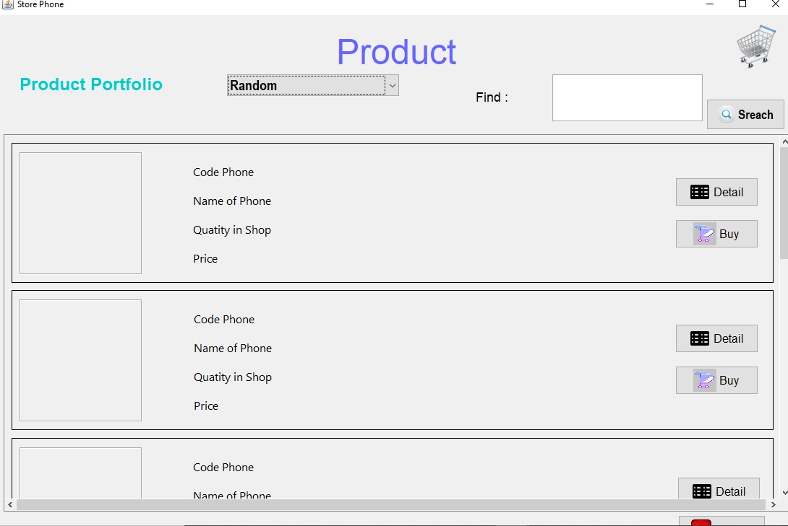

**Đặt tên các điều khiển**

|  |  |  |  |
| --- | --- | --- | --- |
| **TT** | **Điều khiển** | **Tên** | **Giá trị** |
| 1 | JScrollPane | name | spl |
| 1.1 | JPanel | name | tblProduct |
| 1.1.1 | JPanel | name | sp1 |
| 1.1.1.1 | JPanel | name | ListProduct1 |
| 1.1.1.1.1 | JLabel | name | lblImage |
| 1.1.1.1.2 | JLabel | name | lblCodePhone |
|  |  | Text | Code Phone |
| 1.1.1.1.3 | JLabel | name | txtCodePhone |
| 1.1.1.1.4 | JLabel | name | txtNameOfPhone |
| 1.1.1.1.5 | JLabel | name | lblNameOfPhone |
|  |  | Text | Name of Phone |
| 1.1.1.1.6 | JLabel | name | lblPrice |
|  |  | Text | Price |
| 1.1.1.1.7 | JLabel | name | txtPrice |
| 1.1.1.1.8 | JLabel | name | lblQuatityInShop |
|  |  | Text | Quatity in Shop |
| 1.1.1.1.9 | JLabel | name | txtQuatityInShop |
| 1.1.1.1.10 | JButton | Name | btnDetail |
|  |  | Text | Detail |
|  |  | Icon | Detail.png |
| 1.1.1.1.11 | JButton | Name | btnBuy |
|  |  | Text | Buy |
|  |  | Icon | buy.png |
| 1.1.2 | JPanel | name | sp2 |
| 1.1.2.2 | JPanel | name | ListProduct2 |
| 1.1.2.2.1 | JLabel | name | lblImage1 |
| 1.1.2.2.2 | JLabel | name | lblCodePhone1 |
|  |  | Text | Code Phone |
| 1.1.2.2.3 | JLabel | name | txtCodePhone1 |
| 1.1.2.2.4 | JLabel | name | txtNameOfPhone1 |
| 1.1.2.2.5 | JLabel | name | lblNameOfPhone1 |
|  |  | Text | Name of Phone |
| 1.1.2.2.6 | JLabel | name | lblPrice1 |
|  |  | Text | Price |
| 1.1.2.2.7 | JLabel | name | txtPrice1 |
| 1.1.2.2.8 | JLabel | name | lblQuatityInShop1 |
|  |  | Text | Quatity in Shop |
| 1.1.2.2.9 | JLabel | name | txtQuatityInShop1 |
| 1.1.2.2.10 | JButton | Name | btnDetail1 |
|  |  | Text | Detail |
|  |  | Icon | Detail.png |
| 1.1.2.2.11 | JButton | Name | btnBuy1 |
|  |  | Text | Buy |
|  |  | Icon | buy.png |
| 1.1.3 | JPanel | name | sp3 |
| 1.1.3.3 | JPanel | name | ListProduct3 |
| 1.1.3.3.1 | JLabel | name | lblImage2 |
| 1.1.3.3.2 | JLabel | name | lblCodePhone2 |
|  |  | Text | Code Phone |
| 1.1.3.3.3 | JLabel | name | txtCodePhone2 |
| 1.1.3.3.4 | JLabel | name | txtNameOfPhone2 |
| 1.1.3.3.5 | JLabel | name | lblNameOfPhone2 |
|  |  | Text | Name of Phone |
| 1.1.3.3.6 | JLabel | name | lblPrice2 |
|  |  | Text | Price |
| 1.1.3.3.7 | JLabel | name | txtPrice2 |
| 1.1.3.3.8 | JLabel | name | lblQuatityInShop2 |
|  |  | Text | Quatity in Shop |
| 1.1.3.3.9 | JLabel | name | txtQuatityInShop2 |
| 1.1.3.3.10 | JButton | Name | btnDetail2 |
|  |  | Text | Detail |
|  |  | Icon | Detail.png |
| 1.1.3.3.11 | JButton | Name | btnBuy2 |
|  |  | Text | Buy |
|  |  | Icon | buy.png |
| 1.1.4 | JPanel | name | sp4 |
| 1.1.4.4 | JPanel | name | ListProduct4 |
| 1.1.4.4.1 | JLabel | name | lblImage3 |
| 1.1.4.4.2 | JLabel | name | lblCodePhone3 |
|  |  | Text | Code Phone |
| 1.1.4.4.3 | JLabel | name | txtCodePhone3 |
| 1.1.4.4.4 | JLabel | name | txtNameOfPhone3 |
| 1.1.4.4.5 | JLabel | name | lblNameOfPhone3 |
|  |  | Text | Name of Phone |
| 1.1.4.4.6 | JLabel | name | lblPrice3 |
|  |  | Text | Price |
| 1.1.4.4.7 | JLabel | name | txtPrice3 |
| 1.1.4.4.8 | JLabel | name | lblQuatityInShop3 |
|  |  | Text | Quatity in Shop |
| 1.1.4.4.9 | JLabel | name | txtQuatityInShop3 |
| 1.1.4.4.10 | JButton | Name | btnDetail3 |
|  |  | Text | Detail |
|  |  | Icon | Detail.png |
| 1.1.4.4.11 | JButton | Name | btnBuy3 |
|  |  | Text | Buy |
|  |  | Icon | buy.png |
| 1.1.5 | JPanel | name | sp5 |
| 1.1.5.5 | JPanel | name | ListProduct5 |
| 1.1.5.5.1 | JLabel | name | lblImage4 |
| 1.1.5.5.2 | JLabel | name | lblCodePhone4 |
|  |  | Text | Code Phone |
| 1.1.5.5.3 | JLabel | name | txtCodePhone4 |
| 1.1.5.5.4 | JLabel | name | txtNameOfPhone4 |
| 1.1.5.5.5 | JLabel | name | lblNameOfPhone4 |
|  |  | Text | Name of Phone |
| 1.1.5.5.6 | JLabel | name | lblPrice4 |
|  |  | Text | Price |
| 1.1.5.5.7 | JLabel | name | txtPrice4 |
| 1.1.5.5.8 | JLabel | name | lblQuatityInShop4 |
|  |  | Text | Quatity in Shop |
| 1.1.5.5.9 | JLabel | name | txtQuatityInShop4 |
| 1.1.5.5.10 | JButton | Name | btnDetail4 |
|  |  | Text | Detail |
|  |  | Icon | Detail.png |
| 1.1.5.5.11 | JButton | Name | btnBuy4 |
|  |  | Text | Buy |
|  |  | Icon | buy.png |
| 1.1.6 | JPanel | name | sp6 |
| 1.1.6.6 | JPanel | name | ListProduct6 |
| 1.1.6.6.1 | JLabel | name | lblImage5 |
| 1.1.6.6.2 | JLabel | name | lblCodePhone5 |
|  |  | Text | Code Phone |
| 1.1.6.6.3 | JLabel | name | txtCodePhone5 |
| 1.1.6.6.4 | JLabel | name | txtNameOfPhone5 |
| 1.1.6.6.5 | JLabel | name | lblNameOfPhone5 |
|  |  | Text | Name of Phone |
| 1.1.6.6.6 | JLabel | name | lblPrice5 |
|  |  | Text | Price |
| 1.1.6.6.7 | JLabel | name | txtPrice5 |
| 1.1.6.6.8 | JLabel | name | lblQuatityInShop5 |
|  |  | Text | Quatity in Shop |
| 1.1.6.6.9 | JLabel | name | txtQuatityInShop5 |
| 1.1.6.6.10 | JButton | Name | btnDetail5 |
|  |  | Text | Detail |
|  |  | Icon | Detail.png |
| 1.1.6.6.11 | JButton | Name | btnBuy5 |
|  |  | Text | Buy |
|  |  | Icon | buy.png |
| 1.1.7 | JPanel | name | sp7 |
| 1.1.7.7 | JPanel | name | ListProduct7 |
| 1.1.7.7.1 | JLabel | name | lblImage6 |
| 1.1.7.7.2 | JLabel | name | lblCodePhone6 |
|  |  | Text | Code Phone |
| 1.1.7.7.3 | JLabel | name | txtCodePhone6 |
| 1.1.7.7.4 | JLabel | name | txtNameOfPhone6 |
| 1.1.7.7.5 | JLabel | name | lblNameOfPhone6 |
|  |  | Text | Name of Phone |
| 1.1.7.7.6 | JLabel | name | lblPrice6 |
|  |  | Text | Price |
| 1.1.7.7.7 | JLabel | name | txtPrice6 |
| 1.1.7.7.8 | JLabel | name | lblQuatityInShop6 |
|  |  | Text | Quatity in Shop |
| 1.1.7.7.9 | JLabel | name | txtQuatityInShop6 |
| 1.1.7.7.10 | JButton | Name | btnDetail6 |
|  |  | Text | Detail |
|  |  | Icon | Detail.png |
| 1.1.7.7.11 | JButton | Name | btnBuy6 |
|  |  | Text | Buy |
|  |  | Icon | buy.png |
| 1.1.8 | JButton | Name | btnPage1 |
|  |  | Text | 1 |
| 1.1.9 | JButton | Name | btnPage2 |
|  |  | Text | 2 |
| 1.1.10 | JButton | Name | btnPage3 |
|  |  | Text | 3 |
| 1.1.11 | JButton | Name | btnPage4 |
|  |  | Text | 4 |
| 1.1.12 | JButton | Name | btnPage5 |
|  |  | Text | 5 |
| 1.1.13 | JButton | Name | btnLeftEnd |
|  |  | Text | << |
| 1.1.13 | JButton | Name | btnRightEnd |
|  |  | Text | >> |
| 2 | JLabel | name | lblProduct |
|  |  | Text | Product |
| 3 | JLabel | name | lblProduct |
|  |  | Text | Product |
| 4 | JLabel | name | lblProduct |
|  |  | Text | Product |
| 5 | JLabel | name | lblProduct |
| 6 | JButton | Name | btnSearch |
|  |  | Text | Search |
|  |  | Icon | Search_1.png |
| 7 | JButton | Name | btnCancel |
|  |  | Text | Cancel |
|  |  | Icon | Cancel_1.png |
| 8 | JComboBox | name | cboProductPortfolio |
|  |  | Text | Random |
| 9 | JLabel | name | lblBuy |
|  |  | Icon | cart.png |

#### Cửa sổ StatisticalJFrame

Giao Diện

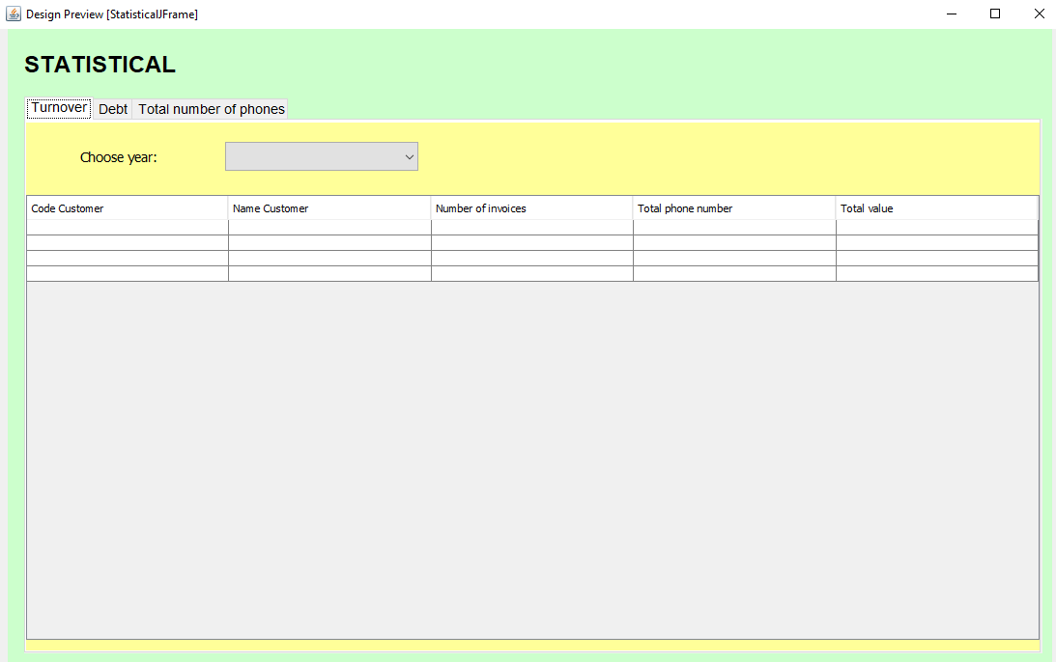

**Đặt tên các điều khiển**

|  |  |  |  |
| --- | --- | --- | --- |
| **TT** | **Điều khiển** | **Tên** | **Giá trị** |
| 1 | JPanel | name | pnStatistical |
| 1.1 | JTabbedPane | name | spl |
| 1.1.1 | JPanel | name | TabTurnOver |
| 1.1.1.1 | JComboBox | name | cboTurnover |
| 1.1.1.2 | JLabel | name | lblChooseYearTO |
|  |  | Text | Choose year |
| 1.1.1.3 | JTable | name | tblTurnOver |
|  |  | Text | CodeCustomer, Number of invoices, Total phone number, Total value |
| 1.1.2 | JPanel | name | TabDebt |
| 1.1.2.1 | JComboBox | name | cboDebt |
| 1.1.2.2 | JLabel | name | lblChooseYearDebt |
|  |  | Text | Choose year |
| 1.1.2.3 | JTable | name | tblDebt |
|  |  | Text | CodeCustomer, Total phone number, Total value, total unpaid order |
| 1.1.3 | JPanel | name | TabTotalNumberOfPhones |
| 1.1.3.1 | JLabel | name | lblChoose MonthYear |
|  |  | Text | Choose Month-Year |
| 1.1.3.2 | JComboBox | name | cboTotalNumberOfPhones |
| 1.1.3.3 | JTable | name | tblTotalNumberOfPhones |
|  |  | Text | Code Phone, Name Phone, Total phone number, Unit price |
| 1.2 | JLabel | name | lblSTATISTICAL |
|  |  | Text | STATISTICAL |