**Maharishi University of Management**

**CS522 – Big Data**

**Prof. Premchand Nair**

**Set Up a Spark**

**September 23th, 2017**

|  |  |  |
| --- | --- | --- |
| Author | ID | Date |
| Minh Hieu Nguyen | 985949 | 09/23/2017 |

Feb 2nd, 2017

Table of Contents

1. Host machine 3

2. Reference Guides sites 3

3. Verifying Spark installation 3

4. Verifying Java Installation 3

5. Install Scala IDE for Eclipse 4

6. Create Scala Project from Eclipse 6

7. Download the Sample Scala Apache Access Log Parser Source Code 12

8. Create Spark project and convert to Maven project 12

9. Download Apache Log File and then put into the input directory in HDFS 14

10. Export to JAR file 17

11. Run MySpark project to Spark 18

# Host machine

I installed vmware and used Cloudera QuickStart VM on my windows

# Reference Guides sites

* Apache Spark Tutorial - <http://www.tutorialspoint.com//apache_spark/index.htm>
* Apache (Unix) Log Samples - <http://www.monitorware.com/en/logsamples/apache.php>
* Scala IDE - <http://scala-ide.org/docs/videos.html>

# Verifying Spark installation

$ /usr/bin/spark-shell

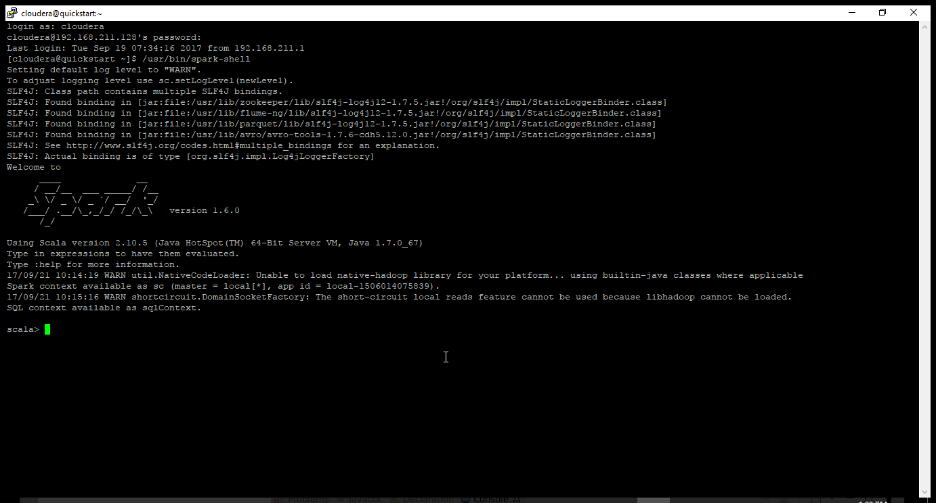

Spark version 1.6.0

Scala version 2.10.6

Configuration location

/etc/spark/conf

TO USE HDFS

/user/cloudera

# Verifying Java Installation

$ java -version

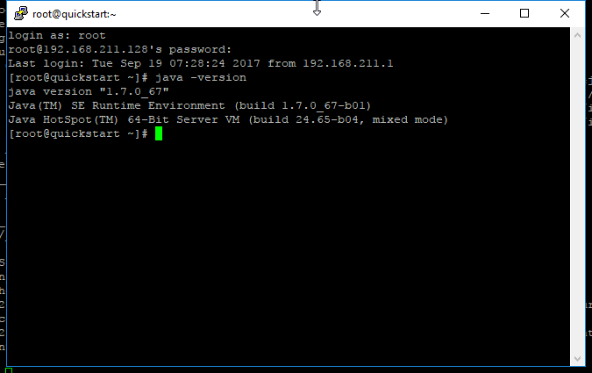

# Install Scala IDE for Eclipse

**Step 1**: Launch Eclipse, then select Help → Install New Software…

**Step 2**: Enter this URL to “Work with” dropdown list

<http://download.scala-ide.org/sdk/lithium/e44/scala211/stable/site>

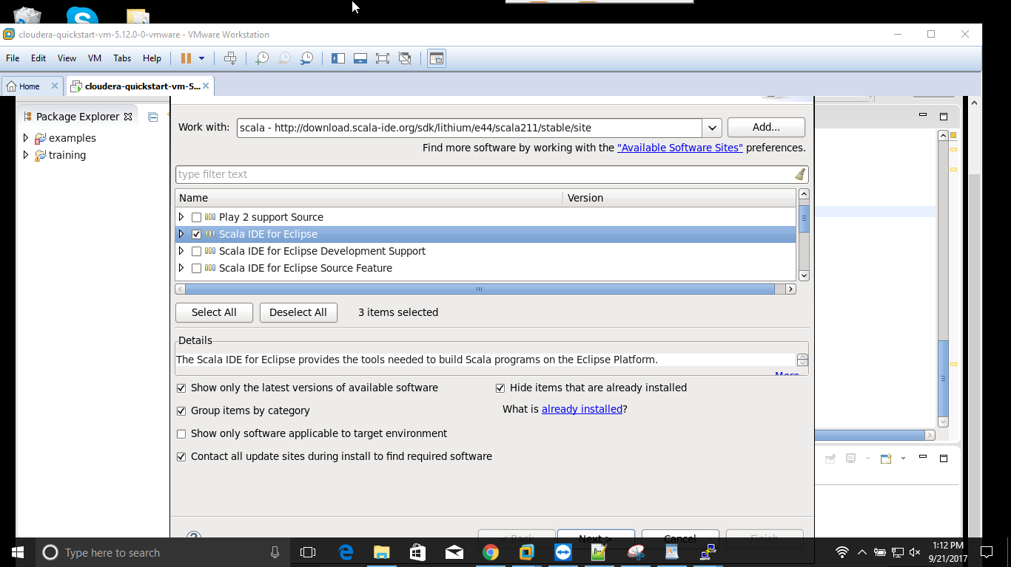

Select the checkbox “**Select Scala IDE for Eclipse**” to install.

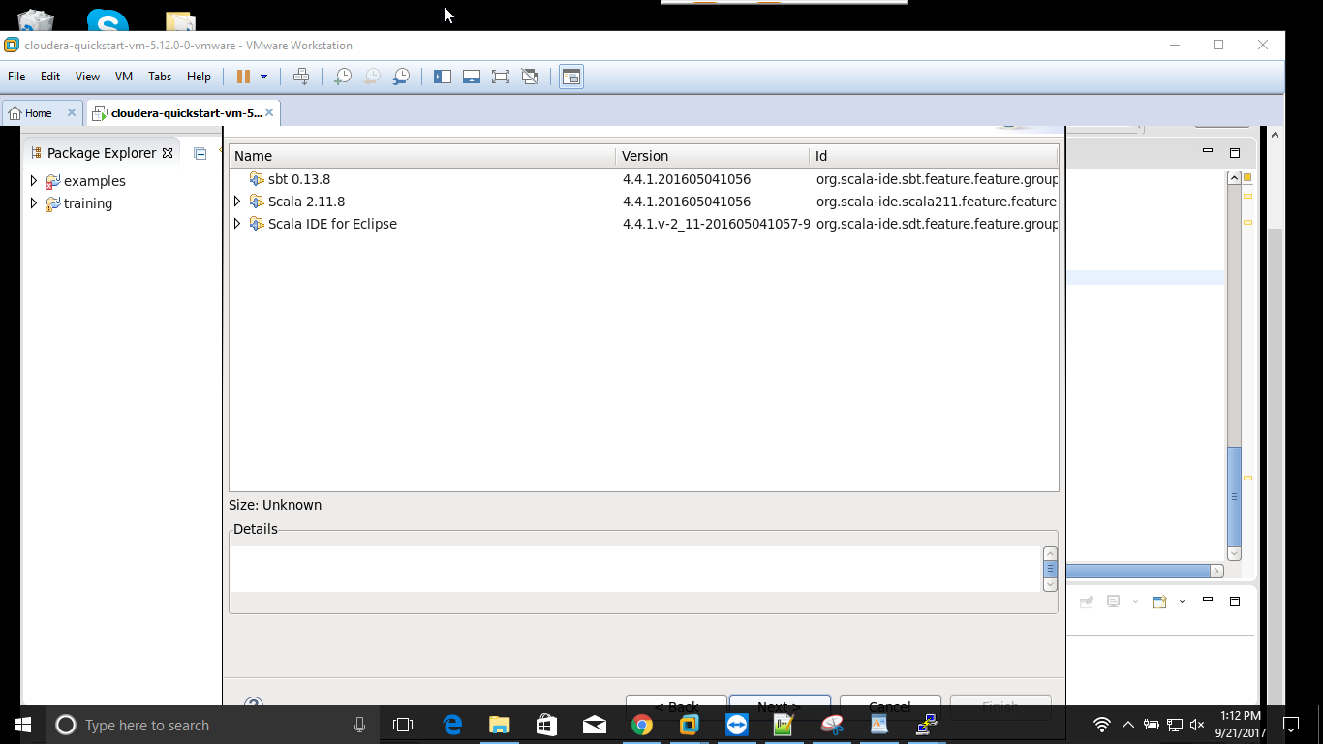

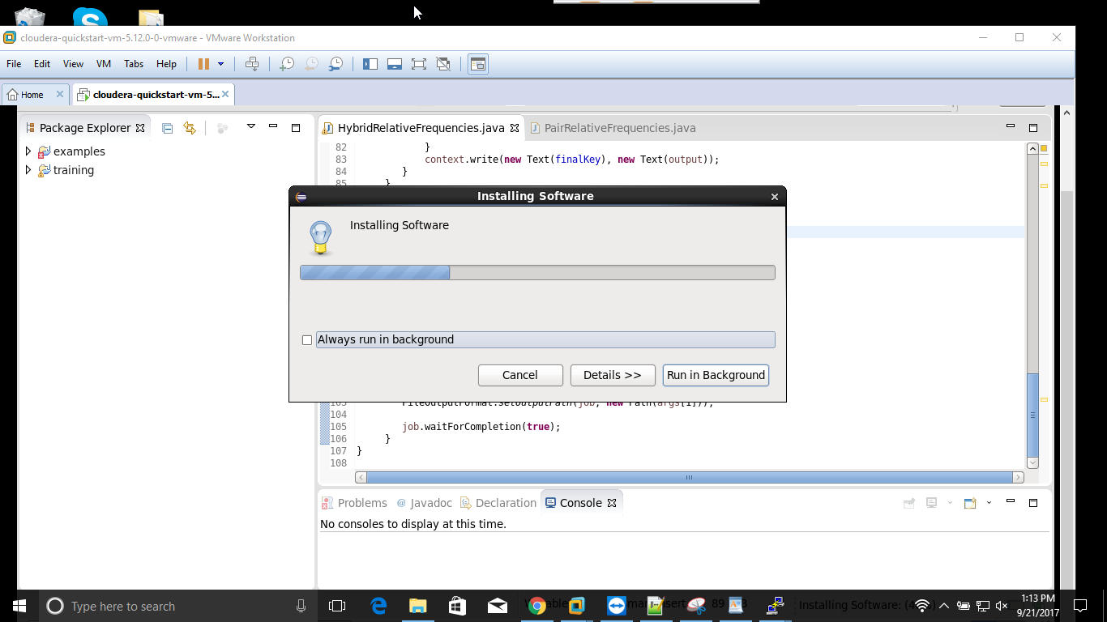

After restarted Eclipse, if it shows a message box like this:

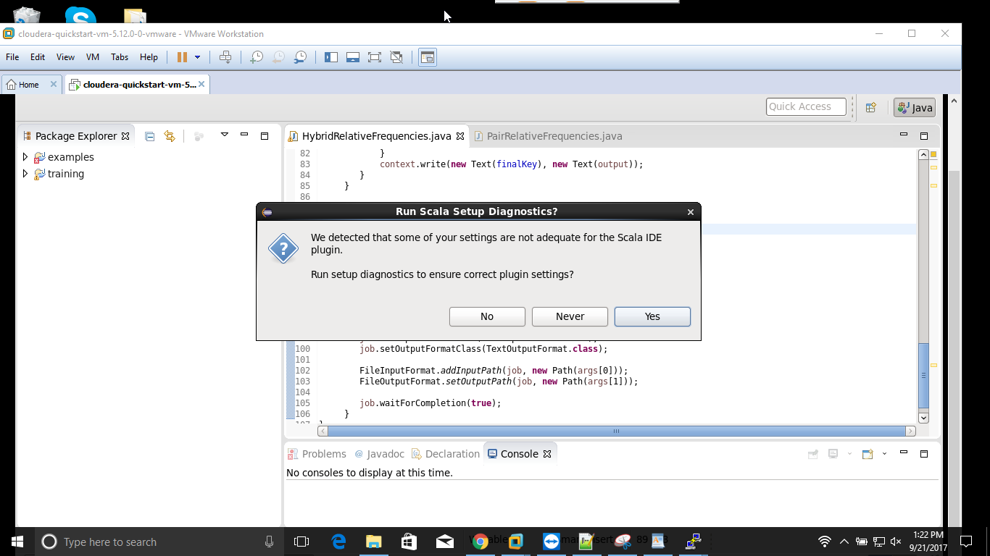

Click on Yes button and following as Wizard such as:

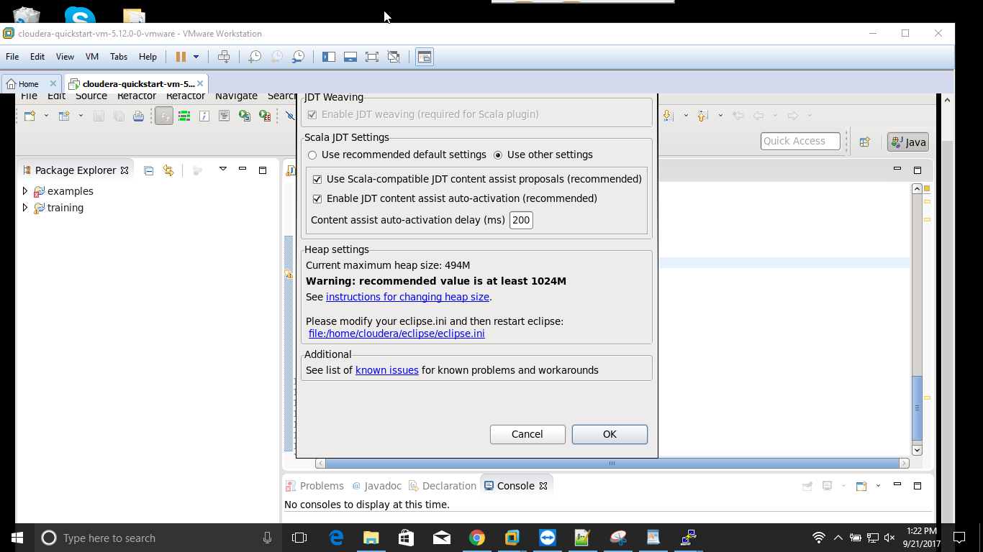

# Create Scala Project from Eclipse

Launch Eclipse 🡪 click on File 🡪 New 🡪 Scala Project

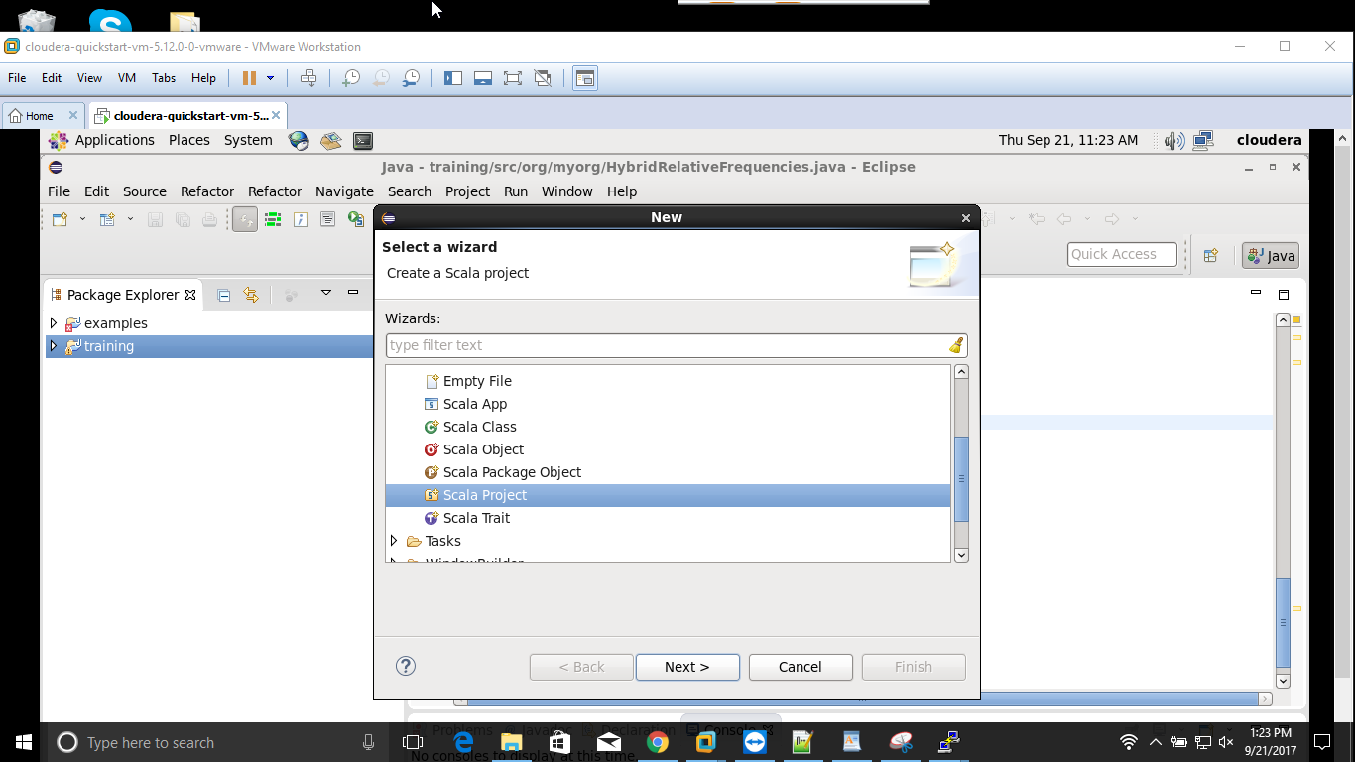

Enter your project name and the click Finish button

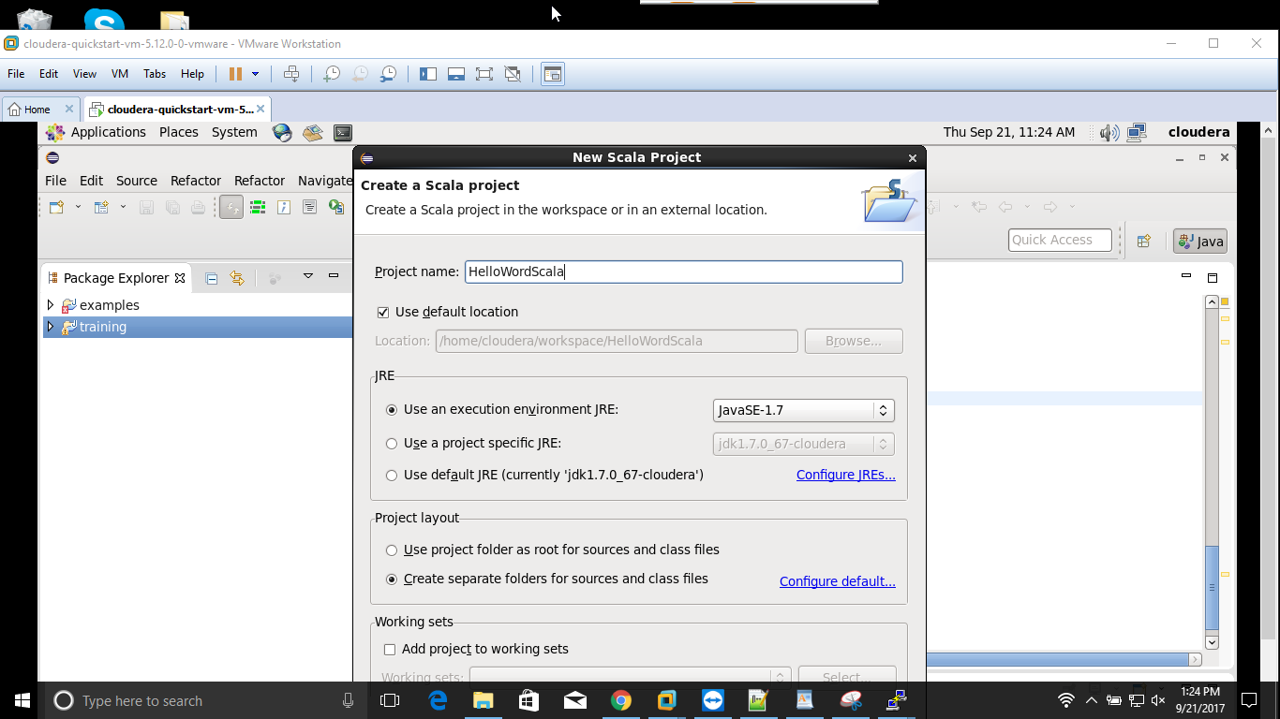

The project has been created like this screenshot:

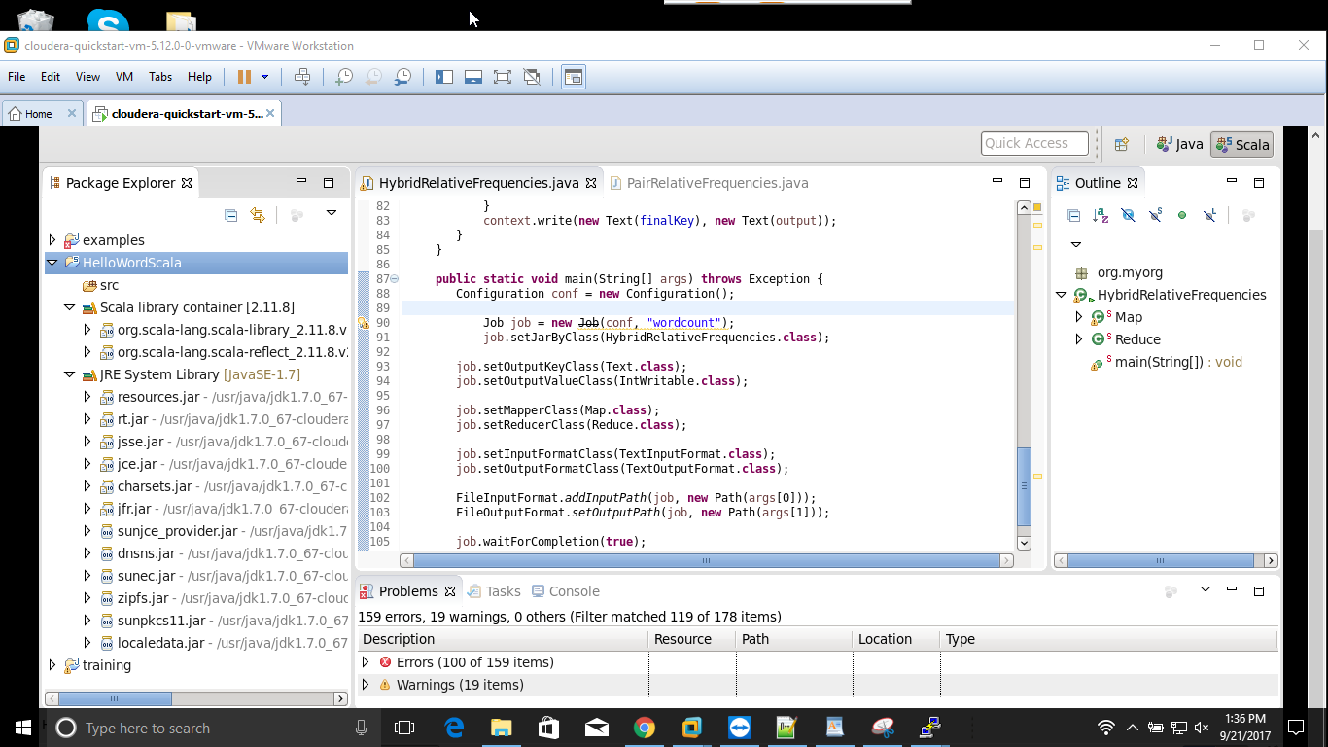

Add a new Scala Object: Right click on your newly created project 🡪 New 🡪 Scala Object. Enter your Object name and then click Finish button

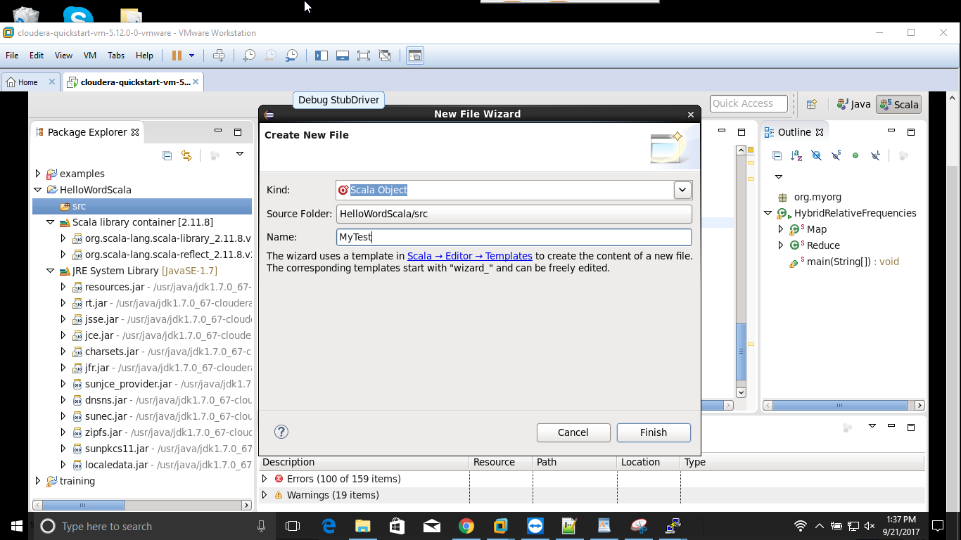

Enter the main method and print out the text named “Hello World, Scala”

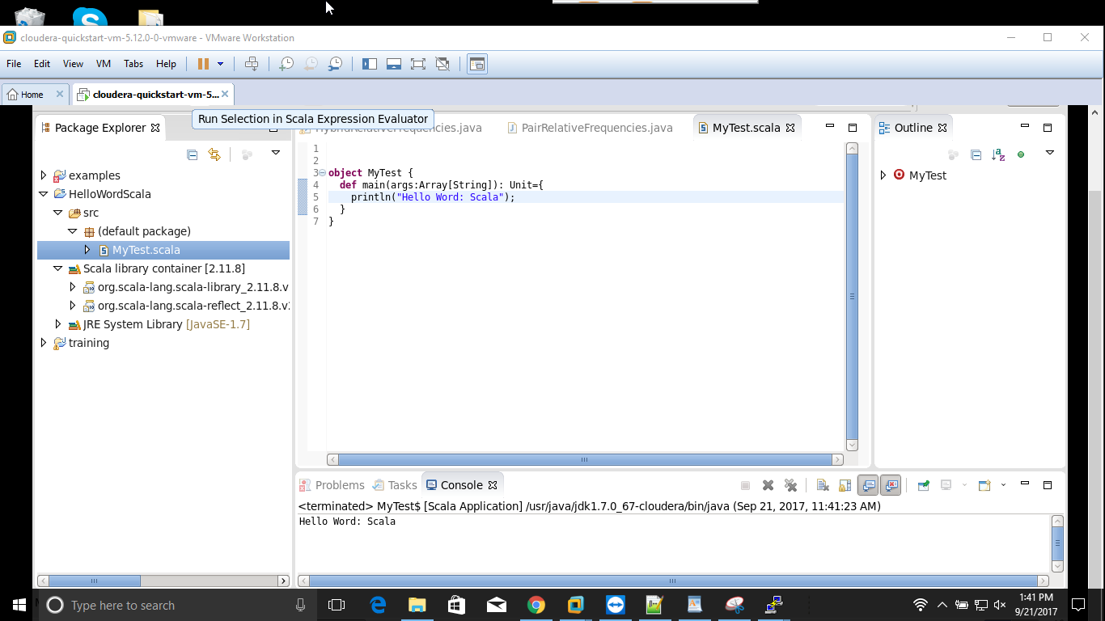

To run the this project, click on Run button (tool tip is Run MyTest.scala”) and see the output like this screenshot:



# Download the Sample Scala Apache Access Log Parser Source Code

**Step 1**: Access to this link: <https://github.com/alvinj/ScalaApacheAccessLogParser>

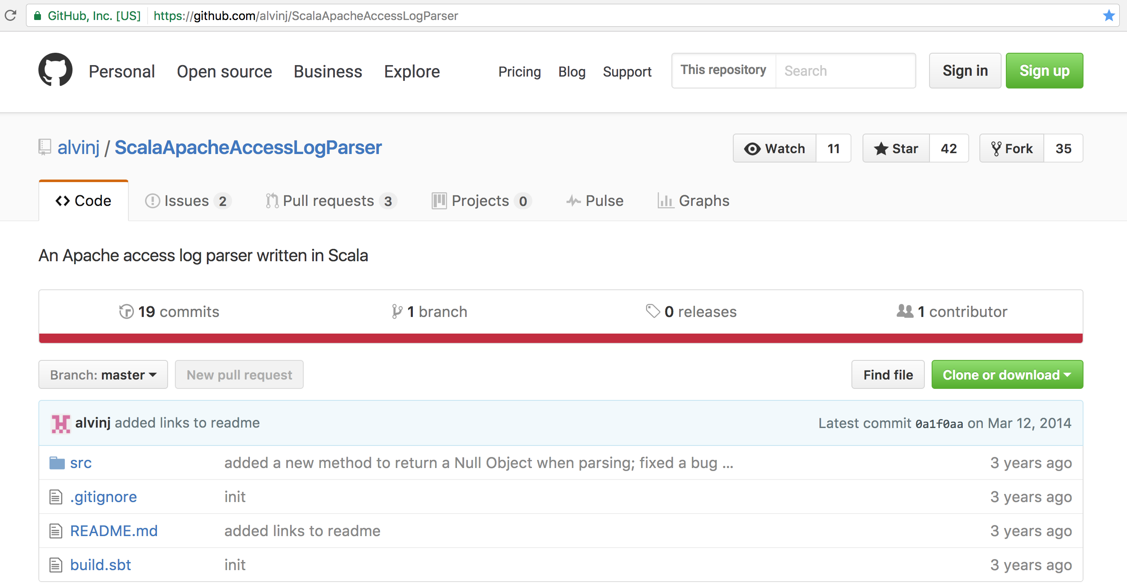

**Step 2**: Click on “Clone or download” button 🡪 save to file as “**ScalaApacheAccessLogParser-master.zip**”

**Step 3**: Extract to your favourite location

# Create Spark project and convert to Maven project

**Step 1**: Create a new Scala project named “MySpark” in Eclipse and then import these two files:

* AccessLogParser.scala
* AccessLogRecord.scala

**Step 2**: Convert to Maven project

Right click on this project, click on Configure 🡪 Convert to Maven project

Add dependency:

<dependency>

<groupId>org.apache.spark</groupId>

<artifactId>spark-core_2.10</artifactId>

<version>2.1.0</version>

</dependency>

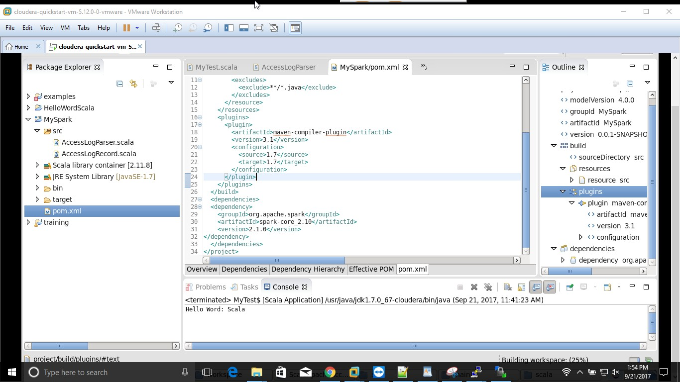

**Step 3**: Add a new Scala class named “ApacheLogFileAnalytics” to parse the Apache (Unix) log file

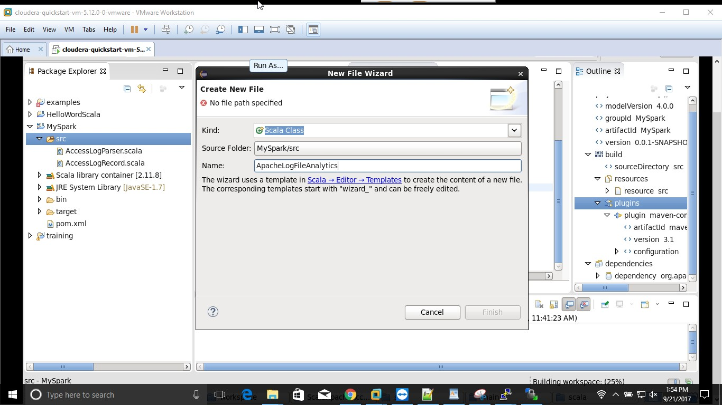

# Download Apache Log File and then put into the input directory in HDFS

**Step 1**: Access to this link: <http://www.monitorware.com/en/logsamples/apache.php>

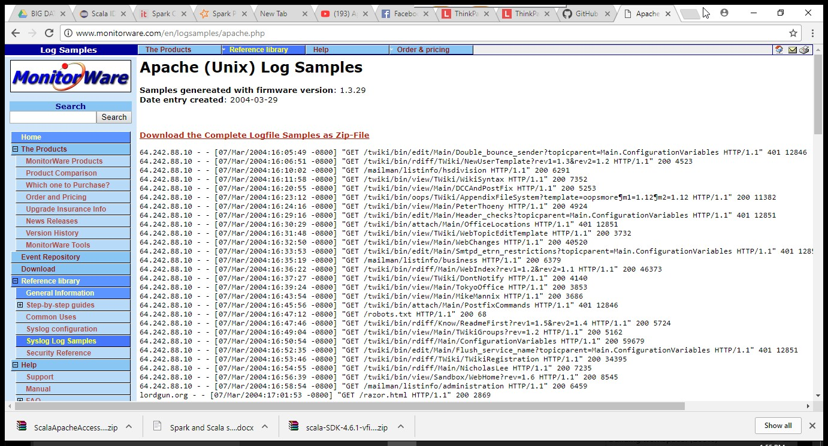

**Step 2**: Click on “**Download the Complete Logfile Samples as Zip-File**” link and save to your favourite location as default file name “**apache-samples.jar**” and extract it.

For my case, I choose “access_log” file.

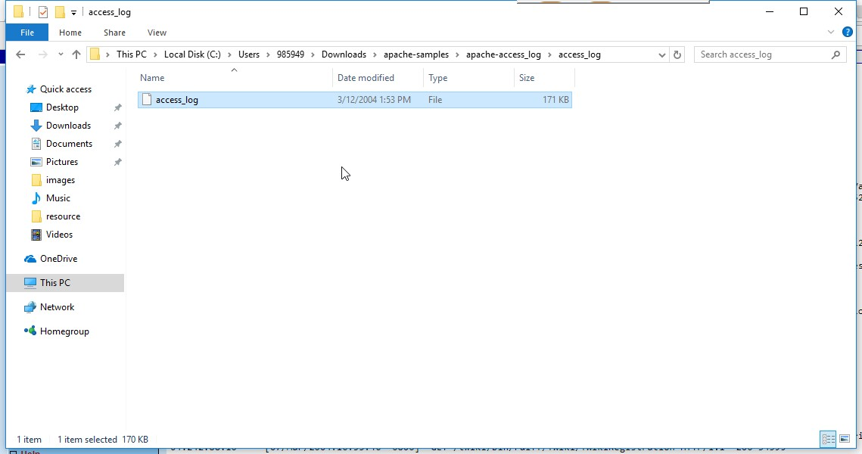

**Step 3**: Open Terminal and issue these commands below

**Step 3.1**: Create input directory in HDFS

$ hadoop fs -mkdir /user/cloudera/spark/input

**Step 3.2**: Put the log file to the input directory in HDFS

$ hadoop fs -put access_log /user/cloudera/spark/input

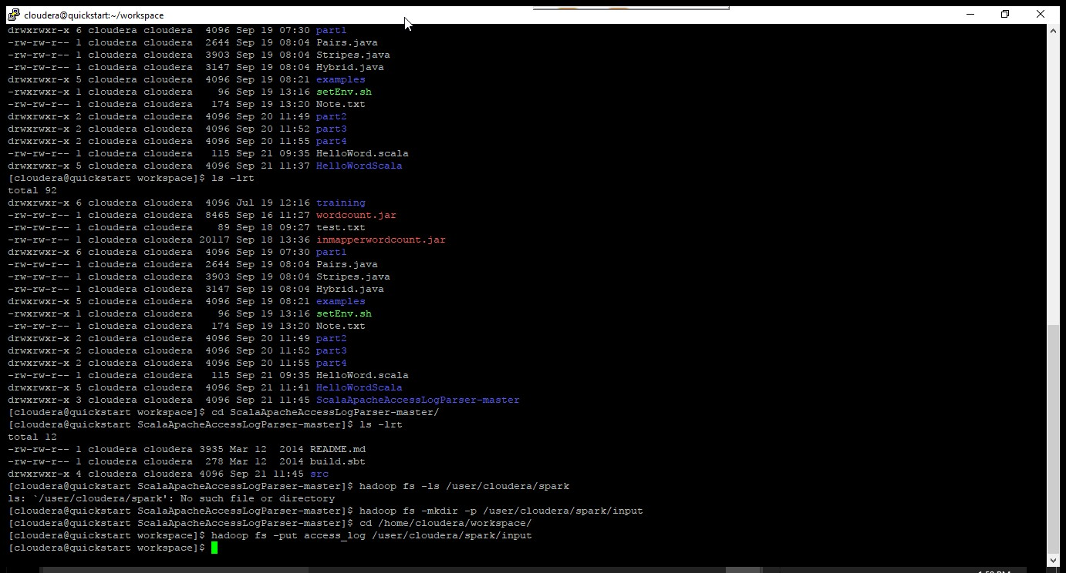

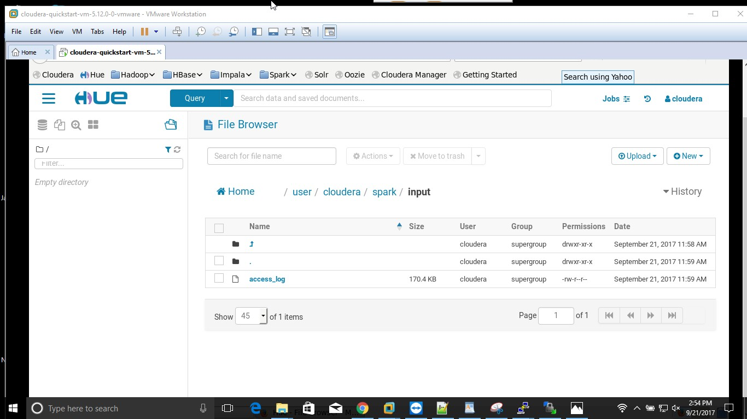

# Export to JAR file

Right click on the project 🡪 click on Export…

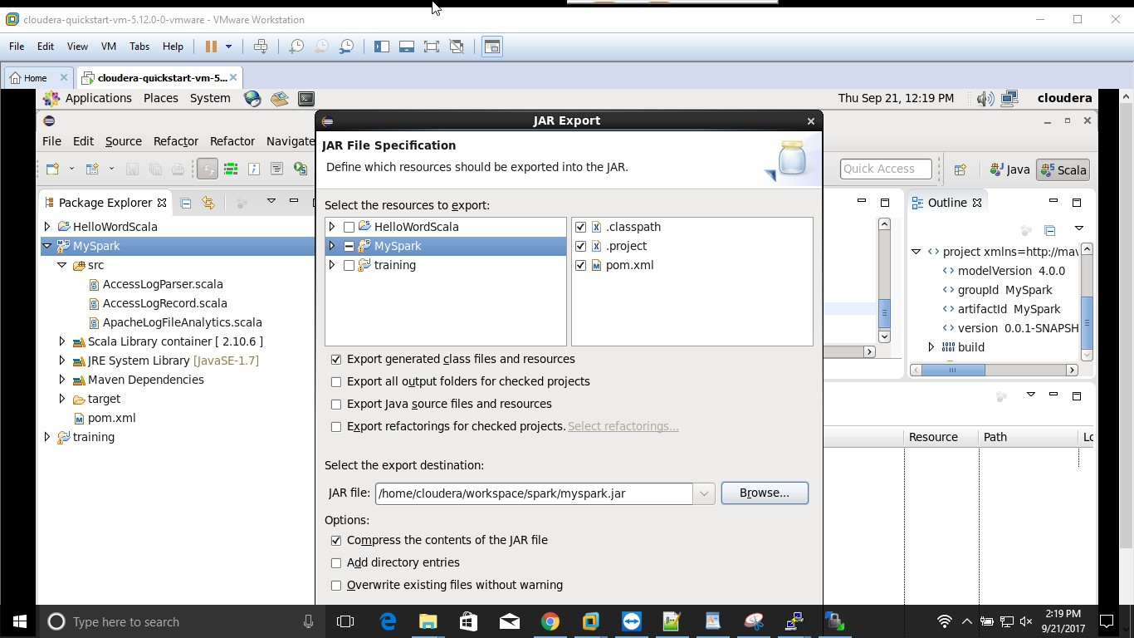

# Run MySpark project to Spark

Deploy the “myspark.jar” file to Spark

$ spark-submit --class "ApacheLogFileAnalytics" myspark.jar "hdfs:///user/cloudera/spark/input/access_log.txt" > output.txt

If run successfully, it will display output file and log file

