Bài 5
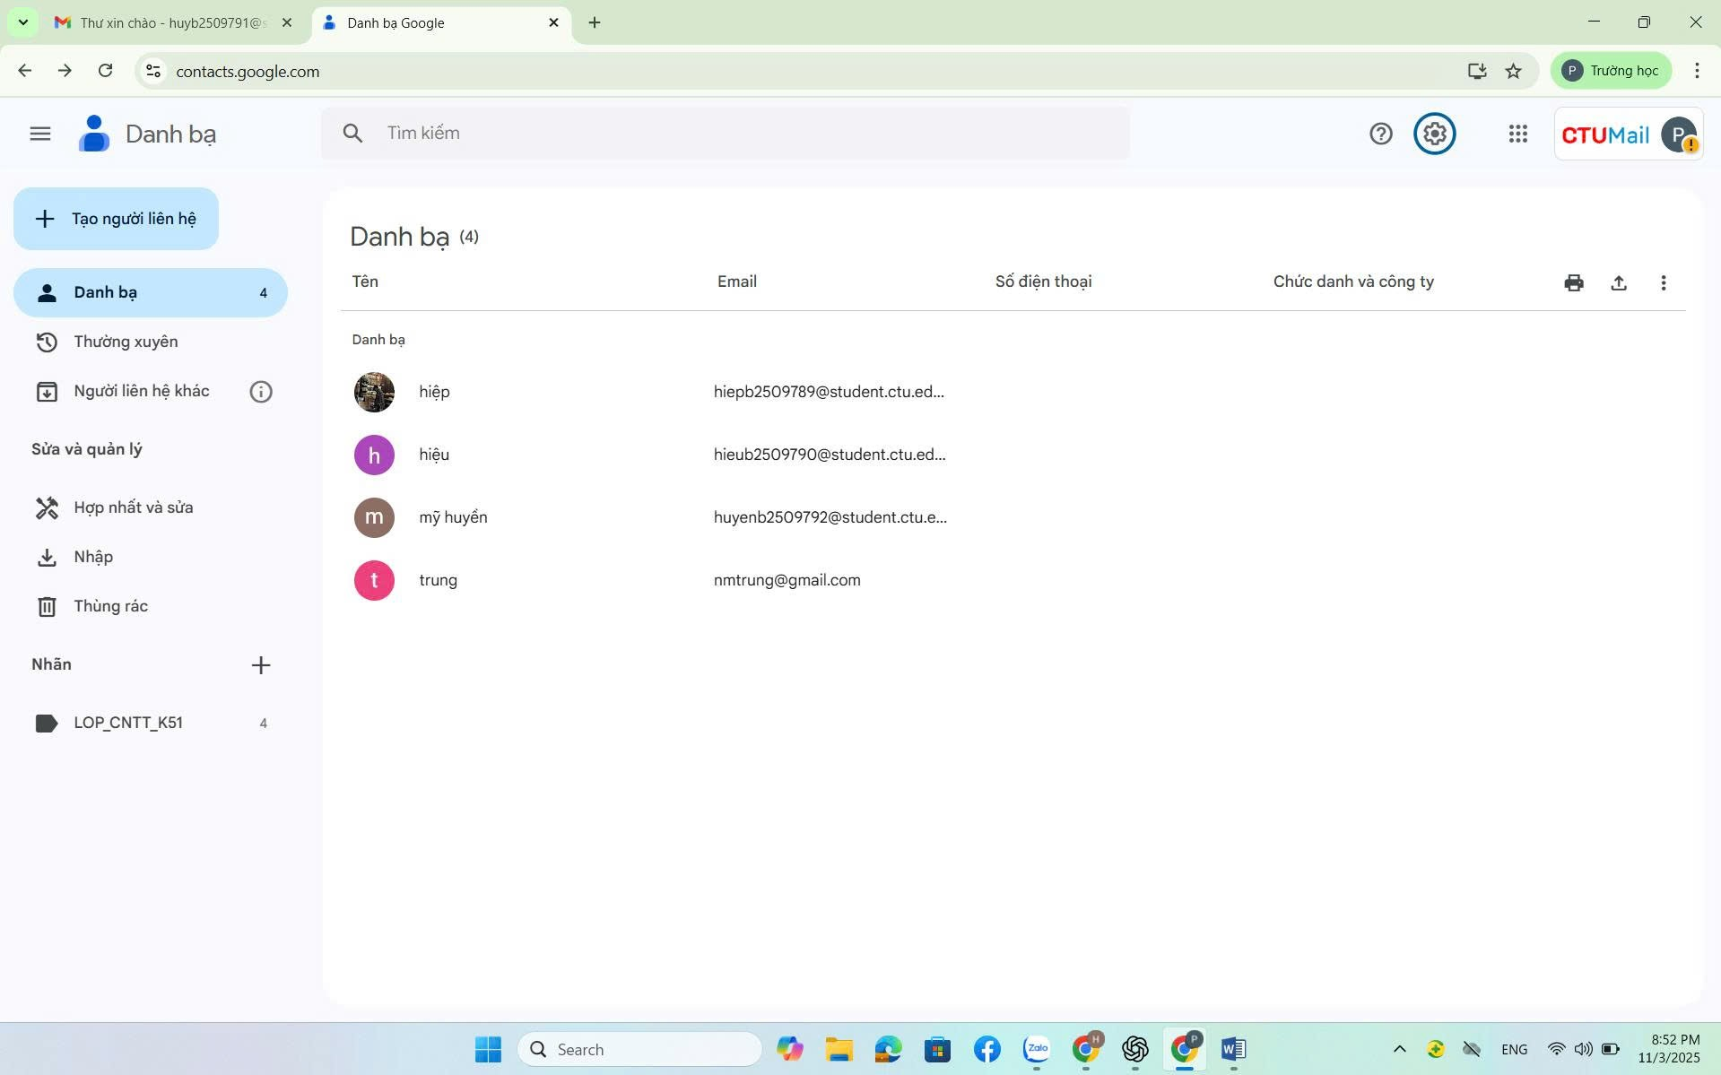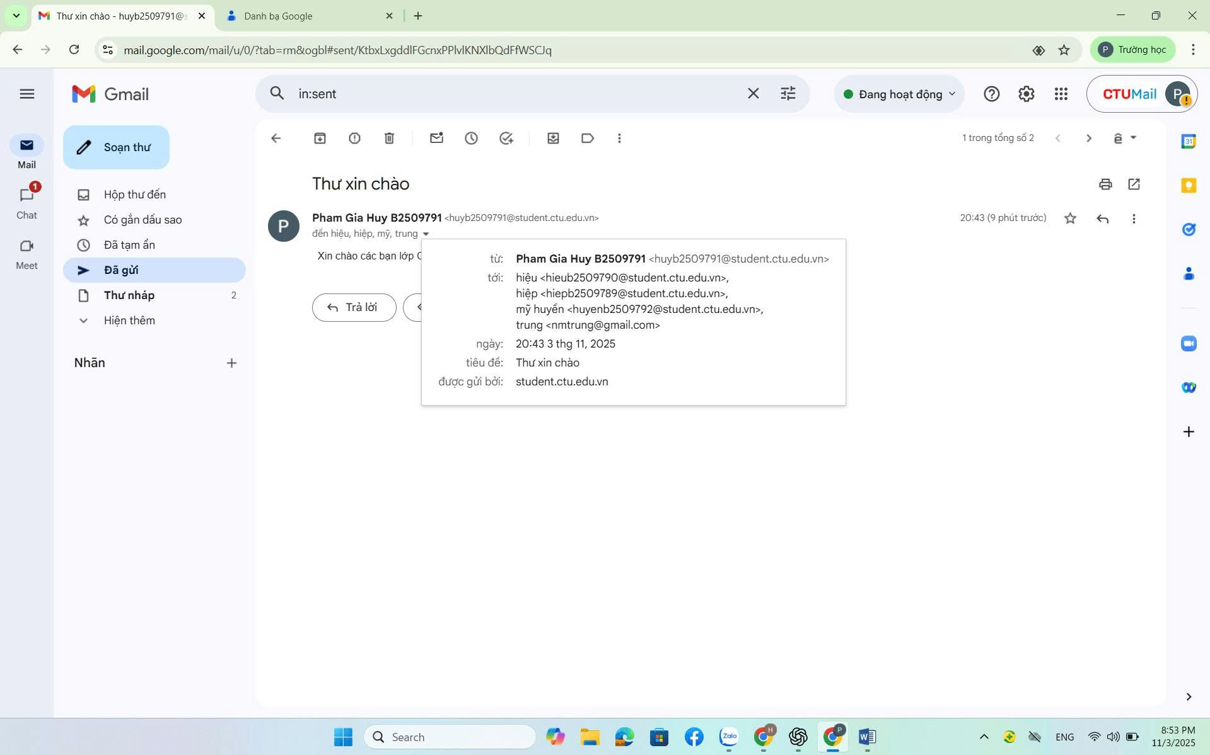
-Link mail: https://contacts.google.com/
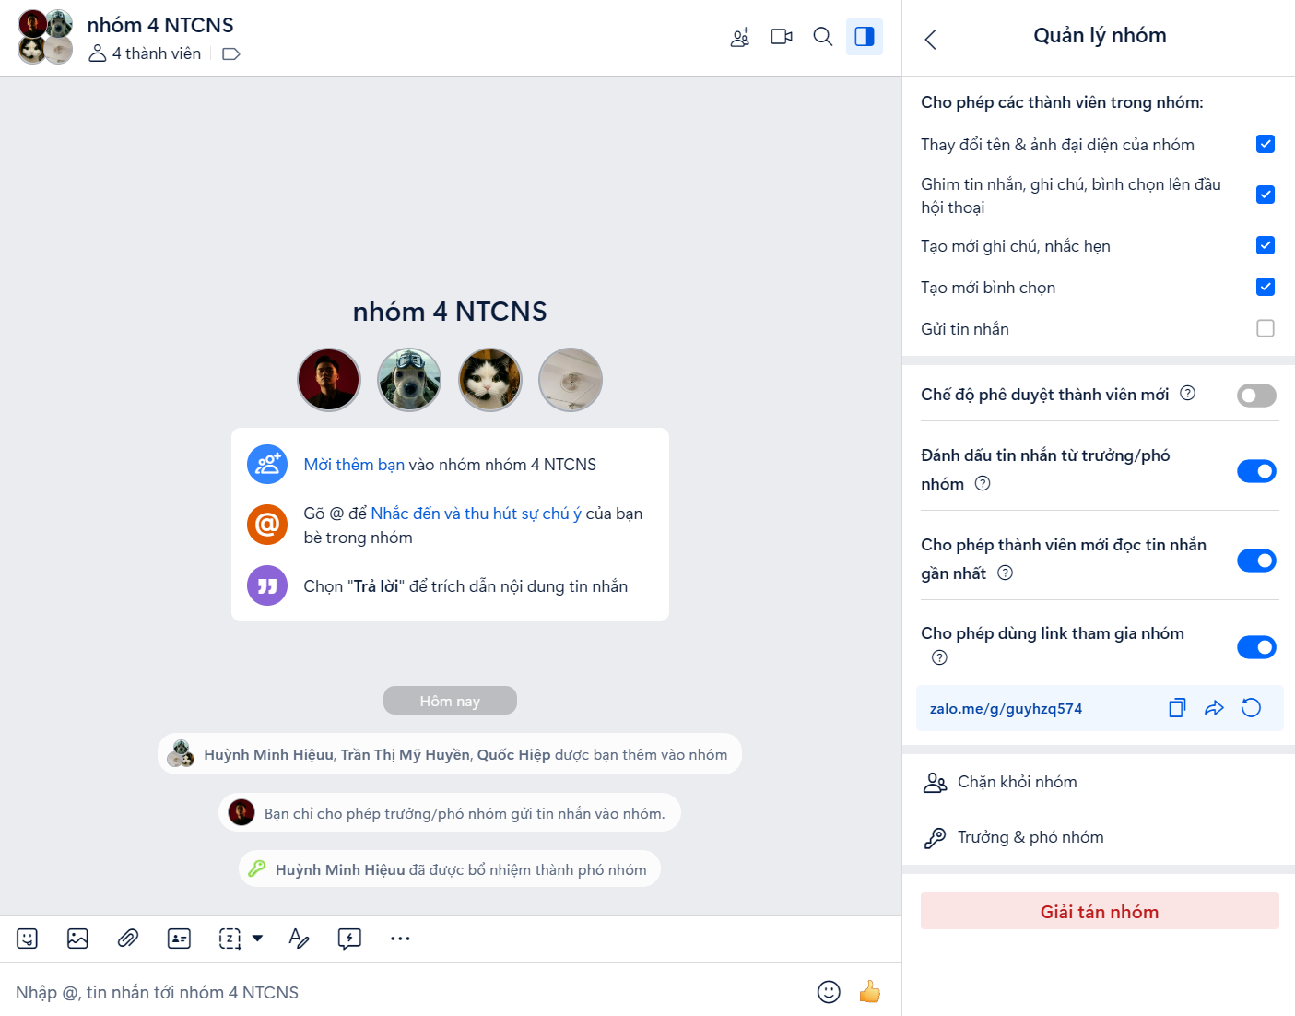
-Link zalo: https://zalo.me/g/guyhzq574
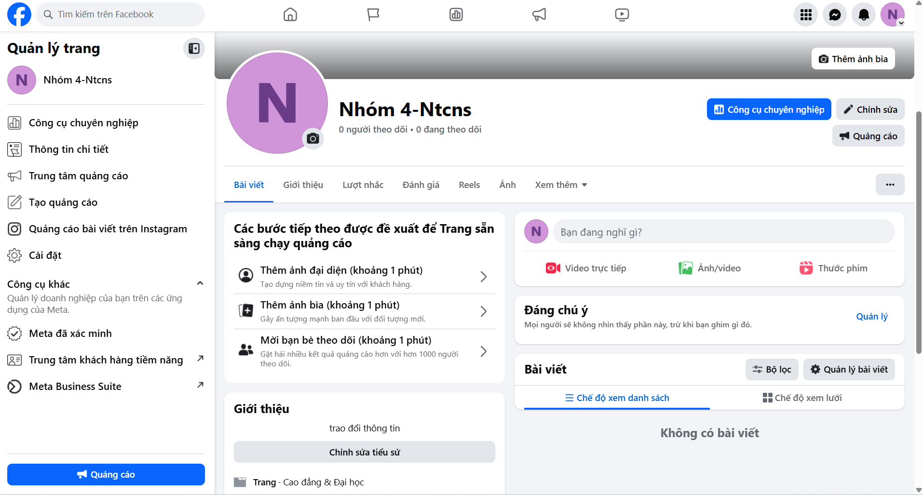
-Link page fb: https://www.facebook.com/profile.php?id=61583154277729
-Link gg meet: https://meet.google.com/vrv-fvxg-xkc

