Final Project: Phase II

Threat Modeling Assignment

Group 12: Minh Hieu Dang
GitHub repository: https://github.com/minhhieu3101/secure_art_gallery.git

1. Project Description Overview

1.1 System Overview
The Secure Art Gallery Web Application is a web-based system designed to manage users, authentication and authorization, gallery and room activities, current occupancy, and administrative functions. The application supports different user roles, including Guest/User, Employee, and Administrator, with access to system features determined by their assigned permissions.
The system also maintains audit logs to record important user activities and security-related events. These records support accountability and help administrators review activities performed within the application.

1.2 System Architecture
The application follows a multi-component architecture consisting of a ReactJS frontend, a NestJS backend/API, a PostgreSQL database, and a C++ audit-log component.
The ReactJS frontend provides the user interface for logging in, viewing information, and performing permitted gallery and room activities. It communicates with the backend through HTTP requests. Since requests originating from the browser cannot be fully trusted, security-sensitive operations must be validated and authorized by the backend.
The NestJS backend/API handles authentication, authorization, input validation, application business logic, and communication with the database and the C++ audit component. PostgreSQL stores persistent application data, including users, sessions, persons, rooms, gallery events, and audit-log records.
The C++ component provides the core audit-log functionality required by the project through the append() and read() functions. The NestJS backend invokes these functions when audit information needs to be recorded or retrieved.
The main application data flow is:
Browser → ReactJS Frontend → NestJS Backend/API → PostgreSQL Database
For audit-log operations, the flow is:
ReactJS Frontend → NestJS Backend/API → C++ Audit Component → Audit-Log Operations

1.3 Technologies and Security Objectives
The system uses ReactJS for the frontend, NestJS and Node.js for the backend/API, PostgreSQL for persistent data storage, and C++ for the required core audit-log operations.
The primary security objectives are to protect user credentials and session information, enforce authentication and role-based authorization, prevent unauthorized access or modification of application data, validate user input, and protect sensitive information. The system also aims to maintain reliable audit records of important activities to support accountability and security monitoring.
This threat modeling assessment examines the system architecture and its interactions to identify potential security threats, evaluate their risks, and recommend appropriate mitigation strategies.
1.4 Security Requirements
The Secure Art Gallery Web Application must meet the following security requirements:
- Authentication: Securely hash passwords and verify user credentials.
- Authorization: Enforce role-based access control on the backend.
- Input Validation: Validate user inputs to prevent invalid data and attacks.
- Data Protection: Prevent SQL injection and unauthorized access to sensitive information.
- Session Security: Validate tokens and invalidate sessions upon logout.
- Business Logic: Enforce valid gallery and room entry and exit sequences.
- Audit Logging: Record important activities and protect logs from unauthorized modification.
- Error Handling: Avoid exposing sensitive information in error messages.

2. Identify Assets
Identifying critical assets is an important step in the threat modeling process because these assets must be protected against unauthorized access, modification, disclosure, and disruption. Based on the architecture and database design of the Secure Art Gallery Web Application, the system contains several important data assets and core components.

2.1 Data Assets
User Accounts and Credentials: The Users table stores user-related information, including user IDs, usernames, password values, and roles. These assets must be protected to prevent account compromise and unauthorized access. Passwords must be stored securely using password hashing rather than plaintext storage.
Session Information: The Sessions table contains session identifiers, user IDs, refresh tokens, expiration dates, and revocation information. This information is security-sensitive because an attacker who obtains valid session credentials may attempt to impersonate a legitimate user. Session data must be protected from unauthorized access and modification.
Room Information: The Rooms table stores room identifiers and room numbers. The accuracy of this information is important for managing gallery rooms and ensuring that room-related operations use valid records. Unauthorized modification could result in incorrect room information or disruption of gallery operations.
Gallery Event Records: The Gallery_events table contains event-related information, including event IDs, person IDs, optional room IDs, event types, creation timestamps, and the user who recorded an event. These records must be protected against unauthorized modification because they represent gallery and room activities.
Audit Logs: Audit-log records contain information such as the user associated with an action, the action performed, and the creation timestamp. These records support accountability and security monitoring. Their integrity and availability are important because missing or modified records may make it more difficult to investigate suspicious activities.
Person-Related Information: The database design includes person-related records associated with gallery events. Access to this information should be restricted according to the application's authorization rules to prevent unauthorized disclosure or modification.

2.2 Core System Components
ReactJS Frontend: The frontend provides the user interface and sends HTTP requests to the backend. Although it is the primary interaction point for users, it must not be treated as a trusted enforcement point for security controls. Client-side restrictions alone cannot guarantee that requests are authorized.
NestJS Backend/API: The backend is a critical security component because it handles authentication, authorization, input validation, business logic, and communication with PostgreSQL and the C++ audit component. A weakness in these controls could expose application data or allow unauthorized operations.
PostgreSQL Database: PostgreSQL stores the application's persistent data, including users, sessions, persons, rooms, gallery events, and audit-log records. Database access must be restricted, and queries should be implemented safely to reduce the risk of unauthorized data access and SQL injection.
C++ Audit Component: The C++ component provides the required append() and read() audit-log functions. It is important for maintaining and retrieving audit information. Access to these functions should be controlled by the backend, and audit operations should handle input and errors safely.

2.3 Asset Protection Priorities
The assets described above require different security protections. User credentials and session information require confidentiality and integrity protections. Room and gallery event records require integrity protections to preserve the accuracy of application data. Audit logs require integrity and availability protections to support accountability and investigations. The frontend, backend, database, and C++ audit component must also be protected against unauthorized access and misuse.
These assets provide the foundation for identifying threats using the STRIDE framework in the next section of the threat modeling process.

3. Identify Threat Actors
Threat actors are people who may try to attack the Secure Art Gallery Web Application. They may try to access information without permission, change data, or disrupt the system. Threat actors can be external attackers or internal users.

3.1 External Threat Actors
1. External Attackers
These attackers do not have valid accounts. They may try to log in without permission, send harmful requests, or find weaknesses in the application.
2. Attackers Using Stolen Accounts
These attackers use stolen passwords, session IDs, or tokens to log in as legitimate users. They may access information or perform actions using the victim's account.
3. Automated Attackers
These attackers use scripts or tools to send many requests to the application. Their actions may slow down the system or make it unavailable.

3.2 Internal Threat Actors
4. Guest/User
A Guest/User may try to access information that they are not allowed to see or change data belonging to other users.
5. Employee
An Employee may try to access administrator functions or change gallery and room records without permission.
6. Administrator
An Administrator has access to important system functions and data. A malicious administrator may misuse these permissions to access sensitive information, change records, or interfere with audit logs.

4. Decompose the System
The Secure Art Gallery Web Application consists of several components that work together to manage users, rooms, gallery events, and audit logs. Each component has a specific responsibility and communicates with other components to perform application operations. Understanding these components and their data flows helps identify where security threats may occur.

4.1 System Components
1. User Interface (ReactJS Frontend)
The ReactJS frontend provides the user interface for Guest/User, Employee, and Administrator accounts. Users can log in, view information, and perform gallery or room activities based on their permissions. The frontend sends HTTP requests to the NestJS backend.
2. Backend API (NestJS)
The NestJS backend receives requests from the frontend and handles the main application logic. It is responsible for authentication, authorization, input validation, and communication with PostgreSQL and the C++ audit component. The backend must check requests before allowing protected operations.
3. Authentication and Authorization
Authentication verifies the user's identity, while authorization checks what the user is allowed to do. For example, an Employee should only be able to perform actions permitted by the Employee role. These checks are handled by the backend before protected operations are performed.
4. Database (PostgreSQL)
PostgreSQL stores the application's persistent data, including users, sessions, persons, rooms, gallery events, and audit-log records. The backend communicates with the database to retrieve or update information when necessary.
5. C++ Audit Component
The C++ component provides the required append() and read() functions for audit-log operations. The append() function adds audit information, while the read() function retrieves audit records. The NestJS backend calls these functions when audit information needs to be recorded or read.
4.2 Entity-Relationship Diagram (ERD)
Figure 1 illustrates the database entities, their relationships, and the structure used to store user, room, gallery event, session, and audit-log data.
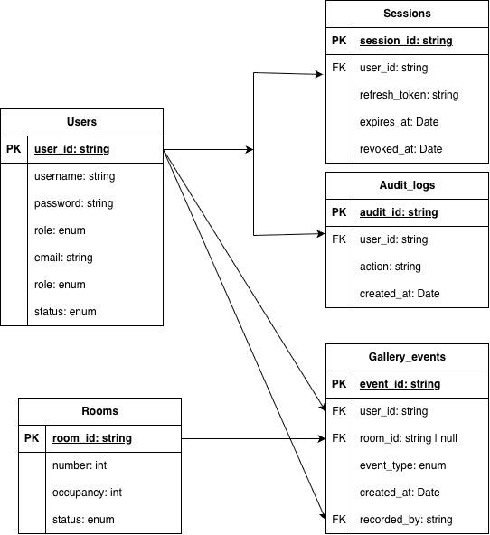
Figure 1. Data Flow Diagram of the Secure Art Gallery Web Application.

4.3 Data Flow Diagram (DFD)
Figure 2 illustrates the main components of the Secure Art Gallery Web Application, the data exchanged between them, and the trust boundaries that separate trusted and untrusted components.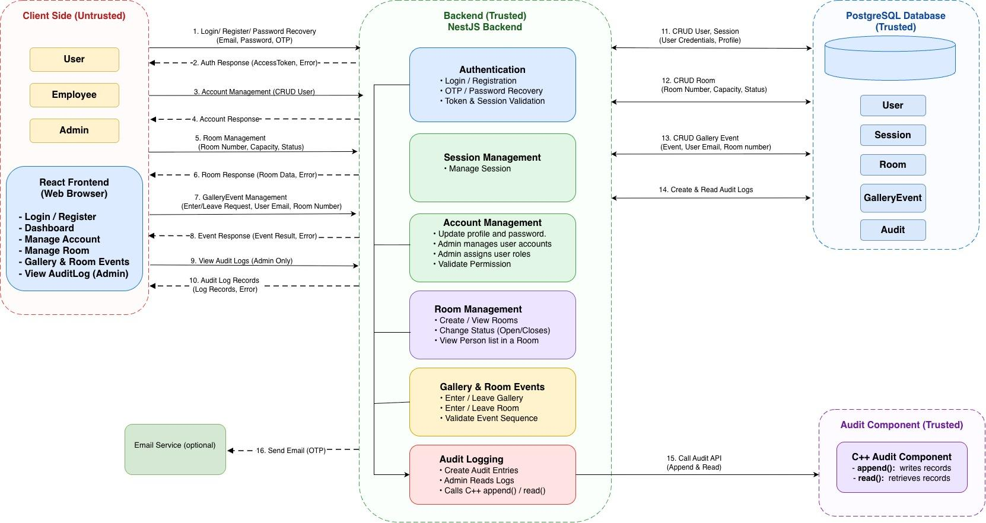
Figure 2. Data Flow Diagram of the Secure Art Gallery Web Application.
The data flows through the system as follows:
Flow 1: User Requests
Users interact with the React frontend to log in, manage accounts, view rooms, perform gallery and room activities, and access audit logs when authorized. The frontend sends HTTP requests to the NestJS backend, which processes the requests and returns responses to the frontend.
Flow 2: Authentication and Session Management
The NestJS backend handles user registration, login, OTP verification, and password recovery. It validates credentials, tokens, and sessions before allowing access to protected functions. The backend also checks user roles and permissions to prevent unauthorized access. Invalid requests or requests without sufficient permissions should be rejected.
Flow 3: Account and Room Management
The backend processes account and room management requests, including updating user profiles, managing user accounts and roles, creating and viewing rooms, and changing room statuses. It communicates with PostgreSQL to retrieve or update the corresponding user, session, and room data.
Flow 4: Gallery and Room Events
Users can enter or leave the gallery and rooms through the frontend. The backend validates event requests and checks the required event sequence before processing them. It communicates with PostgreSQL to store gallery event records and retrieve relevant room or occupancy information. The backend then returns the operation results to the frontend.
Flow 5: Database Operations
The NestJS backend communicates with PostgreSQL to read and update application data. The database stores user information, sessions, rooms, gallery events, and audit logs. The backend processes database results and returns appropriate responses to the frontend.
Flow 6: Audit-Log Operations
When important actions occur, the backend sends audit information to the Audit Logging process. This process records audit entries and allows administrators to retrieve audit logs. The backend calls the C++ audit component, which provides the append() function for writing records and the read() function for retrieving records.
Flow 7: Email and OTP Delivery
When email verification or password recovery requires an OTP, the backend sends an OTP email request to the email service. The service delivers the email to the user.

4.4 Trust Boundaries and Security Considerations
The system contains four important trust boundaries.
Trust Boundary 1: React Frontend to NestJS Backend
The browser is controlled by the user and must be considered untrusted. Requests and input values from the frontend may be modified or forged. Therefore, the backend must validate input data, verify authentication, and enforce authorization for protected operations rather than relying on frontend checks alone.
Trust Boundary 2: NestJS Backend to PostgreSQL Database
The backend communicates with PostgreSQL to retrieve and modify application data. Database access should be restricted to authorized backend operations. Parameterized queries, appropriate database permissions, and input validation should be used to reduce the risks of SQL injection and unauthorized data access.
Trust Boundary 3: NestJS Backend to C++ Audit Component
The NestJS backend invokes the C++ audit component to write and retrieve audit records through the append() and read() functions. Access to these functions should be controlled by the backend. Audit operations should be protected against unauthorized access, tampering, and deletion to preserve the integrity of security records.
Trust Boundary 4: NestJS Backend to Email Service
The backend communicates with the email service to deliver OTP messages for verification and password recovery. Email service credentials should be protected, and OTPs should be validated on the server side. OTP expiration, attempt limits, and single-use validation should be enforced to reduce the risk of unauthorized account access.

5. Security Scenarios, Test Cases, and Mitigation Strategies
This section is based on the API routes supplied for the Secure Art Gallery Project. It follows the application's API groups: Auth, User, Rooms, and GalleryEvents. The scenarios describe expected secure behavior. The OpenAPI route list identifies endpoints, but does not prove which security controls are implemented. Execute the test cases and record actual results.

5.1. Authentication and Session Flow

Security Scenario
Users can create accounts, log in, verify their accounts, and request OTP codes. They can also refresh their authentication credentials or log out of the system. The application must check the user's information before allowing access. If an attacker uses incorrect login information or invalid verification codes, the system should reject the request and prevent unauthorized access.

Potential Threats
- Spoofing: an attacker tries to log in as another user.
- Token misuse: an attacker attempts to reuse an invalid, expired, or stolen token.
- Information Disclosure: authentication endpoints reveal sensitive account information.

Test Cases
Test Case | Test Scenario | Test Input | Test Action | Expected Result | Reason for Failure
TC-01 | Login with correct account | Email: dmh@gmail.com  Password: minhhieu4438 | Login with valid credentials. | The backend authenticates the account and returns the response defined by the API. | No
TC-02 | Login with Incorrect Password | Email: dmh@gmail.com Password: wrong123 | Login with an incorrect password. | The backend rejects the login request. | Incorrect login credentials.
TC-03 | Login with Non-Existing Account | Email:nonexistent@gmail.com  Password:Test@12345 | Log in using a username that does not exist in the system. | The backend rejects the login request and does not allow the user to log in. | Non-existing accounts.
TC-04 | Account Registration | Username: testuser01  Email: testuser01@example.com  Password: Test@12345 | Create a new account with valid information. | The backend creates the account successfully and saves the user information in the database. | No
TC-05 | Verification Code Validation | Invalid or expired OTP code | Submit invalid or expired verification data to verify the account. | The backend rejects the verification attempt and does not activate the account. | The backend must reject invalid or expired OTP codes.

Mitigation Strategies
- Validate credentials and verification data on the backend.
- Check token/session validity for protected routes.
- Invalidate the relevant session or refresh credential during logout, according to implementation.
- Limit repeated login and OTP attempts.
- Return generic authentication errors.
- Do not store passwords or OTP values in logs.

5.2. Account Management and Password Recovery Flow

Security Scenario
Users can request OTP codes, recover their passwords, change their passwords, and view account information. Administrators can grant permissions and delete user accounts. The backend must verify user information and permissions before allowing these actions. Unauthorized requests should be rejected to prevent unauthorized access or changes.

Potential Threats
- Elevation of Privilege: a non-administrator attempts to grant permissions or delete a user.
- Information Disclosure: a user accesses account information they are not allowed to view.
- Tampering: an attacker attempts to change an account or password without authorization.

Test Cases
Test Case | Test Scenario | Test Input | Test Action | Expected Result | Reason for Failure
TC-06 | Password Recovery Validation | Registered email, invalid or expired OTP, new password: NewPass@123 | Enter an invalid or expired OTP with a new password when attempting to reset the password. | The backend rejects the request and does not change the password. | The OTP must be valid and not expired.
TC-07 | Unauthorized User List Access | Account role: User (regular user without administrator permissions) | Log in as a regular user and attempt to view the list of all users. | The backend denies access to the user list. | Only administrators can view the user list.
TC-08 | Unauthorized Account Deletion | Account role: Employee; Target user ID: an existing user's ID | Log in as an employee and attempt to delete another user's account. | The backend denies the request and does not delete the account. | Only authorized administrators can delete user accounts.
TC-09 | Unauthorized Role Modification | Account role: Employee; Target user: an existing user; New role: Administrator | Log in as an employee and attempt to change another user's role to Administrator. | The backend denies the request and keeps the target user's original role unchanged. | Only authorized administrators can change user roles.
TC-10 | Invalid Password Change | Current password: wrong123; New password: abcde | Attempt to change the password using an incorrect current password. | The backend rejects the request and keeps the original password unchanged. | Password length should higher than 6 characters

Mitigation Strategies
- Require users to authenticate before accessing private account information or performing account operations.
- Enforce role-based access control (RBAC) to ensure only administrators can grant permissions, change user roles, or delete accounts.
- Verify OTP codes before account verification or password recovery. Reject invalid, expired, or previously used OTP codes.
- Require the correct current password before allowing password changes, and enforce the project's password policy.
- Verify that users have permission to access or modify the target account before processing a request.
- Invalidate active sessions and refresh tokens when users log out to prevent reuse.
- Record sensitive administrative actions in the audit log without storing passwords, OTP codes, or authentication tokens.

5.3. Room Management Flow

Security Scenario
The Rooms API supports room creation, room lookup, room listing, and room status changes. The backend must validate room numbers, capacity values, and status updates before processing requests. Only authorized users should be allowed to perform room management operations.

Potential Threats
- Tampering: an attacker submits invalid room data or attempts an unauthorized status change.
- Information Disclosure: an unauthorized user accesses room details.
- Elevation of Privilege: a user without management permission attempts to create or change rooms.

Test Cases
Test Case | Test Scenario | Test Input | Test Action | Expected Result | Result for Failure
TC-11 | Add Room with Valid Information | Room number: 101; Capacity: 20 | Log in as an Administrator and create a room using valid information. | The backend creates the room successfully and saves the room information in the database. | The room must be created with valid information.
TC-12 | Invalid Room Creation | Room number: 1001; Capacity: -1; | Attempt to create a room using missing or invalid room information. | The backend rejects the invalid room data and does not create the room. | Room numbers must contain exactly 3 digits, and capacity must be at least 0.
TC-13 | Employee Unauthorized Room Creation | Account role: Employee; Room number: 102; Capacity: 15 | Log in as an Employee and attempt to create a new room. | The backend denies the request and does not create the room. | Only administrators can create rooms.
TC-14 | Unauthorized Room Status Change | Account role: Employee or User  Room status: closed | Log in as a regular user and attempt to change a room's status. | The backend denies the request and leaves the room status unchanged. | Only authorized administrators can change room status.
TC-15 | Invalid Room ID | Room ID: invalid-id-123 | Attempt to view a room using an invalid room ID. | The backend returns a safe error response and does not expose sensitive information. | The room ID must be valid and refer to an existing room.

Mitigation Strategies
- Validate CreateRoomDto and ChangeRoomStatusDTO on the backend.
- Restrict room creation and status changes to authorized roles.
- Allow only supported room status values and valid state transitions.
- Validate room IDs and return safe error messages.
- Check authorization before returning protected room information.

5.4. Gallery and Room Event Flow

Security Scenario
The GalleryEvents API includes operations for entering and leaving the gallery, entering and leaving rooms, and retrieving the list of people in a room. These operations record gallery and room events and provide information about current room occupants. The backend should validate event data, check permissions, and confirm that each operation is valid for the person's current state.

Potential Threats
- Tampering: An attacker submits manipulated event data or attempts an invalid state transition.
- Information Disclosure: An unauthorized user retrieves information about people in a room.
- Repudiation: An important event is not recorded correctly or cannot be verified.
- Elevation of Privilege: A user attempts to perform an event operation without the required permissions.

Test Cases
Test Case | Test Scenario | Test Input | Test Action | Expected Result | Reason for Failure
TC-16 | Successful Gallery Entry and Exit | Valid person email; role: Admin or Employee | Enter the gallery, then leave the gallery | Both actions succeed, and the events are recorded correctly | No
TC-17 | Successful Room Entry and Exit | Valid person email; valid room ID; person has entered the gallery | Enter a room, then leave the same room | Both actions succeed, and the room events are recorded correctly | No
TC-18 | Enter Room Without Entering Gallery | Valid person email; valid room ID; no active gallery entry | Attempt to enter a room before entering the gallery | The backend rejects the action and does not record a valid room entry | The person must enter the gallery before entering a room.
TC-19 | Enter Another Room Without Leaving the Current Room | Valid person email; two valid room IDs; person is currently inside the first room | Attempt to enter the second room without leaving the first room | The backend rejects the action until the person leaves the current room | The person must leave the current room before entering another room.
TC-20 | Leave Room Without Entering the Room | Valid person email; valid room ID; no active entry into that room | Attempt to leave a room that the person has not entered | The backend rejects the action and does not record an invalid room exit | The person must enter the room before leaving it.
TC-21 | Leave Gallery While Still Inside a Room | Valid person email; person has entered the gallery and is still inside a room | Attempt to leave the gallery without leaving the room first | The backend rejects the action until the person leaves the room | The person must leave the room before leaving the gallery.
TC-22 | Successfully View People in a Room by Clicking the Room Number | Role: Admin or Employee; valid room ID; people currently inside the room | View the list of people in the selected room | The system displays the people currently inside the room | The user must have permission to view people in the room.

Mitigation Strategies
- Validate EventGalleryDto and EventRoomDto on the backend.
- Check user roles and permissions before processing event operations.
- Validate room and person identifiers and confirm that referenced records exist.
- Check the person's current state before accepting enter and leave operations.
- Prevent duplicate or inconsistent events by enforcing valid event sequences.
- Create audit records for important event operations and handle logging failures appropriately.

5.5. Audit Logging and Log Access Flow

Security Scenario
The C++ audit component uses append() to record log entries and read() to retrieve them. Only administrators are authorized to view audit logs. User activities must be recorded to support security monitoring and investigations.

Potential Threats
- Information Disclosure: A user without permission reads audit logs.
- Repudiation: A security-sensitive action is not recorded, making investigation difficult.
- Tampering: Audit records are altered through a weakness in the backend or storage layer.

Test Cases
Test Case | Test Scenario | Test Input | Test Action | Expected Result | Result for Failure
TC-23 | Admin Views Audit Logs | Role: Admin; valid account | Open the audit log list | The system displays audit records of user activities. | The system must allow authorized administrators to view audit logs.
TC-24 | Unauthorized Audit Log Access | Role: User or Employee; valid account | Attempt to view the audit log list | The backend denies access because only Admin can view audit logs. | Only Admin can access audit records.
TC-25 | User Activity Is Recorded | Role: User or Employee; perform a valid operation | Perform an operation such as logging in or entering a room, then check the audit log as Admin | The system creates an audit record for the activity. | All required user activities must be recorded in the audit log.
TC-26 | Unauthorized Audit Log Modification | Role: User or Employee; existing audit record | Attempt to modify or delete an audit record | The system prevents unauthorized modification or deletion. | Audit records cannot be modified or deleted through normal application operations, including by administrators.

Mitigation Strategies
- Restrict log endpoints to authorized roles and allow only administrators to view audit logs.
- Validate log IDs and avoid exposing sensitive internal details.
- Use append() and read() according to their intended responsibilities.
- Protect audit records from unauthorized modification or deletion.
- Record important account, room, gallery, authentication, and administrative actions.
- Do not place passwords, OTP values, or authentication tokens in logs.

6. Analyze and Prioritize Threats

Threat ID | STRIDE Category | Identified Threat | Likelihood | Impact | Risk Level
T-01 | Elevation of Privilege | A normal user accesses admin functions without permission. | High | High | High
T-02 | Information Disclosure | Unauthorized users view private user information or audit logs. | Medium | High | High
T-03 | Tampering | Users send invalid requests that cause incorrect room or gallery records. | High | Medium | High
T-04 | Repudiation | Important user activities are not recorded in audit logs. | Medium | High | High
T-05 | Tampering | An attacker changes or deletes audit log records. | Low | High | Medium
T-06 | Spoofing | An attacker uses another user's stolen password or token to log in. | Medium | High | High
T-07 | Tampering | The system accepts an incorrect or expired OTP code. | Medium | High | High
T-08 | Denial of Service | Too many requests make the application unavailable. | Medium | High | High
Note: Risk ratings are preliminary and should be verified through code review and security testing.
7. Mitigation Strategies

Threat ID | Identified Threat | Mitigation Strategy
T-01 | A normal user accesses admin functions without permission. | Use RBAC and NestJS guards to check user roles before allowing access.
T-02 | Unauthorized users view private user information or audit logs. | Allow only authorized users, such as administrators, to access sensitive information.
T-03 | Users send invalid requests that cause incorrect room or gallery records. | Validate input data and check room and gallery event rules before saving records.
T-04 | Important user activities are not recorded in audit logs. | Record important activities, such as login attempts and gallery or room events, using the C++ audit component.
T-05 | An attacker changes or deletes audit log records. | Restrict database permissions and prevent unauthorized users from changing or deleting audit records.
T-06 | An attacker uses another user's stolen password or token to log in. | Secure user credentials, validate tokens, set expiration times, and invalidate sessions after logout.
T-07 | The system accepts an incorrect or expired OTP code. | Check OTP codes and expiration times, limit attempts, and invalidate OTPs after successful use.
T-08 | Too many requests make the application unavailable. | Use rate limiting, limit repeated login attempts, and monitor unusual requests.

8. Document the Process
The threat modeling process for the Secure Art Gallery Web Application documents the system architecture, critical assets, potential threat actors, data flows, and identified security threats.
The STRIDE model was used to identify potential threats, which were then evaluated and prioritized according to their likelihood and impact. Mitigation strategies were proposed to address the identified risks and improve the security of the application.
The documentation includes the system overview, Data Flow Diagram (DFD), STRIDE threat analysis, risk prioritization, and mitigation strategies. Together, these components provide a structured record of the threat modeling process and support future security reviews and testing.

