Senior Design

Electroencephalogram

Mind Controlled Quadcopter

Alex Tran, Minh Le

Date: December 11, 2016

Table of Contents

Title Page1

Table of Contents2

Contact Information3

Problem3

Conceptual Design4-5

Preliminary Design6-7

Risk management8

Detail Design9-11

Finished Plan12

Appendix13

Resume14-16

**Contact Information**

Alex Tran – Phone number (303)-842-8004 – Email Alex.Tran@UCDenver.edu

William Le – Phone number (720)-579-5630– Email: hongminh11091@gmail.com

**Problem**

1. ***Assumption*:**

We’re assuming that our quadcopter is compatible with the information we send to it from the Arduino. We’re also assuming that when data is transferred that the delay from information being sent, won’t have any issues, for example sending a command to power up only for it to respond 5 seconds later. Another assumption we have is that there’ll be enough power for us to transfer these data wirelessly.

1. ***Requirements***

For our design, we want it inexpensive as well as safe for the user and safe for the equipment. We also need to create comfortability with the Mindflex or it may interfere with the person’s concentration, we also hope for minimal delay, an amount that won’t affect the safety and performance of the quadcopter.

1. ***Constraints***

The first constraint is our budget is $200, meaning if anything happens to our equipment, we’ll have to spend from money from our own pockets. Also, if we have good budget, we can have a better hardware with higher accuracy in data transfer. The second constraint is there aren’t many available information to help us, because not many people have attempted to do anything similar to this. The last constraint is time, coding consumes a large amount of time, and when we have to schedule that time to meet up with partners it gets more difficult.

**Conceptual Designs**

1. ***Brainstorming***

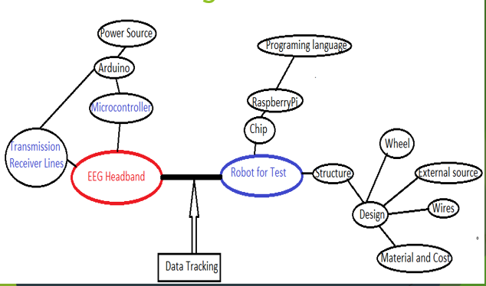

1. ***Six* *Hats***
2. **White Hat -** EEG(Electroencephalogram) is a test used to detect abnormalities related to electrical activity of the brain. This tracks and records brainwave patterns. EEG Products have been applied to Medical and Science fields.
3. **Black Hat -** The implementation will be difficult because we have a lot things that we need to figure out in order to have it working properly the signals from headset may be too similar for recognition.
4. **Red Hat –** Excitement, Enthusiasm motivated curious passionate concerned worried
5. **Yellow Hat -** Understand that the resources are finite at lease we have some resources that are keys to our success on this EEG project. Our project plans are going well, but it could run even better if we know more about Brainwave characteristics.
6. **Blue Hat -** Further focus and study on brainwave characteristic. Spend more time on hardware and software interface. If successful, we take it up a notch for Retardation treatment application.
7. **Green Hat -** Add more electrodes into our Headband to have more accurate and faster signals.
8. ***Patents***

Very low patent search of 26

**Preliminary Design**

1. **Block Diagram**

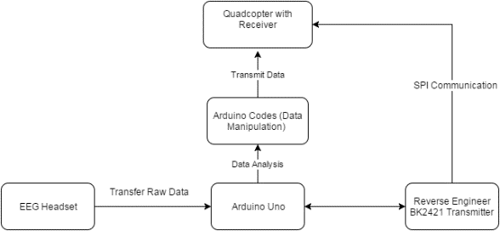

**Transmitter and Arduino Wiring Diagram.**



**Risk management**

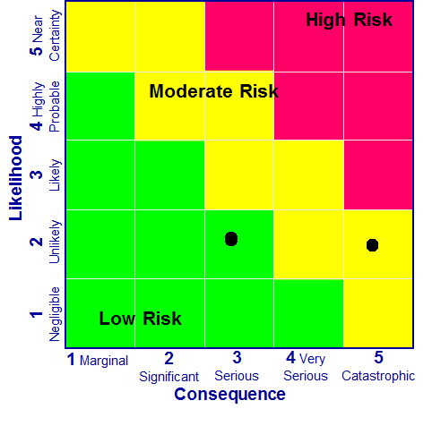

(3,2) Serious but unlikely, Our Mindflex and Arduino can fry, along with that we don’t have an emergency shutoff incase the quadcopter loses control.

(5,2) Catastrophic but unlikely, if something gets wired incorrectly or malfunctions, we could get shocked.

**Detail Design**

1. ***Parts table***

|  |  |  |  |  |
| --- | --- | --- | --- | --- |
| **Purchased** | | | | |
| **Part** | Manufacturer | Part No | Quantity | Cost |
| **SkyWalker Quadcopter**  **With Remote Controller** |  |  | 1 | $70.00 |
| **Arduino** |  |  | 1 | $22 |
| **MindFlex headset** |  |  | 1 | $19.99 |
| **Total** |  |  |  | $112 |

1. ***Parts Design***

Mindflex’s RX connected to Arduino’s TX and both are grounded. Mindflex has its own battery supply while Arduino is powered through a computer/laptop. The computer will be connected to the same internet as the quadcopter.

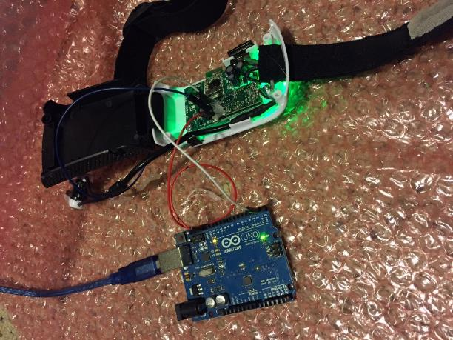

*Figure 1: EEG Chip and Arduino Wiring Connection*

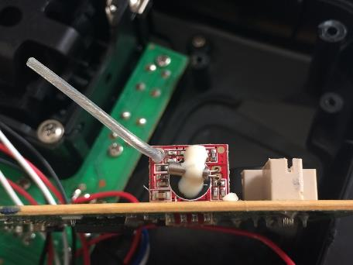

*Figure 2: Transmitter BK2421*

1. ***Information received and plotted***

* ***8 Values*** 
  1. [Delta](http://en.wikipedia.org/wiki/Delta_wave) (1-3Hz): sleep
  2. [Theta](http://en.wikipedia.org/wiki/Theta_wave) (4-7Hz): relaxed, meditative
  3. [Low Alpha](http://en.wikipedia.org/wiki/Alpha_waves) (8-9Hz): eyes closed, relaxed
  4. [High Alpha](http://en.wikipedia.org/wiki/Alpha_waves) (10-12Hz)
  5. [Low Beta](http://en.wikipedia.org/wiki/Beta_wave) (13-17Hz): alert, focused
  6. [High Beta](http://en.wikipedia.org/wiki/Beta_wave) (18-30Hz)
  7. [Low Gamma](http://en.wikipedia.org/wiki/Gamma_wave) (31-40Hz): multi-sensory processing
  8. [High Gamma](http://en.wikipedia.org/wiki/Gamma_wave) (41-50Hz)

These are the types of electrical activity transmitted from the electrode attached to the Mindflex, and with the same values were going to create commands to the quadcopter.

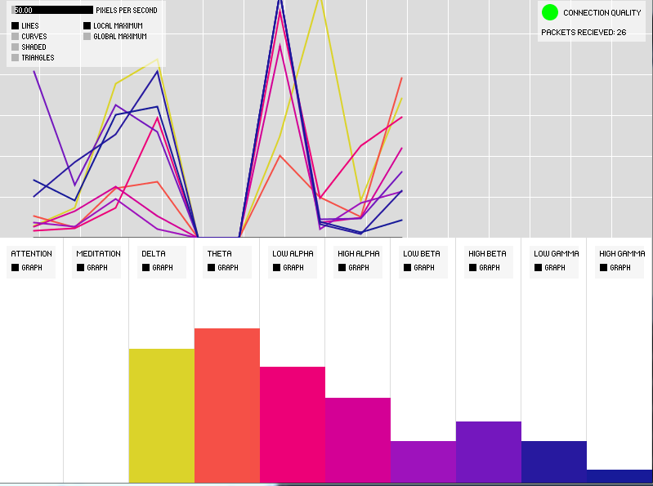

**Finished Plan**

* 1. ***Gantt Chart***

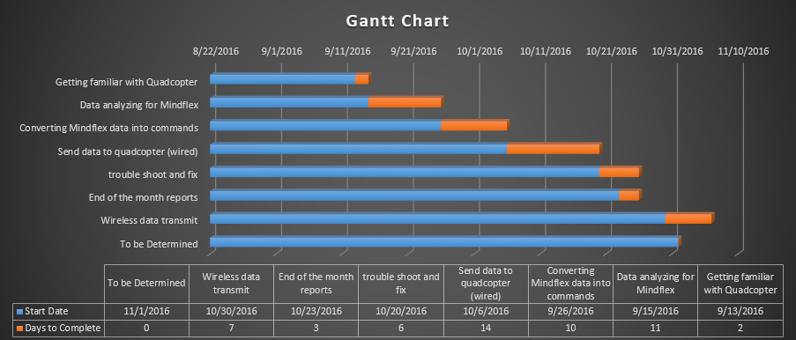

**Conclusion**

We’ve finished our design and have a working product. Our product does what it was intended to do. It’s a cheap project, safe to fly, and has a lot of potential. Our Mindflex controls the quadcopter and allows it to fly through signals sent from the brain.

**Appendix**

***Brochure***

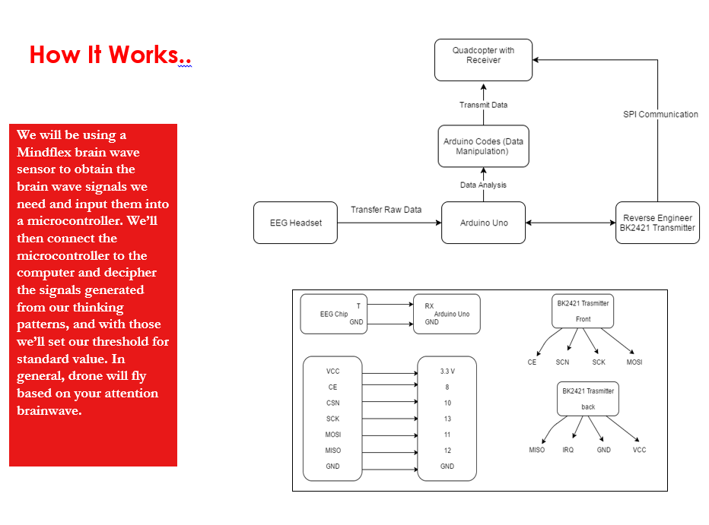

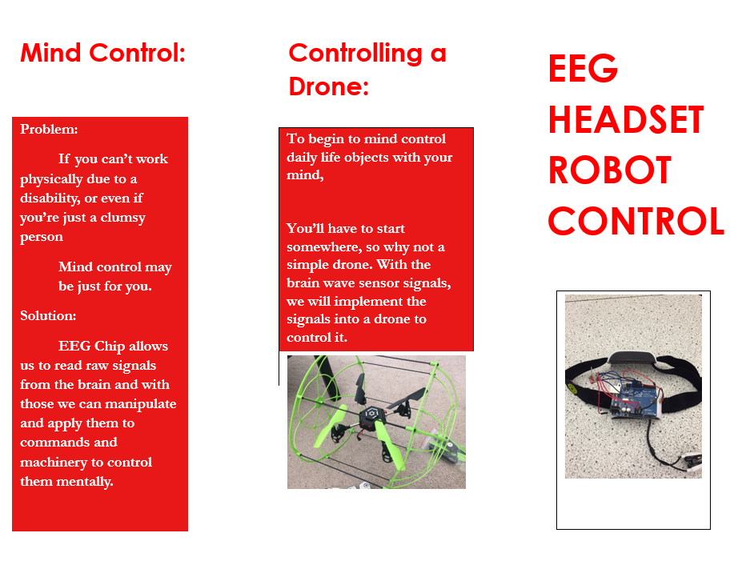

**Resume**

Alex

|  |  |
| --- | --- |
|  |  |
|  | 491 E 132nd Way, Thornton, CO | (303)-842-8004 | Alex.Tran@ucdenver.edu |

Objective

|  |  |
| --- | --- |
|  |  |
|  | I’m in search of a position in IT or computer hardware/software where I can apply the knowledge I’ve learned from years of education. I’m a very motivated individual who aspires to be a very productive for those that offers me the opportunity. |

Skills

|  |  |
| --- | --- |
|  |  |
|  | Technical Skills   * MS Office( Word, Excel, Powerpoint) * C programming, Matlab, Python, Assembly, Verilog * Windows, Linux |
|  | Hardware   * Arduino, De1/De2 SoC |

Work/Volunteer

|  |  |
| --- | --- |
|  |  |
| 2008-Present  2012  Spring 2012 | Restaurant,  Chan’s Inn(Family Owned)   * Cashier, Receptionist, Host, Server, Delivery, Electronic troubleshooting   Boulder Boulder   * Did “Security” (Gave information to people)   Vietnamese Student Association |

Education

|  |  |
| --- | --- |
| 2011-Present | [Degree Earned],  University of Colorado, Denver |
| 2011-Present | University of Colorado, Denver  Major in Electrical Engineering (Specialty in Computer Engineering) |
| 2010-2011 | Front Range Community College  Major in Pre-Pharmacy |

Projects

|  |  |
| --- | --- |
| 2011-Present | [Degree Earned],  University of Colorado, Denver |
| 2011-Present | Brainwave Controlled Robot   * Incomplete, Currently in the works. |
| Spring 2015 | Avoidance Robot   * Robot implemented with Arduino and programmed with C to drive and avoid objects. |

**Minh Hong Le**

2835 W Colorado Ave, Denver, CO 80219

**Phone:** (720)-579-5630 | **Email:** [hongminh11091@gmail.com](mailto:hongminh11091@gmail.com) **LinkedIn:** [https://www.linkedin.com/in/minh-le-4733258a](http://www.indeed.com/url?q=https%3A%2F%2Fwww.linkedin.com%2Fin%2Fminh-le-4733258a&h=734c763b)

**OBJECTIVE**

I’m looking for an Entry Level or Internship position in Hardware/Software Integration. I desire to learn and work in challenging Embedded Systems environment that gives me an opportunity for contributing towards Technology and overall professional development of the organization. I quickly learn and master new technologies; successful working in both team and self-directing settings.

**EXPERTISE**

* **IT Tools**: Active Directory, Zendesk Ticket System, VBScript, Window Server 2012 R2, Remote Desktop.
* **Programming Skills:** C and Python.
* **Operating Systems:** Linux, Window, Mac OS.
* **Hardware-Software:** Raspberry Pi 2 Model B with Python, DE1 SOC, Arduino.
* **Electrical Design tools:** OrCAD Pspice
* **Software:** Microsoft SharePoint 2013, SharePoint Designer 2013, InfoPath Designer 2013, Microsoft Access (2013, 2016), Microsoft Exchange (2013, 2016), NotePad++, Eclipse, Visual Studio, Codeblock, PuTTy, Jupyter Notebook.

**EDUCATION**

**[1/14– Present] University of Colorado, Denver** | **Expected Graduate: December 2016 | Overall: 3.0**

* Bachelor of Science in Electrical Engineering
* Major in Computer Engineering

**[9/12 – 6/14] Portland Community College, Portland OR**

* Association of Science (A.S) in Computer Science
* Received $3,000 International Achievement Scholarship every years.

**WORK AND VOLUNTEER**

**[8/15 – Present] College of Nursing, University of Colorado Anschutz Medical Campus**

**Office of Finance and Business Administration**  **Position:** IT Support Technician

**[2/10 – 4/10] OMSI (Oregon Museum of Science and Industry)**  **Position:** Volunteer Checker.

**PROJECTS**

**Electronic Forms on Intranet Webpage with Access (College of Nursing)**

* **Goal:** Create and design forms on Intranet SharePoint Platform 2013.

**EEG headset-Mind Control (Senior Design Project)**

* **Hardware:** BK2421 Transmitter, Arduino UNO and EEG microcontroller.
* **Goal:** Make the drone fly up and down based on Attention and Relaxation brainwave.

**Printer and Share Drive Mapping**

* **Goal:** Wrote a script that automatically maps User Account with proper printers and share drives every time they log in with their account.

**Color Detection and Object Recognition**

* **System:** Raspberian OS on Raspberry Pi 2 Model B
* **Software:** Geany IDE, GNU.
* **Language:** Python, Linux command lines
* **Github:** https://github.com/mle1001/PI_Project_Python.git.

***ChocAn (Chocoholic Anonymous)***

* **Goal:** ChocAn Information System (CIS) software that meets all Chocoholics Anonymous organization needs.
* Software in a user-friendly manner with organized and accurate output for better business workflow.
* **Design:** Java Eclipse 1.6 IDE, Window Builder PRO for interface, SWING GUI toolkit, MySQL Workbench database for application, Redmine Repository.
* **Test:** Inspection, JUnit, Black-Box testing, Sandwich Integration.
* **Github**: https://github.com/mle1001/ChocAn_Project_Java.git