**FPT ACADEMY INTERNATIONAL**



## FPT – APTECH COMPUTER EDUCATION

CENTRAL-zoo

|  |  |  |  |
| --- | --- | --- | --- |
| **Center Name** | | FPT – Aptech – HCM2  Address: 590 Cach Mang Thang Tam, District 3, Ho Chi Minh City | |
| **Instructor** |  | Ms. Le Mong Thuy |  |
| **Class** |  | T1.2010.E0 |  |
| **Group** |  | 8 |  |
| **Group members** | | **Name** | **Student ID** |
|  |  | Nguyen Hong Quan | Student1266451 |
|  |  | Tran Minh Hoan | Student1225616 |
| **Duration** | Start date | 25th Dec 2020 |  |
| End date | 26th Jan 2021 |  |

**This is to certify that**

**Mr:**

Nguyen Hong Quan

Tran Minh Hoan

**has successfully designed & developed**

eProject: CENTRAL-zoo website

**Submitted by:**

Nguyen Hong Quan

**Date of issue:** Jan 25th 2021

**Authorized Signature:**

# ACKNOWLEDGE

To have a successful project, it is the continuous effort of many people. The most important person is Ms. Le Mong Thuy – our teacher. With many years’ experience of teaching, along with enthusiasm as well as rigorous in guiding the project, she is the person who helped us complete the subject to catch the schedule can achieve our goal. Besides, this is the efforts and curiosity of the members in our group. We have focused on starting the project very early, promoting teamwork by sharing experiences and knowledge with each other throughout the project. The last but not least, we would like to say thank you to our family for always supporting us, creating the best conditions for us to focus on the project, and putting faith in the dreams we pursue.

# SYNOPSIS

CENTRAL zoo is one of the biggest zoo in the town. The land area of the zoo is 33 acres.

CENTRAL zoo was established in the year 1980 with 10 acre land but lately it was modified and land area was also added in the year 2000. Proper residing space for all the type of animals has been made and maintains human security at high rate.

Here we are aiming to design a website CENTRAL zoo which will provide the information about all the animals (like species, animal classification) which are kept and along with their image.



**TABLE OF CONTENTS**

FPT – APTECH COMPUTER EDUCATION 1

PROBLEM DEFINITION 3

CUSTOMER'S REQUIREMENTS SPECIFICATIONS (CRS) 4

Business/Project Objective: 4

Hardware/ Software Requirements: 5

SCOPE OF THE WORK (IN BRIEF) 6

Architecture and design of the system 7

Diagram of the website 8

SITE MAP 11

MOCK OF THE WEBSITE 12

**WEBSITE DESCRIPTION........................................................................................... 14**

# PROBLEM DEFINITION

The Web site is to be created based on the following requirements.

1) The Home Page should be created making use of Sections with a suitable logo

2) The look and feel of the project must be made user friendly and uniformity in the color combination must be maintained.

3) About us

4) Contact Us

5) Animal’s information can be added in the categorized like birds, animals, water animals, and so on.

6) Safari option is there for which dummy booking option can be added.

7) Library of animals and birds

8) Timings of the zoo

9) Navigation of the project made smooth.

10) Events organized

11) Feedback form.

# CUSTOMER'S REQUIREMENTS SPECIFICATIONS (CRS)

**Client: CENTRAL-zoo**

### Business/Project Objective:

CENTRAL zoo is one of the biggest zoo in the town. The land area of the zoo is 33 acres. CENTRAL zoo was established in the year 1980 with 10 acre land but lately it was modified and land area was also added in the year 2000. Proper residing space for all the type of animals has been made and maintains human security at high rate.

We are supposed to create a website for them with the below mentioned requirement specifications.

The website is to be developed for the Windows Platform using HTML5, JavaScript and Geolocation. The site should work well in all leading browsers including Chrome, IE, Firefox etc.

**Input to the system:**

* + - * Searching animals threats,
      * Searching information, documents of CENTRAL zoo.
      * Feedback about our models problem or new models which you want to share.
      * Register members on website.

**Output from the system:**

* Displaying information of models that the user is looking for, including forms, styles, images, guidance.
* Display a website for the CENTRAL zoo which will provide the information about all the animals (like species, animal classification) which are kept and along with their image.

**Process**:

* + - * Create Learning page
      * Validate data input from users.

**Expected delivery date:** 25-Jan-2021.

**List of deliverables:**

* + - * Document Word.
      * User Guide.
      * Source code.

### Hardware/ Software Requirements:

* **For web developer**

**Hardware**

* + Intel Pentium 4 processor or higher
  + 1 Gigabytes of RAM or higher

### Software

* + Windows 7 OS or higher
  + Adobe Dreamweaver
  + Web browsers such as IE, Chrome or Firefox are supporting HTML5, CSS3 and Javascript.

### For web users

**Hardware**

* + Intel Pentium 4 processor or higher
  + 512 Megabytes of RAM or higher

### Software

* + Windows XP OS or higher
  + Web browsers such as IE, Chrome or Firefox are supporting HTML5, CSS3 and Javascript.

# SCOPE OF THE WORK (IN BRIEF)

After a long and detailed discussion, our group has decided to create a website contain the following webpages:

1. ***Homepage***: Display information about CENTRAL zoo.
2. ***Gallery***: Gallery of CENTRAL zoo.
3. ***About***: Display the information of the club(CENTRAL zoo).
4. ***Events***: Events in CENTRAL zoo.
5. ***Contact***: Display the address of the club, allow user to request any information they want to CENTRAL zoo. Feedback of visitors to webmaster.

# Architecture and design of the system

Webpage request



Requested Page

**RENDERING**

**ENGINE**

**CSS CODE**

**HTML CODE**

**WEB SERVER**

**WEB BROWSER**

**CLIENT**

**SERVER**

# 

# Diagram of the website

|  |
| --- |
| HOME |
| GALLERY |
| EVENTS |
| ABOUT |
| CONTACT |
| LOGIN |

END

BEGIN





**TASK SHEET REVIEW 1**

|  |  |  |  |  |  |  |  |
| --- | --- | --- | --- | --- | --- | --- | --- |
| **Project Ref. No.:**  **eP/Advertisement Portal Management**  **System/01** | | **Project Title:** | **Activity Plan Prepared By:** | **Date of Preparation of Activity Plan:** | | | |
| **Sr.**  **No.** | **Task** | **Actual**  **Start Date** | **Actual Days** | **Team**  **Mate Names** | **Status** |
| 1 | Problem Statement | CENTRAL-zoo | Nguyen  Hong  Quan | 27-Dec-20 | 1 | Hoan | Completed |
| 2 | Analysis of CENTRAL-zoo requirements about the website | 27-Dec-20 | 1 | Hoan | Completed |
| 3 | The scope of the work (in brief) | 27-Dec-20 | 1 | Hoan | Completed |
| 4 | Architecture and design of the system | 27-Dec-20 | 1 | Hoan | Completed |
| 5 | Diagram of the website | 27-Dec-20 | 1 | Hoan | Completed |
| 6 | Task Sheet | 27-Dec-20 | 1 | Hoan | Completed |

|  |  |
| --- | --- |
| **Date:** 15-June-2020 | |
| Signature of Instructor:  **Ms. Le Mong Thuy** | Signature of Team Leader:  **Mr.Nguyen Hong Quan** |

# SITE MAP

**LOGIN**

**CONTACT**

**ABOUT**

**EVENTS**

**MENU**

**GALLERY**

**HOME PAGE**

**LOG IN PAGE**

**LOG IN**

### Home page

# Mock of the website

**HEADER**

**LOGO - MENU**

**PICTURE SLIDESHOW**

**GALLERY**

**EVENTS**

**ABOUT**

**LOGIN**

**CONTACT**





**TASK SHEET REVIEW 2**

|  |  |  |  |  |  |  |  |
| --- | --- | --- | --- | --- | --- | --- | --- |
| **Project Ref. No.:**  **eP/Advertisement**  **Portal Management System/01** | | **Project Title:** | **Activity Plan Prepared By:** | **Date of Preparation of Activity Plan:** | | | |
| **Sr.**  **No.** | **Task** | **Actual Start Date** | **Actual Days** | **Team Mate Names** | **Status** |
| 1 | Site map | CENTRAL-zoo | Nguyen Hong Quan | 04-Jun-21 | 1 | Quan | Completed |
| 2 | Mock of the website | 04-Jun-21 | 1 | Quan | Completed |
| 3 | Task sheet | 04-Jun-21 | 1 | Quan | Completed |

|  |  |
| --- | --- |
| **Date:** | |
| Signature of Instructor:  **Ms. Le Mong Thuy** | Signature of Team Leader :  **Mr.Nguyen Hong Quan** |

**WEBSITE DESCRIPTION**

### 1 Home page

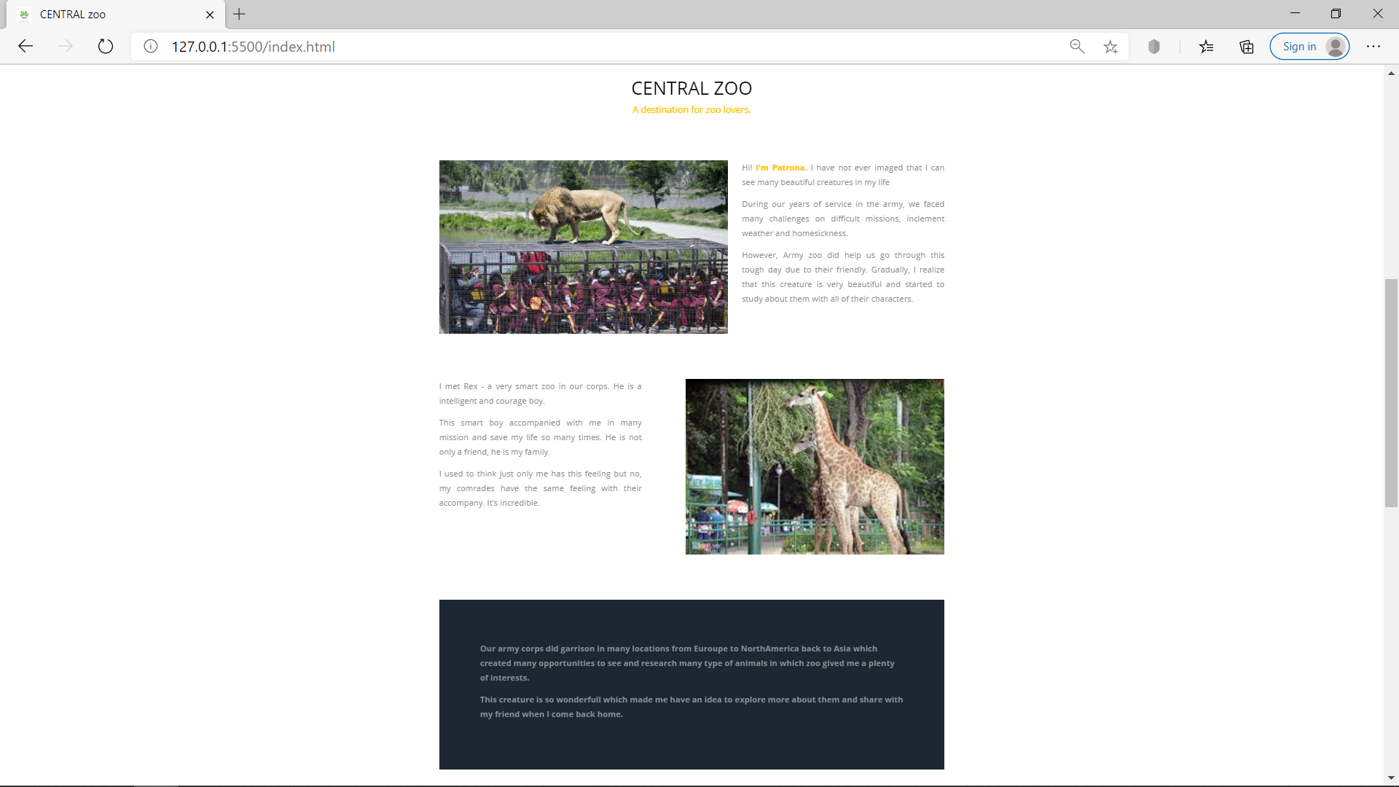

**2 Gallery**

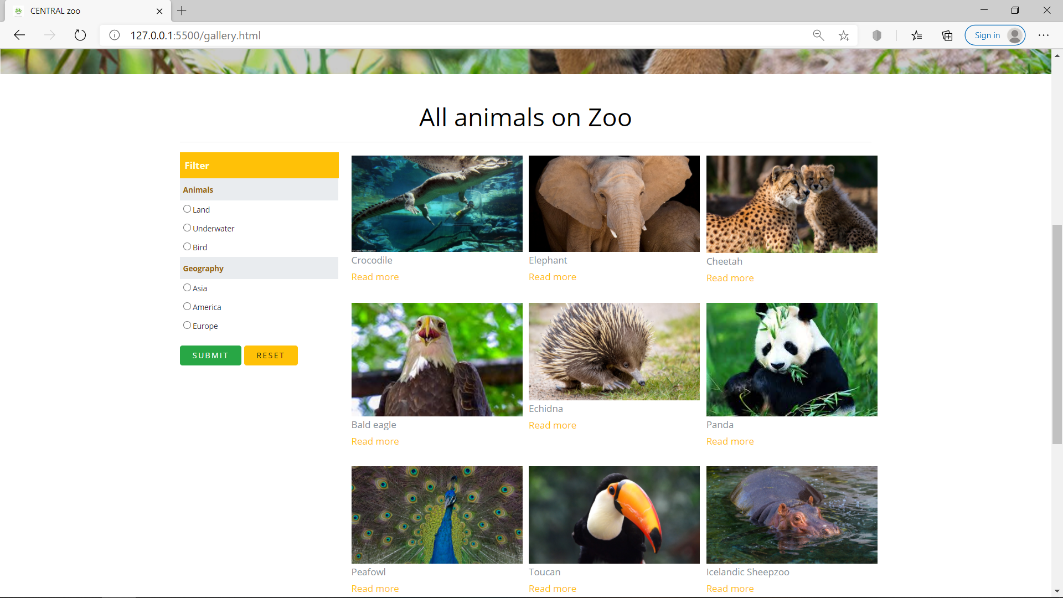

TASK SHEET REVIEW 3

|  |  |  |  |  |  |  |  |
| --- | --- | --- | --- | --- | --- | --- | --- |
| **Project Ref. No.: eP/Advertisement Portal Management System/01** | | **Project Title:** | **Activity Plan Prepared By** | **Date of Preparation of Activity Plan:** | | | |
| **Sr./No.** | **Task** | **Actual Start Date** | **Actual Days** | **Team member name** | **Status** |
| 1 | HOME PAGE | CENTRAL-zoo | Nguyen Hong Quan | 15-Jun-21 | 1 | HOAN | Completed |
| 2 | GALLERY | 15-Jun-21 | 1 | HOAN | Completed |
| 3 | EVENTS | 15-Jun-21 | 1 | QUAN | Completed |
| 4 | ABOUT | 15-Jun-21 | 1 | QUAN | Completed |
| 5 | FEEDBACK |  |  | 15-Jun-21 | 1 | QUAN | Completed |
| 6 | LOGIN |  |  | 15-Jun-21 | 1 | Hoan | Completed |

|  |  |
| --- | --- |
| **Date:** | |
| Signature of Instructor:  **Ms. Le Mong Thuy** | Signature of Team Leader :  **Mr.Nguyen Hong Quan** |