|  |  |
| --- | --- |
|  | **FPT ACADEMY INTERNATIONAL**  **FPT – APTECH COMPUTER EDUCATION** |

**Centre Name: ACE-HCMC-2-FPT.**

**Address: 590 Cach Mang Thang 8, District 3, Ho Chi Minh City, Viet Nam.**

**Railway Reservation & Management System**

**Design Document**

|  |  |  |
| --- | --- | --- |
| **Supervisor:** | Mr. Tran Phuoc Sinh | |
| **Semester:** | 3 | |
| **Batch No:** | T1.1910M3 | |
| **Group No:** | 4 | |
| **Order:** | **Full name** | **Roll No.** |
| 1. | Truong Ngoc Anh Tuan | Student1222904 |
| 2. | Tran Minh Hoan | Student1225616 |
| 3. | Luong Xuan Bac | Student1219640 |
| 4. | Dao Nguyen Duy Khang | Student1225621 |

January 2021

**This is to certify that**

**Mr.**Truong Ngoc Anh Tuan

**Mr.**Tran Minh Hoan

**Mr.**Luong Xuan Bac

**Mr.**Dao Nguyen Duy Khang

**have successfully designed & developed:**

eProject: Railway Reservation & Management System

**Submitted by:**

Mr. Tran Phuoc Sinh

**Date of issue:** JAN 18­­­­­th 2021

**Authorized Signature:**

# Acknowledgement

First and foremost, we would like to express the deepest appreciation to our admirable instructor – Mr. Tran Phuoc Sinh. During the time of the project, he continually and convincingly conveyed a spirit of adventure in regard to research and scholarship, and an excitement in regard to teaching. Without his guidance and persistent help this dissertation would not have been possible. Therefore, once again, we truly value your dedication and guidance, Mr. Sinh.

Next, it would have been impossible to carry out and complete this project without the collaboration among our team members. Although we have gone through many obstacles during the project implementation, eventually we gained what we aimed at by our hard work, our strong commitment and of course, our brotherhood.

Finally, thanks to Aptech’s eProject team, we had a golden opportunity to apply what we have learnt into reality and gain hands-on experience which is essential for our future career.

1. **Problem Definition:**

For the convenience of transportation the government want to building app can buy ticket online. It faster and more convenient traditional, it easy use for citizen and visiter.

**Manager:**

**-**Manager can view the list the condition of the trains, the number of guests.

-Manager can Price adjustments for each station or ticket type.

-Manager can delete,update,edit and create the train.

-Manager can delete,update,edit and create time running.

-Manager can view user information or delete user.

**User:**

* User can login account.
* User can buy ticket online or cancel.
* Edit user information or password.
* User can view price of the tickets, price through each station.
* User can view time running.
* User can view detail the train.

**Advantages:**

The buy ticket online application will help buy ticket faster, easy.

+ Manager can edit, create, delete detail the train and time running or view user information.

+ User can buy ticket online faster traditional, can view time running exactly, view deltail of the train and read news about change schedule.

+ visiter can view the train detail, time running, price ticket, read news about change schedule and create account.

**Disadvantages:**

+ Can’t buy if don’t connect internet.

+ If a large number of users login the application can an error occurred.

+ Can’t buy ticket if don’t register account.

1. **Requirement Specification**

## **1.Customer's Requirement Specifications**

Online buyticket has put forwarded all the list of data’s, he/she required in the application which is stated below:

* 1. **Manager**

+ Manager will have the authority to enter the details of the train run. Details to be maintained like time running, price ticket, name of the train or name station.

+ Manager can even view the list of all the customer booking ticket, information user. Edit password for user (if he or she forgot password), information of user.

+ Manager even will have the responsibility to edit, update, add, save or delete the time running, name train,name station,price.

* 1. **User**

+ User login can’t book ticket online

+ User can view detail the train, station, time running, price.

+ User can view and edit your information and password.

* 1. **Visiter**

+Visiter can register account.

+ Vister can view detail the train, station, time running, price.

## **2.Functional Requirement Specifications**

### **2.1 Function of Candidate:**

### ***User can:***

* REQ-2.1.1. Booking ticket.
* REQ-2.1.2. Login, log out.
* REQ-2.1.3. Edit password,Information.
* REQ-2.1.4. View detail train,time running,station,price, receive information about unexpected incidents.
* REQ-2.1.5. Cancel ticket.

### **2.2 Function of Manager:**

***Manager can:***

* REQ-2.2.1. Login, log out.
* REQ-2.2.2.View information user.
* REQ-2.2.3. Edit update delete detail train,time running, price,station.
* REQ-2.2.4. Edit password user.
* REQ-2.2.5. Delete User.

### **2.3 Non-Functional:**

* REQ-2.3.1. Improve performance by AJAX
* REQ-2.3.2. Increase security by using HashPassword.

## 3.System Requirement Specifications

### **3.1** Server requirements:

#### Hardware:

|  |  |
| --- | --- |
| **Component** | **Requirement** |
| **CPU** | Processor type:  Pentium IV-compatible processor or faster  Processor speed:  Recommended: 2.0 GHz or faster |
| **OS** | Microsoft Windows XP or higher with IIS |
| **Memory (RAM)** | RAM:  Minimum: 512 MB  Recommended: 2 GB or more |
| **Hard Drive** | Free space:  Minimum: 200 MB  Recommended: 50 GB or more  Maximum: Operating system maximum |

#### Software:

|  |  |
| --- | --- |
| **Component** | **Requirement** |
| **ASP.NET Core** | Version .NET Core 3.1 |
| **RDBMS** | Sql Server 2012 or more |

### **3.2** **Client requirements**:

#### Hardware:

|  |  |
| --- | --- |
| **Component** | **Requirement** |
| **CPU** | Processor type:  Pentium III-compatible processor or faster  Processor speed:  Recommended: 1.0 GHz or faster |
| **OS** | All OS(Window ,Linux ,Android ,Mac OS …) |
| **Memory (RAM)** | RAM:  Minimum: 512 MB  Recommended: 1 GB or more  Maximum: Operating system maximum |
| **Hard Drive** | Free space:  Minimum: 10 MB |

#### Software:

|  |  |
| --- | --- |
| **Component** | **Requirement** |
| **Web Browser** | Firefox 3.0,Chrome or Higher….. |

### **3.3 Development Software**:

* Sql Server 2012
* Microsoft Visual Studio 2019.

### **Technology:**

|  |  |  |  |
| --- | --- | --- | --- |
| **Framework** | **Front End** | **Back End** | **Database** |
| **Entity Framework Core 3.1.0** | **Html 5, CSS 3** | **C#** | **Sql server 2012 or higher** |
| **ASP.NET CORE 3.1** | **Jquery 3.5.1** | **Sql Database** |
| **AJax 3.2.6** | **Bootstrap 3** |  |

# TASK SHEET REVIEW 1

|  |  |  |  |  |  |  |  |
| --- | --- | --- | --- | --- | --- | --- | --- |
| **Project Ref. No.:**  **eP/Advertisement** **Portal Management** **System/04** | | **Project Title:** | **Activity Plan** **Prepared** **By:** | **Date of Preparation of Activity Plan:** | | | |
| **Sr.No.** | **Task** | **Actual Start** **Date** | **Actual** **Days** | **Team** **Mate** **Names** | **Status** |
| 1 | Acknowledgement | Railway Reservation &  Management System | Truong Ngoc Anh Tuan | 21/1/2021 | 1 | All member | Completed |
| 2 | Problem Definition | 21/1/2021 | 1 | All member | Completed |
| 3 | Requirement Specification | 21/1/2021 | 1 | All member | Completed |
| 4 | Task sheet review | 21/1/2021 | 1 | Tuan | Completed |

|  |  |
| --- | --- |
| **Date: 21/1/2021** | |
| Signature of Instructor:  **Mr. Tran Phuoc Sinh** | Signature of Team Leader:  **Truong Ngoc Anh Tuan** |

**REVIEW2**

#### **ARCHITECTURE AND DESIGN OF THE PROJECT:**

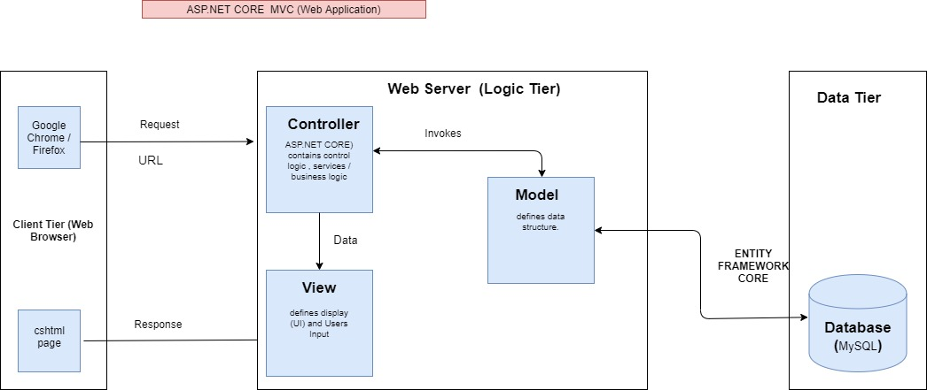

dasdasdasda