1. Concept
   1. Templates

* A CloudFormation template is a JSON or YAML formatted text file.
* Uses the template as blueprints for building your AWS resources.
  1. Stacks
* When you use CloudFormation, you manage related resources as a single unit called a stack.
* All the resources in a stack are defined by the stack’s CloudFormation template.
  1. Change sets
* Summary of your proposed changes.
* Change sets allow you to see how your changes might impact your running resources.

1. How does AWS CloudFormation works

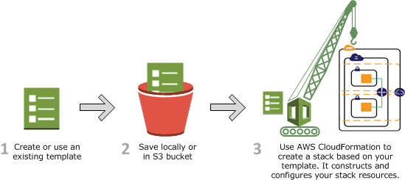

* 1. Create a CloudFormation template
* Using <https://console.aws.amazon.com/cloudformation/designer> or your own text editor.
* CloudFormation provisions and configures resources by making calls to the AWS services that are described in your template.
* After all the resources have been created, CloudFormation reports that your stack has been created.
  1. Updating a stack with change sets
* Create a change set by submitting a modified version of the original stack template, different input parameter values, or both. CloudFormation compares the modified template with the original template and generates a change set.

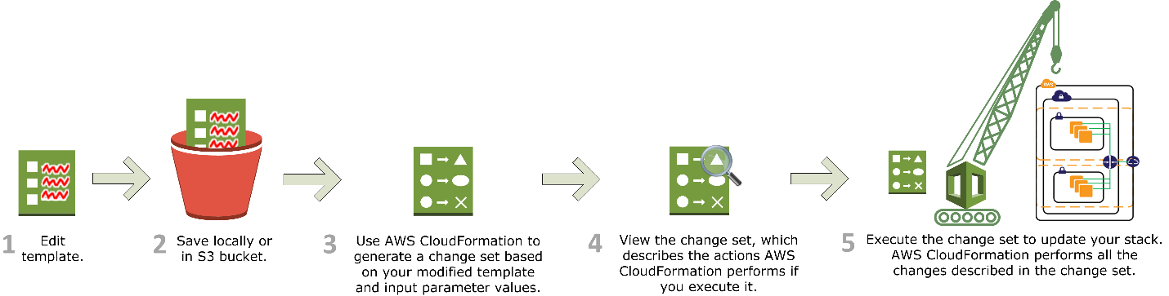

Referent Document

https://docs.aws.amazon.com/AWSCloudFormation/latest/UserGuide/cfn-whatis-concepts.html