

ENGLISH LEARNING APPLICATION

* **Faculty: Ho Hoan Kiem**
* **Batch:**
* **Team Member:**
  + - * **Đào Nhật Minh**
      * **Hoàng Yến Minh**

**Ho Chi Minh City, Oct 11 2017**

Table of Contents

1. Review 1

* **Problem Definition..…………………………………………………………………………………01**
* **Customer Request Specification……………………………………………………………… 02**

1. Review 2

* ***Use Case Diagram* 04**
* ***Class Diagram* 15**
* ***Sequence Diagram* 16**
* ***ERD* 18**
* ***Entity Description* 19**
* ***Table Relationship Diagram* 26**

1. Review 3

* Interface Design………………………………………………………………………………..... 27
* Site Map……………………………………………………………………………………………… 51
* Report ………………………………………………………………………………………………..53
* Tasksheet……………………………………………………………………………………………. 56

REVIEW 1

Problem Definition

1. **The Object Of The Project**

This project will aim at creation of a English Learning Application. This will be accessible to all customers who have a valid User Id and Password. This application provides the following facilities:

* Taking a test
* Manage a bank exam questions
* Rank of score
* View the test which had done before.

Customer Request   
 Specification

1. **Functional Requirements**

Following is a list of functionalities of the system. More functionalities that you find appropriate can be added to this list.

* Customer must have a valid User Id and password to login to the system
* If a wrong password is given thrice in succession, that account will be locked and the customer will not be able to use it. When an invalid password is entered a warning is given to the user that his account is going to get locked.
* After the valid user logs in he is shown the list of test he has to do.
* On selecting the test he is taken to a page which shows the exam with time count down.
* User can view score and details of test question with answers, after he finished his exam.
* User can do the test again for 3 times and system will get the best score to save.
* After 3 times he did exam. The exam had blocked.
* User can view, update his profile.

# Hardware/ Software Requirements

By adding new technologies such as ASP.NET 3.5, and 3-layer architecture, the web site becomes more interactive with users, security and easily updated.

1. **System Requirement**

* **For Users**
  + **Hardware**
    - CPU: Pentium IV 2.0 GHz or higher
    - RAM: 512 MB or higher
  + **Software**
    - OS: Windows 7/XP Professional/Server 2003…
    - Browser: Internet Explorer 8.0 or higher
* **For Software Developers**
  + **Hardware**
    - CPU: Pentium IV 2.0 GHz or higher
    - RAM: 512 MB or higher
  + **Software**
    - OS: Windows XP Professional/Server 2003…
    - Environment: Microsoft .NET Framework 3.5
    - Database Management System: Microsoft SQL Server 2014
    - IDE: Microsoft Visual Studio 2017
    - Web Server: Internet Information Services (IIS) JSP / Servlets Dev. Kit

|  |  |  |
| --- | --- | --- |
| **Date: Oct 11, 2017** | **Prepared by Project Group 7**  **Team Leader:** | **Approved by**  **Mr Ho Hoan Kiem** |
| **Signature** |  |  |

REVIEW 2

**USE CASE DIAGRAM**

**Customer :**

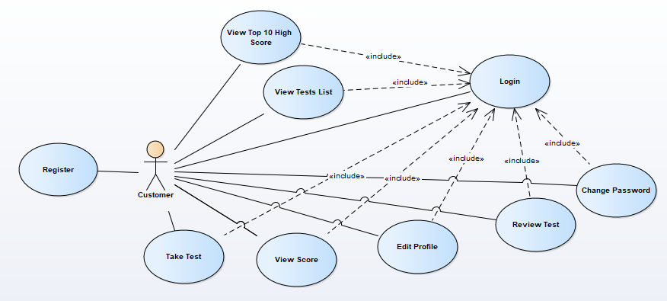

**Administrators :**

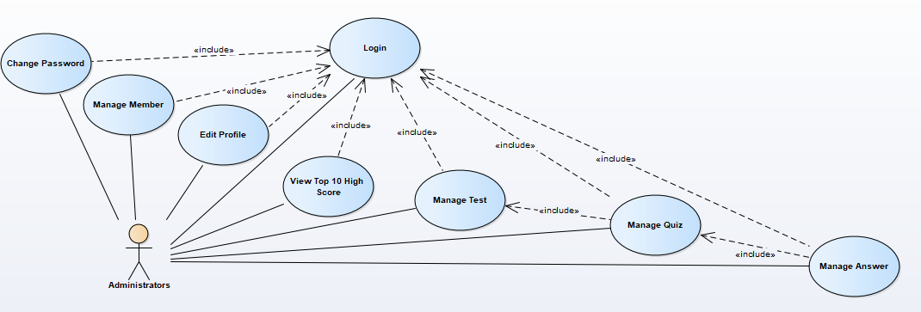

**USE CASE DESCRIPTION**

1. **Actor:**

* **Customers :** include all visitors that use this application. They are guests and members. ***Guest*** is the person that uses this website but doesn’t register. ***Member*** is the person that uses this winform and register to become a member of us.
* **Winform administrators :** The person(s) that manage and maintain this web site.

1. **Usecase:**

|  |  |
| --- | --- |
| **Usecase** | Register |
| **Short Description** | Register account to become a member of the winform. |
| **Pre-Conditions** |  |
| **Post-Conditions** |  |
| **Main flow** | _Guest must provide mandatory information :   * Username. * Password. * Confirm Password. * Email * Date Of Birth.   _Guest provides supplementary information :   * Name. * Sex * Phone   _Guest clicks on Register button.  _System checks the information which guest provided  _System get time of created and create new account for guest that registers to this form.  _Guest becomes a member of this application. |
| **Alternative flow(s)** | _If guest clicks on the Reset button, all the field will be reset.  _If the mandatory information that guest provided, is missed or not exactly, system notifys the error. All cases are :   * Username has existed in Database. * Password is less than 6 characters or more than 30 characters. * Confirm Password and Password are not the same. * Email is invalid or has existed in database. * Date Of Birth must more than 16 years old. * Any fields are blank.   _If the suplementary information that guest provided, is invalid form, system nofitfys the error. All cases are :   * PhoneNumber has any character is not a digit. * Birthday is not along with format “dd/MM/yyyy”.   _System must be insert the date that guest register to become member.  _If server notifys any error when it’s processing, system must be write report into Log file. |

|  |  |
| --- | --- |
| **Usecase** | Login |
| **Short Description** | Log in application to use any function of member. |
| **Pre-Conditions** | User had registered |
| **Post-Conditions** |  |
| **Main flow** | _Guest inputs the login information :   * Username. * Password.   _Guest clicks on the Login button.  _System check the Username and Password.  _If Username and Password are valid, system will move member to Login Form.  _ If a wrong password is given thrice in succession, that account will be locked and the customer will not be able to use it. When an invalid password is entered a warning is given to the user that his account is going to get locked. |
| **Alternative flow(s)** | _If guest clicks on “Reset” button, the Username field and Password field are blank.  _If Username field or Password field is invalid form or blank when guest clicks on the “Login” button, system will notify the error.  _If server notifies any error when it’s processing, system must be write report into Log file. |

|  |  |
| --- | --- |
| **Usecase** | Edit Profile |
| **Short Description** | Edit member’s information. |
| **Pre-Conditions** | Member logined |
| **Post-Conditions** |  |
| **Main flow** | _Guest login to this application.  _Member clicks on the menu to shown his(her) information.  _Member check and update information.  _Member clicks Update Information.  _System check this information and save it on the server.  _System notify report to member. |
| **Alternative flow(s)** | _If any information edit are invalid, system will notify the error.  _If server notifies any error when it’s processing, system must be write report into Log file. |

|  |  |
| --- | --- |
| **Usecase** | Change Password |
| **Short Description** | Change member’s password |
| **Pre-Conditions** | Member logined |
| **Post-Conditions** |  |
| **Main flow** | _Guest login to this application.  _Member clicks on the menu to shown his(her) information.  _Member clicks Change Password  _Member inputs:   * Old Password * New Password * Confirm New Password   _System check this information and save it on the server.  _System notify report to member. |
| **Alternative flow(s)** | _If old password is invalid, system will notify the error.  _If a wrong old password is given five in succession, that account will be locked and the customer will not be able to use it.  _If new password and confirm new password are not match, system will notify the error.  _If server notifies any error when it’s processing, system must be write report into Log file. |

|  |  |
| --- | --- |
| **Usecase** | Take A Test |
| **Short Description** | Customers can do a exam |
| **Pre-Conditions** | Member logined |
| **Post-Conditions** |  |
| **Main flow** | _Guest login to this application.  _Member clicks on the menu to Take a test of his(her) , and user will go to Test Page having 3 test to do.  _ Member selecting the test his(her) wants to do.  _ Test Doing Page will open and time will count.  _Time out, Test Doing Page will be closed.  _System checks this question of the test base on the server.  _System saves score in database.  _System shows the score for member to view. |
| **Alternative flow(s)** | _If member clicks Submit before time out. System’ll stop time counter and implement next steps.  _If server notifies any error when it’s processing, system must be write report into Log file. |

|  |  |
| --- | --- |
| **Usecase** | Review A Test |
| **Short Description** | View tests had done. |
| **Pre-Conditions** | Member logined and finished this test |
| **Post-Conditions** |  |
| **Main flow** | _Guest login to this application.  _Member clicks on the menu to All Tests List page.  _Member clicks Test his(her) did it before, and clicks review questions and answers.  _System checks this test and load this test from the server to client to view. |
| **Alternative flow(s)** | _If server notifies any error when it’s processing, system must be write report into Log file. |

|  |  |
| --- | --- |
| **Usecase** | View Score |
| **Short Description** | Show score of tests. |
| **Pre-Conditions** |  |
| **Post-Conditions** |  |
| **Main flow** | _Guest login to this application.  _Member clicks on the menu to All Tests List page.  _Member clicks on the Test, scores list will appear  _System selects score to show |
| **Alternative flow(s)** | _If server notifies any error when it’s processing, system must be write report into Log file. |

|  |  |
| --- | --- |
| **Usecase** | View Top Score |
| **Short Description** | Member view top 10 high score |
| **Pre-Conditions** | Member logined |
| **Post-Conditions** |  |
| **Main flow** | _Guest login this application.  _Member clicks on the menu Top Scores.  _System shows top high score on table. |
| **Alternative flow(s)** | _If server notifies any error when it’s processing, system must be write report into Log file. |

|  |  |
| --- | --- |
| **Usecase** | Administrator Login |
| **Short Description** | Log in application to use any function of member. |
| **Pre-Conditions** |  |
| **Post-Conditions** |  |
| **Main flow** | _Guest inputs the login information :   * Username. * Password.   _Guest clicks on the Login button.  _System check the Username and Password.  _If Username and Password are valid, system will move member to Login Form. |
| **Alternative flow(s)** | _If guest clicks on “Reset” button, the Username field and Password field are blank.  _If Username field or Password field is invalid form or blank when guest clicks on the “Login” button, system will notify the error.  _If server notifies any error when it’s processing, system must be write report into Log file. |

|  |  |
| --- | --- |
| **Usecase** | Administrator Edit Profile |
| **Short Description** | Edit admin’s information. |
| **Pre-Conditions** | Admin logined |
| **Post-Conditions** |  |
| **Main flow** | _Guest login to this application.  _Admin clicks on the menu to shown his(her) information.  _Admin check and update information.  _ Admin clicks Update Information.  _System check this information and save it on the server.  _System notify report to admin. |
| **Alternative flow(s)** | _If any information edit are invalid, system will notify the error.  _If server notifies any error when it’s processing, system must be write report into Log file. |

|  |  |
| --- | --- |
| **Usecase** | Change Password |
| **Short Description** | Change admin’s password |
| **Pre-Conditions** | Admin logined |
| **Post-Conditions** |  |
| **Main flow** | _Guest login to this application.  _ Admin clicks on the menu to shown his(her) information.  _ Admin clicks Change Password  _ Admin inputs:   * Old Password * New Password * Confirm New Password   _System check this information and save it on the server.  _System notify report to admin. |
| **Alternative flow(s)** | _If old password is invalid, system will notify the error.  _If a wrong old password is given five in succession, that account will be locked and the customer will not be able to use it.  _If new password and confirm new password are not match, system will notify the error.  _If server notifies any error when it’s processing, system must be write report into Log file. |

|  |  |
| --- | --- |
| **Usecase** | Manage Test |
| **Short Description** | Manage news of this application. |
| **Pre-Conditions** | Admin logined |
| **Post-Conditions** |  |
| **Main flow** | _Administrator can view, insert, search, update, delete tests.  _Administrator chooses the correlative function.  _System passes administrator to the page that administrator can interact with system. |
| **Alternative flow(s)** | _If server notifys any error when it’s processing, system must be write report into Log file. |

|  |  |
| --- | --- |
| **Usecase** | Manage Quiz |
| **Short Description** | Manage quizs of this application. |
| **Pre-Conditions** | Admin logined |
| **Post-Conditions** |  |
| **Main flow** | _Administrator can view, search, insert, update, delete quizs.  _Administrator chooses the correlative function.  _System passes administrator to the page that administrator can interact with system. |
| **Alternative flow(s)** | _If server notifys any error when it’s processing, system must be write report into Log file. |

|  |  |
| --- | --- |
| **Usecase** | Manage Answer |
| **Short Description** | Manage answers of this application. |
| **Pre-Conditions** | Admin logined |
| **Post-Conditions** |  |
| **Main flow** | _Administrator can view, insert, update, delete answers.  _Administrator chooses the correlative function.  _System passes administrator to the page that administrator can interact with system. |
| **Alternative flow(s)** | _If server notifys any error when it’s processing, system must be write report into Log file. |

|  |  |
| --- | --- |
| **Usecase** | Manage Members |
| **Short Description** | Manage news of this website. |
| **Pre-Conditions** | Admin logined |
| **Post-Conditions** |  |
| **Main flow** | _Administrator can view, search, delete members.  _Administrator chooses the correlative function.  _System passes administrator to the page that administrator can interact with system. |
| **Alternative flow(s)** | _If server notifys any error when it’s processing, system must be write report into Log file. |

|  |  |
| --- | --- |
| **Usecase** | View Top Score |
| **Short Description** | Admin view top 10 high score |
| **Pre-Conditions** | Admin logined |
| **Post-Conditions** |  |
| **Main flow** | _Guest login this application.  _ Admin clicks on the menu Top Scores.  _System shows top high score on table. |
| **Alternative flow(s)** | _If server notifies any error when it’s processing, system must be write report into Log file. |

**CLASS DIAGRAM**

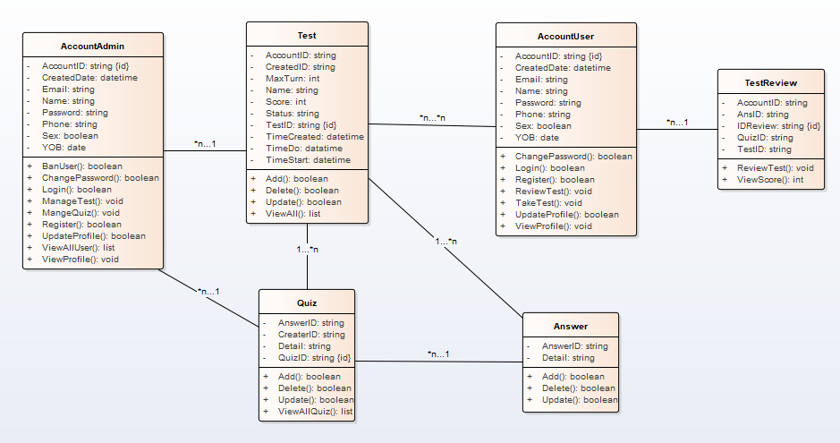

**ENTITY RELATIONSHIP DIAGRAM (ERD)**

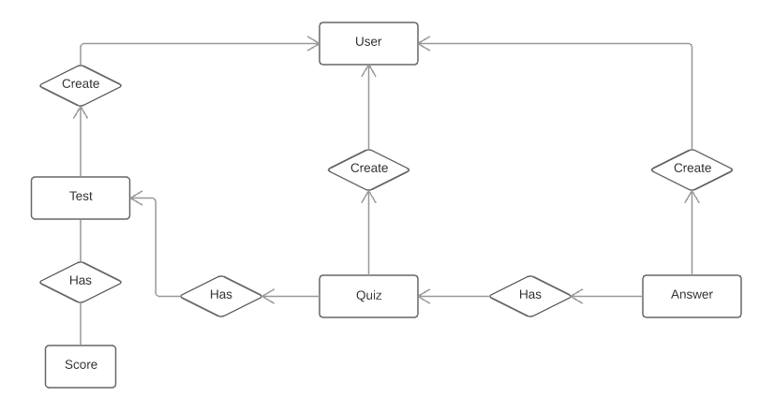 **ENTITY DESCRIPTION**

**1. Customer:**

Customer

**2. Test:**

**3. Quiz :**

Test

Quiz

**4. Answer :**

Answer

**5. Test Review :**

Test Review

**6. Test Score :**

Test Score

**7. Test Control :**

Test Control

**8. Quiz Manage :**

Quiz Manage

**9. Admin :**

Admin

**TABLE DESIGN**

1. **Account:**

|  |  |  |  |  |  |
| --- | --- | --- | --- | --- | --- |
| **No** | **Column Name** | **Data Type** | **Size** | **Check** | **Description** |
| 1 | **🗝**AccountID | Nvarchar | 50 | Not Null | Customer ID |
| 2 | Password | Varchar | 18 | Not Null | Customer’s password |
| 3 | Name | Varchar | 50 | Null | Customer’s user name |
| 4 | DateOfBirth | date |  | Null | Customer’s birthday |
| 5 | Sex | Varchar | 8 | Null | Customer’s gender |
| 6 | Phone | Varchar | 11 | Null | Customer’s phone |
| 7 | Email | Varchar | 50 | Null | Customer’s email |
| 8 | DateOfCreate | Datetime |  | Null | Create account time |

1. **Test :**

|  |  |  |  |  |  |
| --- | --- | --- | --- | --- | --- |
| **No** | **Column Name** | **Data Type** | **Size** | **Check** | **Description** |
| 1 | **🗝**TestID | Int | Identity | Not Null | ID |
| 2 | Status | bit |  | Null | Status Test |
| 3 | Name | Varchar | 100 | Null | Test Name |
| 4 | QuizFrom | int | Identity | Null | Quiz ID From Test |
| 5 | QuizTo | int | Identity | Null | Quiz ID End Test |

1. **Quiz :**

|  |  |  |  |  |  |
| --- | --- | --- | --- | --- | --- |
| **No** | **Column Name** | **Data Type** | **Size** | **Check** | **Description** |
| 1 | **🗝**Quiz ID | Int | Identity | Not Null | ID |
| 2 | Details | Varchar | 300 | Null | Content |
| 3 | QuizAdderID | Varchar | 20 | Null | ID Creater |
| 4 | AnswerID | Varchar | 10 | Null | ID Answer |

1. **Answer:**

|  |  |  |  |  |  |
| --- | --- | --- | --- | --- | --- |
| **No** | **Column Name** | **Data Type** | **Size** | **Check** | **Description** |
| 1 | **🗝**Answer ID | Int | Identity | Not Null | ID |
| 2 | Details | Varchar | 100 | Null | Answer Content |

1. **TestReview:**

|  |  |  |  |  |  |
| --- | --- | --- | --- | --- | --- |
| **No** | **Column Name** | **Data Type** | **Size** | **Check** | **Description** |
| 1 | **🗝** IDView | Int |  | Not Null | ID |
| 2 | QuizID | Int |  | Null | ID Quiz |
| 3 | IDTestScore | Int |  | Null | ID Test Score |
| 4 | AnswerID | Int |  | Null | ID Answer |

1. **TestScore :**

|  |  |  |  |  |  |
| --- | --- | --- | --- | --- | --- |
| **No** | **Column Name** | **Data Type** | **Size** | **Check** | **Description** |
| 1 | **🗝** IDTestScore | Int |  | Not Null | ID |
| 2 | TestID | Int |  | Null | ID Test |
| 3 | AccountID | Nvarchar | 50 | Null | ID Account |
| 4 | Score | Int |  | null | Score |
| 5 | TimeDo | Int |  | Null | Turn Do |
| 6 | TimeStart | datetime |  | Null | Time Start |

1. **TestControl:**

|  |  |  |  |  |  |
| --- | --- | --- | --- | --- | --- |
| **No** | **Column Name** | **Data Type** | **Size** | **Check** | **Description** |
| 1 | **🗝**IDTestControl | Int |  | Not Null | ID |
| 2 | TestID | Int |  | Null | Test ID |
| 3 | QuizID | Int |  | Null | Quiz ID |

1. **QuizManage:**

|  |  |  |  |  |  |
| --- | --- | --- | --- | --- | --- |
| **No** | **Column Name** | **Data Type** | **Size** | **Check** | **Description** |
| 1 | IDQuizControl | Int |  | Not Null | ID Quiz Control |
| 2 | QuizID | Int |  | Null | ID Quiz |
| 3 | AnswerID | Int |  | Null | ID Answer |

1. **Account Admin:**

|  |  |  |  |  |  |
| --- | --- | --- | --- | --- | --- |
| **No** | **Column Name** | **Data Type** | **Size** | **Check** | **Description** |
| 1 | **🗝**AdminID | Nvarchar | 50 | Not Null | Admin ID |
| 3 | AdminPassword | Varchar | 50 | Not Null | Password Admin |
| 4 | AdminName | Varchar | 100 | Not Null | Name Admin |

**Note**

**🗝** Primary key

✓ Unique constraint

**TABLE RELATIONSHIP DIAGRAM**

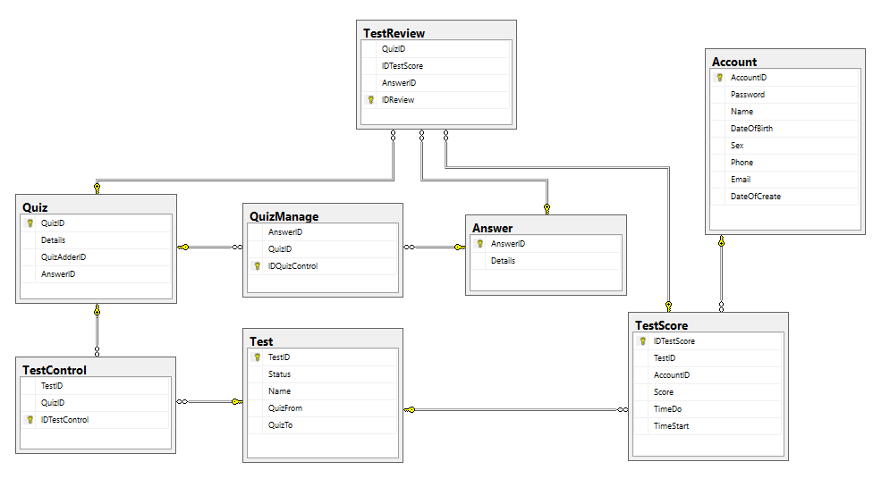

|  |  |  |
| --- | --- | --- |
| **Date: Oct 20, 2017** | **Prepared by Project Group 7**  **Team Leader:** | **Approved by**  **Mr. Ho Hoan Kiem** |
| **Signature** |  |  |

REVIEW 3

**INTERFACE DESIGN**

1. **Home Page**

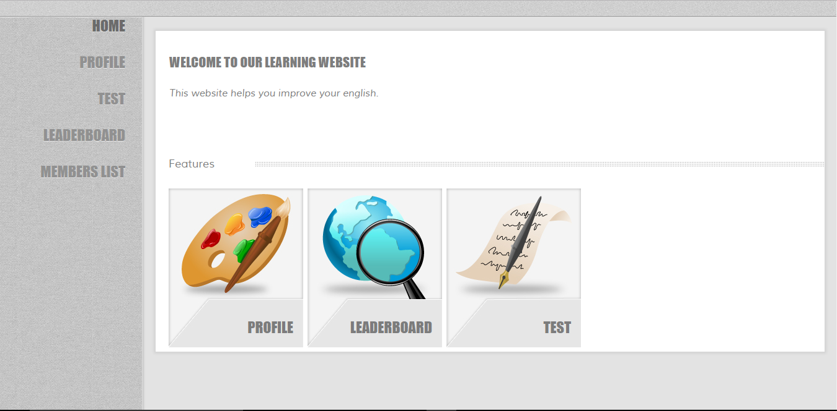

|  |  |  |  |  |  |
| --- | --- | --- | --- | --- | --- |
| **Name** | **Type** | **Event** | **Validation** | **Description** | **Status** |
| Home | HyperLink | Click |  | Link to Home Page |  |
| Profile | HyperLink | Click |  | Link to Profile Page |  |
| Test | HyperLink | Click |  | Link to Test Page |  |
| LeaderBoard | HyperLink | Click |  | Link to Leader Board Page |  |
| Members List | HyperLink | Click |  | Link to Members List Page |  |

1. **Login:**

|  |  |  |  |  |  |
| --- | --- | --- | --- | --- | --- |
| **Name** | **Type** | **Event** | **Validation** | **Description** | **Status** |
| User Name | TextBox |  | String, not null | Input Customer’s user name |  |
| Password | TextBox |  | String, not null, | Input Customer’s password |  |
| Remember Me | Check Box |  | Stick | Remember Customer next time |  |
| Login | Button |  | Click | Login |  |
| Sign Up | Button |  | Click | Sign Up |  |

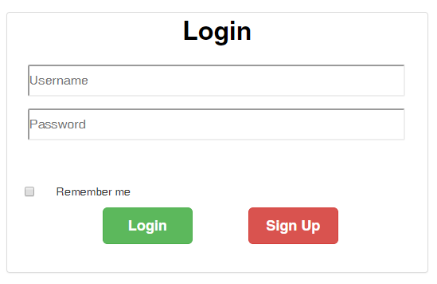

**2.Create Account Customer:**

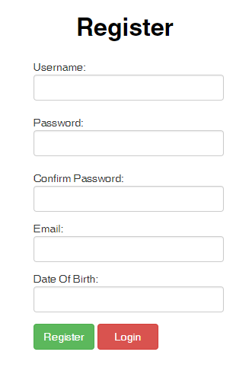

|  |  |  |  |  |  |
| --- | --- | --- | --- | --- | --- |
| **Name** | **Type** | **Event** | **Validation** | **Description** | **Status** |
| UserName | TextBox |  | String, not null | Input UserName Customer |  |
| Password | TextBox |  | String, not null, | Input Customer’s New password |  |
| Confirm Password | TextBox |  | String,not null, match password | Input Customer’s Config Password |  |
| Email | TextBox |  | String, not null, mail | Input Full Name Customer |  |
| Birthday | BasicDate picker |  | Date,not null | Input BirthDay customer |  |
| Register | Button | Click |  | Register Customer |  |
| Login | Button | Click |  | Login Customer |  |

**3.Change Password:**

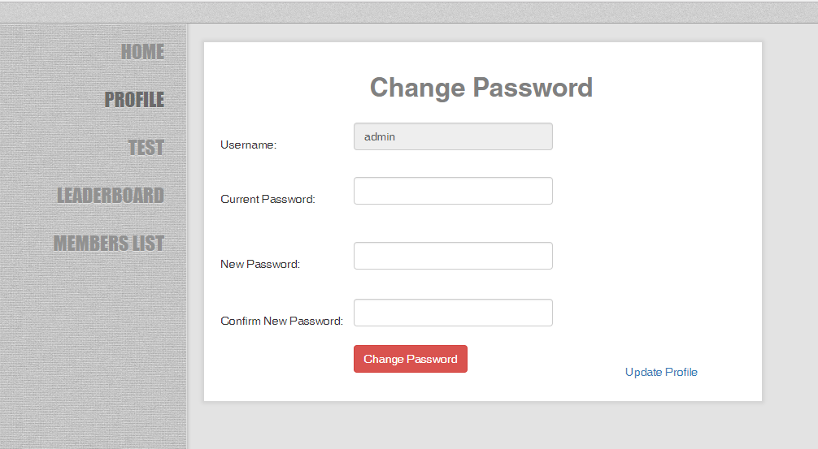

|  |  |  |  |  |  |
| --- | --- | --- | --- | --- | --- |
| **Name** | **Type** | **Event** | **Validation** | **Description** | **Status** |
| Username | TextBox |  | String, read only | Input Customer’s Password old |  |
| New Password | TextBox |  | String, null | Input Customer’s New password |  |
| Confirm Password | TextBox |  | String, null | Input Customer’s Confirm Password |  |
| Current Password | TextBox |  | String, null | Input Customer’s Old Password |  |
| Change Password | Button |  | Click | Change Password |  |
| Update Profile | HyderLink | Click |  | Link to Profile Page |  |

**4.Update Profile:**

|  |  |  |  |  |  |
| --- | --- | --- | --- | --- | --- |
| **Name** | **Type** | **Event** | **Validation** | **Description** | **Status** |
| Username | TextBox |  | String, not null | Input Customer’s Username |  |
| Name | TextBox |  | String, not null | Input Customer’s Name |  |
| Birthday | BasicDate picker |  | Date, not null | Input Customer’s birthday |  |
| Male | Radio |  | Stick | Choose gender |  |
| Female | Radio |  | Stick | Choose gender |  |
| Phone | TextBox |  | String, not null | Input Customer’s phone |  |
| Email | Textbox |  | String, not null, validate mail | Input Customer’s mail |  |
| Update | Button | Click |  | Update Profile |  |
| Change Password | HyperLink | Click |  | Link to Change Password Page |  |

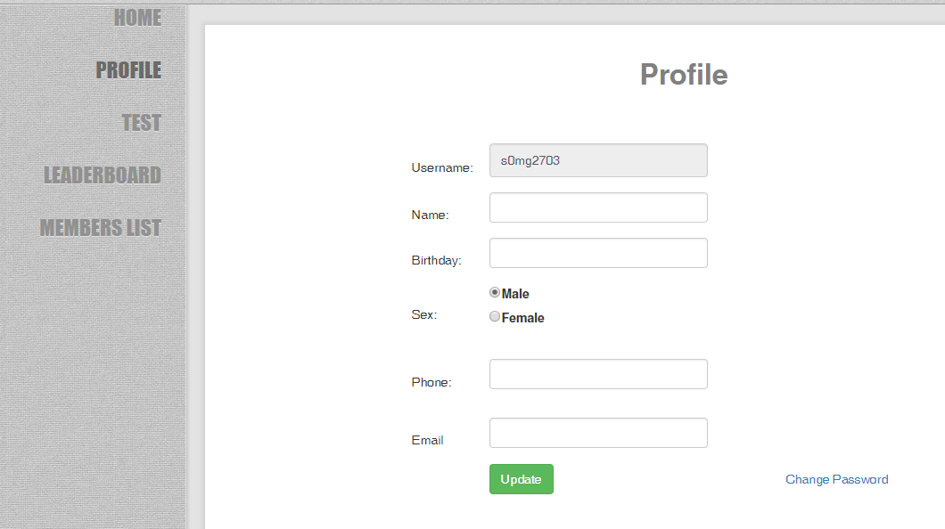

**5.Test:**

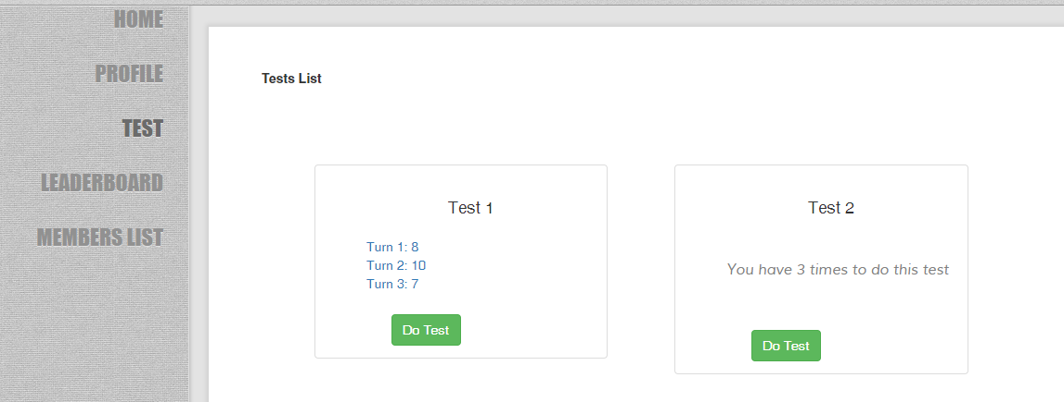

|  |  |  |  |  |  |
| --- | --- | --- | --- | --- | --- |
| **Name** | **Type** | **Event** | **Validation** | **Description** | **Status** |
| Turn 1, 2, 3 | HyperLink | Click |  | Review score of test |  |
| Do Test | Button | Click |  | Do Test |  |

**6.Add Quiz:**

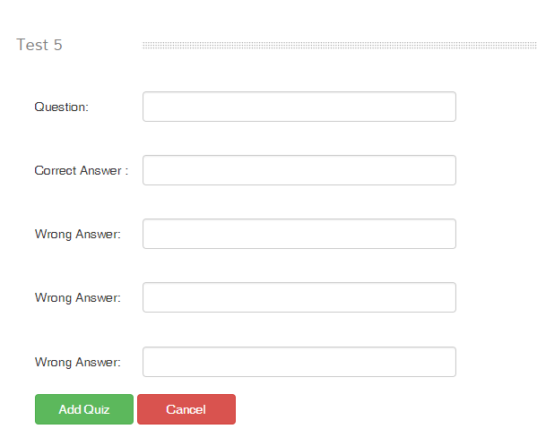

|  |  |  |  |  |  |
| --- | --- | --- | --- | --- | --- |
| **Name** | **Type** | **Event** | **Validation** | **Description** | **Status** |
| Test 5 | label |  | String, not null | Input the number of test |  |
| Question | TextBox |  | String, not null | Input content of question |  |
| Correct Answer | TextBox |  | String, not null | Input content of correct answer |  |
| Wrong Answer | TextBox |  | String, not null | Input content of wrong answer |  |
| Add Quiz | Button | Click |  | Add quiz to database |  |
| Cancel | Button | Click |  | Cancel quiz |  |

**7.Members List:**

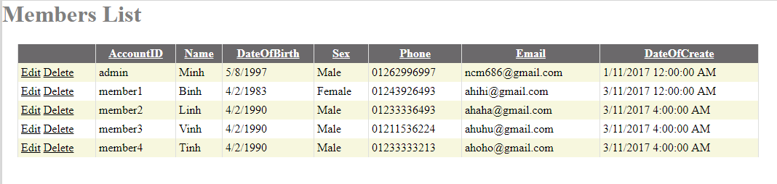

|  |  |  |  |  |  |
| --- | --- | --- | --- | --- | --- |
| **Name** | **Type** | **Event** | **Validation** | **Description** | **Status** |
| Members List | GridView |  |  | Load information |  |
| Edit | HyperLink | Click |  | Update profile member |  |
| Delete | HyperLink | Click |  | Delete profile member |  |

**8.Test Manager:**

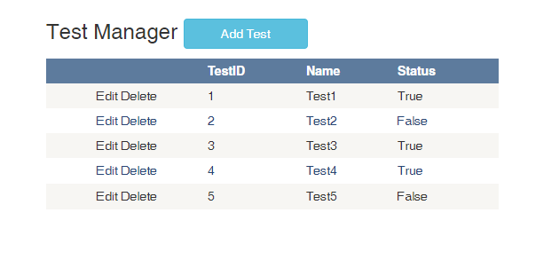

|  |  |  |  |  |  |
| --- | --- | --- | --- | --- | --- |
| **Name** | **Type** | **Event** | **Validation** | **Description** | **Status** |
| Test List | GridView |  |  | Load data of test list |  |
| Add Test | Button | Click |  | Add new test |  |
| Edit | HyperLink | Click |  | Update information |  |
| Delete | HyperLink | Click |  | Delete information |  |

**9.Do Test:**

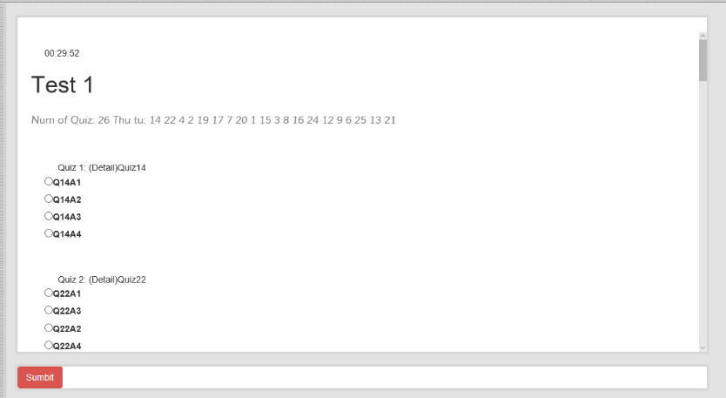

|  |  |  |  |  |  |
| --- | --- | --- | --- | --- | --- |
| **Name** | **Type** | **Event** | **Validation** | **Description** | **Status** |
| Test 1 | Label |  | String, not null | Input name of test |  |
| Quiz number | Label |  | String, not null | Load the random quiz number |  |
| Quiz answer | Radio button |  | Click | Choose quiz answer |  |
| Time counter | Timer |  | Read Only | Counter timer doing test |  |
| Submit | Button |  | Click | Submit test |  |

**10.Review Test:**

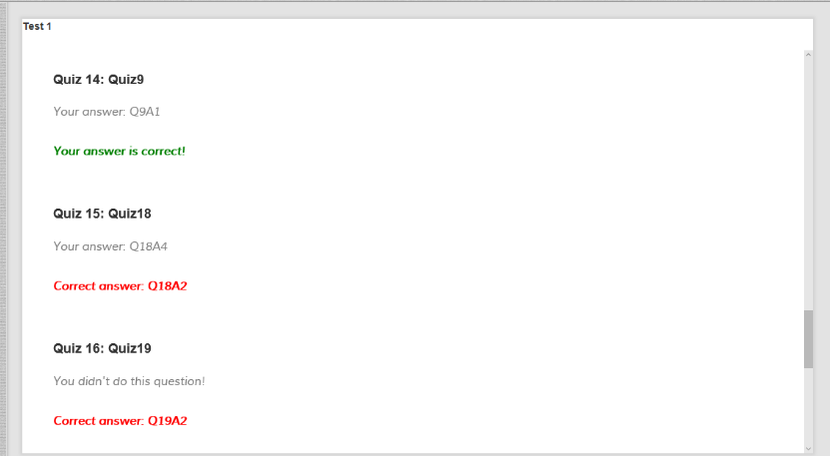

|  |  |  |  |  |  |
| --- | --- | --- | --- | --- | --- |
| **Name** | **Type** | **Event** | **Validation** | **Description** | **Status** |
| Quiz number | Label |  | String, not null | Load the random quiz number |  |
| User answer | Label |  | String, not null, | Load user’s answer of test |  |
| Correct answer | Label |  | String,not null | Load correct answer of test |  |

**11.Review Test:**

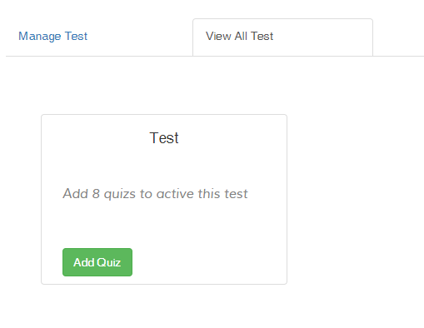

|  |  |  |  |  |  |
| --- | --- | --- | --- | --- | --- |
| **Name** | **Type** | **Event** | **Validation** | **Description** | **Status** |
| Manage tests | Hyperlink | Click |  | Link to Manage Test Page |  |
| View test | Hyperlink | Click |  | Link to View Test Page |  |
| Test name | Label |  | String,not null | Load name of test |  |
| Add Quiz | Button | Click |  | Link to Add Quiz Page |  |

**12. Top 5**

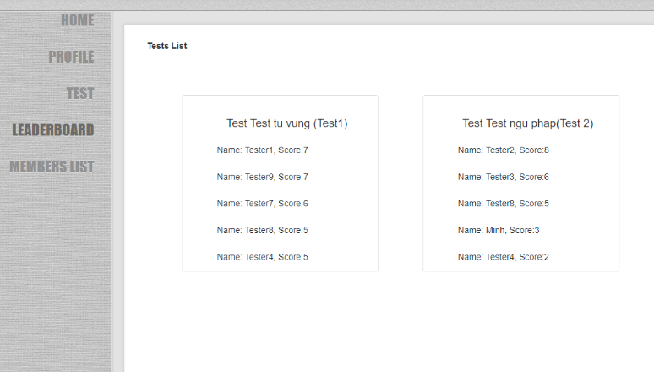

|  |  |  |  |  |  |
| --- | --- | --- | --- | --- | --- |
| **Name** | **Type** | **Event** | **Validation** | **Description** | **Status** |
| Test name | Label |  | String, not null | Test name |  |
| Test score | Label |  | String, not null | Test score lists |  |

**TASK SHEET**

|  |  |  |  |  |  |  |
| --- | --- | --- | --- | --- | --- | --- |
| **Project Group** | | **Project Title**  **English Learning Application** | | **Date of Preparation** | | **Activity Plan Prepared by**  **Hoang Yen Minh** |
| **No** | **Task Title** | | **Planned Start Date** | **Planned Completed Date** | **Team Mate Names** | **Status** |
| 1 | Login Customer | | Oct 9, 2017 | Nov 4, 2017 | **Dao Nhat Minh** |  |
| 2 | Do Test | |
| 3 | Review Test | |
| 4 | Add Test | |
| 5 | Edit, delete members | |
| 6 | Add, delete Quiz | |
| 7 | Show test detail | |
| 8 | Show all tests as admin view | | **Hoang Yen Minh** |
| 9 | Show all tests as customer view | |
| 10 | Sign up | |
| 11 | MasterPage | |
| 12 | Show top high score | |
| 13 | Change Password | |
| 14 | Update profile | |

|  |  |  |
| --- | --- | --- |
| **Date: Nov 5, 2017** | **Prepared by Project Group 7**  **Team Leader:** | **Approved by**  **Mr. Ho Hoan Kiem** |
| **Signature** |  |  |