Dr.-Ing. Minh Nhat Nguyen
minh.nguyen@kit.edu
+49 (0)721 608 24361

ONLINE PROFILES
- ORCID ID: 0000-0002-8614-4640
- Scopus ID: 57214793785
- Web of Science ResearcherID: AAL-7775-2020
- LinkedIn: https://www.linkedin.com/in/nguyen-nhat-minh/

RESEARCH INTERESTS
Dr.-Ing. Minh Nhat Nguyen is an early-career researcher who conducts research with pressure-driven (micro-, ultra- and nanofiltration) membranes and reactive (adsorptive and photocatalytic) membranes for water treatment.
By breaking down the complexity of the membrane at multiple scales, he investigates the fundamental physiochemical interactions at the membrane surface as well as inside the membrane pores, and aims to reveal the interconnection between material nanostructure, mass transfer, and reactivity.
His research contributes to the understanding of membrane processes for removing pollutants, namely, steroid hormones, pesticides, and nanoplastics, that are toxic at very low concentrations in the water sources.

ACADEMIC EXPERIENCE
From Jan 2026: Karlsruhe Institute of Technology (KIT), Eggenstein-Leopoldshafen, Germany
Group Leader at the Institute for Advanced Membrane Technology (IAMT)
Main research fields: 1) reactive membranes, 2) nanofluidic membranes, and 3) structure−performance correlation in membrane processes

Oct 2022 − present: KIT, Eggenstein-Leopoldshafen, Germany
Postdoctoral Researcher in Membrane Technology at IAMT, funded by DFG SOLEMBA project

Jan − Apr 2022: DVGW-Technologiezentrum Wasser (TZW), Karlsruhe, Germany
Research Intern in Water Management (part of Ph.D. program)
Apr 2017 − Apr 2018: KIT, Eggenstein-Leopoldshafen, Germany
Research Assistant in Membrane Technology at IAMT (then: Membrane Technology Department, Institute of Functional Interfaces − IFG-MT)
Sep 2014 – Mar 2017: Institute of Environmental Technology, Vietnam Academy of Science and Technology (VAST), Hanoi, Vietnam
Researcher in Environmental Management (2014–16: part-time; 2016–2017: full-time)

EDUCATION
May 2018 – Sep 2022: KIT, Eggenstein-Leopoldshafen, Germany
Ph.D. (Dr.-Ing.) in Process Engineering & Membrane Technology
Research conducted at IAMT under the supervision of Prof. Dr. Andrea Iris Schäfer, Department of Chemical and Process Engineering (CIW)

Dissertation title: “Incorporation of carbon-based nanoparticles into ultrafiltration membranes to remove steroid hormone micropollutants” ; Grade: 1.0 ; Graduation date: 19 Sep 2022.

Sep 2014 − Jul 2016: University of Science and Technology of Hanoi (USTH), Vietnam, joint with National Institute of Applied Sciences (INSA), Toulouse, France
M.Sc. in Water – Environment – Oceanography ; Grade: 15.34 / 20

Sep 2011 – Jul 2014: University of Durham, Durham, United Kingdom
B.Sc. Upper Second-Class Honours (2:1) in Chemistry

2009 – 11: A-Level studies, St. Andrew’s College, Cambridge, United Kingdom
Subjects: Maths (A*), Further Maths (A), Chemistry (A), Biology (B)
Advanced Extension Award 2010 in Maths (Distinction) ; UK Senior Mathematical Challenge 2009 (Gold Certificate – highest award for non-native students)

ACTIVITIES IN THE RESEARCH SYSTEM
- Memberships: European Membrane Society (EMS), European Desalination Society (EDS), Membrane Society of Australasia (MSA)
- Scientific Conference Committee: Nanofiltration 2022, Achalm, Germany
- Co-supervision: Master students Jinju Zhang (2017−18), Phuong B. Trinh (2018), Rubén Hervás-Martínez (2019), Guillaume Bricault (2025); HiWi student Luiza von Sperling (2017−20)
- Teaching involvement (at KIT):
  - Bachelor’s course VL 22644 International Concepts of Water Technologies (2017−19)
  - Master’s course VL 2233120 Membrane Materials & Processes Research Masterclass (2023−25)
  - Master’s course VL 2233130 Water – Energy – Environment Nexus in a Circular Economy: Research Proposal Preparation (2025)
- Participated in IAMT Team Days 2020 and 2021 (https://www.iamt.kit.edu/245.php) organized by IAMT-KIT, and in offered courses on writing grant proposals, leadership, communication skills, formulating research questions, telling stories, integrity in research, etc.
- Support strategic collaborations between IAMT-KIT and:
  - Chinese Academy of Sciences via Prof. Chuanfang Yang (co-supervision, joint paper)
  - Nanjing University of Science and Technology via Prof. Jiansheng Li (joint paper)
  - Lawrence Livermore National Laboratory via Dr. Francesco Fornasiero (joint paper)
  - TZW: DVGW-Technologiezentrum Wasser via Dr. Pia Lipp (DAAD-funded internship, joint paper)
  - Australian National University via Prof. Ben Corry (DAAD-PPP mobility grant, joint paper in preparation)
  - Tel Aviv University via Prof. Ines Zucker (joint paper)
  - Ruhr University Bochum via Prof. Poul Petersen (joint paper submitted)
  - University of Lodz via Prof. Babak Minofar (joint paper submitted)
  - Technion via Prof. Tamar Segal-Peretz (BMFTR-MOST grant)
  - Leibniz Institute of Surface Engineering (IOM) via Prof. Agnes Schulze (two joint papers in preparation)
  - Boston University via Prof. Chuanhua Duan (grant preparation)
  - National Taiwan University (NTU) via Prof. Yu-Ming Tu (joint review paper in preparation)

HONOURS AND AWARDS
Contributions to Grants
- M. N. Nguyen, A.I. Schäfer, T. Segal-Peretz: Germany−Israel BMFTR−MOST Grant (475k EUR), Enhancing Boron and Micropollutant Removal from Water by Molecular Layer Deposition Membranes (EMPOWERED), Contributions: core technical sections and management.
- A.I. Schäfer, DAAD-PPP Mobility between KIT and Australian National Uni. (23.48k EUR), Improving micropollutant and inorganic pollutant removal from water supplies via molecular dissection of their transport in nanofiltration membranes, Jan 2024 – Dec 2025. Contributions: core technical sections and management.

Scholarships
- DAAD-BMBF Ph.D. Scholarship in Sustainable Water Management, May 2018 – Jul 2022
- Scholarships for Excellence, 2014–15 and 2015–16, USTH, Vietnam

Conference Awards
- MSA Best Oral Presentation Award, IMSTEC 2025, Gold Coast, Australia
- M.S./Ph.D. Students Award, Euromembrane 2022, Sorrento, Italy
- DAAD Travel Grant, Lake Tahoe Nanofluidics 2022 in San Francisco, US (Not accepted due to VISA reason)
- DAAD Travel Grant and Third Prize for Best Oral Presentations, GTSW 2019 in Ho Chi Minh City, Vietnam

Others
- Ph.D. Aspirant Grant (Apr 2017), awarded by KHYS, KIT, Germany

PUBLICATIONS
Total: 16 papers; First author: 9 papers; Co-supervisor role: 6 papers.

- M. Krajewska, M.N. Nguyen, A.I. Schäfer (2026) Interference of the real water matrix with micropollutant removal via advanced filtration: Insights from the Goreangab Reservoir in Namibia, accepted by Environmental Science & Technology. (concepts, supervision, manuscript revision)
- P.B. Trinh, M.N. Nguyen, Z. Futera, B. Minofar, M. Personeni, P.B. Petersen, A.I. Schäfer (2025) Removal of glyphosate and aminomethylphosphonic acid (AMPA) by nanofiltration membranes: Effects of hydration, submitted. (concepts, supervision, manuscript revision)
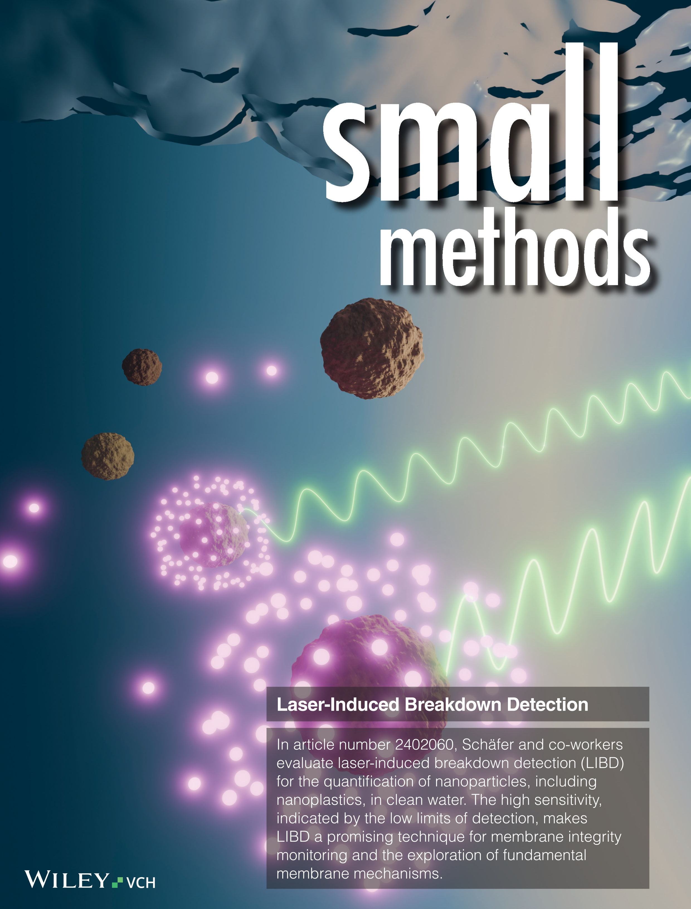
- H.-Y. Lin, M.N. Nguyen, A.I. Schäfer (2025) Steroid hormone micropollutant removal from membrane bioreactor effluents using single-walled carbon nanotube composite nanofiber membranes, Chemical Engineering Journal, 170335. doi.org/10.1016/j.cej.2025.170335 (concepts, supervision, manuscript revision)
- M.N. Nguyen, P. Lipp, I. Zucker, A.I. Schäfer (2025) Quantification of nanoplastics and inorganic nanoparticles via laser-induced breakdown detection (LIBD), Small Methods, 9, 2402060. doi.org/10.1002/smtd.202402060 (concepts, experiments, manuscript writing)
*Frontispiece: doi.org/10.1002/smtd.70045
- M.N. Nguyen, A. Turshatov, B.S. Richards, A.I. Schäfer (2025) Photodegradation of steroid hormone micropollutants with palladium-porphyrin coated porous PTFE of varied morphological and optical properties, Water Research, 274, 123034. doi.org/10.1016/j.watres.2024.123034 (experiments, data analysis, manuscript writing)
- M.N. Nguyen, C.S. Raota, A. Turshatov, B.S. Richards, A.I. Schäfer (2024) Collision theory and membrane photocatalysis: Steroid hormones meet singlet oxygen in palladium-porphyrin-coated polytetrafluoroethylene membranes, Chemical Engineering Journal, 501, 157582. doi.org/10.1016/j.cej.2024.157582 (concepts, experiments, manuscript writing)
- A. Imbrogno, M.N. Nguyen, A.I. Schäfer (2024) Tutorial review of error evaluation in experimental water research at the example of membrane filtration, Chemosphere, 357, 141833. doi.org/10.1016/j.chemosphere.2024.141833 (concepts, data analysis, manuscript revision)
- M.N. Nguyen, M.L. Jue, S.F. Buchsbaum, S.J. Park, F. Vollnhals, S. Christiansen, F. Fornasiero, A.I. Schäfer (2024) Interplay of the forces governing steroid hormone micropollutant adsorption in vertically aligned carbon nanotube membrane nanopores, Nature Communications, 15, 1114. doi.org/10.1038/s41467-024-44883-2 (concepts, experiments, manuscript writing)
- M. Tagliavini, M.N. Nguyen, A.I. Schäfer (2023) Predicting steroid hormone removal in a thin activated carbon layer coupled with ultrafiltration, Chemical Engineering Journal, 462, 142125. doi.org/10.1016/j.cej.2023.142125 (data validation, manuscript revision)
- M.N. Nguyen, R. Hervás-Martínez, A.I. Schäfer (2021) Organic matter interference with steroid hormone removal by single-walled carbon nanotubes − ultrafiltration composite membrane, Water Research, 199, 117148. doi.org/10.1016/j.watres.2021.117148 (concepts, data validation, supervision, manuscript writing)
- M.N. Nguyen, P.B. Trinh, A.I. Schäfer (2021) Incorporation of single-walled carbon nanotubes in ultrafiltration support structure for the removal of steroid hormone micropollutants, Separation & Purification Technology, 264, 118405. doi.org/10.1016/j.seppur.2021.118405 (concepts, data validation, supervision, manuscript writing)
- M.N. Nguyen, P.G. Weidler, R. Schwaiger, A.I. Schäfer (2021) Interactions between carbon-based nanoparticles and steroid hormone micropollutants in water, Journal of Hazardous Materials, 402, 122929. doi.org/10.1016/j.jhazmat.2020.122929 (concepts, experiments, manuscript writing)
- Z. Liao, M.N. Nguyen, G. Wan, J. Xie, L. Ni, J. Qi, J. Li, A.I. Schäfer (2020) Low pressure operated ultrafiltration membrane with integration of hollow mesoporous carbon nanospheres for effective removal of micropollutants, Journal of Hazardous Materials, 397, 122779. doi.org/10.1016/j.jhazmat.2020.122779 (experiments, manuscript revision)
- J. Zhang, M.N. Nguyen, Y. Li, C. Yang, A.I. Schäfer (2020) Steroid hormone micropollutant removal from water with activated carbon fiber-ultrafiltration composite membranes, Journal of Hazardous Materials, 391, 122020. doi.org/10.1016/j.jhazmat.2020.122020 (concepts, supervision, manuscript revision)
- M.N. Nguyen, P. Loulergue, N.K.V. Leitner, B. Teychene (2019) Electron beam irradiation of polyvinylidene fluoride/polyvinylpyrrolidone ultrafiltration membrane in presence of zwitterions molecules − Evaluation of filtration performances, Radiation Physics and Chemistry, 159, 101-110. doi.org/10.1016/j.radphyschem.2019.02.029 (experiments, manuscript writing)
- M.N. Nguyen, N.K.V. Leitner, B. Teychene (2017) Modification of hollow fiber membranes through electron beam irradiation, Chemical Engineering Transactions (Proceeding), 60, 289-294. doi.org/10.3303/CET1760049 (experiments, manuscript writing)

CONFERENCES
Oral Presentations
- M.N. Nguyen, Camila S. Raota, Andrey Turshatov, Bryce S. Richards, Andrea I. Schäfer, Collisions between singlet oxygen and steroid hormone micropollutants in photocatalytic membrane pores, IMSTEC 2025, Australia – MSA Best Oral Presentation Award
- M.N. Nguyen, M.L. Jue, S.F. Buchsbaum, S.J. Park, F. Fornasiero, A.I. Schäfer, Adsorption of steroid hormone micropollutants in the nanopores of vertically aligned carbon nanotube membranes regulated by the interplay of forces, Lenzerheide Nanofluidics 2024, Switzerland.
- M.N. Nguyen, M.L. Jue, S.F. Buchsbaum, S.J. Park, F. Fornasiero, A.I. Schäfer, Influence of the forces on the adsorption of steroid hormone micropollutants in the nanoconfinement of VaCNT membranes, Euromembrane 2022 - The Special Edition to Celebrate the 40th EMS Anniversary, Italy. – M.S./Ph.D. Students Award
- M.N. Nguyen, P.B. Trinh, A.I. Schäfer, Steroid hormone micropollutant removal with single-walled carbon nanotube – ultrafiltration composite membranes, Euromembrane 2022, Italy.
- M.N. Nguyen, P.B. Trinh, A.I. Schäfer, Immobilization of single-walled carbon nanotubes within ultrafiltration membranes for steroid hormone removal, Green Technologies for Sustainable Water (GTSW) 2019, Vietnam. – Third Prize for Best Oral Presentations
- M.N. Nguyen, P.B. Trinh, A.I. Schäfer, Immobilization of carbon-based nanoparticles within ultrafiltration membranes for hormone removal, Euromembrane 2018, Spain.

Poster Presentations
- M.N. Nguyen, C.S. Raota, A. Turshatov, B.S. Richards, A.I. Schäfer, Photodegradation of steroid hormone micropollutants in palladium porphyrin membranes: Role of collision frequency, Lenzerheide Nanofluidics 2024, Switzerland.
- M.N. Nguyen, R. Hervás-Martínez, A.I. Schäfer, Interference of organic matter with steroid hormone adsorption in single walled carbon nanotube – ultrafiltration composite membranes, Nanofiltration 2022, Germany.
- M.N. Nguyen, M.L. Jue, S.F. Buchsbaum, S.-J. Park, F. Fornasiero, A.I. Schäfer, Adsorption of steroid hormone micropollutants in the nanoconfinement of vertically-aligned single-walled carbon nanotube membranes, Nanofiltration 2022, Germany.
- M.N. Nguyen, M. Tagliavini, A.I. Schäfer, Permeate side adsorption in ultrafiltration for effective micropollutant removal – A comparison of adsorption mechanisms, International Congress on Membranes & Membrane Processes (ICOM) 2020, online.

SKILLS
Experimental systems
- Operation of multi-scale dead-end and crossflow filtration systems with flat-sheet membranes
- Integration of light sources (UV/Vis LEDs and solar simulators) into photocatalytic membrane systems
- LabView program development for experimental control and data acquisition.

Analytical techniques
- Laser-induced breakdown detection (LIBD)
- Liquid chromatography − organic carbon detection − organic nitrogen detection (LC-OCD-OND)
- Nanoparticle tracking analysis (NTA)
- Total organic carbon analysis (Sievers M9 and Shimadzu TOC-L)
- Radiotracer analysis, namely, liquid scintillation counting (LSC) and high-performance liquid chromatography − flow scintillation analysis (HPLC-FSA)

Membrane and nanoparticle characterization techniques
- Contact angle measurement (sessile drop and captive bubble modes)
- UV-Vis spectrophotometry with an integrating sphere
- Dynamic and electrophoretic light scattering (DLS/ELS)
- Thermogravimetric analysis (TGA)
- Streaming potential analysis

Modelling
- Equilibrium / non-equilibrium molecular dynamics (EMD / NEMD) with simple nanopore systems (GROMACS)

Other skills
- IT (as chief IT admin of IFG-MT / IAMT, KIT since 2018)
- SAP systems
- Web design
- Map development (using ArcGIS and QGIS)

