Thực hành buổi 4
- Chạy lệnh docker
docker –version
docker run hello-world
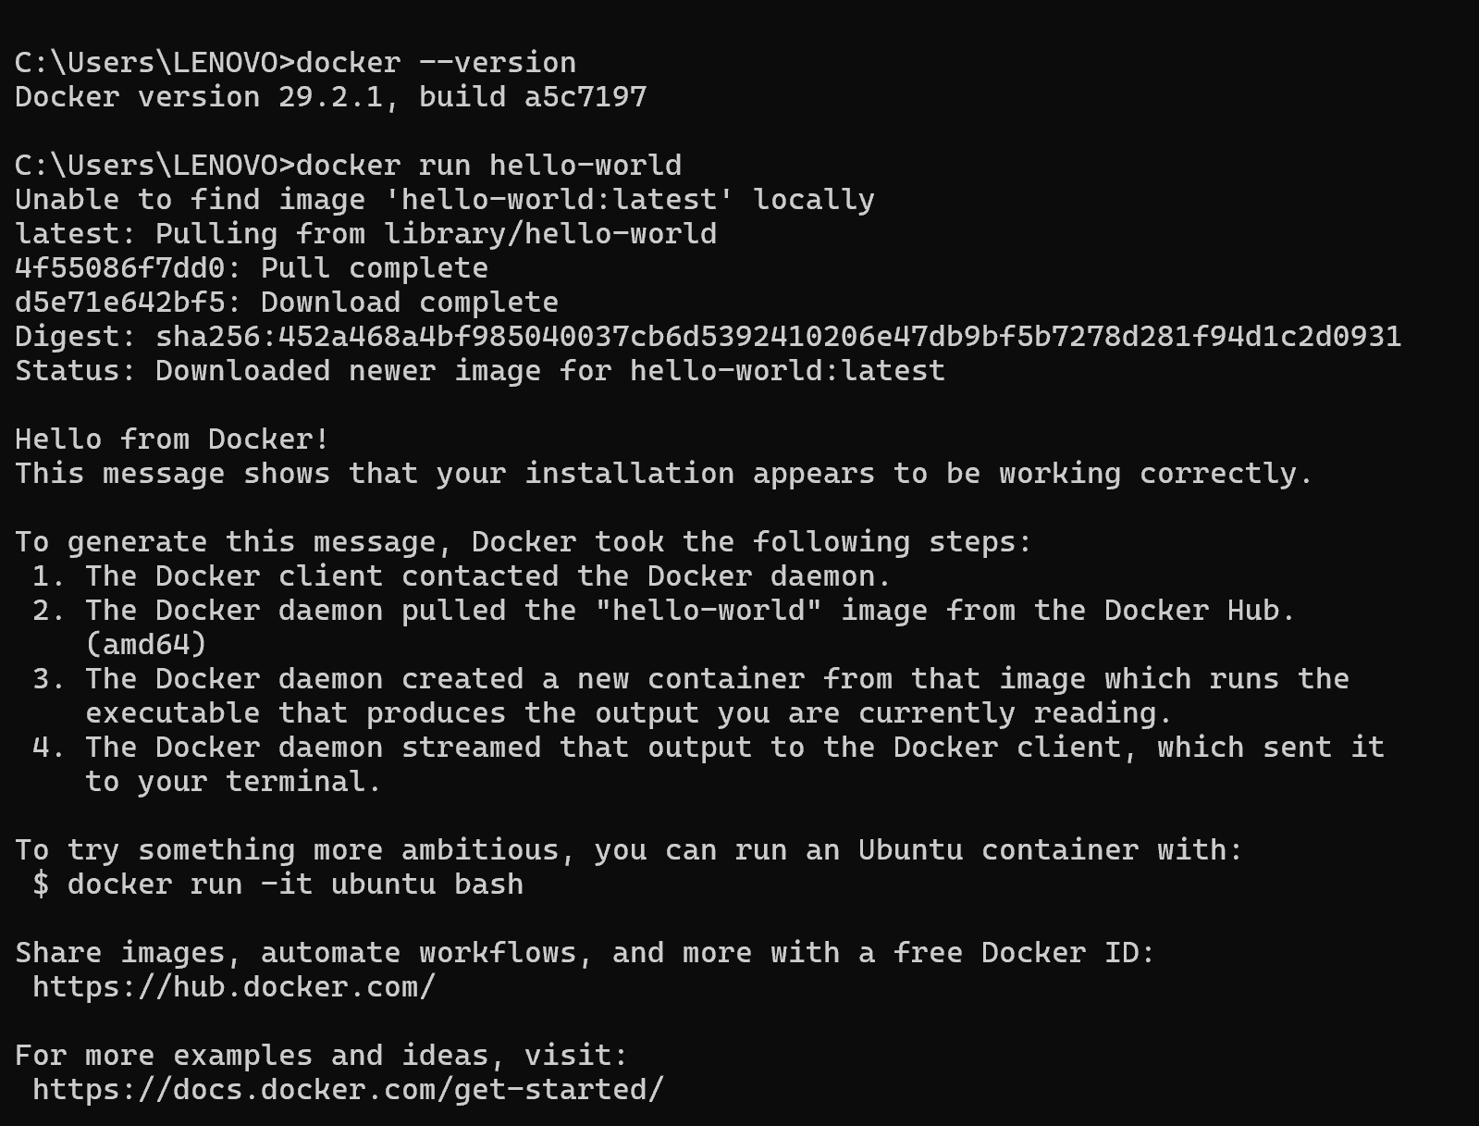
docker pull nginx
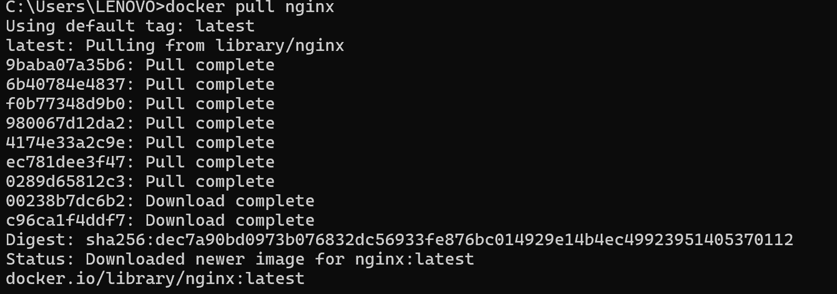
docker images
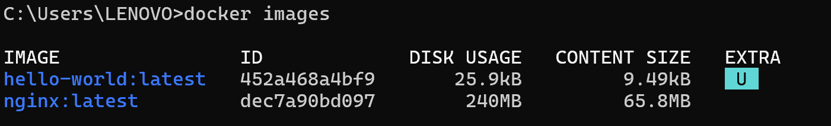
docker run -d nginx
docker ps
docker ps -a
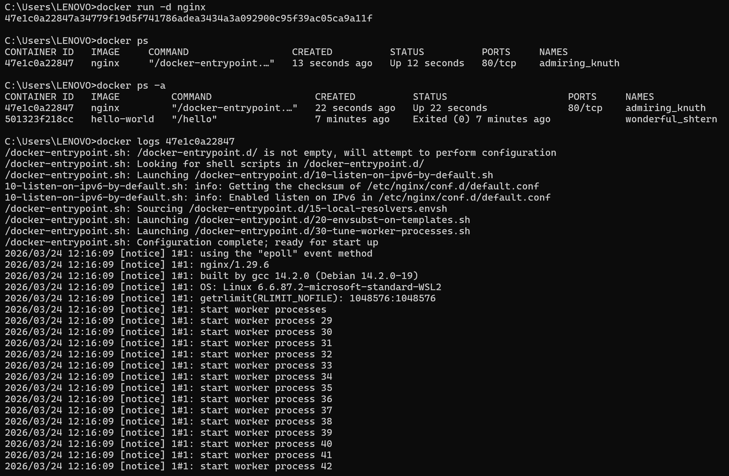
docker exec -it 47e1c0a22847 bash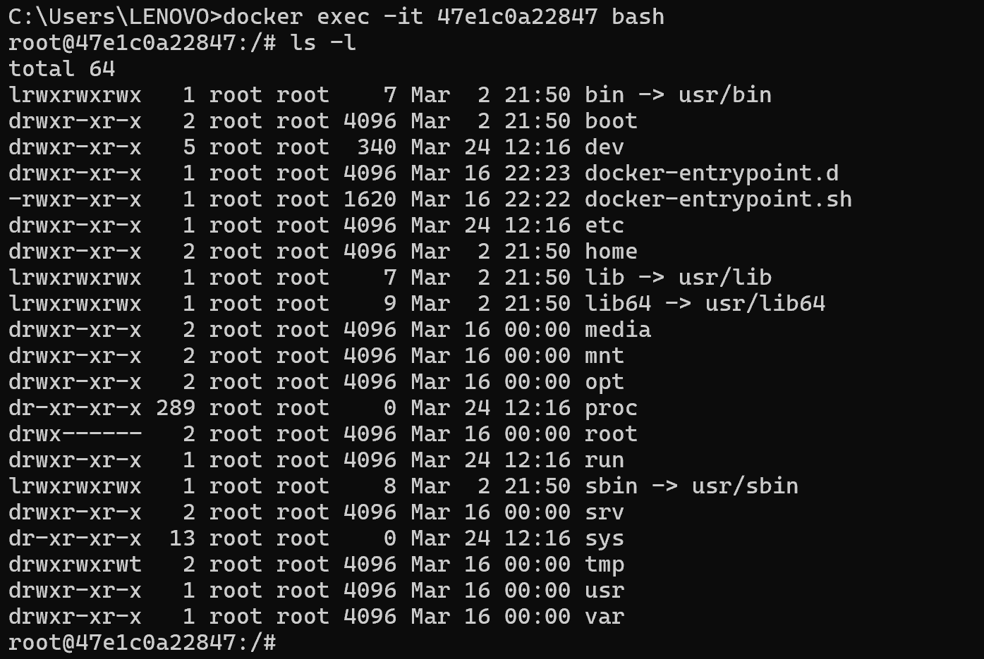
docker stop
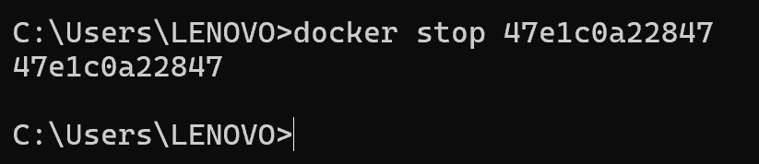
docker restart
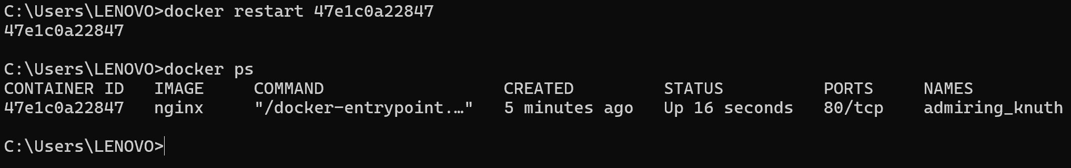
Docker rm
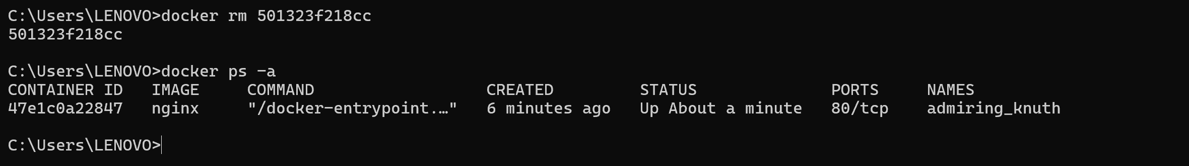
docker container prune
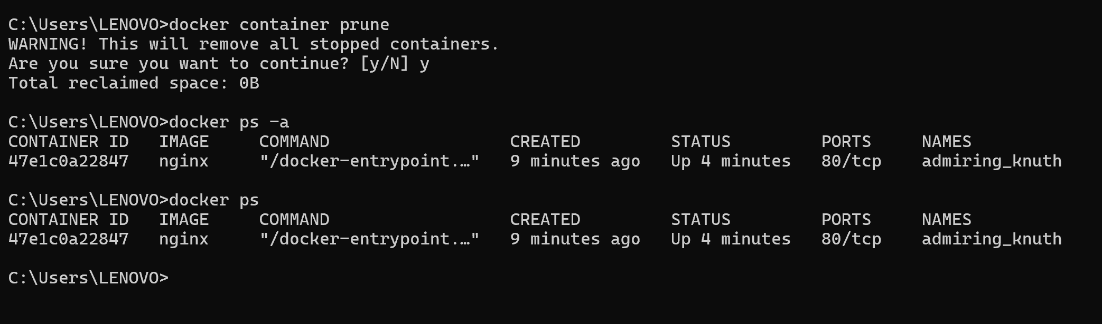
docker rmi <image_id>
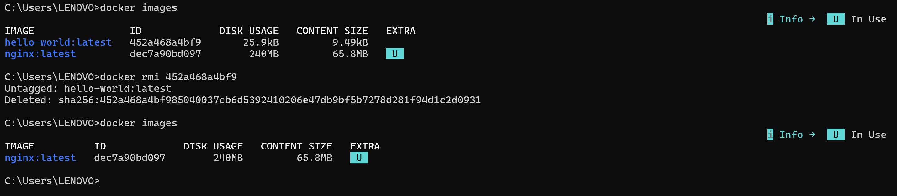
docker image prune -a
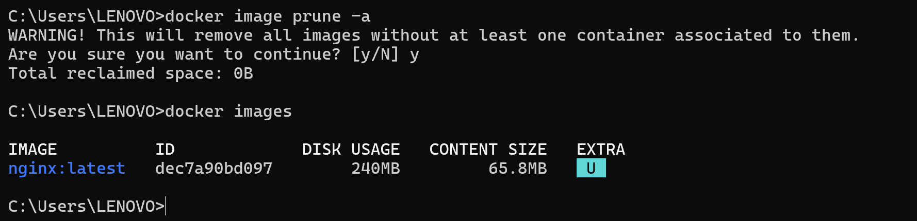
docker run -d -p 8080:80 nginx
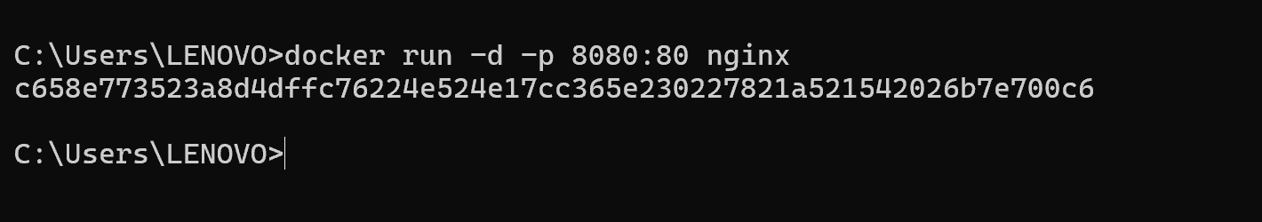
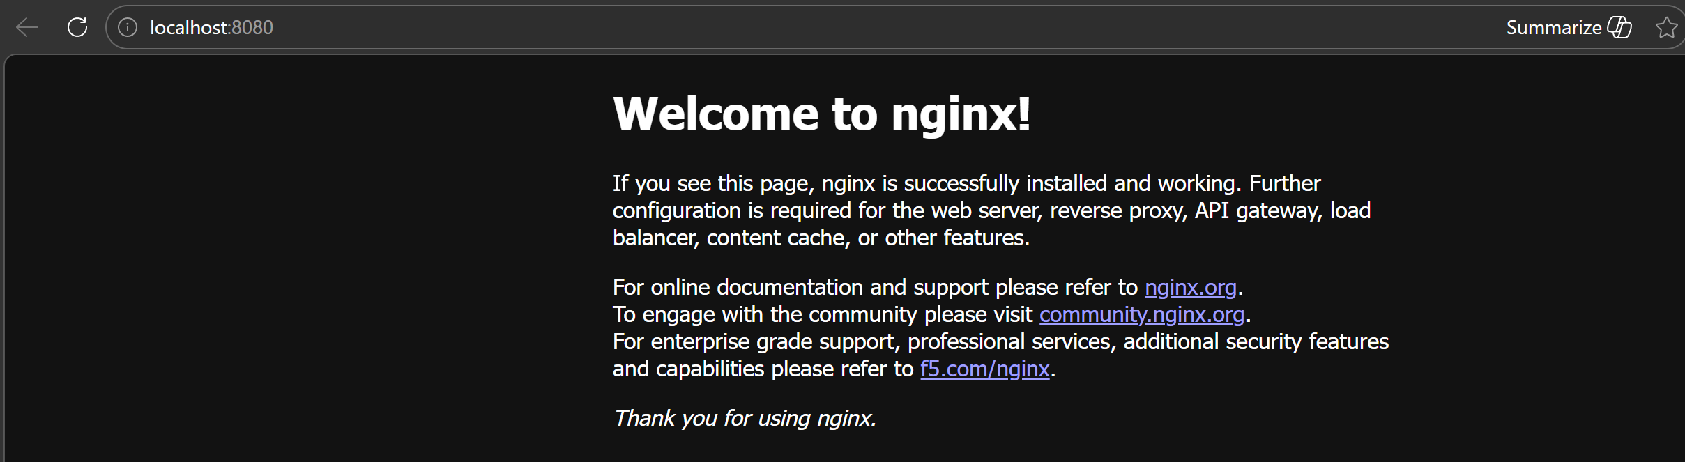
docker inspect <container_id>
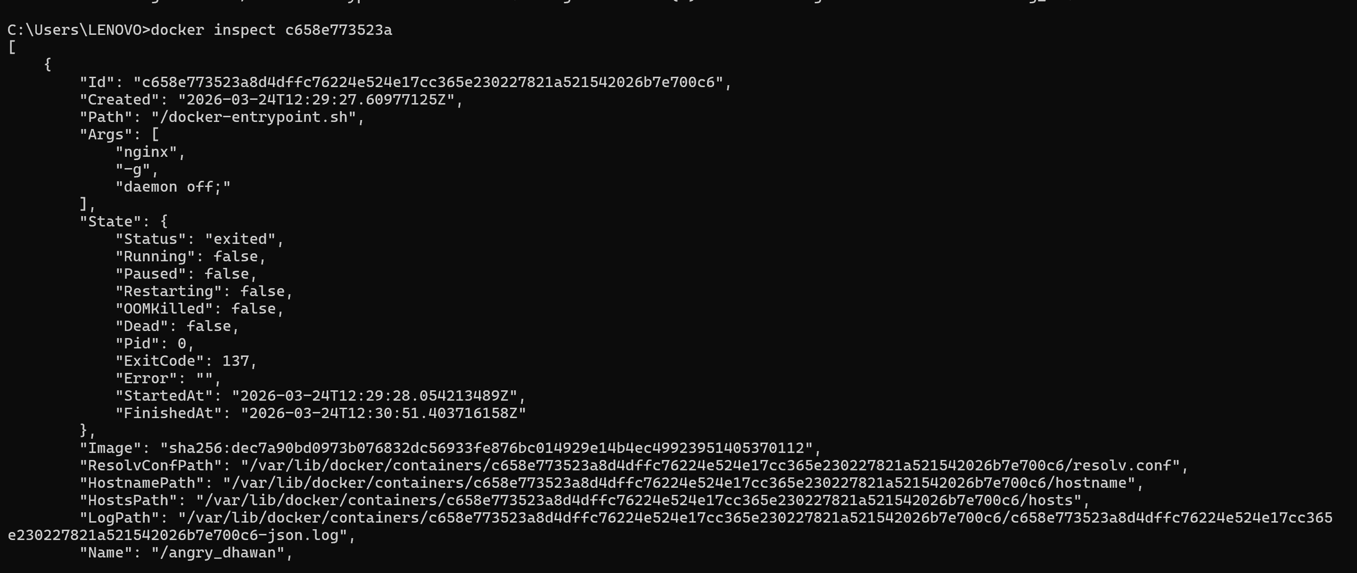
docker run -d -v mydata:/data nginx
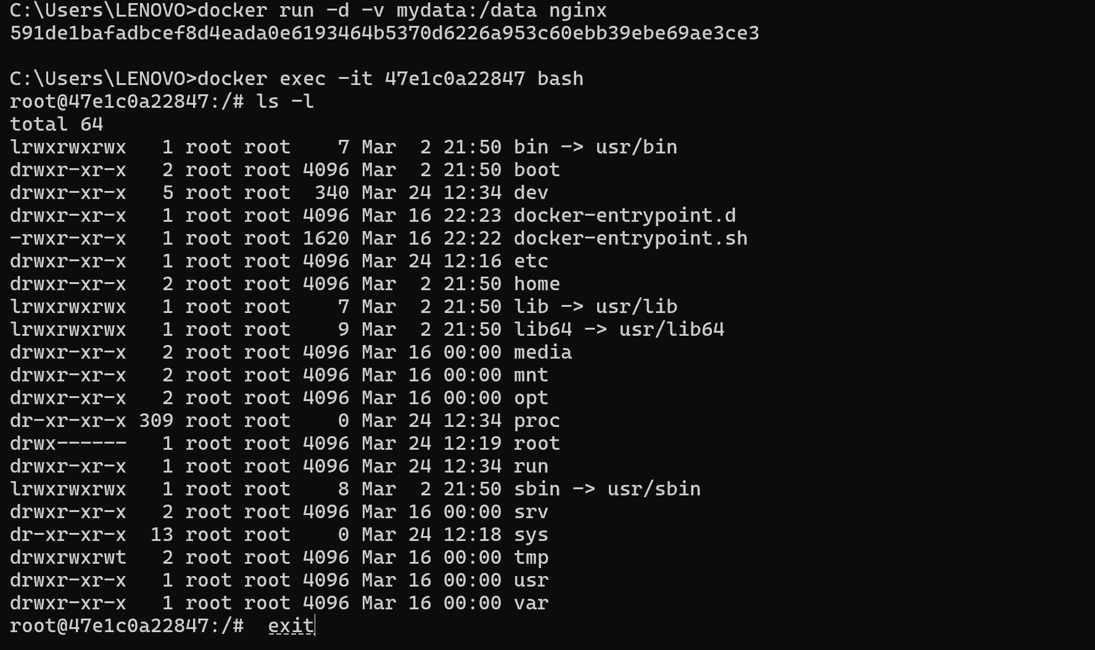
docker volume ls
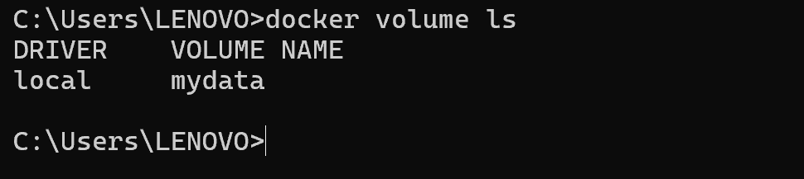
docker volume prune
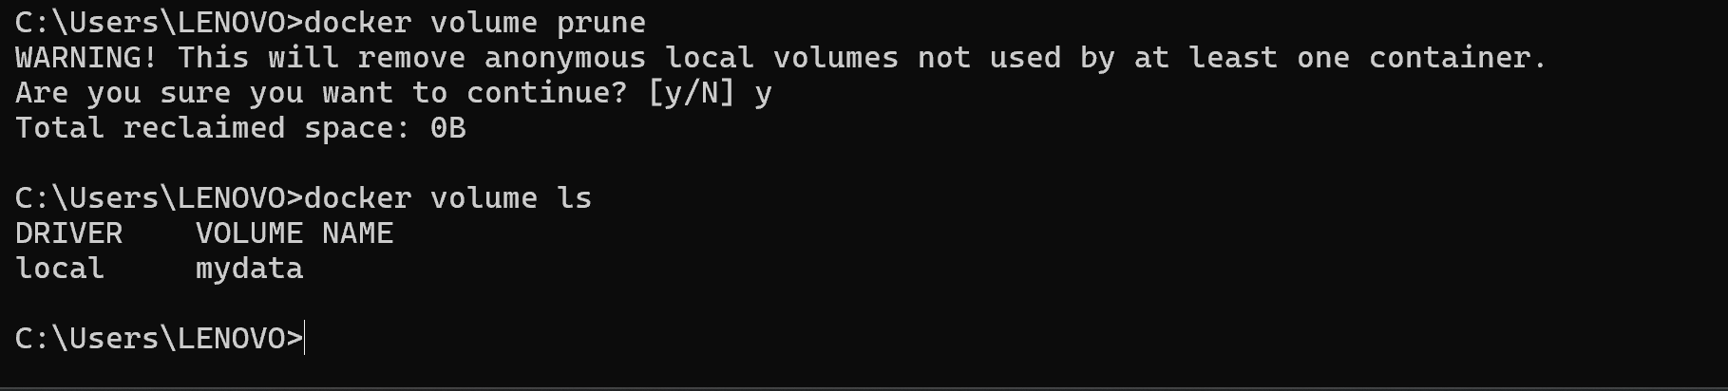
docker run -d --name my_nginx nginx
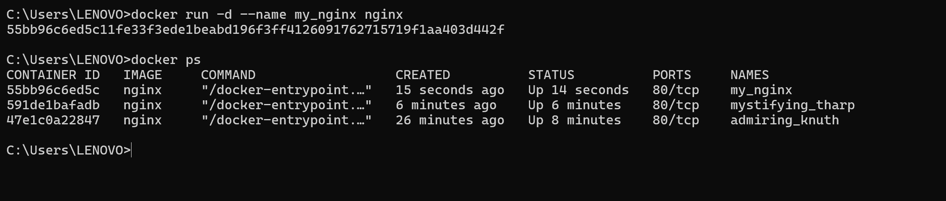
docker stats
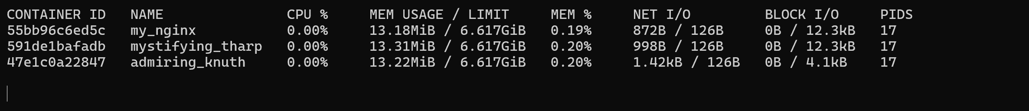
docker network ls
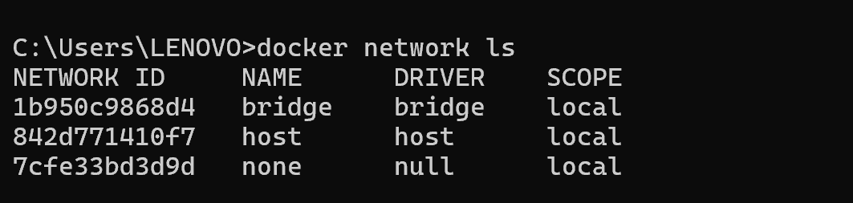
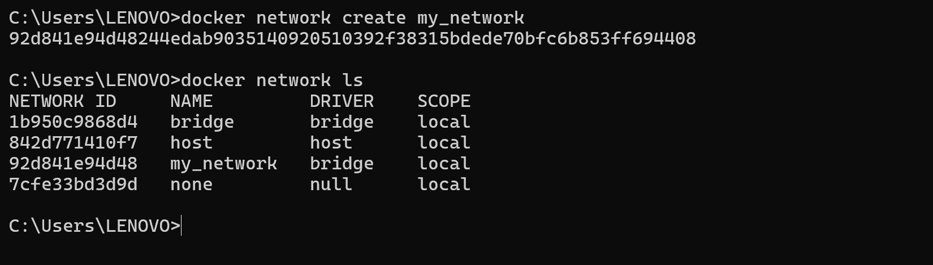
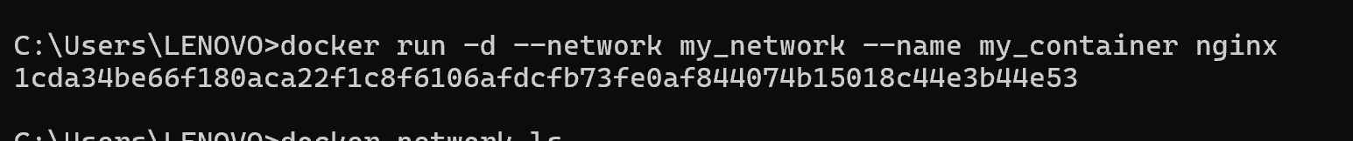

- Thao tác dockerfile

