How to Enable Two‑Factor Authentication (2FA) for a Google Account

Step 1
Step 1: Open your Google Account page at https://myaccount.google.com and sign in to your account.
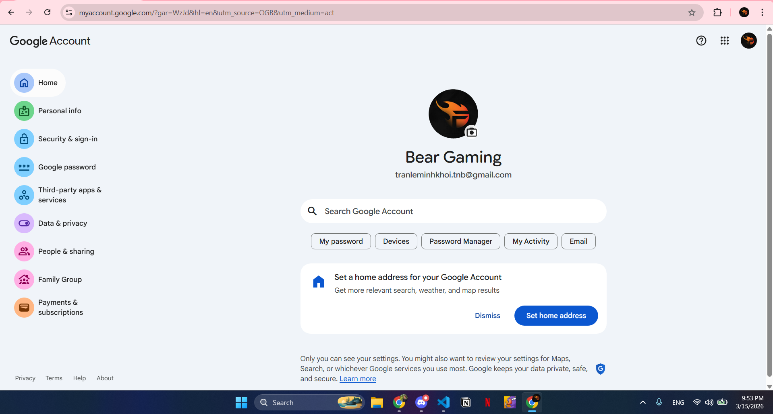

Step 2
Step 2: Click on 'Security & sign‑in' (Bảo mật và đăng nhập) from the left sidebar.
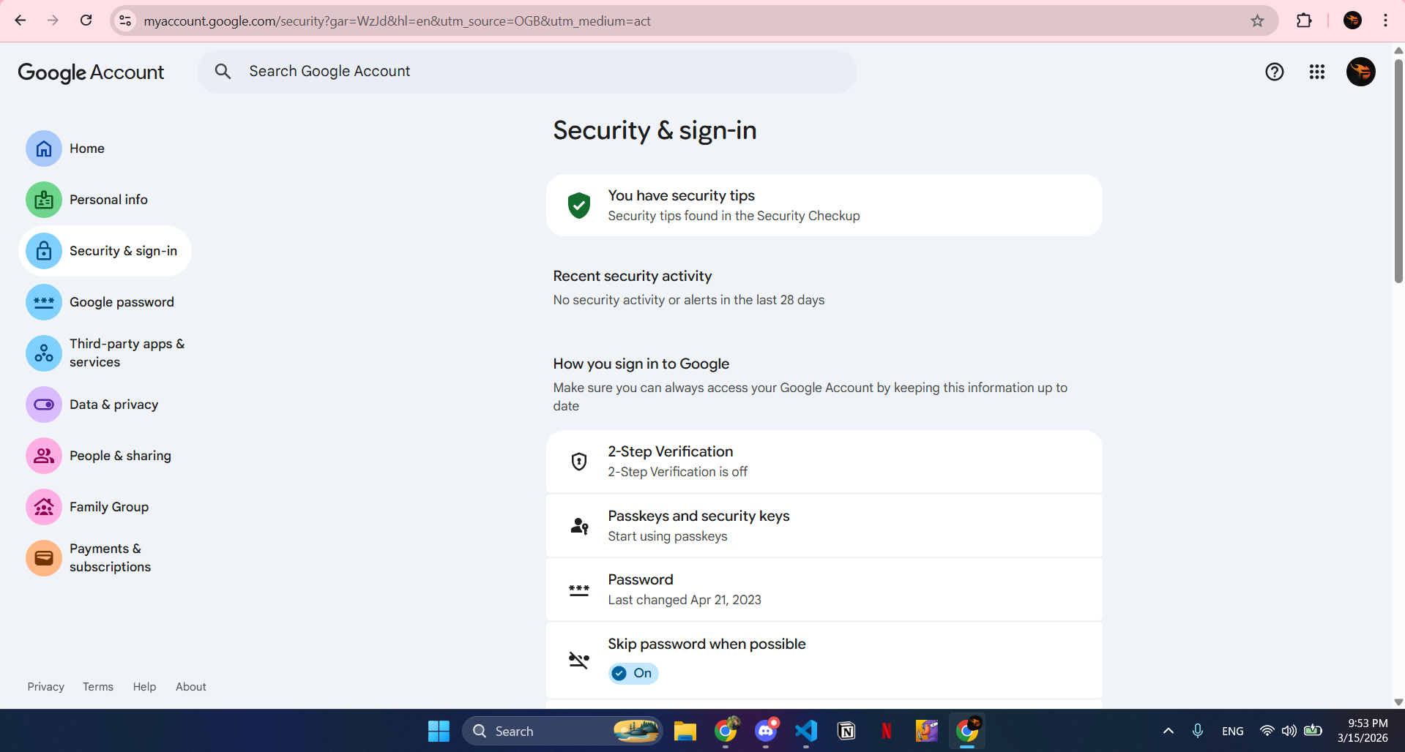

Step 3
Step 3: In the section 'How you sign in to Google', select '2‑Step Verification'.
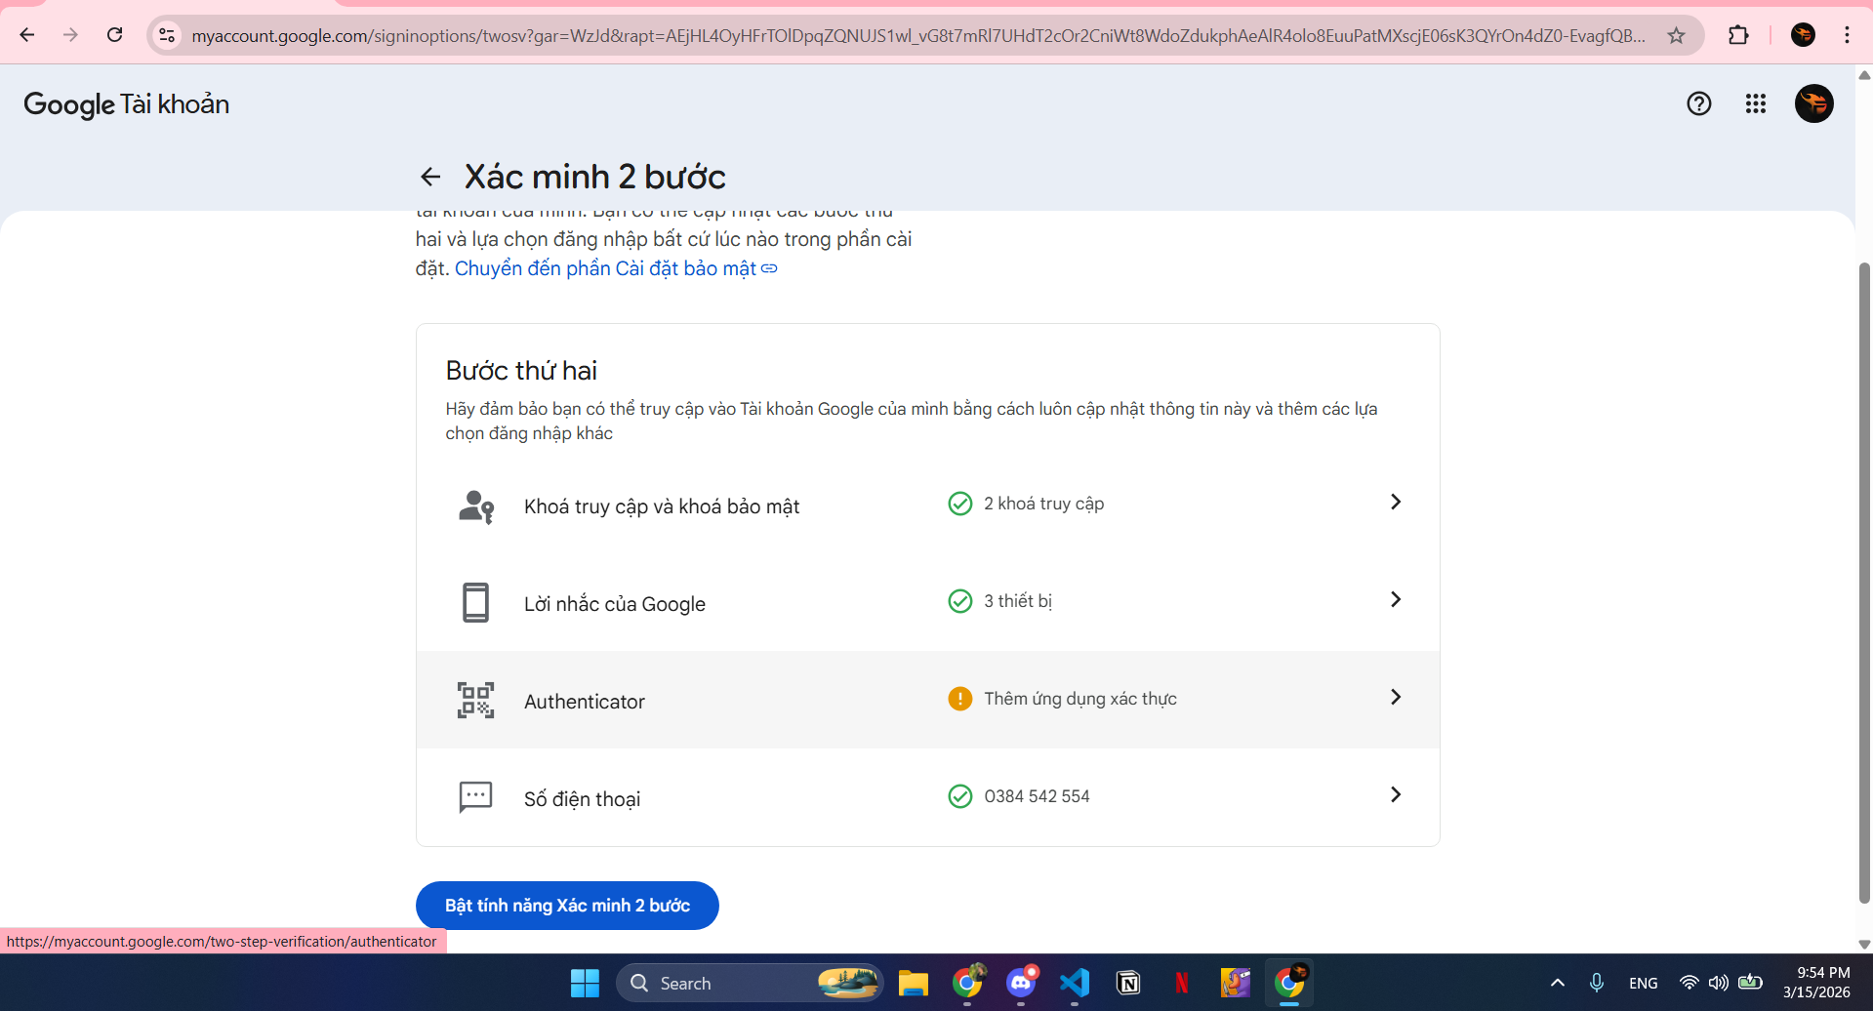

Step 4
Step 4: Scroll down and choose 'Authenticator' to add an authentication app.
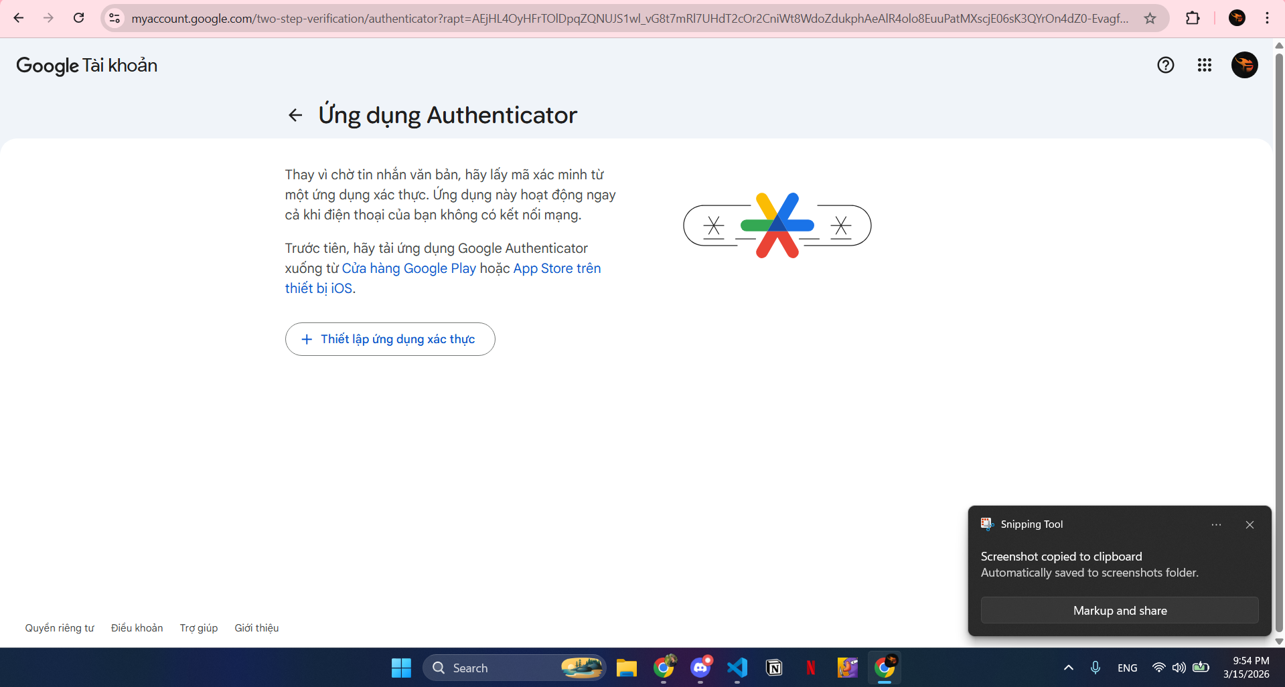

Step 5
Step 5: Click 'Set up Authenticator app' and install Google Authenticator on your phone if you have not installed it.
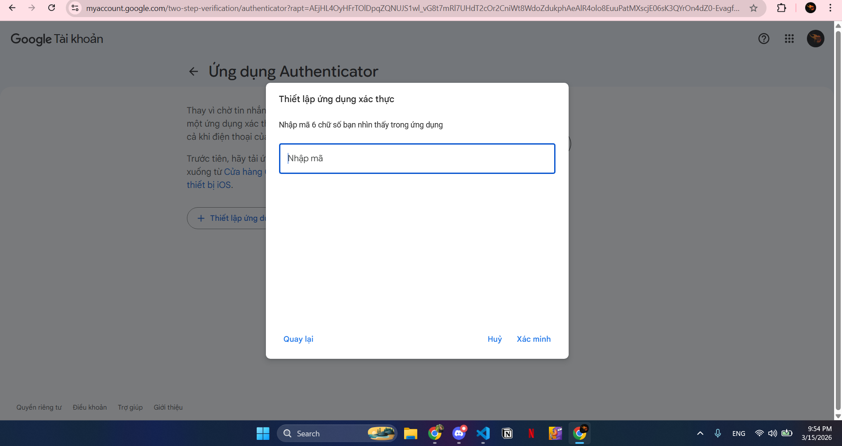

Step 6
Step 6: Scan the QR code with the Google Authenticator app to generate a 6‑digit verification code.
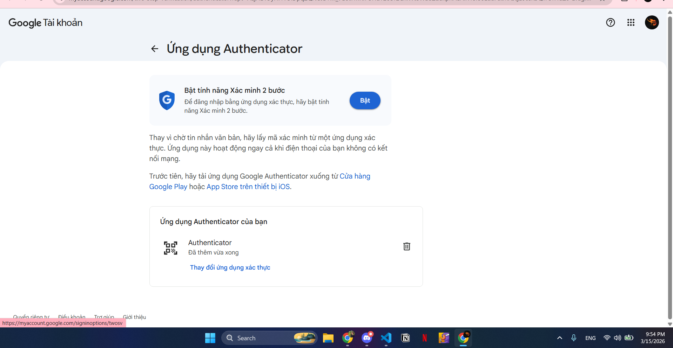

Step 7
Step 7: Enter the 6‑digit code from the Authenticator app into the verification field and click 'Verify'.
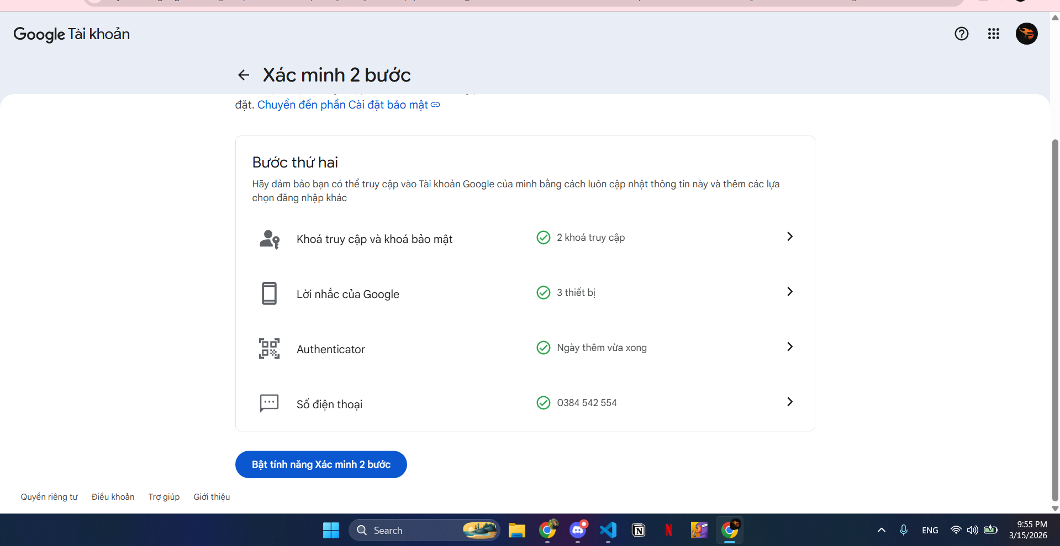

Step 8
Step 8: After verification, click 'Turn on 2‑Step Verification'. Your account will now have 2FA enabled.
