GUIDELINE:

1. Unzip our project folder, open this with any IDE support Java 21.



1. Our sourcecodes are in ‘src’ folder

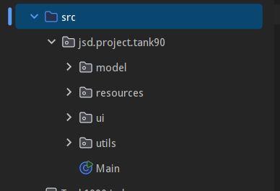

1. Open and go to the Main.java file, run it

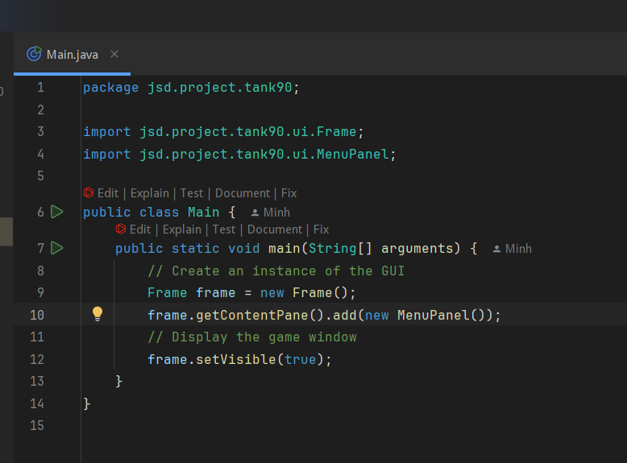

1. Game screen will display, press Enter to play

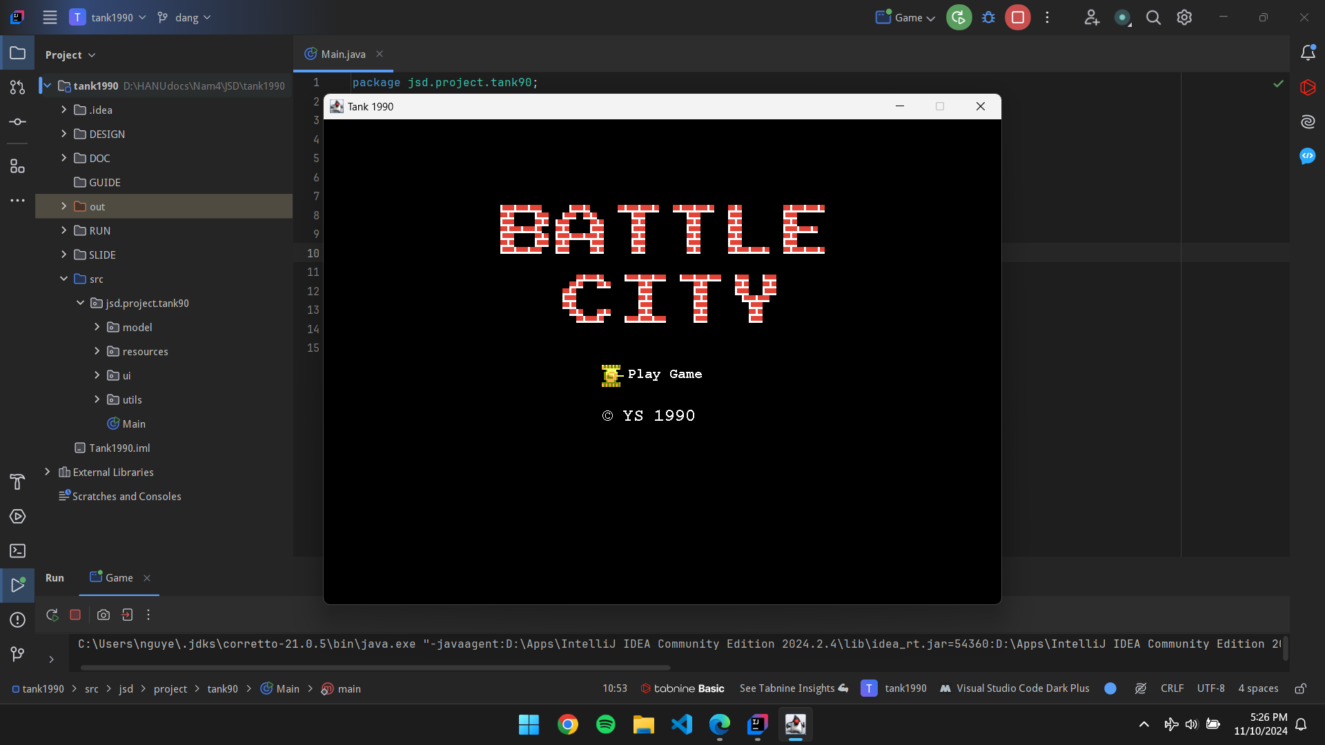

1. Use up and down in keyboard to select map and press enter.

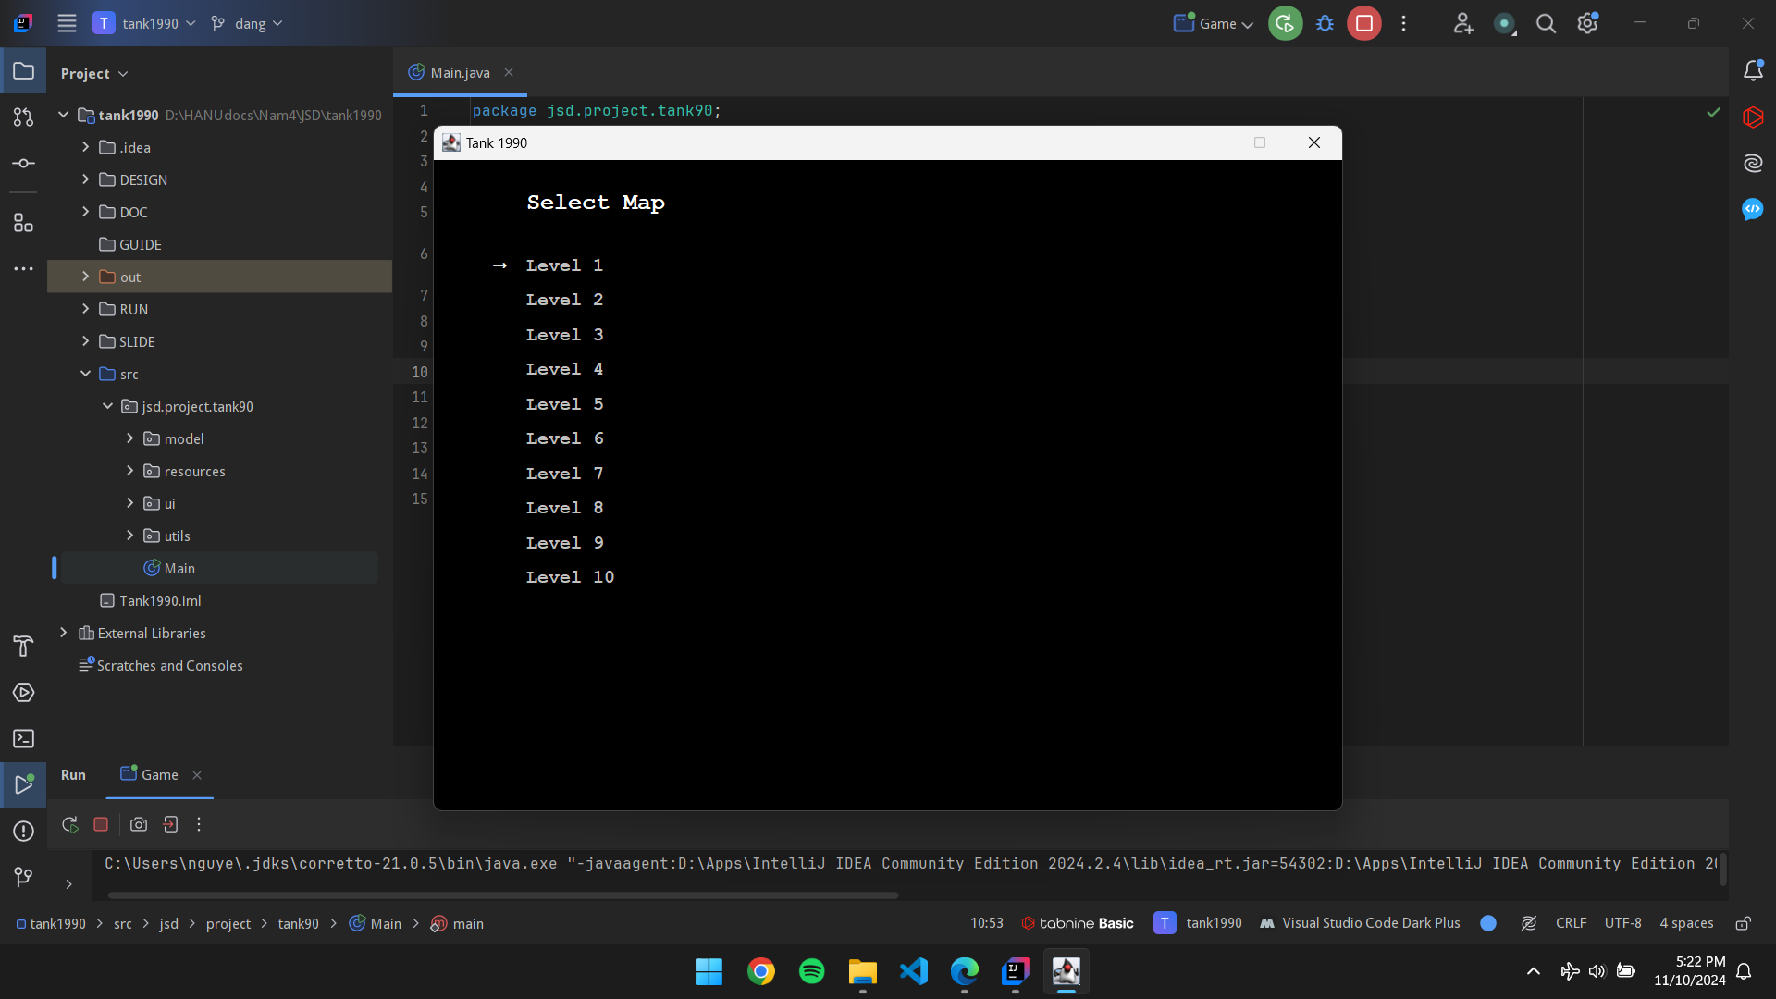

1. Follow the guide in the sidepanel and enjoy our game

