Laboratory Exercise 11

Interrupts & IO programming

Assignment 1

**# Source code đã chỉnh sửa**

.data

.eqv IN_ADRESS_HEXA_KEYBOARD 0xFFFF0012

.eqv OUT_ADRESS_HEXA_KEYBOARD 0xFFFF0014

.text

main: li $t1, IN_ADRESS_HEXA_KEYBOARD

li $t2, OUT_ADRESS_HEXA_KEYBOARD

li $t3, 0x01 # check row 4 with key C, D, E, F

li $t4, 0x08

polling:

sb $t3, 0($t1)

lb $a0, 0($t2)

print:

li $v0, 34

syscall

sleep:

li $a0, 100

li $v0, 32

syscall

back_to_polling:

beq $t3, $t4, reset

sll $t3, $t3, 1

j polling

reset:

li $t3, 0x01

jal polling

**# Demo**

1. Row 1

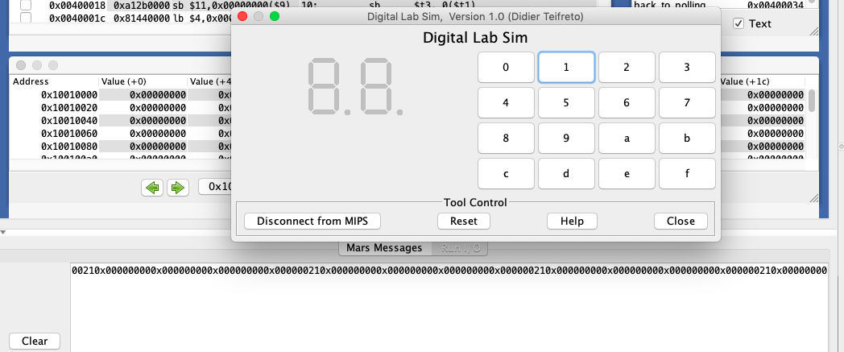

1. Row 2

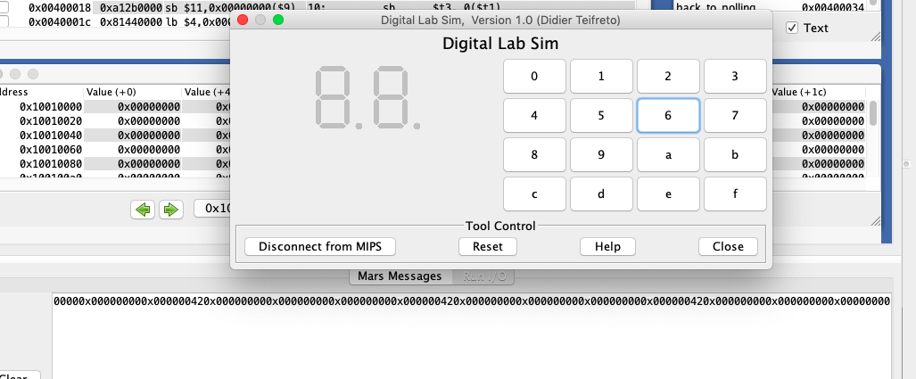

1. Row 3

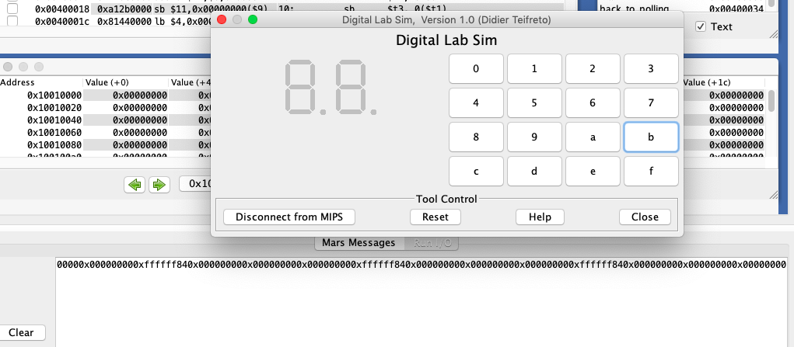

1. Row 4

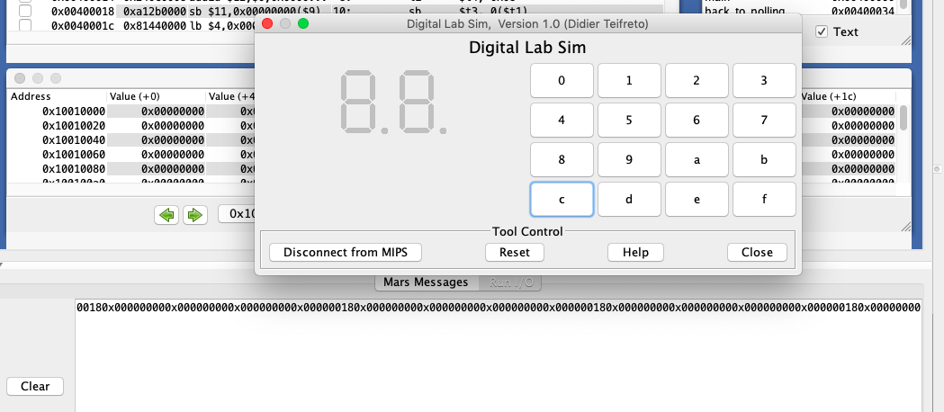

Assignment 2

**# Source Code**

.eqv IN_ADRESS_HEXA_KEYBOARD 0xFFFF0012

.data

Message: .asciiz "Oh my god. Someone's presed a button.\n"

.text

main:

li $t1, IN_ADRESS_HEXA_KEYBOARD

li $t3, 0x80 # bit 7 of = 1 to enable interrupt

sb $t3, 0($t1)

Loop:

nop

nop

nop

nop

b Loop

end_main:

.ktext 0x80000180

IntSR:

addi $v0, $zero, 4 # show message

la $a0, Message

syscall

next_pc:

mfc0 $at, $14

addi $at, $at, 4

mtc0 $at, $14

return:

eret

**# Demo**

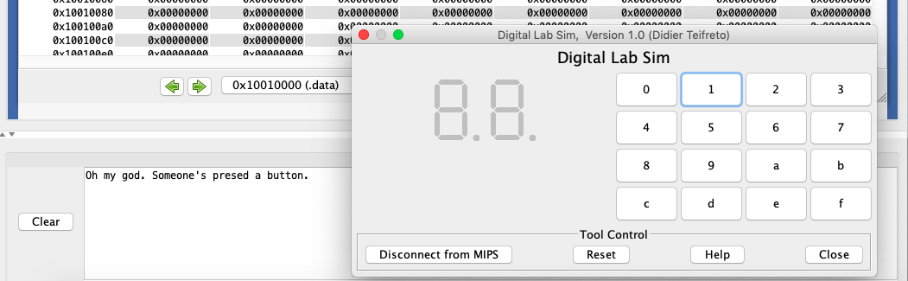

**# Giải thích:**

* Ấn một kí tự bất kỳ bằng thiết bị Digital Lab Sim thì message sẽ được in ra màn hình.

Assignment 3

**# Source code đã sửa đổi**

.eqv IN_ADRESS_HEXA_KEYBOARD 0xFFFF0012

.eqv OUT_ADRESS_HEXA_KEYBOARD 0xFFFF0014

.data

Message: .asciiz "Key scan code "

.text

main:

li $t1, IN_ADRESS_HEXA_KEYBOARD

li $t3, 0x80 # bit 7 = 1 to enable

li $t4, 1

sb $t3, 0($t1)

xor $s0, $s0, $s0

Loop: addi $s0, $s0, 1

prn_seq:

addi $v0, $zero, 1

add $a0, $s0, $zero

syscall

prn_eol:

addi $v0, $zero, 11

li $a0, '\n'

syscall

sleep:

addi $v0, $zero, 32

li $a0, 300

syscall

nop

b Loop

end_main:

.ktext 0x80000180

IntSR:

addi $sp, $sp, 4

sw $ra, 0($sp)

addi $sp, $sp, 4

sw $at, 0($sp)

addi $sp, $sp, 4

sw $v0, 0($sp)

addi $sp, $sp, 4

sw $a0, 0($sp)

addi $sp, $sp, 4

sw $t1, 0($sp)

addi $sp, $sp, 4

sw $t3, 0($sp)

prn_msg:

addi $v0, $zero, 4

la $a0, Message

syscall

get_cod:

li $t1, IN_ADRESS_HEXA_KEYBOARD

li $t3, 0x80

add $t3, $t3, $t4

sb $t3, 0($t1)

li $t1, OUT_ADRESS_HEXA_KEYBOARD

lb $a0, 0($t1)

beq $a0, $zero, continue # Nếu output = 0 thì chuyển qua # hàng khác

j prn_cod # Output # 0 🡪 kết quả trên # hàng đó

continue:

sll $t4, $t4, 1 # tăng index hàng thêm 1

beq $t4, 8, prn_cod # 80 + i*2 = hexa của hàng

j get_cod # tiếp theo

prn_cod:

li $v0, 34

syscall

li $v0, 11

li $a0, '\n'

syscall

next_pc:

mfc0 $at, $14

addi $at, $at, 4

mtc0 $at, $14

restore:

lw $t3, 0($sp)

addi $sp, $sp, -4

lw $t1, 0($sp)

addi $sp, $sp, -4

lw $a0, 0($sp)

addi $sp, $sp, -4

lw $v0, 0($sp)

addi $sp, $sp, -4

lw $ra, 0($sp)

addi $sp, $sp, -4

lw $ra, 0($sp)

addi $sp, $sp, -4

return: eret

🡪 Sửa code hàm get_cod

1. Row 1

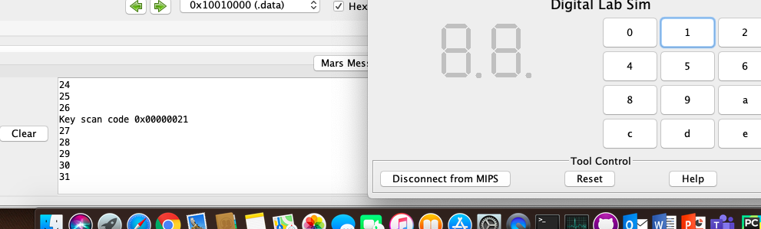

1. Row 2

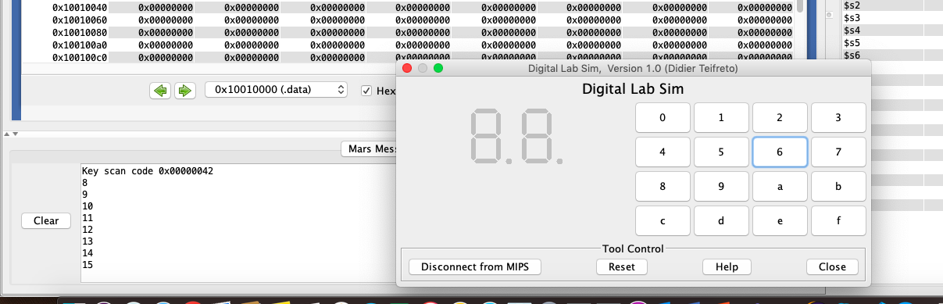

1. Row 3

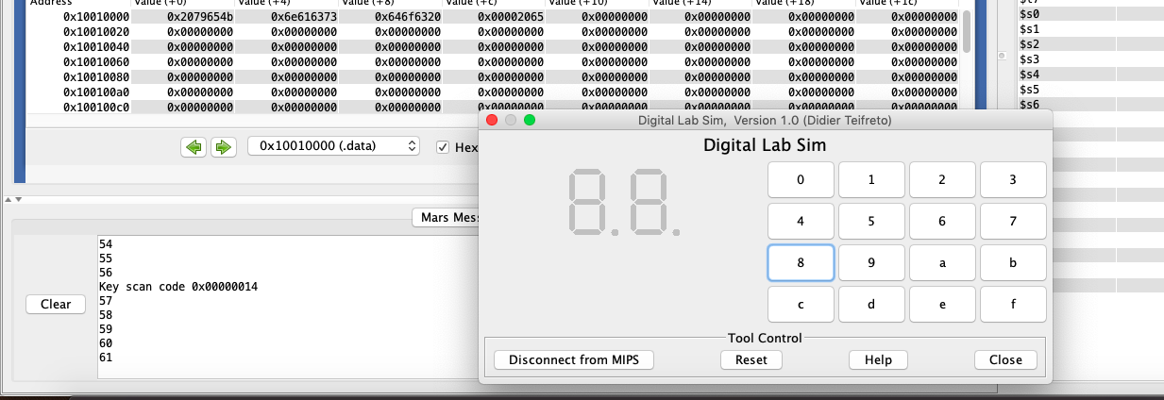

1. Row 4

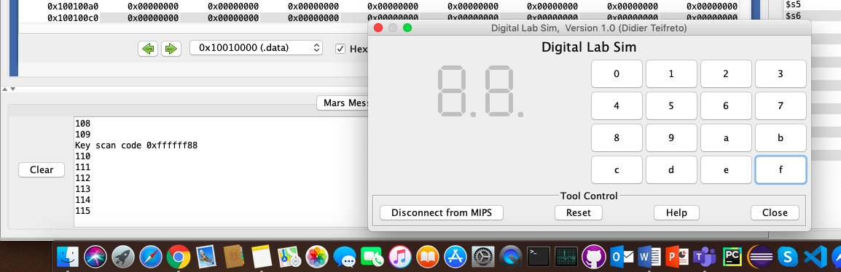

Assignment 4

**# Source Code**

.eqv IN_ADRESS_HEXA_KEYBOARD 0xFFFF0012

.eqv COUNTER 0xFFFF0013

.eqv MASK_CAUSE_COUNTER 0x00000400

.eqv MASK_CAUSE_KEYMATRIX 0x00000800

.data

msg_keypress: .asciiz "Someone has pressed a key!\n"

msg_counter: .asciiz "Time inteval!\n"

.text

main:

li $t1, IN_ADRESS_HEXA_KEYBOARD

li $t3, 0x80 # bit 7 = 1 to enable

sb $t3, 0($t1)

li $t1, COUNTER

sb $t1, 0($t1)

Loop:

nop

nop

nop

sleep: addi $v0, $zero, 32

li $a0, 200

syscall

nop

b Loop

end_main:

.ktext 0x80000180

IntSR:

dis_int:

li $t1, COUNTER # BUG: must disable with Time Counter

sb $zero, 0($t1)

get_caus:

mfc0 $t1, $13

IsCount:

li $t2, MASK_CAUSE_COUNTER

and $at, $t1, $t2

beq $at, $t2, Counter_Intr

IsKeyMa:

li $t2, MASK_CAUSE_KEYMATRIX

and $at, $t1, $t2

beq $at, $t2, Keymatrix_Intr

others: j end_process

Keymatrix_Intr:

li $v0, 4 # Processing Key Matrix Interrupt

la $a0, msg_keypress

syscall

j end_process

Counter_Intr:

li $v0, 4 # Processing Counter Interrupt

la $a0, msg_counter

syscall

j end_process

end_process:

mtc0 $zero, $13

en_int:

li $t1, COUNTER

sb $t1, 0($t1)

next_pc:

mfc0 $at, $14

addi $at, $at, 4

mtc0 $at, $14

return: eret

**# Demo**

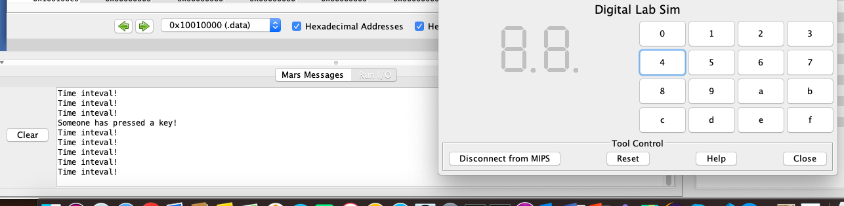

**# Giải thích:**

* Vòng lặp mãi mãi chỉ kết thúc nếu người dùng ấn dừng.
* Sau mỗi khoảng thời gian ngắn thì message “Time interval!” sẽ được in ra console.
* Tuy nhiên nếu người dùng nhập số bằng thiết bị Digital Lab Sim thì message “Some one has pressed a key!” sẽ được in ra console.

Assignment 5

**# Source Code**

.eqv KEY_CODE 0xFFFF0004

.eqv KEY_READY 0xFFFF0000

.eqv DISPLAY_CODE 0xFFFF000C

.eqv DISPLAY_READY 0xFFFF0008

.eqv MASK_CAUSE_KEYBOARD 0x0000034

.text

li $k0, KEY_CODE

li $k1, KEY_READY

li $s0, DISPLAY_CODE

li $s1, DISPLAY_READY

loop: nop

WaitForKey:

lw $t1, 0($k1)

beq $t1, $zero, WaitForKey

MakeIntR:

teqi $t1, 1

j loop

.ktext 0x80000180

get_caus:

mfc0 $t1, $13

IsCount:

li $t2, MASK_CAUSE_KEYBOARD

and $at, $t1, $t2

beq $at, $t2, Counter_Keyboard

j end_process

Counter_Keyboard:

ReadKey:

lw $t0, 0($k0)

WaitForDis:

lw $t2, 0($s1)

beq $t2, $zero, WaitForDis

Encrypt:

addi $t0, $t0, 1

ShowKey:

sw $t0, 0($s0)

nop

end_process:

next_pc:

mfc0 $at, $14

addi $at, $at, 4

mtc0 $at, $14

return: eret

**# Demo**

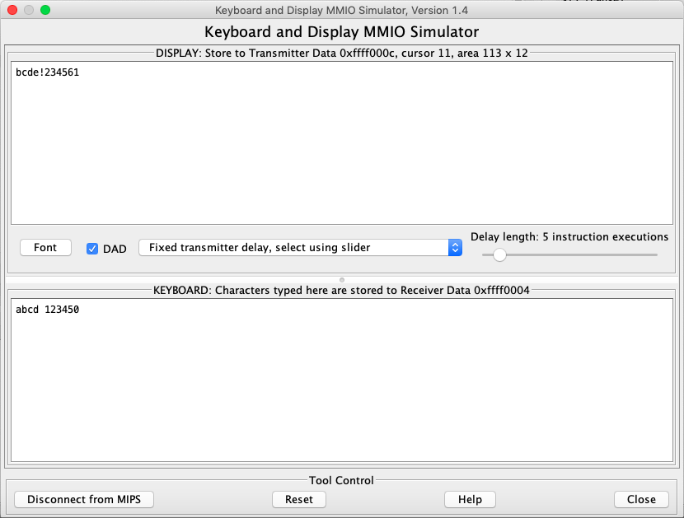

**# Giải thích**

* Chương trình chỉ kết thúc khi người dùng ấn dừng.
* Các kí tự nhập vào sẽ được tính bằng mã ASCII của kí tự đó + 1.