

**Centre Name: ACE-HCMC-2-FPT.**

**Address: 590 Cach Mang Thang 8, District 3, Ho Chi Minh City, Viet Nam.**

TASHA

Supervisor: Ms. Le Mong Thuy

Semester: 01

Batch No: T1 – 1910 – M1

Group No: 04

|  |  |  |
| --- | --- | --- |
| **Supervisor:** | Ms. Le Mong Thuy | |
| **Semester:** | 1 | |
| **Batch No:** | T1.1910.M1 | |
| **Group No:** | 4 | |
| **Order:** | **Full name** | **Roll No.** |
| 1. | Le Minh | Student1225645 |
| 2. | Do Minh Phong | Student1233869 |
| 3. | Tran Ngoc Bao Thien | Student1225634 |

Month 12 Year 2019

**This is to certify that**

Mr. Le Minh

Mr. Do Minh Phong

Mr. Tran Ngoc Bao Thien

**Have successfully designed & developed:**

eProject: TASHA website

**Submitted by:**

Ms. Le Mong Thuy

**Authorized Signature:**

|  |  |  |
| --- | --- | --- |
|  | Prepare by (student) | Approved by (Faculty) |
|  | Group 4 | Ms. Le Mong Thuy |
| Signature |  |  |
| Date |  |  |

**TABLE OF CONTENTS**

SYNOPSIS________________________________________________4

* PROBLEM DEFINITION
* PROBLEM IDENTIFICATION
* CUSTOMER’S REQUIREMENTS SPECIFICATIONS

SCOPE OF THE WORK (in brief)_______________________________6

TASK SHEET REVIEW 1_____________________________________7

SITE MAP_________________________________________________8

MOCK OF THE WEBSITE____________________________________9

TASK SHEET REVIEW 2____________________________________13

SCREEN SHOT___________________________________________14

CHECKLIST OF VALIADATIONS_____________________________19

SUBMISSION CHECKLIST__________________________________20

TASK SHEET REVIEW 3____________________________________21

1. **SYNOPSIS**

**CUSTOMER’S REQUIREMENTS SPECIFICATIONS**

TASHA- the home store is Branded Company famous for home kitchen appliances. It provides collection of n number of appliances with different category to match the fast life of the generation. The Tasha group of companies had made huge profit in the year 2013. In order to enhance its business the organization wants you to develop the website.

**Requirement Specification:**

The Web site is to be created based on the following requirements.

1. The Home page must include images with slide show and links for navigation.
2. Proper template must be designed for the website, few section of the webpage can be included to show or advertise the upcoming products.
3. Categories like Cookware, Refrigeration, Appliances, food storage, Knives and tools, Laundry and other accessories.
4. List such as:
   1. Cookware:
      1. Cooking pots
      2. Cooking Pans
      3. Frying Pans
      4. Cookware Sets
      5. Handis
      6. Kadais [Karahi]
      7. Grill pans
      8. Tawas
      9. Egg Poachers
      10. Steamers
   2. Refrigeration
      1. Freezers
      2. Refrigerators
   3. Appliances
      1. Blenders
      2. Bread makers
      3. Coffee makers
      4. Ice-cream and sorbet makers
      5. Electric kettles
      6. Food choppers
      7. Toasters
   4. Food storages
      1. Flask
      2. Spice jars
      3. Storage bags
      4. Lunch boxes
      5. Vacuum bottles
   5. Others
      1. Knifes
      2. Janitorial supplies
      3. Utensil
5. Support Link can be added for proving aid services such as

* Manuals
* Expert tips
* Register complain
* Feedback
* Contact

1. Store Locators: must display the address location of all the branches available. Address should be displayed using GeoLocation API (eg. GoogleMaps).
2. Navigation of the project must be made precise and uniformity must be maintained.

**Hardware / Software Requirements**

**Hardware**

* A minimum computer system that will help you access all the tools in the courses is a Pentium 166 or better.
* 64 Megabytes of Ram or better.

**Software**

* Notepad / HTML editor
* Dreamweaver
* IE 5.0 / Netscape 6.0

**SCOPE OF THE WORK (IN BRIEF)**

After giving time for team’s members to have discussion together, we have come to an idea that archive most of the requirements from the customer:

1. The home page will have images slider to show products of the store and upcoming products will be show in sliders. Contact us page will have email link and location map.
2. User can view and know the price of the product.
3. User also can give feedback.

**TASK SHEET REVIEW 1**

|  |  |  |  |  |  |  |  |
| --- | --- | --- | --- | --- | --- | --- | --- |
| **Project Ref. No.:**  **eP/Advertisement** **Portal Management** **System/01** |  | **Project Title:** | **Activity plan prepare by:** |  |  |  |  |
| **No.** | **Task** |  |  | **Actual start date** | **Actual days** | **Team mate name** | **Status** |
| **1** | Problem identifications |  |  | 7/12/2019 | **1** | All | Completed |
| **2** | Analysis of Tasha requirements about the website | **TASHA** | **LE MINH** | 7/12/2019 | **1** | All | Completed |
| **3** | The scope of the work(in brief) |  |  | 7/12/2019 | **1** | All | Completed |
| **4** | Diagram of the website |  |  | 8/12/2019 | **1** | All | Completed |
| **5** | Task sheet |  |  | 8/12/2019 | **1** | L. MINH | Completed |

|  |  |
| --- | --- |
| **DATE:** |  |
| Signature of Instructor:  Ms. Le Mong Thuy | Signature of team leader:  Minh Le |

**SITE MAP**

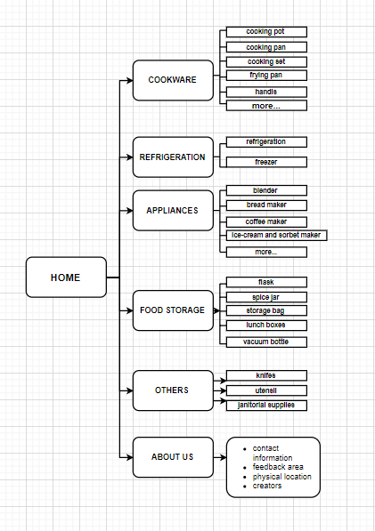

**MOCK OF THE WEBSITE**

**HOME PAGE**

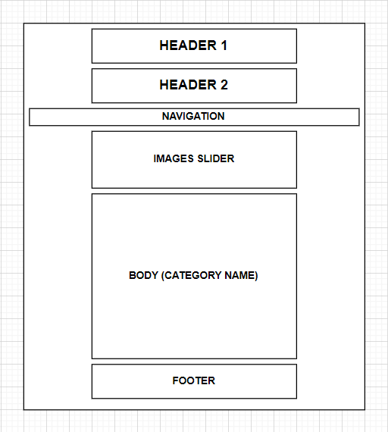

**PRODUCT PAGE**

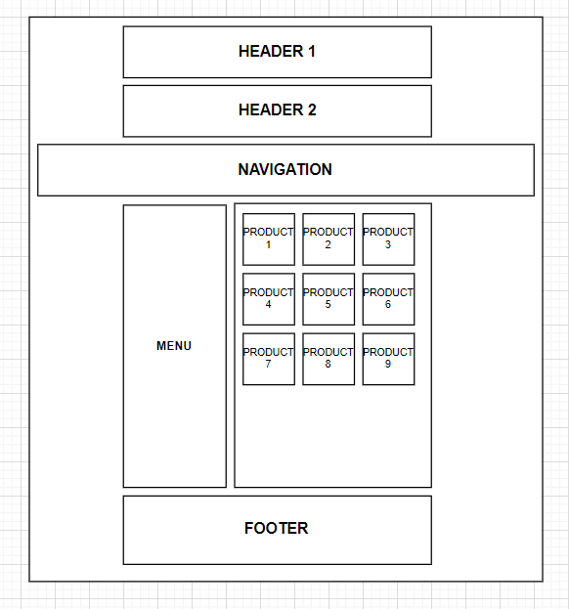

**PRODUCT DETAIL PAGE**

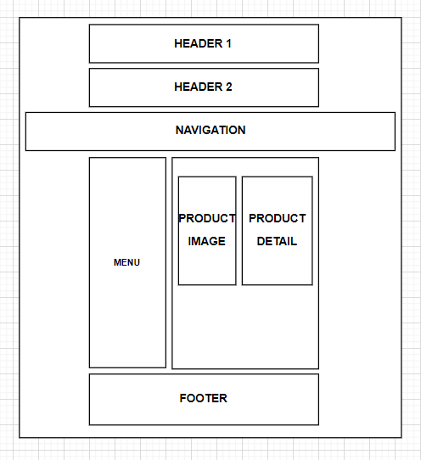

**ABOUT US PAGE**

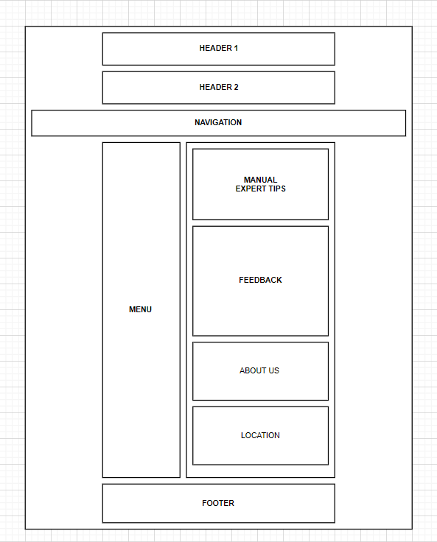

**TASK SHEET REVIEW 2**

|  |  |  |  |  |  |  |  |  |  |
| --- | --- | --- | --- | --- | --- | --- | --- | --- | --- |
| **Project ref. no: eP/Advertisement Portal Management System/01** |  | **Project title:** | **Activity plan prepared by:** | **Date of preparation of activity plan:** | |  | |  |  |
| **Sr. no:** | **Task** |  |  | **Actual start days** | **Actual days** | | **Team mate names** | | **Status** |
| **1** | Site map |  |  | 9/12/2019 | 1 | | All | | Completed |
| **2** | Mock of website | **TASHA** | **LE MINH** | 9/12/2019 | 1 | | All | | Completed |
| **3** | Task sheet |  |  | 9/12/2019 | 1 | | All | | Completed |
|  |  |  |  | 9/12/2019 | 1 | | L.MINH | | Completed |

|  |  |
| --- | --- |
| **DATE:** |  |
| Signature of Instructor:  Ms. Le Mong Thuy | Signature of team leader:  Minh Le |

**Website description**

* First, all the data is published on github server.
* Second, the index.html file is used to redirect to the home.html.
* There are 7 categories pages we put in the eProject folder, and detail of products are inside product folder.
* The home page will contain most information as well as link to any page of every pages. Image slider can contain 5 images, developer can easy update it.
* Most of the picture and information was taken from amazon.com.

**SCREENSHOT**

**Header:**

* The homepage will have slide image, and the categories

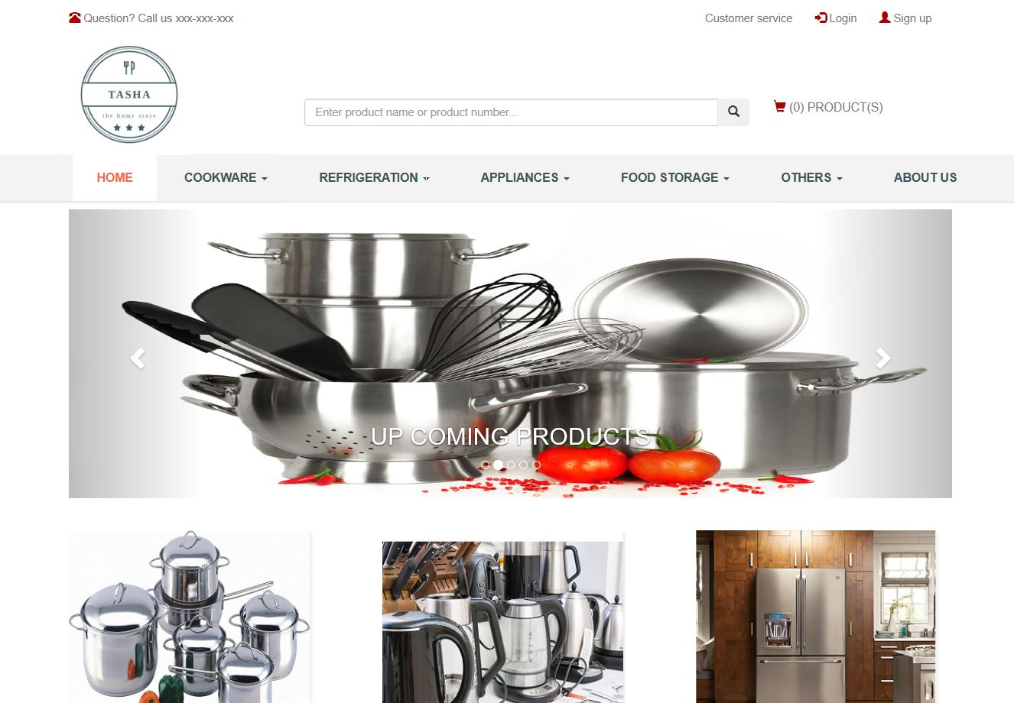

**Footer :**

* Home page footer

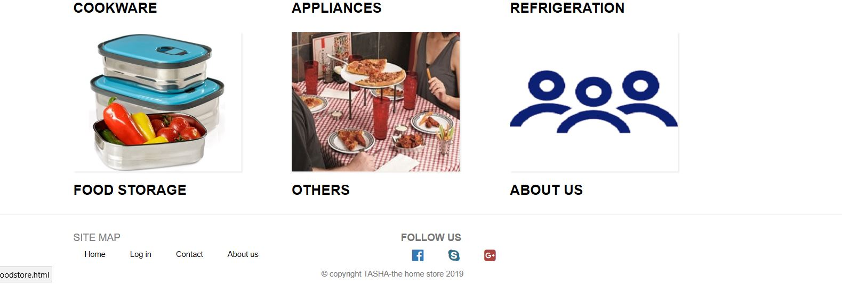

**Category page**

* After click on one tab from the navigation

For example: After click COOKWARE, we will see each group of product

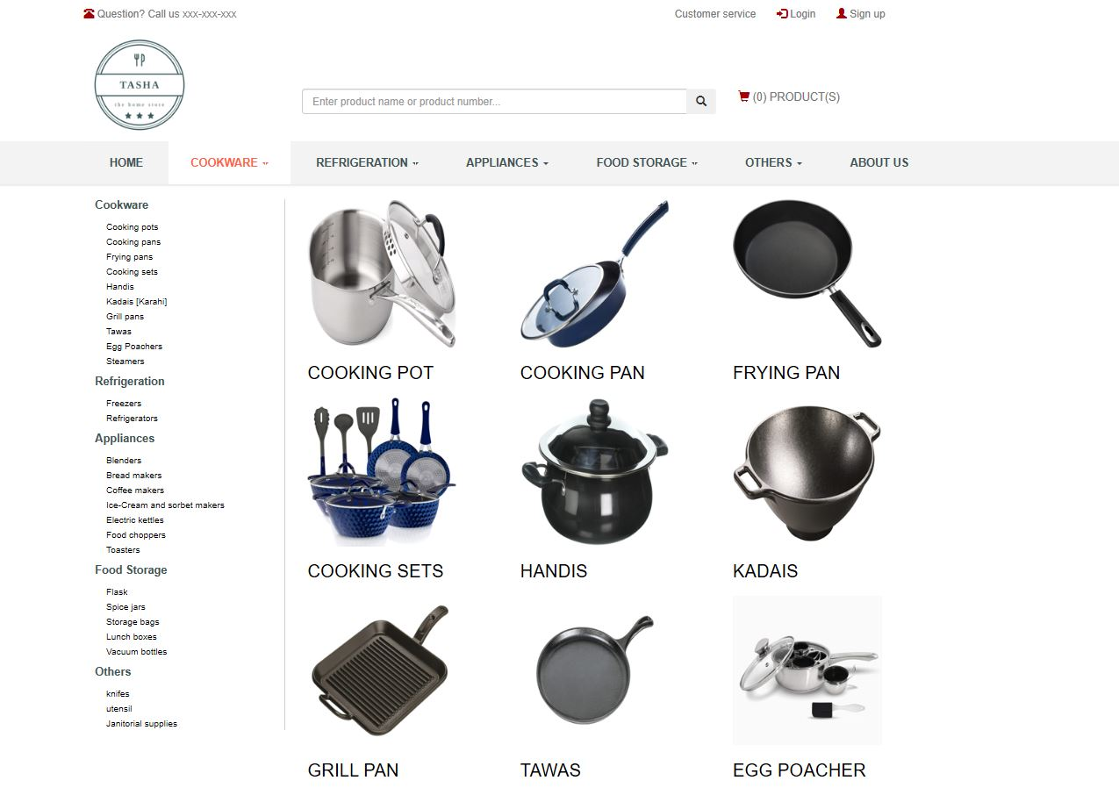

**Details**

* After click on one group of a product you will see products in that group
* Clicking on one specific product it will display detail right under the photo

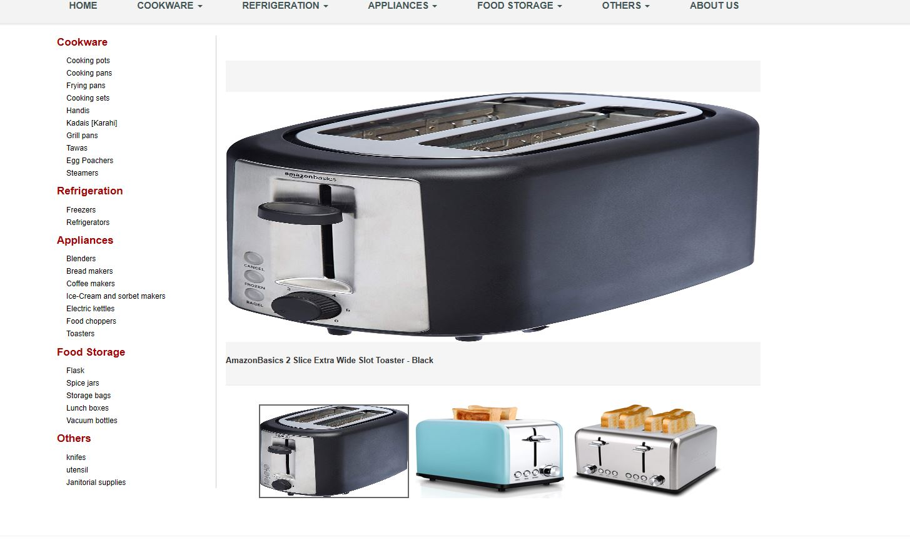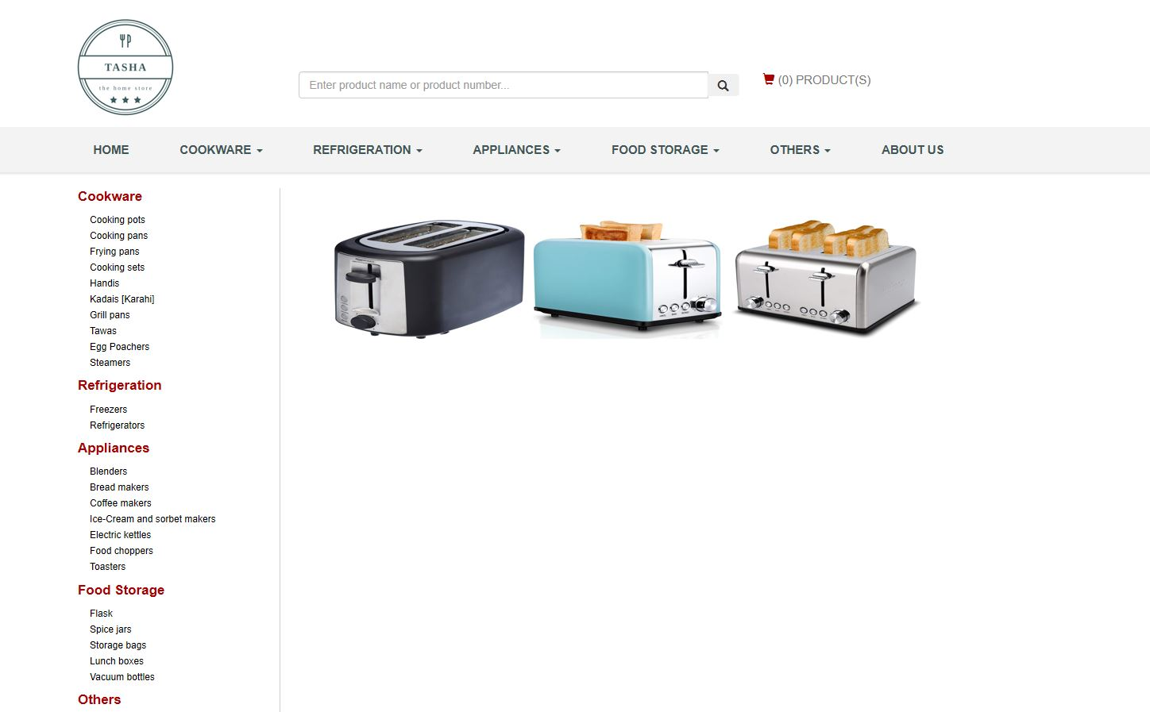

**Login:**

* When we click on ABOUTUS, it will show the description and login part.
* It also included feedback from customer.

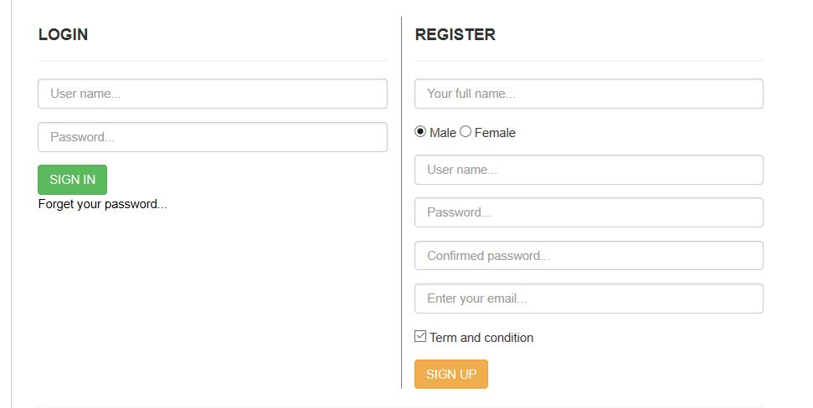

**Location:**

* Location is included in ABOUTUS page

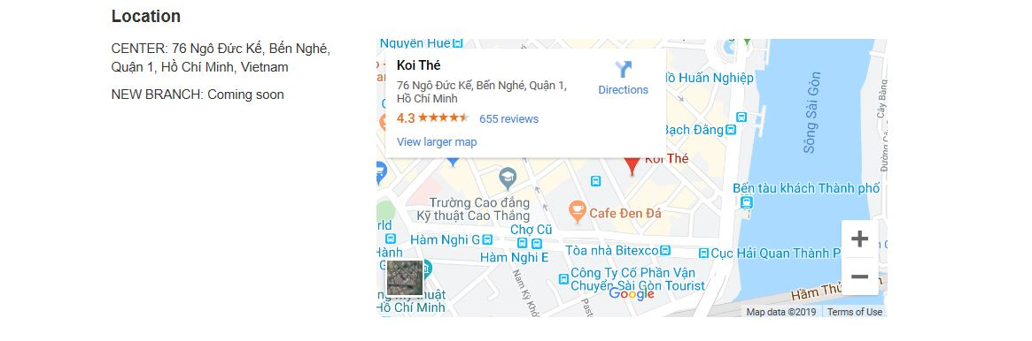

**Feedback**

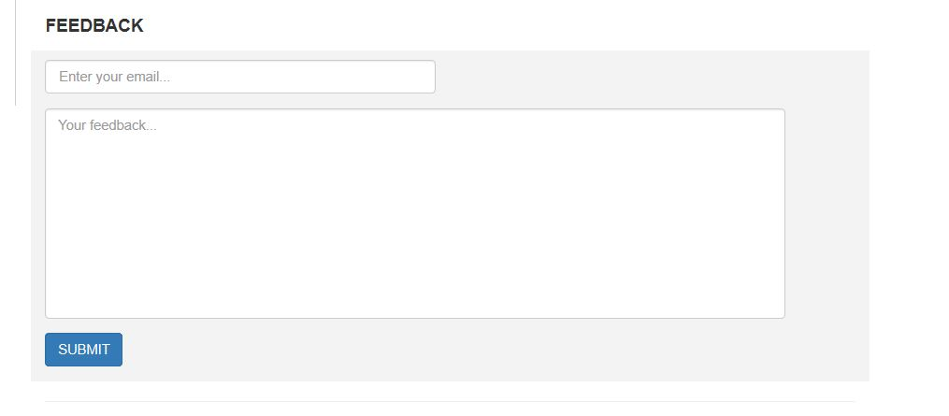

|  |  |
| --- | --- |
| **Option** | **Validated** |
| Do all text links lead to the appropriate Web sites? | Yes |
| Do all the image links lead to the appropriate Web sites? | Yes |
| Are all the images and links clearly visible on the page? | Yes |
| Is the Web page opening property in on the tested Web browsers? | Yes |
| Is the Web page taking too long to load? | No |
| Is the navigation sequence correct through all the Web pages on the site? | Yes |
| Is the Javascript code working as expected in all click events? | No |

**Submission Checklist**

|  |  |  |  |  |  |
| --- | --- | --- | --- | --- | --- |
| **Sr. No.** | **Particulars** | **Yes** | **No** | **Na** | **Comments** |
| **1** | Are all the users able to view the images and links? | Yes |  |  |  |
| **2** | Have all the views, modules, and controllers been property integrated and is the site functional as a Single Page Application? | Yes |  |  |  |
| **3** | Are the GUI contents devoid of spelling mistakes? | Yes |  |  |  |
| **4** | Is the application user-friendly? | Yes |  |  |  |
| **5** | Is the Web site launching correctly in the browser? | Yes |  |  |  |

**Task sheet review 3**

|  |  |  |  |  |  |  |  |
| --- | --- | --- | --- | --- | --- | --- | --- |
|  | **Project Ref. No.:**  **eP/Advertisement Portal Management System/01** | **Project title:** | **Activity Plan Prepared By:** |  | **Date of Preparation of Activity plan** | | |
| Sr. No | Task |  |  | **Actual start date** | **Actual days** | **Team members** | **Status** |
| 1 | Home |  |  | 10/12/19 | 2 | Minh | Completed |
| 2 | Cookware |  |  | 10/12/19 | 2 | Phong | Completed |
| 3 | Refrigeration |  |  | 12/12/19 | 2 | Phong | Completed |
| 4 | Appliances |  |  | 12/12/19 | 2 | Thien | Completed |
| 5 | Food Storage | **TASHA** | **Minh** | 10/12/19 | 2 | Thien | Completed |
| 6 | Laundry and other |  |  | 13/12/19 | 1 | Minh | Completed |
| 7 | Support link |  |  | 13/12/19 | 1 | Minh | Completed |
| 8 | Footer |  |  | 13/12/19 | 1 | Minh | Completed |
| 9 | Checklist of validations |  |  | 23/12/19 | 1 | Minh | Completed |
| 10 | Submission Checklist |  |  | 23/12/19 | 1 | Minh | Completed |

|  |  |
| --- | --- |
| **DATE:** |  |
| Signature of Instructor:  Ms. Le Mong Thuy | Signature of team leader:  Minh Le |