Revision Unit 2 Sport

The History of Basketball
​
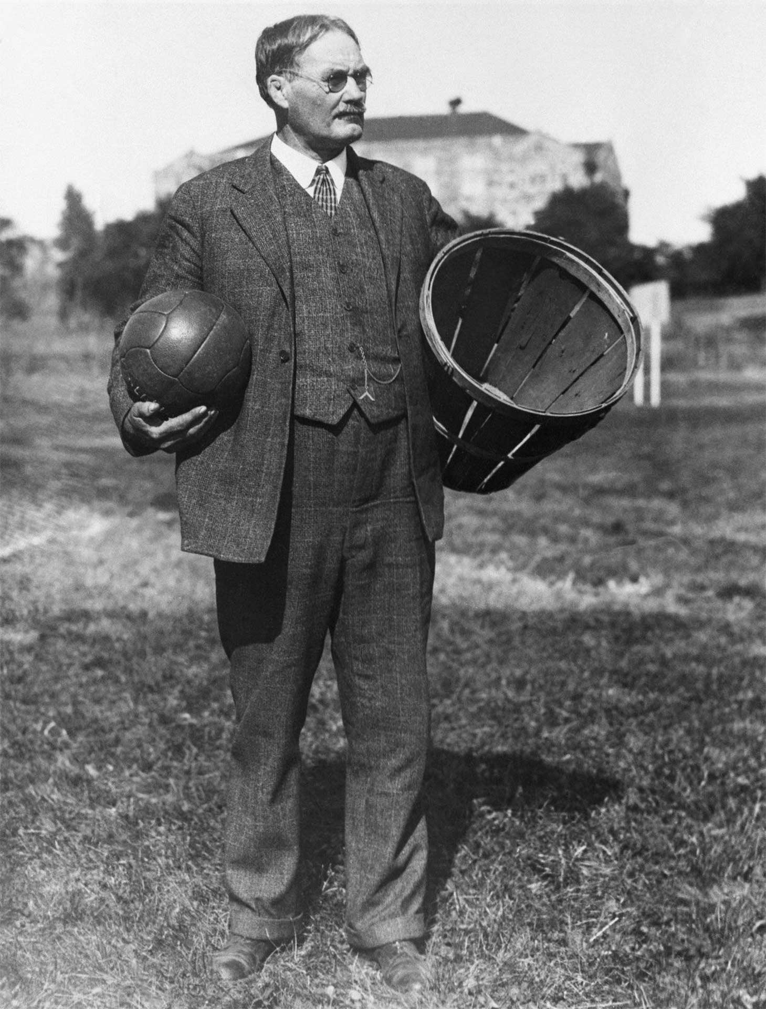
The first basketball 'hoops' were peach baskets.
Basketball is one of the most popular sports in the world today, but it started in a very simple way. In December 1891, a gym teacher named James Naismith wanted to find a game his students could play indoors during the cold winters in Massachusetts. He nailed two peach baskets to the balcony railings of the gym and used a soccer ball for the game. Unlike today, the baskets had solid bottoms, so every time a player scored, the referee had to climb a ladder to get the ball back!
As the game grew, people made changes to make it faster and more exciting. In the beginning, there were no backboards, which meant fans in the balcony could reach over and block the shots. Backboards were added to stop this from happening. The soccer ball was eventually replaced by a larger orange ball that was easier to bounce and grip.
In 1946, the Basketball Association of America was formed, which later became the National Basketball Association (NBA) in 1949. This organization helped turn basketball into a professional sport. Today, players like LeBron James and Michael Jordan are famous for their skills, but it all began with a soccer ball and two peach baskets.

Part A: Multiple Choice
Circle the best answer.

1. Who invented basketball?
A) Michael Jordan
B) James Naismith
C) A referee in Massachusetts
D) LeBron James

2. What was used as the first basketball?
A) A tennis ball
B) A volleyball
C) A larger orange ball
D) A soccer ball
3. Why were backboards added?
A) To hold the peach baskets
B) To stop fans from blocking shots
C) To make the game slower
D) To help players bounce the ball

Part B: Written Answers
Answer using evidence from the text.
4. What major change happened to the sport in the late 1940s? Explain in your own words.
​

5. Based on the passage, explain why the game was much slower when it was first invented compared to how it is played now.
​

Part C: Challenge Question
Think carefully and support your answer with evidence from the text.
6. The passage says people made changes to make basketball "faster and more exciting." In your own words, explain how each change (backboards, the orange ball, and the NBA) solved a problem from the early game. Then give your opinion: which change do you think mattered most, and why?
​

​

Activity 2: Modal Verbs and Action Verbs in Sports
​
Grammar Guide: Modal Verbs
can — shows ability or permission.
could — shows past ability or a possibility.
must — shows a strong requirement or rule.
should — shows advice or what is best to do.
might — shows a small possibility.
shouldn't — shows that something is not a good idea (negative advice).
mustn't — shows something is forbidden or not allowed.
need to — shows something is necessary.
don't need to — shows something is not necessary.
Ought to – shows necessity.

Modal Verbs
Read each sentence about sports. Choose the best modal verb from the word bank to complete the sentence. Use each word at least once.

Word Bank: can, could, must, should, might, shouldn't, mustn't, need to, don't need to

1. A soccer player ______ not touch the ball with their hands unless they are the goalie.
2. LeBron James ______ play both basketball and football very well when he was in high school.
3. If you want to get better at free throws, you ______ practice every single day.
4. Michael Jordan ______ stick his tongue out whenever he jumped toward the hoop.
5. You ______ win the game if you stay focused and work together as a team.
6. Athletes ______ drink plenty of water to stay hydrated during a long match.
7. A basketball player ______ score a three-pointer if they shoot from behind the arc.
8. Even if a team is losing, they ______ still win if they make a big comeback in the final minute.
9. Players ______ argue with the referee, or they will get a penalty.
10. You ______ eat a huge meal right before a game.
11. Before a big match, players ______ get a good night's sleep.
12. You ______ bring your own ball to practice because the coach provides them.

Action Verbs Matching
Draw a line to match each sports-themed action verb to its correct definition.
​
Term |  | Definition
Dribble |  | To hit or kick a ball before it touches the ground.
Sprint |  | To run at full speed over a short distance.
Tackle |  | To bounce a ball repeatedly with one hand while moving.
Volley |  | To start a point by hitting the ball into the opponent's court.
Serve |  | To knock down or stop an opponent who has the ball.
​

First Conditional Game Scenarios
​
Grammar Rule: The First Conditional
We use the first conditional to talk about things that might happen in the future.
Structure: If + [present simple], [will + verb]
Example: If LeBron James practices hard, he will win the game.
Unless means "if... not". We use it to talk about the condition that must be true for something to happen. Example: Unless the team practices hard, they will not win the game. (= If the team does not practice hard, they will not win.) Note: the clause after "unless" is always positive — we don't use "not" after unless.
Complete each sports scenario using the first conditional. Use if or unless where the sentence needs it. Use the source facts about LeBron James and Michael Jordan to help you think of logical results.
1. If the team wins this game...
​

2. Unless the referee blows the whistle...
​

3. If I practice my free throws every day like Michael Jordan...
​

4. Unless LeBron James starts a new project for the I PROMISE School...
​

5. If a player stays calm under pressure...
​

6. Unless you never give up on your dreams...
​

​

Invent a New Sport
LeBron James and Michael Jordan became legends by mastering basketball, but every sport had to be invented by someone! Now it is your turn to be a creator. Use your imagination to design a brand-new sport that people would love to play.
​
Sport Profile
Name of the Sport:
Equipment Needed:
(e.g., ball, net, rackets)
Number of Players:
​
Writing Checklist
As you write your rules, make sure to include:
- 3 Modal Verbs: can, could, must, should, might.
- 3 Action Verbs: dribble, sprint, tackle, volley, serve, throw, catch, etc.
How to Play
Write a set of 5 clear rules for your new sport. Explain how players move, how they score points, and what they are not allowed to do. Remember to use your modal verbs and action verbs!
​

